W4640 | Haoyang Chen | hc2812 | HW5

3.5

(a)

(b)

(c)

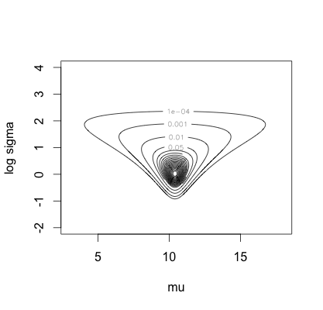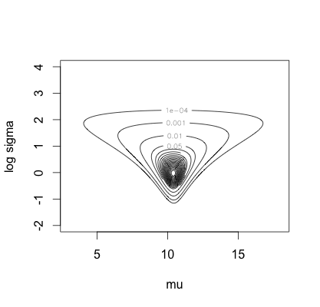

2.5% 25% 50% 75% 97.5%

[1,] 10.426601 0.6933751 9.1517278 10.054718 10.412948 10.807167 11.766502

[2,] 1.412234 0.6710720 0.6724254 0.986343 1.249111 1.641871 2.929167

2.5% 25% 50% 75% 97.5%

[1,] 10.411018 0.6716420 9.1055276 10.0100503 10.386935 10.763819 11.819095

[2,] 1.349437 0.6486137 0.6111198 0.9320659 1.186318 1.603778 3.020818

# 3.5c

post.a <- function(mu, sd, y){

ldens <- 0

for (i in 1:length(y)){

ldens <- ldens + log(dnorm(y[i], mu, sd))

}

return(ldens)

}

post.b <- function(mu, sd, y){

ldens <- 0

for (i in 1:length(y)){

ldens <- ldens + log(pnorm(y[i] + 0.5, mu, sd) - pnorm(y[i] - 0.5, mu, sd))

}

return(ldens)

}

summ <- function(x){

return(c(mean(x), sqrt(var(x)), quantile(x, c(.025, .25, .5, .75, .975))))

}

#ignoring rounding

nsim <- 2000

y <- c(10, 10, 12, 11, 9)

n <- length(y)

ybar <- mean(y)

sample_variance <- sum((y - ybar) ^ 2) / (n - 1)

mugrid <- seq(3, 18, length=200)

logsdgrid <- seq(-2, 4, length=200)

contours <- c(.0001, .001, .01, seq(.05, .96, .05))

logdens <- outer(mugrid, exp(logsdgrid), post.a, y)

dens <- exp(logdens - max(logdens))

contour(mugrid, logsdgrid, dens, levels=contours, xlab='mu', ylab='log sigma', title="Posterior Density, Ignoring Rounding", labelx=0, cex=2)

sd <- sqrt((n - 1) * sample_variance / rchisq(nsim, 4))

mu <- rnorm(nsim, ybar, sd / sqrt(n))

print(rbind(summ(mu), summ(sd)))

# Consider rounding

logdens <- outer(mugrid, exp(logsdgrid), post.b, y)

dens <- exp(logdens - max(logdens))

contour(mugrid, logsdgrid, dens, levels=contours, xlab='mu', ylab='log sigma', title="Posterior Density, Considering Rounding", labelx=0, cex=2)

dens.mu <- apply(dens, 1, sum)

muindex <- sample(1:length(mugrid), nsim, replace = T, prob = dens.mu)

mu <- mugrid[muindex]

sd <- rep(NA, nsim)

for (i in 1:nsim) {

sd[i] <- exp(sample(logsdgrid, 1, prob = dens[muindex[i],]))

}

print(rbind(summ(mu), summ(sd)))

(d)

> mean((z[, 1] - z[, 2]) ^ 2)

[1] 0.1610319

# 3.5d

z <- matrix(NA, nsim, length(y))

for (i in 1:length(y)){

lower <- pnorm(y[i] - .5, mu, sd)

upper <- pnorm(y[i] + .5, mu, sd)

z[, i] <- qnorm(lower + runif(nsim) * (upper - lower), mu, sd)

}

mean((z[, 1] - z[, 2]) ^ 2)