CP3405

Design Thinking III

Group – PB1

Assignment – 1 (Pilot Study)

Project: Maze Game

Sai Kham Thura Nyunt

Saaipranav Subramanian

Htet Arkar Win

Hayoi Shan

Jianhong Li

Huynh Truong Thien Duong

Chelsea Tandyo

Jonathan Roi Agarrado

**Section – 1**

The project challenge is to create an AR maze game. The game should be easy to play and navigate, and the maze should be challenging enough to keep players engaged. The game should also be visually appealing and have a clear objective. Developing an easy AR maze game project also has its own set of pros and cons.

**Pros**:

**Engaging**: Maze games can be engaging and fun for players, especially if they are designed well. They can help players improve their problem-solving skills and spatial awareness.

**Educational**: Maze games can be designed to be educational, incorporating mini games that require players to answer questions or solve puzzles related to a specific topic.

**Easy to develop**: With the availability of tools like Maze, it is easy to create a maze game for any project need, from surveys to usability tests, and share it with users in a matter of minutes with a URL.

**Augmented Reality**: By using AR technology, maze games can be superimposed onto the real-world environment, creating a more immersive experience for players.

**Cons**:

**Learning curve**: While there may be a learning curve for beginners, the benefits of using Maze far outweigh any challenges. This means that it may take some time to learn how to use the platform effectively.

**Limited customization**: Maze may have limited customization options for the maze game. This means that the game may not be as visually appealing as desired.

**Technical issues**: Developing an AR maze game can be challenging, and technical issues may arise during the development process. These issues can affect the game's performance and user experience.

Overall, a maze game is excellent for developing and testing an AR maze game. Because of its ease of use and remote testing features, it is an excellent tool for testing the game with a big number of users. However, for those looking for a more graphically pleasing game, its limited customizing choices may be a detriment.

**Personas**

Name: John

Age: 33

Occupation: Worker

**Behaviors & Habits**: He loves thins likes things like VR and AR. He is very concerned about the technological development of AR and VR and looks forward to the emergence of better interactive products than these two.

**Frustrations**: He suffered from office stress at workplace and wanted to find a way to relax.

He wants to be able to interact with reality in virtual setting.

**Needs & Goals**: He wants an app or a game that evolves AR or VR or at least that would help him relax as well as challenge in somewhat mentally.

Name: Saai

Age: 36

Occupation: Unemployed

**Behaviors & habits**:Jobless and no passion in life, just looking for games to play, is also fascinated by the gaming industry and its potential to make his life more enjoyable.

**Pain Points & Frustrations**: Frustrated that there are no more fun and exciting games anymore. Whishes more people would spend money on creating enjoyable and fun AR games. Being unemployed, he struggles to make ends meets and supports himself, which leads him to stress and anxiety.

**Needs & Goals**: He needs a stress relief and distraction to help with his anxiety. Especially a temporary one to help deal with what he is currently stressing with right now. Along with this he could also use some sense of achievement and s much needed escape from reality.

name: Zed

age: 25

job: streamer, game developer

**Behaviors & habit**: He enjoys exploring new games, trying out different genres, and showcasing his gaming skills to entertain and inspire his viewers and upper-class men.

**Pain Points & Frustrations**: Main concern is keeping his viewers engaged and entertained during his live streams, He worries that without fresh and exciting content, his audience might lose interest.

He is always on the lookout for the latest gaming trends and technologies to stay as trendy as possible.

**Needs & Goals**: He sees AR as an exciting way to enhance viewer engagement, add interactive elements to his gameplay, and stand out from his peers.

The design of the whole game will have a simple map and a controllable player. Figma and example links are as below.

Figma Link

<https://www.figma.com/file/Y9n6SNeavG7Ab1NhSpVhVt/maze?type=design&t=vofUMbo0Tit8eLf7-6>

Sample map design of the maze (1st draft iteration)

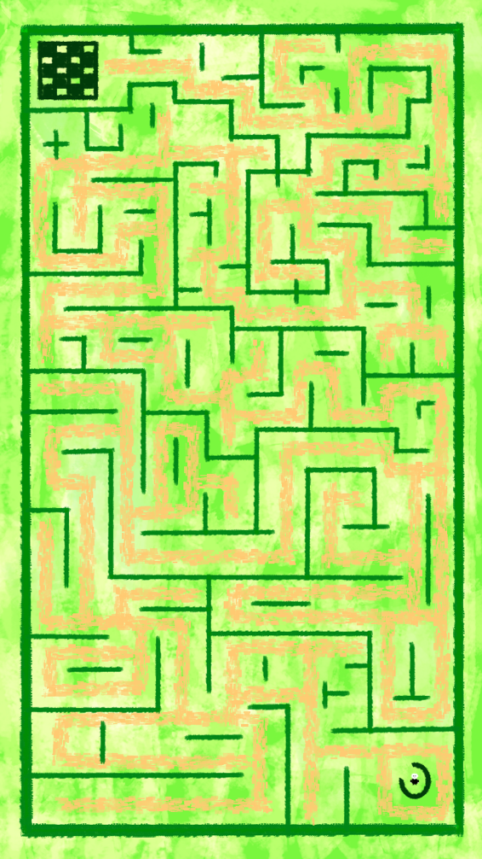

Sample design of the player (1st draft iteration)

**Section – 2**

Based on what the proposed solution and the what the team can achieve, the two below aspects are the most tricky or difficult aspects of the overall project.

**Technical difficulty**: In the group there are mixed student from different trimesters, and none of the group members are not skillful enough to generally and easily adapt to the new software environment. In developing this AR game, unity engine is the most important platform to use, and it will create some difficulty for the group in adapting to the working environment of the software. The team will also consider some html, CSS and JavaScript as the last resort if the unity engine creates a problem and a halt in the development of the AR game.

**Ensuring the game is visually appealing**: While Maze User Testing may be a useful tool for testing the game, it may have limited customization options for the maze game. This means that the game may not be as visually appealing as desired. Designing a visually appealing game may require additional resources or expertise outside of the Maze platform.

Overall, these aspects of the project may require careful consideration and planning to ensure the game is engaging and visually appealing while also being appropriately challenging.

**Section: 3**

**Week 1 Sprint Review**: During the first week, we formed our group for the project and discussed the project's objectives. We introduced ourselves and assigned roles and responsibilities to each team member to come up with ideas for what we are going to do on the project.

**Week 2 Sprint Review**: In the second week, the goal is to decide on what idea if the project we should continue. Two people came up with what to do with the ideas and coordinated on who should research what part of the project such as assigning people to research about what type of game is suitable and fairly easy and researching about what type of platform the game should be developed on. In the end the project will be a fairly easy Maze game.

**Week 3 Sprint Review**: During the third week, we focused on choosing the appropriate development tools for our AR maze game. We researched different AR development platforms and discussed their pros and cons. Eventually; we settled on a specific tool that best suits our project's requirements such as unity.

**Week 4 Sprint Review**: In the fourth week, we delved into the creative aspect of our game. We came up with various character ideas that will be included in the game. Each team member contributed their concepts, and together we refined and selected the characters that fit well within the game's theme and mechanics.

**Section – 4**

Scrum is a project management paradigm that stresses cooperation, accountability, and incremental progress toward a well-defined goal. It is a common software development technique that includes activities such as daily scrums, sprints, sprint planning meetings, sprint reviews, and sprint retrospectives. Scrum's suitability for an AR labyrinth game project would be determined by a variety of factors, including the size of the development team, the complexity of the project, and the needs and structure of the company. It may be beneficial to engage with experienced Scrum practitioners or project managers to assess if Scrum is the best fit for the specific project requirements. The technical feasibility of the project will be determined by the game's specific requirements and complexity, as well as the Group's technical expertise and resources. It may be beneficial for the team to perform additional study and preparation to determine the project's feasibility and identify any potential challenges or constraints. As summarized in section 3 since all the group members have no problem on determining who will coordinate as well as most members having experience working with each other projects, the groups works overall very coordinated as the workload is equally spread throughout the group as well as everyone completes their workload.