## 1. What is Android?

Android is software system for mobile phones, tablets and a growing range of devices encompassing everything from wearable computing to in-car entertainment.

Android is an open source project (led by Google but it doesn't belong to them) called AOSP (Android Open Source Project). Google uses this project as a base to create its version of Android, which is then used by the other manufacturers.

     A lot of companies are developing customized AOSP, like Amazon, etc.

     Almost every tech company requires Android developer.

## 2. AOSP architecture

* Linux Kernel(C)

     This provides a level of abstraction between the device hardware and it contains all the essential hardware drivers like camera, keypad, display etc.

* Libraries(C++)

     On top of Linux kernel there is a set of libraries including open-source Web browser engine WebKit.

* Android Framework(Native Java)

     The Application Framework layer provides many higher-level services to applications in the form of Java classes. Application developers are allowed to make use of these services in their applications.

* Applications (where we are focused on)

和上面三层完全分离。不是以开机关机决定app在不在 而是决定于install／uninstall

通过sdk的interface调用系统里的implementation和上面三层链接

## 3. Android Projects Structure

* **app/java/**

Main folder that contains java source file, java files are mainly focused on logic purposes

两个test一个unit test 一个测试安卓系统相关（例如界面）

* **app/java/res/layout/activity_main.xml(重要)**

Main activity layout file, Each activity will have one layout file associated with it. The layout file defines how the UI looks like (if you are not familiar with xml file, you can find basic concept in [*http://www.w3schools.com/xml/xml_whatis.asp*](http://www.w3schools.com/xml/xml_whatis.asp) )

* **app/java/com.laioffer.eventreporter/MainActivity.java**

The Java class for your activity. When you build and run the app, the **Activity** class    starts the  activity and loads the layout file to show UI

* **app/manifests/AndroidManifest.xml (整个程序的入口)**

The [manifest file](https://developer.android.com/guide/topics/manifest/manifest-intro.html) describes the fundamental characteristics of the app and defines each of its components. The manifest file provides essential information about your app to the Android system, which the system must have before it can run any of the app's code.

* **app/build.gradle**

**通过gradle来定义需要用到什么library 什么版本**

Build configuration file, Google uses gradle as their build tool

Some configuration artifacts,

**compiledSdkVersion** is the platform version against which you will compile your app.

**minSdkVersion** is the earliest version of the Android SDK that your app supports.

**targetSdkVersion** indicates the highest version of Android with which you have tested   your application.

**dependencies**

* **drawable/ (比如尖角圆角，也可以放图片)**

Directories for drawable objects (such as bitmaps) that are designed for various densities, such as medium-density (mdpi) and high-density (hdpi) screens. Other drawable directories contain assets designed for other screen densities. Here you'll find the **ic_launcher.png** that appears when you run the default app.

* **values/(定义color style strings 等等)**

**定义后可以被java文件调用**

**for localization**

Directory for other XML files that contain a collection of resources, such as string and color definitions. Similar to drawable, values/ contains non-drawable resources, such as strings, colors, etc. The strings.xml file defines the "Hello world!" string that displays when you run the default app.

## 4. Android Activity

Concept

一个界面，他有逻辑操作的功能和user interaction的功能。

     An [Activity](https://developer.android.com/reference/android/app/Activity.html) is an application component that provides a screen with which users can interact in order to do something, such as dial the phone, take a photo, send an email, or view a map. Each activity is given a window in which to draw its user interface. The window typically fills the screen, but may be smaller than the screen and float on top of other windows.

Activity Lifecycle

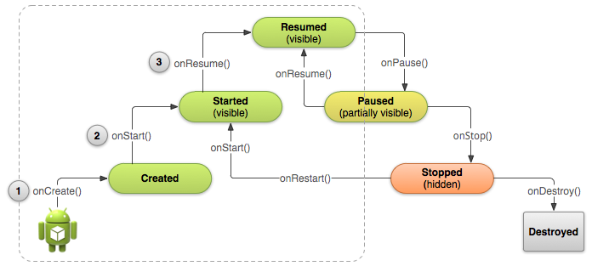

## 5. Android ListView

[**ListView**](https://developer.android.com/reference/android/widget/ListView.html) is a view group that displays a list of scrollable items. The list items are automatically inserted to the list using an [**Adapter**](https://developer.android.com/reference/android/widget/Adapter.html) that pulls content from a source such as an array or database query and converts each item result into a view that's placed into the list.

6. Adapter

What is the adapter pattern?

We need an CD driver (adapter) connected to MAC that allows CD to run.

Example

List Items -🡪 Adapter -🡪 List View

## 7. Fragment

A [Fragment](https://developer.android.com/reference/android/app/Fragment.html) represents a behavior or a portion of user interface in an [Activity](https://developer.android.com/reference/android/app/Activity.html). You can combine multiple fragments in a single activity to build a multi-pane UI and reuse a fragment in multiple activities. You can think of a fragment as a modular section of an activity, which has its own lifecycle, receives its own input events, and which you can add or remove while the activity is running (sort of like a "sub activity" that you can reuse in different activities).

## 8. Why do we need fragment?

## Controlled by fragmentmanager

* A modular section of activity (UI + logic) 模块化
* Like activity, it has its own lifecycle
* Support multiple devices, 在不同大小的device上有不同的显示效果（tablet and phone）

9. Fragment LifeCycle

可以随时attach／detach from activity

* OnAttach(): The fragment instance is associated with an activity instance.
* OnCreate(): Initialize the fragment’s components
* OnCreateView(): Start create an User Interface for the fragment
* OnActivityCreated(): this is called after the Activity's onCreate() has completed.
* OnStart(): fragment gets visible
* onResume(): Fragment becomes active
* onPause(): The system calls this method as the first indication that the user is leaving the fragment
* [onStop()](https://developer.android.com/reference/android/app/Fragment.html#onStop()) fragment is no longer visible to the user either because its activity is being stopped or a fragment operation is modifying it in the activity.
* onDestroyView(): destroy view

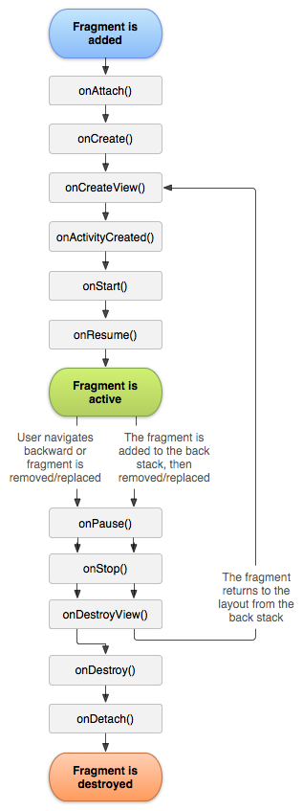

## 10. Fragment Communication

     All Fragment-to-Fragment communication is done through the associated Activity. **Two       Fragments should never communicate directly**.

因为每个fragment需要绝对独立性，可以随时添加删除而不影响别的fragment

## 11. What is FireBase

Firebase is a [mobile](https://en.wikipedia.org/wiki/Mobile_application) and [web application](https://en.wikipedia.org/wiki/Web_application) platform with tools and infrastructure designed to help developers build high-quality apps. Firebase is made up of complementary features that developers can mix-and-match to fit their needs.

后端，有很多功能， 一系列的service的集合

## 12. Why use FireBase

* Firebase is a mobile platform that helps you quickly develop high-quality apps, grow your user base, and earn more money. Firebase is made up of complementary features that you can mix-and-match to fit your needs.(快速)
* Implementing Firebase is quick and easy. With intuitive APIs packaged into a single SDK, you can focus on solving your customer problems and not waste time building complex infrastructure.(简单)
* Deliver cross-platform apps with APIs packaged into single SDKs for iOS, Android, JavaScript, C++, and Unity. Expand to a different platform without modifying your infrastructure.(跨平台)

## 13. Firebase Features

* **Realtime Database**: A cloud-hosted NoSQL database. Data is stored as JSON, synced across connected devices in milliseconds, and available when your app goes offline(upload很快)
* **Cloud Storage**: Store and serve user-generated content like images, audio, and video directly in your mobile app, using the Firebase SDKs. (存储)
* **Cloud Messaging**: Formerly known as Google Cloud Messaging (GCM), Firebase Cloud Messaging (FCM) is a cross-platform — Android, iOS, and Web — solution that lets you reliably deliver and receive messages and notifications at no cost.(和notification连用，发信息给手机)
* **AdMob**: Monetize your app while giving your users a great experience.
* **Crash Reporting**: Receive actionable information on stability issues after you publish your app.
* **Analytics**: Firebase Analytics is a free app measurement solution that provides insight on app usage and user engagement.
* Others

## 14. Singleton

FireBase uses Singleton Design Pattern as rule. Two important features for Singleton

* There is only one FireBase instance across the application
* It does not matter where and when we use FireBase instance

什么时候用singleton？ ： 当这个class被广泛应用到各个地方 比如 log(print message)

class Singleton {

   // Step1: Make instance only one

   private static Singleton instance;

   // Step2: Hide constructor

   private Singleton(){

...

   }

   // Step3: Main function to use singleton

   public static synchronized Singleton getInstance(){

if (instance == null){

     instance = new Singleton();

}

return instance;

    }

}

synchronized –- lock. 其他线程要等这个线程跑完才能跑

## 15. Communication between Activities

9.1. Intent

An intent provides a facility for performing late runtime binding between the code in different applications. Its most significant use is in the launching of activities, where it can be thought of as the glue between activities. It is basically a passive data structure holding an abstract description of an action to be performed.

Activity看成基地， intent是信使to send message。 同时intent也可以带补给品等等不止是message。 补给品等stored in a bundle（hash map with different types） format

9.2. Fundamental usage of intent

* Start an **activity**
* Start a **service (application in back-end. Never shown in UI)**
* Deliver a **broadcast(send message to whole system, not to specific object)** to other APPs.

9.3. Implicit intent and Explicit intent

* Explicit Intents specify the component to start by name (the fully-qualified class name). You'll typically use an explicit intent to start a component in your own app, because you know the class name of the activity or service you want to start. For example, you can start a new activity in response to a user action or start a service to download a file in the background.

      Intent intent = new Intent(context, EventActivity.class);

定义intent从哪里去哪里

* Implicit intents do not name a specific component, but instead declare a general action to perform, which allows a component from another app to handle it

只定义条件，谁满足这个条件intent就去哪里（通过intent filter）

9.4. Intent filter

An intent filter is an expression in an app's manifest file that specifies the type of intents that the component would like to receive. For instance, by declaring an intent filter for an activity, you make it possible for other apps to directly start your activity with a certain kind of intent. Likewise, if you do *not* declare any intent filters for an activity, then it can be started only with an explicit intent.

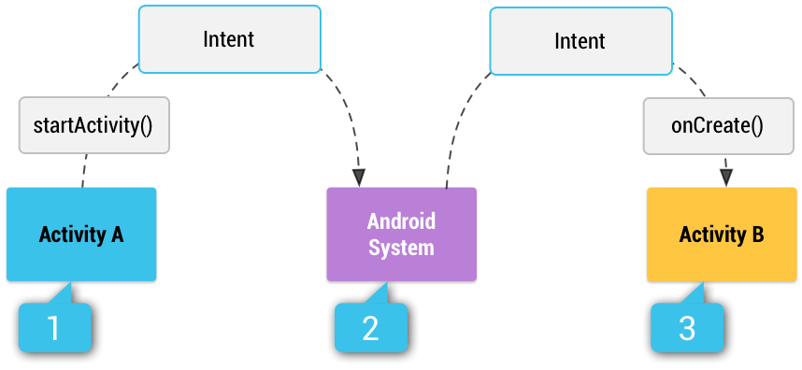

Step1: Activity A creates an [Intent](https://developer.android.com/reference/android/content/Intent.html) with an action description and passes it to [startActivity()](https://developer.android.com/reference/android/content/Context.html#startActivity(android.content.Intent)).

Step2: The Android System searches all apps for an intent filter that matches the intent.

Step3: The system starts the matching activity (Activity B) by invoking its [onCreate()](https://developer.android.com/reference/android/app/Activity.html#onCreate(android.os.Bundle)) method and passing it the [Intent](https://developer.android.com/reference/android/content/Intent.html).

9.5. Change default launching activities

|  |
| --- |
| <intent-filter>  **<action android:name="android.intent.action.MAIN" />**  **<category android:name="android.intent.category.LAUNCHER" />**  </intent-filter> |

## 16. Design user interface of Event activity

## Design Introduction

For better user experience, we are going to use one activity that contains multiple fragments. These fragments could be parallel, we can not design them as different activities. The best strategy is to align them into one activity with different fragments. These fragments might contain function like

* Show Events
* Show my information
* Show personal chat
* Etc
* Report events could be activity or fragment

17. Firebase Realtime Database structure

4.1. Introduction

All Firebase Realtime Database data is stored as JSON objects. You can think of the database as a cloud-hosted JSON tree.

4.2. Data contrast between SQL and FireBase Realtime Database

4.3. Best practice

Problem: from messages table, we can see

"name": "eclarke",

"message": "The relay seems to be malfunctioning.",

"timestamp": 1459361875337

are located in one grid, which could not be represented appropriately in SQL database. But in Firebase Database, it is allowed. So, we have to avoid doing this in database.

* **Avoid nesting data: Firebase Database allows nested JSON at most 32 levels, but we want to keep our data as flat as possible**

18.