Systematic Multi-Asset Funds with News-Sentiment Analytics

FINS 3645 Fin Mkt Data Design & Analysis - T2 2026

Haoyu Cao Z5536563

August 13, 2026



Executive Summary
In this paper, we review a prototype application for investment purposes, called AtlasFlow, which allows to get diversified exposure on the stock market and major cryptocurrencies via portfolio construction techniques. The application involves portfolio optimization, rolling backtesting, and sentiment analysis based on news.
As the results show, the simplicity of some methods may outweigh the use of more complicated methods, since the presence of noise in financial data is inevitable. The best-performing portfolio on a risk-adjusted basis is Equity Equal-Weight with an annual return rate of 7.37%, volatility of 17.71% and Sharpe ratio of 0.416. The minimum variance portfolio performed well in terms of risk control, with 13.47% of volatility and -16.50% maximum drawdown. On the contrary, the Maximum Sharpe ratio strategy was highly sensitive to returns estimates.
Furthermore, the project also provided three additional advanced extensions. With regard to the conventional risk parity method (the Sharpe ratio of 0.229), the use of Hierarchical Risk Parity (HRP) enhanced the Sharpe ratio of the portfolio to 0.250, with more stable asset allocation. FinVADER lexicon, which is specifically developed for finance-related tasks, lowered the share of neutral sentiment classifications (|compound| < 0.05) from 24.1% to 23.0%, reducing false-neutrals on this bundled headline dataset. Besides that, sentiment analysis was implemented using equal-weighted ticker sentiment within each sector.
But, using sentiment analysis did not provide any improvement in portfolio returns, resulting in a lower return, a worse Sharpe ratio, and higher downside risk for a "one-day lagged sentiment tilt" strategy.
In general, AtlasFlow should be based on strong portfolio construction techniques with the sentiment analysis being an additional signal. Further implementation will require consideration of realistic transaction costs, a longer historical sample, and improving of sentiment analysis from the sectoral to the individual asset level.

1. Fund Design and Backtest Methodology

1.1 Product Concept and Investor Need
AtlasFlow platform was created for easing the investment process among individual traders. Although it is now very easy to acquire different types of stocks and cryptocurrencies through the internet brokers' services, the creation of a diversified portfolio based on these assets is a difficult task. One has to think about the expected returns, volatility, correlation of the asset and the whole portfolio risk, among others; and all these become even more complicated with an increase in the number of assets within the portfolio.
AtlasFlow has managed to handle this issue efficiently by incorporating various types of assets and different portfolio strategies into one platform. The tool provides three series of portfolios: "Equity family," which consists of 50 large-cap equities of the United States from ten different sectors and is intended for investors looking for classic equity investments; "Crypto family," which consists of 10 main cryptocurrencies, and is intended for risk-loving investors who can tolerate high volatility; and "Combined family," which includes all 60 assets in order to provide multi-asset diversification within one product. Each series is constructed according to five different portfolio strategies, namely: Equal Weight, Minimum Variance, Maximum Sharpe Ratio, Risk Parity, and Hierarchical Risk Parity (HRP). Thus, 15 basic funds are provided; also, a "sentiment-augmented fund" is included in order to check the effectiveness of news data in the investment process.

1.2 Portfolio Construction Methods
Table 1: Optimisation Methods
Method | Objective | Main Strength | Main Risk
Equal Weight | 1/n allocation | Minimal estimation dependence and broad diversification | Does not respond directly to differences in risk
Minimum Variance | Minimize $w'Σw$ | Targets lowest realised portfolio volatility | Can concentrate in low-volatility assets; covariance estimates can be unstable
Maximum Sharpe | Maximize estimated excess return per unit of risk $(\frac{(μ-r_{f})}{σ}$) | Potentially attractive when expected returns are accurately estimated | Extremely sensitive to mean-return estimation error
Risk Parity | Equalize risk contribution | Balances portfolio risk rather than capital | Covariance inversion unstable when correlations are high
HRP | Hierarchical clustering assets and allocate recursively | No matrix inversion; robust to correlated assets | Clustering can miss changing market regimes

The "Equal Weight" strategy presents the easiest standard for comparison, since this strategy does not involve any calculations of expectations and covariance relationships. The simplicity of this approach is beneficial when operating in the markets characterized by “noise,” as the portfolio will not blindly follow assets that have shown good performance in the estimation period.
However, the "Minimum Variance" strategy works in a completely different way. Unlike the strategies that try to estimate the stocks that will provide maximum return, this one tries to build a minimum variance portfolio by using the covariance matrix. In other words, it makes the model much less dependent on the forecast of the expected return but must to estimate the covariance.
The "Maximum Sharpe Ratio" strategy is very attractive from a theoretical point of view because it maximizes the risk-adjusted returns directly. In reality, though, the expected return vector proves to be one of the hardest-to-estimate inputs. Small variations in the sample means cause huge shifts in the optimal allocations, and this issue becomes especially relevant when there are many stocks but little historical data.
The "Risk Parity" strategy strives to achieve the condition whereby all assets contribute approximately equal amounts to the overall risk of the portfolio. Although the concept presents a practical approach to allocating risks, conventional methods of application may be numerically unstable if the covariance matrix becomes "ill-conditioned" or correlations increase among assets (López de Prado, 2016).
HRP has been applied in the case study as an innovative allocation strategy. This technique involves grouping of the assets using distances between correlation and then performing recursive allocation (Lopez de Prado, 2016). The fact that HRP technique does not involve inversion of the entire covariance matrix makes the technique highly suitable in cases where there exist high asset correlations. Although the technique is not necessarily the best for maximizing profits, it improves allocation techniques.

1.3 Walk-Forward Out-of-Sample Design
Performance comparisons will be highly dependent upon the backtesting process used. Using information in the future for strategy evaluation purposes can lead to excellent but worthless results. For this reason, the study makes use of a walk-forward out-of-sample testing methodology. Portfolio weights will be computed using only past information up to the rebalancing period and will not be changed until the following rebalance is performed.
• Estimation window:504 trading days, approximately two years.
• First live date:3 January 2022 for Equity and Combined funds, and 20 May 2021 for Crypto.
• Rebalancing: every 21 trading days.
• Annualisation:252 trading days for Equity and Combined funds;365 days for Crypto funds to reflect its seven-day trading calendar.
• Risk-free rate:0%, as a stated simplifying assumption.
• Transaction costs:0%, also treated as an explicit simplifying assumption.
In each rebalance, the weighting of stocks is calculated on the basis of returns of the previous 504 trading days only. The out-of-the sample period for the test ranges from the current rebalance date until the following rebalance date when the weights will be recalculated on the basis of the updated estimation period returns.
Calendar alignment is yet another factor that needs to be considered when implementing the strategy. The current backtest uses a stock market trading calendar with around 252 trading days per year for Equity and Combined portfolios. Crypto only portfolios retain the native seven-day cryptocurrency calendar. For Combined portfolios, the return data for cryptocurrencies is matched against this calendar through a left join operation. Thus, price changes of cryptocurrencies happening only over the weekend period are not part of the Combined portfolio return sequence. Although this approach limits the ability of the cryptocurrency component within Combined portfolios to include all possible weekly price changes, it provides a consistent trading setup for comparing different portfolios.

2. Out-of-Sample Results and Fund Fact Sheets

2.1 Performance Overview
Table 2: Performance Metrics by Fund and Method
Family | Method | Ann. Return | Ann. Volatility | Sharpe Ratio | Max Drawdown
Equity | Equal Weight | 7.37% | 17.71% | 0.416 | -20.32%
Equity | Minimum Variance | 3.83% | 13.50% | 0.284 | -16.42%
Equity | Risk Parity | 4.47% | 16.23% | 0.275 | -18.99%
Equity | HRP | 3.20% | 15.25% | 0.210 | -18.26%
Equity | Maximum Sharpe | -2.66% | 19.30% | -0.138 | -24.98%
Combined | Minimum Variance | 3.70% | 13.47% | 0.275 | -16.50%
Combined | HRP | 3.77% | 15.07% | 0.250 | -18.74%
Combined | Equal Weight | 4.82% | 20.91% | 0.230 | -26.94%
Combined | Risk Parity | 3.89% | 16.94% | 0.229 | -21.39%
Combined | Maximum Sharpe | -7.33% | 19.76% | -0.371 | -27.47%
Crypto | Minimum Variance | 19.30% | 58.01% | 0.333 | -75.84%
Crypto | HRP | 12.27% | 67.88% | 0.181 | -76.10%
Crypto | Risk Parity | 9.82% | 69.93% | 0.140 | -75.91%
Crypto | Equal Weight | 6.90% | 71.54% | 0.097 | -76.33%
Crypto | Maximum Sharpe | 5.95% | 74.89% | 0.079 | -79.49%
Equity/Combined: 3 January 2022 – 29 December 2023
Crypto: 20 May 2021 – 1 January 2024

Figure 1 in the Appendix gives a visual comparison of the Sharpe ratios of the fifteen funds. The findings reveal that there are significant differences between the portfolio construction methods and assets.
"Equity Equal-Weight" was the most effective portfolio in terms of both Sharpe ratio (0.416) and the highest annual return (7.37%). Though not the least risky in terms of maximum drawdown of -20.32%, due to its superior risk-adjusted return, it was the best-performing equity investment strategy in this set. This is consistent with the findings of the existing literature, whereby in cases of small samples with high dimensionality, simple allocation strategies based on the "1/n" rule usually beat optimal allocation strategies (Yuan & Zhou, 2023). Considering that the portfolio consists of 50 stocks and has only 504 estimation days' data available, there is considerable estimation error in the covariance matrix and no valid signal in the average returns.
The minimum variance portfolio exhibited the lowest maximum drawdown at −16.45% and second-lowest volatility at 13.49%, while producing a decent Sharpe ratio of 0.28. It is, therefore, the better option for risk management products. The “minimum variance” approach pays no regard to estimates of mean return whatsoever, instead considering only the covariance structure, and thereby avoiding the two main causes of estimation error that affect “maximum Sharpe ratio” portfolios.
All "Maximum Sharpe Ratio" funds were bad in all categories. "Maximum Sharpe Ratio" diversified funds yielded -7.33% annualized return and had a Sharpe ratio of -0.371. As it follows from the logic above, it is simple; estimates of the daily mean returns have much noise, and optimization techniques give a lot of weight to those assets that happen to have a positive mean in the estimation period. When mean returns revert—or if they were noise to begin with—the fund takes losses. "Maximum Sharpe Ratio" equity funds showed a somewhat better result (-2.66% annualized return and -0.138 Sharpe ratio), but the performance pattern was the same.
The crypto market experienced a "crypto winter" period from 2022 to 2023 due to the failure of Terra/Luna (Briola et al., 2023) and the bankruptcy of FTX (Vidal-Tomás et al., 2023). Despite that, "minimum variance" crypto portfolios managed to generate positive return (19.30%) coupled with high volatility (58.01%). Although cryptocurrencies have been used in diversified portfolios for diversification reasons, in reality, they became more correlated to stocks in times of market turmoil in this particular time period.

2.2 What the Results Mean for Portfolio Choice
For conservative investors, the "Combined Minimum-Variance" portfolio is the safest among all historical portfolios considered. The lower volatility and drawdowns of this portfolio make its risk assessment more straightforward, but the 16.50% drawdown should not be ignored. For moderate investors focused on achieving growth in the long term, the "Equity Equal-Weight" portfolio is preferable because it provides the highest equity Sharpe ratio and uses stable weight allocations without using estimates of the expected returns. However, for aggressive investors, there are several issues. The "Crypto Minimum Variance " portfolio is the one that showed the highest results, but with 75.84% drawdown, it is unreasonable to recommend this portfolio only on the basis of returns. Thus, the application should show information about risk, drawdowns, and returns together, not ranked by returns only.

2.3 Growth of $1 and Drawdown Behaviour
It can be observed that Appendix Figure 2 (Growth of $1 Comparison) offers a clearer picture of the findings compared to annualized figures alone. The Equity Equal Weight portfolio slowly differentiates itself from the rest of the portfolios due to its blend of good performance and low risk characteristics. On the other hand, the Combined Minimum Variance fund follows a smoother path. While the upside may not be so visible, the path is certainly more stable. Figure 8 in Appendix displays two separate quadrants, where cryptocurrency funds are positioned in the top right-hand corner, indicating high volatility (58%-75%) and positive returns, whereas stock funds are in the bottom left-hand corner, demonstrating moderate volatility (13%-20%) and varying returns.
The drawdown chart for the Combined Max-Sharpe fund（Appendix Figure 3）shows that there are three significant drawdowns of greater than 15%, with the largest one at -27.47% near the end of 2022. The fund did not fully recover by the end of the sample period. This is typical of mean-variance optimizers in noisy environments, where they tend to follow winners until their momentum turns (Mei et al., 2022; Wood et al., 2021).

2.4 Weight Stability and Concentration
The each panel in Appendix Figure 4 illustrates the sector-level allocation for the Combined family across different portfolio methods. Max-Sharpe demonstrates the most concentrated and unstable weight profile, while Equal Weight and HRP illustrate the most smooth and diversified weight trajectories. Minimum Variance weight profile is dominated by defensive sectors such as healthcare and consumer goods.

3. Construction and Evaluation of the News-Sentiment Index

3.1 Data and Processing Pipeline
The sentiment analysis part intends to see if unstructured news data can help in the portfolio construction process using quantitative methods. The source data set includes 149,683 unique news headlines that have been gathered for 50 stock items during the time period between 2020 and 2023. It is important to understand that the goal is not to prove the fact that all the headlines include trading signals, but to analyze if financial language can help in revealing the changes in market situation.
The specific process involved in the investigation includes:
1. Headline text assembly: the headlines are mapped to the same or next equity trading day. Stopwords removal and lower-casing is not used since VADER makes use of punctuation, casing, and negation in scoring its rules.
2. VADER sentiment scoring: ticker-day text bundle is scored using the NLTK's SentimentIntensityAnalyzer module. The compound score can take values between -1 and +1.
3. FinVADER modification: the general purpose lexicon is modified by adding about 50 words which are related to the finance domain, such as 'surge', 'plunge', 'bullish', and 'bankruptcy'.
4. Equal-weight sector aggregation: The scores are aggregated on the level of sectors using equal-weighted tickers and lagged by one trading day. The lag is crucial. Otherwise, it might be the case that the model will utilize information which was not available at the time when the portfolio decision was being made. The lag introduces some delay, which is an acceptable compromise.

3.2 Handling No-News Days
The practical sentiment model requires a way to deal with cases where there is no relevant news for an asset. Assuming that the lack of news is always neutral would destroy useful data, while assuming that the previous sentiment score should always be used could lead to out-of-date signals. Therefore, the practical sentiment model uses the carry-forward approach for five trading days, after which the signal returns to zero; once a sector gets no news for five trading days, the sentiment score becomes zero again. This five-day approach is just a pragmatic decision, rather than the optimal one. The idea is that the news sentiment can be valid for several trading days, but it is not valid forever. The duration should be varied in future tests.

3.3 Sentiment Index Behaviour Over Time
As depicted in Appendix Figure 5, the Sector Sentiment Index is mostly consistent with major events occurring in the market. In the wake of the market crash resulting from the outbreak of COVID-19 in March 2020, sentiment became very negative across all sectors, especially in the energy and financial sectors where it fell within -0.4 to -0.5. This proves the efficiency of the Sector Sentiment Index as an effective means of measuring crises. During the recovery period of 2021, the technology and consumer discretionary sectors showed consistent positive sentiment. The market downturn of 2022 saw negative sentiment rising significantly across all markets, especially those with growth prospects. There was notable dispersion as well, with the difference in sentiment between the most optimistic and pessimistic sectors being 0.3-0.5 in most days.
The patterns offer face validity proof for the idea that the sentiment measures are able to identify shifts in investors' moods during market history events. However, the possibility of capturing past crises accurately does not guarantee that it will be possible to forecast future returns. For that reason, this study sees sentiment as a useful research variable but not a reliable predictor or alpha generator. It is a matter of investigation whether sentiment has any predictive or causal value.

3.4 Fear & Greed Index
The Fear & Greed Index provides a market-wide view of investor sentiment, complementing the sector-level index. The z-score is designed to flag genuinely unusual extremes rather than persistent optimism or pessimism. From Appendix Figure 7, the standardised z-score successfully identifies fear spikes that coincide with known market stress events, including the COVID crash in March 2020 and the Omicron announcement in late 2021. This alignment gives face validity to the sentiment measure as a descriptive indicator of market psychology, even though it does not demonstrate predictive power for future returns.

3.5 Limitations of the Sentiment Measure
The Sector Sentiment index properly identifies known macroeconomic events such as the market crash in 2020, market recovery in 2021, and market decline in 2022 and shows reasonable diversification by industry sector. Extreme values correspond to known times of stress in the market. Nevertheless, there are certain shortcomings left:
First, the data is composed of headlines but not entire articles. Headlines tend to be concise and lack any context; thus, a headline can be quite negative even though the actual news can be surprisingly positive and vice versa. It obviously puts a natural ceiling on how well the classification can work.
Second, the problem is the neutral residual. FinVADER lowers the neutral category to about 23.0% (from the initial 24.1%), which is a modest improvement. Still, it means that a considerable share of the headlines does not produce extreme scores. It does not mean that they are useless; some news could indeed be neutral. But it certainly makes less directional data available for portfolios.
Finally, it is the problem of coverage. The sentiment algorithm works only for equities; thus, cryptocurrency positions cannot react to cryptocurrency news sentiment signals.

4. Innovation Extensions and Evaluation

4.1 Extension 1: Hierarchical Risk Parity (HRP)
HRP methodology stands out as the most innovative way of constructing a portfolio among all risk parity methodologies. The covariance structure is used in traditional risk parity to compute marginal risk contribution; in case the correlation increases, and hence the covariance matrix becomes ill-conditioned, a small shift in the estimates may cause a large change in the portfolio weights. However, HRP solves the problem through restructuring the optimization problem (Antonov et al., 2024). In the HRP approach, the correlation matrix is transformed into the distance measure, given as $d=\sqrt{0.5\left(1-ρ\right)}$, and then used in hierarchical clustering, which results in the formation of clusters with similar asset behavior without necessarily having to invert the covariance matrix (Lopez de Prado, 2016).
From among the portfolio strategies, the Sharpe ratio for Combined HRP is 0.250, and the volatility of 15.07%, while the Sharpe ratio for the Combined conventional risk parity strategy is 0.229, and its volatility is 16.94% (Table 2). This difference may be small, but it is consistent because the HRP strategy provides smoother weight dynamics and lower turnover rates, especially around the correlation spike in 2022 when the conventional risk parity strategy had unstable weight dynamics. Overall, the HRP strategy is an appropriate methodology that ensures better numerical stability. Even though the outperformance in the sample is insignificant, optimization stability brings some value to risk management.

4.2 Extension 2: FinVADER Lexicon
This extended version of FinVADER was created with transparency in mind. In other words, instead of substituting VADER with an opaque model, the method makes changes to the lexicon to provide finance-specific sentiment values ​​to popular financial lexemes. The problem that needs to be tackled here lies with the limitation of general-purpose sentiment lexicons, which do not consider the importance of certain words like "surge," "plummet," "downgrade," and "bankruptcy" as they can be very informative in finance news.
The proportion of neutral classifications (defined as |compound| < 0.05) was reduced from 24.1% for the original VADER to 23.0% for FinVADER (see Appendix Figure 9), implying that the extension has been successful on a descriptive basis. The extension has improved the quantity of directional data and provided cross-sectional differentiation during market stress. Although it is not enough to show any economic value, this finding shows how domain adaptation can benefit NLP.

4.3 Sentiment Fusion: Before and After
Table 3: Fusion Before-vs-After — Combined Maximum-Sharpe
Metric | Base Max-Sharpe | Sentiment-Augmented
Annualised Return | -7.33% | -8.26%
Annualised Volatility | 19.76% | 21.03%
Sharpe Ratio | -0.371 | -0.393
Maximum Drawdown | -27.47% | -31.80%

As can be seen in Table 3 and Appendix Figure 6, the sentiment-augmented Max-Sharpe results in a lower Sharpe ratio (-0.393 versus -0.371) and a deeper drawdown (-31.80% versus -27.47%). A small tilt factor of 30% does not seem to be strong enough to counter the adverse trend of the basic strategy during this sample period, indicating that the sentiment information adds noise but not value to the optimization process.
This study is still very useful despite the subpar performance of the tests carried out. From this experiment, there is a demonstration of the chasm between “theoretically nice ideas” and “profitable strategies.” The solution to this is not in the elimination of the use of sentiment factors, but in improving the signals—by way of using long-term sentiment moving averages, better lexicons, or even specific entity scores instead of industry scores—and applying them to benchmark funds, instead of “maximum Sharpe ratio” funds.

5. The App and the Investor Journey

5.1 Target User
AtlasFlow is tailored for an individual investor with financial literacy but is not technically inclined and wants to invest in systemic funds instead of stocks. The user knows the basics such as returns, volatility, and Sharpe ratio but does not use optimizers or write codes. His/her difficulty in making investment decisions lies in selecting the numerous funds available.

5.2 Investor Journey
Step 1: Fund Comparison.
The investor arrives at the Fund Comparison page and finds a table of all the funds sorted by Sharpe ratio and filters by fund family and by method. They notice right away that Equity Equal-Weight has the best Sharpe ratio and that Combined Max-Sharpe is negative. The table tells: “Which fund grew the most? Which fund used risk most efficiently?”

Step 2: Fact Sheet Review.
Opening up a fund brings up the Fact Sheet which has four metrics cards (return, volatility, Sharpe ratio, and drawdown), the growth-of-$1 chart, the drawdown chart and the latest holdings list. The Fact Sheet answers: “What did this fund do? How badly were the losses? What does it own now?”
Step 3: Allocation.
On the Allocation page, the investor can allocate their investment into any combination of funds through a slider input. The application calculates the resulting portfolio’s annualised return, volatility, Sharpe ratio, drawdown and draws the growth-of-$1 curve. That answers: “How do I mix the funds instead of investing into just one?”
Step 4: Sentiment Interpretation.
On the Sentiment page, the investor sees four analytics components: (1) a market-wide Fear & Greed Index showing standardised aggregate sentiment over time; (2) a VADER vs FinVADER comparison demonstrating the reduction in false-neutral classifications; (3) the sector sentiment index time series with selectable sectors; and (4) a monthly heat map together with the latest snapshot table. From this they know which sectors have currently good or bad news sentiment and whether the overall market mood is unusually fearful or greedy. This answers: “What does the news environment tell me?”

5.3 Responsible Communication
Responsible communication plays an important role in this regard since the application provides information about backtested investment results. All pages should contain information that past results are not indicative of future success, that cryptocurrency investments are highly risky, and that sentiment index indicates only a research result and not an instruction for trade.
In addition, there should be some indication of the limits of the evidence in the interface. Although the backtest data provided is out-of-sample with respect to any portfolio decision, they still apply to a particular period (2021–2023).

6. Critical Reflection and Recommendations

6.1 What Worked
The first major success pertains to the evidence of constructing estimation-robust portfolios. The equal-weight method works excellently in equity investments, while the minimum-variance method provides strong risk control among all the portfolio methods. This indicates an important takeaway from quantitative finance that in the case of financial problems where estimation noises and sample sizes are concerned, estimation robustness usually beats theoretical optimality.
Another success pertains to Hierarchical Risk Parity (HRP). As opposed to the conventional risk parity approach, HRP generates smoother portfolio weights and also provides slightly better risk-adjusted return.
Finally, a success related to expanding FinVADER is observed. Expansion of the lexicon helps avoid spurious neutral cases and create dynamic and interpretable sentiment indices for particular industries.
6.2 What Did Not Work
First, the portfolio with the Maximum Sharpe ratio underperforms. This problem stems from the issue of estimation errors associated with the mean return (Kristensen & Vorobets, 2024). From 504 daily observations, the standard error associated with the estimate of the mean daily return equals $SE(r̄) ≈ \frac{σ}{\sqrt{504}}$. In case the daily volatility for an asset lies in the range of 20%-25%, the value of $SE(r̄)$ varies between 0.9% and 1.1%.
In the second place, the performance of sentiment integration in our analysis was poor. Sentiment indicators were too noisy to rescue the suboptimal Max Sharpe base fund. Even though it was required to introduce a one-day lag in order to make the sentiment-based approach forward-looking, it could have resulted in overlooking sentiment reversal patterns that might happen quickly. Moreover, the fact that we relied only on the headlines meant that we had access to incomplete information.

6.3 Limitations
Table 4: Limitations
Area | Limitation | Implication
Data | Sample limited to 2020–2023 | Results not necessarily representative of future market regimes
Text data | Headlines not full articles | Sentiment signals are crude and contextually weak
Coverage | No crypto news signal | Crypto fund does not benefit from sentiment-based allocation
Implementation | Zero transaction costs | Reported returns do not reflect true investment performance
Model | Fixed 504-day estimation window | Not much flexibility in adjusting to different market regimes

6.4 Three Concrete Recommendations
Recommendation 1: Replace Max-Sharpe with minimum variance as the base of sentiment fusion
The first recommendation involves using the sentiment in the minimum variance portfolio as opposed to the maximum Sharpe portfolio. The use of the minimum variance approach means that there are no estimations of the mean return and any changes in the performance caused by sentiment will be due to sentiment only. The main measure of performance is the change in Sharpe ratio while other measures include maximum drawdown, turnover, volatility, and sector exposure stability. The benefit of such an approach is the ability to determine whether the sentiment contributes to performance or not.
Recommendation 2: Implement turnover penalty in the backtest
The second recommendation is the move from gross-cost backtesting to net-cost backtesting. Gross cost backtests currently make some assumptions about transaction costs being zero, causing high turnover strategies like the Max Sharpe strategy to look much better than what it actually is. The truth is that bid-ask spreads and market impacts reduce profits, especially in the cryptocurrency markets. We recommend conservative transaction cost estimates, including 10 basis points per transaction or 20 basis points roundtrip. It is important to know if the rankings of the funds change significantly when this cost is taken into consideration; in case the strategy fails to work when costs are taken into account, then this should be known.
Recommendation 3: Roll the sentiment model into an entity-level sentiment model.
The third recommendation concerns increasing the accuracy of sentiment signals. Although sector-level aggregation is helpful in constructing market-wide indicators, information that is unique to each individual firm could get averaged away when aggregated at the sector level. For example, a very positive headline for one stock amid a poorly performing industry will simply be averaged away. In order to overcome this problem, we can rate headlines on a ticker-level basis and construct 5-day and 10-day moving averages for sentiments. Instead of taking the level of the moving average into account, we would base our signal on whether the sentiment is rising or falling, where a rising sentiment leads us to overweight, and falling sentiment leads us to underweight.

References
Antonov, A., Lipton, A., & López de Prado, M. (2024). Overcoming Markowitz’s instability with the help of the hierarchical risk parity (HRP): Theoretical evidence. SSRN Electronic Journal. https://doi.org/10.2139/ssrn.4748151
Briola, A., Vidal-Tomás, D., Wang, Y., & Aste, T. (2023). Anatomy of a Stablecoin’s failure: The terra-luna case. Finance Research Letters, 51, 103358. https://doi.org/10.1016/j.frl.2022.103358
Kristensen, L., & Vorobets, A. (2024). Portfolio optimization and parameter uncertainty. SSRN Electronic Journal. https://doi.org/10.2139/ssrn.4709317
López de Prado, M. (2016). Building diversified portfolios that outperform out of sample. The Journal of Portfolio Management, 42(4), 59–69. https://doi.org/10.3905/jpm.2016.42.4.059
Mei, X., Zhu, H., & Chen, C. (2022). Mean-variance portfolio selection with estimation risk and transaction costs. Applied Economics, 55(13), 1436–1453. https://doi.org/10.1080/00036846.2022.2097191
Vidal-Tomás, D., Briola, A., & Aste, T. (2023). FTX’s downfall and Binance’s consolidation: The fragility of centralised digital finance. Physica A: Statistical Mechanics and Its Applications, 625, 129044. https://doi.org/10.1016/j.physa.2023.129044
Wood, K., Roberts, S., & Zohren, S. (2021). Slow momentum with fast reversion: A trading strategy using Deep learning and changepoint detection. The Journal of Financial Data Science, 4(1), 111–129. https://doi.org/10.3905/jfds.2021.1.081
Yuan, M., & Zhou, G. (2023). Why naive $ 1/n $ diversification is not so naive, and how to beat it? Journal of Financial and Quantitative Analysis, 59(8), 3601–3632. https://doi.org/10.1017/s0022109023001175

Appendix. Required Exhibits
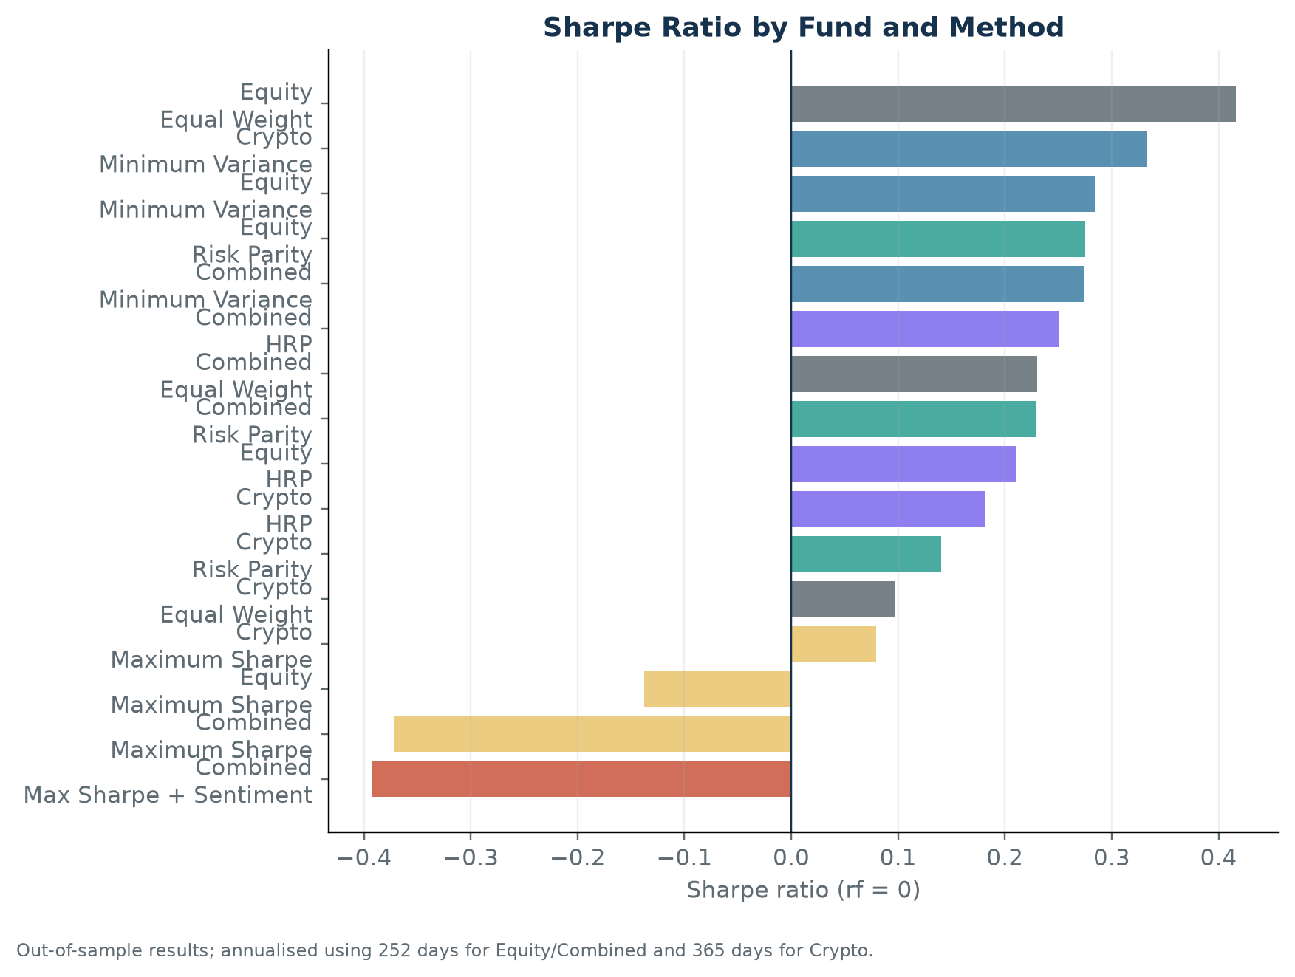
Figure 1: Sharpe Ratio by Fund and Method. Ranking of the fifteen core funds using annualised Sharpe ratios.
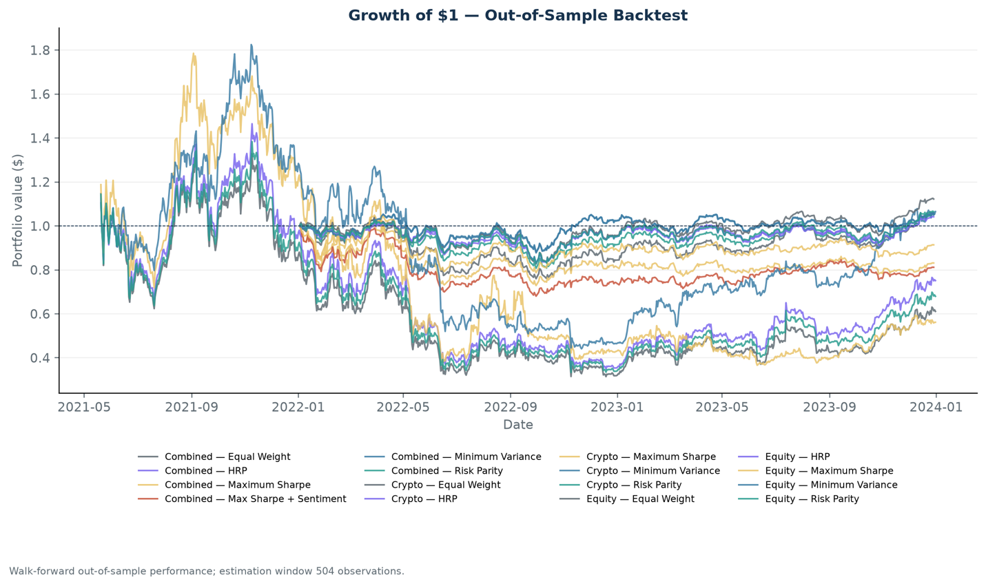
Figure 2: Growth of $1 — Out-of-Sample Backtest. Walk-forward comparison of fund performance over the out-of-sample evaluation periods.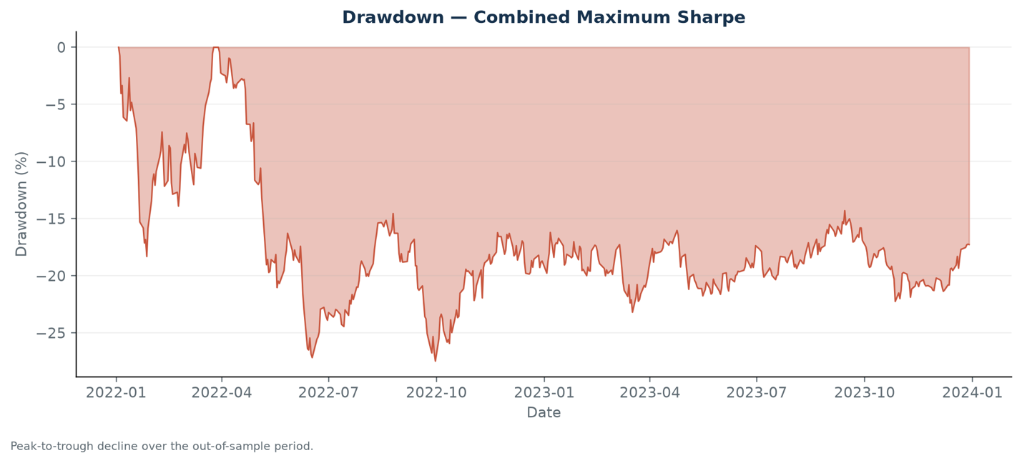
Figure 3: Drawdown — Combined Maximum-Sharpe. Peak-to-trough decline, with the deepest drawdown of 27.47% occurring in late 2022.
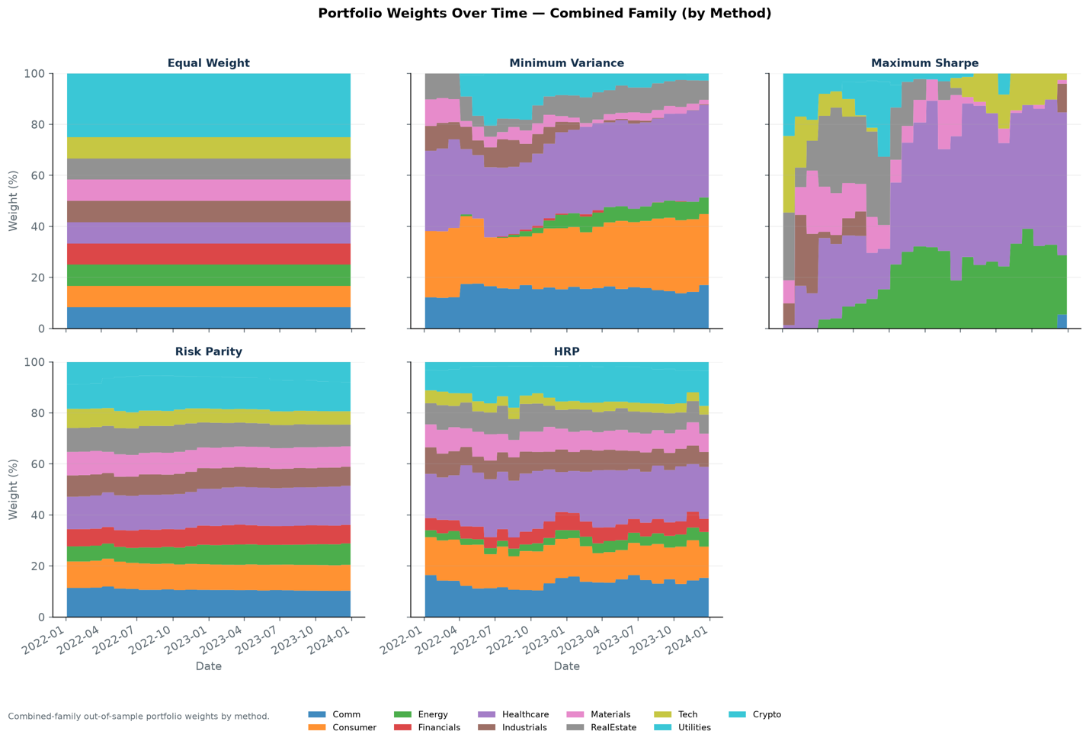
Figure 4: Portfolio Weights Over Time — Combined Family (by Method). Sector-level stacked area chart showing allocation evolution
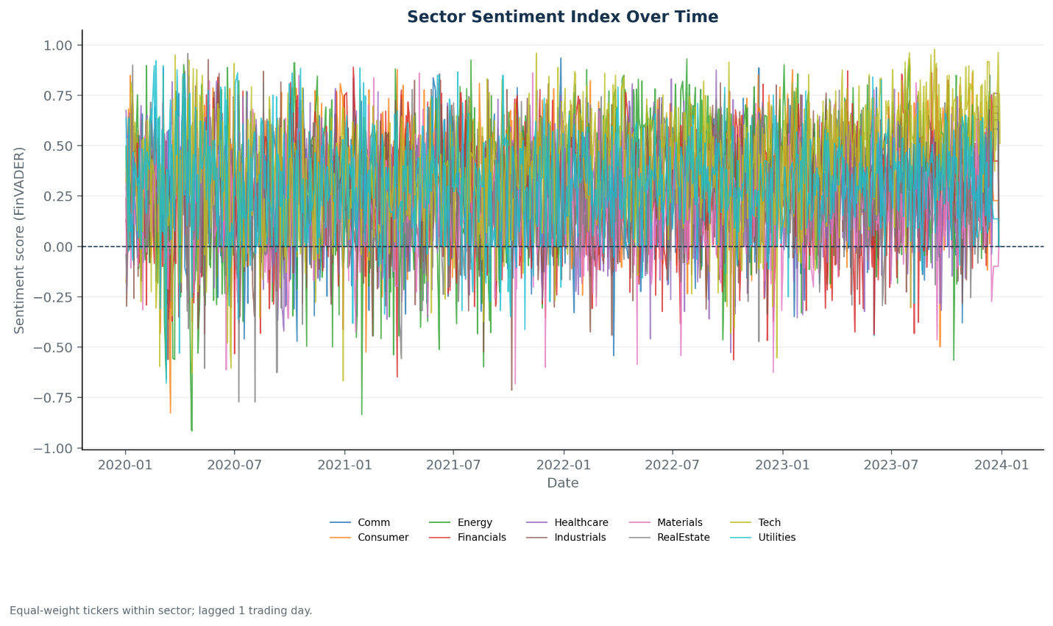
Figure 5: Sector Sentiment Index Over Time. Equal-weight tickers within sector, lagged by one trading day, covering 2020–2023.
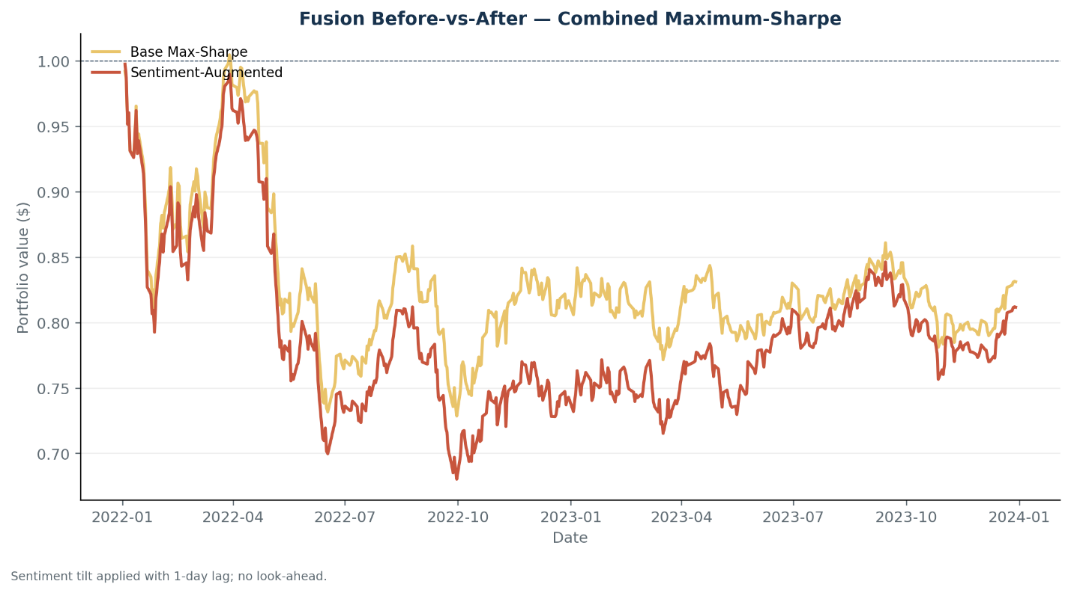
Figure 6: Fusion Before-vs-After — Combined Maximum-Sharpe. Comparison of the base and sentiment-augmented portfolios.
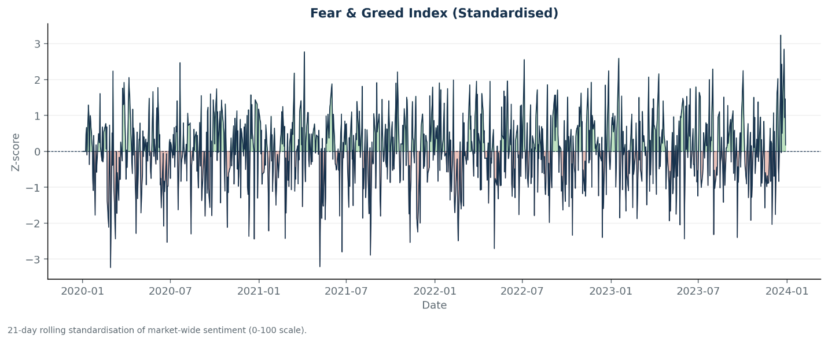
Figure 7: Fear & Greed Index. Standardised market-wide sentiment index revealing fear spikes during the COVID crash and Omicron announcement.
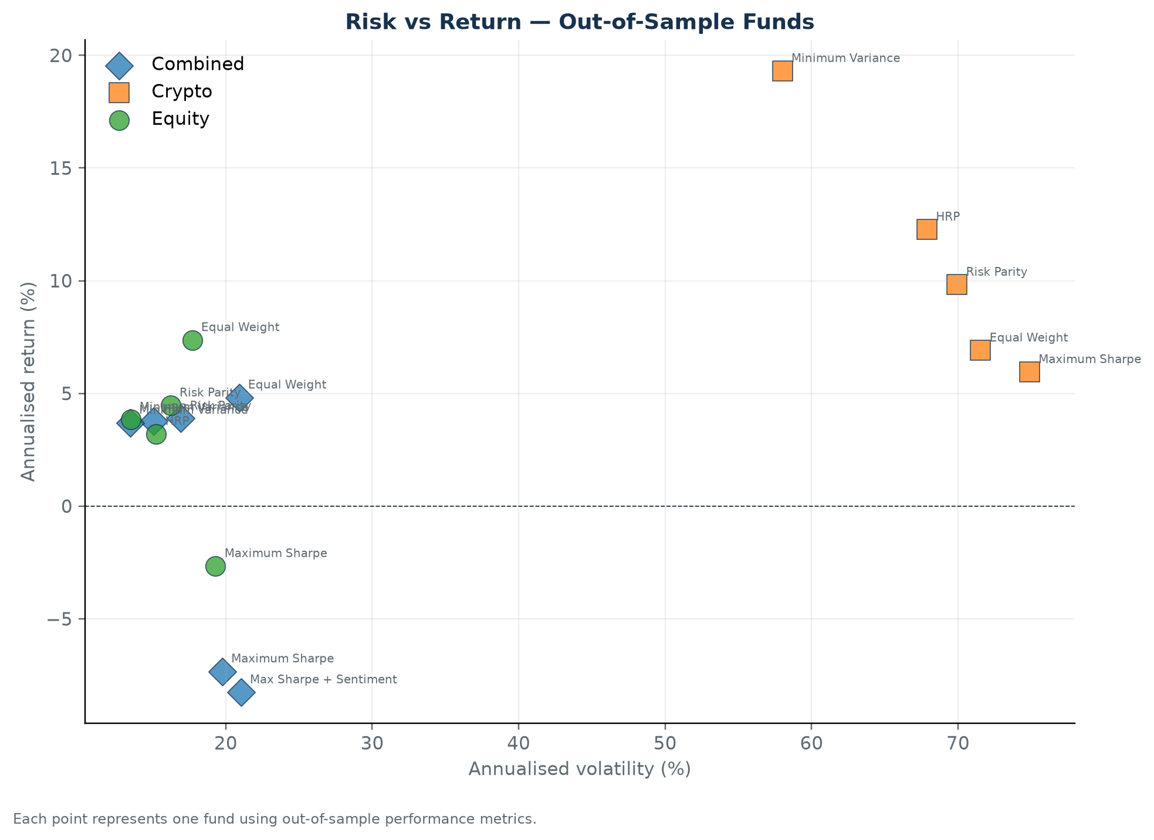
Figure 8: Risk vs Return — Out-of-Sample Funds. Scatter plot placing each fund by volatility (horizontal) and return (vertical). Crypto funds cluster in the high-volatility region, while equity funds occupy the lower-risk left side.
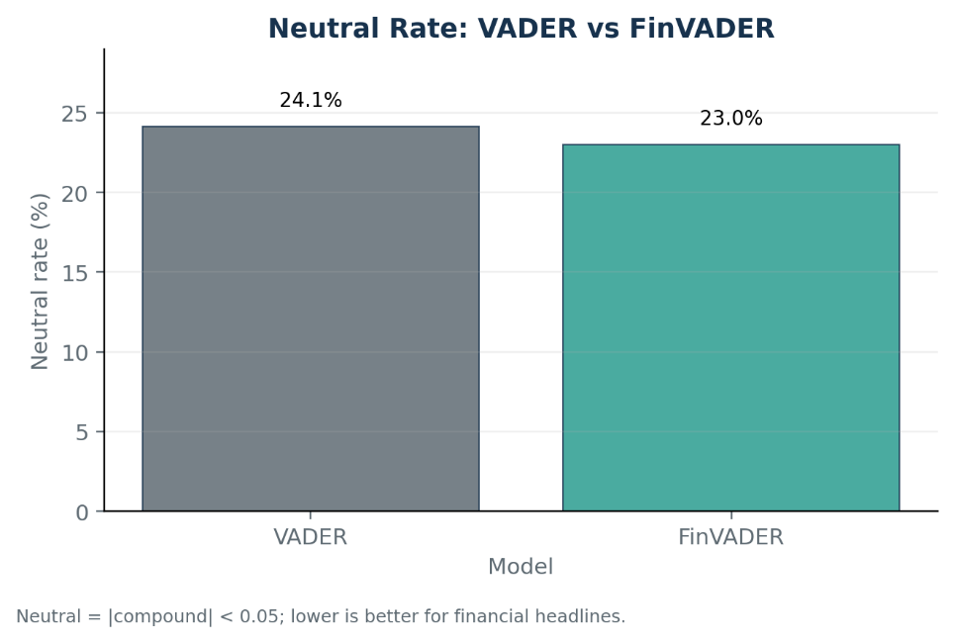
Figure 9: Neutral Rate: VADER vs FinVADER. FinVADER reduces the share of neutral-classified headlines from 24.1% to 23.0%, demonstrating that the finance lexicon captures more directional sentiment.

