Decantr — Assignment 2
Module: Software Engineering für betriebliche Anwendungen — Masterkurs: Web Application Engineering (IN2087)
Team members: [Your names here]
Supervisor: [Advisor name]
Date: [Submission date]

Table of Contents
- Customer Journeys
  - Wine Business Owner — Sophie Wagner
  - Wine Enthusiast — Alex Chen
- UML Class Diagram

Customer Journeys
Two customer journeys are described below. Each journey represents a customer segment: Sophie Wagner as a Wine Business owner (B2B), and Alex Chen as a Wine Enthusiast (B2C). Decantr responds to the different needs of both sides of the platform and helps them carry out their goals.

Wine Business Owner — Sophie Wagner
Sophie Wagner is the 42-year-old owner of “Weinkultur,” a boutique wine bar in Munich’s Schwabing district. She holds a sommelier certification and hosts two to three tasting events per month. Despite her expertise, Sophie struggles with collecting structured feedback from guests — she currently uses paper forms that are tedious to analyze — and her marketing reach is limited to Instagram and a small mailing list. She heard about Decantr from a fellow bar owner at a wine fair and decides to try the platform.

Step 1: Registration & Subscription
Mockup | Desc
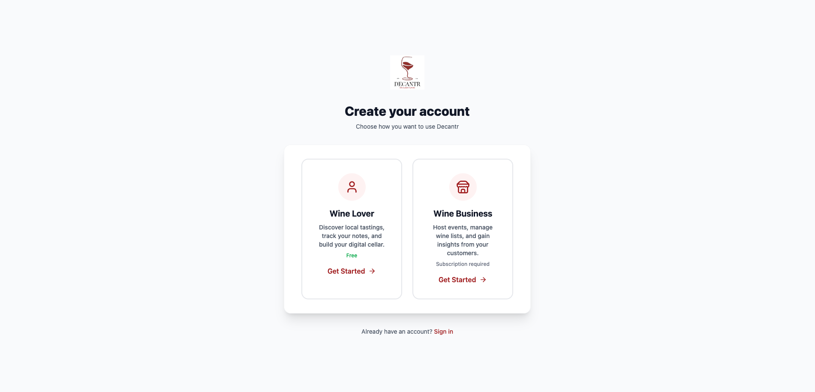 | Sophie navigates to the Decantr website and clicks “Sign up.” On the registration page, she is presented with two clear options: “Wine Lover” (free) and “Wine Business” (subscription required). She selects “Wine Business,” which takes her to the next step.
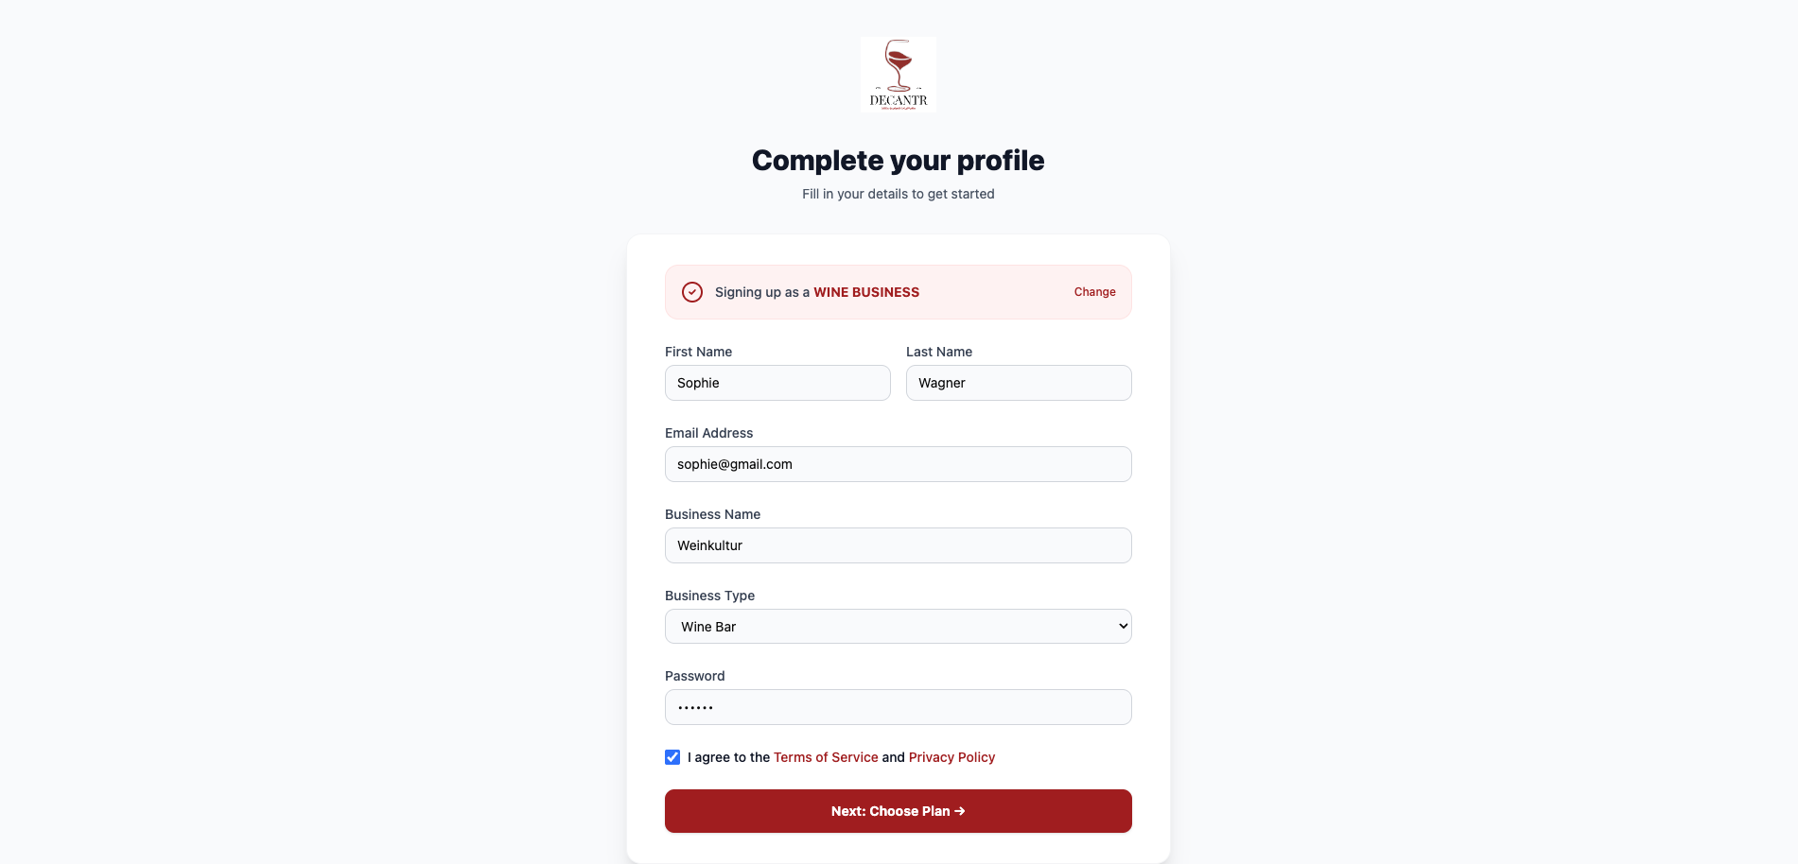 | She fills in her personal details — first name, last name, and email — along with her business information: “Weinkultur” as the business name and “Wine Bar” as the business type. After setting a password and agreeing to the terms of service, she clicks “Next: Choose Plan →.”
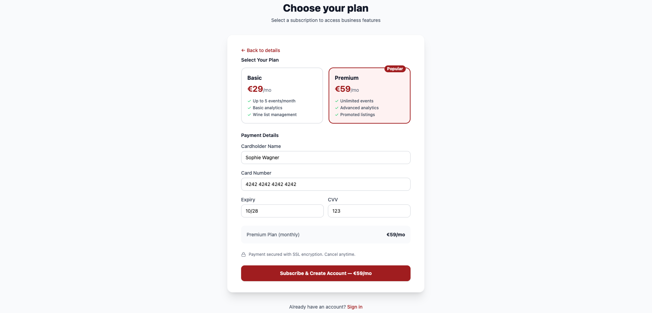 | Sophie is presented with two subscription plans: Basic (€29/mo) and Premium (€59/mo). She selects the Premium plan for unlimited events and advanced analytics. She enters her credit card details and clicks “Subscribe & Create Account.” After payment processing, she is directed to her business dashboard.
Frontend: Registration form with role-based fields, multi-step flow, plan selection cards, payment form. Backend: POST /api/auth/register — Creates User + Business + Subscription documents. Payment processed via Stripe API. Database: Create User, Business, Subscription documents.

Step 2: Managing Wine Inventory
Mockup | Description
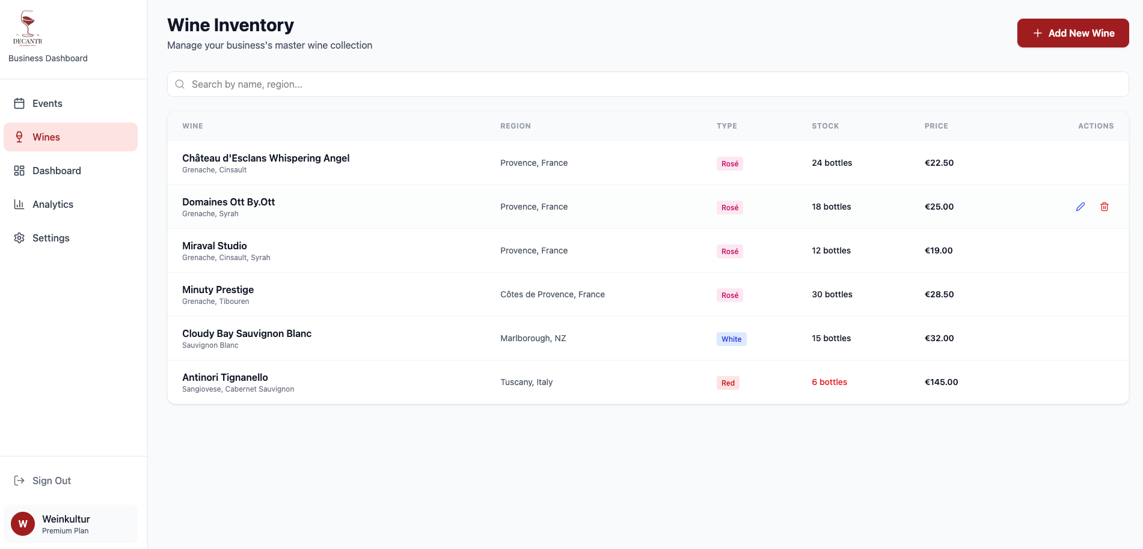 | Before creating events, Sophie first builds her wine inventory. She navigates to the “Wines” section in the sidebar and sees her existing collection displayed in a table: wine name (with grape variety), region, type (color-coded badges), stock count, and price. She can search and filter wines.
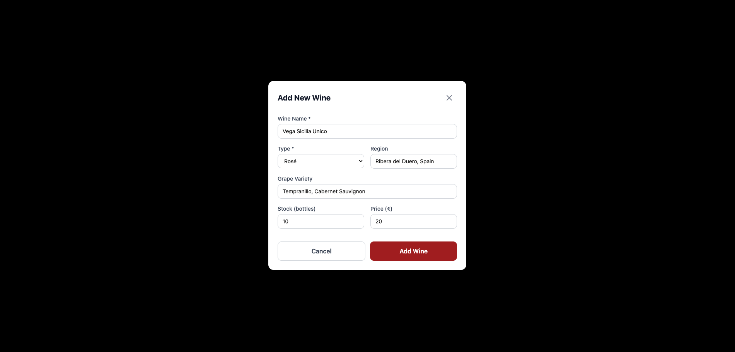 | Sophie clicks “Add New Wine” to expand her collection. A modal appears where she enters the wine name, type, region, grape variety, stock quantity, and price. She can also edit existing wines or delete ones she no longer carries. This demonstrates full CRUD functionality on her wine inventory.
Frontend: Data table with search, Add/Edit modal form, Delete with confirmation. Backend: - POST /api/wines — Create a new wine in inventory. - GET /api/business/:id/wines — Read all wines. - PUT /api/wines/:id — Update wine details. - DELETE /api/wines/:id — Delete a wine. Database: Full CRUD on Wine documents.

Step 3: Creating a Tasting Event
Mockup | Description
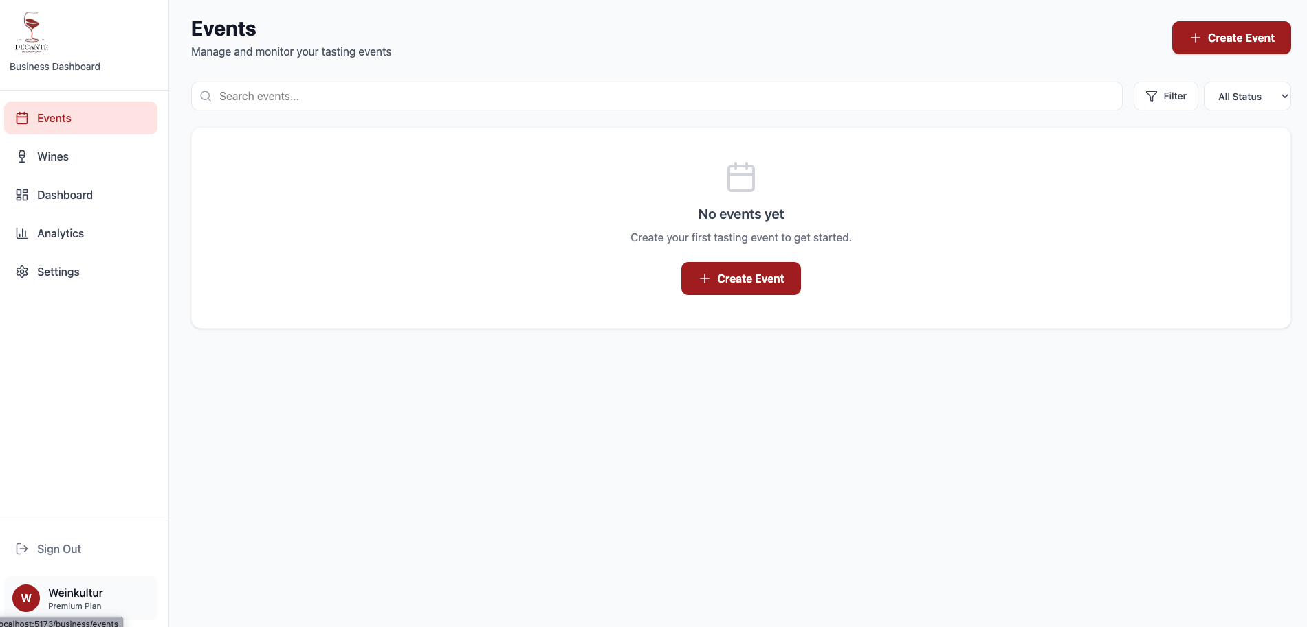 | Sophie navigates to the “Events” section. She sees her list of past and upcoming events with status badges (Published, Draft, Completed), registration progress bars, and revenue for each. She clicks “Create Event” to start a new one.
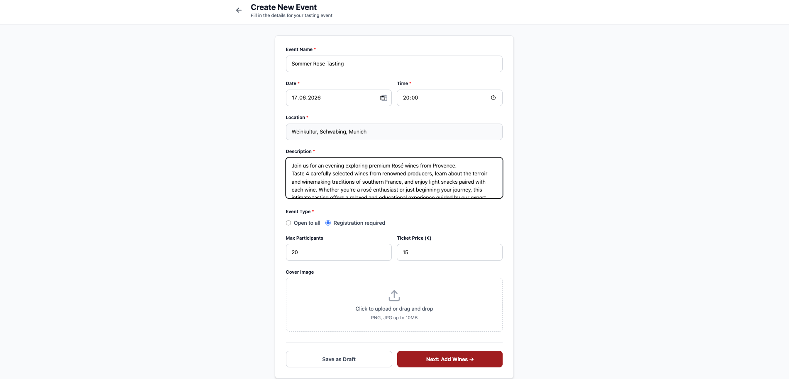 | Sophie fills out the event creation form: event name (“Summer Rosé Tasting”), date (June 14, 2026), time (18:00), location (pre-filled with her bar address), description, event type (“Registration required”), max participants (20), and ticket price (€15). She clicks “Next: Add Wines →.”
Frontend: Event list with status badges, Create Event form with date picker, radio buttons, number inputs. Backend: POST /api/events — Creates Event document with status “draft”. Database: Create Event document.

Step 4: Adding Wines to the Event
Mockup | Description
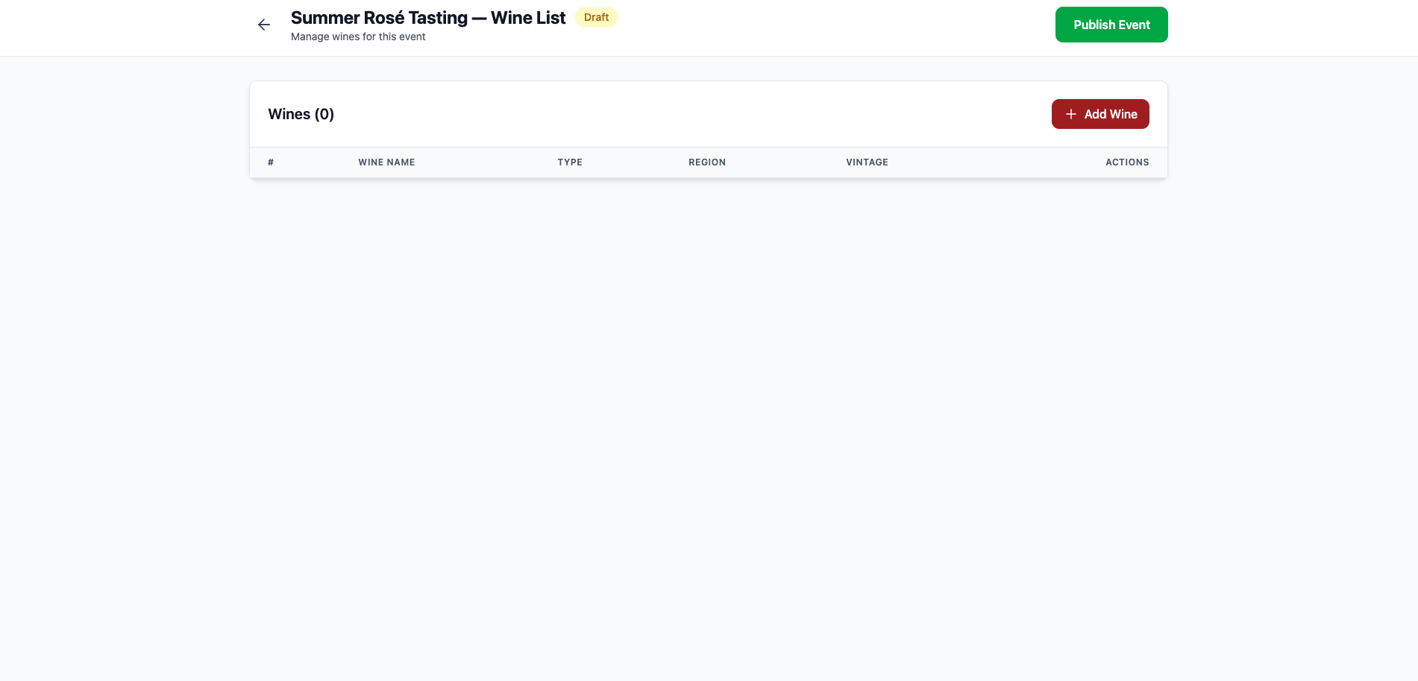 | On the wine list management page, Sophie adds wines from her inventory to the tasting event. She sees the current wine list in a table format showing order number, wine name, type, region, and vintage with Edit and Delete action buttons.
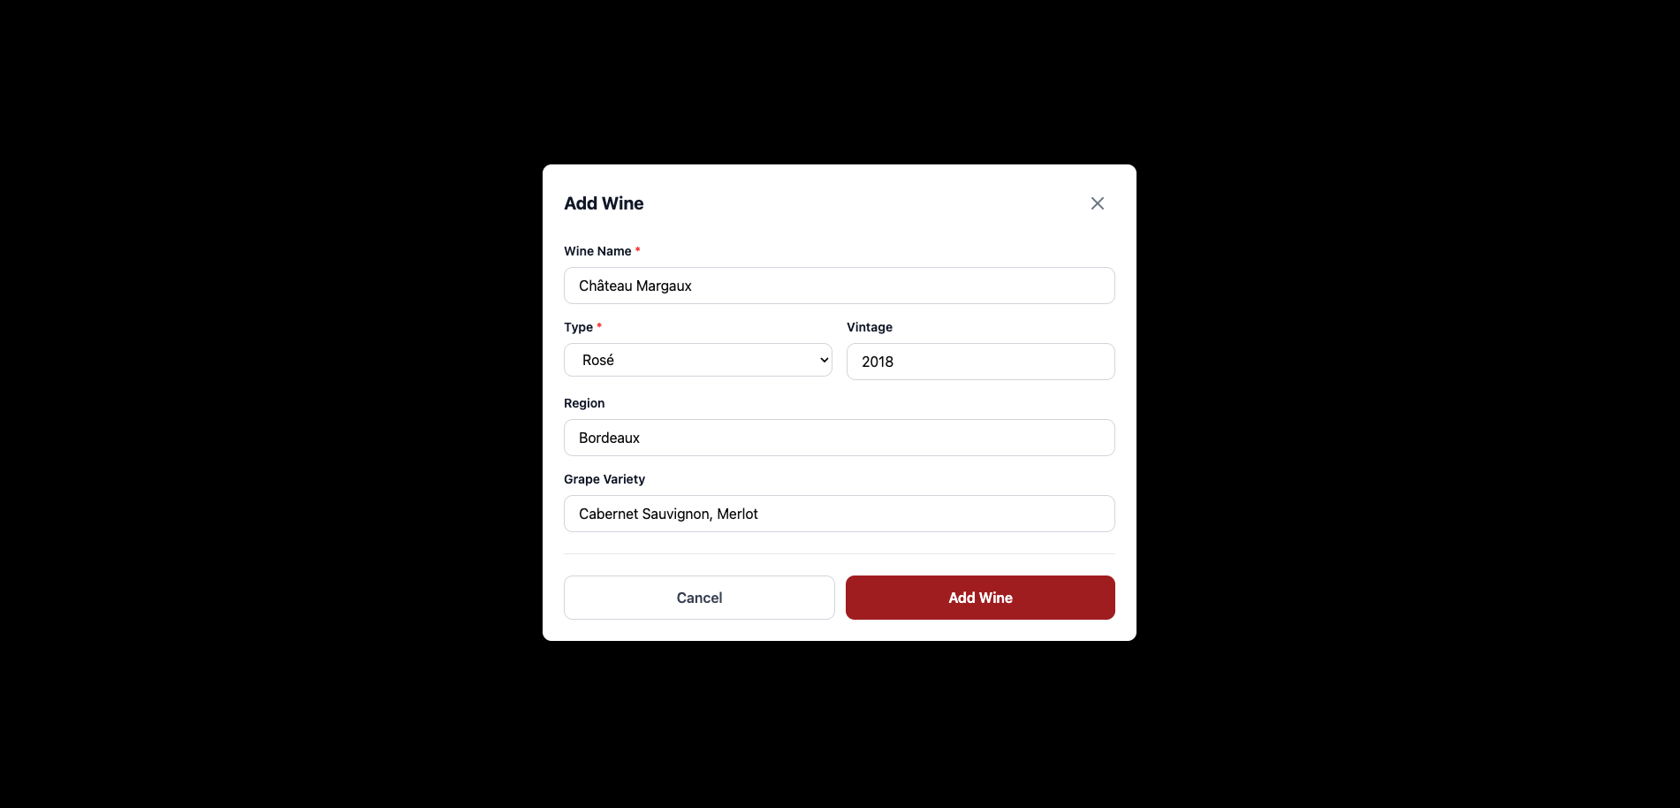 | Sophie uses the “Add Wine” button to open a modal form. She enters the wine name, selects the type (Rosé/Red/White/Sparkling), vintage year, region, and grape variety. Each wine is added to the event’s tasting order.
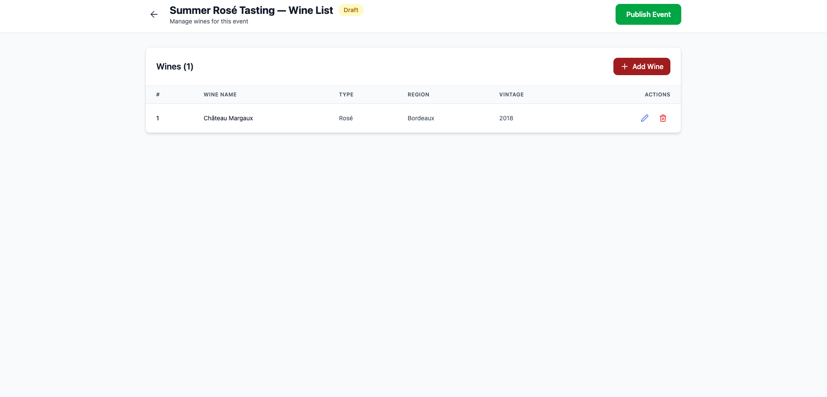 | She notices an incorrect vintage on one wine and uses the edit button to correct it. She also removes a wine that is no longer available. The table updates in real-time, demonstrating Create, Read, Update, and Delete operations on the event’s wine list.
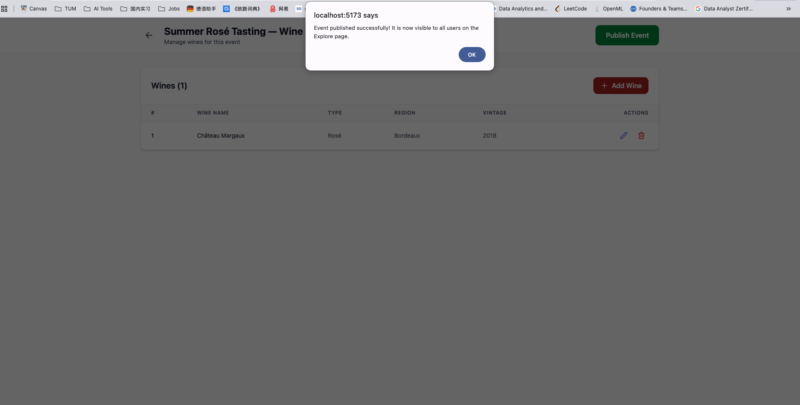 | Satisfied with her selection, Sophie clicks the green “Publish Event” button. The event status changes from “Draft” to “Published” and becomes immediately visible to all wine enthusiasts on the Explore page.
Frontend: Wine table with CRUD actions, Add/Edit modal, Publish button. Backend: - POST /api/events/:id/wines — Create wine entry for event. - PUT /api/wines/:id — Update wine details. - DELETE /api/wines/:id — Delete wine from event. - PUT /api/events/:id — Update event status to “published”. Database: Full CRUD on event Wine documents. Update Event status.

Step 5: Reviewing Event Performance & Feedback
Mockup | Description
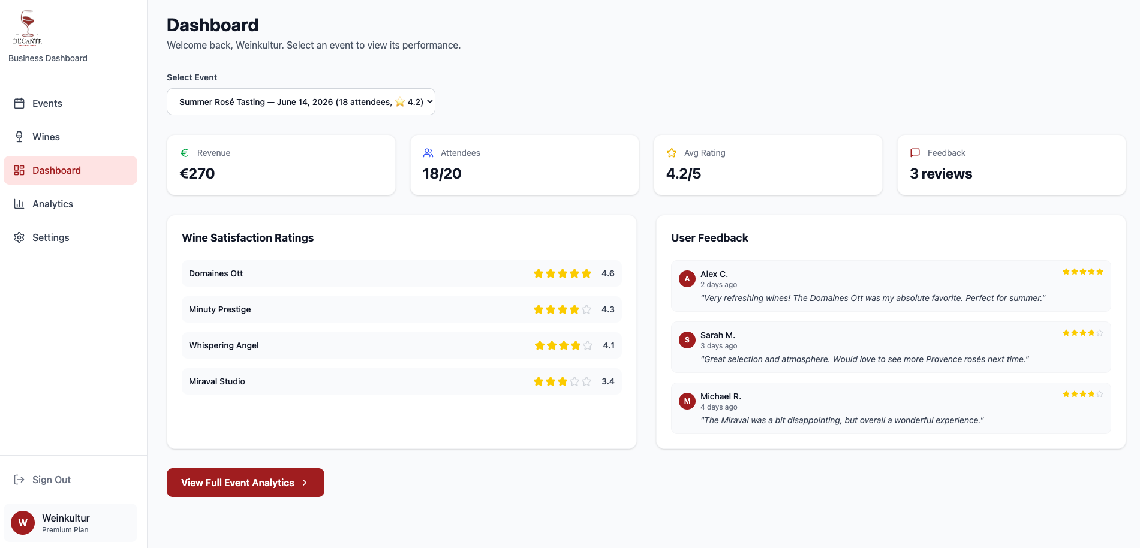 | After the event concludes, Sophie returns to her Dashboard. She selects “Summer Rosé Tasting” from the event dropdown to view its performance. She sees key metrics (revenue €270, 18/20 attendees, avg rating 4.2/5), wine satisfaction ratings displayed as star ratings sorted from highest to lowest, and real user feedback with text comments and individual star ratings.
Frontend: Event selector dropdown, stat cards, star rating list (sorted), user feedback cards with quotes. Backend: GET /api/events/:id/analytics — Aggregates TastingNotes: average ratings per wine, user comments. Database: Read TastingNotes (aggregated), Registrations.

Step 6: Business Analytics Overview
Mockup | Description
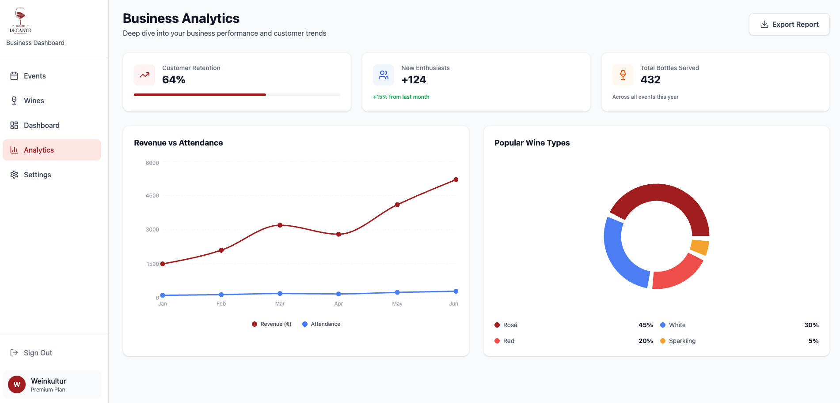 | Sophie navigates to the “Analytics” section for a holistic view across all her events. She sees customer retention (64%), new enthusiasts gained (+124), total bottles served (432), a Revenue vs Attendance trend chart over 6 months, and a Popular Wine Types pie chart showing the distribution of preferences (Rosé 45%, White 30%, Red 20%, Sparkling 5%).
Frontend: Charts (Recharts: LineChart, PieChart), metric cards with progress indicators. Backend: GET /api/business/:id/analytics — Cross-event aggregation of revenue, attendance, wine type preferences. Database: Read Events, TastingNotes, Registrations (historical aggregation).

Wine Enthusiast — Alex Chen
Alex Chen is a 29-year-old software engineer who recently moved to Munich. He enjoys wine socially and attends tasting events at least once a month, mostly drinking wine when going out rather than at home. He’s beginning to develop a genuine interest in understanding wine better but doesn’t consider himself an expert. Alex discovers Decantr through a friend who recently attended a tasting event organized through the platform.

[MOCKUP: Login page — Wine Lover / Wine Business role selection]
Alex opens the Decantr website and sees the login page with two role options. Since he’s new to the platform, he clicks “Sign up” and selects “Wine Lover.” He fills in his name, email, and password, then clicks “Create Account.” He is immediately directed to the Explore page.
Frontend: Registration form with role selection. Backend: POST /api/auth/register — Creates User with role “taster”. Returns JWT. Database: Create User document.

[MOCKUP: Discover Events — map view with pins + event cards list]
The Explore page shows Alex an interactive map with pins marking nearby tasting events, alongside a scrollable list of upcoming events. He applies filters for “This Week” and “Nearby.” He spots “Summer Rosé Tasting” at Weinkultur — €15, 12/20 registered, 4.5 stars.
Frontend: Map component, filterable event cards, search. Backend: GET /api/events?status=published&location=munich — Returns filtered events. Database: Read Events, Registrations (count).

[MOCKUP: Event Details page]
Alex views the full event page: cover image, description, what’s included (4 tastings, notes, snacks, sommelier guidance), host info (“Weinkultur” ⭐ 4.7), location map, and €15 price with “Register Now” button.
Frontend: Event detail layout. Backend: GET /api/events/:id — Full event data with host info. Database: Read Event, Business, Wines.

[MOCKUP: Payment modal]
Alex clicks “Register Now.” A payment modal shows the order summary (€15), Credit Card / PayPal options, card form fields, and SSL security note. He pays and sees “Payment Successful! ✓”
Frontend: Payment modal, processing animation, success confirmation. Backend: POST /api/registrations — Creates Registration, processes payment via Stripe. Database: Create Registration (paymentStatus: completed).

[MOCKUP: Tasting Notes interface]
At the event, Alex records tasting notes for each wine: appearance (color swatch), aroma tags (Citrus, Strawberry…), palate tags (Dry, Crisp…), star rating, and personal notes.
Frontend: Step-by-step form, tag chips, star rating, progress bar. Backend: POST /api/tasting-notes — Creates TastingNote per wine. Database: Create TastingNote documents.

[MOCKUP: Event Summary + Save to Cellar]
Post-event summary reveals wine names with ratings. Taste profile insight: “You prefer Dry, Fruity, Light-bodied wines.” Prompt to save favorites to cellar.
Frontend: Wine reveal cards, taste profile, Strava-style save prompt. Backend: GET /api/users/:id/tasting-summary, POST /api/cellar. Database: Read TastingNotes + Wines. Create CellarEntries.

[MOCKUP: My Cellar — Journal tab]
Alex’s wine journal shows all tasted wines with ratings, tags, notes, and event context. Statistics show total wines tasted and average rating.
Frontend: Journal list with wine cards, stats, search/filter. Backend: GET /api/users/:id/cellar — Retrieves cellar entries. Database: Read CellarEntries + Wines + TastingNotes.

UML Class Diagram
[INSERT UML CLASS DIAGRAM HERE — 1 full page]
This UML class diagram represents Decantr’s conceptual data model. The central class is User, specialized into Wine Enthusiast (B2C) and Business (B2B).
Business → owns Business entity → creates Events → features Wines Wine Enthusiast → creates Registrations (with payment) → records TastingNotes → saves CellarEntries
Key Enumerations: - UserRole: Taster, Business - EventStatus: Draft, Published, Ongoing, Completed, Cancelled - WineType: Red, White, Rosé, Sparkling, Dessert - BusinessType: Wine Bar, Winery, Event Organizer, Wine Shop - PaymentStatus: Pending, Completed, Failed, Refunded - PaymentMethod: Credit Card, PayPal - SubscriptionTier: Basic, Premium - EventType: Open, Registration Required
Key Relationships: - User (Business) owns one Business (1:1) - Business hosts many Events (1:) - Event features many Wines (1:) - User (Enthusiast) has many Registrations (1:) - Registration linked to one Event (:1) - User (Enthusiast) creates many TastingNotes (1:) - TastingNote references one Wine and one Event - User (Enthusiast) has many CellarEntries (1:) - CellarEntry references one Wine - Business has one Subscription (1:0..1)

