

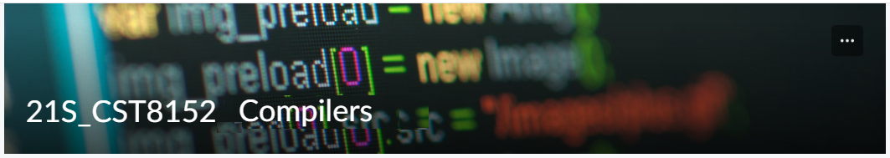

MODEL TASK FOR ASSIGNMENT 2.1 – YOUR LANGUAGE

Language: [Cloud]
Team - [Haoyun Deng] - Id: [041012253]

- Note: This task is part of the Assignment 2 from Compilers Course. Any problem, contact your lab professor.

PART 1: RE – Regular Expression (1.5 mark)

Lexeme Classes: Define the classes to be used in your regular expression:

Answer:
Letters = L = a-z & A-Z
Numbers = N = 0-9
Period=P = .
Comment = C = #
Comment = C1,C2 = #=,=#
New Line = NL = /n
Quotes = Q = ‘
Underscore= U = _
Open Parenthesis = OP = (
Other = O = ^LNPCNLQUC1C2

Define the RE to be used for: variables, literals and keywords:

Answer:

* Comments:C[^NL]*NL,C1[^C2]*C2

* Variables:L[L|N|U]*

* Methods:L[L|N|U]*OP

* Literals:
- Numbers
Int Literal = IL = N[N]*
Float literal = FL = N[N]*PN[N]*
- Strings
String Literal = SL = Q[^Q]*Q

* Keywords: KEY = "begin" "for" "while" "do" "end" "elseif" "else" "break" "catch" "try" "global" "local" "return" "continue" "const" "false" "finally" "function" "true" "false"

PART 2: TD – Transition Diagram (1.5 marks)

Activity: Starting from the previous lexeme classes and obeying the RE, it is possible to define the automata for your language:

Answer (draw / copy image of the automata):

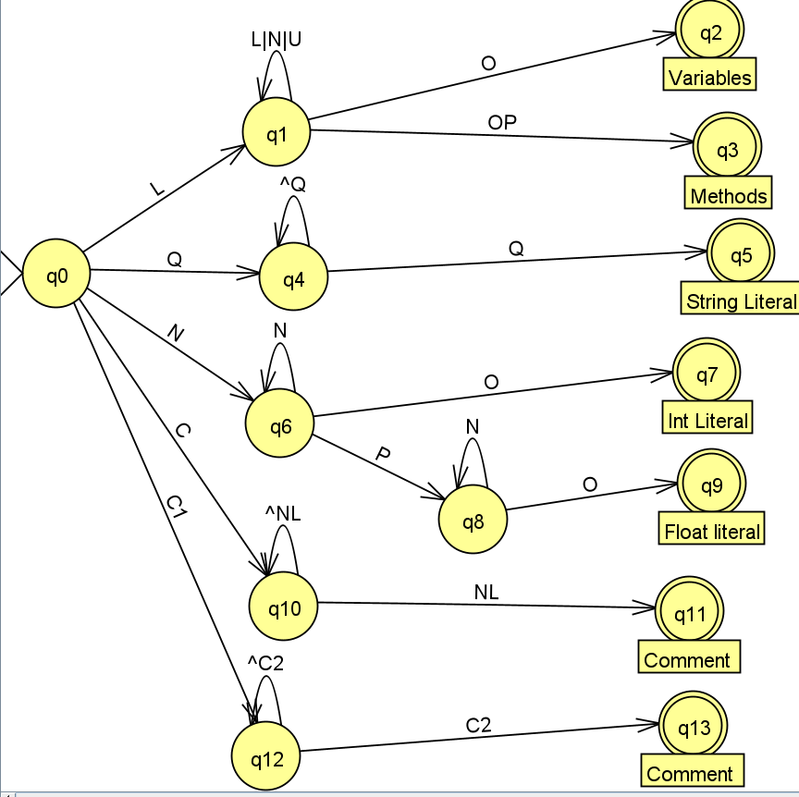

PART 3: TT – Transition Table (2 marks)

Activity: Now, it is possible to define the TT for these lexemes:

Answer (Transition Table):
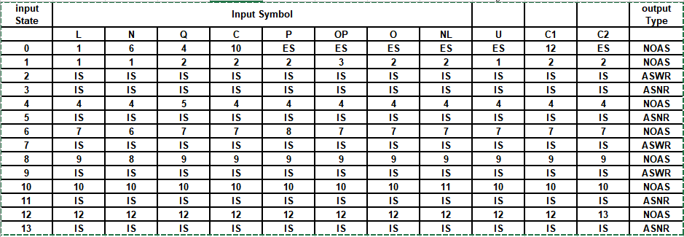

Update: Feb 3rd 2023.

Adapted from resources developed by Prof. Svillen Ranev (Algonquin College, 2019)

