Algonquin College Logo

# SCHOOL OF ADVANCED TECHNOLOGY

### ICT - Applications & Programming

### Computer Engineering Technology – Computing Science



A11

Game Interface

Team:

[Haoyun Deng] - Id: [041012253]

Game Proposal - Picross

***This template is suggested (not mandatory) to answer A11 Specification.***

|  |  |
| --- | --- |
| **Part**  **1** | **GUI Definition** |

**EXPLANATION**

*The purpose of this assignment is to define the elements of the GUI application to be used in your game implementation.*

* ***Example (Prof. suggestion)****:*

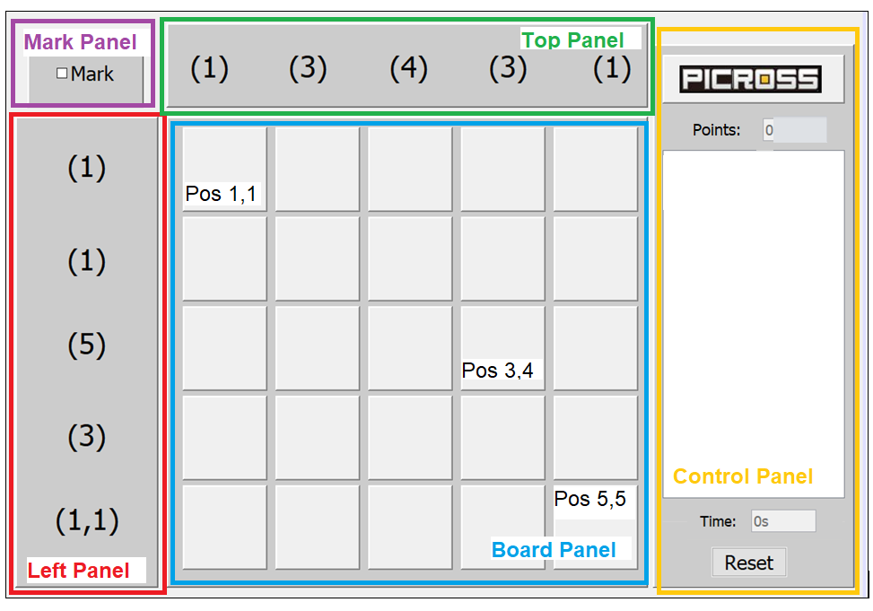

* ***Note****: The professor interface is also a proposal. It means that your own implementation can be different. What does matter is that the game functionality will be respected.*
  1. **Defining the Components**

**List of components**

*Include the list of components that you will use (they can be from Swing or JavaFX).*

·JFrame The window in which the game is executed class：baseWindow

· JMenuBar A menu bar containing all menus class：menuBar

· JMenu A menu showing switching languages class: languageMenu

·JPanel top panel displays a numeric hint for each column class：topPamel

·JPanel left panel displays a numeric hint for each row class：leftPamel

·JPanel broad panel provides an area for the player to play class：broadPamel

·JPanel Features panel contains all extra function buttons class：featuresPamel

· JTextArea Enter the number of squares in the resulting rectangle class：Dimension

·JButton The mode selection button switches between design mode and game mode class：modeButton

·JButton The Random Generate button will generate a pattern with a specified side length class：randomButton

·JButton The save button will save the player's current state into an array class： saveButton

·JButton The load button will read the saved state from the specified array class： loadButton

·JButton The Solve button will show the completed pattern class：solveButton

·JButton The reset button will reset the game to the state it was in when it started class：resetButton

·JPanel Info panel will include all info boxes class：infoPamel

· JTextArea Display information about each step of the user class：stepTxt

·JTextField Displays the number of seconds since starting the game class：timeTxt

·JTextField Display the player's score class：pointTxt

**Functionalities and Behaviors**

*What are the behaviors and functionalities that you will provide? How these elements are related with functionalities.*

Switch language through menu action: click

The main game area will be a Panel action: click

Use the panel to display the number of prompts

Will detect mouse click events to play the game

Use panels to display hinted numbers

Use the panel to display a control menu, including all buttons

Use TextField to to input the matrix to be generated action:type

Use button to operate mode selection action: click

Use button to operate randomly generated action: click

Use buttons to operate save and load action: click

Use button to operate reset action: click

Use a dialog to display the correct pattern, pop up by clicking a button

Use the panel to display a Info menu, including all the information display

Use TextArea to display step information

Use TextField to display time

Use TextField to display point

**Languages**

*Define (at least two) languages to be used – remembering that English is mandatory for one option.*

Language 1: English (mandatory)

Language 2: Chinese: Chinese is my mother tongue and the Chinese player base is vast, so I want to make this game more accessible

**Details**

*Drawn your interface (ex: in an image from Paint / Powerpoint slide, or any sketch tool), describing:*

* *The components;*
* *The properties (ex: size, dimension, color, position, etc)*
* *Additional GUI components (ex: the layout to be used).*

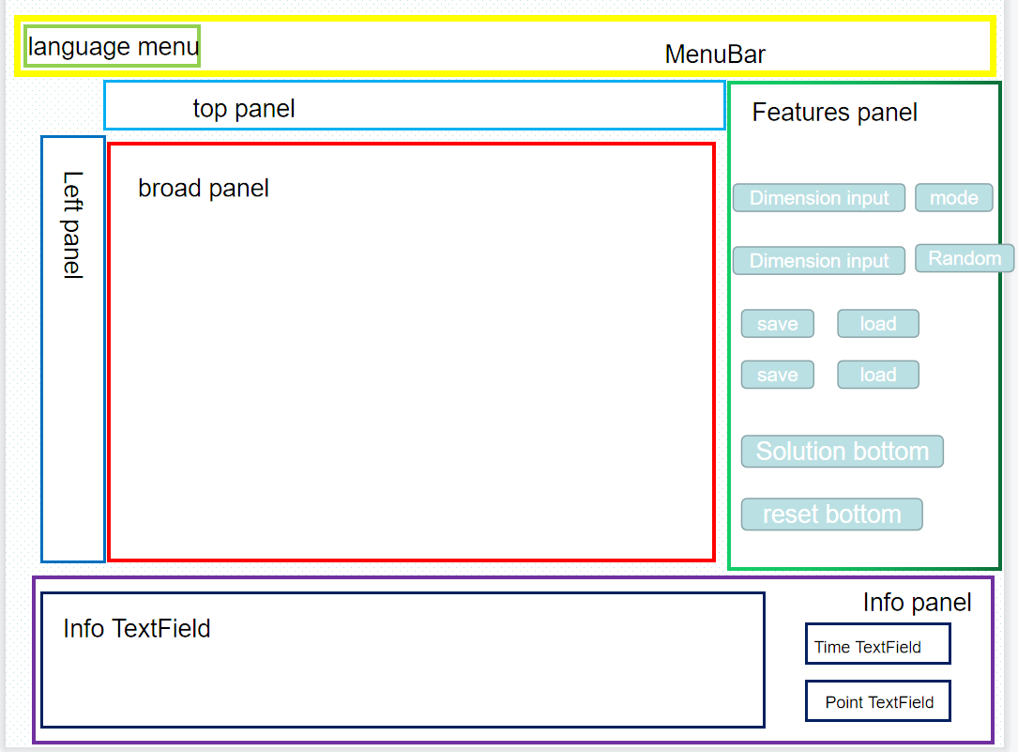

* 1. **User Manual**

**Basic cycle**

*Create a brief description about how your game can be used.*

* *Note: your process does not need to be followed exactly when you are going to the implementation. For while, it is only a script about how to play.;*

First about the basics - how to play the main game. You need to use the mouse to click in a large square matrix according to the numbers given. Make the lit squares form a prescribed pattern.

It is planned to use the MouseEvent event in Swing to monitor the player's click, and use a 2-dimensional array to store the data.

Mode: It is planned to set a button, which will create a blank square after clicking, the player can draw a pattern, and the pattern will be completed after pressing the button

Dimension: Set an input box to create a grid according to the number of inputs before setting the random button

Solution: The program will store a correct pattern as an array of information, and will provide a button for the player to view the correct pattern. After the player clicks, a dialog box will pop up to display this pattern

File configuration: Another 2-dimensional array will be used to save the current state, and two buttons are planned to be used to save and read. When saving is pressed, the array will copy the current state

Random creation: When it is turned on every time, a random pattern will be executed, and the number prompted will be generated by traversing this pattern

Points:Provides a textbox that will update the user's score in real time based on their actions

Reset: It is also provided by the button, and the current array is cleared after pressing

Info: Use the text box to display the step information. After monitoring the click event, output the change information of the array to the text box

Timer: Realize the display of the timer through the text box.

**FINAL SUGGESTIONS**

*Here some ideas to think about your language....*

* *Try to create a game whose execution can be very intuitive (easy to be played).*
* *Remember that this game will be in fact implemented only in the next assignment.*

**References**

*[Include eventual references used here]*

* ***NOTE****: Even if you use one specific tool (ex: ChatGPT), report it here.*

Algonquin College

Winter, 2023