z



Linear and Nonlinear pendulum models

Project 2



2017-11-17

Haoze He:20700291

David Liu：20621518

# Introduction:

In this project, we will study the linear and nonlinear pendulum models. The linear model can be seen as the approximation of the nonlinear(the real) model when the angle is small.

# Linear Model:

$$\frac{d^{2}θ}{dt^{2}}+ω_{0}^{2}θ=0,θ\left(0\right)=θ_{0},θ{\left(0\right)}^{'}=0$$

The solution of the IVP above is:

$θ(t)=θ_{0}cos⁡(ω_{0}t)$ (Details will be shown in the appendices)

Let $ω_{0}=2$.

This is the diagram for the $θ_{0}=0,1,2,3,π$

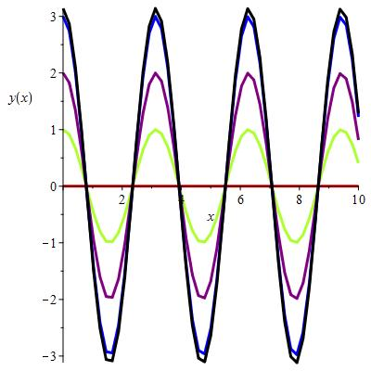

This is the diagram for the $θ_{0}=0.1,0.2,0.3,0.4,0.5$

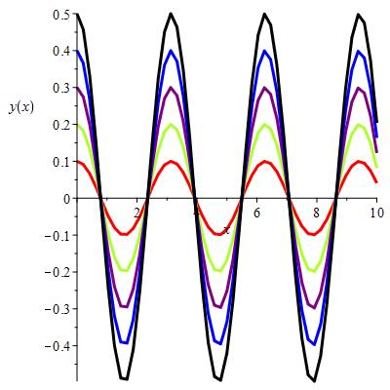

The only difference when the $θ_{0}$ varies is the amplitude of the curve, which can be obviously seen in the two diagrams above.

# NonLinear Model:

$$\frac{d^{2}θ}{dt^{2}}+ω_{0}^{2}sin⁡(θ)=0,θ\left(0\right)=θ_{0},θ{\left(0\right)}^{'}=0$$

In class we have noted that this model has the equilibrium solution $θ=0$,and that this corresponds to the pendulum hanging straight down.

Let me show another equilibrium solution is $θ=π$.

When $θ=π$.

$$θ^{'}=0,θ^{''}=0,\sin\left(θ\right)=0$$

So $\frac{d^{2}θ}{dt^{2}}+ω_{0}^{2}\sin\left(θ\right)=0+0=0$.Therefore $θ=π$ is another equilibrium solution. This case correspond to the physical situation where the pendulum is left upright and released then it will go upwards and downwards with the restriction of the spring, the angle will not change, only the position in the vertical axis will change.

The diagrams below are for the numerical approximations of the solution of the nonlinear DE with $ω_{0}=2$.

$$\frac{d^{2}θ}{dt^{2}}+ω_{0}^{2}sin⁡(θ)=0,θ\left(0\right)=θ_{0},θ{\left(0\right)}^{'}=0$$

This is the diagram for the $θ_{0}=0,1,2,3,3.14,π$

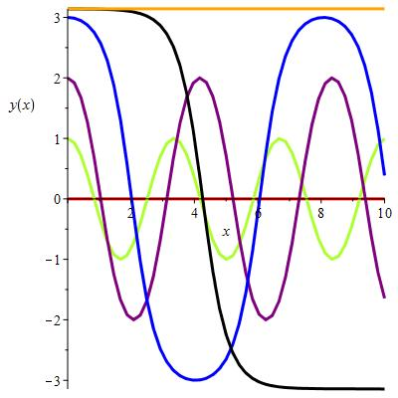

Compared to the previous diagram of the linear model, when $θ_{0}=0,1,2,3$, the plot is almost the same. But when it comes to 3.14(when it is close to $π$),the nonlinear plot is significantly different from the linear one(the nonlinear does not seem periodical but the linear one is periodical). When it comes to $π,$ the nonlinear curve is a straight line while the linear curve is a typical cos curve.

This is the diagram for the $θ_{0}=0.1,0.2,0.3,0.4,0.5$

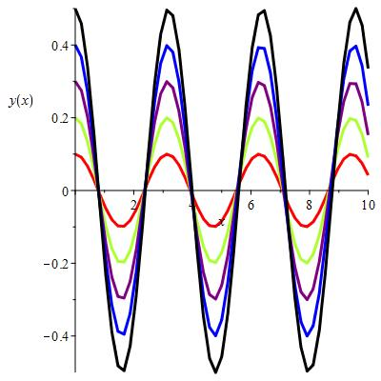

All of these plots look almost the same as the linear ones. The reason is that in this situation ${(θ}_{0}=0.1,0.2,0.3,0.4,0.5$), $θ_{0}$ is small, which means that we can treat sin($θ_{0}$) as $θ_{0},$ so the linear and nonlinear curves look like each other.

# Another linear Model:

We use the linear approximation of sin($θ$) at $θ=π$

$$\sin\left(π\right)=0$$

$${\sin\left(π\right)}^{'}=\cos\left(π\right)=-1$$

Let $φ=θ-π$

$$φ is small,Hence$$

$$\sin\left(θ\right)=\sin\left(φ+π\right)≈\sin\left(π\right)+{\sin\left(π\right)}^{'}\left(φ\right)=-φ$$

Also we know $\frac{d^{2}φ}{{dt}^{2}}= \frac{d^{2}(θ-π)}{{dt}^{2}}= \frac{d^{2}θ}{{dt}^{2}}$

So we substitute $\sin\left(θ\right)=-φ$ into the differential equation, we get:

$$\frac{d^{2}φ}{dt^{2}}-ω_{0}^{2}φ=0$$

$$φ(0)=φ_{0}$$

$$φ{\left(0\right)}^{'}={\left(θ-π\right)}^{'}\left(0\right)=θ^{'}\left(0\right)=0$$

The solution for this IVP is

$φ\left(t\right)=\frac{φ_{0}}{2}e^{ω_{0}t}+\frac{φ_{0}}{2}e^{-ω_{0}t}$ (Details will be shown in appendices)

The diagram below is the plots for $φ_{0}=-0.01,-0.1,-1$

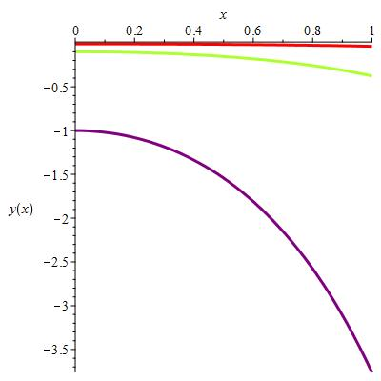

The diagram below is the plots for nonlinear model of this question.

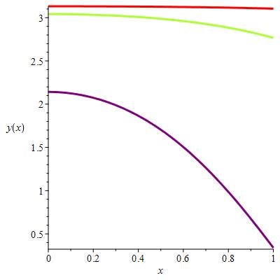

The approximation is good, at least the shape of the curves are the same and the values at certain points(transformed to the same $θ$) do not differ much. This is much better than the first linear model. The reason for this is that solution for the linear model in this section is an exponential curve, which is not periodical, it is overdamping so that It will not repeat itself and features a higher possibility to demonstrate the actual solution.

# Models with Forcing:

$$\frac{d^{2}θ}{dt^{2}}+ω_{0}^{2}θ=F_{0}cos⁡(ωt),θ\left(0\right)=θ_{0},θ{\left(0\right)}^{'}=0$$

If $ω=ω_{0}=2$, the particular solution for this DE will be:

$$θp\left(t\right)=\frac{F_{0}}{2ω_{0}}tsin(ω_{0}t)$$

With the initial condition $θ\left(0\right)=0,θ{\left(0\right)}^{'}=0$, We can get:

$$θ\left(t\right)=\frac{F_{0}}{2ω_{0}}tsin\left(ω_{0}t\right)+c1\sin\left(ω_{0}t\right)+c2cos⁡(ω_{0}t)$$

$$θ\left(0\right)=0→c2=0$$

$$θ\left(t\right)=\frac{F_{0}}{2ω_{0}}tsin\left(ω_{0}t\right)+c1\sin\left(ω_{0}t\right)$$

$$θ'\left(t\right)=\frac{F_{0}}{2ω_{0}}\left(sin\left(ω_{0}t\right)+tω_{0}\cos\left(ω_{0}t\right)\right)+c1ω_{0}\cos\left(ω_{0}t\right)$$

$$θ'\left(0\right)=0→c1=0$$

So $$θ\left(t\right)=\frac{F_{0}}{2ω_{0}}tsin(ω_{0}t)$$

Otherwise, the particular solution for this DE will be:

$$θp\left(t\right)=\frac{F_{0}}{ω_{0}^{2}-ω^2}cos(ωt)$$

With the initial condition $θ\left(0\right)=0,θ{\left(0\right)}^{'}=0$,We can get:

$$θ\left(t\right)=\frac{F_{0}}{ω_{0}^{2}-ω^{2}}(cos\left(ωt\right)-\cos{{(ω}_{0}}t))$$

Here is the diagram for $ω=1$:

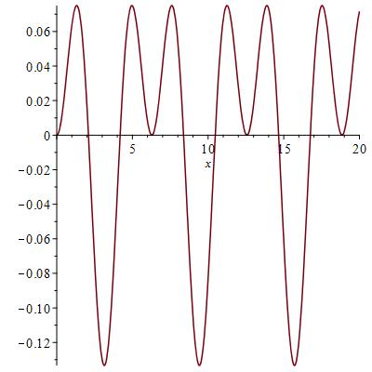

Here is the diagram for $ω=2$:

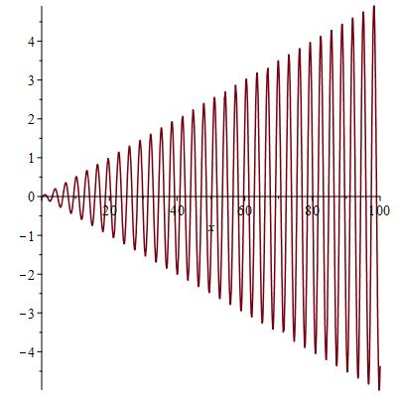

Here is the diagram for $ω=3$:

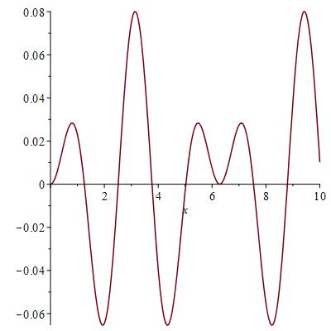

In the case $ω=ω_{0}$, I do not expect the linear model to be valid since as the t approaches to infinity, the amplitude approaches to infinity, as the t gets greater, the amplitude gets greater, the $θ$ will get greater, but the linear approximation only works for $θ$, so it is not valid. However, in the case $ω!=ω_{0}$,the linear model works since seen from the above pictures, the amplitude is always small whatever the t is, and if the amplitude is small, the $θ$ is small, when $θ$ is small, the linear approximation works.

$$\frac{d^{2}θ}{dt^{2}}+ω_{0}^{2}sin⁡(θ)=F_{0}cos⁡(ωt),θ\left(0\right)=θ_{0},θ{\left(0\right)}^{'}=0$$

The diagram below is the plots for $θ_{0}=0$

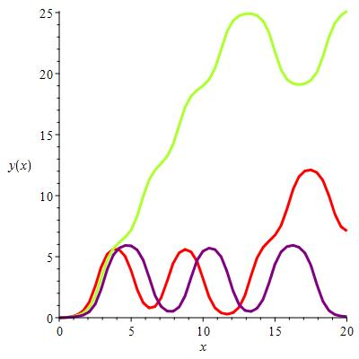

(green- $ω=2$ red- $ω=1$ purple- $ω=3$)

The diagram below is the plots for $θ_{0}=1$

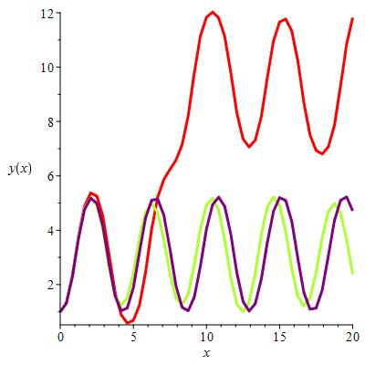

(green- $ω=2$ red- $ω=1$ purple- $ω=3$)

The observation:

Generally, the curve of the exact solution will seem periodical. With the difference of choice of $θ_{0}$, for a fixed $ω$,the frequency of the curve of the solution will change. With the difference of choice of $ω$,for a fixed $θ_{0}$, the frequency of the curve of the solution will also change.

# Contribution:

For this project, David Liu plotted all the curves and solve the eqations, Haoze He summarize and analyze them to reach the final conclusion to the given questions.

# Appendices:

Details for deriving solutions:

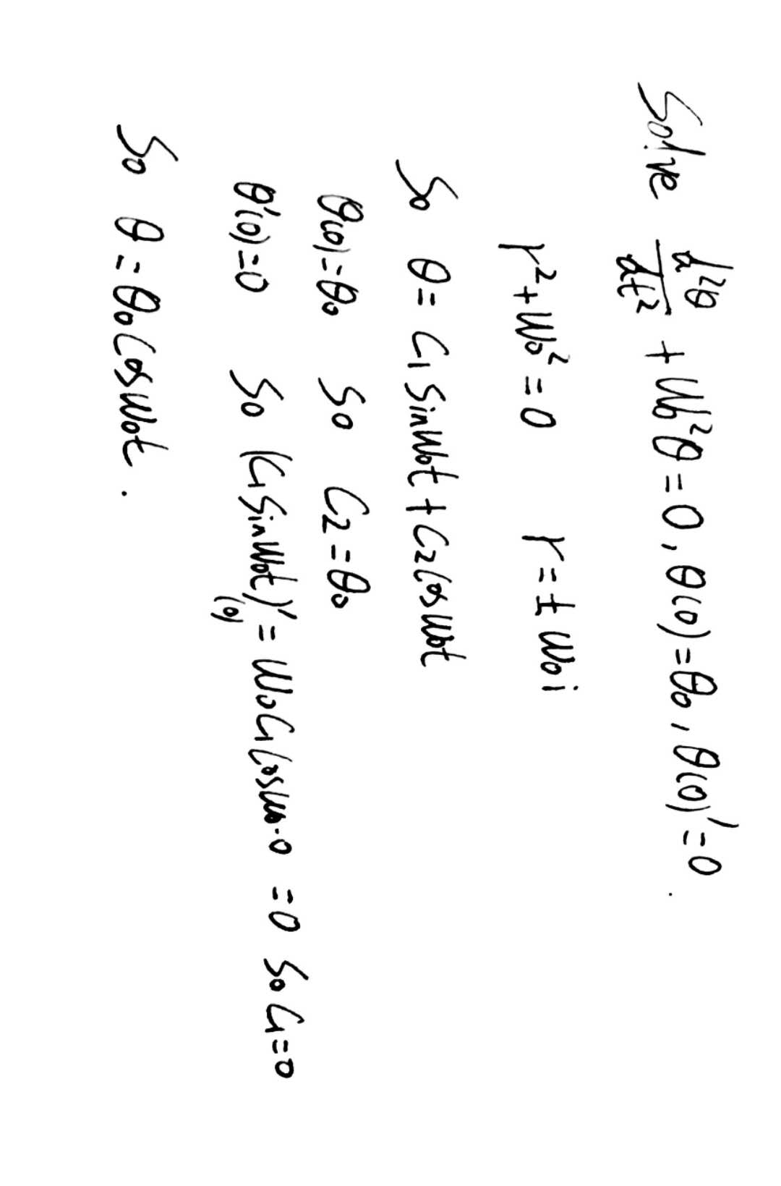

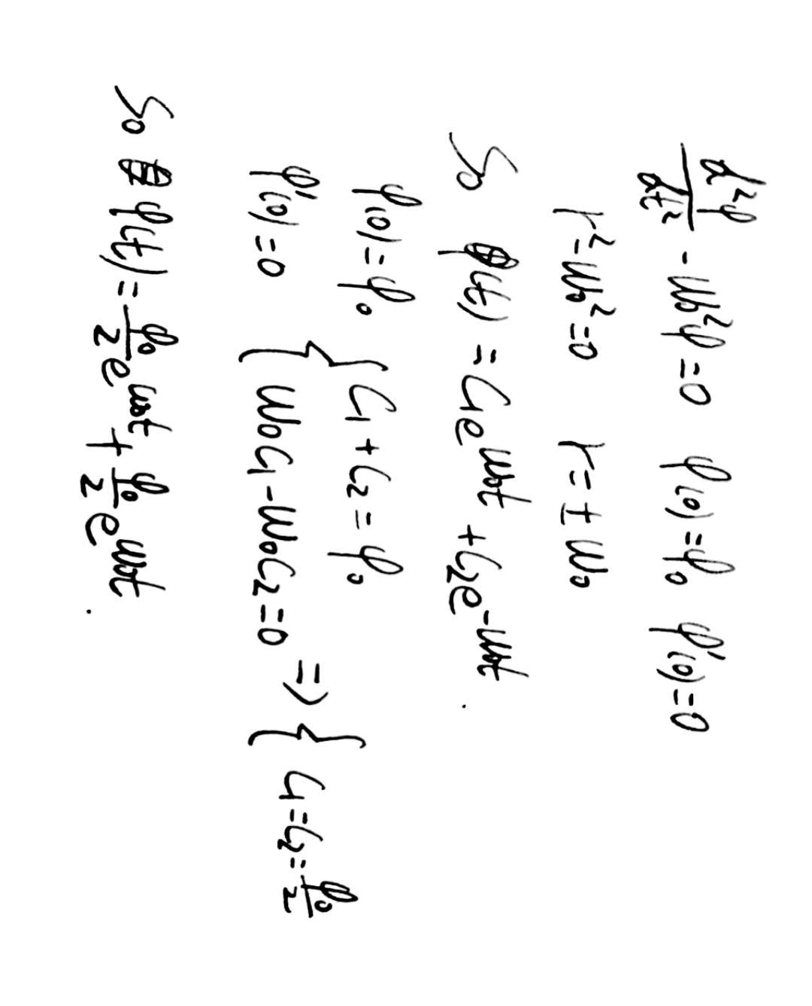

The following pages will be MapleOutput: