Autonomous-Pathfinding-Vehicle-Project

I. Function Introduction
This project is an embedded vehicle system based on Raspberry Pi and WiringPi library.
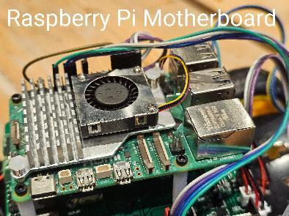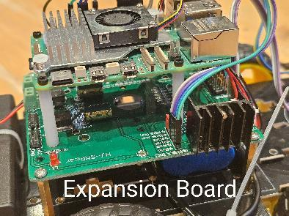
It mainly has the following functions:
Automatic trajectory: use the forward sensor to detect the ground trajectory, to realize the cart traveling along the preset path.
Automatic stop/steering to avoid obstacles: when the infrared obstacle avoidance sensor detects an obstacle in front or to the side, it stops immediately or bypasses the obstacle by steering action.
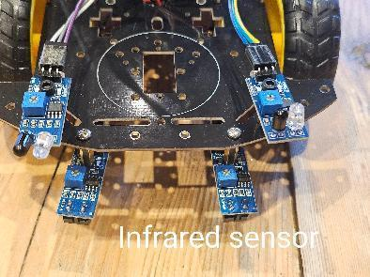
WiFi remote control: establish connection with PC through WiFi module, the car can be remotely controlled in real time on PC to realize remote control and monitoring.
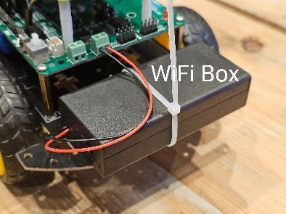

II. Code Fundamentals

1. Hardware abstraction and interface separation
Encapsulate the GPIO operation of WiringPi through the GpioWrapper abstract class, providing purely virtual methods such as pinMode, digitalWrite, digitalRead, pwmWrite, wiringPiISR, and so on.
WiringPiWrapper is implemented in the main program to map the real WiringPi functions to the interface, which is easy to replace MockGpio for simulation test in the unit test.

2. Interrupt Driver Design
Use wiringPiISR to register an interrupt callback on the infrared sensor pin (INT_EDGE_BOTH mode), and the hardware immediately triggers an interrupt to call InfraredTracking::sensorISR when the sensor state changes.
Calling the singleton instance_->processSensors() in the static callback realizes fast processing of sensor data and eliminates the polling delay.

3. Motion control and state management
The high and low level combinations of the four motor pins are used to control the movements of the cart, such as forward, stop, left turn, right turn, etc., and to adjust the motor speed using PWM signals.
processSensors() determines the traveling or obstacle avoidance logic according to the readings of forward (LEFT, RIGHT) and sideways (BLEFT, BRIGHT) sensors, and calls the corresponding motion methods (runForward, turnLeft, turnRight, brake).
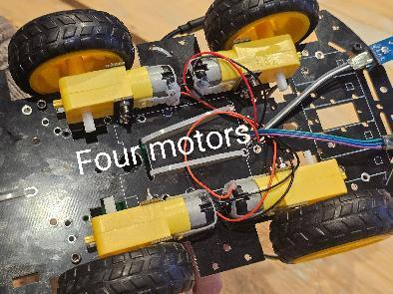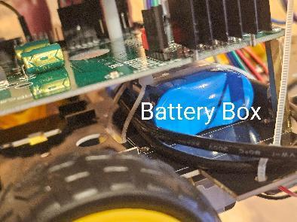

4. Non-blocking main loop and signal processing
The main function only sleeps in while (true) to keep the process running; the core logic is executed in the interrupt service routine to realize efficient event-driven.
The core logic is executed in the interrupt service routine for efficient event driving. The SIGINT signal handling function is registered to capture the Ctrl+C exit, which gracefully stops the motion of the cart and releases the resources.

5. Unit test
Based on the Google Test framework, using MockGpio to simulate the GPIO interface can verify the initialization GPIO mode settings, the number of interrupt registrations, and the correctness of the sensor logic for motor control under different input conditions.

III. Practical issues that the project could address
Industrial and Warehouse Automation: After lifting the body power and encapsulating the body, it can be used for automatic handling or path inspection in indoor warehouses, reducing labor cost and improving operation safety.
Family and service scenarios: can be expanded to sweeping, food delivery, patrol and other service robots to realize intelligent home applications.

IV. Project deficiencies
Sensors are not sensitive enough: only rely on infrared module, easy to misjudge under strong light or complex ground environment.
Lower speed: fixed PWM duty cycle and no closed-loop feedback, limited power output.
Insufficient body strength: the lightweight chassis of acrylic plate has limited carrying capacity and is not suitable for heavy loads.
High terrain requirements: only traces on flat, contrasting trajectories, poor adaptability to bumpy or reflective ground.
Short endurance: limited battery capacity, long-time operation is restricted.

V. Improvements and Prospects
Multi-sensor fusion: Integrate ultrasonic, laser or TOF sensors to improve obstacle detection accuracy and environmental adaptability.
Visual recognition: add camera and image processing module to realize environment sensing, target recognition and SLAM positioning.
Power and Structure Optimization: Upgrade the motor drive and battery capacity, and adopt aluminum alloy or carbon fiber chassis to improve the carrying capacity and range.
Robotic arm and transportation platform: expand the functions to carry objects or realize simple grasping tasks to enhance the breadth of application scenarios.
Intelligent scheduling and remote monitoring: develop software for the upper computer and combine it with the cloud to realize multi-vehicle collaboration, path planning and remote operation and maintenance management.

