Reinforcement learning-guided graph generation for target-efficiency-driven LNP lipid design
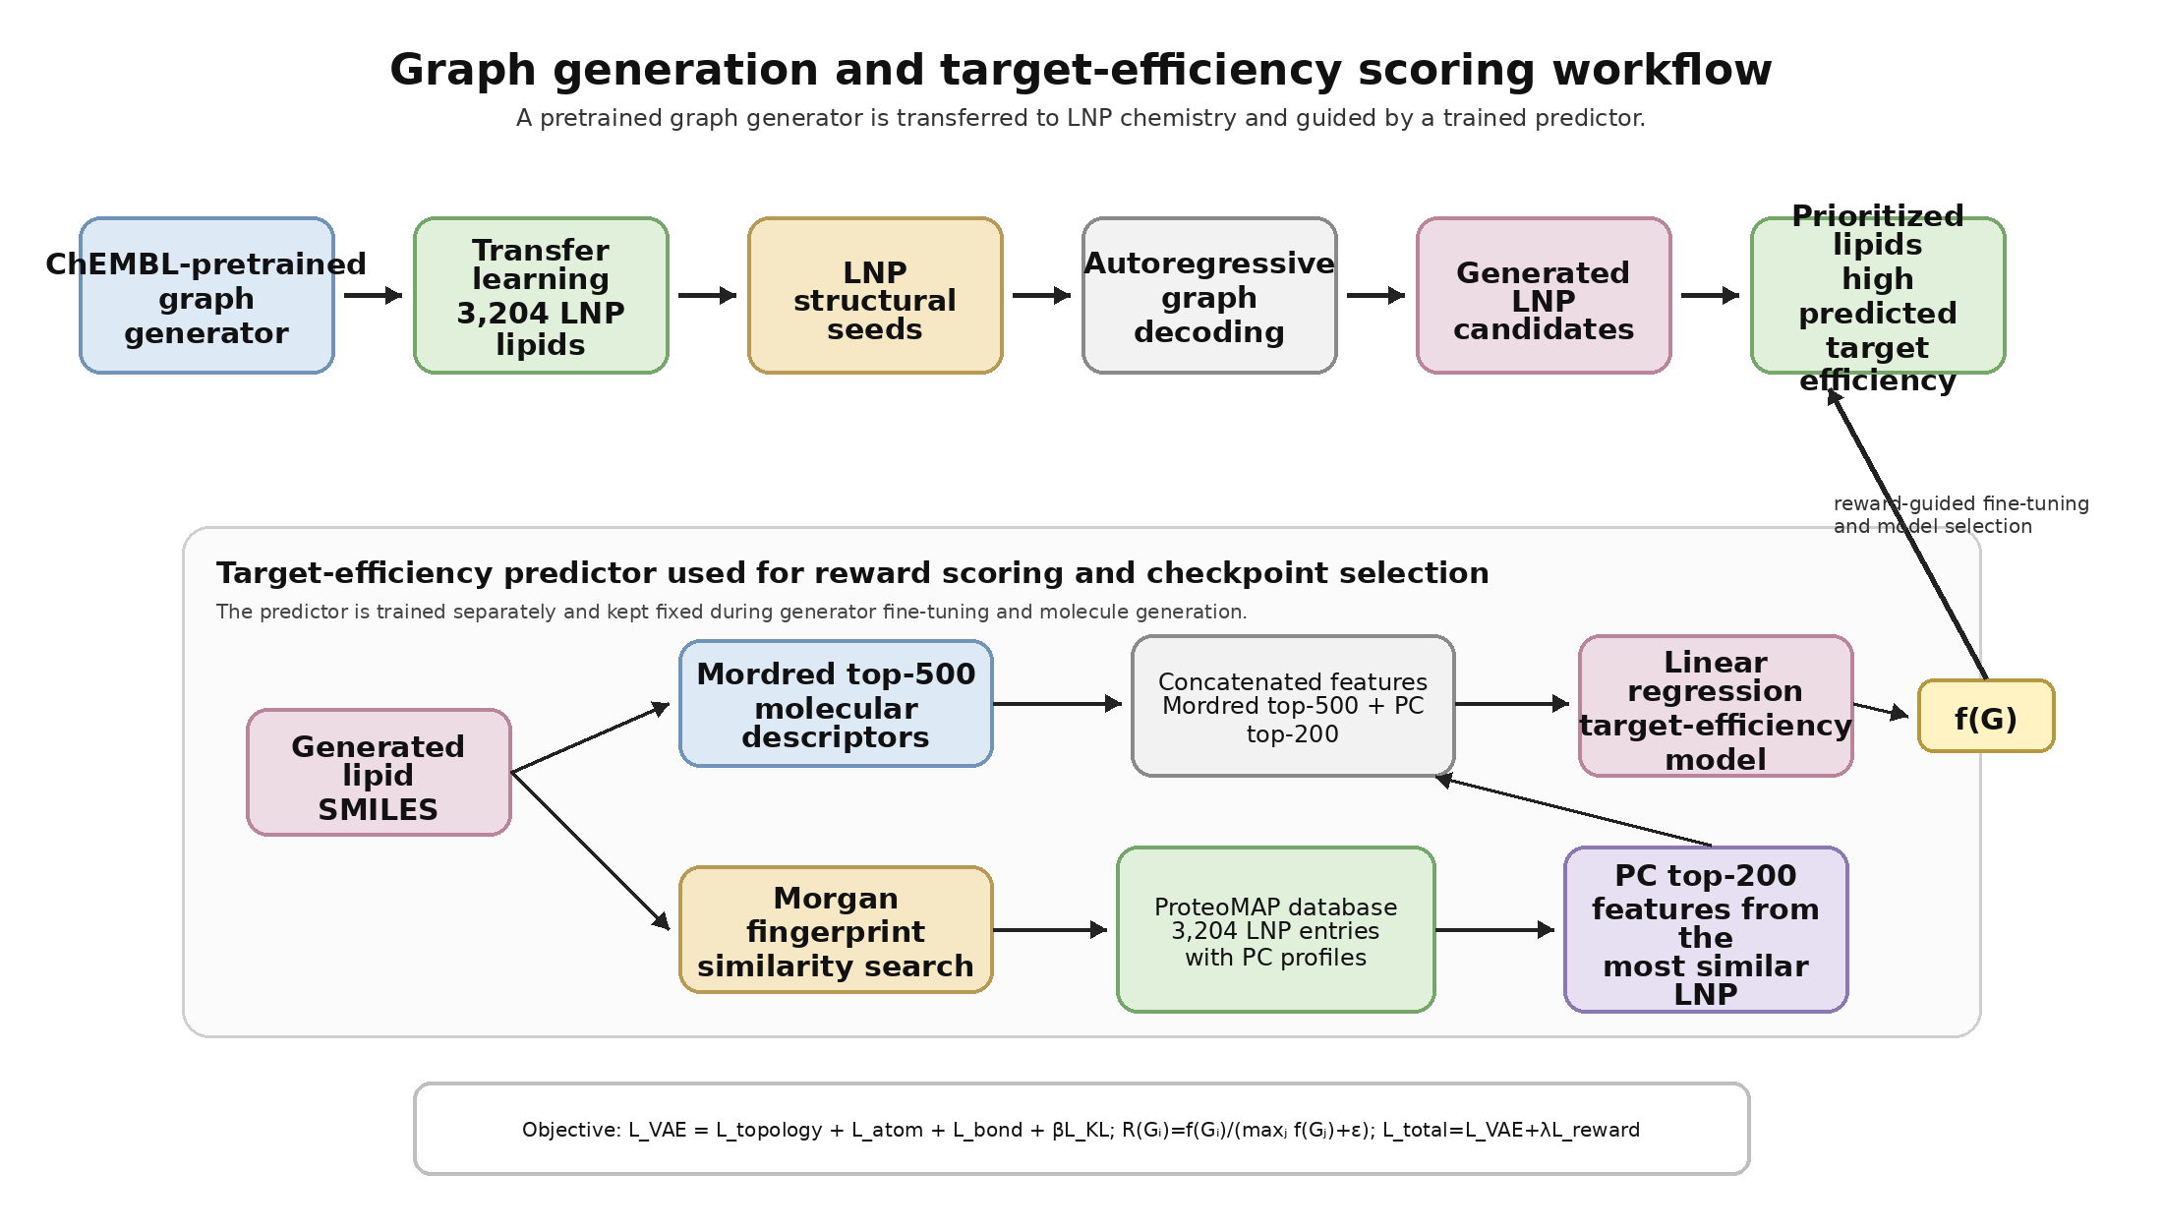
Framework for reinforcement learning-guided LNP lipid generation. A ChEMBL-pretrained graph generator was transferred to LNP chemistry using 3,204 ionizable lipid structures. Generated candidates were scored by a trained linear-regression target-efficiency predictor that combines Mordred top-500 molecular descriptors with PC top-200 features retrieved from the ProteoMAP database by similarity search.

Overview
Lipid nanoparticle (LNP) optimization remains challenging because the relationship between lipid chemical structure, protein corona formation and delivery performance is highly nonlinear. Conventional screening can identify active lipids, but it is inefficient for exploring broader LNP chemical space. To address this limitation, , we developed a reinforcement learning-guided molecular graph generation framework to generate LNP lipid candidates with high predicted target efficiency.
The framework integrates three components: a ChEMBL-pretrained graph generator that provides general chemical knowledge, LNP-specific transfer learning on 3,204 ionizable lipid structures, and a trained target-efficiency scoring model that combines molecular descriptors with protein corona features retrieved from the ProteoMAP database. This design enables the generator to explore LNP-relevant chemical space while prioritizing candidates based on predicted delivery performance informed by both lipid chemistry and protein corona signatures.
The generative backbone was adapted from a graph completion framework originally developed for substructure-conditioned molecular generation by Jin, Barzilay and Jaakkola. In the original framework, molecular substructures are used to condition graph completion. In our implementation, we did not perform new Monte Carlo tree search-based rationale extraction and do not describe the method as multi-objective rationale optimization. Instead, the pretrained graph-completion model is used as a transfer-learning backbone, and LNP-derived structural inputs are used as molecular starting graphs for candidate generation. To avoid overinterpreting these inputs as newly inferred property rationales, we refer to them throughout as LNP structural seeds or structural inputs.

Data and input representation
The LNP-specific training set contained 3,204 ionizable lipid structures. These structures were used for transfer learning of the graph generator and also served as the structural inputs for generation. In parallel, a target-efficiency predictor was trained separately and then used as a fixed scoring function during the generative workflow.
ProteoMAP was used as a database of experimentally measured LNP protein corona profiles. In the target-efficiency scoring model, generated lipids without direct proteomic measurements were annotated by similarity-based transfer: each generated structure was compared with reference LNP entries using Morgan fingerprint Tanimoto similarity, and the protein corona feature vector of the most similar reference entry was assigned to the generated molecule.

Target-efficiency predictor
To guide generation toward improved delivery performance, generated molecules were scored by a fixed target-efficiency predictor. Molecular descriptors were calculated from lipid structures using Mordred -based feature extraction. A selected set of Mordred top-500 molecular descriptors was combined with PC top-200 protein corona features from ProteoMAP. The protein corona features represent experimentally measured corona protein patterns associated with LNP structures. The resulting descriptor-corona feature matrix was standardized using a pre-fitted scaler, and a linear regression machine-learning model was trained to predict target efficiency. This predictor was not updated during generator fine-tuning or molecule generation; it was called only as an external scoring to assign target-efficiency scores to generated candidates.
For generated molecules, direct protein corona measurements were not available. Therefore, protein corona features were assigned by similarity-based transfer from the ProteoMAP database. Each generated molecule was converted to a Morgan fingerprint and compared with ProteoMAP entries using Tanimoto similarity. The PC top-200 feature vector of the most structurally similar ProteoMAP entry was transferred to the generated molecule. The final predictor input for each candidate was therefore the concatenation of Mordred top-500 descriptors and similarity-transferred PC top-200 features. The trained linear regression model then produced the predicted target-efficiency score.

Graph generator architecture
Molecules were represented as graphs
$$G=\left(V,E\right),$$
where atoms correspond to nodes (V) and chemical bonds correspond to edges (E). Molecular generation was implemented using an atom-level variational graph neural network that learns to construct chemically valid molecules through autoregressive graph expansion.
The encoder is a message-passing neural network that computes atom-level hidden states and aggregates them into a graph-level embedding (h_G). This graph embedding is projected to the parameters of a Gaussian latent distribution. A latent vector (z) is sampled using the reparameterization trick:
$$z=μ\left(h_{G}\right)+\exp\left(Σ\left(h_{G}\right)\right)⋅ϵ,ϵ∼N\left(0,I\right).$$
Conditioned on $z$ and the current partial graph, the decoder iteratively generates atoms and bonds until termination. The model was pre-trained on a large corpus of bioactive molecules from ChEMBL by maximizing a variational reconstruction objective.
$$L_{recon}=L_{topology}+L_{atom}+L_{bond}.$$
The variational training objective is
$$L_{VAE}=L_{recon}+βL_{KL}.$$
In the implemented model, the recurrent message-passing module uses an LSTM cell, hidden size 400, embedding size 400, latent size 20, message-passing depth 10 and decoder iteration depth 3.

Transfer learning and reward-guided fine-tuning
The generator was initialized from a ChEMBL-pretrained graph-completion checkpoint derived from the Jin et al. model. This pretrained model provides general chemical grammar, atom-bond connectivity patterns and substructure-conditioned molecular completion ability learned from a large corpus of bioactive molecules. Rather than training a generator from scratch using only the relatively small LNP dataset, we transferred this pretrained model to LNP chemistry by fine-tuning it on the 3,204 LNP structures.
During LNP-specific fine-tuning, generated molecules were evaluated by the fixed target-efficiency predictor. For each generated molecule $G_{i}$, the predictor returned a scalar target-efficiency score $f(G)$. To stabilize scoring across decoded batches, scores were normalized within each batch:
$$R\left(G_{i}\right)=\frac{f\left(G_{i}\right)}{\max_{j}f\left(G_{j}\right)+ϵ},$$
The reward term was defined as
$$L_{reward}=-\frac{1}{B}\sum_{i=1}^{B}{R}\left(G_{i}\right),$$
and combined with the variational objective:
$$L_{total}=L_{VAE}+λL_{reward}.$$
This reward-guided fine-tuning biases the generator toward molecular regions associated with higher predicted target efficiency, while the reconstruction objective helps preserve chemically valid graph construction and structural stability. The target-efficiency predictor remains fixed and serves as an external scoring function. The best-performing checkpoint was selected according to the average predicted target efficiency of decoded molecules.

Fine-tuning was performed for 50 epochs using the Adam optimizer with gradient clipping to ensure stable updates. The best model achieving the highest average predicted target efficiency over decoded molecules was selected for generation.

Molecular generation and candidate decoding
After fine-tuning, candidate molecules were generated using the best-performing checkpoint. In the final generation run, the 3,204 LNP structural inputs were used as starting graphs and num_decode was set to 5. Therefore, the generation procedure produced up to
$$3,204×5=16,020$$
decoding attempts before downstream filtering. The generation batch size controls computational throughput and does not change the total number of decoding attempts.
Generated candidates were filtered to retain valid single-component molecules that preserved the conditioning structural input. The remaining molecules were scored using the fixed linear-regression target-efficiency predictor. Candidate prioritization was based on predicted target efficiency together with chemical validity, novelty and physicochemical ranges relevant to LNP lipid design, including molecular weight, LogP, hydrogen-bond acceptors, hydrogen-bond donors and pKa.

Key implementation parameters
Component | Setting
Generative backbone | Atom-level variational graph neural network / graph-completion model
Pretraining source | ChEMBL-pretrained checkpoint derived from Jin et al. graph-completion model
LNP transfer-learning set | 3,204 ionizable lipid structures
Conditioning input | LNP structural seeds / structural inputs
Encoder | Message-passing neural network with LSTM recurrent unit
Hidden size | 400
Embedding size | 400
Latent size | 20
Message-passing depth | 10
Decoder iteration depth | 3
Optimizer | Adam
Learning rate | 5 ×1e-4
Training batch size | 40
KL weight | β = 0.3
Reward weight | λ = 0.1
Gradient clipping | Global norm 20.0
Target-efficiency predictor | Linear regression model trained separately and kept fixed
Predictor input | Mordred top-500 molecular descriptors + PC top-200 protein corona features
PC feature assignment for generated molecules | Morgan fingerprint Tanimoto similarity search against ProteoMAP database
Final generation setting | 3,204 structural inputs × num_decode 5 = up to 16,020 decoding attempts

Suggested figure legend
Figure X. Reinforcement learning-guided graph generation for target-efficiency-driven LNP lipid design. A ChEMBL-pretrained graph generator was transferred to LNP chemical space using 3,204 ionizable lipid structures. LNP-derived structural inputs were used as starting graphs for autoregressive graph decoding. Generated candidate lipids were scored by a trained linear-regression target-efficiency predictor that combines Mordred top-500 molecular descriptors with PC top-200 protein corona features. For candidates without direct protein corona measurements, PC features were retrieved from the ProteoMAP database by Morgan fingerprint-based Tanimoto similarity search. The resulting workflow prioritizes generated LNP lipids with high predicted target efficiency while retaining chemically valid graph construction.

