A Software Group Project Report

On

Niwas-Saathi
Submitted by

Harsh Parekh (IU2141050116)
Sumit Parmar (IU2141050122)
Viraj Parmar (IU2141050123)
Dhrumil Patel (IU2141050131)
Guided by
Divyani Tirthyani
Assistant professor
Computer Engineering Department
In partial fulfillment for the award of the degree Of

BACHELOR OF TECHNOLOGY

In
Computer Engineering



INSTITUTE OF TECHNOLOGY AND ENGINEERING INDUS UNIVERSITY CAMPUS, RANCHARDA, VIA-THALTEJ
AHMEDABAD-382115, GUJARAT, INDIA,

WEB: www.indusuni.ac.in
Nov-Dec 2024
Table of Content

Chapter/Section | Title | Page No.
 | ABSTRACT | 3
CHAPTER 1 | INTRODUCTION | 5
1.1 | Brief Overview of the Project Topic | 6
 | - Introduction to the topic | 6
 | - Relevance / Need of the project | 7
1.2 | Purpose / Problem Statement | 3
 | - Problem identification | 3
 | - Objectives | 3
1.5 | Technology Overview | 6
 | - Overview of relevant technologies | 6
 | - Tools and platforms used | 6
 | - Justification for technology selection | 6
CHAPTER 2 | LITERATURE REVIEW | 7
2.1 | Literature Review | 8
 | - Summary of existing research | 8
 | - Key findings and gaps | 8
 | - How the project addresses these gaps | 8
CHAPTER 3 | SYSTEM DESIGN & MODULE DESCRIPTION | 10
3.1 | System Architecture | 11
 | - Components and their interactions | 11
 | - Data flow and control flow diagrams | 11
3.2 | Module Description | 12
 | - Overview of each module | 12
 | - Detailed functionality of each module | 12
3.3 | Screenshots & Functionality Overview | 13
3.4 | Results and analysis | 14
 | - Code snippets and explanations | 14
 | -Screenshots
CHAPTER 4 | LIMITATIONS & FUTURE ENHANCEMENTS | 15
4.1 | Limitations | 16
4.2 | Future Enhancements | 17
CHAPTER 5 | CONCLUSION | 18
5.1 | Conclusion | 19

ABSTRACT

Abstract of Project:
Niwas Saathi is a web application designed to streamline the process of finding affordable, safe, and convenient hostel accommodations for students and job seekers. The platform addresses the challenges of locating verified, budget-friendly accommodations, especially for those relocating to new cities for educational or professional opportunities. Niwas Saathi provides a centralized database of verified hostel listings, ensuring users have access to accurate and trustworthy information. The platform offers customized search filters tailored to user needs, including proximity to universities or workplaces, budget constraints, and amenities such as Wi-Fi, laundry, and security. Niwas Saathi supports flexible rental terms, including short-term stays and semester-based contracts, catering to the dynamic needs of students and job seekers. The web application ensures a seamless user experience with an intuitive design, making it easy to search, compare, and book hostels. Listings on Niwas Saathi are verified to ensure safety and reliability. Users can access reviews and ratings from previous residents, providing transparency and confidence in their accommodation choices. Niwas Saathi simplifies the process of hostel hunting, reducing the stress of relocation and empowering users to make informed decisions about their living arrangements. The platform fosters a sense of community while ensuring safety, convenience, and affordability.

INTRODUCTION

1.1 Brief Overview of Project:
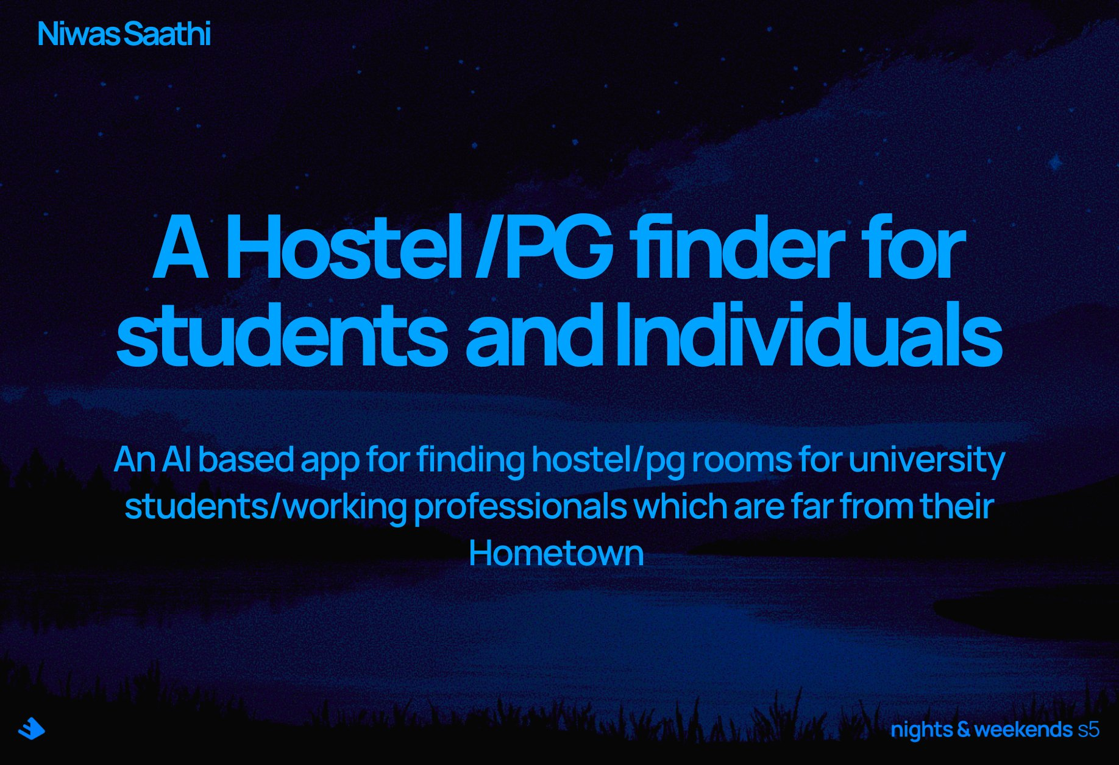
Niwas – Saathi:
Introduction:
Niwas Saathi is an innovative hostel-finding web application tailored to meet the needs of students and job seekers. The platform aims to ease the process of finding safe, affordable, and verified accommodation in new cities.
- Target Audience:
The platform primarily serves:
  - Students: Looking for affordable hostels near universities and colleges.
  - Job Seekers: In need of temporary accommodation close to business districts and job centres.
- Core Features:
  - Centralized Accommodation Listings: A comprehensive database of verified hostels, ensuring users can access reliable options in their chosen city.
  - Advanced Search Filters: Users can customize their search based on factors like proximity to institutions or workplaces, budget, and required amenities.
  - Flexible Rental Options: Supports short-term, month-to-month, and semester-based contracts, providing flexibility for users with varying needs.
  - Safety and Security: Verified listings and user reviews help ensure a secure and trustworthy accommodation search process.
- User Experience:
Niwas Saathi offers a user-friendly interface that simplifies the search, comparison, and booking of hostels. The intuitive design helps users find suitable accommodations quickly and efficiently.
- Community Focus:
The platform fosters a sense of community by connecting students and job seekers with similar needs, promoting social interaction and networking opportunities.

Relevance/Need of Niwas-Saathi:
  - Increasing Student and Job Seeker Mobility:
As more students and job seekers relocate to new cities for education and career opportunities, finding suitable, safe, and affordable accommodation becomes a significant challenge. Niwas Saathi addresses this growing need by offering a reliable platform specifically tailored to these groups.
  - Lack of Centralized Solutions:
Currently, students and job seekers often face a fragmented and time-consuming process of searching through various platforms, dealing with unverified listings, or encountering scams. Niwas Saathi provides a centralized platform with verified listings, eliminating the uncertainty and hassle associated with finding trusted accommodation.
  - Affordability and Flexibility:
Both students and job seekers typically operate on tight budgets and require flexible rental terms that traditional rental platforms do not always accommodate. Niwas Saathi offers affordable options with flexibility in rental durations (short-term, semester-based, etc.), making it highly relevant to the unique circumstances of its target users.
  - Safety Concerns:
Safety is a top priority, particularly for young people relocating to unfamiliar cities. Niwas Saathi ensures that all listed hostels are verified, helping users avoid unsafe or untrustworthy accommodations and giving peace of mind to both residents and their families.
  - User-Friendly Experience:
The platform simplifies the accommodation search with an intuitive, easy-to-navigate interface that caters specifically to the needs of students and job seekers, reducing the time and effort needed to find a suitable hostel.

  - Problem Statement:
Problem Identification:
- Student Accommodation Shortage:
Many students and job seekers face significant challenges when relocating for educational or career opportunities, particularly in finding affordable and safe accommodation. Due to increasing demand, on-campus housing is often insufficient, leading students to search for off-campus hostels or shared accommodations. Similarly, job seekers, especially those on temporary assignments or internships, struggle to find short-term housing that suits their needs. This shortage puts pressure on students and job seekers, often forcing them to settle for subpar or overpriced options that do not meet their expectations in terms of safety, convenience, or affordability.
- Fragmented Information:
The current landscape of hostel-finding platforms is highly fragmented, with information scattered across multiple websites, local listings, and classified ads. This lack of centralization leads to inaccurate, outdated, or incomplete data on available hostels, making it difficult for users to compare options. Additionally, many platforms lack verification systems, leaving students and job seekers vulnerable to fraudulent listings or misleading advertisements. As a result, the search for accommodation becomes a daunting task, filled with uncertainty and risk.
- Time-Consuming Process:
Searching for suitable accommodation involves a multi-step process that is often tedious and time-consuming. Students and job seekers must sift through various platforms to find potential options, contact landlords or property managers, and verify the authenticity of listings. In many cases, users also need to physically visit the accommodation to assess its condition and amenities, which adds another layer of complexity and effort. Furthermore, understanding the terms of rental agreements—especially when it comes to hidden fees, deposits, or lease durations—can be overwhelming, leading to delays in securing a place to stay.
- Inflexibility in Rental Options:
Traditional rental contracts are typically designed for long-term tenants, which often do not suit the needs of students and job seekers who may require more flexible arrangements. For example, students may only need housing during the academic semester, and job seekers may only require temporary accommodation while they transition between jobs or cities. However, many rental agreements impose rigid terms, such as one-year leases, large deposits, and limited options for early termination. This lack of flexibility makes it difficult for users to find suitable accommodations that align with their timelines and budgets.

Objectives:
- Centralized Platform:
Niwas Saathi offers a one-stop solution for finding hostels, consolidating verified and reliable listings in a single platform, eliminating the need to search across multiple sources.
- Verified and Affordable Hostels:
All hostels listed on the platform are verified to ensure safety and trustworthiness, while providing options that are budget-friendly for students and job seekers.
- Customized Search Filters:
Users can personalize their search by applying filters based on location, price range, proximity to institutions or workplaces, and specific amenities like Wi-Fi, laundry, or security.
- Flexible Rental Options:
Niwas Saathi accommodates the varying needs of its users by offering flexible rental terms, including short-term and semester-based options, ideal for students and job seekers with temporary housing needs.
- User-Friendly Experience with Reviews:
The platform is designed to be intuitive and easy to navigate, featuring user reviews and ratings to help users make informed decisions about their accommodation options.

  - Technology Overview:
Purpose and Functionality:
Niwas Saathi is designed to facilitate the search for affordable and verified hostel accommodations for students and job seekers, providing a centralized platform that simplifies the booking process.
- Front-End Technologies:
  - HTML and CSS: These foundational technologies create a dynamic and responsive user interface, ensuring that the website is accessible and visually appealing across various devices.
  - User-Centric Components: The homepage displays available hostels, popular areas, and community events, while integrated search filters allow users to customize their search based on budget, location, and amenities.
- Back-End Technologies:
  - Node.js and Express.js: This JavaScript runtime and web application framework handle server-side logic and manage API requests efficiently, enabling smooth communication between the front-end and the database.
  - MongoDB: As a NoSQL database, MongoDB stores user information, hostel listings, reviews, and booking details, allowing for flexible data management and retrieval.
- Payment Processing:
  - Stripe: Integrated for secure payment processing, Stripe handles transactions for bookings, including payment cancellations and refunds, ensuring a safe and seamless financial experience for users.
- AI-Based Chatbot:
  - Decision-Tree Algorithm: Implemented to assist users with queries related to hostel searches and bookings, the chatbot enhances user engagement and provides quick, informative responses.
- CI/CD Practices:
  - Git and GitHub: Utilizing these tools facilitates version control and collaboration among developers, enabling continuous integration and delivery (CI/CD) for consistent updates and improvements to the website.
- User Experience:
  - The combination of these technologies creates an intuitive and user-friendly experience, empowering users to find and book their desired hostel accommodations effortlessly while ensuring safety, reliability, and efficiency.

Tools and Platforms Used:

Front-End:
- HTML and CSS:
Used to build the structure and styling of the user interface. HTML creates the content structure, while CSS ensures the website is visually appealing, dynamic, and responsive across devices.
- Home Page Components:
  - Displays available hostels.
  - Lists popular areas and highlights relevant community or networking events for users.
  - Provides essential information at a glance to guide users in their accommodation search.
- Search Filters:
Users can search for hostels based on various criteria such as budget, location, and amenities, improving the overall user experience and efficiency of finding suitable accommodations.
- Listing Pages:
Each hostel's listing page includes details such as photos, reviews, ratings, and amenities, allowing users to make informed decisions based on trusted data.

Back-End:
- Node.js with Express.js:
A JavaScript runtime environment and web application framework used for handling server-side logic and managing APIs. It provides an efficient, scalable solution for data handling and backend operations.
- MongoDB:
A NoSQL database used to store user data, hostel listings, reviews, and booking details. Its flexible schema structure is ideal for dynamic data handling in web applications like Niwas Saathi.

Payment Integration:
- Stripe:
A secure, easy-to-integrate payment processing service used to handle transactions for bookings. It also includes features such as payment cancellations and refunds, ensuring a smooth booking process for users.

AI-Based Chatbot:
- Decision-Tree Algorithm:
The chatbot leverages decision-tree algorithms to answer user queries effectively, guiding them through the hostel search and booking process or resolving common concerns.

CI/CD:
- Git and GitHub:
Git is a version control system, and GitHub is a cloud-based hosting service for managing code repositories. Together, they ensure continuous integration and continuous delivery (CI/CD) by enabling collaboration, tracking changes, and automating the deployment process for Niwas Saathi
Justification for technology selection:
The technologies chosen for Niwas Saathi were carefully selected to ensure a seamless, efficient, and user-friendly experience for students and job seekers seeking hostel accommodations. HTML and CSS serve as the foundation for a responsive and visually appealing interface, essential for engaging users on various devices. The use of Node.js and Express.js on the back end provides a robust framework for handling server-side logic and API management, allowing for quick data retrieval and processing. This is complemented by MongoDB, which offers flexibility in data storage and retrieval, accommodating the dynamic nature of hostel listings and user information.
Additionally, integrating Stripe for secure payment processing ensures that financial transactions are safe and efficient, a critical component for user trust. The implementation of an AI-based chatbot utilizing a decision-tree algorithm enhances user interaction by providing instant support for queries, thereby improving customer satisfaction. Finally, utilizing Git and GitHub promotes collaboration and continuous development, ensuring that the platform remains up-to-date and responsive to user needs. Together, these technologies create a powerful, reliable platform that effectively addresses the challenges faced by users in their search for suitable hostel accommodations.

Literature
Review

2.1 Literature Review:
- Research Summary:
The research conducted for Niwas Saathi highlights a significant demand for affordable and safe hostel accommodations among students and job seekers in urban areas. It identified key challenges in the current market, such as fragmented information, unverified listings, and a time-consuming search process. Through user surveys, we gathered insights on preferences for search filters, desired amenities, and the need for flexible rental options.
The technological evaluation favoured a stack comprising HTML, CSS, Node.js, Express.js, and MongoDB, chosen for their scalability and community support. Competitive analysis revealed gaps in existing platforms, emphasizing the need for a user-friendly experience with verified listings and secure payment solutions. Integrating Stripe for transactions ensures safety and efficiency, ultimately allowing Niwas Saathi to provide a comprehensive, reliable platform tailored to the accommodation needs of its target audience.
- Key Findings and Gaps:
1. Poor User Experience:
- Existing hostel-finding platforms are often cluttered and lack a user-friendly interface, leading to frustration among users during their accommodation search.
2. Lack of Verified Listings:
Many current platforms do not guarantee verified or safe accommodations, increasing the risk of users encountering scams or substandard housing options.
3. Customization for Users:
- Few platforms provide personalized search filters tailored specifically to the unique needs of students and job seekers, limiting their ability to find suitable accommodations quickly.
4. Lack of Transparency:
- Hidden fees, unclear rental terms, and unreliable landlords frequently lead to financial and legal disputes, undermining user trust and satisfaction in the accommodation search process.
5. Absence of Comprehensive Solutions:
- There is a noticeable gap in platforms that integrate verified listings, user-friendly interfaces, and personalized options, resulting in a need for a holistic solution that addresses these issues effectively

- How project covers the problems:
• Enhanced User Experience:
- Niwas Saathi is designed with a clean, intuitive interface that simplifies navigation, making it easy for users to search for and compare hostels without feeling overwhelmed.
• Verified Listings:
- The platform ensures all hostel listings are thoroughly vetted and verified, providing users with confidence in their accommodation choices and reducing the risk of scams or low-quality housing.
• Personalized Search Filters:
- Niwas Saathi offers customized search options that cater to the specific needs of students and job seekers, allowing users to filter results based on budget, location, amenities, and rental terms.
• Transparent Pricing and Terms:
- The platform emphasizes transparency by clearly outlining rental terms, potential fees, and payment processes, minimizing the likelihood of financial disputes and enhancing user trust.
• Comprehensive Solution:
- Niwas Saathi integrates all essential features—verified listings, user-friendly design, personalized search, and transparent information—into one platform, addressing the fragmented nature of existing solutions and providing a holistic approach to hostel finding.
• Community Engagement:
- By showcasing community and networking events, Niwas Saathi fosters a sense of belonging among users, further enriching the experience beyond just finding accommodation.
• User Reviews and Ratings:
- The inclusion of user reviews and ratings for each listing allows prospective tenants to make informed decisions based on the experiences of others, enhancing trust and accountability.

SYSTEM DESIGN
&
MODULE DESCRIPTION

3.1 System Architecture:
- Components and their interactions
- User Interface (UI) Components:
  - Homepage:
    - Displays featured hostels, popular areas, and community events.
    - Interacts with the Search Filters to provide tailored results.
  - Search Filters:
    - Allows users to input preferences such as budget, location, and amenities.
    - Interacts with the Listing Pages to update results based on user input.
  - Listing Pages:
    - Shows detailed information about each hostel, including photos, reviews, ratings, and booking options.
    - Interacts with the Payment System to facilitate bookings.
  - User Reviews and Ratings:
    - Collected from users who have stayed at hostels.
    - Displays feedback on the Listing Pages to inform potential tenants.
- Back-End Components:
  - API Layer:
    - Handles requests from the front-end, ensuring smooth data exchange between the user interface and the database.
    - Manages interactions between Search Filters, Listing Pages, and User Authentication.
  - Database (MongoDB):
    - Stores user data, hostel listings, reviews, and booking details.
    - Interacts with the API to retrieve or update information as needed, ensuring data consistency.
- Payment Processing:
  - Payment Gateway (Stripe):
    - Facilitates secure payment processing for bookings.
    - Interacts with the Listing Pages to handle transactions and provide confirmation to users after successful payments.
- AI Chatbot:
  - Decision-Tree Algorithm:
    - Provides instant support for user queries related to hostel searches and bookings.
    - Interacts with the User Interface to respond to user inquiries and guide them through the platform.
Interaction Flow:
- Users visit the Homepage, enter preferences in Search Filters, and view updated Listing Pages.
- Upon selecting a hostel, users can view details and submit a booking, which triggers the Payment Gateway for transaction processing.
- The AI Chatbot assists users with any questions throughout the process, ensuring they have support.

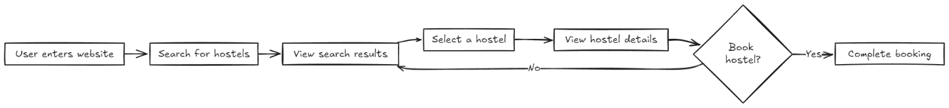
- Control – Flow Diagrams
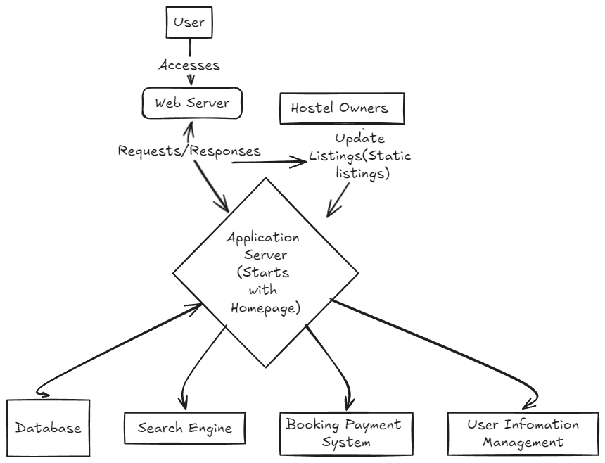

3.2 Module Description:
Overview and Detailed Functionality of each Module:
- User Authentication Module:
  - Purpose: This module allows users to register and log in to their accounts securely.
  - Features:
    - Users can create accounts using email or social media profiles.
    - Password recovery and reset functionalities are available.
    - Ensures user data security through encryption and secure sessions.
- Search Module:
  - Purpose: Enables users to search for hostels based on their preferences and requirements.
  - Features:
    - Offers customizable search filters, including budget, location, amenities, and rental duration.
    - Displays real-time results based on user inputs.
    - Allows sorting and pagination of search results for easy navigation.
- Listing Module:
  - Purpose: Provides detailed information about each hostel available on the platform.
  - Features:
    - Displays hostel descriptions, photos, pricing, availability, and user reviews.
    - Includes a comparison feature to allow users to evaluate multiple hostels side by side.
    - Users can directly book from this module, initiating the payment process.
- Payment Module:
  - Purpose: Handles secure transactions for hostel bookings.
  - Features:
    - Integrates with Stripe for secure payment processing.
    - Allows users to make bookings, process payments, and manage payment cancellations.
    - Sends confirmation emails to users after successful transactions.
- User Reviews and Rating Module:
  - Purpose: Collects and displays user feedback on hostels.
  - Features:
    - Users can submit reviews and rate their experiences after staying at a hostel.
    - Displays average ratings and feedback on the hostel listing pages.
    - Encourages transparency and helps future users make informed decisions.
- AI Chatbot Module:
  - Purpose: Provides instant assistance to users for queries related to hostels and the booking process.
  - Features:
    - Utilizes a decision-tree algorithm to guide users through their questions and concerns.
    - Can assist with search queries, booking issues, and general information about hostels.
- Community and Networking Module:
  - Purpose: Facilitates community engagement and networking among users.
  - Features:
    - Lists community events, workshops, and networking opportunities relevant to students and job seekers & allow users to sign-up for events.
3.3 Screenshots & Functionality Overview:
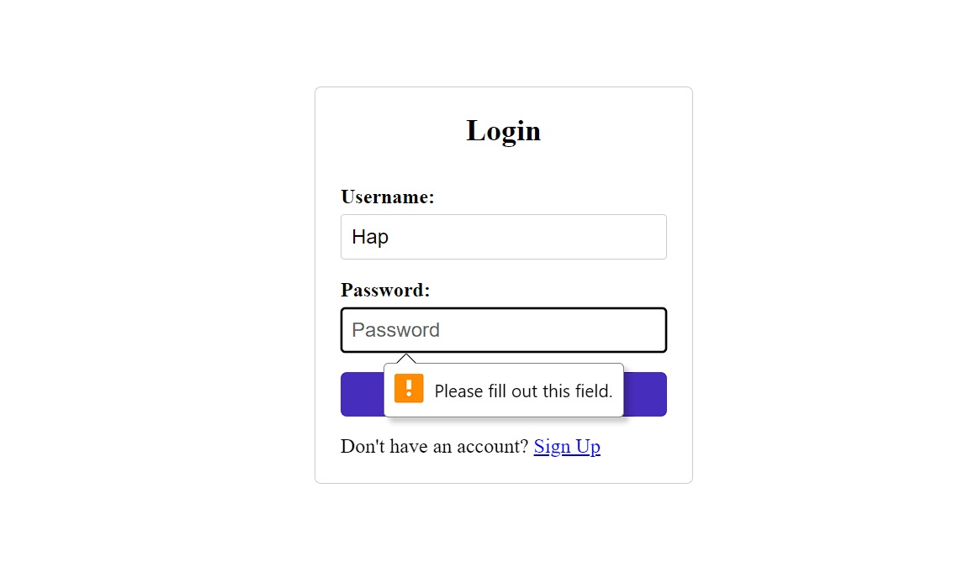
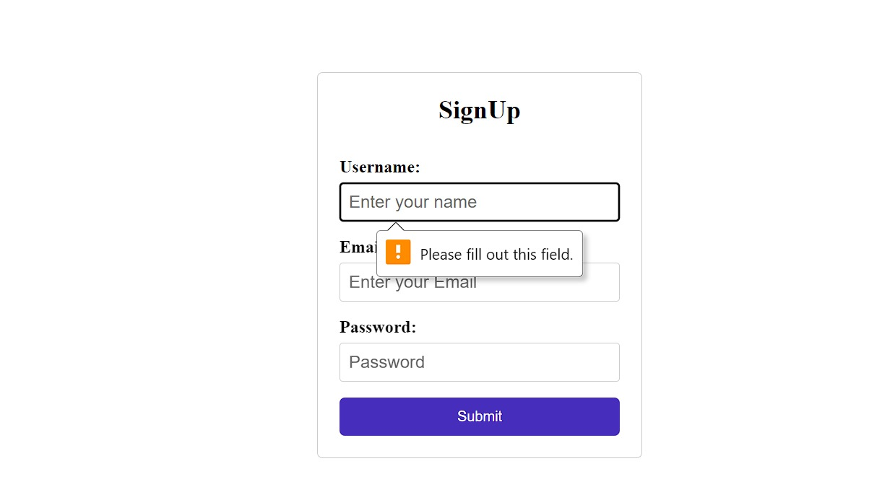
Sign Up/Login Page:

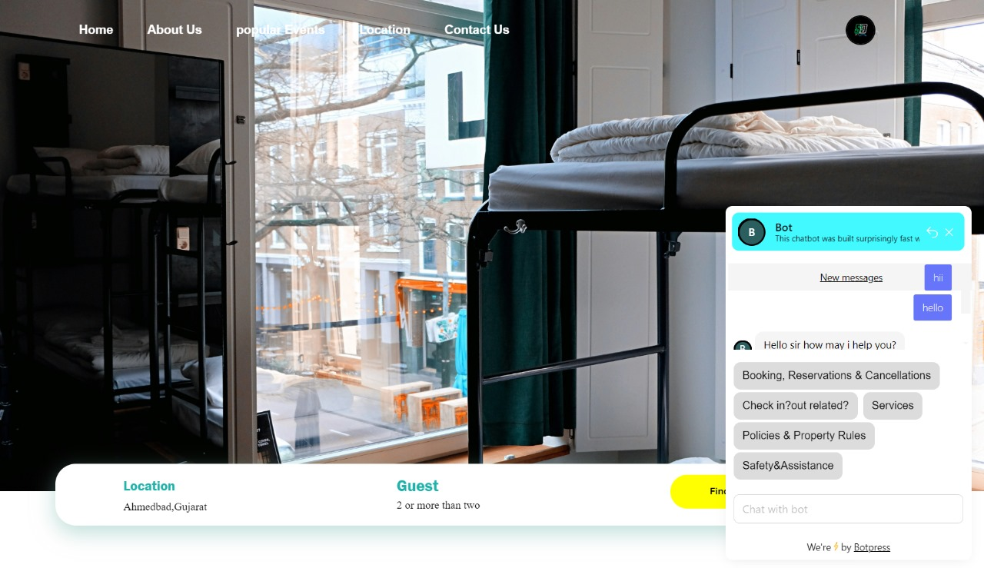
Homepage and FAQ Bot:
Particular Hostel Interface:
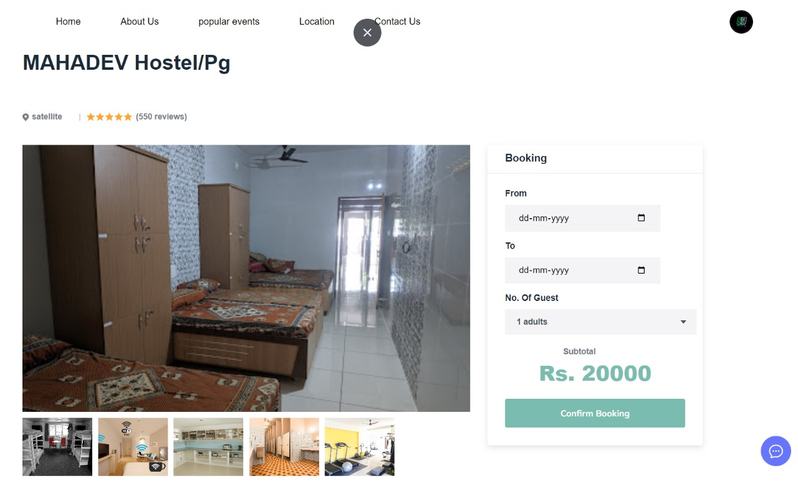

Hostel Listings Page:

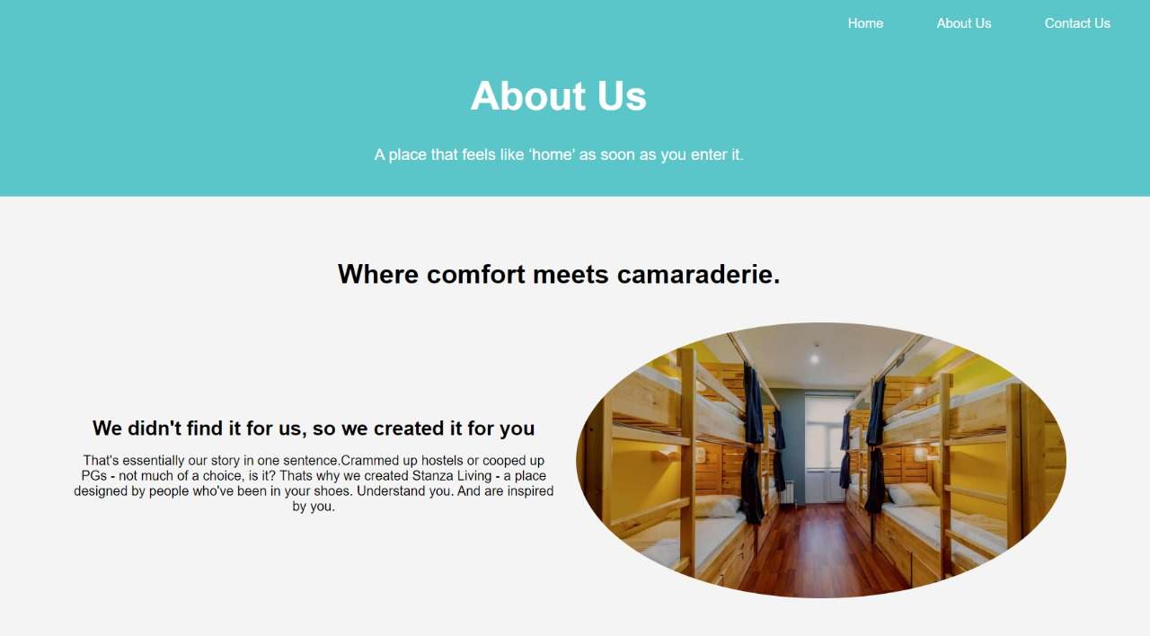
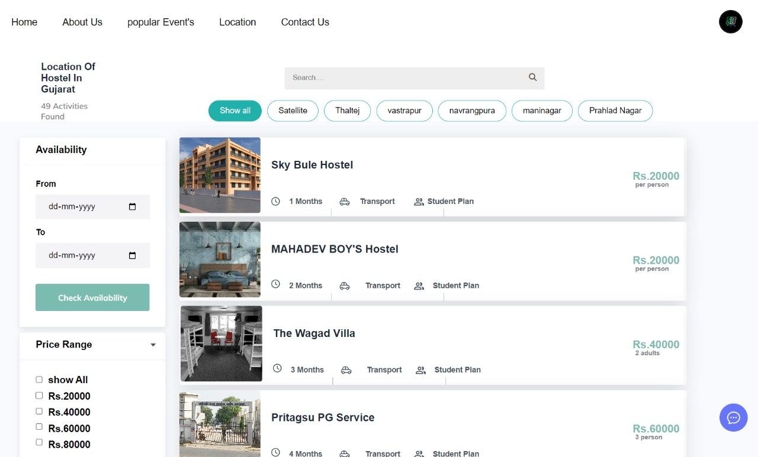
About Us Page:

Payment Interface:

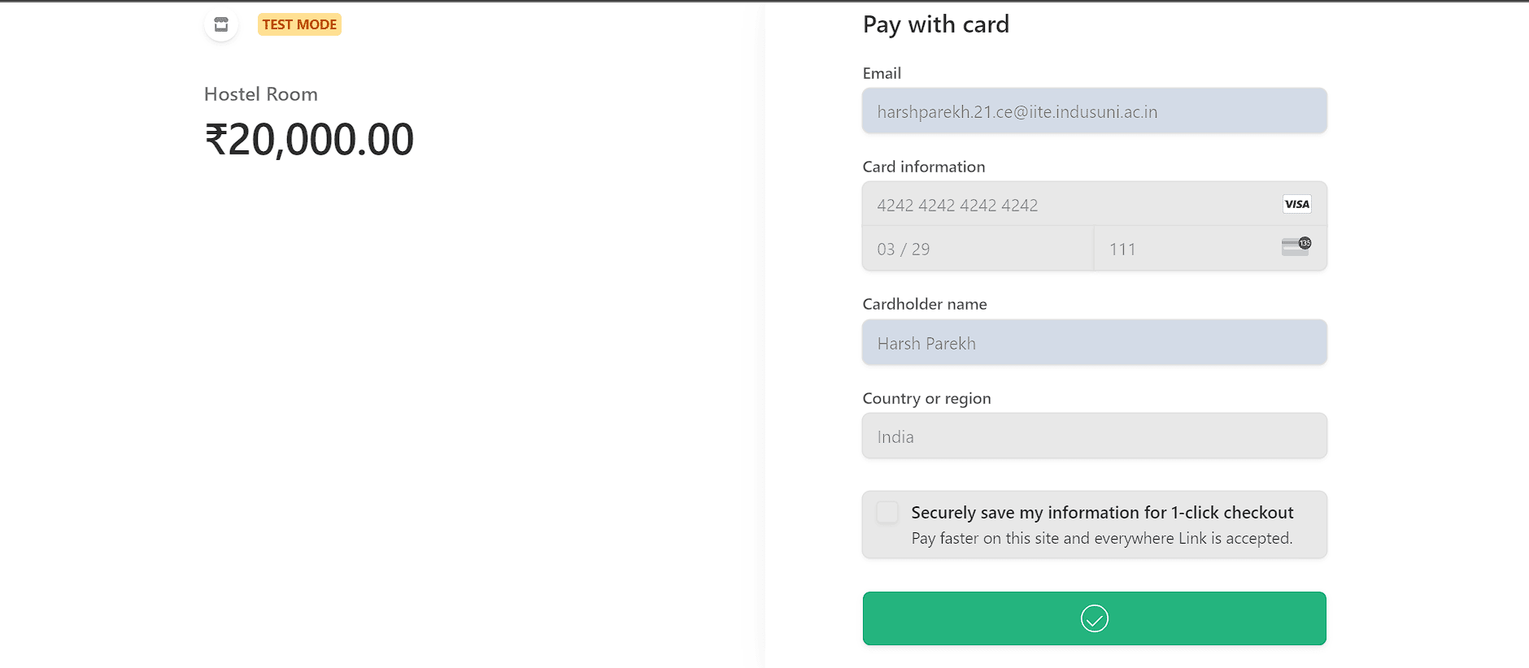
Review Page:
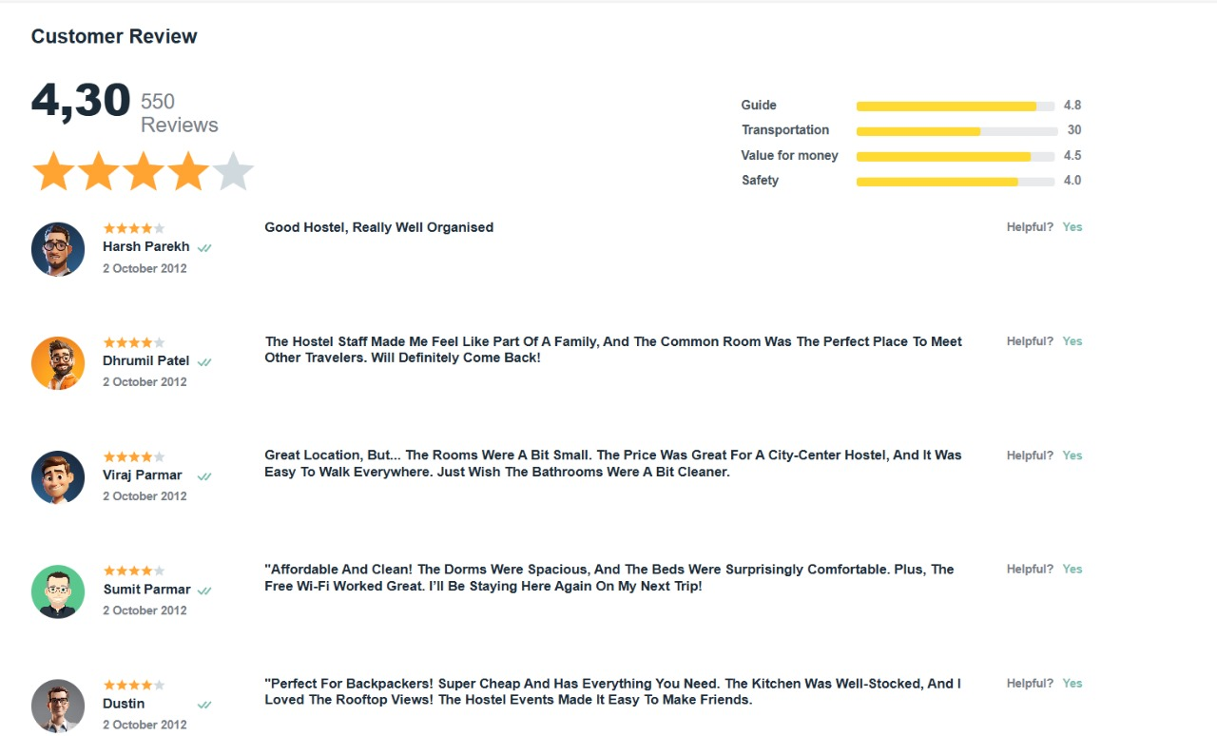

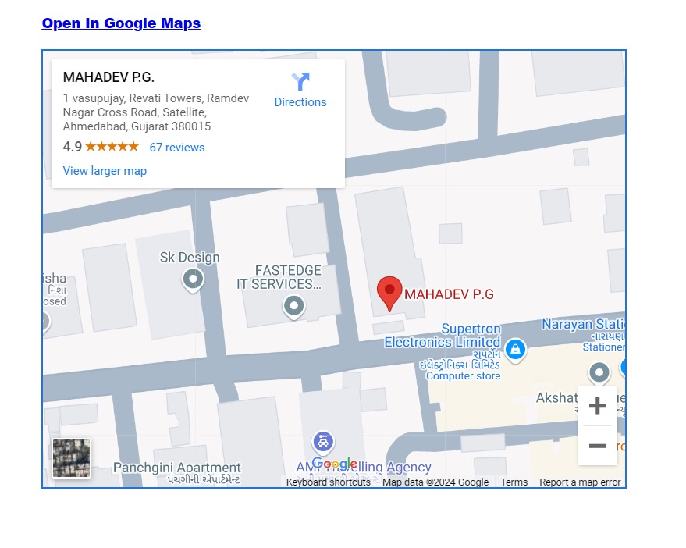
Map Location Layout in every hostel:

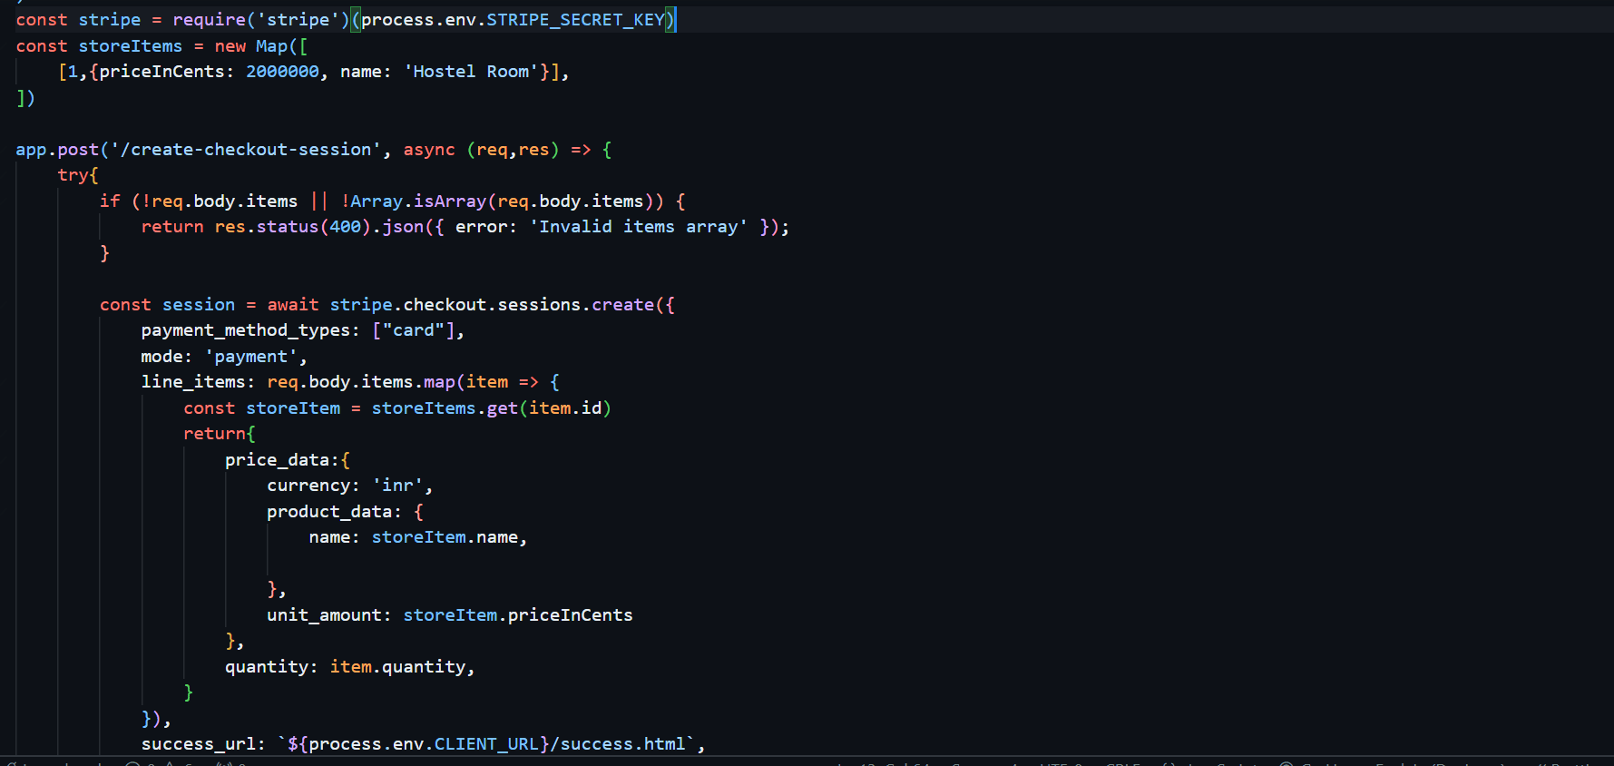
3.4 Results and analysis:
Code Snippet of Payment Integration:
• Create a Stripe Account:
- Sign up for a Stripe account and obtain API keys (publishable key and secret key) for integration.
• Install Stripe SDK:
- Include the Stripe library in the Niwas Saathi application, either through a CDN or by installing it via npm.
• Set Up Payment Form:
- Create a secure payment form in the front-end where users can enter their payment details (credit/debit card information).
• Tokenize Payment Information:
- Use Stripe.js to tokenize the payment information entered by the user, creating a secure token that represents their payment details without storing sensitive information.
• Send Token to Server:
- After tokenization, send the generated token to the server via an API call for processing.
• Process Payment on Server:
- Use the Stripe secret key on the server to create a charge using the token received. Handle success and error responses accordingly.

• Confirm Payment:
- Upon successful payment, send a confirmation response back to the front-end to notify the user of a successful booking.
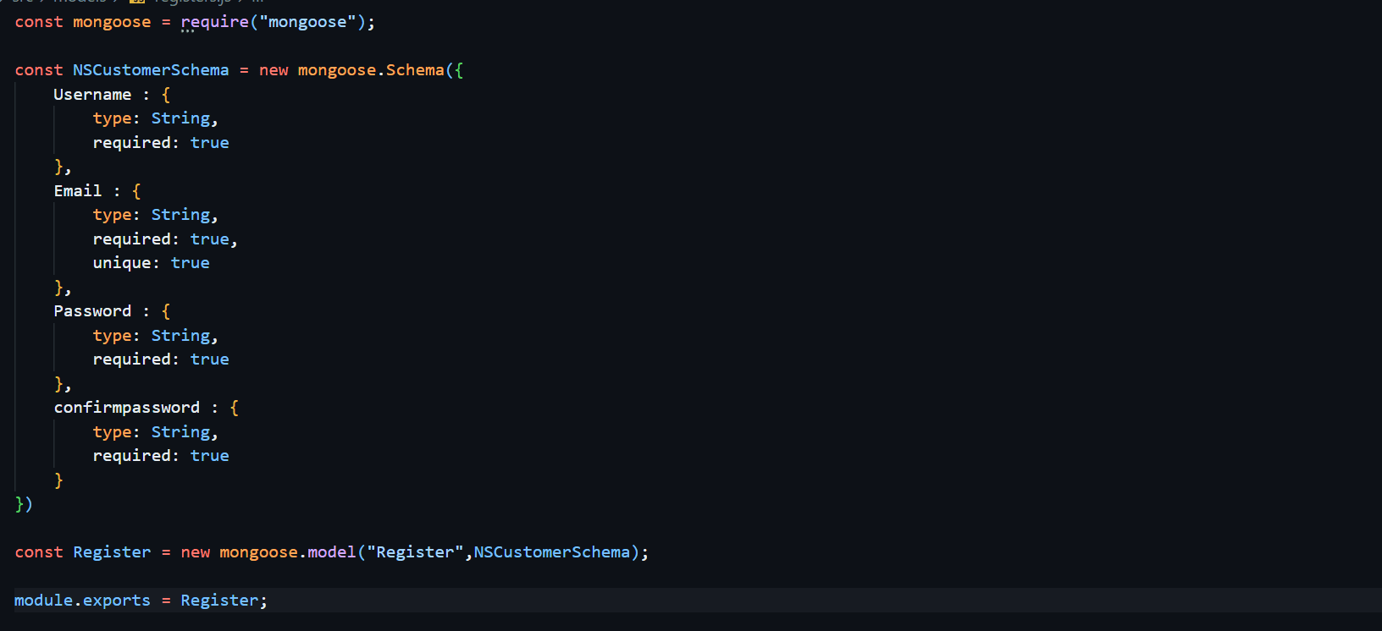
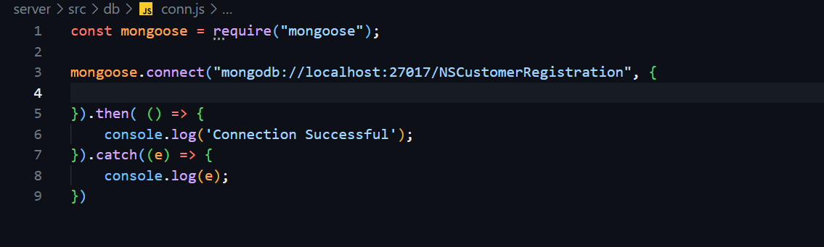
Code Snippet of MongoDB Setup:

• Install MongoDB:
- Download and install MongoDB on your server or use a cloud service like MongoDB Atlas for easier management.
• Create a Database:
- Use the MongoDB shell or a GUI tool (like MongoDB Compass) to create a new database for Niwas Saathi, e.g., Niwas Saathi.
• Define Collections:
- Create collections within the database for storing different types of data:
  - Username & password: To store user information (name, email, password hash, etc.).

• Schema Design:
- Define the schema for each collection to ensure data consistency and validation. You can use libraries like Mongoose for schema definition in Node.js.
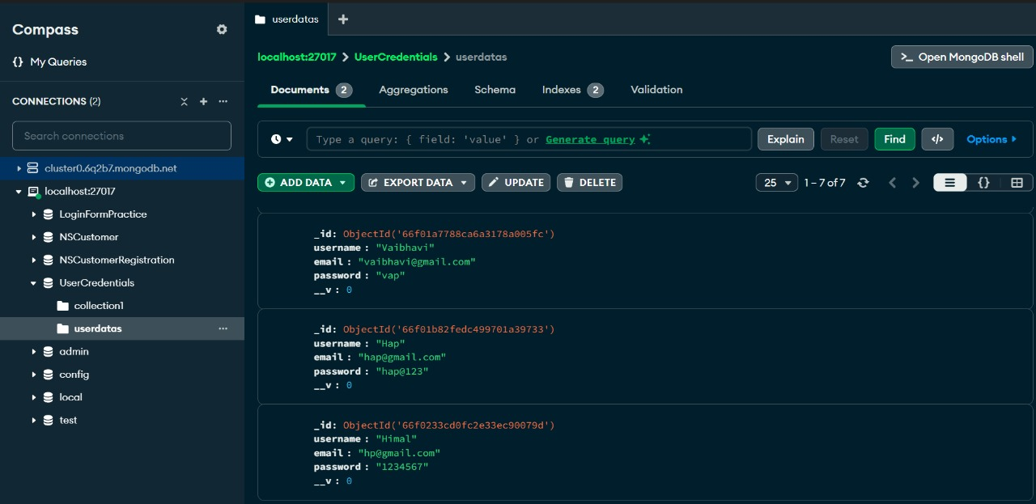
Screenshots of MongoDB and Bot Interface:
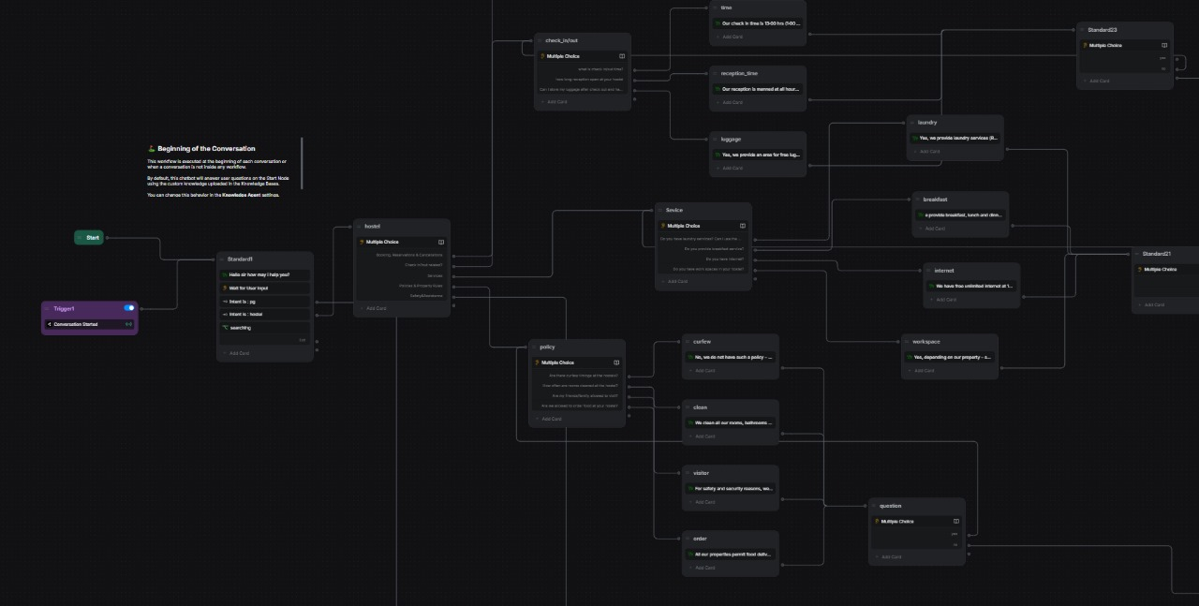

LIMITATIONS

4.1 Limitations:
• Geographical Limitations:
- Currently, Niwas Saathi may focus on specific regions or cities, limiting access for users seeking accommodations in less covered areas.
• User Base Dependency:
- The platform's effectiveness relies heavily on user-generated content (reviews and listings). A low user base may result in insufficient data for informed decision-making.
• Payment Processing Delays:
- Potential delays in payment processing or issues with payment gateways like Stripe may cause user frustration and affect bookings.
• Limited Language Support:
- The platform may only support a few languages, which could exclude non-native speakers and reduce accessibility for diverse user groups.
• Lack of Offline Access:
- Users must have internet access to use the platform, which could be a limitation for those in areas with poor connectivity

CONCLUSION

5.1 Conclusion:
Niwas Saathi emerges as a comprehensive solution to the persistent challenges faced by students and job seekers in their search for affordable and reliable hostel accommodations. By addressing critical gaps in existing platforms—such as poor user experience, lack of verified listings, and insufficient customization—Niwas Saathi is poised to redefine the way users find housing. The platform's user-friendly interface, personalized search filters, and emphasis on transparency provide a seamless experience, ensuring users can easily locate and secure suitable accommodations.
The integration of cutting-edge technology, including a robust back-end powered by Node.js and a dynamic front-end utilizing HTML and CSS, enhances the platform's performance and reliability. By leveraging MongoDB for data management and Stripe for secure payment processing, Niwas Saathi not only guarantees data integrity but also prioritizes user security during transactions. The incorporation of an AI-based chatbot further enriches user interaction, providing instant support for queries and improving overall engagement.
As Niwas Saathi continues to evolve, its commitment to user satisfaction will drive ongoing enhancements, such as geographical expansion, multilingual support, and advanced filtering options. These initiatives aim to make the platform even more accessible and user-centric, catering to the diverse needs of its audience. Additionally, fostering community engagement through events and networking opportunities positions Niwas Saathi as more than just a hostel-finding service; it becomes a hub for connection and collaboration among students and job seekers.
In conclusion, Niwas Saathi is not just a project; it represents a vision for a more efficient and user-friendly approach to finding accommodation. By harnessing technology and focusing on user needs, Niwas Saathi stands out as a reliable partner for individuals navigating the complexities of hostel living. As the platform grows and adapts to the changing landscape of student accommodation, it promises to provide invaluable support and guidance, ultimately helping users feel at home wherever they may be.

