The update includes:
- ocean depth data show:click the depth data chart toggle button: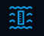, and then left click on the globe, ended with right click , like the distance measure, it will show a depth chart along the polyline:
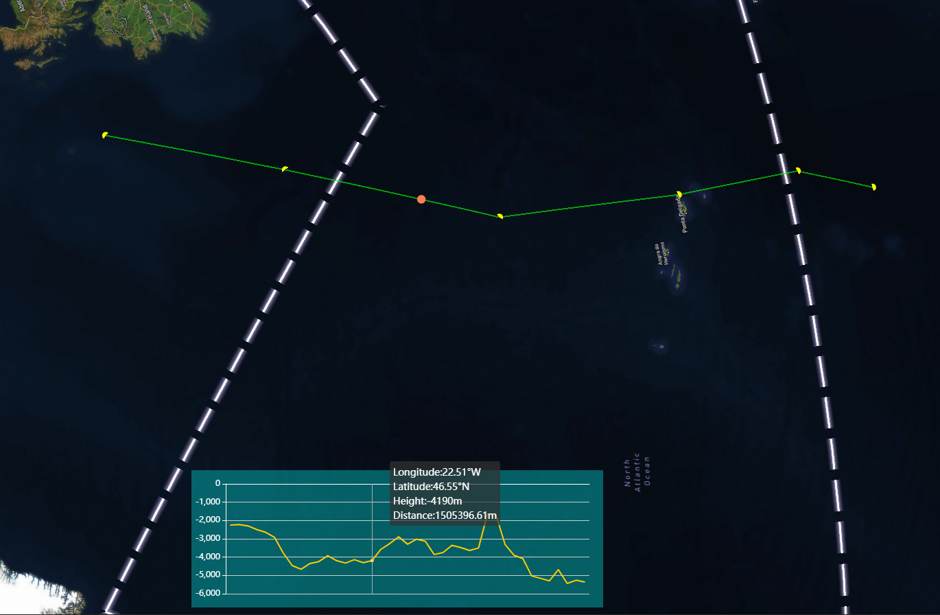
- Ocean water material add: The toggle button is 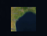
- Undersea feature name WMS imagery show:The toggle button is 
- World bathymetric WMS imagery show: The toggle button is 