## 实验报告

**example1.py代码如下：**

#Information Of You  
import turtle, datetime  
def drawGap():   
 turtle.penup()  
 turtle.fd(5)  
def drawLine(draw):  
 drawGap()  
 turtle.pendown() if draw else turtle.penup()  
 turtle.fd(40)  
 drawGap()  
 turtle.right(90)  
def drawDigit(d):  
 drawLine(True) if d in [2,3,4,5,6,8,9] else drawLine(False)  
 drawLine(True) if d in [0,1,3,4,5,6,7,8,9] else drawLine(False)  
 drawLine(True) if d in [0,2,3,5,6,8,9] else drawLine(False)  
 drawLine(True) if d in [0,2,6,8] else drawLine(False)  
 turtle.left(90)  
 drawLine(True) if d in [0,4,5,6,8,9] else drawLine(False)  
 drawLine(True) if d in [0,2,3,5,6,7,8,9] else drawLine(False)  
 drawLine(True) if d in [0,1,2,3,4,7,8,9] else drawLine(False)  
 turtle.left(180)  
 turtle.penup()  
 turtle.fd(20)  
def drawDate(date):  
 turtle.pencolor("red")  
 for i in date:  
 if i == '-':  
 turtle.write('年',font=("Arial", 18, "normal"))  
 turtle.pencolor("green")  
 turtle.fd(40)  
 elif i == '=':  
 turtle.write('月',font=("Arial", 18, "normal"))  
 turtle.pencolor("blue")  
 turtle.fd(40)  
 elif i == '+':  
 turtle.write('日',font=("Arial", 18, "normal"))  
 else:  
 drawDigit(eval(i))  
def main():  
 turtle.setup(800, 350, 200, 200)  
 turtle.penup()  
 turtle.fd(-350)  
 turtle.pensize(5)  
 drawDate(datetime.datetime.now().strftime('%Y-%m=%d+'))  
 turtle.hideturtle()  
 turtle.done()  
main()

**执行结果如下：**

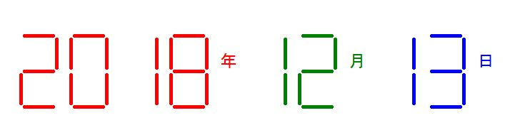

**example2.py代码如下：**

#Information Of You  
import turtle, time  
def drawGap():   
 turtle.penup()  
 turtle.fd(5)  
def drawLine(draw):   
 drawGap()  
 turtle.pendown() if draw else turtle.penup()  
 turtle.fd(40)  
 drawGap()  
 turtle.right(90)  
def drawDigit(d):  
 drawLine(True) if d in [2,3,4,5,6,8,9] else drawLine(False)  
 drawLine(True) if d in [0,1,3,4,5,6,7,8,9] else drawLine(False)  
 drawLine(True) if d in [0,2,3,5,6,8,9] else drawLine(False)  
 drawLine(True) if d in [0,2,6,8] else drawLine(False)  
 turtle.left(90)  
 drawLine(True) if d in [0,4,5,6,8,9] else drawLine(False)  
 drawLine(True) if d in [0,2,3,5,6,7,8,9] else drawLine(False)  
 drawLine(True) if d in [0,1,2,3,4,7,8,9] else drawLine(False)  
 turtle.left(180)  
 turtle.penup()  
 turtle.fd(20)  
def drawDate(date):  
 turtle.pencolor("red")  
 for i in date:  
 if i == '-':  
 turtle.write('时',font=("Arial", 18, "normal"))  
 turtle.pencolor("green")  
 turtle.fd(40)  
 elif i == '=':  
 turtle.write('分',font=("Arial", 18, "normal"))  
 turtle.pencolor("blue")  
 turtle.fd(40)  
 elif i == '+':  
 turtle.write('秒',font=("Arial", 18, "normal"))  
 else:  
 drawDigit(eval(i))  
def main():  
 turtle.setup(800, 350, 200, 200)  
 turtle.penup()  
 turtle.fd(-350)  
 turtle.pensize(5)  
 drawDate(time.strftime("%H-%M=%S+",time.localtime()))  
 turtle.hideturtle()  
 turtle.done()  
main()

**执行结果如下：**

