This Playbook will focus steps required to use  **google-cloud-storage** API client library to programmatically on-board files to Google Cloud Storage (GCS location)

**Prerequisites:**

1.Python version should be higher than 3

2.Make sure to download Python client library for Google Cloud Storage (GCS)

(pip install --upgrade google-cloud-storage )

3.Existing GCP project access.

4.Service account and json key for authentication.

**How to create Service Account and download the Json key for authentication ?**

Service accounts are used by applications to make authorized APIs calls on the Google Cloud Platform(GCP).

**Login to GCP Console Page:**

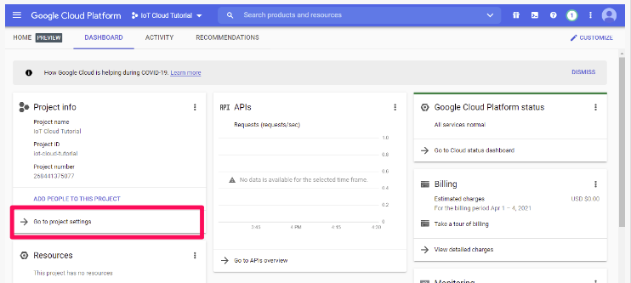

**Create the service account:**



## Select the newly created service account and Crete key:

## 

## Download the Key:

## 

## Place this Json key in local and while initializing give this path as below

## os.environ["GOOGLE_APPLICATION_CREDENTIALS"]=r"C:\Users\Sidharth.chhotaray\Downloads\service_key.json"

## Now run below command to execute the Python utility script.

## python GCS_Data_ingestion.py "happiest_health_bucket" "APItest/epfo.pdf" "C:\Users\Sidharth.chhotaray\Downloads\epfo.pdf"

## It will accept 3 parameters.

## 1st parameter should be GCP Bucket name without gs://

## example : "happiest_health_bucket"

## 2nd parameter should be Target GCP Bucket name along with filename without gs://

## example : "APItest/epfo.pdf"

## 3rd parameter should be Local file names and path thats needs to be uploaded

## example "C:\Users\Sidharth.chhotaray\Downloads\epfo.pdf"

## Once it’s completed log will show the file name and uploaded gcs bucket location.