Task 3:What other test scenarios would you create to test the “Create Talent” and Edit talent details functions of this website? Describe what inputs you would test for and the expected outputs.

Test scenarios:
- Verify if there is a ‘Cancel’ button available to erase the entered text.
- Verify the login page and all its controls in different browsers
- Verify responsiveness
- Verify if a user cannot enter the characters more than the specified range in each field (Username and Password).
Verify name is mandatory or not
5.Enter the value as blank spaces on mandatory fields and click on Submit button
6.Enter the value as Special Character & Numbers on mandatory field and click on Submit button (a. 12345, b. /--+-, c. 12354/--+-)
7.Check Data type(s) for required field
8.Enter value as "a to Z" and check the character length and click on Submit button
9.Check tab validation is working or not
10.Check mouse hover functionality
11.Check spelling and Grammar in Confirmation message
12.Verify that the user can enter a date manually on the date following the date format.
13. Email address - invalid format, wrong email address
14.Save form with all blank fields
15.Save form with blank/unselected required fields
16. Save form with invalid values
17.Navigate forward, backward, refresh

Task 4:
In what other ways would you recommend this website be tested so that users are happy with this application and user data remains secure?
- Check LogIn Page with Tab Key.User should be able to use tab to navigate on the LogIn page.LOG IN button should be highlighted so that user can know that tab is now on LogIn button.
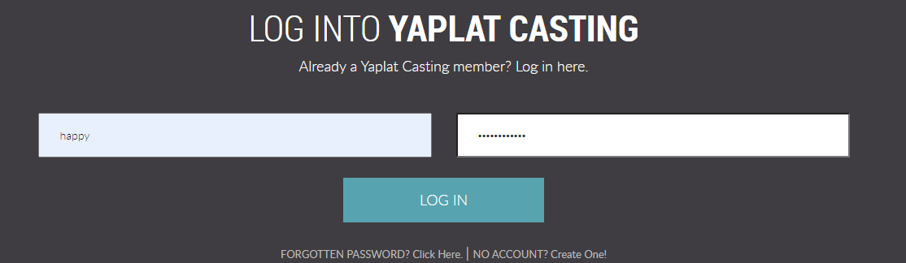

2. Please refer below screenshot, sometimes validations are not working properly as First Name and Last Name has accepted numbers.

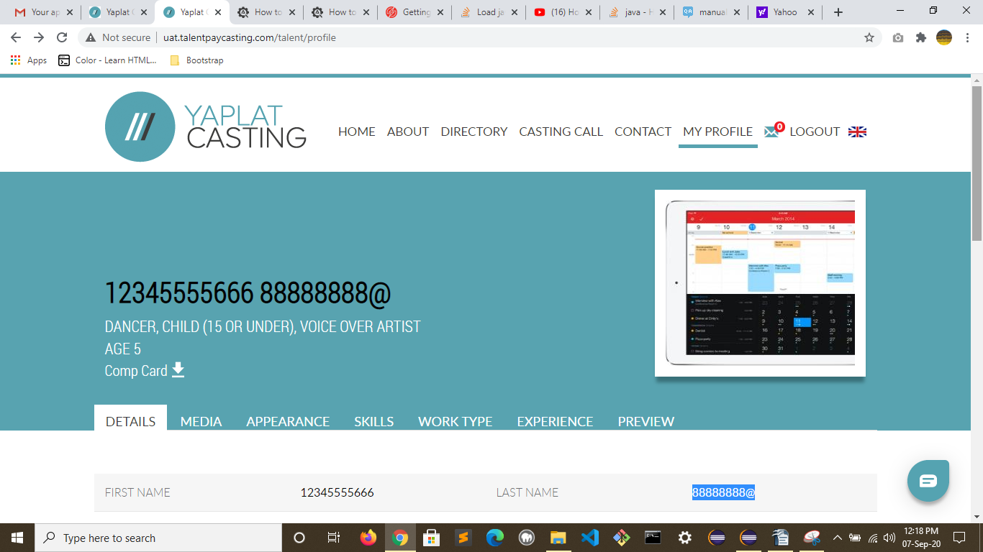

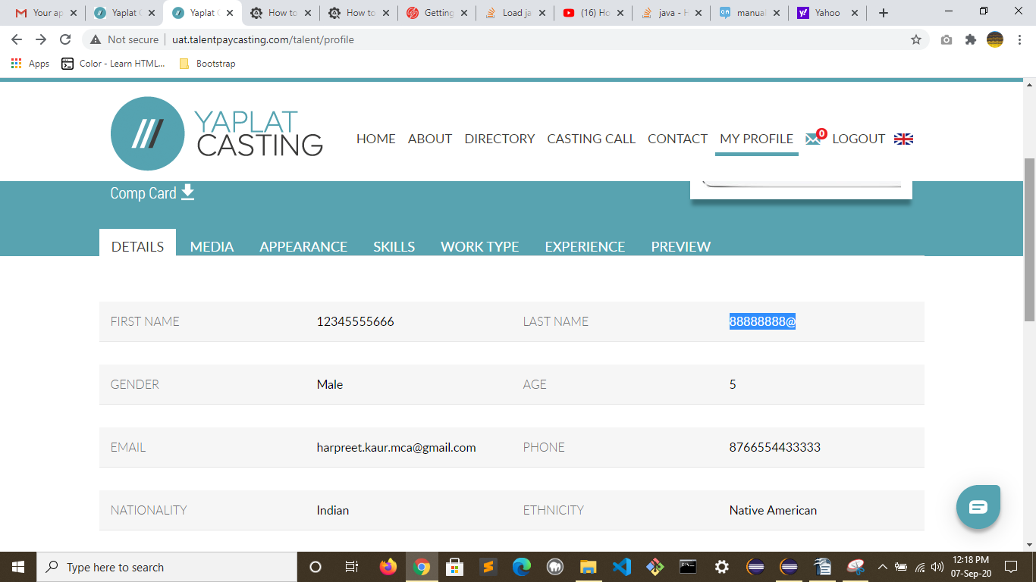

3. On Step 6 of 6 ,CLIENT/BRAND/TITLE is mandatory field, but there is no asterisk(*) ,that user knows this is mandatory to fill.
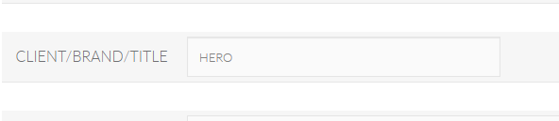
4. No check on the phone Number field, user can enter any number of digits.

5. If someone don't have passport, Expiry Date field should be disabled.Please refer below:

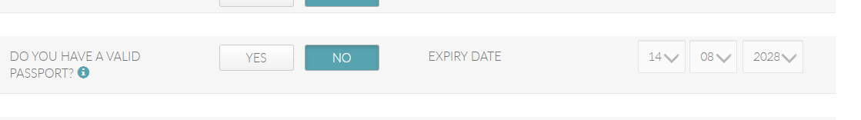
6. Not even a single mandatory field but there is message that “Fields marked with asterisk (*)are mandatory”.Please refer below screenshot:

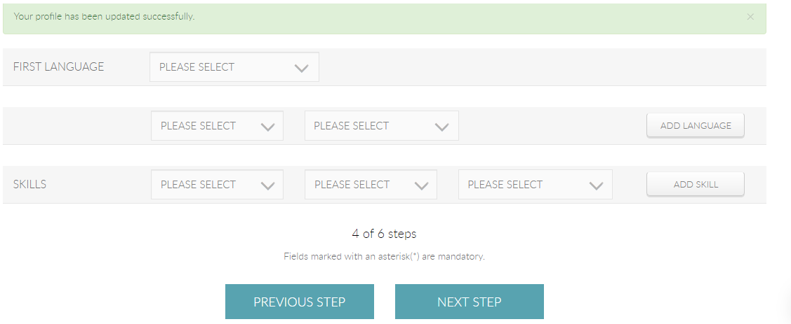
7. When user edit profile on any step, there should be an update button so that user don't need to go for all 6 steps to update his/her profile. Whenever clicked on previous step button ,there is message that ”Your profile has been updated successfully”.Please refer above screenshot.

8.There should be some limit on selecting the worktype .Please refer the below screenshot.

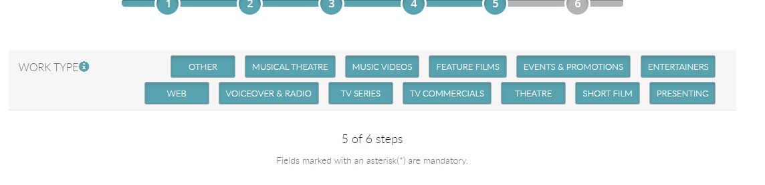

Task 5:
Create a screen capture video which shows your scripts from Task 1 and 2 running, give audio commentary if you wish. Create some documentation instructing other testers how to run your automated test scripts from scratch. This would include installation instructions on the libraries and frameworks your tests are dependent on.

Project: I have used Selenium Maven Project In Eclipse IDE for automation Testing.
Following is the structure of the project:

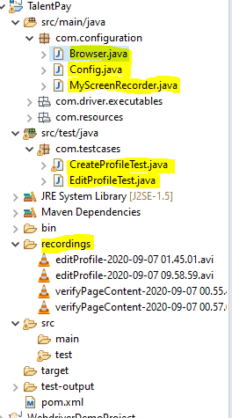
There are three configuration files created in src/main/java
Browser.java to set chrome or Firefox browser.
Config.java is the properties file.
MyScreenRecorder.java This utility can be used to create AVI/Mp4 recording files for your test case execution, which can be shared to developers while logging the bugs.

There are two test files created in src/test/java

CreateProfileTest.java for Creating an automated test script to create a new talent profile .
EditProfileTest.java for Editing the newly created talent profile using an automated script.

Framework: TestNG is the testing framework used.

Libraries: Following dependencies are added in pom.xml .

<dependency>
<groupId>org.seleniumhq.selenium</groupId>
<artifactId>selenium-java</artifactId>
<version>3.141.59</version>
</dependency>

<dependency>
<groupId>org.testng</groupId>
<artifactId>testng</artifactId>
<version>6.14.3</version>
<scope>test</scope>
</dependency>

Recordings: I have used Monte Screen Recorder, a Java library that assist me in creating the video captures of Selenium tests. There is recordings folder in project structure where you can find videos of tests running.(Refer above screenshot) .I have used following dependency for Monte Screen Recorder:

<!-- https://mvnrepository.com/artifact/com.github.stephenc.monte/monte-screen-recorder -->
<dependency>
<groupId>com.github.stephenc.monte</groupId>
<artifactId>monte-screen-recorder</artifactId>
<version>0.7.7.0</version>
</dependency>

To play videos,right click the video and open with the appropriate video player. It works fine with VLC media player.

To run testcases Right click on CreateProfileTest.java ->Run As->TestNG Test.
Similary Right click on EditProfileTest.java->Run As->TestNG Test.

