Task – 1 Repository Setup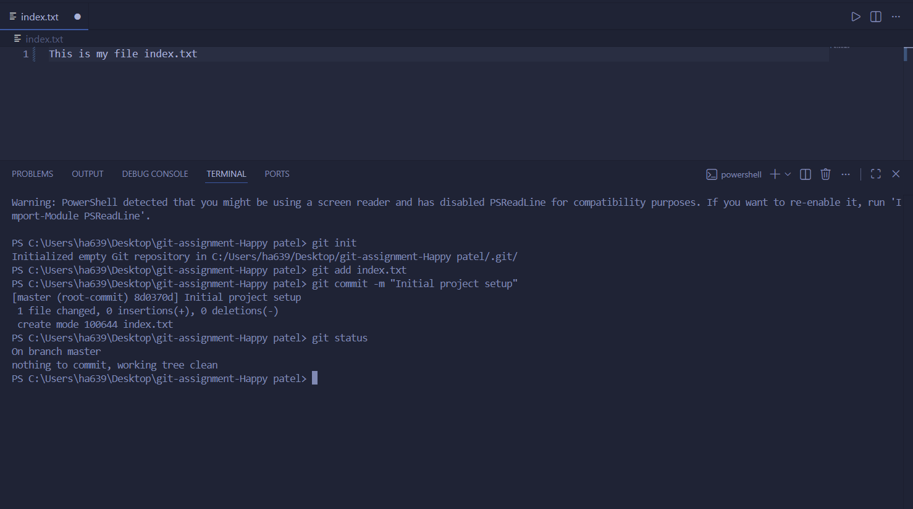

Task – 2 Branch Creation & Work
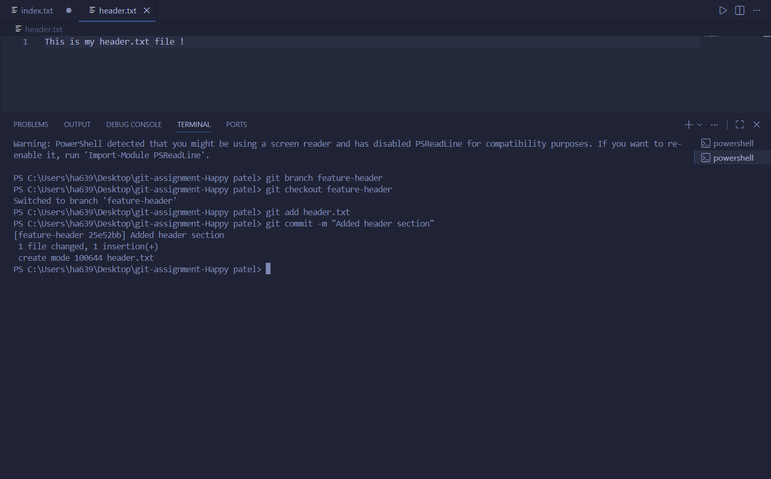

Task – 3 Branch Switching Observation

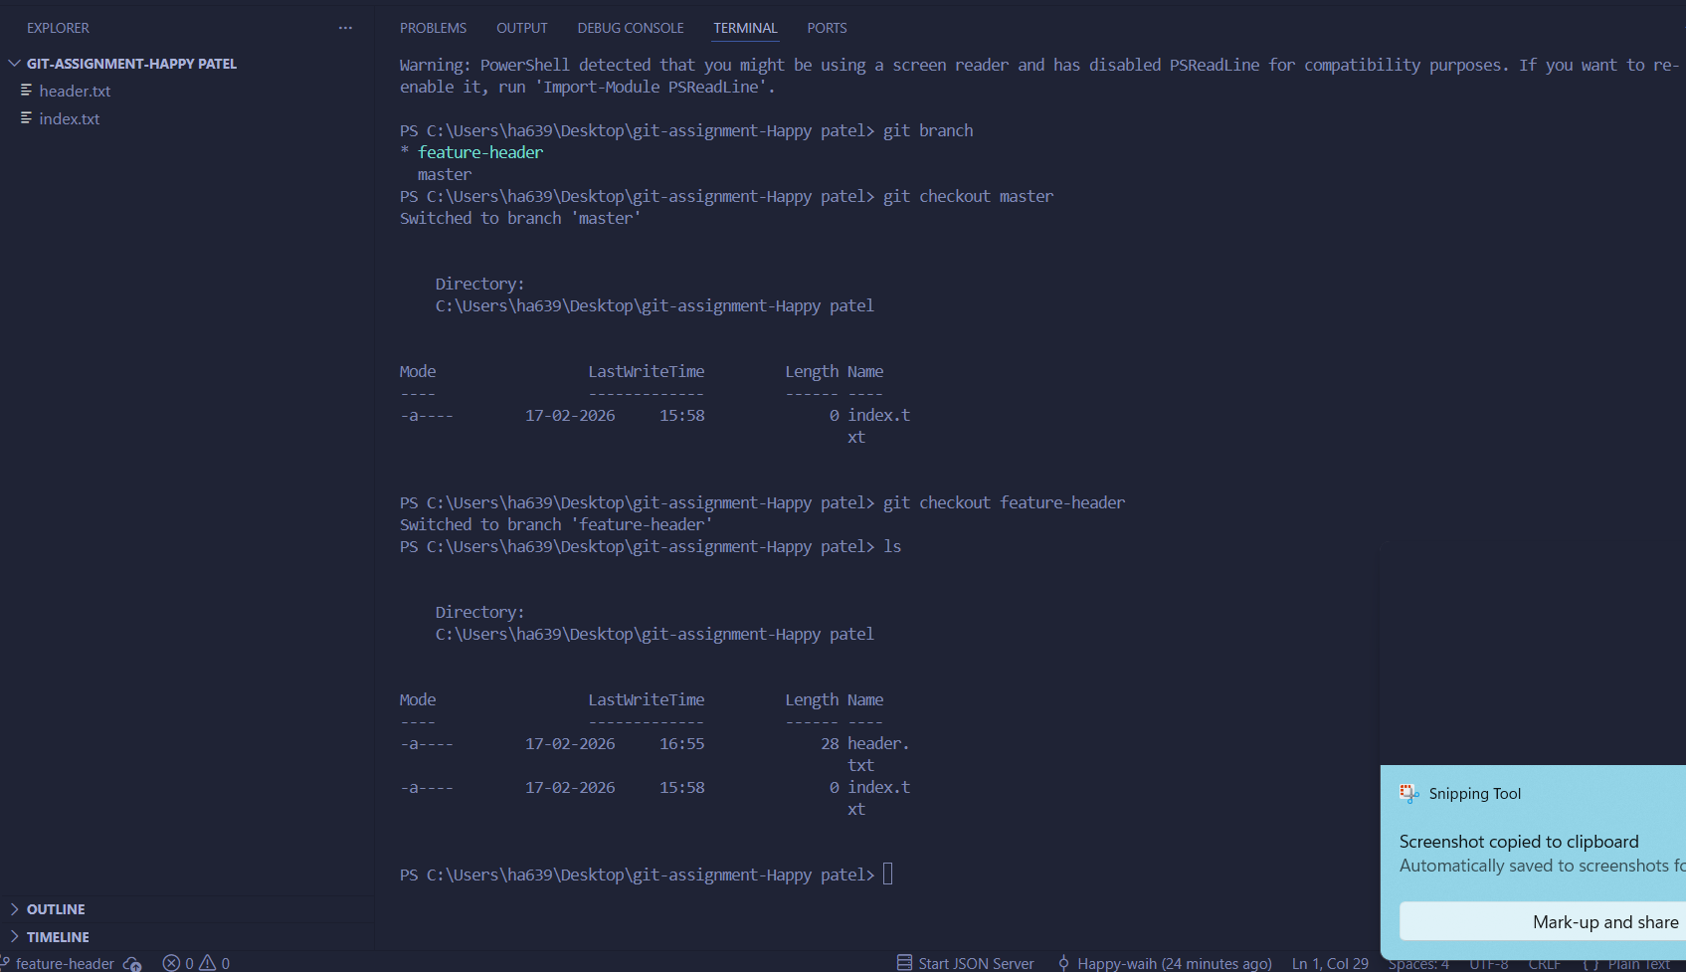

Task – 4 Undo a Mistake
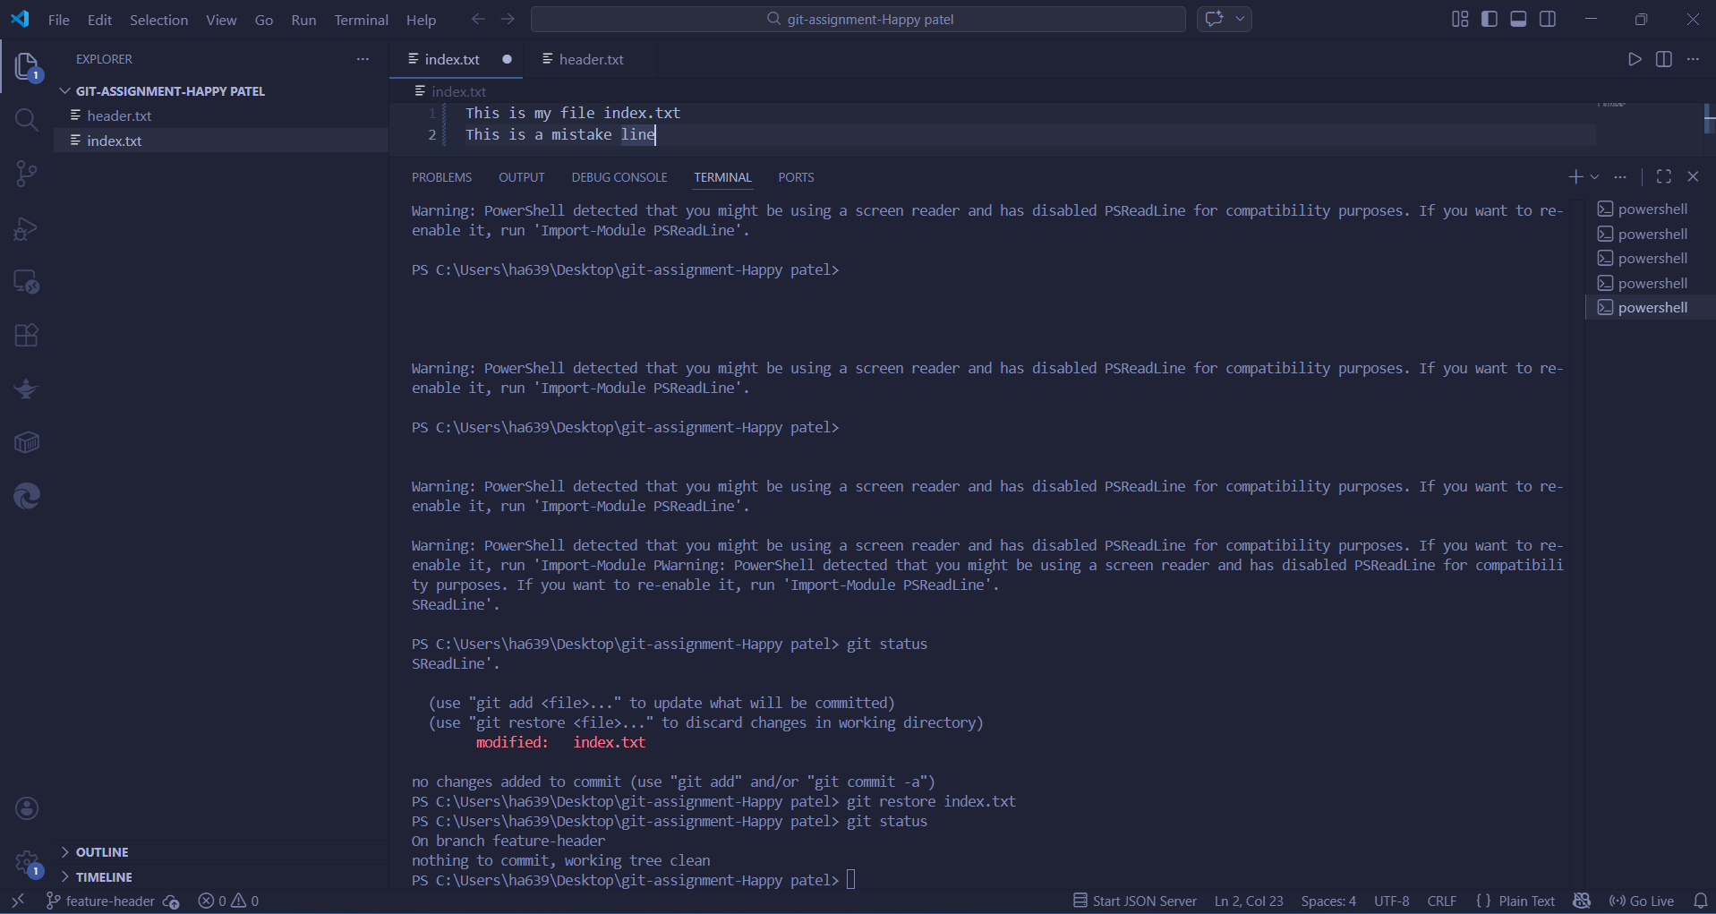

Task – 5 Merge Feature Branch

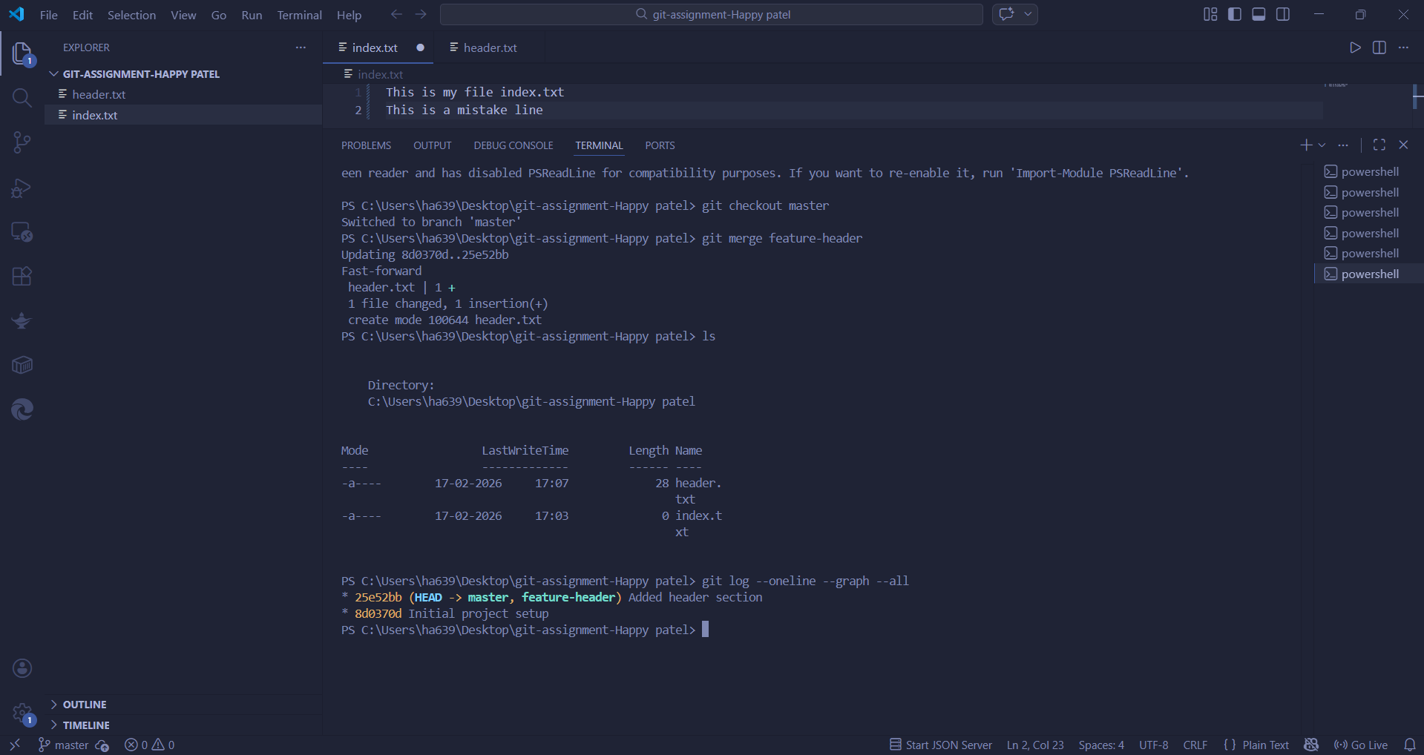

Task – 6 Checkout a Commit (Detached HEAD)

