Wolf/Dog Locomotion

One step is 11 keyframes

1. One side of feet will move 1.5 units forward

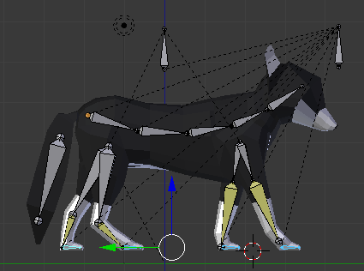

1. Move all limbs forward 3 units at the last step keyframe (11)

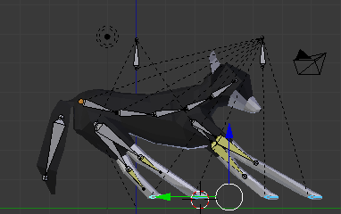

1. Move to frame 6. Move the feet up 1.5 blender units

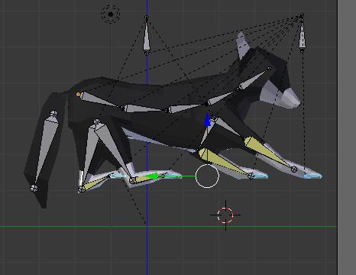

1. Set the feet to rotate around individual origins to stop them rotating around the median point
2. Set frame number to 6.Rotate feet around Y 15 degrees.

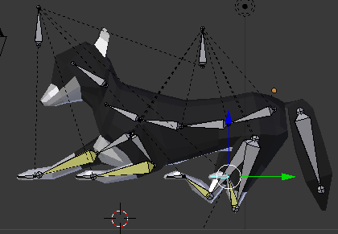

1. Set frame number to 9 Rotate feet around Y -25

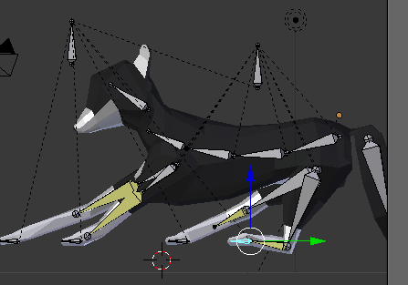

1. Frame 1. Move the body bone down by 0.5 blender units

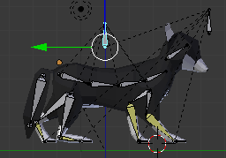

1. At the last frame of the walk cycle (11). Move the body bone forward by 3 units
2. Open Animation Layout
3. Change body bone movement Interpolation type to Linear
4. Move frames for front left foot forward by 2 frames
5. Move frames for back right foot forward by 12 frames

