**Modern Web Technologies – Lab 4:**

**Lab 4: Using MongoDB and MongoSH for a laptop store.**

For this lab, I just want you to practice making queries with mongoSH. Think about your shopping apps (amazon, bestbuy, etzy), what do they filter through.

**I have posted a json file you can upload to compass inside the same Lab 4 area**

Here is the document structure:

{

"brand": "Dell",

"model": "XPS 13",

"processor": "Intel Core i7",

"ram": "16GB",

"storage": "512GB SSD",

"price": 1299.99,

"stock": 10

},

Here is a list of queries I want you to try:

* Comparison queries **[Complete 4 of 6]**
  + Find laptops with the price equal to $999.99.

* + Find laptops with prices not equal to $1299.99.

* + Find laptops with a price greater than $1500.

* + Find laptops with a price greater than or equal to $1399.99.

* + Find laptops with a price less than $1000.

* + Find laptops with a price less than or equal to $1099.99.

* Logical queries **[Complete 3 of 4]**
  + Find laptops with a price less than $1000 OR with a stock greater than 10.

* + Find laptops with a price less than $1000 AND with a stock greater than 10.

* + Find laptops with a price NOT equal to $999.99.

$ne is no longer supported by Mongodb compass that is why it gives error instead we can use $nor

* + Find laptops with a price NOT equal to $999.99 NOR with stock NOT equal to 8.

The query displays no results, it means there is no data in the collection that matches the specified conditions for the prompt.

* Element operators: **[Complete 2 of 2]**
  + Find laptops with the "description" field using **exists**.

The query displays no results, it means there is no data in the collection that matches the specified conditions for the prompt.

* + Find laptops with the "reviews" field missing.
    - Hint: $exist, you can use 0 and 1 or true and false

* Array operators: **[Complete 2 of 2]**
  + Find laptops with a genre of "Gaming" in their genres array.

The query displays no results, it means there is no data in the collection that matches the specified conditions for the prompt.

* + Find laptops with the genre "Business" using $in.

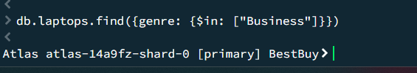

The query displays no results, it means there is no data in the collection that matches the specified conditions for the prompt.

* Text Search Operators: **[Complete 1 of 1]**
  + Perform a text search for laptops with the word "performance".
    - Hint: use the $text tag and the $search tag

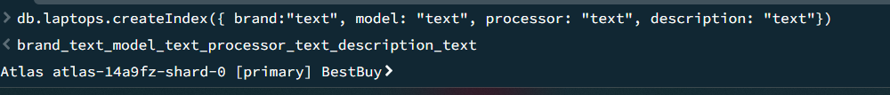

The query displays no results, it means there is no data in the collection that matches the specified conditions for the prompt.

* Array Update Operators: **[Complete 1 of 1]**
  + Add a new review to a laptop with a specific title.
    - (e.g., "Laptop Title", review: user: John Doe, rating: 4)

* + - Hint: use the update command and the $push to append a new field of data
    - The review is an array holding the fields user and rating.

