**UnknownEntity GDD**

**Theme**: High-fantasy, generic knights, swords and shields with the potential for more original enemies and biomes, ex: the [Silithid](https://wow.gamepedia.com/Silithid) from WoW which are insect looking enemies of initially unknown origin which gives interesting avenues to explore, they could’ve come from a meteor ([Starship trooper bugs](https://starshiptroopers.fandom.com/wiki/Arachnid)), created by the fallout of a massive magical accident (nuclear bomb, magical radiation), an old god sleeping deep underground could be producing them as meaninglessly as skin flakes, etc.

**Art:** Low resolution pixel art with minimal amounts of animations.

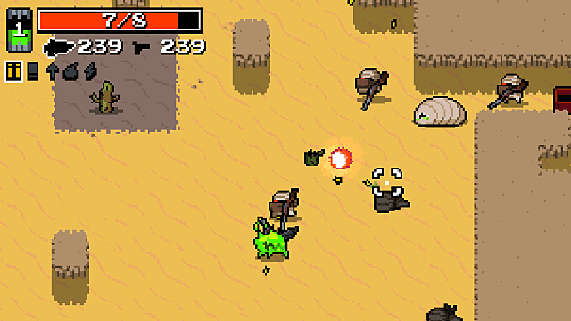

^ [Nuclear Throne](https://store.steampowered.com/app/242680/Nuclear_Throne/), good inspiration for simple pixel art and very small amount of animations.

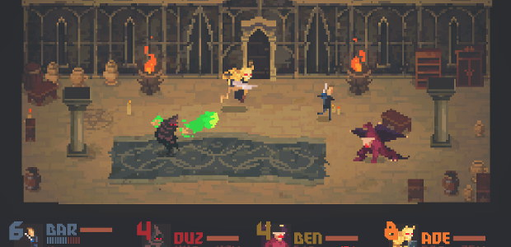

^ [Crawl](https://store.steampowered.com/app/293780/Crawl/), very good references for everything from the pixel art to the animations.

**Biomes**: A more general term for the different areas the player will encounter, they differ in thematic, generic ex: snow, lava, forest, etc. Most of the enemies encountered should be specific to the **biome**, but a generic type for ex: skeleton may exist in a forest and dungeon biome.

**Level design:** Separated into “**rooms**” which don’t necessarily mean interior, rectangular, standard rooms. The rooms would be semi-procedurally put together; enemies are spawned together in predetermined groups to make sure a balance is struck, ex: two shield skeletons and a mage, three wolfs and a rune master, etc. the enemy groups vary in difficulty based on monster combination, room layout, individual monster strength, etc. The rooms themselves will vary in size, larger outside areas to tight dungeon corridors.

**Enemies:** A balance of simpler more traditional RPG enemies which require little in the way of tactical thinking to beat to enemies with strong strength–weakness relation. Meaning simpler enemies can be taken on in many ways with little impact; deal damage to them, avoid their attacks. Enemies with stronger strength-weakness relation or “**tactical**” enemies will require the player to adjust his gameplay and combat approach in order to kill the enemies without sustaining too much damage, these enemies can have varying degrees complexity; skeleton with a large shield, while its shield is raised it walks slowly but takes greatly reduced damage (potentially from specific directions) once he attacks he has a slow backswing animation giving the player time to deal significant damage to it before it raises its shield again, an animated armor variant of the large shield enemy could also push back the player stunning him very briefly if he gets too close adding a layer of complexity largely based on the room space; harder in a corridor specially if ranged enemies are behind it. A more tactical enemy; a mage spawns spires which gradually build up charges in the mage until he releases it into a powerful attack, the player can chose to destroy the spire stopping the charge at the cost of sustaining attacks from other enemies, attempt to kill the mage before the charge is complete, kill other enemies and attempt to avoid the powerful attack, the room could also greatly affect the difficulty based on its size, openness, cover.

**Map:** The map displays the player’s progression and the biome for coming levels. It will also give the player options for which path to choose from, showing the player rewards he can expect in the levels.

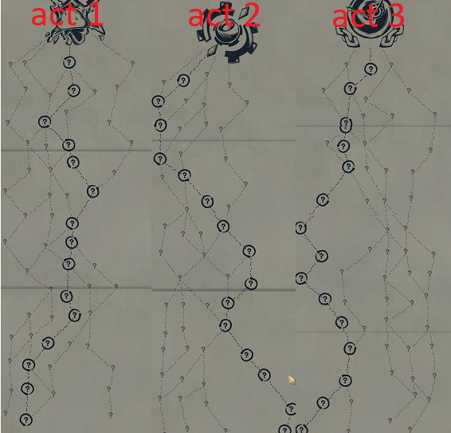

^ Randomly generated paths from the game: [Slay The Spire](https://store.steampowered.com/app/646570/Slay_the_Spire/).

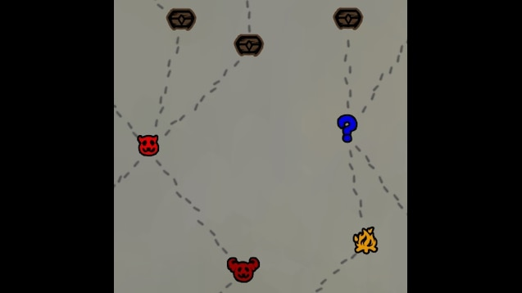

^ The map nodes with exposed information. Depending on the icon it means the player is guaranteed to encounter a boss, find a chest, a rest area, etc.

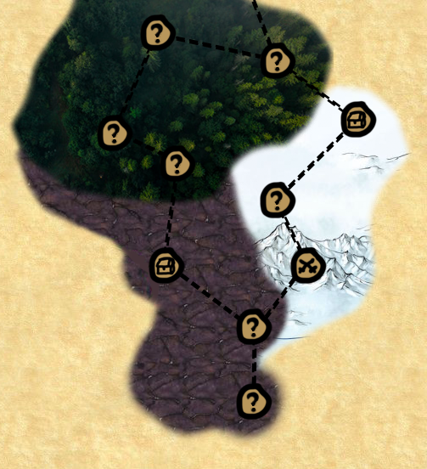

^ Example of a map with nodes and biomes.

*Weather, random weather systems move through the map changing the levels. Hidden switches in the levels that let you change the orientation of the wind, letting you decide where the forecast will head to. Certain forecasts in certain biomes and levels could unlock rarer secrets, rare weapons, etc. Ex: Storm on a boss that uses a sword, lightning hits the sword and electrifies it, now instead of dropping a sword he drops a lightning sword. In a storm weather lightning could strike randomly in the level, probably avoiding the player but stunning and possibly damaging enemies. If the player is low on health there could be a 0.001 change that if a lightning strike is about to hit it hits the enemy nearest to the player, if it occurs the chance is lowered even more for the rest of the run.

**Short Term Goals:** By studying his needs and wants the player decides which path he wants to take based on what the levels contain. Ex: The player only has one weapon set, so he decides to take the path that will lead him to a mini-boss whom drops a weapon.

**Final Goal:** Kill the last boss.

**Consequences of death:** Death occurs when the player’s life reaches 0. Every death gives the player a scar based on his cause of death. Ex: player dies from a fireball gets the scar: 3rd degree burn, healing received is reduced by 20%. Upon dying the player will be put back on the map at the node prior to the one he died in, thus if he was at a fork he may chose a different level or path. If the player kills the monster that killed him he will obtain redemption, gaining the positive side of his scar ex: 3rd degree burn, healing received is reduced by 20%, the player’s attacks will cause the enemy to suffer X damage over X seconds. After accumulating X scars, the next death will end the player’s run.

**Permanent Unlocks:** When the player’s run ends, if requirements have been met he will unlock new starting options as of now, weapons which offer different initial playstyles. The only rule for the unlocks is that they are alternative ways to play or start the run thus not making the game easier.



^ A choice of weapons to start with.

**Skills Points:** When the player “levels up” he gets to pick a skill out of X skills presented to him pseudo-randomly, meaning that the pool the skills are randomly picked from is modified based on a number of factors, previous skills chosen, level, weapons, amount of scars, etc.

**Attacking:** When attacking continuously the attacks will go through a **combo** sequence. Meaning if the player attacks again within his combo grace period he will continue the combo until the last combo attack then go on cooldown. If the player does not attack during the grace period his attack will go on cooldown. Both the grace period and the cooldown start immediately after an attack so the grace period does not make the cooldown longer.

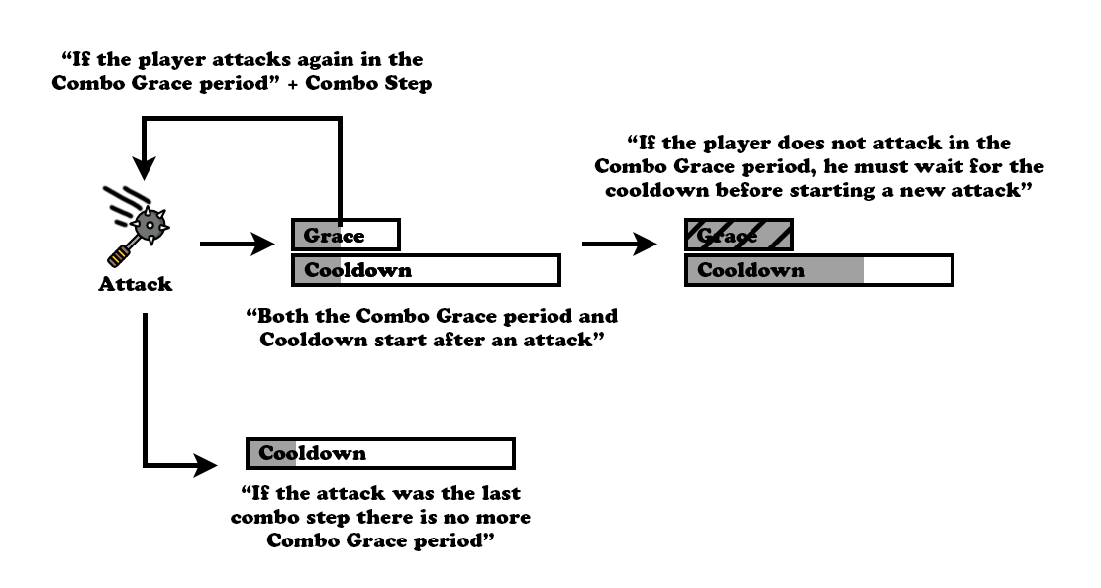

The player’s attacks all have an area of effect.

**Weapon Swapping:** The player will be able to equip two weapon sets. Swapping between the sets has a cooldown of X seconds. The player’s weapon sets do not have a shared attack cooldown, allowing the player to create an extended attack combo by switching weapon sets after an attack with a certain weapon.

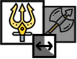

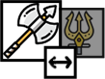

**Shrine:** The player can find shrines which give new active abilities. The abilities presented are selected from a pool dependent on the Biome the shrine is located in. This lets more experienced or researched players attempt to reduce the randomness and try to obtain certain skills.



**Health system:** Here I should describe what the health system will be like, 100 life? Hit based? Less life? (let’s say 10 and enemies hit for set amount, 1, 2 ,3). How does the player regenerate life? Health pools, potions, flasks (rechargeable on certain actions PoE style), push forward combat ALA Doom and Bloodborne where being aggressive is rewarded with a chance to regain life, maybe combo based?