ALGO Trading Platform (stage one)

1. **Subject**
2. Display backtest result as chart image generated backtest engin

Example for image.

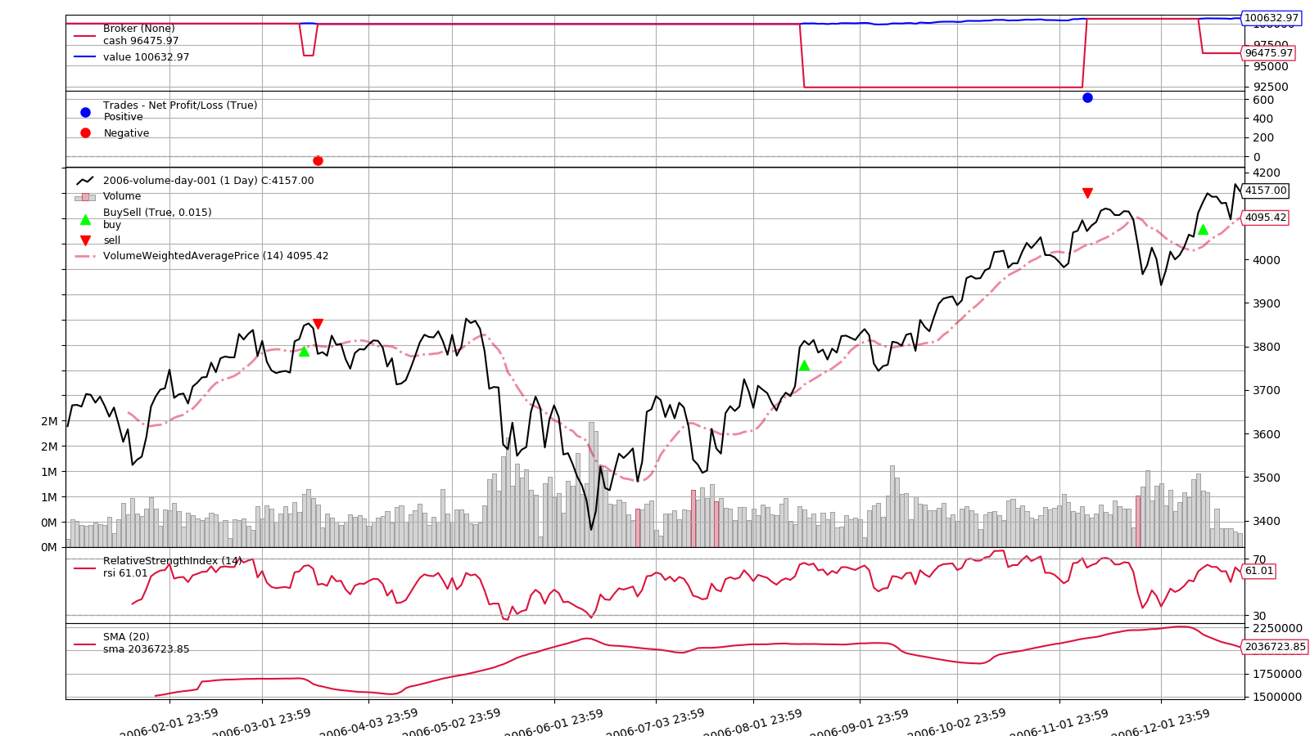

1. Edit Strategy by user
   1. Edit strategy by user with python
   2. Use Backtrader

Example for strategy : <https://www.backtrader.com/home/helloalgotrading/>

1. Backtest of strategy
2. Trading with Angel broker by a example option
3. We need login to zerodha every day manually (if possible automate)
4. Landing page /login,signup
5. **Architecture**

UI

feed

Zerodha

Strategy

Angel

1. **UI**

First stage will have only one page(Build strategy page without login/signup).

<https://www.figma.com/proto/dNjUIWGsrMuhUi017yl3Cy/AlgoTrading?node-id=4%3A119&scaling=min-zoom&page-id=1%3A35&starting-point-node-id=1%3A36>

The page will edit /backtest strategy

The page will have functions.

- Chart (select symbol and period)

- Edit strategy

- Backtest and show result

1. **Require**

UI : reactjs and PHP

Trading part : Python

1. **Timeline**

Deliver first version : within 8days

Get review : 2 weeks.

1. **Payment terms**

- 70% after first version : 2100 USD

- 30% after review : 900USD

1. **Payment options**

Payment via payonner that we will provide