Sensorless Controller for BLDC Motor

Tested with Turnigy motor on a DIY quadcopter

Characteristics:

* Current: 120A
* Voltage: 10 to 20V (3S and 4S Lipo)
* Power dissipation without heatsink : 300W

3D view of the BLDC Controller:

* Top layer :

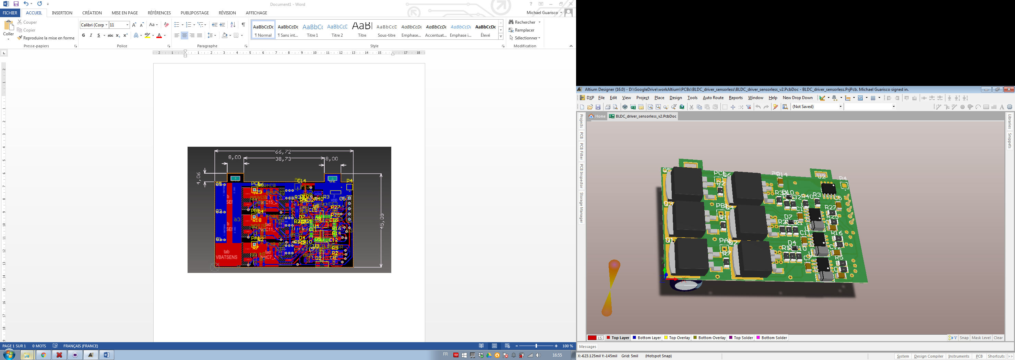

* Bottom layer :

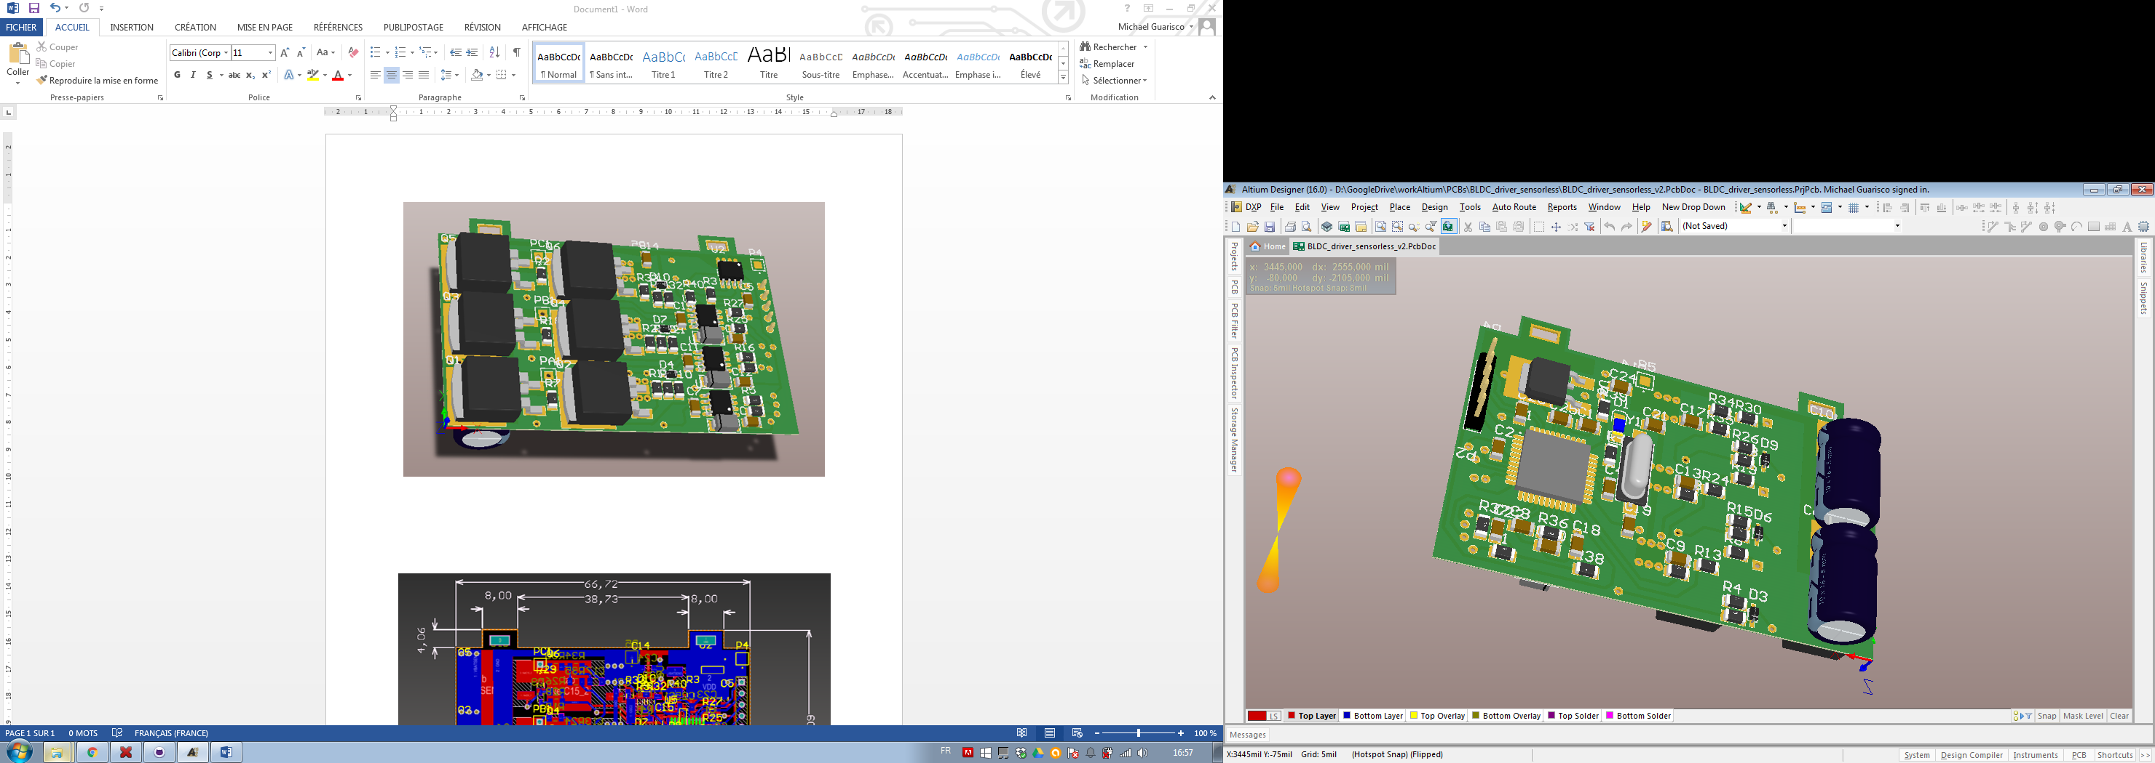

Dimensions :

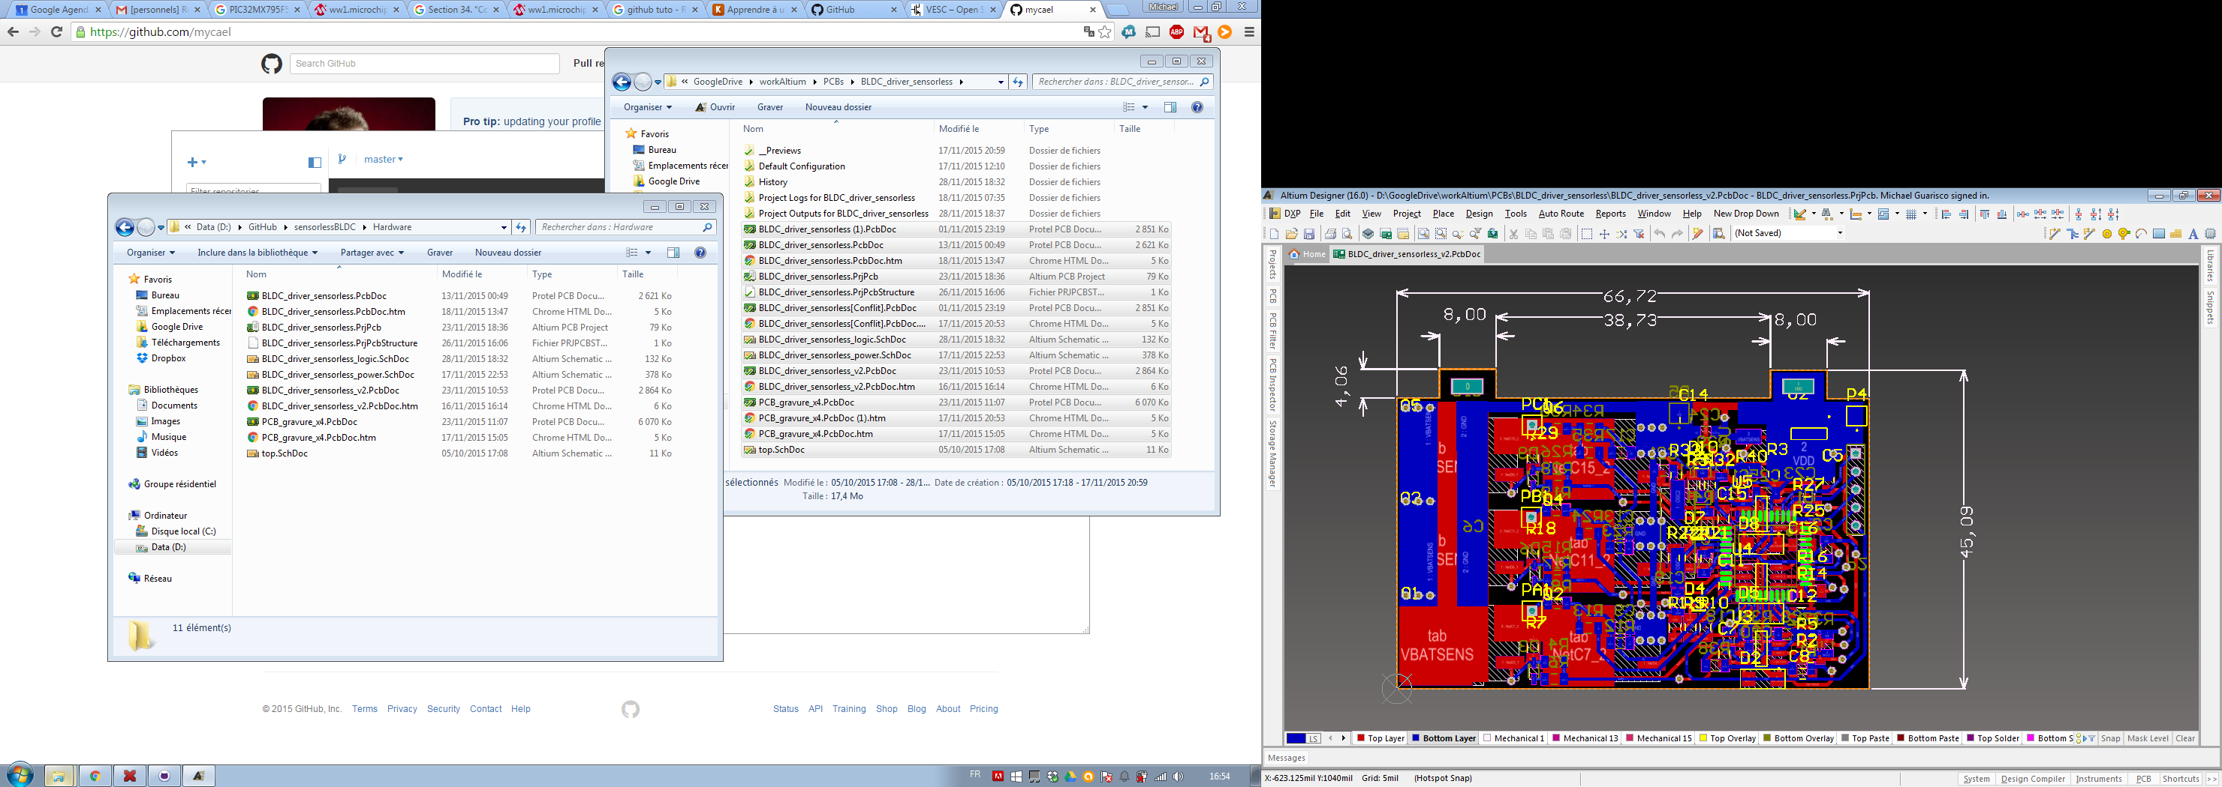

*To be completed …*