UNIVERSITY OF VIETNAM NATIONAL UNIVERSITY
UNIVERSITY OF SCIENCE


THEORY PROJECT REPORT
AUGMENTED REALITY AND ARTIFICIAL INTELLIGENT

Course: Computer Graphics
Instructors: Mr. Ly Quoc Ngoc

Team Members Infomation
Tran Hai Duc– Student ID: 23127173
Nguyen Cong Chien – Student Id: 23127331

Ho Chi Minh City, Octorber 2025
Contents
Chapter 1. Introduction 3
1. General Background 3
2. Research Motivation 5
3. Problem Statement 9
4. Contributions 11
Chapter 2. Related Works 14
1. Overview of the Studies and Techniques 14
2. Representative Studies and Techniques 16
3. Research Gaps 27
Chapter 3. Proposed Method 27
1. Part 1: Overview of the segment anything model (SAM) 27
2. Part 2: Image Encoder 29
3. Part 3: Prompt Encoder 31
4. Part 4: Mask Decoder 34
5. Construction pipeline of the SA-1B dataset 37
6. The Role of prompt in SAM training 40
7. SAM Algorithm 41
Chapter 4. Implementation and Experiments 41
Chapter 5. Conclusion and Future Work 41
Appendix 41
Refference 41
Knowledgement 41

Chapter 1. Introduction
  - General Background
The problem of segmentation based on visual prompts focuses on using user-provided visual cues—such as bounding boxes, points, or masks—to guide a segmentation model in extracting the exact region of interest from an image.
Instead of segmenting all objects automatically, the model performs targeted segmentation, driven directly by user intent.
This approach is especially useful in interactive systems, where users want precise control over which object or region should be segmented.
To better understand this problem, two key concepts need to be clarified: image segmentation and visual prompt.
Image segmentation can be viewed as classifying every pixel in an image into predefined regions or object classes. As a result, the image is divided into multiple meaningful segments, where pixels belonging to the same segment share the same label.
The goal of image segmentation is to simplify or change the representation of an image so that it becomes easier to analyze and interpret.
In semantic or instance segmentation, these segments often correspond to real-world objects or regions.
A prompt is an input provided by the user to guide a model toward a desired output. For example, when interacting with a language model such as ChatGPT, a user provides a text prompt to request specific information or actions. More detail categories of prompts will be displayed as table follow:
Table: Categories of Prompts
Prompt Category | Description | Input Form | Example Usage
Text Prompt | Uses natural language to describe the user’s intention or target. Commonly applied in language models or multimodal systems. | Text string | “Segment the person in the image”
Visual Prompt – Point | A single or multiple points placed inside or near the target object to indicate the region of interest. | 2D point coordinates | Clicking on an object to select it for segmentation
Visual Prompt – Bounding Box | A rectangular box that encloses the target object, providing spatial constraints for segmentation. | Rectangle (x, y, width, height) | Drawing a box around a car to segment it
Visual Prompt – Mask | A pixel-level annotation that explicitly defines the target region. Provides the strongest supervision. | Binary or soft mask | Refining segmentation by painting over the object
Visual Prompt – Other | Alternative visual cues such as strokes, lines, scribbles, or contours to guide segmentation. | Free-form drawing | Roughly sketching over an object
Multimodal Prompt | Combines text and visual prompts to improve clarity and precision of user intent. | Text + visual input | Bounding box + “segment the main object”
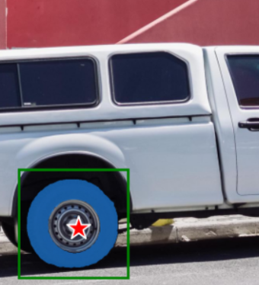
Figure 1.1.1: Example of visual prompts, a star is represented for a point, a green regtangle is illustrated for bounding box, and the blue region is showed for mask. The mask can be also considered the output of the image segmentation based on visual prompt.
In this report, the research group focuses exclusively on visual prompts for image segmentation. Text prompts and multimodal prompts are not analyzed or discussed within the scope of this study.

  - Research Motivation
    - Scientific Significant
A natural question arises: why do we need image segmentation based on visual prompts instead of conventional segmentation methods, such as semantic, instance, or panoptic segmentation^{[1]}?
In fact, these approaches address different problem settings and are both widely applied in practice.
The key difference lies in the goal, input, and computational strategy of each method.
To better understand their distinctions, Table below presents a comparison between promptable (interactive) segmentation and generic segmentation.
Table: Comparison Between Promptable Segmentation and Generic Segmentation
Aspect | Promptable Segmentation (Interactive Segmentation) | Generic Segmentation
Input | Requires a visual prompt (point, bounding box, mask, etc.) | No prompt required
Objective | Extract the exact region specified by the prompt; classify pixels into two classes (foreground / background) | Classify all pixels in the image into multiple predefined classes
Processing Scope | Operates only on the region indicated by the prompt | Processes the entire image
Output | Binary mask (true / false for each pixel) | Per-pixel class probabilities or region IDs
From the comparison above, it can be clearly observed that promptable segmentation focuses only on a specific region of interest, whereas generic segmentation must operate on the entire image.
As a result, prompt-based segmentation can significantly reduce computational cost, especially in interactive scenarios where users only need a single object or region.
A limitation of visual prompt–based segmentation is that it typically returns a binary mask rather than a full set of region IDs for all objects in the image.
However, this limitation is often acceptable in practice, as interactive segmentation can be leveraged to gradually build meaningful regions through user interaction, while still maintaining lower training and inference costs.
Impact of Large-Scale Datasets
Another major factor contributing to the prominence of visual prompt–based segmentation is the availability of large-scale datasets, most notably SA-1B^{[2]}, which contains over one billion image–mask pairs.
Such datasets make training interactive segmentation models significantly easier and more scalable.
Models like Segment Anything Model (SAM) demonstrate that, with sufficient data, it is possible to achieve strong generalization and zero-shot segmentation, allowing the model to segment unseen objects without retraining.
This greatly reduces the burden of task-specific model training and enables rapid deployment across diverse domains.
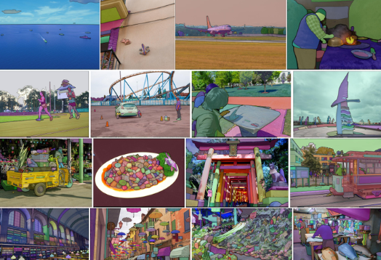
Figure 1.2.a.1: SA-1B datasets^{[2]}
Limitations
Despite these advantages, the use of extremely large datasets also leads to heavier models, increasing memory consumption and computational requirements during inference.
Therefore, while visual prompt–based segmentation offers flexibility and efficiency in interaction, it introduces new challenges in terms of model size and deployment.

    - Practical Significant
This section presents several real-world applications of image segmentation, highlighting the practicality and effectiveness of interactive (visual prompt–based) segmentation.
One of the most intuitive examples is object extraction in mobile photography. Modern smartphones, such as the iPhone, allow users to separate a person from the background using a simple finger gesture.
This interaction internally relies on image segmentation to accurately isolate the subject of interest.
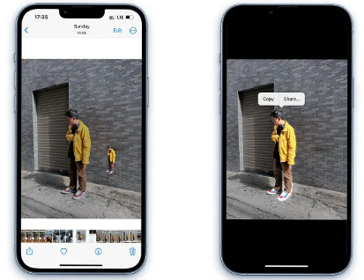
Figure 1.2.b.1: Extracting a person from an image on an iPhone.
Another important application is in the medical domain, where image segmentation is used to identify and analyze pathological regions.
For example, segmentation techniques can be applied to detect damaged or painful areas in knee images, allowing clinicians to examine affected regions in greater detail. In this scenario, users may provide visual prompts by marking areas of concern, which are then segmented for further analysis. ^{[3]}
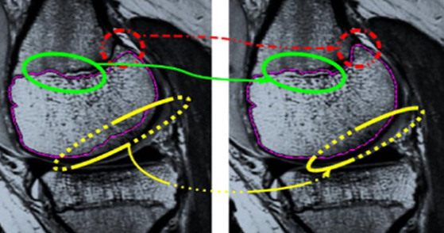
Figure 1.2.b.2: Segmentation of painful regions in knee images by user-provided visual prompts^{[3]}

Image segmentation is also widely used in robotics, particularly for guiding robot tracking and manipulation tasks.
In such systems, users provide prompts indicating target regions, and the robot uses segmentation results to understand where and how to interact with the environment. The goal is to enable the robotic arm to accurately manipulate objects or regions specified by the user ^{[4]}.
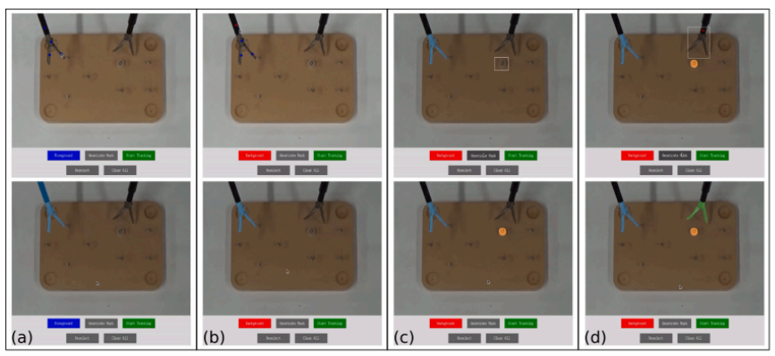
Figure 1.2.b.3: The upper row shows user prompts provided to the robot, while the lower row presents the corresponding segmentation results. The objective is for the robotic arm to interact with the highlighted target region^{[4]}.
In summary, interactive image segmentation has broad applicability across many real-world domains, including entertainment, robotics, healthcare, and beyond.
The core philosophy behind interactive segmentation is the precise extraction of regions that are important to the user, thereby enhancing human–computer interaction.
Moreover, since interactive segmentation operates only on a user-specified region of interest, it reduces computational complexity compared to methods that process the entire image.
This combination of accuracy, efficiency, and interactivity makes visual prompt–based segmentation a powerful and practical approach in modern computer vision systems.

  - Problem Statement
    - System Inputs and Outputs
Input
The input consists of two essential components:
- Image: the original image to be segmented.
- Visual prompt: user-provided visual guidance indicating the region of interest, such as points, bounding boxes, masks, or other visual cues.
Output
The output is a binary pixel-level mask, represented as an array in which each pixel takes one of two values:
- True: the pixel belongs to the target region to be segmented.
- False: the pixel does not belong to the region of interest.
    - Framework
The pipeline used for testing and model usage (inference) consists of the following steps:
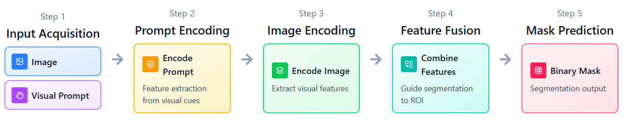
Figure 1.3.b.1: pipeline used for testing and model usage (inference)
This pipeline is commonly used in both traditional segmentation methods and deep learning–based models during inference (e.g., the predict function in trained models). It consists of the following five steps:
- Step 1 - Input acquisition: The system receives the input image along with a visual prompt provided by the user.
- Step 2 - Prompt feature extraction: The visual prompt is encoded into a feature representation using a prompt encoder.
- Step 3 - Image feature extraction: The input image is processed by an image encoder to extract visual features.
- Step 4 - Feature fusion and mask computation: Image features and prompt features are combined and compared to identify pixels or regions that are relevant to the prompt, leading to the computation of a segmentation mask.
- Step 5 - Prediction and output: The model predicts and returns the final segmentation result as a binary mask.
Training Pipeline for deep-learning approach (refer to the Segment Anything Model – SAM^{[5]})
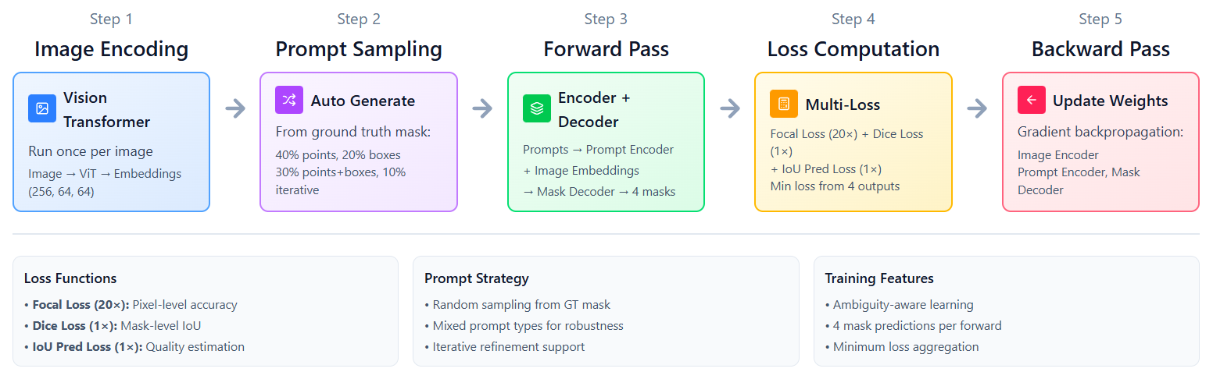
Figure 1.3.b.2: pipeline used for deep-learing training approach
For deep learning–based approaches, it is essential to consider model architecture design, training strategy, and dataset construction.
Although different models adopt different architectures and dataset generation strategies, their training pipelines generally follow the same five fundamental steps. Five-Step Training Pipeline
- Step 1 - Image Encoding: The input image is processed by an image encoder to extract high-level visual features.
- Step 2 - Label acquisition (manual or automatic): Ground-truth labels are obtained either through manual annotation or automatically generated methods.
- Step 3 - Forward pass: The extracted image features (and prompt features, if applicable) are passed through the network to produce a predicted segmentation mask.
- Step 4 - Loss computation: The predicted mask is compared with the ground-truth label using appropriate loss functions (e.g., binary cross-entropy, Dice loss).
- Step 5: Backward pass and parameter update: Gradients are computed via backpropagation, and model parameters are updated using an optimizer.

  - Contributions
In this report, the research group focuses on improving pixel-level understanding in leaf images, with an emphasis on semantic segmentation as a foundational capability for downstream visual tasks.
Most existing prompt-based segmentation models, including recent foundation models, generate binary masks as output. While such masks effectively indicate whether a pixel belongs to a selected region, they provide limited semantic information. A pixel labeled as true or false does not express what that pixel represents in a meaningful context.
This work explores a natural extension of segmentation: enhancing pixel representations so that segmented pixels carry semantic meaning, rather than serving solely as region indicators. By doing so, segmentation becomes not just an end task, but a semantic prior that supports higher-level reasoning such as classification, analysis, and decision-making.
Case Study: Leaf Disease Segmentation for Semantic Understanding
To demonstrate this idea, the research group investigates the task of leaf disease analysis.
Leaf disease recognition has been extensively studied in computer vision; however, most existing methods operate at the image level or object level, producing a single disease label for an entire image or leaf. Such coarse predictions fail to capture where diseases occur, how they spread, and how multiple disease types may coexist within the same image.
By contrast, pixel-level segmentation of disease regions provides substantially richer information:
- It enables precise localization of diseased areas on leaves,
- It allows multiple disease regions to be analyzed independently,
- It supports scenarios involving multiple leaves and multiple disease types in a single image.
Rather than treating segmentation as a preprocessing step for classification, this work treats segmentation as a core representation learning problem, where each pixel contributes to a deeper semantic understanding of plant health.
Proposed Framework
To achieve this goal, the research group proposes a framework that builds upon and extends the Segment Anything Model (SAM).
The framework consists of two main stages:
1. Disease Region Segmentation
SAM is employed to generate high-quality segmentation masks for potential disease regions on leaf images.
At this stage, segmentation focuses on accurately identifying visually coherent regions, without assigning disease-specific semantic labels.
2. Semantic Enhancement of Segmented Pixels
Beyond binary segmentation, an additional deep learning model is introduced to enhance the semantic representation of segmented pixels.
This model is trained using self-supervised learning, enabling it to learn meaningful visual features without requiring dense pixel-level annotations.
Importantly:
- The training data consists only of images depicting different leaf diseases,
- No explicit pixel-wise semantic labels are used,
- Semantic understanding emerges from representation learning rather than manual annotation.
Through this process, segmented regions are transformed from simple binary masks into semantically informative pixel groups, which can subsequently support tasks such as disease classification, comparison, and progression analysis.
Summary of Contributions
In summary, this work makes the following contributions:
- It leverages SAM to perform accurate segmentation of disease regions on leaf images.
- It enhances pixel-level representations using a self-supervised learning backbone, moving beyond binary true/false masks.
- It demonstrates how semantically enriched segmentation can serve as a foundation for downstream tasks, including classification, without relying on dense annotations.
Overall, this approach bridges the gap between interactive segmentation and semantic understanding, advancing from binary pixel decisions toward meaningful pixel-level interpretation that supports real-world agricultural applications.

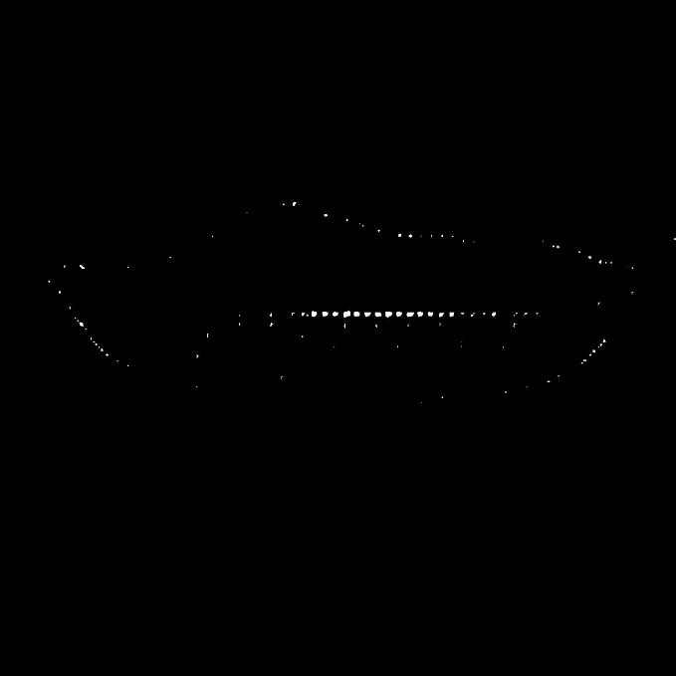
Figure 1.3.b.2: Research’s team demo, the original image is the top image, the left-bottom image is only SAM result, the right-bottom image is SAM + SSL backbone result

Chapter 2. Related Works
        - Overview of the Studies and Techniques
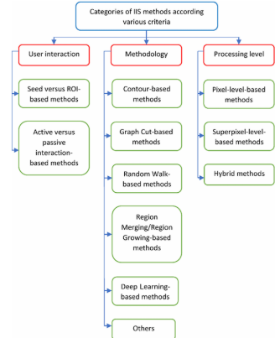
Figure 2.1.1: Categories of Interactive Segmentation according various criteria^{[5]}
User Interaction–Based Methods
The most classical category of interactive segmentation relies on continuous user interaction. In this setting, users must repeatedly provide guidance to the system in order to obtain accurate segmentation results.
A representative example of this category is the seed-based method, where users manually indicate foreground or background regions. One of the most well-known techniques is Intelligent Scissors^{[6]}, which requires users to continuously trace object boundaries using a mouse. While such methods can produce precise contours, they are time-consuming, labor-intensive, and highly dependent on user expertise.
Methodology-Level Approaches
More advanced methodologies aim to reduce the level of user involvement while maintaining segmentation accuracy. These approaches can be broadly divided into two categories: traditional methods and deep learning–based methods.
Traditional Methods
Among traditional approaches, contour-based methods^{[7]} focus on detecting object boundaries by exploiting low-level image features such as edges, gradients, and intensity variations. These methods reduce the need for continuous user input but often struggle with complex backgrounds, occlusions, and weak boundaries.
Deep Learning–Based Methods
With the advent of deep learning, interactive segmentation has significantly improved in both robustness and usability. In this category, user input is typically simplified to a small number of clicks or points. Representative methods include: RITM (Reviving Iterative Training with Masks), Focal Click, Simple Click, Segment Anything Model (SAM)^{[8][9][10][11]}
These methods leverage deep neural networks to interpret sparse user prompts and generate accurate segmentation masks. Compared to classical approaches, they substantially reduce interaction cost while offering better generalization across diverse image domains.
Processing-Level Methods
Beyond interaction and model design, some approaches focus on improving interactive segmentation through processing-level techniques. In this category, superpixel-based methods^{[12]} are commonly used to group pixels into perceptually meaningful regions before segmentation. This research will not dive in this method, reference^{[12]} can provide more detail.

        - Representative Studies and Techniques
          - User Interaction–Based Methods
As discussed earlier, a representative method of the user interaction–based segmentation category is Intelligent Scissors^{[6].}
In Intelligent Scissors, each pixel in an image is modeled as a node in an undirected graph, where neighboring pixels are connected by edges. The weight of each edge is determined by a local cost function, which reflects the likelihood that a pixel lies on an object boundary.
Specifically, the local cost between two pixels $p$ and $q$ is formulated by combining multiple image features, including:
- Laplacian zero-crossing,
- Gradient magnitude,
- Gradient direction,
- Edge pixel value,
- “Inside” pixel value,
- “Outside” pixel value.
These features are integrated into a unified cost function:
$$l(p,q)=ω_{Z}f_{Z}(q)+ω_{G}f_{G}(q)+ω_{D}f_{D}(p,q)+ω_{P}f_{P}(q)+ω_{I}f_{I}(q)+ω_{O}f_{O}(q)$$
where each $ω$ denotes the weight associated with the corresponding feature. The objective of the algorithm is to compute the minimum-cost path between user-defined seed points such that the path aligns with the object boundary.
During interaction, the user continuously moves the cursor along the object contour. As long as the cursor remains close to the true boundary, the algorithm dynamically updates the optimal path by minimizing the accumulated cost.
When the cursor deviates too far from the boundary, the current path can no longer be reliably maintained. In such cases, the system introduces a new seed point, from which the segmentation process continues. This procedure is repeated until the entire object contour is closed.

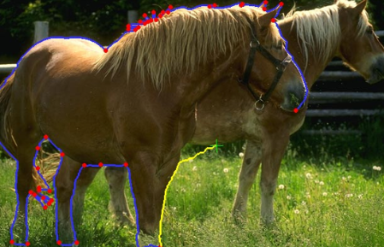
Figure 2.2.a.1: illustrates this process: the user traces the outline of a horse by moving the mouse, while red points indicate seed positions generated either at initialization or when the cursor deviates excessively from the boundary. The process is iteratively performed until a complete segmentation is obtained.
Discussion and Limitations
Although Intelligent Scissors can produce highly accurate contours, it relies heavily on continuous user interaction, making it time-consuming and impractical for large-scale or fully automated applications. Moreover, modeling each pixel as a node in a graph significantly increases computational complexity, especially for high-resolution images.
These limitations motivate the exploration of more advanced approaches that reduce human involvement and simplify computational modeling, such as deep learning–based interactive segmentation methods.
Nevertheless, in certain specialized scenarios—particularly in complex 3D segmentation tasks—the fine-grained control offered by Intelligent Scissors remains valuable. Further applications and extensions of this method can be found in^{[13] [14]}

          - Traditional Method
Contour-based methods^{[7]} represent a prominent class of segmentation techniques that gained significant attention during the early 2010s. These methods aim to extract object boundaries by explicitly modeling and evolving contours, making them an important milestone in the development of interactive and semi-automatic segmentation.
A representative approach in this category is the Active Contour Model (ACM)^{[7]}. One of the key advantages of ACM is that it enables segmentation through a combination of image information and simple user-provided prompts, allowing users to guide the segmentation process without continuous interaction.
User Input and Problem Formulation
In ACM, the user provides two simple inputs:
- A red line, indicating pixels that lie inside the target region,
- A blue line, indicating pixels that lie outside the target region.
Based on these inputs, the segmentation problem is formulated as an energy minimization task. Instead of directly classifying pixels, ACM introduces a continuous function $u(x)∈[0,1]$defined over the image domain $Ω$. The segmentation is obtained by solving the following optimization problem:
$$\underset{0≤u≤1}{min⁡}\left(\int_{Ω}{g_{b}}∣∇u∣dx + λ\int_{Ω}{h_{r}}u dx\right)$$
where:
- $g_{b}$is an edge-based weighting function, typically derived from image gradients,
- $∣∇u∣$enforces contour smoothness and boundary regularization,
- $h_{r}$encodes regional constraints derived from user input,
- $λ$ controls the trade-off between boundary alignment and region consistency.

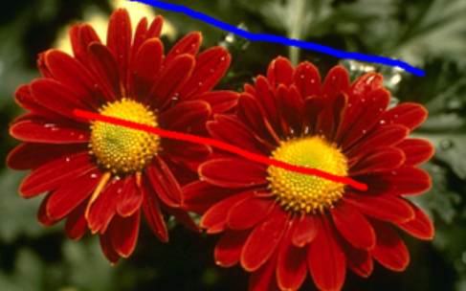
Figure 2.2.b.1: red line – foreground, blueline - background
From Optimization to Segmentation
Once the optimization problem is solved, the result is the function $u(x)$, which represents a soft segmentation map rather than a binary mask.
The final segmentation is obtained by applying a threshold $T$to $u(x)$:
$$C_{in}=\{x∣u(x)>T\}$$
Pixels with values greater than the threshold are classified as belonging to the target region, while the remaining pixels are considered background.
Why This Is a Contour-Based Method
This formulation explains why ACM is categorized as a contour-based method. The first term of the energy function explicitly models the object boundary by penalizing variations of $u$weighted by image gradients. As a result, the evolving contour is encouraged to align with strong edges in the image.
The second term introduces region-based information, ensuring that the segmentation remains consistent with the user-provided interior and exterior constraints. Together, these terms allow the contour to evolve toward a boundary that balances edge evidence and regional coherence.
Discussion and Limitations
Compared to pixel-level graph-based methods, ACM is computationally more efficient and requires less user interaction. However, its performance strongly depends on the quality of image gradients.
In scenarios where object boundaries are weak, noisy, or visually ambiguous, the edge-based term $g_{b}∣∇u∣$ becomes unreliable. As a result, the contour evolution may fail to converge to the correct boundary, rendering the method ineffective for such challenging cases.
These limitations highlight the difficulty of relying solely on low-level image features and motivate the transition toward learning-based segmentation approaches, which can capture higher-level semantic information beyond simple contour cues.
          - Deep-Learning Based Methods
            - RITM (Reviving Iterative Training with Masks)^{[8]}
RITM (Reviving Iterative Training with Masks) is a representative deep learning–based interactive segmentation method that significantly improves segmentation accuracy while reducing the amount of user interaction. The model adopts a Deep Residual Learning backbone, with ResNet^{[15]} serving as the core feature extractor.
Backbone and Learning Strategy
The ResNet backbone in RITM is responsible for extracting high-level semantic features from the input image. Beyond standard forward propagation, RITM introduces an iterative training strategy during the backward pass. Instead of treating each user interaction independently, the model learns to refine its predictions based on previous errors and corrective clicks.
This training strategy enables the network to:
- Adapt its internal representations to ambiguous or challenging regions,
- Learn how user corrections should influence future segmentation results,
- Achieve better convergence with fewer user interactions during inference.
As a result, RITM demonstrates improved robustness compared to earlier interactive segmentation approaches.
RITM Segmentation Pipeline
The overall workflow of RITM can be summarized as follows:
Step 1: Click Encoding
User interactions are encoded as two types of signals:
- Positive clicks (+), indicating pixels belonging to the target object,
- Negative clicks (−), indicating pixels belonging to the background.
These clicks are transformed into spatial maps that preserve their locations and semantic intent.
Step 2: Image Feature Extraction and Concatenation
The original image is processed in parallel with the encoded click maps. The two sources of information are then concatenated, allowing the network to jointly reason about visual appearance and user guidance.
Step 3: Convolutional Processing
The concatenated features are passed through several convolutional layers. These layers serve to:
- Fuse spatial information from clicks and image content,
- Propagate click influence to neighboring pixels,
- Capture local context before global feature extraction.
Step 4: Backbone-Based Learning
The processed features are fed into the ResNet backbone, which learns hierarchical representations that integrate both image semantics and user intent. The final output is a refined segmentation mask that aligns with the provided interactions.
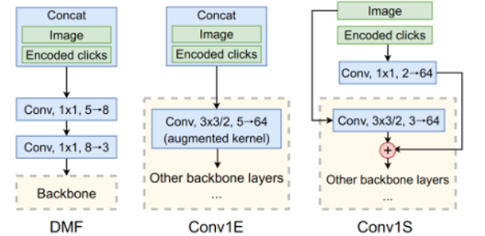
Figure 2.3.c.i.1: RITM training pipeline
Training Dataset
RITM is trained using a combination of the COCO^{[15]} and LVIS datasets. These datasets provide:
- A large number of images,
- High-quality, manually annotated instance segmentation masks,
- Diverse object categories and complex scene layouts.
All masks used during training are fully manually annotated, ensuring reliable supervision for learning interactive segmentation behavior.
Discussion and Limitations
During training, RITM must jointly optimize:
- The backbone network parameters,
- The click-encoding mechanism,
- The iterative refinement strategy.
This joint training process significantly increases computational complexity and training time.
In particular, RITM does not rely on a fixed set of user interactions; instead, it explicitly simulates user clicks during training in an iterative manner.
At each training iteration, the model first produces an intermediate segmentation mask. Based on the prediction errors of this mask, new positive or negative clicks are generated to mimic how a real user would correct the segmentation. These simulated clicks are then re-encoded and fed back into the network as additional inputs for the next iteration.
            - Focal Click: Two-Stage Interactive Segmentation with Local Refinement^{[9]}
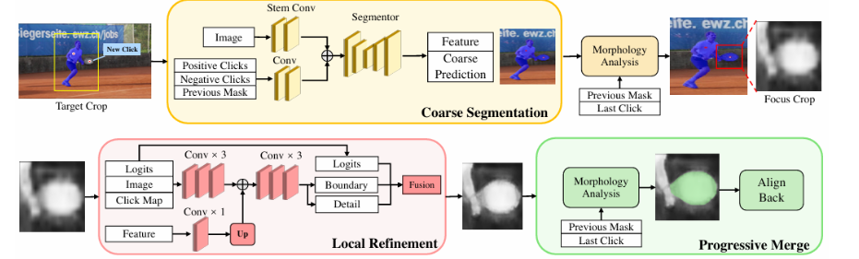
Figure 2.3.c.ii.1: Focal training pipeline
Focal Click is an interactive segmentation method that builds upon the RITM framework and aims to further improve segmentation accuracy through a two-click interaction mechanism. While the model still adopts a ResNet backbone, its key innovation lies in the introduction of a Local Refinement module, which explicitly focuses on correcting errors introduced after the initial interaction.
Two-Click Interaction Strategy
Unlike RITM, which relies on iterative click simulation over multiple interaction steps, Focal Click explicitly models segmentation refinement using two clicks:
- The first click serves as a coarse interaction, providing an initial estimation of the target region.
- The second click focuses on correcting errors made in the initial prediction, allowing the model to refine boundary details and ambiguous regions.
This design reflects a realistic user behavior, where an initial click roughly identifies the object, and subsequent clicks are used to correct mistakes.
Focal Click Pipeline
The overall segmentation pipeline of Focal Click can be summarized as follows:
Step 1: Coarse Segmentation
The input image, together with the encoded positive and negative clicks from the first interaction, is processed through convolutional layers and fed into the ResNet backbone. This stage produces a coarse segmentation mask, which captures the general shape of the target object.
Step 2: Focus Region Extraction
Based on the coarse prediction and the most recent click, a focus region is extracted using morphological analysis. This region highlights areas where segmentation errors are likely to occur, such as object boundaries or ambiguous regions.

Step 3: Local Refinement
The extracted focus region is passed through the Local Refinement module, which consists of additional convolutional layers designed to:
- Enhance boundary details,
- Refine local structures,
- Correct misclassified pixels from the first segmentation stage.
This module operates at a higher spatial resolution, enabling more precise adjustments than global feature extraction alone.
Step 4: Progressive Merge
The refined local prediction is merged back into the coarse segmentation mask, producing the final output. This progressive merging strategy ensures consistency between global structure and local detail.
Performance and Trade-offs
By explicitly modeling local refinement, Focal Click achieves higher segmentation accuracy than RITM, particularly around object boundaries and fine structures. However, this improvement comes at a cost.
First, the method requires two manual clicks per interaction cycle, increasing user effort compared to single-click methods. Second, training remains interaction-heavy, as the model must learn both coarse segmentation and refinement behavior through simulated clicks. As a result, training complexity and computational cost remain high.
While Focal Click demonstrates clear performance gains over RITM, its dependence on manual interaction and complex training procedures continues to motivate research toward more scalable and less interaction-dependent segmentation paradigms.

            - Simple Click^{[10]}
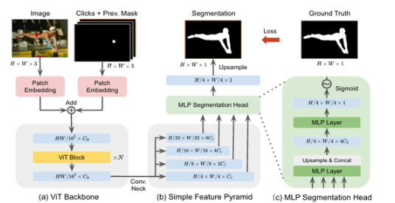
Figure 2.3.c.iii.1: Simple Click training pipeline
With the rapid adoption of transformer architectures in computer vision, interactive segmentation methods have also evolved accordingly. Among these approaches, Simple Click represents a modern, transformer-based solution that not only leverages advanced modeling capacity but also significantly simplifies the training process.
Unlike earlier methods that rely heavily on manually annotated segmentation masks, Simple Click reduces annotation cost by reusing existing masks generated by previous interactive segmentation methods, such as RITM and Focal Click. This design choice directly addresses the scalability limitations of interaction-heavy training pipelines.
Simple Click replaces convolutional backbones with a Vision Transformer (ViT)^{[16]} backbone, enabling global context modeling through self-attention. More importantly, it introduces a training paradigm that avoids repeated manual or simulated interactions, making the overall pipeline more efficient.
In this report, we do not discuss the Vision Transformer (ViT) backbone and the Simple Click method in the same level of detail as RITM and Focal Click. Instead, we focus on their conceptual differences and overall contributions to interactive segmentation. Readers interested in the architectural details and training strategies of ViT-based interactive segmentation are referred to reference^{[10]} for a comprehensive explanation.
            - SAM^{[11]}
Finally, the state-of-the-art method and the primary approach selected by our research group is the Segment Anything Model (SAM). Since its initial release, SAM has undergone several major iterations, evolving into more advanced versions with improved performance and scalability.
Similar to Simple Click, SAM adopts a Vision Transformer (ViT) as its image encoder. However, the fundamental distinction of SAM lies in the concept implied by its name: “segment anything.” Unlike previous interactive segmentation methods that are designed for specific object categories or rely heavily on carefully simulated user interactions, SAM is trained to generalize across an extremely broad range of visual concepts.
This capability is largely enabled by the SA-1B dataset^{[11]}, which contains over one billion segmentation masks. The scale and diversity of this dataset far exceed those of traditional manually annotated datasets, allowing SAM to learn highly generalizable segmentation representations.
In addition, SAM introduces an efficient prompt-based training mechanism, where prompts such as points, boxes, or masks are automatically generated during training. This self-prompting strategy significantly simplifies the training pipeline and removes the need for complex click simulation or iterative interaction modeling, which are required by earlier methods such as RITM and Focal Click.
As a result, SAM achieves strong generalization performance across diverse domains and tasks, making it a foundation model for segmentation rather than a task-specific interactive method.
Since SAM constitutes the core methodology explored in this work, we reserve a detailed discussion of its architecture, training strategy, and adaptations for Section 3, where the proposed approach is presented in full detail.

        - Research Gaps
Although SAM demonstrates exceptional performance and strong generalization as a foundation segmentation model, its output is fundamentally limited to binary masks. As discussed in the Contributions section, such masks indicate where a region is located but do not fully capture what the pixels represent at a semantic level.
In this work, we aim to leverage the strong segmentation capability of SAM to enhance pixel-level semantic understanding, rather than treating segmentation as an end task. Specifically, we focus on improving the model’s ability to distinguish leaf pixels from non-leaf pixels and to generate more reliable and coherent leaf segmentations under challenging conditions.
By building upon SAM’s robust mask generation, our approach seeks to elevate pixel representations from simple binary decisions to semantically enriched representations. This enhanced understanding facilitates downstream tasks, such as leaf identification and disease analysis, while preserving SAM’s strong generalization ability.
In the following section, we present our proposed framework, which exploits SAM as a powerful segmentation prior and extends it toward more meaningful pixel-level interpretation tailored to leaf-centric analysis.

Chapter 3. Proposed Method
              - Part 1: Overview of the segment anything model (SAM)
- Introduction
The Segment Anything Model (SAM) is a foundation model for promptable image segmentation, developed by Meta AI. The model is designed to generate high-quality segmentation masks for arbitrary objects in an image based on various forms of user input, such as point clicks, bounding boxes, or coarse masks.
By decoupling segmentation from specific object categories, SAM enables flexible and interactive segmentation across a wide range of visual domains without requiring task-specific retraining.

- Design Objectives
SAM is designed with three primary objectives:
- Flexibility: The model supports multiple types of prompts, including points, bounding boxes, masks, and text-based guidance, enabling diverse interaction paradigms.
- Computational Efficiency: The image encoder processes the input image only once, while the prompt encoder and mask decoder operate in real time, allowing efficient interactive usage.
- Strong Generalization: SAM is capable of performing well across various domains in a zero-shot manner, without fine-tuning on downstream datasets.
- Overall Architecture
SAM consists of three main components, which are designed to operate independently while remaining tightly coupled through shared embeddings:
- Image Encoder: This component processes the input image and produces high-quality image embeddings. It is the most computationally expensive module but needs to be executed only once per image.
- Prompt Encoder: The prompt encoder transforms different types of user prompts (points, bounding boxes, masks) into corresponding embedding vectors. This component is lightweight and optimized for fast execution.
- Mask Decoder: The mask decoder combines image embeddings and prompt embeddings to generate the final segmentation masks. In addition to the masks, it also predicts an IoU-based confidence score that reflects the quality of each segmentation output.
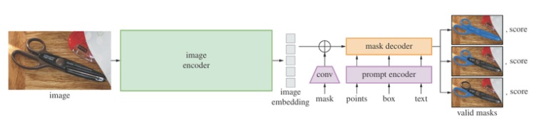
Figure 3.1.c..1: SAM Pipeline

              - Part 2: Image Encoder
- Introduction
The Image Encoder serves as the core component of the Segment Anything Model (SAM), functioning as the primary module responsible for extracting rich semantic representations from the input image. This component is based on a Vision Transformer (ViT) architecture, which is specifically optimized for high-resolution image segmentation tasks.
By encoding the image into a dense and expressive feature space, the Image Encoder provides the foundation upon which prompt-based segmentation is performed.
- Vision Transformer Architecture
    - Patch Embedding
The first step of the Image Encoder is to divide the input image into a set of small, non-overlapping patches. For an input image of size 1024 × 1024 pixels and a patch size of 16 × 16, the image is decomposed into 64 × 64 = 4,096 patches.
Each patch is then projected into a higher-dimensional embedding space. This projection is implemented using a 2D convolutional layer whose kernel size and stride are both equal to the patch size. This design ensures that patches do not overlap and are processed uniformly.
    - Positional Encoding
After obtaining the patch embeddings, the model must preserve the spatial information of each patch relative to the original image. To achieve this, SAM employs absolute positional embeddings, which are learnable vectors with the same dimensionality as the patch embeddings.
These positional embeddings are added to the patch embeddings and are learned during training, enabling the model to encode spatial location information explicitly.
    - Transformer Blocks with Window Attention
The transformer blocks constitute the core of the Image Encoder. Each block consists of the following key components:
- Multi-Head Self-Attention (MHSA): Instead of computing attention across all 4,096 patches—which would be computationally expensive due to quadratic complexity—SAM adopts a window-based attention mechanism. The image is partitioned into smaller windows (e.g., 14 × 14 patches), and self-attention is computed independently within each window.
This approach significantly reduces computational complexity from $O(n^{2})$to approximately $O(w^{2}×k)$, where $w$denotes the window size and $k$the number of windows.
To preserve global context, SAM introduces a small number of global attention blocks, in which attention is computed across the entire image. The positions of these blocks are predefined; for example, in ViT-H, global attention is applied at blocks 7, 15, 23, and 31.
- Relative Position Bias: During each attention operation, SAM incorporates relative positional bias, allowing the model to learn spatial relationships between patches based on their relative positions. This mechanism complements the absolute positional embeddings used at the input stage and improves spatial reasoning within attention windows.
- Feed-Forward MLP: Following the attention layer, each patch embedding is passed through a feed-forward multilayer perceptron (MLP) consisting of two fully connected layers with GELU activation. The hidden dimension of the MLP is expanded to four times the embedding dimension before being projected back to the original size.
- Residual Connections: Both the attention module and the MLP are equipped with residual (skip) connections, which facilitate stable gradient flow and improve training convergence.
    - Neck: Output Processing
After passing through all transformer blocks, the extracted features are processed by a lightweight neck module consisting of two convolutional layers:
- A 1 × 1 convolution to reduce the channel dimension from the transformer embedding size to 256 channels,
- A 3 × 3 convolution to smooth the features and increase the effective receptive field.
Each convolutional layer is followed by Layer Normalization, which helps stabilize training and improve feature consistency.
- Image Encoder Output
The Image Encoder produces image embeddings with the shape (B, 256, 64, 64), where:
- B denotes the batch size,
- 256 is the number of feature channels after dimensionality reduction,
- 64 × 64 corresponds to the spatial resolution, which is 1/16 of the original image resolution.
These embeddings contain rich semantic information about objects, structures, and contextual relationships within the image. Importantly, they can be cached and reused for multiple prompts, enabling efficient segmentation of multiple objects within the same image.
Since the Image Encoder is executed only once per image, its computational cost is amortized across multiple prompt-based inference steps, making SAM highly efficient for interactive segmentation scenarios.
              - Part 3: Prompt Encoder
  - Introduction
The Prompt Encoder acts as the critical interface between user intent and the segmentation capability of the model. Its primary role is to transform various forms of human-provided visual inputs—such as clicks, bounding boxes, and masks—into mathematical representations that can be effectively processed by the Mask Decoder.
By converting intuitive user interactions into structured embeddings, the Prompt Encoder enables SAM to perform flexible and interactive segmentation across diverse scenarios.
  - Supported Prompt Types
The Prompt Encoder supports three types of visual prompts:
- Point prompts
- Bounding box prompts
- Mask prompts
Notably, SAM does not support text-based prompts for visual segmentation in its core design; all prompts are spatial and visual in nature.
    - Point Prompts
Point prompts are the simplest yet one of the most powerful forms of interaction. Users provide clicks on the image to indicate whether a pixel belongs to the foreground (positive) or background (negative) of the target object.
Encoding Mechanism
Each point prompt is encoded through a two-stage process:
Step 1: Positional Encoding
The 2D coordinates $\left(x , y\right)$of each point are first normalized to the range $\left[0 , 1\right]$. These normalized coordinates are then transformed using Fourier feature mapping, which applies a random Gaussian projection to generate high-frequency features.
This transformation enables the model to capture fine-grained spatial patterns across multiple scales, improving localization accuracy and spatial sensitivity.
Step 2: Learned Type Embedding
Based on the semantic label of the point (positive, negative, or padding), a corresponding learned embedding vector is added to the positional encoding. Each point type has its own embedding, learned during training.
This design allows the model to explicitly distinguish between points that indicate object presence and those that indicate background exclusion.
    - Box Prompts
Bounding box prompts provide stronger spatial constraints than point prompts. A box is defined by two corner points: top-left and bottom-right.
Encoding Mechanism
Box prompts are encoded by treating each corner as a special point:
- Each corner coordinate is passed through the same Fourier positional encoding used for point prompts.
- Distinct learned embeddings are added to differentiate the top-left and bottom-right corners.
This encoding scheme enables the model to infer not only the location but also the scale, orientation, and spatial extent of the region of interest.
    - Mask Prompts
Mask prompts carry the richest amount of information among all prompt types. They are typically derived from predictions produced in previous iterations during interactive refinement.
Encoding Mechanism
The input mask, represented at a low resolution of 256 × 256, is processed by a lightweight convolutional neural network consisting of three layers:
- Two convolutional layers with stride 2 to downsample the mask from 256 → 128 → 64
- Each convolution is followed by Layer Normalization and GELU activation
- A final 1 × 1 convolution increases the channel dimension to 256
The output is a dense feature map with shape (256, 64, 64), which is spatially aligned with the image embeddings produced by the Image Encoder.
    - No-Prompt Case
When no mask prompt is provided, the model utilizes a learned “no mask” embedding. This embedding is a 256-dimensional vector that is broadcast across the 64 × 64 spatial grid.
The “no mask” embedding is learned to represent the absence of mask information, ensuring that the model remains functional when segmentation is driven solely by point or box prompts.

  - Sparse vs. Dense Embeddings
The Prompt Encoder produces two distinct types of embeddings:
- Sparse Embeddings
Generated from point and box prompts, with shape (B, N, 256), where:
  - B is the batch size,
  - N is the total number of prompt elements.
These embeddings function as discrete tokens, each corresponding to an individual prompt.
- Dense Embeddings
Generated from mask prompts, with shape (B, 256, 64, 64).
These embeddings form a spatial feature map, where each grid location encodes information about the corresponding image region.
This separation allows the Mask Decoder to efficiently integrate local, discrete guidance from sparse prompts with global, spatially dense information from mask prompts.
              - Part 4: Mask Decoder
- Introduction
The Mask Decoder is the component where image embeddings and prompt embeddings are fused to generate accurate segmentation masks.
The central challenge of this stage is enabling user-provided prompts to effectively guide the mask generation process, while preserving spatial coherence and semantic consistency in the predicted output.
To address this challenge, SAM introduces a carefully designed Two-Way Transformer architecture, allowing bidirectional interaction between prompts and image features.
- Two-Way Transformer Architecture
The core of the Mask Decoder is a Two-Way Transformer, which enables information to flow dynamically between token representations (prompts and outputs) and dense image features.
    - Token Preparation
The decoding process begins with the construction of token representations.
Learnable Output Tokens
SAM defines a set of five learnable output tokens:
- 1 IoU token, responsible for predicting mask quality
- 4 mask tokens, each corresponding to a candidate segmentation mask
Concatenation with Prompt Tokens
These five output tokens are concatenated with the sparse prompt embeddings produced by the Prompt Encoder.
As a result, the transformer processes a total of (5 + N) tokens, where N denotes the number of user-provided prompts.
This unified token sequence allows output tokens and prompt tokens to interact directly within the transformer.
    - Image Feature Processing
Image embeddings from the Image Encoder undergo the following transformations:
- Flattening: The image embeddings are reshaped from
$\left(B , 256 , 64 , 64\right)$to $\left(B , 4096 , 256\right)$
- Dense Prompt Injection: Dense prompt embeddings (from mask prompts) are added directly to the image features.
This design provides an elegant mechanism for injecting mask-related guidance into all spatial locations.
- Positional Encoding: Positional embeddings are added to preserve spatial structure after flattening.
This process ensures that image features retain both spatial context and prompt-specific information.
    - Two-Way Attention Mechanism
The Two-Way Transformer consists of two transformer layers, each performing a sequence of attention operations:
Token Self-Attention
All tokens (output tokens and prompt tokens) attend to each other.
This allows multiple prompts (e.g., several clicks) to interact, refine, and resolve conflicts among themselves.

Cross-Attention: Tokens → Image
Tokens attend to image features, enabling prompts to query the image and extract relevant visual information for segmentation.
Cross-Attention: Image → Tokens
Image features attend back to tokens, allowing the image representation to be modulated by user intent.
This step is critical, as it explicitly injects prompt-driven guidance into the image features.
Feed-Forward MLPs
Both token embeddings and image features pass through MLP layers to further aggregate and transform information.
This bidirectional attention design ensures rich interaction between prompts and image content, rather than a one-way conditioning mechanism.
    - Final Attention Layer
After the two transformer layers, a final cross-attention operation is applied, where output tokens attend to image features one last time.
This step extracts the precise information needed to generate high-quality segmentation masks.
- Mask Generation via Hypernetwork
After transformer processing, the decoder outputs:
- Processed tokens with shape $\left(B,5+N,256\right)$
- Processed image features with shape $\left(B , 4096 , 256\right)$
Upsampling Image Features
The image features are reshaped back into spatial form and passed through a series of transposed convolution layers to upsample the resolution from 64 × 64 to 256 × 256.
Each upsampling step doubles the spatial resolution and is followed by normalization and activation layers.
Dynamic Convolution via Hypernetwork
This is one of the most distinctive components of SAM:
- Each of the four mask tokens is processed by a dedicated MLP
- Each MLP outputs a 32-dimensional vector, acting as dynamic convolution weights
- These weights are used to perform matrix multiplication with the upsampled image features
- The result is four distinct segmentation masks, each representing a different plausible interpretation
Unlike fixed convolution kernels, this hypernetwork-based approach allows each mask token to learn a unique way of filtering image features, enabling flexible and diverse mask generation.
- IoU Prediction Head
The IoU token is passed through a separate MLP to predict four IoU scores, each corresponding to one of the generated masks.
These predicted scores serve multiple purposes:
- Allowing the model to self-assess mask quality
- Enabling users to select the most reliable mask
- Stabilizing training by providing an explicit quality prediction target
- Ambiguity Handling
SAM explicitly addresses ambiguity in interactive segmentation by generating multiple mask candidates.
- Single-mask mode: Only the first mask is returned, typically used for unambiguous prompts such as bounding boxes.
- Multi-mask mode: The remaining three masks are returned, designed for ambiguous prompts such as a single click.
This mechanism effectively handles inherent uncertainty.
For example, a single click on a shirt may correspond to multiple valid segmentations (the entire person, the shirt, or a sleeve). SAM produces several reasonable options and delegates the final selection to the user.
              - Construction pipeline of the SA-1B dataset
- Overall Structure
The training of the Segment Anything Model (SAM) is divided into two major components.
The first component focuses on the Data Engine, whose primary goal is to construct a large-scale and diverse segmentation dataset known as SA-1B.
The SA-1B dataset is built through a three-stage annotation pipeline, gradually transitioning from human-assisted labeling to fully automatic mask generation.
Stage 1: Assisted Manual Annotation
- Scale: 120,000 images
- Annotation strategy: Human-in-the-loop
In the first stage, human annotators use an early version of SAM as an interactive annotation tool. Annotators provide clicks on objects of interest, after which SAM predicts an initial segmentation mask. The annotators then manually refine these predictions when necessary.
This stage significantly accelerates the annotation process compared to fully manual labeling while maintaining high-quality masks.
- Output:
  - 4.3 million segmentation masks
- Role in pipeline:
  - Provides high-quality supervision to train the first SAM model (SAM v1)
Stage 2: Semi-Automatic Annotation
- Scale: 180,000 images
- Annotation strategy: Model-assisted with selective human intervention
In the second stage, SAM v1, trained on data from Stage 1, is deployed to automatically generate segmentation masks.
Only predictions with high confidence (IoU > 0.90) are accepted without human correction.
Human annotators are required only for:
- Objects missed by the model
- Difficult or ambiguous regions where automatic segmentation fails
- Output:
  - 10 million masks
  - Approximately 60% automatically generated
  - Approximately 40% manually refined
This stage balances annotation quality and scalability, dramatically increasing dataset size while limiting manual effort.
Stage 3: Fully Automatic Annotation
- Scale: 11 million images
- Annotation strategy: Fully automatic
In the final stage, a more advanced model (SAM v2, trained on data from Stages 1 and 2) is used to generate masks without any human involvement.
For each image:
- A 32 × 32 grid sampling strategy is applied, resulting in 1,024 point prompts per image
- SAM predicts masks for each sampled point
- Aggressive filtering criteria are applied:
  - IoU > 0.86
  - Stability score > 0.92
Only high-quality and stable masks are retained.
- Output:
  - 1.1 billion segmentation masks
- Human annotation:
  - None
Final Dataset Statistics
The final SA-1B dataset contains:
- 11.1 million images
- 1.1 billion segmentation masks
Notably:
- Only 0.4% of the total masks involve human annotation
- 99.6% of the masks are generated automatically
This data-centric design demonstrates that SAM’s strong generalization capability is primarily driven by scale, diversity, and quality of supervision, rather than reliance on dense manual labeling.

              - The Role of prompt in SAM training
- Bootstrapped Ground Truth Construction
In SAM, ground truth masks are not created through a single static annotation process.
Instead, they are constructed via a bootstrapping pipeline that progressively improves both data quality and model capability:
Model → mask prediction → human refinement → high-quality mask → prompt generation → improved model
This process forms a human-in-the-loop semi-automatic system, where ground truth masks are gradually accumulated and refined across stages.
Importantly, prompts are not the original data.
They are mechanisms used to query the model about an already known ground truth mask.
- Prompts as Training Signals, Not Inference Inputs
A key design principle of SAM is that prompts play different roles during data collection and during model training.
Prompts during data collection (Stages 1–3)
During the construction of the SA-1B dataset:
- Prompts originate from human clicks (Stages 1–2) or automatic grid sampling (Stage 3)
- These prompts are used to generate candidate masks
- Human annotators may refine these masks to produce ground truth annotations
At this stage, prompts serve as a data acquisition tool, enabling efficient mask generation.
- Prompts during model training
During the actual training loop, prompts are not provided by users.
Instead, they are automatically generated from ground truth masks.
Given a ground truth mask, prompts are synthesized as follows:
- Pixels inside the mask → positive point prompts
- Pixels outside the mask → negative point prompts
- Tight enclosure of the mask → bounding box prompt
- Mask from a previous iteration → mask prompt
Thus, prompts are derived from the ground truth rather than being part of it.
              - SAM Algorithm

Chapter 4. Implementation and Experiments

Chapter 5. Conclusion and Future Work

Appendix
ARAI tổng kết lý thuyết của các type
Survey các application
Survey input output
Survey sử dụng interactive, perception và markless
Bảng đánh giá các giải pháp

Refference
https://www.intelivita.co.uk/blog/augmented-reality-apps (chia 5 ARAI)
https://www.mobileuserexperience.com/google-glass-is-a-welcome-experiment-in-bad-user-experience/2907/ (google glass khó sử dụng)

Knowledgement

