Build OpenXC demo iOS app

# **Steps for OpenXC Demo app setup using cocoapod:**

1. Install XCode 8 or latest in your machine if not installed.
2. Create an empty folder on your machine and name it accordingly.
3. Open terminal and go to that folder “**cd <folder Path>**”.
4. Copy the link from GitHub which you want to clone (master or next) branch.
5. Use command in terminal **“git clone <link>”** and press enter. It will start cloning the project inside your folder.
6. After cloning go to openxc-ios-library Example folder **“cd openxc-ios-library/Example”**.
7. If necessary, install cocoapods using **“sudo gem install cocoapods”.**
8. Run **“pod install”** from terminal. Note: May take a while.
9. Open. xcworkspace file and run the app in device or simulator.

In the example, you will find “openxcframework.xcworkspace”.

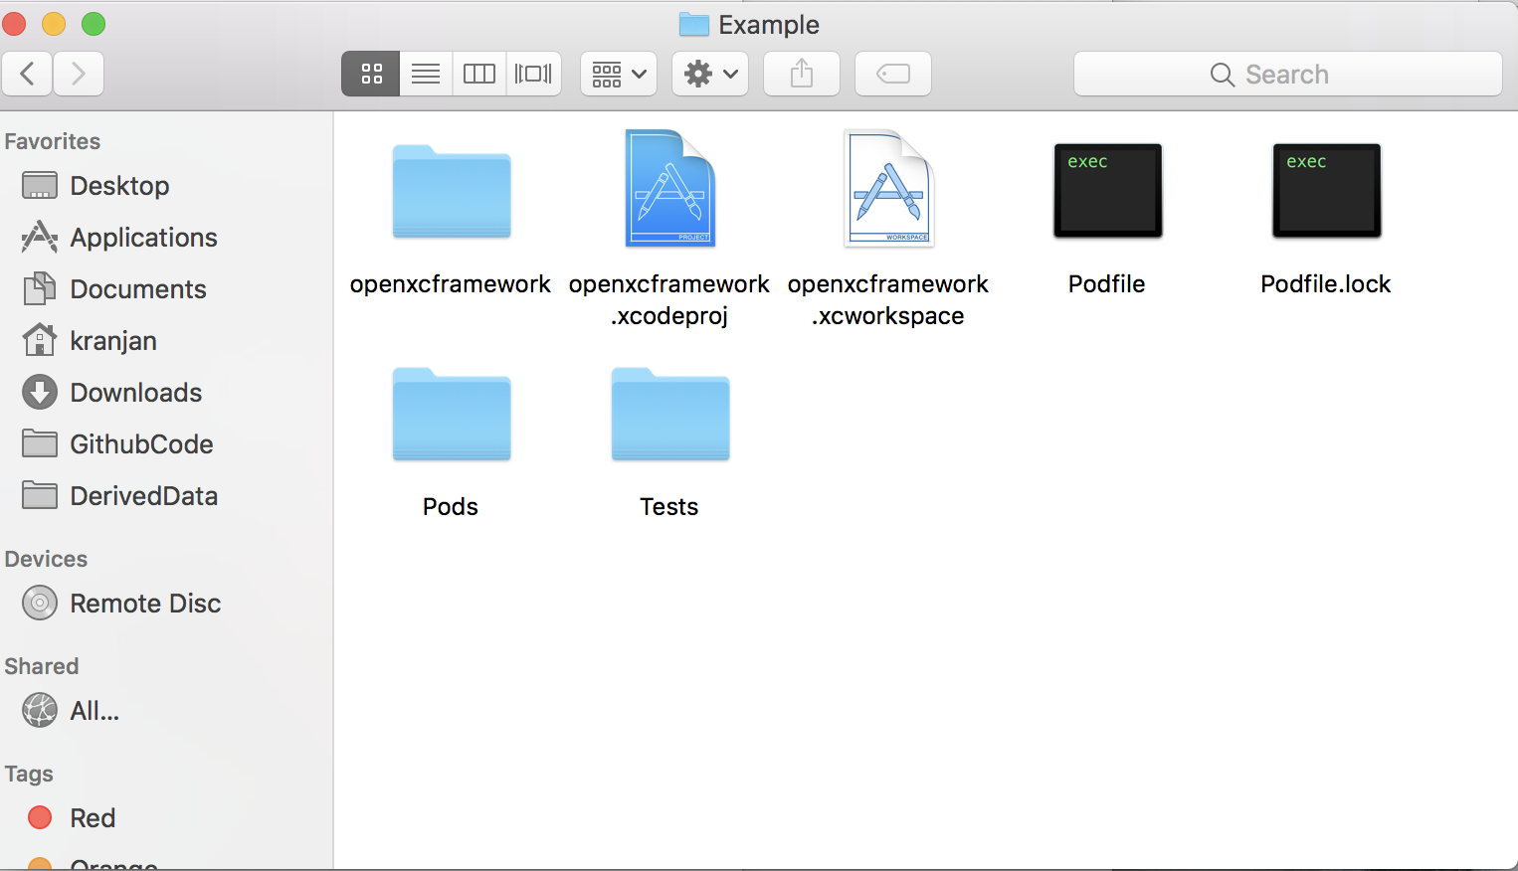

After Opening the “openxcframework.xcworkspace” file.

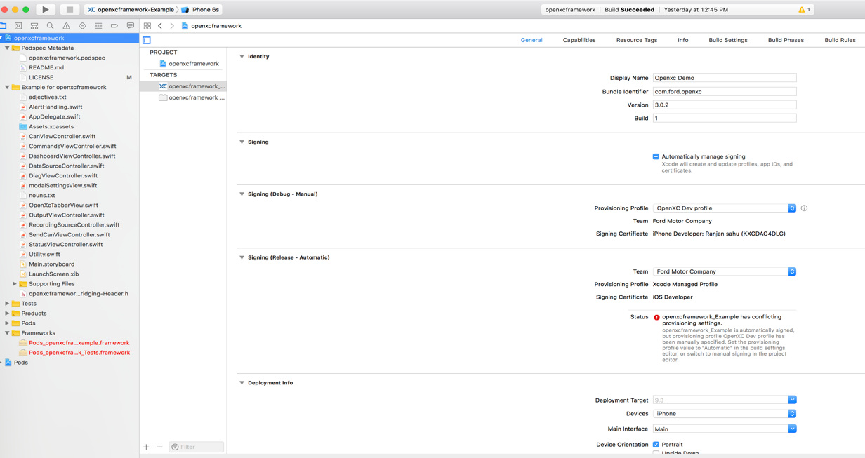

Once you run the app you will get this screen.

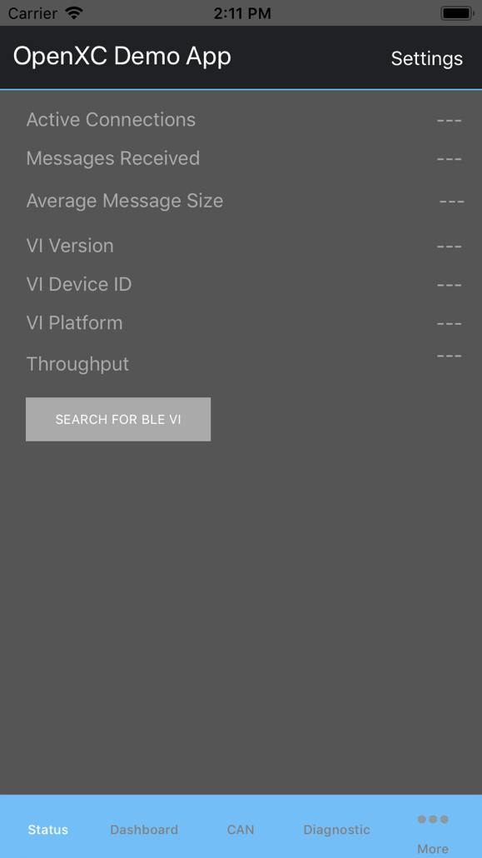

# **Steps for “openxc-ios-library” setup in new app using cocoapod:**

1. Install XCode 8 or latest in your machine if it is not installed.
2. Open Xcode create a new project, or you can use an existing project.
3. Open terminal and go to that folder (new project/existing project) “**cd <folder Path>**”.
4. Run the command from terminal **“pod init”**
5. A pod file will be located in your project folder.
6. Open the pod file, and add **“pod openxcframework”** to the pod file and save**.**
7. Run the command **“pod install”** in terminal.
8. The. xcworkspace file will appear in your project folder.
9. Open the file and the pod has been added to the **“openxcframework”** in your project.
10. If an update is available for the framework, run **“pod update”** in the terminal to retrieve.

After running the command “pod init”.

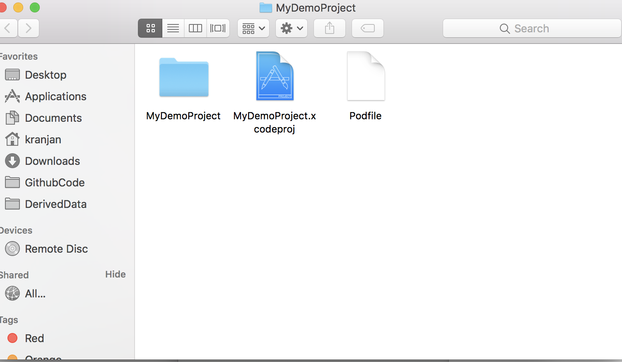

After adding pod into pod file.

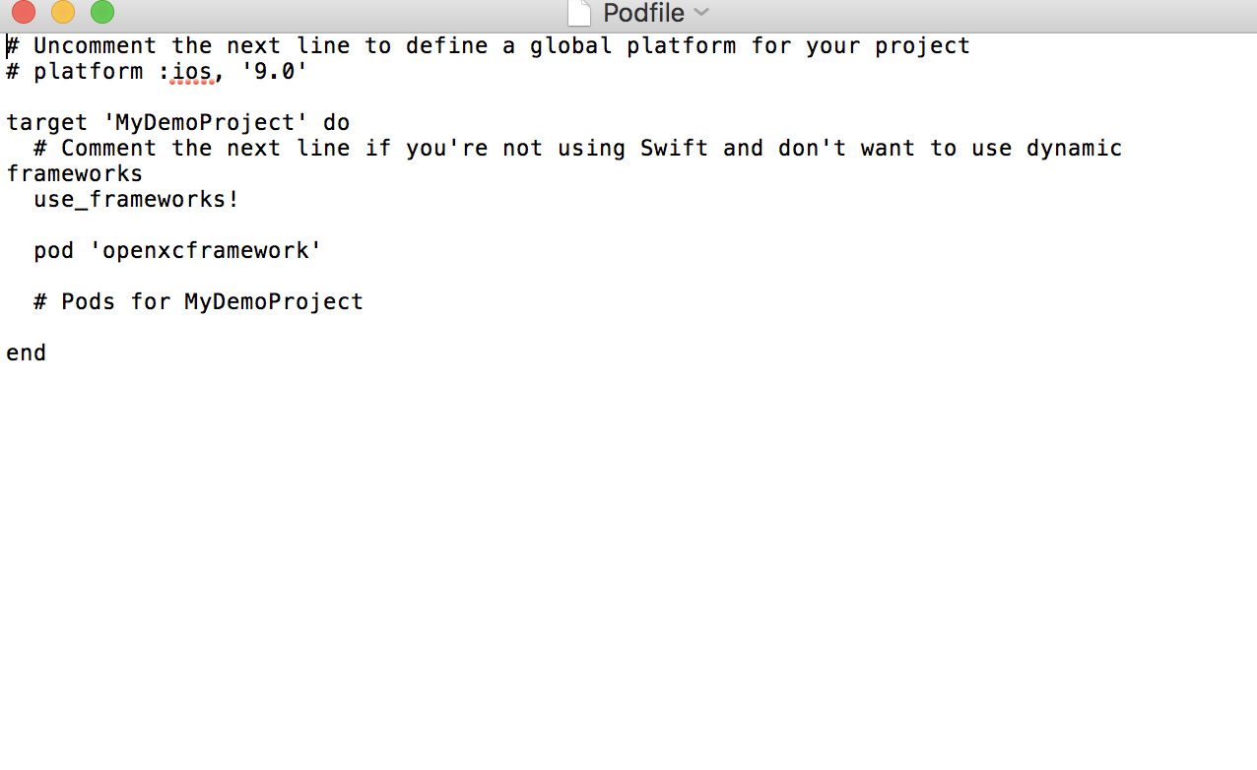

After running “pod Install” command your terminal looks like this.

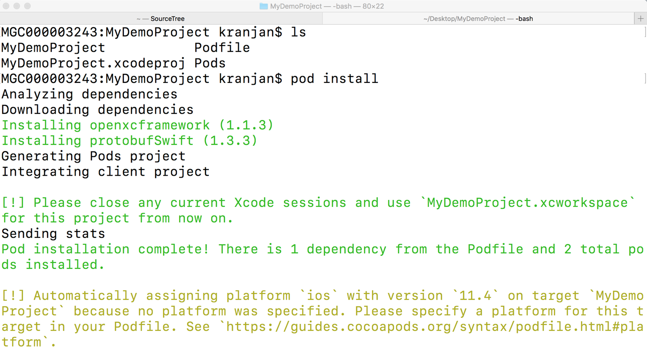

After “pod install” command the project file Structure.

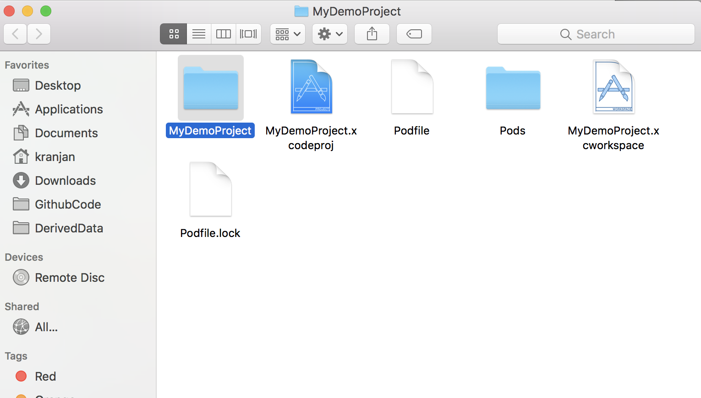

After opening of ”.xcworkspace” your bundle structure.

