# **1. INTRODUCTION**

**1.1 Definition:**

Nowadays, In This Time We See when any virus come then no one touch anyone and no one take anything by anyone hand , Now How can solve this problem , so we make a humanoid robot for solving this problem , our robot controlling by wireless , we use our mobile for giving command for robot working , our robot connected by our mobile so we can control our robot anywhere and in this robot we add food and medicine serving for system , So If you want to give any think anyone so we use that time our robot , robot go to that person and give your materials and come back and in this robot we add hand sanitizer if any one give to robot any think then first robot sanitize his hand automatically and take that materials so there is no virus problem for taking our materials and any think and if we want to say that person any think then in robot we added voice system so we type SMS in our mobile and press command and robot make that sound for saying that person your SMS , So Our Robot very helpful for any virus time and in hospital for servicing medicine and food for patient , So Our Robot Making Purpose is Successfully , Because Our Robot Work perfectly and its Servicing is very easy and Best .In This Robot We Show controlling by wireless for serving food and medicine , So this robot can serve anything without human support , we can stay our chair and control by mobile and give command and he follow that command and do that work , in this robot we show automatic hand sanitizer when any one come for taking food that time he can sanitize his hand with our touch any think , and In This robot we use wireless voice system for talking if we do not go on there for food service time and we want to same say that parson , we type that SMS on our mobile and press command then robot speaker make that voice and give your SMS to that person , our robot help for area like if we want to serve medicine in hospital and there are covid patient and we don't want to go on there then we can use this robot on there for service medicine and food .

**1.2 Project Overview:**

A remote controlled vehicle is any mobile machine controlled by means that is physically not connected with origin external to the machine. There are many types in it, based on the controls – radio control device, Wi-Fi controlled and even Bluetooth controlled. These Robot are always controlled by humans and take no action autonomously. The main target in such vehicles would be to safely reach a designated point, manoeuvre the area and reach back to the point of origin. In this project we make use of the Bluetooth technology to control our machine car. We don’t call this as a robot as this device doesn’t have any sensors. Thereby, sensor less robots are machines. This machine can be controlled by any human using his android mobile phone, by downloading an app and connecting it with the Bluetooth module present inside our car. User can perform actions like moving forward, backward, moving left and right by the means of command using his-her mobile phone app. The task of controlling our car is taken car by the Arduino UNO with micro controller ATMEGA32, 16 MHz processor, 2 KB SRAM (Static Random Accessible Memory) and 32 KB flash memory. Arduino play a major role in the control section and had made it easier to convert digital signals and analogue signals into physical movements. The major reason for using a Bluetooth based tech is that we can change the remote anytime – mobiles phones, tablets and laptops and physical barriers like wall or doors do not affect the car controls.

**1.3 Scope:**

There is an excellent scope of humanoids in the future as technology gets better every day. Recent scenarios like the COVID-19 pandemic have shaken the industry in ways we never imagined. Humanoid robots, while being one of the smallest groups of service robots in the current market, have the greatest potential to become the industrial tool of the future. Companies like Softbank Robotics have created human-looking robots to be used as medical assistants.

.

**1.4 Hardware Specification:**

System requirements are as follows:

* Arduino UNO.
* Bluetooth module HC-05
* Gear motor 60RPM
* Motor driver L298D
* Speaker
* 5v Bluetooth amplifier wireless HI-FI module with mic audio player decoder
* Infrared module
* 12v Adapter
* DC Water pump
* 11.1v Battery
* 1k Resister
* Transistor TIP 32C

**1.5 Software Specification:**

* Arduino IDE.
* Android app.

**2. LITERATURE SURVEY**

**2.1 Existing System:**

Service robots are most commonly used to assist human employees in their daily tasks so they can focus on the most valuable customer- and patient-centric work. In retail organizations, service robots help enhance and personalize the customer experience as well as improve in-store operations.

Examples are cleaning robot for public places, delivery robot in offices or hospitals, fire-fighting robot, rehabilitation robot and surgery robot in hospitals. In this context, an operator is a person designated to start, monitor and stop the intended operation of a →robot or a →robot system.

Service robots assist human beings, typically by performing a job that is dirty, dull, distant, dangerous or repetitive. They typically are autonomous and/or operated by a built-in control system, with manual override options. The term "service robot" does not have a strict technical definition.

**2.2 Proposed System:**

In This Time We See when any virus come then no one touch anyone and no one take anything by anyone hand. Now how can solve this problem, so we make a humanoid robot for solving this problem. Our robot controlling by wireless. We use our mobile for giving command for robot working. Our robot connected by our mobile so we can control our robot anywhere and in this robot we add food and medicine serving for system. So if you want to give any think anyone so we use that time our robot.

Robot go to that person and give your materials and come back and in this robot we add hand sanitizer if any one give to robot any think then first robot sanitize his hand automatically and take that materials so there is no virus problem for taking our materials and any think and if we want to say that person any think then in robot we added voice system so we type SMS in our mobile and press command and robot make that sound for saying that person your SMS. Our Robot very helpful for any virus time and In hospital for servicing medicine and food for patient. So Our Robot Making Purpose is Successfully, Because Our Robot Work perfectly and its Servicing is very easy and best.

**2.3 Feasibility Study:**

Some people get carried away by the things a robot can do that they rush to deploy one without carrying out any feasibility studies. A feasibility study is very necessary before you start any project that requires a robot. Also before you get any investors on board, it is very important to know exactly why you need one and if the requirements you have need the services of a robot while ensuring that whatever visions you have are worth spending your money.

**2.3.1 Economical Feasibility**

The development of this application is economically feasible as it only requires a suitable environment and open-source technologies with no extra charges. To date, most robot adoption has occurred in manufacturing, where there are robots designed to perform a wide variety of manual tasks more efficiently and consistently than humans. But with continued innovation, robot use is spreading to many other sectors too, from agriculture to logistics to hospitality.

**2.3.2 Technical Feasibility**

A technical feasibility study assesses the details of how you intend to deliver a product or service to customers. Think materials, labour, transportation, where your business will be located, and the technology that will be necessary to bring all this together.

Technological feasibility is established when the Company has completed a detailed program design and has determined that a product can be produced to meet its design specifications, including functions, features and technical performance requirements.

**2.3.3 Behavioural Feasibility**

The modes of behaviour for the robot toward the patient were decided to be aiming at cheerfulness, politeness, responsibility, intellect, logic, helpfulness, personalization, trust, and convenience.

**3. SYSTEM ANALYSIS AND DESIGN**

**3.1 Requirement Specification:**

Let’s see the requirement one by one in brief:

* Hardware Requirements
* Software Requirements

**Hardware Requirements:**

1. **Arduino UNO:**

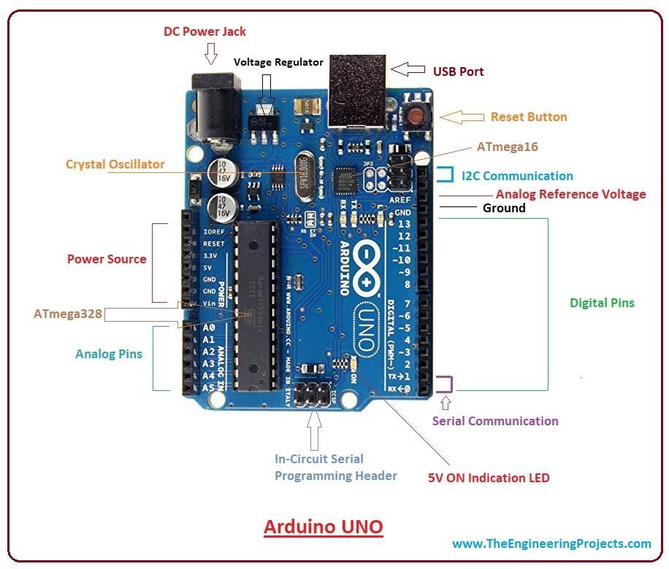

The Arduino Uno is an open-source microcontroller board dependent on the Microchip ATmega328P microcontroller and created by Arduino.cc. It is programmable with the Arduino IDE through a kind B USB cable. It can be controlled by the USB link or by an outside 9-volt battery, however it acknowledges voltages between 7 and 20 volts.

.

1. **Bluetooth module HC-05:**

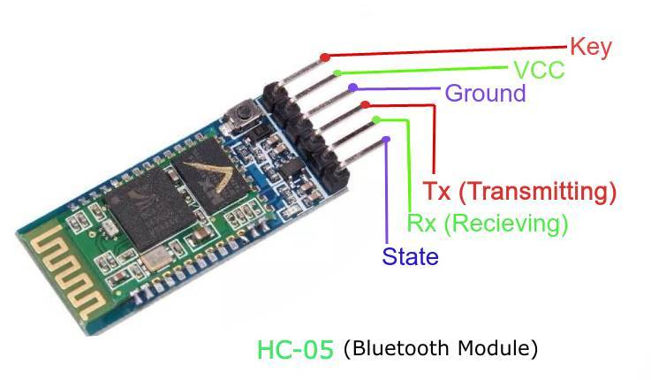

HC‐05 module is simple to use Bluetooth SPP (Serial Port Protocol) module, designed for clear wireless serial association setup. The HC-05 Bluetooth Module is utilized in a Master or Slave configuration, creating it a good resolution for wireless communication.

1. **Gear motor 60RPM:**

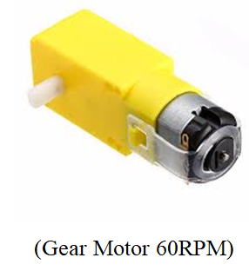

In Robotics Gears are used to transfer rotational forces between axles. They can change speed and direction. The axles can stand in any orientation, however not all orientation can be done with 2 gears. Commonly gears are used to reduce the speed of a motor.

1. **Motor driver L298D:**

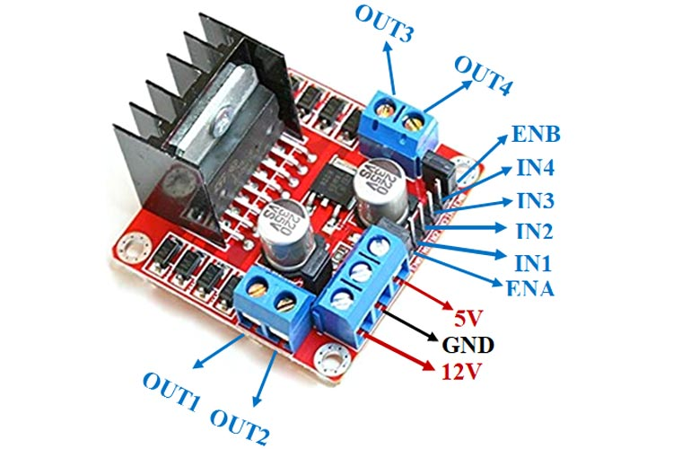

This L298N Based Motor Driver Module is a powerful engine driver ideal for driving DC Motors and Stepper Motors. It utilizes the well known L298 engine driver IC and has the locally available 5V controller which it can gracefully to an outside circuit. It can control up to 4 DC engines, or 2 DC engines with directional and speed control.

1. 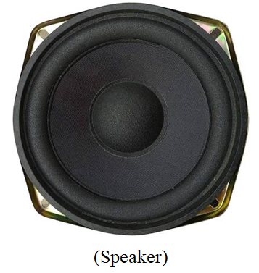**Speaker:**

The primary objective of speakers is to offer audio output for the listener. The electromagnetic waves are converted into sound waves through the speaker as they are transducers. The devices, like an audio receiver or computer, give audio input to speakers, which may be in the form of analog or digital.

1. **5v Bluetooth amplifier wireless HI-FI module with mic audio player:**

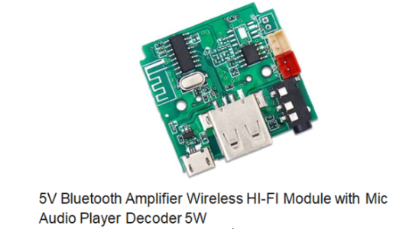

A simple circuit board to support Bluetooth audio and inbuilt amplifier. It supports various audio connection options like USB, memory card, and Bluetooth.

1. 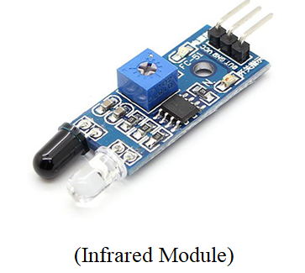**Infrared module:**

IR Sensor module has great adaptive capability of the ambient light, having a pair of infrared transmitter and the receiver tube, the infrared emitting tube to emit a certain frequency, encounters an obstacle detection direction (reflecting surface), infrared reflected back to the receiver tube receiving, after a comparator circuit processing, the green LED lights up, while the signal output digital signal

1. **12v Adapter:**

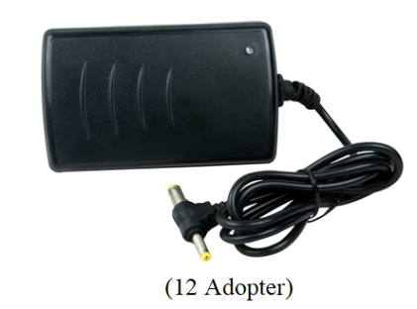

The 12 Volt Adapter Power Supply is used in: Pads, Laptop computers, lighting, mobile equipment and many more. They are now finding their way into more consumer toys, games and other home goods.

1. **DC Water pump:**

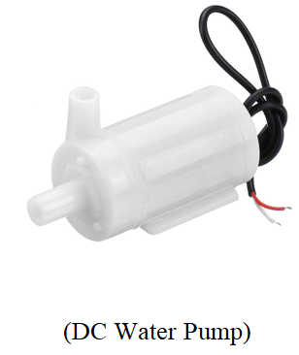

DC powered pumps use direct current from motor, battery, or solar power to move fluid in a variety of ways. Motorized pumps typically operate on 6, 12, 24, or 32 volts of DC power. Solar-powered DC pumps use photovoltaic (PV) panels with solar cells that produce direct current when exposed to sunlight.

1. **11.1v Battery:**

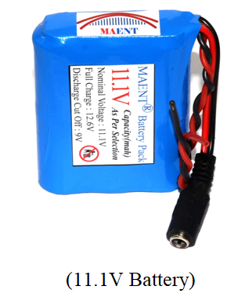

11.1V is a same type battery as 12.6V battery. They are a battery based on Lithium cell which every cell of Lithium have Voltage ranged from 3.7V (discharged) to 4.2V (charged).

1. **1k Resister:**

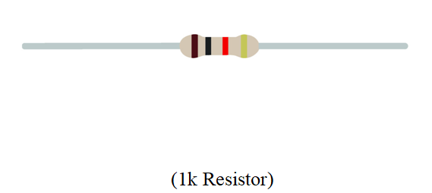

Commonly used in breadboards and other prototyping applications, these 1K ohm resistors make excellent pull-ups, pull-downs and current limiters.

1. **Transistor TIP 32C:**

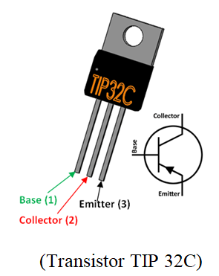

The TIP32 is a PNP Power transistor. Since it has high collector current of about 2A it can be used for Power switching or large signal amplification. The transistor is mainly known for its high amplification capacity since 2A is not much of a higher capacity.

**Software Requirements:**

1. **Arduino IDE**

The Arduino Integrated Development Environment (IDE) is a cross-stage application (for Windows, macOS, Linux) that is written in capacities from C and C++. It is utilized to compose and transfer projects to Arduino perfect sheets. Arduino programs are written in the Arduino Integrated Development Environment (IDE). Arduino IDE is a special software running on your system that allows you to write sketches (synonym for program in Arduino language) for different Arduino boards. The Arduino Integrated Development Environment - or Arduino Software (IDE) - contains a text editor for writing code, a message area, a text console, a toolbar with buttons for common functions and a series of menus. It connects to the Arduino hardware to upload programs and communicate with them. **The open-source Arduino Software** (IDE) makes it easy to write code and upload it to the board.

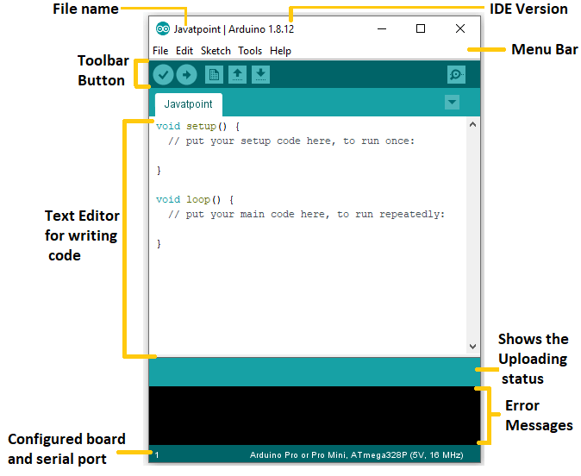

**This is the code you will have to upload to your Arduino board.**

chart;

voidsetup() {

pinMode(13,OUTPUT); //left motors forward

pinMode(12,OUTPUT); //left motors reverse

pinMode(11,OUTPUT); //right motors forward

pinMode(10,OUTPUT); //right motors reverse

pinMode(9,OUTPUT); //Led

Serial.begin(9600);

}

voidloop() {

if(Serial.available()){

t=Serial.read();

Serial.println(t);

}

if(t=='F'){ //move forward(all motors rotate in forward direction)

digitalWrite(13,HIGH);

digitalWrite(11,HIGH);

}

elseif(t=='B'){ //move reverse (all motors rotate in reverse direction)

digitalWrite(12,HIGH);

digitalWrite(10,HIGH);

}

elseif(t=='L'){ //turn right (left side motors rotate in forward direction, right side motors doesn't rotate)

digitalWrite(11,HIGH);

}

elseif(t=='R'){ //turn left (right side motors rotate in forward direction, left side motors doesn't rotate)

digitalWrite(13,HIGH);

}

elseif(t=='W'){ //turn led on or off)

digitalWrite(9,HIGH);

}

elseif(t=='w'){

digitalWrite(9,LOW);

}

elseif(t=='S'){ //STOP (all motors stop)

digitalWrite(13,LOW);

digitalWrite(12,LOW);

digitalWrite(11,LOW);

digitalWrite(10,LOW);

}

delay(100);

}

1. **Android APP**

**Android:**

Android is an open-source operating system which means that any manufacturer can use it in their phones free of charge. It was built to be truly open. Android is built on the open Linux Kernel. Furthermore, it utilizes a custom JAVA virtual machine.

**Android Application on mobile phones:**

An android app is meant for phones with android based operating systems. They can be downloaded from the android app Market which is pre-loaded on every android phone. Blue control APP and Bluetooth Spp APP are some examples.

**Android Application Operated Bluetooth:**

The Android platform includes support for the Bluetooth network stack, which allows a device to wirelessly exchange data with other Bluetooth devices. The application framework provides access to the Bluetooth functionality through the Android Bluetooth APIs.

**Android Application:**

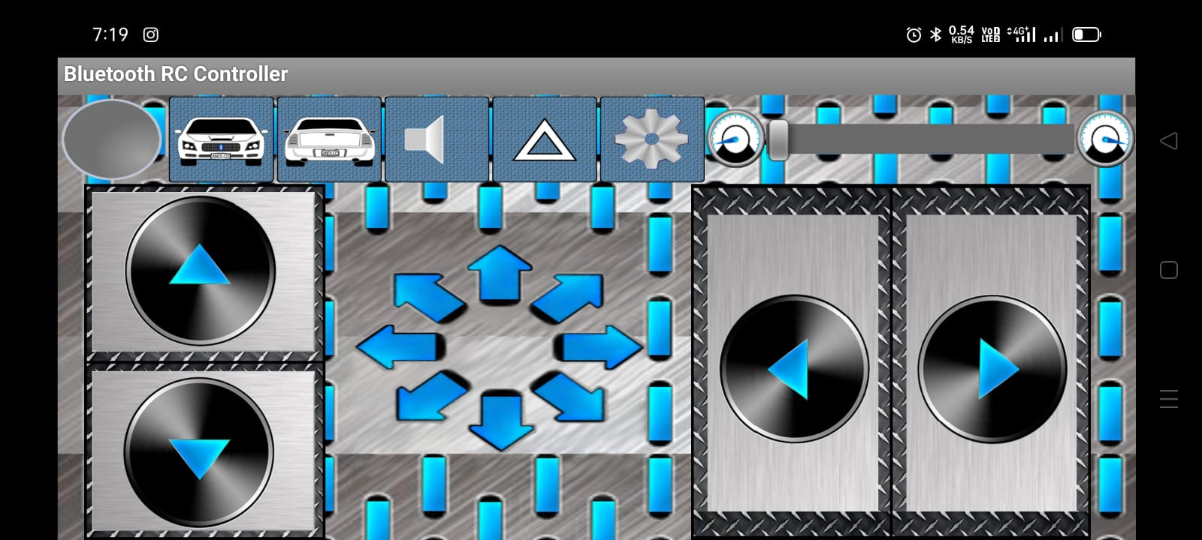

**3.2** **Working Principle:**

In This Robot We show three working So We explains making and connection step by step:

* **Step 1: How we make robot working details:**

Working Take a closer look on the Wiring Diagram. We could notice the power source, four 1.5 volt batteries connected to the 12V power pin of L298 Motor Drive and ground of Motor Drive and Arduino UNO. This supplies essential power to the circuit. A total of 6 volts is being supplied to this system, where the maximum permissible amount is 12 volts. Digital wires of Arduino are connected with the input1, input2, input3 and input4 of the motor drive. Motors are connected to the either sides of Motor Drive which are the outputs terminals. To complete the power source circuit, 5V of Motor Drive is connected to Vin power pin of Arduino UNO. Followed by this, HC05 Bluetooth Module’s Vcc is connected to 5V pin of Arduino UNO, which supplies power to Bluetooth Module. Ground to Ground connections are also made. Transistor logic pins, Transmitter (TX) and Receiver (RX) of Arduino UNO are connected to RXD and TXD of HC05 respectively. The program is uploaded to Arduino before connecting the Bluetooth module. After all successful connections, switch on the power source. Lights at Motor Drive, Arduino UNO and HC05 would indicate the correct connection. Upon successful connection of your Bluetooth module with any android device, we could control this device. By passing the command, for example, to move forward we pass ‘F’. This command is transmitted by our device to Bluetooth module, which in turn transmits to Arduino UNO. Arduino receives is and passes the same to Motor Drive through its digital pins. Motor Drive will get this through their input pins and exercise them through their output pins were motor is connected.

* **Step 2: Automatic Hand Sanitizer System:**

The schematic is very simple and easy to understand. IR proximity sensor detects the presence of a hand and makes the OUT pin LOW. Normally OUT pin keeps HIGH. When it goes low it turns on the PNP transistor and the pump becomes on. I used the BD136 power transistor for the circuit. A 1K resistor is connected between sensor OUT and the base of the transistor. It protects the transistor from burning out. Turn the potentiometer of the sensor from the lowest sensitivity level, and slightly increase it to achieve your desired detection range. Do NOT make it too sensitive because the pump might act spontaneously without any trigger!. For powering the circuit and the motor a 14500 Li-ion cell is used and it is connected with a USB charging circuit. For the sanitizer container, you can select any similar glass or plastic container, such as a plastic coffee storage container. My selected one is a glass Horlicks container. An encloser for the circuit is designed according to the cap size and the file is attached.

* **Step 3: Bluetooth Speaker Circuit :**

In this system we use Bluetooth module and speaker we Connected Bluetooth module to speaker directly and give Arduino Battery power to Bluetooth module and open our mobile app and connected to Bluetooth and type the SMS and press the speaker button and sound make the sound of that SMS..

**3.3** **Diagram:**

**Block Diagram:**

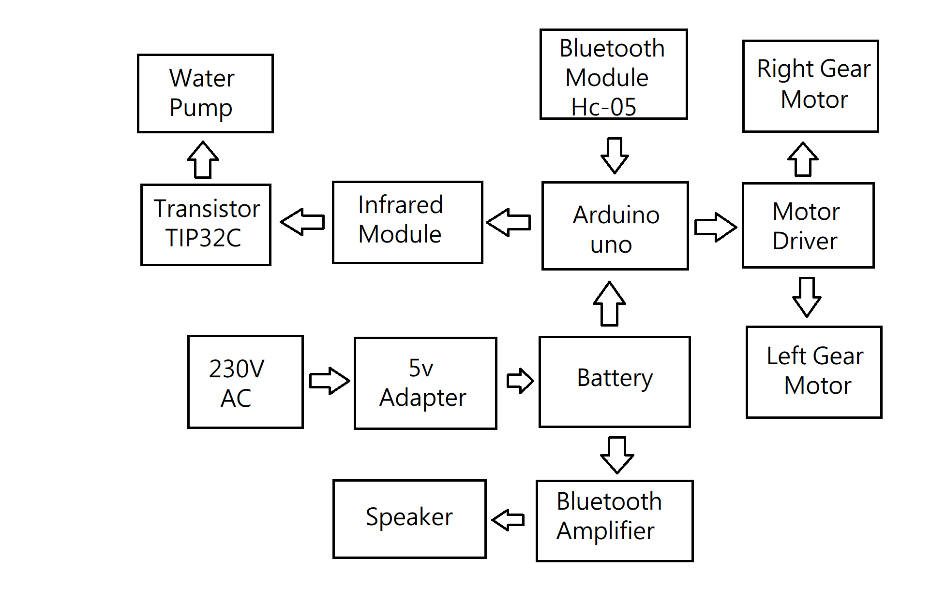

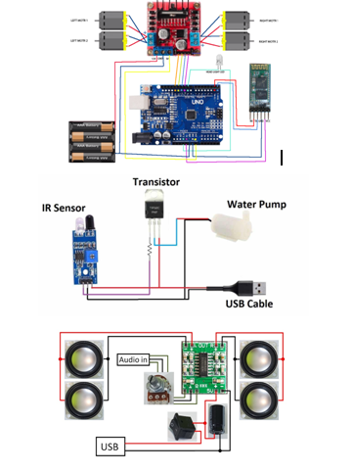**Circuit Diagram:**

Working Take a closer look on the Wiring Diagram. We could notice the power source, four 1.5 volt batteries connected to the 12V power pin of L298 Motor Drive and ground of Motor Drive and Arduino UNO. This supplies essential power to the circuit. A total of 6 volts is being supplied to this system, where the maximum permissible amount is 12 volts. Digital wires of Arduino are connected with the input1, input2, input3 and input4 of the motor drive. Motors are connected to the either sides of Motor Drive which are the outputs terminals. To complete the power source circuit, 5V of Motor Drive is connected to Vin power pin of Arduino UNO. Followed by this, HC05 Bluetooth Module’s Vcc is connected to 5V pin of Arduino UNO, which supplies power to Bluetooth Module. Ground to Ground connections are also made. Transistor logic pins, Transmitter (TX) and Receiver (RX) of Arduino UNO are connected to RXD and TXD of HC05 respectively. The program is uploaded to Arduino before connecting the Bluetooth module. After all successful connections, switch on the power source. Lights at Motor Drive, Arduino UNO and HC05 would indicate the correct connection. Upon successful connection of your Bluetooth module with any android device, we could control this device. By passing the command, for example, to move forward we pass ‘F’. This command is transmitted by our device to Bluetooth module, which in turn transmits to Arduino UNO. Arduino receives is and passes the same to Motor Drive through its digital pins. Motor Drive will get this through their input pins and exercise them through their output pins were motor is connected. The schematic is very simple and easy to understand. IR proximity sensor detects the presence of a hand and makes the OUT pin LOW. Normally OUT pin keeps HIGH. When it goes low it turns on the PNP transistor and the pump becomes on. I used the BD136 power transistor for the circuit. A 1K resistor is connected between sensor OUT and the base of the transistor. It protects the transistor from burning out. Turn the potentiometer of the sensor from the lowest sensitivity level, and slightly increase it to achieve your desired detection range. Do NOT make it too sensitive because the pump might act spontaneously without any trigger!. For powering the circuit and the motor a 14500 Li-ion cell is used and it is connected with a USB charging circuit. For the sanitizer container, you can select any similar glass or plastic container, such as a plastic coffee storage container. My selected one is a glass Horlicks container. An encloser for the circuit is designed according to the cap size and the file is attached. In this system we use Bluetooth module and speaker we Connected Bluetooth module to speaker directly and give Arduino Battery power to Bluetooth module and open our mobile app and connected to Bluetooth and type the SMS and press the speaker button and sound make the sound of that SMS. HC-05 Bluetooth Module is an easy to use Bluetooth SPP (Serial Port Protocol) module, designed for transparent wireless serial connection setup. Its communication is via serial communication which makes an easy way to interface with controller or PC.

**3.4 Application:**

* Low range Mobile Surveillance Devices
* Military Applications (no human intervention)
* Assistive devices (like wheelchairs)
* Home automation

**3.5 Advantages:**

* It can move in all 8 directions i.e., in 360 degrees.
* Robots can work in factories and do the same thing over and over again and not do it any differently.
* This robot is serve food or products, to carry material from one place to another, to send medicines to the patients kept in the isolated environments etc.

**3.6 Disadvantages:**

* Results from humanoid robots will be that many people are going to lose their jobs.
* They Need Constant Power.
* They're Restricted to their Programming.
* The Perform Relatively Few Tasks.
* They Have No Emotions.
* They Impacts Human Interaction.
* They Require Expertise to Set Them Up.
* They're Expensive to Install and Run.

**4. OUTPUT**

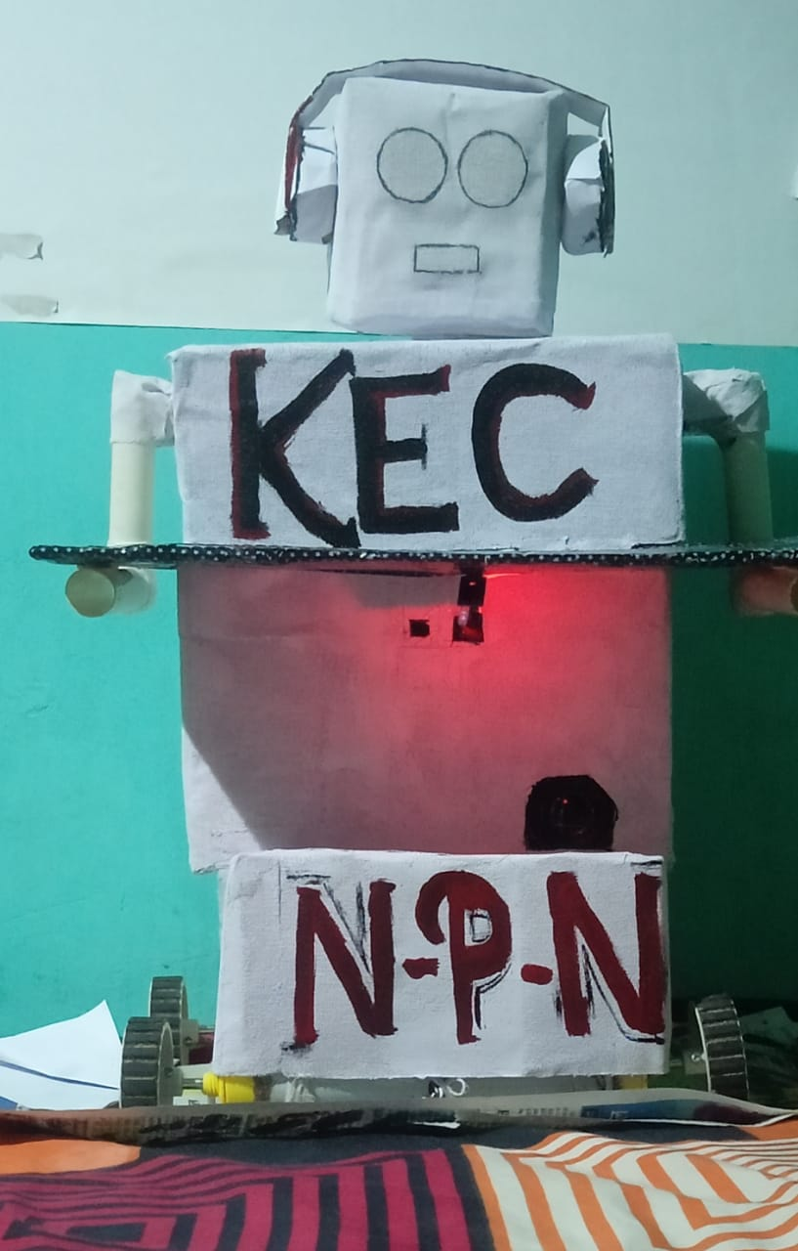

# **5. CONCLUSION**

To us the need of internet and the things which are internet based are very much important nowadays. IOT or internet of things is the very important part in both computer and our daily lives. The above model describes how the Arduino programs the robot motor module and by IoT we actually rotate the wheels and give direction to the robot. IoT gives us the opportunity to work with different platforms and it helps us to create various interesting modules to work on. We also tested the applications used to food servicing robot. Due to the new concept of Wireless Controlled robot using Bluetooth, Wi-Fi and IOT, In A Future we use this type of robot in our life for servicing food and for other work , so our project successful and its working amazing so our conclusion is good after complete our project.

**5. REFRENCES**

1. Arduino UNO

<https://www.electronicscomp.com/arduinounor3compatiblebestpriceindia?gclid=Cj0KCQjw4SBhCgARIsAAlegrWlfdMD3n54iBBkOSfsmHvSx4H6I_Ijke7v5yPvCAdbpifUqA7oaAsjhEALwwcB>

2. All module buy by this website

<https://compoindia.com/>

3. Coding for using this app

<https://www.arduino.cc/en/software>

4. https://www.shutterstock.com/search/car+drawing

5. https://www.instructables.com/Smartphone-Controlled-RC-Car-Using-Arduino/