Night Time Mosquitos VR Experience.

**Game Concept:**

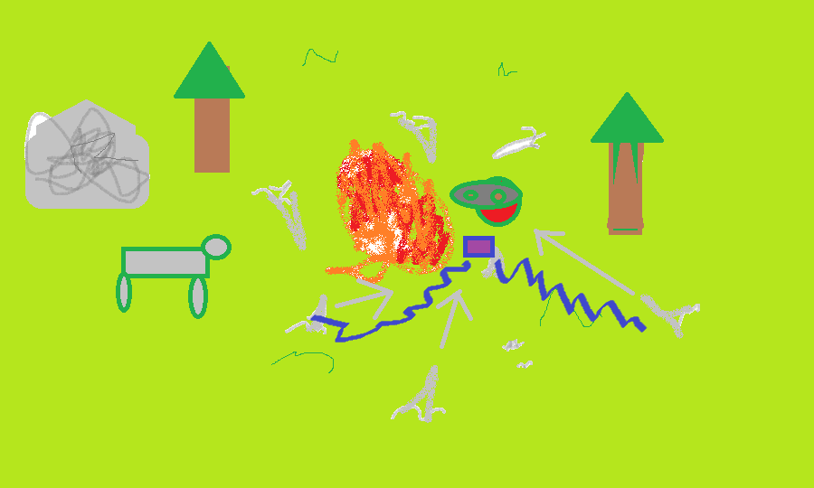You see beautiful natural scenery at night. There are animals standing and you have a horse. Nice fire. And then you get annoyed by robot mosquitos that you need to shoot down with electromagnetic waves that have the right frequency.

**Target Platform:**

Oculus for now.

Cross-Platform (VR Standard Assets).

**Game Mechanics:**

Click to shoot down mosquitos. Punch them. Adjust the frequency of your waves by dials on the device (Laser shooter).

* Reticle for gaze-based interactions
* You don’t move much.
* They stop before they reach you. But their sound is annoying.

**Assets:**

**Sound**: Sound of fire cracking, laser shooting, nighttime bug sounds, sound of mosquitos, mosquitos getting shot.

**Models:** Mosquitos, nature, fire, animals, weapon, skybox, trees.