2

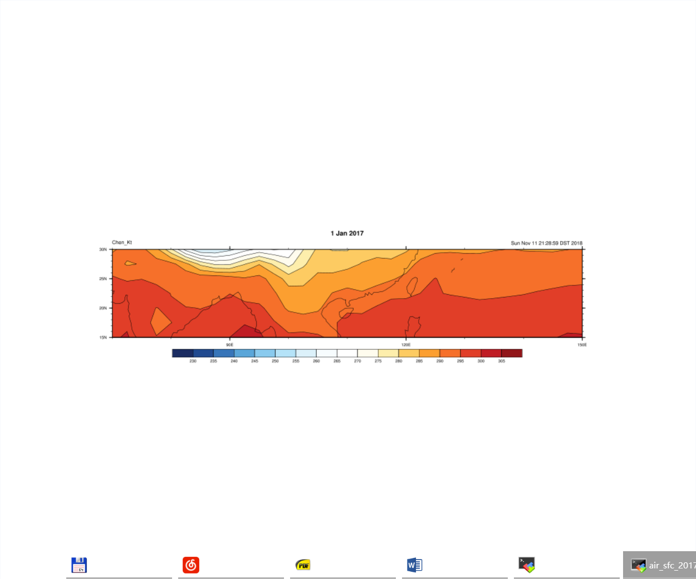

3

Copyright (C) 1995-2018 - All Rights Reserved

University Corporation for Atmospheric Research

NCAR Command Language Version 6.5.0

The use of this software is governed by a License Agreement.

See http://www.ncl.ucar.edu/ for more details.

Variable: f

Type: file

filename: air.sig995.201701

path: air.sig995.201701.nc

file global attributes:

CDI : Climate Data Interface version ?? (http://mpimet.mpg.de/cdi)

history : Sat Nov 03 18:11:23 2018: cdo selmon,1 air.sig995.2017.nc ../air.sig995.201701.nc

created 2013/12 by Hoop (netCDF2.3)

Conventions : COARDS

title : mean daily NMC reanalysis (2014)

description : Data is from NMC initialized reanalysis

(4x/day). These are the 0.9950 sigma level values.

platform : Model

References : http://www.esrl.noaa.gov/psd/data/gridded/data.ncep.reanalysis.html

dataset_title : NCEP-NCAR Reanalysis 1

CDO : Climate Data Operators version 1.7.0 (http://mpimet.mpg.de/cdo)

dimensions:

lon = 144

lat = 73

x = 2

time = 31 // unlimited

variables:

float lon ( lon )

standard_name : longitude

long_name : Longitude

units : degrees_east

axis : X

float lat ( lat )

standard_name : latitude

long_name : Latitude

units : degrees_north

axis : Y

double time ( time )

standard_name : time

long_name : Time

units : hours since 1800-1-1 00:00:00

calendar : standard

axis : T

float air ( time, lat, lon )

long_name : mean Daily Air temperature at sigma level 995

units : degK

_FillValue : -9.96921e+36

missing_value : -9.96921e+36

precision : 2

least_significant_digit : 1

GRIB_id : 11

GRIB_name : TMP

var_desc : Air temperature

dataset : NCEP Reanalysis Daily Averages

level_desc : Surface

statistic : Mean

parent_stat : Individual Obs

actual_range : ( 193.85, 318.65 )

double time_bnds ( time, x