1. Various Loans: Yearly and Branch Level Information.

1. Trending of Loans on Weekly For Specific Branch: 2002

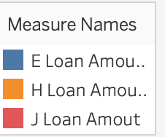

This trending helps to understand on a regular basis specific loan in terms of Amount is happening.

1. E-Loan/ H Loan and J Loan On Weekly Basis.

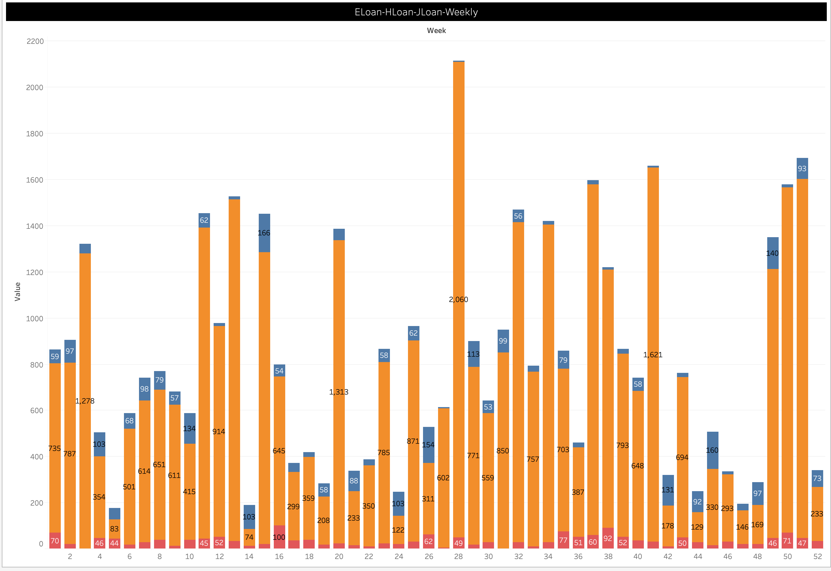

Here we can see that even weekly basis, we can see the contribution of specific loan.

1. Total Loan Amount vs Total Number of Loans (Yearly basis)

This is to check Overall Total Amount against Total Transactions over a period of time

1. E-Loan Amount – Yearly Wise

E Loan is major contribution over a period of time.

1. Total Loan Amount: Weekly Trending

1. Total Number of Loans : Weekly basis

