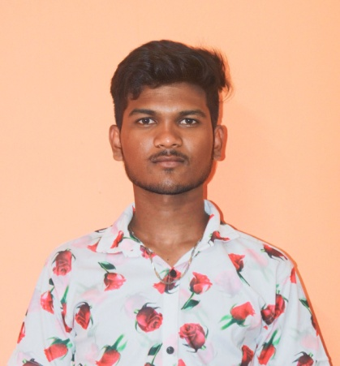SAMSON V

Front-end developer & web developer

**Email:** [sson76628@gmail.com](mailto:sson76628@gmail.com)

**Phone No:** 9363125355

**Address:** Avvai street, Thiruvalluvar nagar, katpadi,

Vellore District.

**ABOUT ME:**

* I am a BCA graduate at DON BOSCO COLLEGE as a fresher, I would like to explore more in my career and I would like to be a good programmer.

**CAREER OBJECTIVE:**

* I want to become a good passionate programmer is my goal. Having a good knowledge of programming will help me to do many projects. Like to work in a big company by putting heart and soul with full of hard work. Use modern programming languages to build a innovative projects that will be useful to the clients. My ambition is to become a software engineer.

**EDUCATIONAL PROFILE:**

|  |  |  |  |  |
| --- | --- | --- | --- | --- |
| **QUALIFICATION** | **INSTITUTION** | **UNIVERSITY/BOARD** | **YEAR OF PASSING** | **MARKS** |
| BCA | DON BOSCO COLLEGE | THIRUVALLUVAR UNIVERSITY | 2024 | 73% |
| HSC 12th | T.M.K.V.GOVT.BOYS.  HR.SEC.SCHOOL | STATE BOARD | 2021 | 80% |
| HSC 11th | T.M.K.V.GOVT.BOYS.  HR.SEC.SCHOOL | STATE BOARD | 2020 | 64% |
| SSLC 10TH | T.M.K.V.GOVT.BOYS.  HR.SEC.SCHOOL | STATE BOARD | 2019 | 67% |

**PROJECTS COMPLETED:**

* Personal portfolio using html, css, JavaScript, bootstrap.

([www.happysamson.000webhostapp.com](http://www.happysamson.000webhostapp.com)).

* Sacred heart church management system for Gandhi nagar parish, Vellore using html, css, javascript, bootstrap, php and mysql.

**PERSONAL SKILLS:**

* Programming.
* Communication.

**PROGRAMMING SKILLS:**

* C
* C++
* JAVA
* HTML
* CSS
* SQL(Query)

**Hobbies:**

* Playing volleyball.
* Watching movies.
* Listening to songs.
* Drawing.

**Declaration:**

* I hereby declare that all the information given above is true and correct to the best of my knowledge.