# 1、

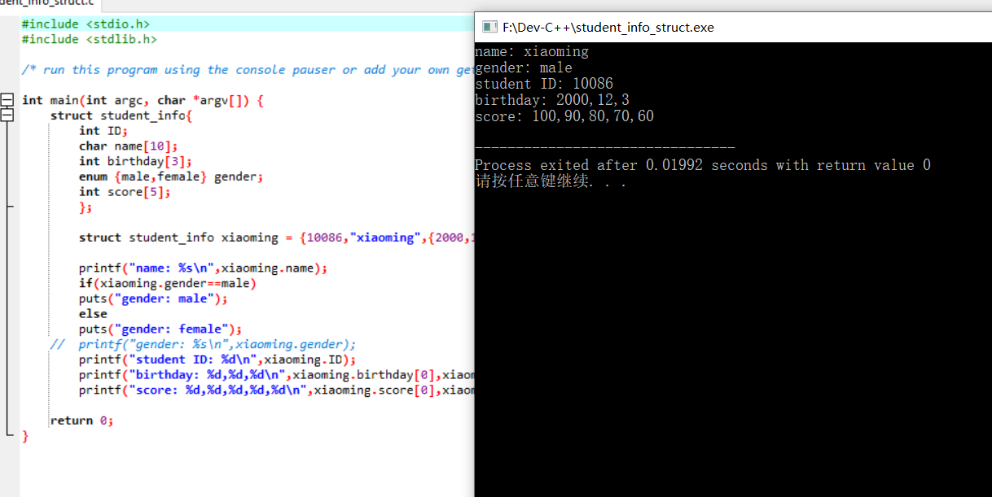#include <stdio.h>

#include <stdlib.h>

/* run this program using the console pauser or add your own getch, system("pause") or input loop */

int main(int argc, char *argv[]) {

struct student_info{

int ID;

char name[10];

int birthday[3];

enum {male,female} gender;

int score[5];

};

struct student_info xiaoming = {10086,"xiaoming",{2000,12,3},male,{100,90,80,70,60}};

printf("name: %s\n",xiaoming.name);

if(xiaoming.gender==male)

puts("gender: male");

else

puts("gender: female");

// printf("gender: %s\n",xiaoming.gender);

printf("student ID: %d\n",xiaoming.ID);

printf("birthday: %d,%d,%d\n",xiaoming.birthday[0],xiaoming.birthday[1],xiaoming.birthday[2]);

printf("score: %d,%d,%d,%d,%d\n",xiaoming.score[0],xiaoming.score[1],xiaoming.score[2],xiaoming.score[3],xiaoming.score[4]);

return 0;

}

# 2、

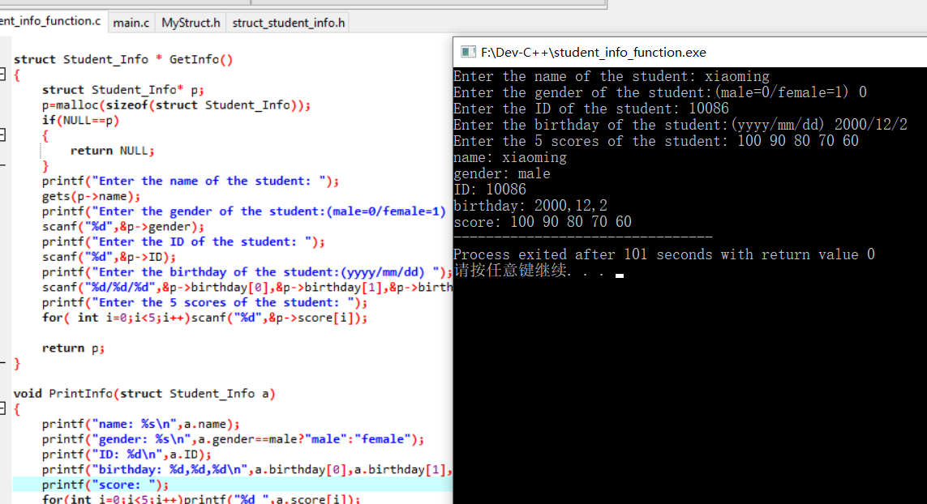#include <stdio.h>

#include <stdlib.h>

#include "struct_student_info.h"

/* run this program using the console pauser or add your own getch, system("pause") or input loop */

struct Student_Info * GetInfo();

void PrintInfo(struct Student_Info a);

int main(int argc, char *argv[]) {

struct Student_Info xiaoming=*GetInfo();

PrintInfo(xiaoming);

return 0;

}

struct Student_Info * GetInfo()

{

struct Student_Info* p;

p=malloc(sizeof(struct Student_Info));

if(NULL==p)

{

return NULL;

}

printf("Enter the name of the student: ");

gets(p->name);

printf("Enter the gender of the student:(male=0/female=1) ");

scanf("%d",&p->gender);

printf("Enter the ID of the student: ");

scanf("%d",&p->ID);

printf("Enter the birthday of the student:(yyyy/mm/dd) ");

scanf("%d/%d/%d",&p->birthday[0],&p->birthday[1],&p->birthday[2]);

printf("Enter the 5 scores of the student: ");

for( int i=0;i<5;i++)scanf("%d",&p->score[i]);

return p;

}

void PrintInfo(struct Student_Info a)

{

printf("name: %s\n",a.name);

printf("gender: %s\n",a.gender==male?"male":"female");

printf("ID: %d\n",a.ID);

printf("birthday: %d,%d,%d\n",a.birthday[0],a.birthday[1],a.birthday[2]);

printf("score: ");

for(int i=0;i<5;i++)printf("%d ",a.score[i]);

}

# 3、

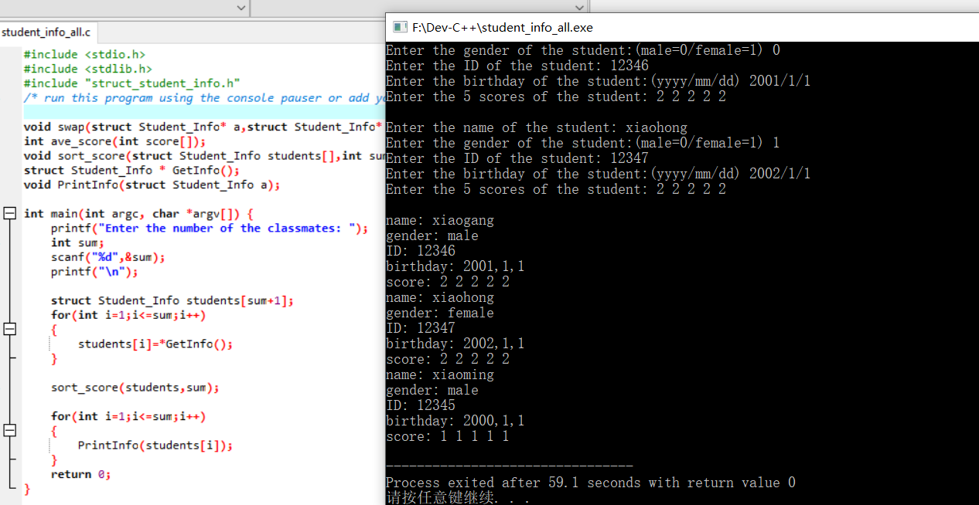

#include <stdio.h>

#include <stdlib.h>

#include "struct_student_info.h"

/* run this program using the console pauser or add your own getch, system("pause") or input loop */

void swap(struct Student_Info* a,struct Student_Info* b);

int ave_score(int score[]);

void sort_score(struct Student_Info students[],int sum);

struct Student_Info * GetInfo();

void PrintInfo(struct Student_Info a);

int main(int argc, char *argv[]) {

printf("Enter the number of the classmates: ");

int sum;

scanf("%d",&sum);

printf("\n");

struct Student_Info students[sum+1];

for(int i=1;i<=sum;i++)

{

students[i]=*GetInfo();

}

sort_score(students,sum);

for(int i=1;i<=sum;i++)

{

PrintInfo(students[i]);

}

return 0;

}

void sort_score(struct Student_Info students[],int sum)

{

for(int i=1;i<=sum;i++)

{

for(int j=i;j<=sum;j++)

{

if(ave_score(students[i].score) < ave_score(students[j].score))

{

swap(&students[i],&students[j]);

}

}

}

}

int ave_score(int score[])

{

return (score[0]+score[1]+score[2]+score[3]+score[4])/5;

}

void swap(struct Student_Info* a,struct Student_Info* b)

{

struct Student_Info temp=*a;

*a=*b;

*b=temp;

}

void PrintInfo(struct Student_Info a)

{

printf("name: %s\n",a.name);

printf("gender: %s\n",a.gender==male?"male":"female");

printf("ID: %d\n",a.ID);

printf("birthday: %d,%d,%d\n",a.birthday[0],a.birthday[1],a.birthday[2]);

printf("score: ");

for(int i=0;i<5;i++)printf("%d ",a.score[i]);

printf("\n");

}

struct Student_Info * GetInfo()

{

struct Student_Info* p;

p=malloc(sizeof(struct Student_Info));

if(NULL==p)

{

return NULL;

}

printf("Enter the name of the student: ");

scanf("%s",&p->name);

printf("Enter the gender of the student:(male=0/female=1) ");

scanf("%d",&p->gender);

printf("Enter the ID of the student: ");

scanf("%d",&p->ID);

printf("Enter the birthday of the student:(yyyy/mm/dd) ");

scanf("%d/%d/%d",&p->birthday[0],&p->birthday[1],&p->birthday[2]);

printf("Enter the 5 scores of the student: ");

for( int i=0;i<5;i++)scanf("%d",&p->score[i]);

printf("\n");

return p;

}