# 1、

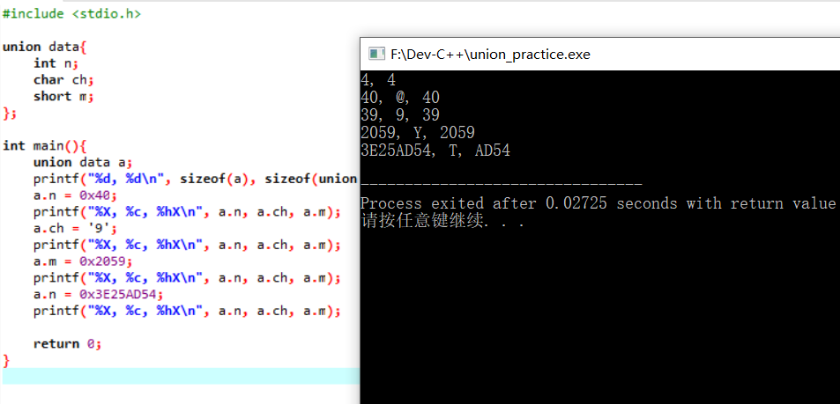

1. 对于第一行输出，分析：共用体所占空间即为其所含最大类型变量所占空间；
2. 对于第二行输出，分析：0x40存在4个byte中的第一个，故in和short都可输出，其中%hx是将short类型按16进制输出的格式控制符。且0x40对应的10进制是64，以64为ASCII码的是@;
3. 对于第三行输出，分析：‘9’所对应的ASCII码是57，换算成16进制就是0x39，存在第一个byte中，故short也可输出；
4. 对于第四行输出，0x2059将0x59（也就是低位）存在第一个byte中，将0x20存在第二个byte中，故short也可输出，但char仅对应0x59，换算成10进制就是89，也就是ASCII码中的Y；
5. 对于第五行输出，从第一个byte到第四个byte，依次存储 0x54,0xAD,0x25,0x3E，故short仅输出AD54，char仅对应0x54，换算成10进制就是84，也就是ASCII中的T。

# 2、

#include <stdio.h>

#include <stdlib.h>

/* run this program using the console pauser or add your own getch, system("pause") or input loop */

int main(int argc, char *argv[]) {

struct address_format

{

int srtsubnet;

int srcnode;

union{

int dstsubnet;

int dstgroup;

};

union{

int dstnode_2a;

struct{

int dstnode_2b;

int group;

int grpmemb;

};

int unique_node_id[6];

};

};

return 0;

}

# 3、

//node_practioce_main.c

#include <stdio.h>

#include <stdlib.h>

#include "node_practice_operation.h"

/* run this program using the console pauser or add your own getch, system("pause") or input loop */

void main(int argc, char *argv[]) {

printf("-------create with 1 node-------\n");

INFO info1={2000};

node *head=create(info1);

printf("length=%d\n",length(head));

print(head);

printf("\n");

printf("--------Insert after 1st Node-----\n");

INFO info2={2001};

insert(head,info2,1);

printf("length=%d\n",length(head));

print(head);

printf("\n");

printf("-------Insert after 2nd Node-----\n");

INFO info3={2002};

insert(head,info3,2);

printf("length=%d\n",length(head));

print(head);

printf("\n");

printf("-----------Delete 3rd Node------\n");

delete(head,2);

printf("length=%d\n",length(head));

print(head);

printf("\n");

printf("--------Destroy all nodes-------\n");

destory(head);

printf("-----------destroy done-------\n\n");

printf("-------create several nodes -----\n");

head=create(info1);

insert(head,info2,1);

insert(head,info3,2);

printf("length=%d\n",length(head));

print(head);

printf("\n");

// printf("------After bubble_sort1 ----\n");

// bubble_sort1(head);

// print(head);

// printf("\n");

// printf("------After bubble_sort2-----\n");//wrong

// bubble_sort2(head);

// print(head);

// printf("\n");

// printf("------After selection_sort------\n");

// selection_sort(head);

// print(head);

// printf("\n");

printf("-----After insertion_sort-------\n");

head =insertion_sort(head);

print(head);

printf("\n");

// printf("------After quick_sort---------\n");\\amazing, it works

// quick_sort(head);

// print(head);

// printf("\n");

}

//node_practice_operation.c

#include "node_practice_operation.h"

node * create(INFO info)//only used to create and return a head node

{

node * head;

head=malloc(sizeof(node));

if(NULL==head)

{

printf("Error: malloc failed in create \n");

}

head->info=info;

head->next=NULL;

return head;

}

int length(node * head)//include head

{

int len=0;

while(NULL!=head)

{

head=head->next;

len++;

}

return len;

}

node* insert(node * head,INFO info,int position)//插入到head之后的第position个位置

{

if(position<0 || position>length(head))

{

printf("Illegal position in insert");

return;

}

node* new_node=malloc(sizeof(node));

if(NULL==new_node)

{

printf("Error: malloc failed in insert \n");

}

new_node->info=info;

if(position==0)

{

new_node->next=head;

head=new_node;

}

else

{

while(--position)head=head->next;

new_node->next=head->next;

head->next=new_node;

}

return new_node;

}

void delete(node* head,int position)//删除head之后的第position个节点

{

if(position<1 || position>length(head))

{

printf("Illegal poisition in delete");

return;

}

while(--position)head=head->next;

head->next=head->next->next;

}

void print(node *head)

{

while(NULL!=head)

{

printf("the score of the node is: ");

printf("%d\n",head->info.score);

head=head->next;

}

}

void destory(node* head)

{

int count=length(head);

while(--count)

{

delete(head,count);

}

free(head);

}

void swap(int *a,int *b)

{

int temp=*a;

*a=*b;

*b=temp;

}

void bubble_sort1(node* head)//soga,in my opinion...in fact,it's selection sort

{

for(node* p=head;NULL!=p; p=p->next)

{

for(node* q=p;NULL!=q;q=q->next)

{

if(q->info.score > p->info.score)

{

swap(&p->info.score,&q->info.score);//jiao huan liang jie dian weizhi

}

}

}

}

void bubble_sort2(node* head)//bubble sort is j & j+1, but not i & j(selection) emmm maybe

{

int len=length(head);

int flag;

node *c1,*c2;

for(int i=0;i<len-1;i++)

{

flag=0;

for(int j=0;j<len-1-i;j++)

{

c1=get_node(head,j);

c2=c1->next;

if(c1->info.score < c2->info.score)

{

swap_info(&c1->info,&c2->info);

flag=1;

}

}

if(flag==0)

{

break;

}

}

}

void swap_info(INFO* a,INFO* b)

{

INFO temp=*a;

*a=*b;

*b=temp;

}

node* get_node(node* head, int pos)//return NO.pos node after head, just like a arrray

{

if(pos<0 || pos>=length(head))

{

printf("Illegal position in get_node");

return NULL;

}

while(NULL!=head && pos--)head=head->next;

return head;

}

void selection_sort(node * head)//from big to small

{

node *c1,*c2;

int len=length(head);

for(int i=0;i<len;i++)

{

int flag=i;

for(int j=i+1;j<len;j++)

{

c1=get_node(head,j);

c2=get_node(head,flag);

if(c1->info.score > c2->info.score)

{

flag=j;

}

}

if(i!=flag)

{

c1=get_node(head,i);

c2=get_node(head,flag);

swap_info(&c1->info,&c2->info);

}

}

}

node* insertion_sort(node* head)

{

int len=length(head);

node *c1,*c2;

for(int i=1;i<len;i++)

{

c1=get_node(head,i);

int flag=i;

for(int j=i-1;j>=0;j--)

{

c2=get_node(head,j);

if(c1->info.score > c2->info.score)

{

node* p=insert(head,c1->info,j);

if(j==0)

{

delete(head,flag);

head=p;

}

else

{

delete(head,flag+1);

}

}

else

{

c2->next=c1;

}

flag--;

}

}

return head;

}

void quick_sort_recursive(node* head,int start,int end)//just like a array

{

if(start>=end)return;

int left=start,right=end;

INFO mid=head->info;

INFO com1,com2;

while(left<right)

{

do

{

left++;

com1=get_node(head,left)->info;

}while(com1.score <= mid.score && left<end);

do

{

com2=get_node(head,right)->info;

right--;

}while(com2.score >= mid.score && right>start);

right++;//使right与com2对应

if(left<right)

{

swap_info(&com1,&com2);

}

}

swap_info(&mid,&com2);

quick_sort_recursive(head,start,left-1);//left is the first number of the higher area

quick_sort_recursive(head,left,end-1);

}

void quick_sort(node* head)

{

int len=length(head);

quick_sort_recursive(head,0,len-1);

}

//node_practice_operation.h

#include <stdio.h>

#include <stdlib.h>

#include "node_practice_struct.h"

node * create(INFO info);//only used to create and return a head node

int length(node * head);//include head

node* insert(node * head,INFO info,int position);//插入到head之后的第position个位置

void delete(node* head,int position);//删除head之后的第position个节点

void print(node *head);

void destory(node* head);

void swap(int *a,int *b);

void bubble_sort1(node* head);//soga,in my opinion...in fact,it's selection sort

void bubble_sort2(node* head);//bubble sort is j & j+1, but not i & j(selection) emmm maybe

void swap_info(INFO* a,INFO* b);

node* get_node(node* head, int pos);//return NO.pos node after head, just like a arrray

void selection_sort(node * head);//from big to small

node* insertion_sort(node* head);

void quick_sort_recursive(node* head,int start,int end);//just like a array

void quick_sort(node* head);

//node_practice_struct.h

typedef struct {

int score;

}INFO;

typedef struct mystruct{

INFO info;

struct mystruct* next;

}node;