

**计算机与程序设计基础**

实

验

指

导

书

信息科学与工程学院

实验一

目录

1 2

2 3

3 4

4 5

5 6

# 1

#include<stdio.h>

int main()

{

float r=10;

float pi=3.14;

printf("the volume of a ball is:%f",(4.0f/3.0f)*pi*r*r*r);

}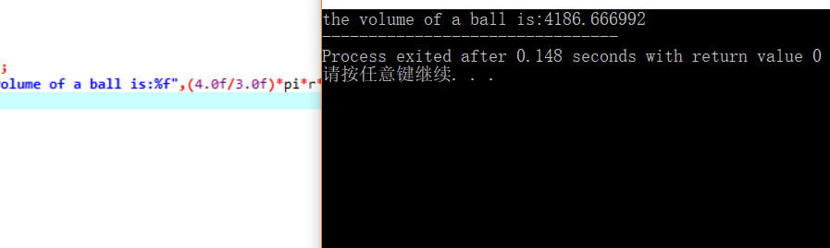

# 2

#include<stdio.h>

int main()

{

printf("Enter amount of loan:");

float loan;

scanf("%f",&loan);

printf("\nEnter interest rate:");

float rate;

scanf("%f",&rate);

printf("\nEnter monthly payment:");

float payment;

scanf("%f",&payment);

float x1=loan-payment+loan*((rate/100.0f)/12);

printf("\nBalance remaininf after first payment:%.2f",x1);

float x2=x1-payment+x1*((rate/100.0f)/12);

printf("\nBalance remaininf after second payment:%.2f",x2);

float x3=x2-payment+x2*((rate/100.0f)/12);

printf("\nBalance remaininf after third payment:%.2f",x3);

return 0;

}

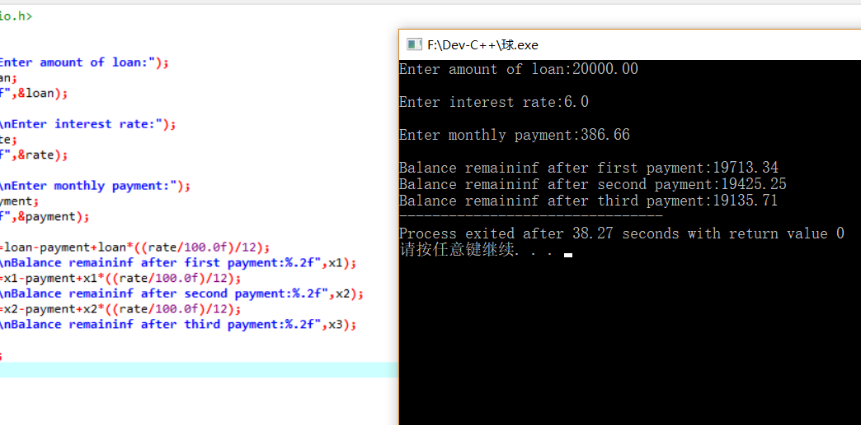

# 3

#include<stdio.h>

int main()

{

printf("Enter item number:");

int num;

scanf("%d",&num);

printf("Enter unit price:");

double price;

scanf("%lf",&price);

printf("Enter purchase date (mm/dd/yyyy):");

int m,d,y;

scanf("%d/%d/%d",&m,&d,&y);

printf("\nItem\tUnit\tPurchase\n\tPrice\tDate\n");

printf("%d\t$%6.2lf\t%d/%d/%d",num,price,m,d,y);

return 0;

}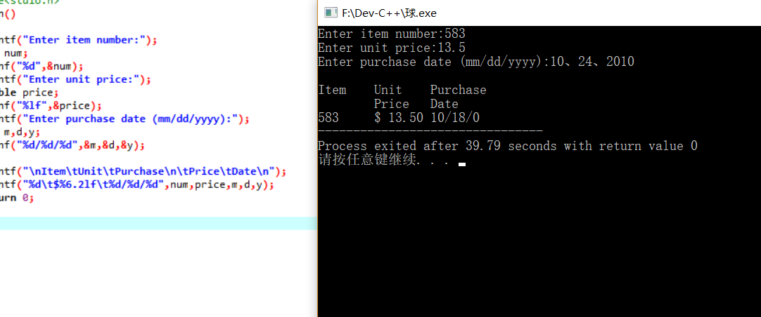

# 4

#include<stdio.h>

int main()

{

printf("Enter a number between 0 and 32767:");

int x;

scanf("%d", &x);

int a[6];

for (int i = 1; i <= 5; i++)

{

a[i] = x % 8;

x = x / 8;

}

int t = a[1] + a[2] * 10 + a[3] * 100 + a[4] * 1000 + a[5] * 10000;

if (t >= 10000)

printf("In octal,your number is:%5d",t);

else

printf("In octal,your number is:0%-5d",t);

return 0;

}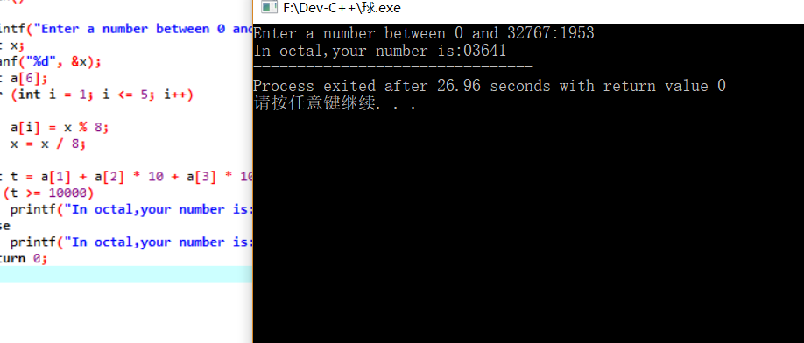

# 5

#include<stdio.h>

int main()

{

printf("enter a number of three digit:");

int x;

scanf("%d",&x);

int a[4];

for(int i=1;i<=3;i++)

{

a[i]=x%10;

x=x/10;

}

printf("the answer is:%d",a[1]+a[2]+a[3]);

return 0;

}