

目录

1、 2

2、 3

3、 4

4、 5

5、 6

# 1、

#include <stdio.h>

#include <stdlib.h>

int main()

{

printf("Enter an expression: ");

double a[100]={0};

char b[100]={0};

int i=0;

for(i=1;;i++)//get the value or control of expression

{

scanf("%lf",&a[i]);

scanf("%c",&b[i]);

if(b[i]=='\n')

{

break;

}

}

for(int j=1;j<=i;j++)//calculate the value of experssion

{

if(b[j]=='+')

{

a[j+1]=a[j]+a[j+1];

}

if(b[j]=='-')

{

a[j+1]=a[j]-a[j+1];

}

if(b[j]=='*')

{

a[j+1]=a[j]*a[j+1];

}

if(b[j]=='/')

{

a[j+1]=a[j]/a[j+1];

}

if(b[j]=='\n')

{

printf("Value of expression: ");

printf("%g",a[j]);

return 0;

}

}

}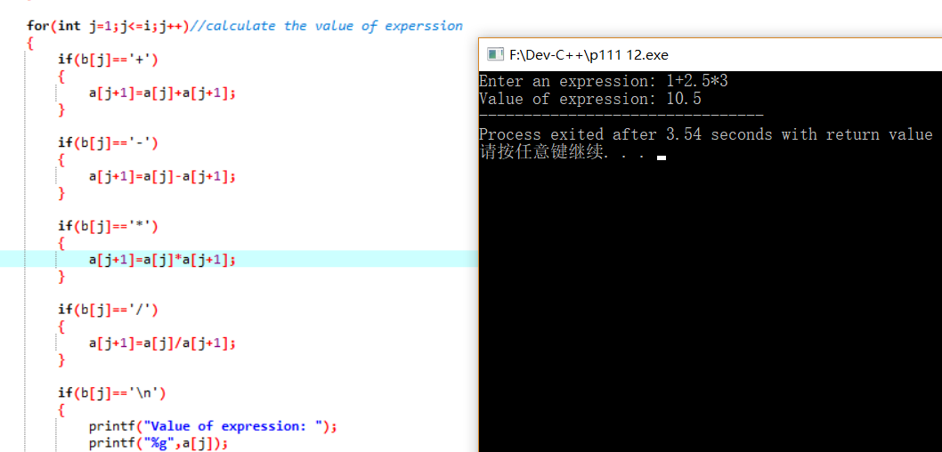

# 2、

#include <stdio.h>

#include <stdlib.h>

#include <math.h>

int main()

{

printf("Enter a positive number: ");

double dest=0;

scanf("%lf",&dest);

double guess=1;

double ans=1;

for(int i=1;;i++)

{

guess=ans;

ans=(guess+dest/guess)/2;

if(fabs(guess-ans)<0.00001*guess)

{

printf("Square root: ");

printf("%lf",ans);

break;

}

}

}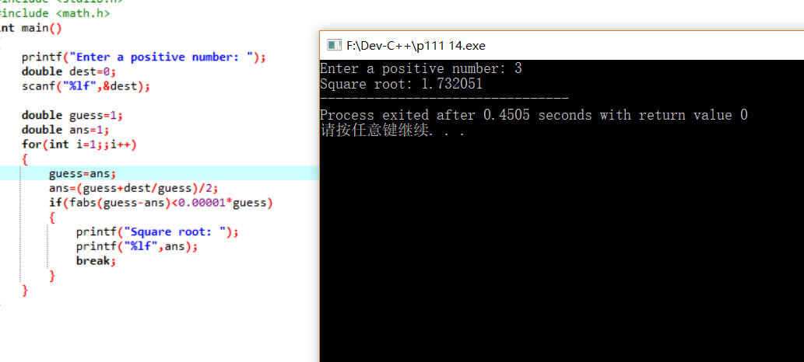

# 3、

#include <stdio.h>

#include <stdlib.h>

int main()//reverse a sentence

{

printf("Enter a sentence:");

char a[100];

gets(a);

char end; //get the end of a sentence

int i=0;

do

{

if(a[i]=='.' || a[i]=='?' || a[i]=='!')

{

end=a[i];

break;

}

i++;

}while(1);

printf("Reversal of sentence: ");//ex

int loca;//get the location of the ' '

int p;//get the location of the last ' '

for(int j=i;j>=0;j--)//reverse the sentence

{

if(a[j]==' ')

{

loca=j;

p=0;

do

{

printf("%c",a[++loca]);

p++;

}while(a[loca+1]!=' ' && a[loca+1]!='?');

printf(" ");

}

}

int lastone=0;

do

{

printf("%c",a[lastone++]);

}while(lastone!=loca-p);

printf("%c",end);

}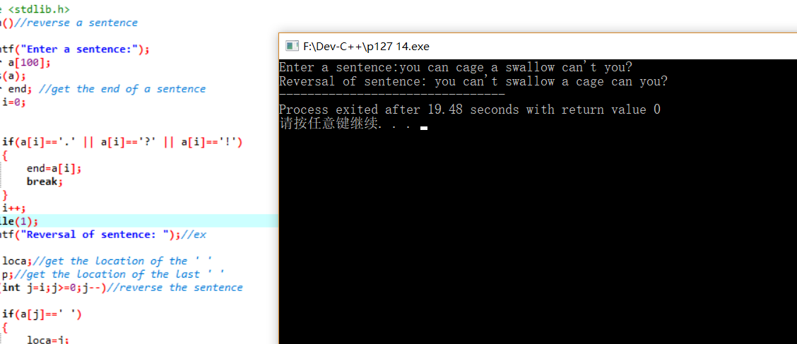

# 4、

#include <stdio.h>

#include <stdlib.h>

int main()

{

printf("Enter message to be encrypted: ");

char a[100];

gets(a);

printf("Enter shift amount (1-25): ");

int amo;

scanf("%d",&amo);

char b[100]={0};

for(int i=0;i<=99;i++)

{

if(a[i]>=90-amo+1 && a[i]<=90)b[i]=a[i]-26+amo;//up

else if(a[i]>=122-amo+1 && a[i]<=122)b[i]=a[i]-26+amo;

else if(a[i]>=65 && a[i]<90-amo+1)b[i]=a[i]+amo;

else if(a[i]>=97 && a[i]<122-amo+1)b[i]=a[i]+amo;

else b[i]=a[i];

}

printf("Encrypted message: ");

puts(b);

}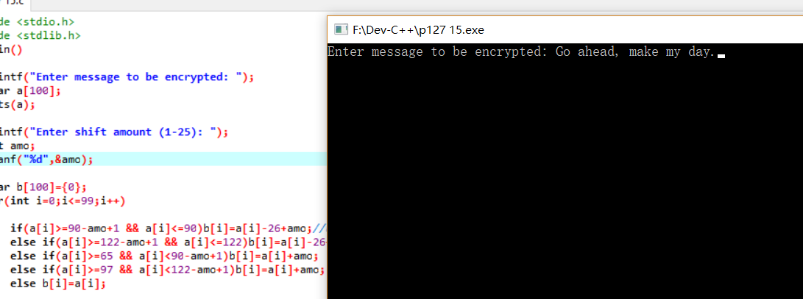

# 5、

#include <stdio.h>

#include <stdlib.h>

int main()

{

printf("Enter a string composed of int: ");

char a[100];

scanf("%s",a);

printf("the number of the string is: ");

for(int i=0;;i++)

{

if(a[i]=='\0')break;

printf("%d",a[i]-'0');

}

}