致伟大的杨老师：

这是王云鹏的第九周课下作业，请过目。

目录

p126 8 1

p126 14 4

p126 15 6

p126 16 7

p222 1 9

p222 18 11

# p126 8

#include <stdio.h>

//input the score of five students and get its sum,ave,after that,get the ave ,max, min of five courses

int main()

{

printf("please enter five scores of a student, and press the Enter, and repeat that untill getting five students:\n ");

int a[6][6];

for(int i=1;i<=5;i++)

{

for(int j=1;j<=5;j++)

{

scanf("%d",&a[i][j]);

}

}

int std_sum[5];

float std_ave[5];

for(int i=1;i<=5;i++)//std_sum

{

std_sum[i]=a[i][1]+a[i][2]+a[i][3]+a[i][4]+a[i][5];

printf("the sum of No.%d students is:",i);

printf("%d\n",std_sum[i]);

}

for(int i=1;i<=5;i++)//std_ave

{

std_ave[i]=std_sum[i]/5.0f;

printf("the ave of No.%d students is:",i);

printf("%.2f\n",std_ave[i]);

}

float cor_ave[5];

int max[5];

int min[5];

for(int i=1;i<=5;i++)//the ave of every course

{

cor_ave[i]=(a[1][i]+a[2][i]+a[3][i]+a[4][i]+a[5][i])/5.0f;

printf("the ave of No.%d course is:");

printf("%.2f\n",cor_ave[i]);

}

for(int i=1;i<=5;i++)//the max of every course

{

int max=0;

for(int j=1;j<=5;j++)

{

if(max<a[j][i])

max=a[j][i];

}

printf("the max of No.%d course is:",i);

printf("%d\n",max);

}

for(int i=1;i<=5;i++)//the min of every course

{

int min=100;

for(int j=1;j<=5;j++)

{

if(min>a[j][i])

min=a[j][i];

}

printf("the min of No.%d course is:",i);

printf("%d\n",min);

}

} 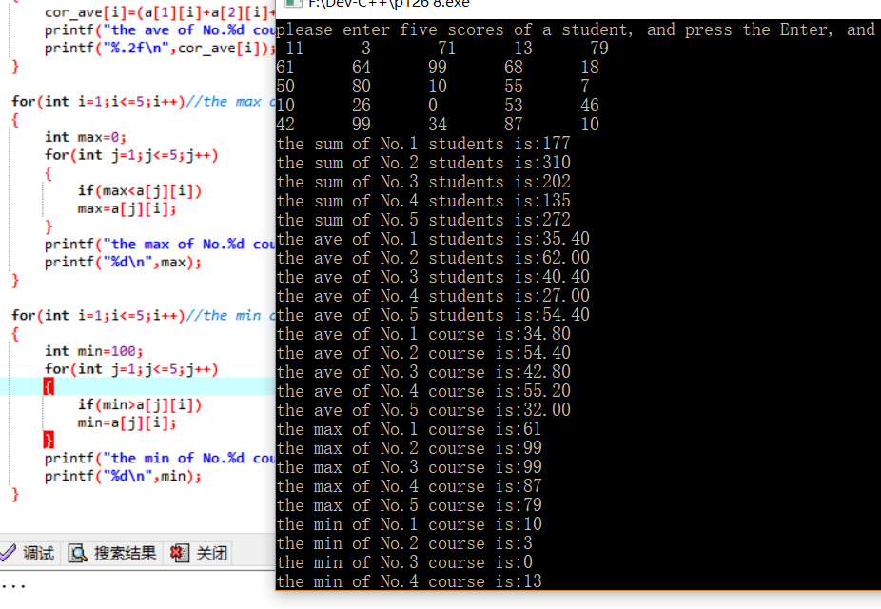

# p126 14

#include <stdio.h>

#include <stdlib.h>

int main()//reverse a sentence

{

printf("Enter a sentence:");

char a[100];

gets(a);

char end; //get the end of a sentence

int i=0;

do

{

if(a[i]=='.' || a[i]=='?' || a[i]=='!')

{

end=a[i];

break;

}

i++;

}while(1);

printf("Reversal of sentence: ");//ex

int loca;//get the location of the ' '

int p;//get the location of the last ' '

for(int j=i;j>=0;j--)//reverse the sentence

{

if(a[j]==' ')

{

loca=j;

p=0;

do

{

printf("%c",a[++loca]);

p++;

}while(a[loca+1]!=' ' && a[loca+1]!='?');

printf(" ");

}

}

int lastone=0;

do

{

printf("%c",a[lastone++]);

}while(lastone!=loca-p);

printf("%c",end);

} 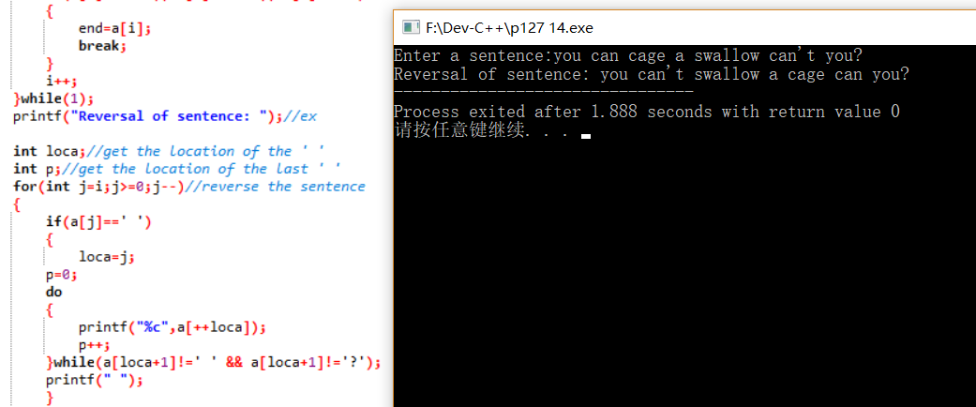

# p126 15

#include <stdio.h>

#include <stdlib.h>

int main()

{

printf("Enter message to be encrypted: ");

char a[100];

gets(a);

printf("Enter shift amount (1-25): ");

int amo;

scanf("%d",&amo);

char b[100]={0};

for(int i=0;i<=99;i++)

{

if(a[i]>=90-amo+1 && a[i]<=90)b[i]=a[i]-26+amo;//up

else if(a[i]>=122-amo+1 && a[i]<=122)b[i]=a[i]-26+amo;

else if(a[i]>=65 && a[i]<90-amo+1)b[i]=a[i]+amo;

else if(a[i]>=97 && a[i]<122-amo+1)b[i]=a[i]+amo;

else b[i]=a[i];

}

printf("Encrypted message: ");

puts(b);

}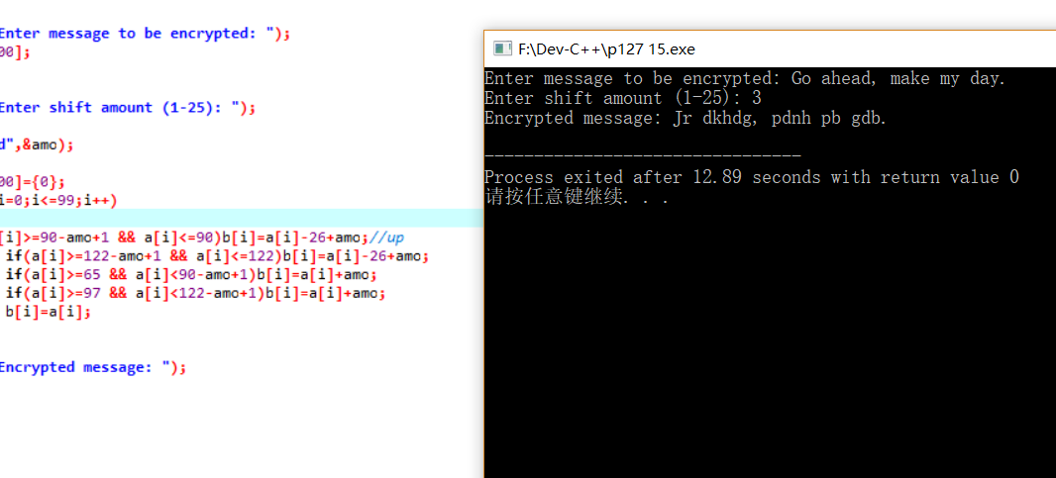

# p126 16

#include <stdio.h>

#include <stdlib.h>

#include<ctype.h>

int main()

{

char a[100]={0};

printf("Enter first word: ");

gets(a);

int b[100]={0};

for(int i=0;i<=99;i++)//transform to ascii

{

b[i]=tolower(a[i]);

}

printf("Enter second word: ");

char c[100]={0};

gets(c);

int d[100]={0};

for(int i=0;i<=99;i++)//transform to ascii

{

d[i]=tolower(c[i]);

}

for(int i=0;i<=99;i++)//compare b and d

{

for(int j=0;j<=99;j++)

{

if(b[i]==d[j])

{

d[j]=0;

break;

}

}

}

int count=0;//judge

for(int i=0;i<=99;i++)

{

if(d[i]==0)count++;

}

if(count==100)printf("The words are anagrama");

else printf("The words are not anagram");

}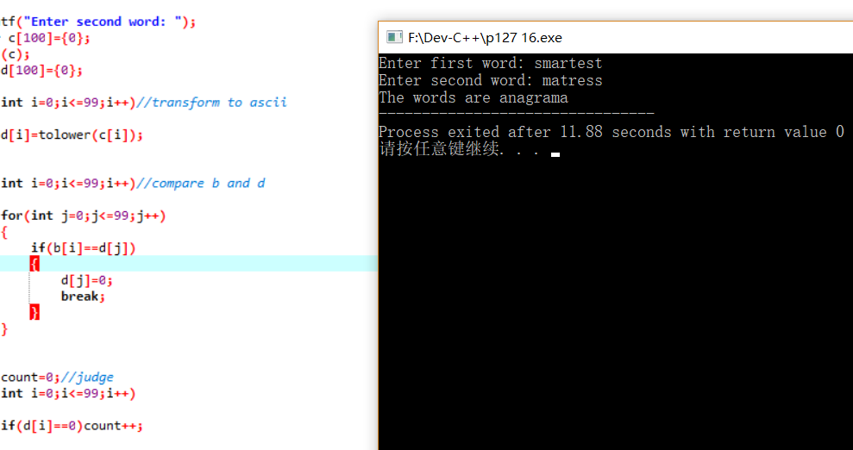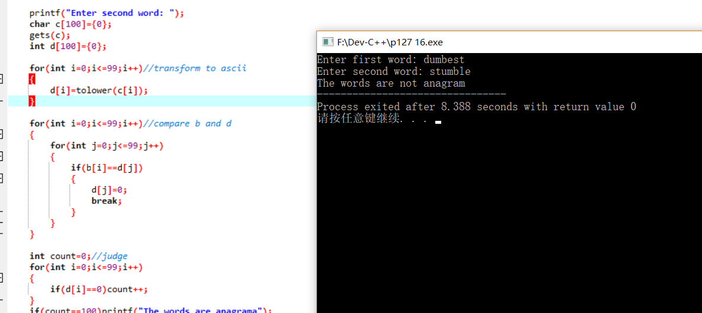

# p222 1

#include <stdio.h>

#include <stdlib.h>

int main()

{

char a[100][20]={0};

int i=0;

do

{

printf("Enter word: ");

gets(a[i]);

i++;

}while(strlen(a[i-1])!=4);

char* min=a[0];

char* max=a[0];

for(int i=0;i<=99;i++)

{

if(strlen(a[i])==0)break;

if(strcmp(a[i],min)<0)min=a[i];

if(strcmp(a[i],max)>0)max=a[i];

}

printf("Smallest word: ");

printf("%s\n",min);

printf("Largest word: ");

printf("%s",max);

}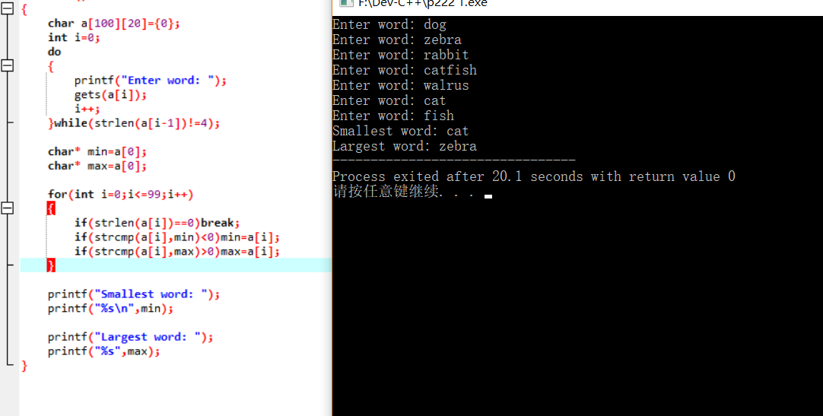

# p222 18

#include <stdio.h>

#include <stdlib.h>

int main()

{

printf("Enter a date (mm/dd/yyyy): ");

int day;

int year;

int month;

char* m[]={"January","Frbruary","March","April","May","june","july","August","September","October","November","December"};

scanf("%d/%d/%d",&month,&day,&year);

printf("You enter the date %s %d, %d",m[month-1],day,year);

}