

**计算机与程序设计基础**

实

验

指

导

书

信息科学与工程学院

目录

1 1

2 2

3 4

4 6

5 8

# 1

#include<stdio.h>

int main()

{

float m;

scanf("%f",&m);

if(m<=750)printf("%f",m/100);

else if(m<=2250)printf("%f",7.50+(m-750.0)*(1.0f/100.0f));

else if(m<=3750)printf("%f",37.50+(m-2250.0)*(3.0f/100.0f));

else if(m<=5250)printf("%f",82.50+(m-3750.0)*(4.0f/100.0f));

else if(m<=7000)printf("%f",142.50+(m-5250.0)*(5.0f/100.0f));

else printf("%f",230.00+(m-7000.0)*(6.0f/100.0f));

return 0;

}

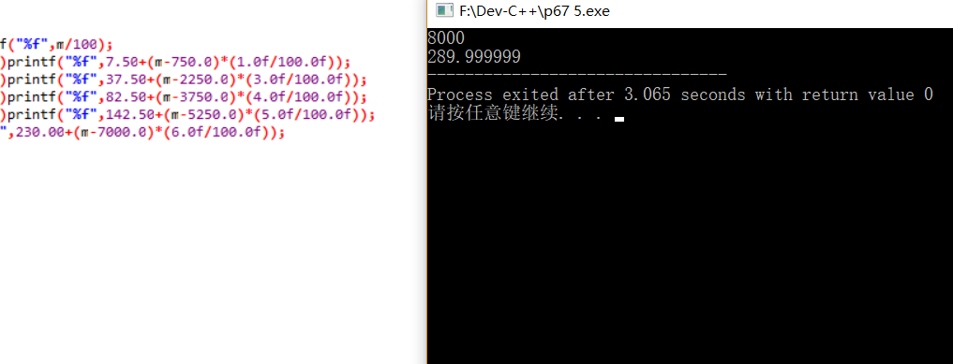

# 2

#include <stdio.h>

int main()

{

printf("please enter a number of two digit:");

int x[3];

int i;

for(i=1;i<=2;i++)

{

scanf("%1d",&x[i]);

}

switch(x[1])

{

case 1:goto TAG1;

case 2:printf("twenty-");goto TAG2;

case 3:printf("thirty-");goto TAG2;

case 4:printf("fourty-");goto TAG2;

case 5:printf("fifty-");goto TAG2;

case 6:printf("sixty-");goto TAG2;

case 7:printf("seventy-");goto TAG2;

case 8:printf("eighty-");goto TAG2;

case 9:printf("ninety");goto TAG2;

}

TAG1:

switch(x[2]){

case 1:printf("eleven");return 0;

case 2:printf("twelve");return 0;

case 3:printf("thirteen");return 0;

case 4:printf("fourteen");return 0;

case 5:printf("fifteen");return 0;

case 6:printf("sixteen");return 0;

case 7:printf("seventeen");return 0;

case 8:printf("eighteen");return 0;

case 9:printf("nineteen");return 0;

}

TAG2:

switch(x[2]){

case 1:printf("one");break;

case 2:printf("two");break;

case 3:printf("three");break;

case 4:printf("four");break;

case 5:printf("five");break;

case 6:printf("six");break;

case 7:printf("seven");break;

case 8:printf("eight");break;

case 9:printf("nine");break;

}

}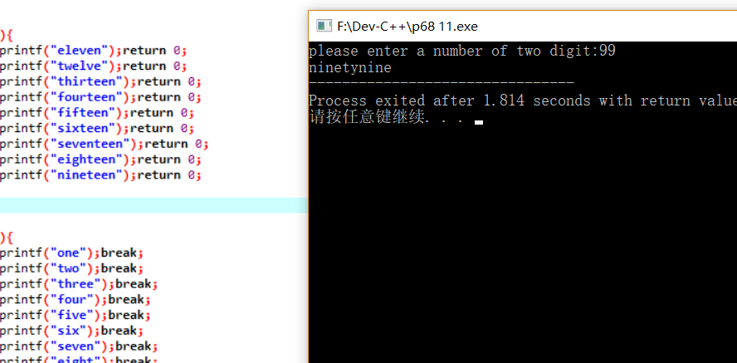

# 3

#include <stdio.h>

int main()

{

printf("Enter number of days in month:");

int num;

scanf("%d",&num);

if(num<28 || num>31)

{

printf("error: number of days!");

return 0;

}

printf("Enter starting day of the week(1=Sun,7=Sat):");

unsigned int beg;

scanf("%ud",&beg);

if(beg>7 || beg==0)

{

printf("error: starting day!");

return 0;

}

int i;

for(i=1;i<beg;i++)

{

printf("\t");

}

for(i=1;i<=num;i++)

{

printf("%d\t",i);

if(i==8-beg)printf("\n");

if(i==15-beg)printf("\n");

if(i==22-beg)printf("\n");

if(i==29-beg)printf("\n");

}

}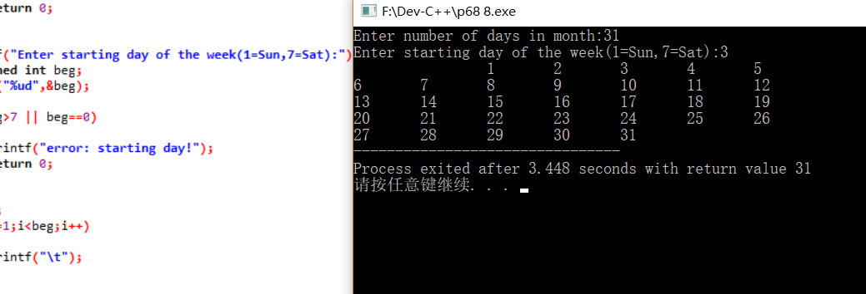

# 4

#include <stdio.h>

int ama(int n)

{

int i;

int x=1;

for(i=1;i<=n;i++)

{

x*=i;

}

return

x;

}

int main()//print e

{

printf("to get the value of e, enter a number of int:");

unsigned n;

scanf("%ud",&n);

int i;

double e=1.0f;

for(i=1;i<=n;i++)

{

double x;

x=1.0f/ama(i);

e+=x;

}

printf("the value of e is:%lf",e);

}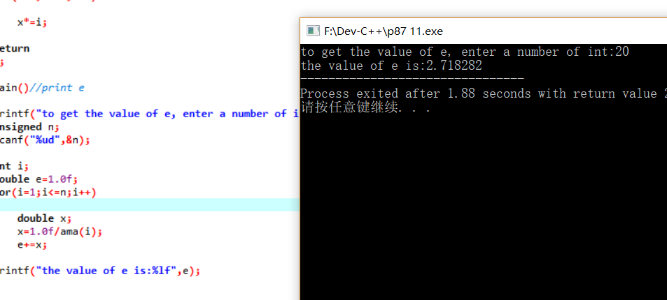

# 5

#include <stdio.h>

int findsum(int i,int* a)

{

int j;

int t=0;

int x=0;

for(j=1;j<i;j++)

{

if(i%j==0)

{

a[t++]=j;

x+=a[t-1];

}

}

return x;

}

int main()

{

printf("enter a initial number and a ending number:");

int init,end;

scanf("%d%d",&init,&end);

if(init>end)

{

int x;

x=init;

init=end;

end=x;

}

int i;

for(i=init;i<=end;i++)

{

int a[100];

if(i==findsum(i,a))

printf("%d\n",i);

}

}

