

# 1

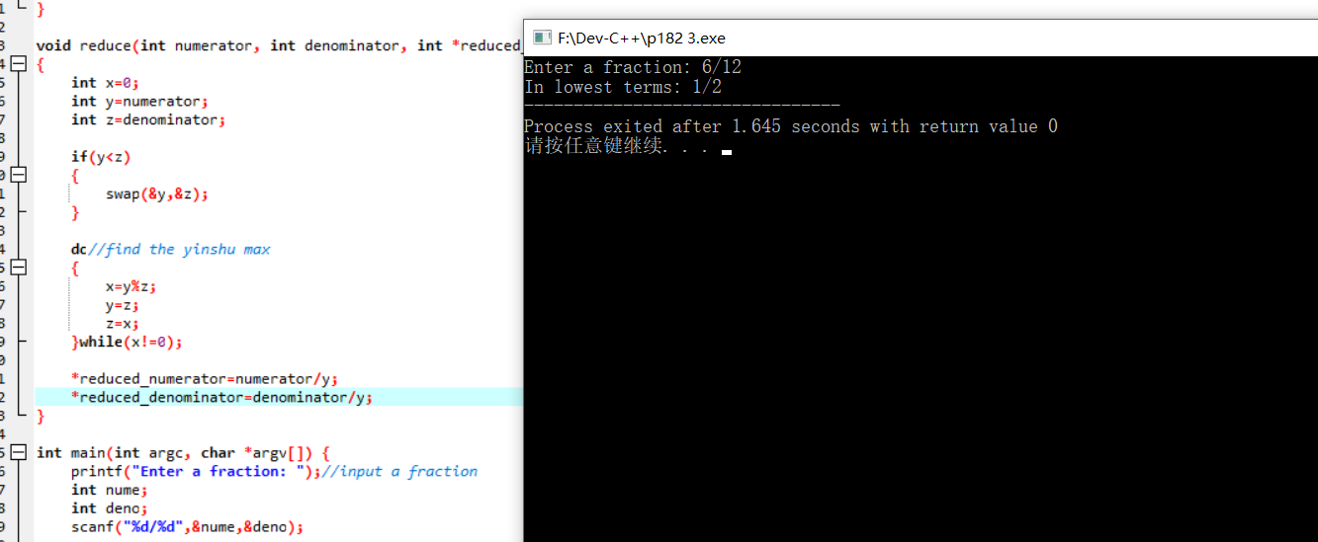#include <stdio.h>

#include <stdlib.h>

/* run this program using the console pauser or add your own getch, system("pause") or input loop */

void swap(int *a,int *b)//exchange value

{

int temp;

temp=*a;

*a=*b;

*b=temp;

}

void reduce(int numerator, int denominator, int *reduced_numerator, int *reduced_denominator)//simplify

{

int x=0;

int y=numerator;

int z=denominator;

if(y<z)

{

swap(&y,&z);

}

do//find the yinshu max

{

x=y%z;

y=z;

z=x;

}while(x!=0);

*reduced_numerator=numerator/y;

*reduced_denominator=denominator/y;

}

int main(int argc, char *argv[]) {

printf("Enter a fraction: ");//input a fraction

int nume;

int deno;

scanf("%d/%d",&nume,&deno);

int reduced_numerator=0;

int reduced_denominator=0;

reduce(nume,deno,&reduced_numerator,&reduced_denominator);//simplify

printf("In lowest terms: ");//output

printf("%d/%d",reduced_numerator,reduced_denominator);

return 0;

}

# 2

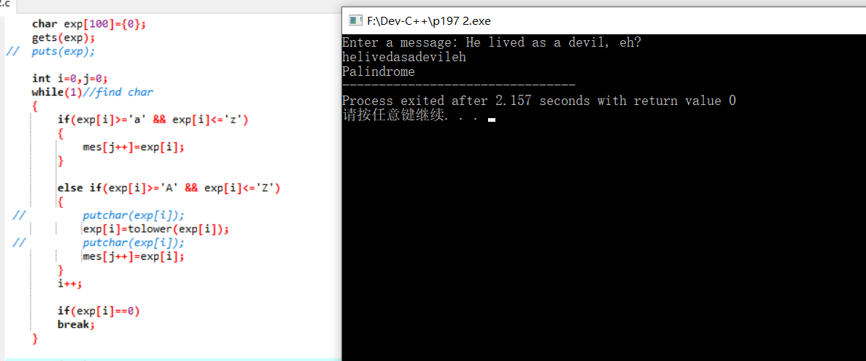

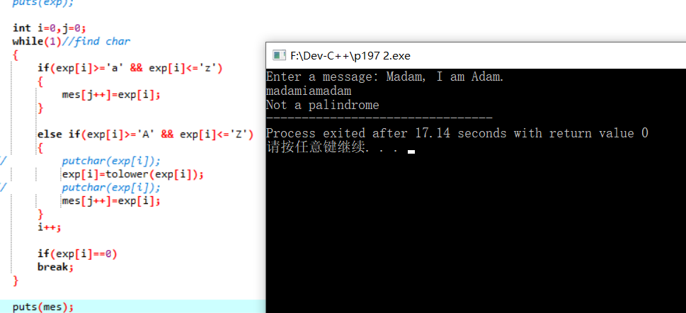#include <stdio.h>

#include <stdlib.h>

#include <ctype.h>

/* run this program using the console pauser or add your own getch, system("pause") or input loop */

char* inv(char* mes)//inverse the array

{

int cnt=0;

char inv_mes[100];

for(int i=0;i<100;i++)

{

if(mes[i]!=0)cnt++;

}

int i=0;

do

{

inv_mes[i++]=mes[--cnt];

}while(cnt!=0);

return inv_mes;

}

int judge(char *mes)//judge

{

if(strcmp(mes,inv(mes)))

return 0;

else

return 1;

}

int main(int argc, char *argv[]) {

printf("Enter a message: ");//input

char mes[100]={0};

char exp[100]={0};

gets(exp);

// puts(exp);

int i=0,j=0;

while(1)//find char

{

if(exp[i]>='a' && exp[i]<='z')

{

mes[j++]=exp[i];

}

else if(exp[i]>='A' && exp[i]<='Z')

{

// putchar(exp[i]);

exp[i]=tolower(exp[i]);

// putchar(exp[i]);

mes[j++]=exp[i];

}

i++;

if(exp[i]==0)

break;

}

puts(mes);

int a=judge(mes);//judge if huiwen or not

if(1==a)printf("Palindrome");

if(0==a)printf("Not a palindrome");

return 0;

}

# 3

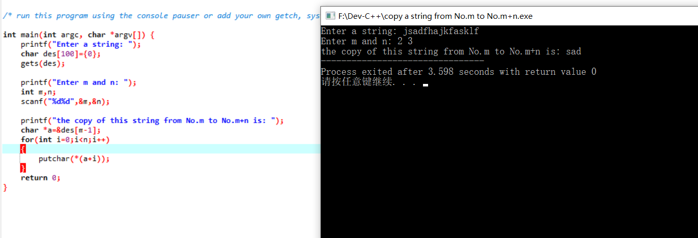

#include <stdio.h>

#include <stdlib.h>

/* run this program using the console pauser or add your own getch, system("pause") or input loop */

int main(int argc, char *argv[]) {

printf("Enter a string: ");

char des[100]={0};

gets(des);

printf("Enter m and n: ");

int m,n;

scanf("%d%d",&m,&n);

printf("the copy of this string from No.m to No.m+n is: ");

char *a=&des[m-1];

for(int i=0;i<n;i++)

{

putchar(*(a+i));

}

return 0;

}