致伟大的杨老师：

这是王云鹏的第十一周作业，请过目

目录

一、 1

二、 3

三、 4

四、 6

五、 8

六、 11

七、 12

# 一、

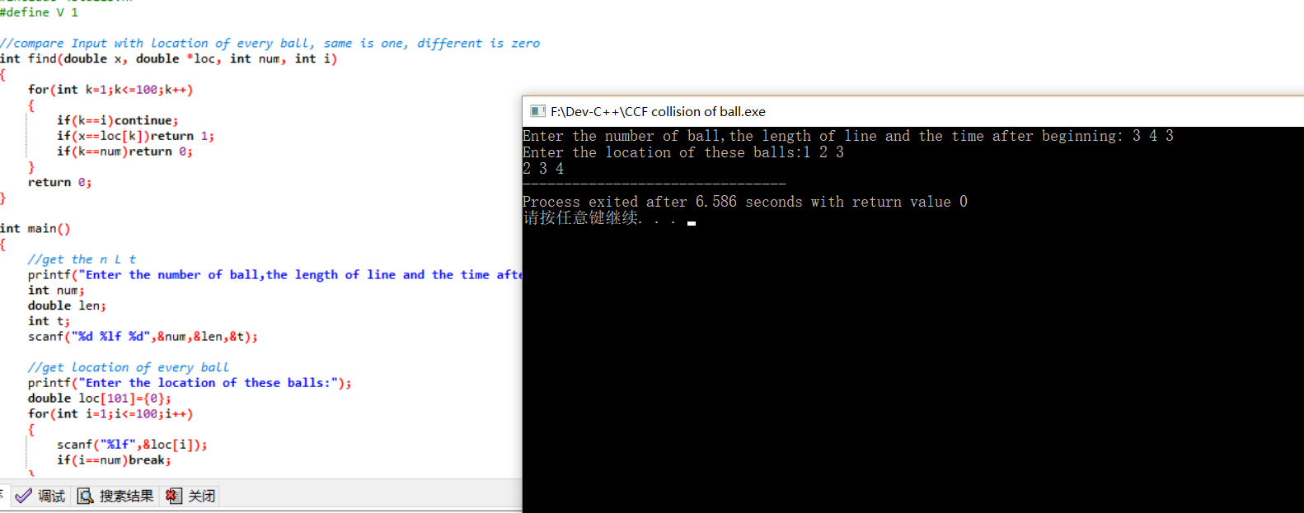

#include <stdio.h>

#include <stdlib.h>

#define V 1

//compare Input with location of every ball, same is one, different is zero

int find(double x, double *loc, int num, int i)

{

for(int k=1;k<=100;k++)

{

if(k==i)continue;

if(x==loc[k])return 1;

if(k==num)return 0;

}

return 0;

}

int main()

{

//get the n L t

printf("Enter the number of ball,the length of line and the time after beginning: ");

int num;

double len;

int t;

scanf("%d %lf %d",&num,&len,&t);

//get location of every ball

printf("Enter the location of these balls:");

double loc[101]={0};

for(int i=1;i<=100;i++)

{

scanf("%lf",&loc[i]);

if(i==num)break;

}

//calculate the location

int v[101]={0};

for(int i=1;i<=100;i++)//initialize v

{

v[i]=1;

if(i==num)break;

}

for(int j=1;;j++)//timing 0.5s

{

for(int i=1;i<=100;i++)//location of every ball

{

loc[i]=loc[i]+v[i]*0.5;

if(i==num)break;

}

for(int i=1;i<=100;i++)//v of every ball

{

if(loc[i]==0 || loc[i]==len)v[i]=-1*v[i];//change the v when crash the ends

if(find(loc[i],loc,num,i))v[i]=-1*v[i];//change the v when crash the ball

if(i==num)break;

}

if(j==t*2)//print the answer

{

for(int i=1;i<=100;i++)

{

printf("%g ",loc[i]);

if(i==num)break;

}

break;

}

}

}

# 二、

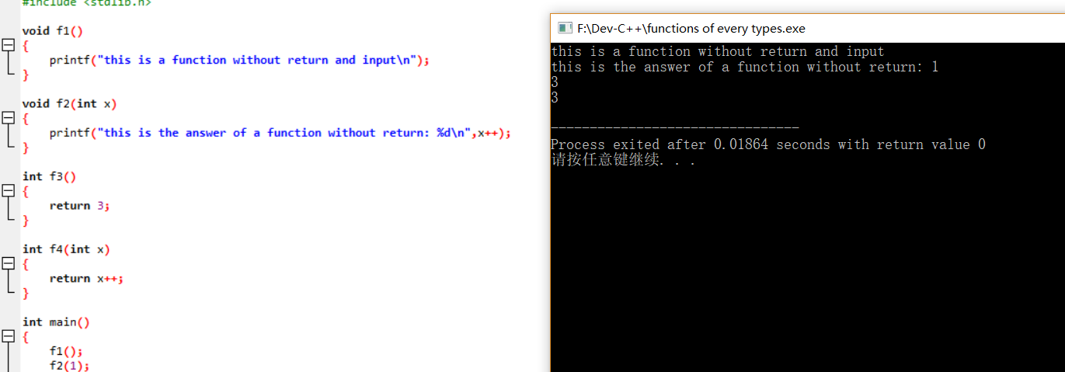#include <stdio.h>

#include <stdlib.h>

void f1()

{

printf("this is a function without return and input\n");

}

void f2(int x)

{

printf("this is the answer of a function without return: %d\n",x++);

}

int f3()

{

return 3;

}

int f4(int x)

{

return x++;

}

int main()

{

f1();

f2(1);

printf("%d\n",f3());

printf("%d\n",f4(3));

}

# 三、

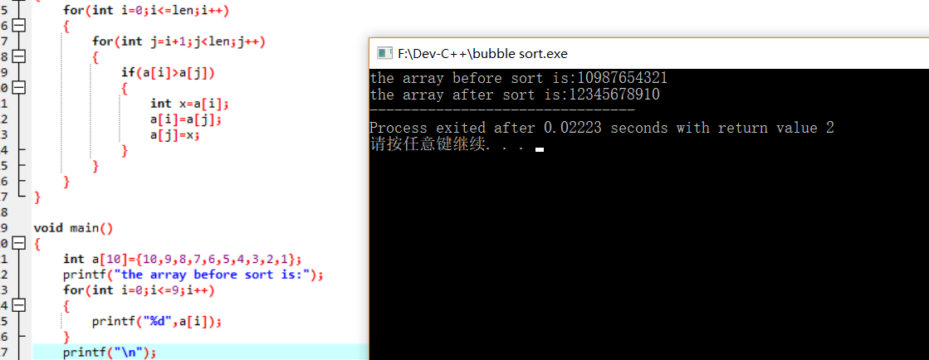#include <stdio.h>

#include <stdlib.h>

void BubbleSort(int a[], int len)

{

for(int i=0;i<=len;i++)

{

for(int j=i+1;j<len;j++)

{

if(a[i]>a[j])

{

int x=a[i];

a[i]=a[j];

a[j]=x;

}

}

}

}

void main()

{

int a[10]={10,9,8,7,6,5,4,3,2,1};

printf("the array before sort is:");

for(int i=0;i<=9;i++)

{

printf("%d",a[i]);

}

printf("\n");

BubbleSort(a,10);

printf("the array after sort is:");

for(int i=0;i<=9;i++)

{

printf("%d",a[i]);

}

}

# 四、

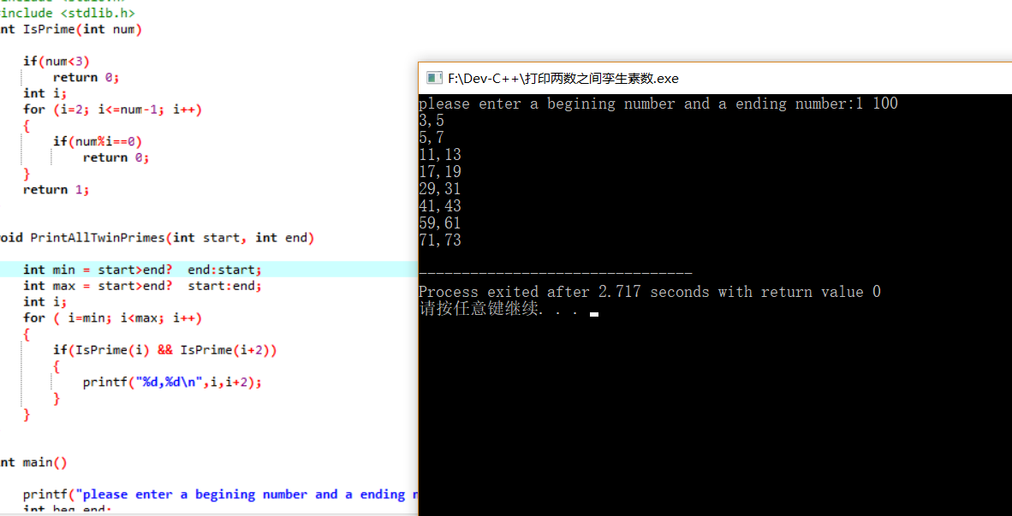#include <stdio.h>

#include <stdlib.h>

int IsPrime(int num)

{

if(num<3)

return 0;

int i;

for (i=2; i<=num-1; i++)

{

if(num%i==0)

return 0;

}

return 1;

}

void PrintAllTwinPrimes(int start, int end)

{

int min = start>end? end:start;

int max = start>end? start:end;

int i;

for ( i=min; i<max; i++)

{

if(IsPrime(i) && IsPrime(i+2))

{

printf("%d,%d\n",i,i+2);

}

}

}

int main()

{

printf("please enter a begining number and a ending number:");

int beg,end;

scanf("%d%d",&beg,&end);

PrintAllTwinPrimes(beg,end);

}

# 五、

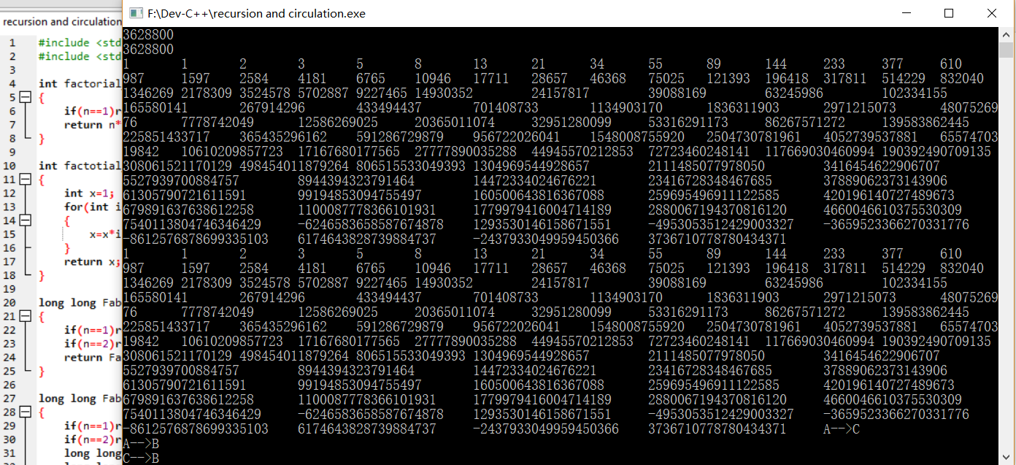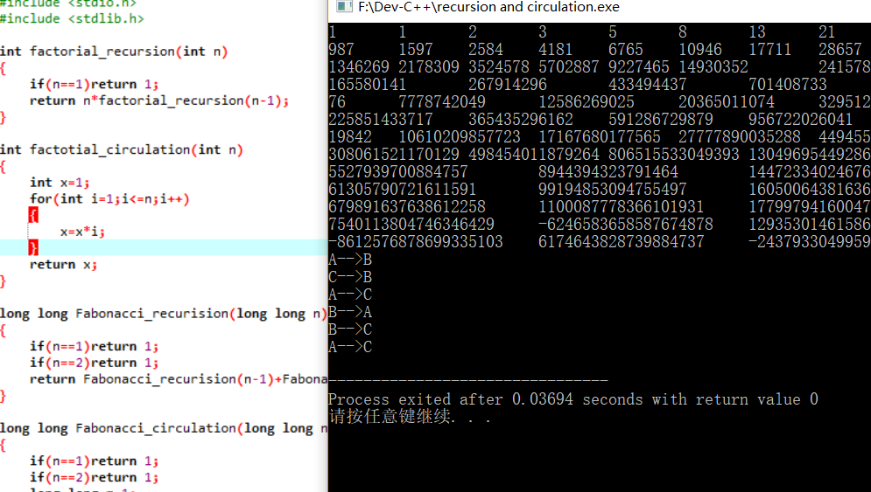#include <stdio.h>

#include <stdlib.h>

int factorial_recursion(int n)

{

if(n==1)return 1;

return n*factorial_recursion(n-1);

}

int factotial_circulation(int n)

{

int x=1;

for(int i=1;i<=n;i++)

{

x=x*i;

}

return x;

}

long long Fabonacci_recurision(long long n)

{

if(n==1)return 1;

if(n==2)return 1;

return Fabonacci_recurision(n-1)+Fabonacci_recurision(n-2);

}

long long Fabonacci_circulation(long long n)

{

if(n==1)return 1;

if(n==2)return 1;

long long m=1;

long long l=1;

long long x;

for(long long i=1;i<=n-2;i++)

{

x=m+l;

m=l;

l=x;

}

return x;

}

void move(char a, char b)

{

printf("%c-->%c\n",a,b);

}

void hanoi(int n,char a,char b,char c)

{

if(n==1)move(a,c);

else

{

hanoi(n-1,a,c,b);

move(a,c);

hanoi(n-1,b,a,c);

}

}

int main()

{

printf("%d\n",factorial_recursion(10));

printf("%d\n",factotial_circulation(10));

for(long long i=1;i<=100;i++)

{

printf("%lld\t",Fabonacci_recurision(i));

}

printf("\n");

for(long long i=1;i<=100;i++)

{

printf("%lld\t",Fabonacci_circulation(i));

}

hanoi(3,'A','B','C');

}

# 六、

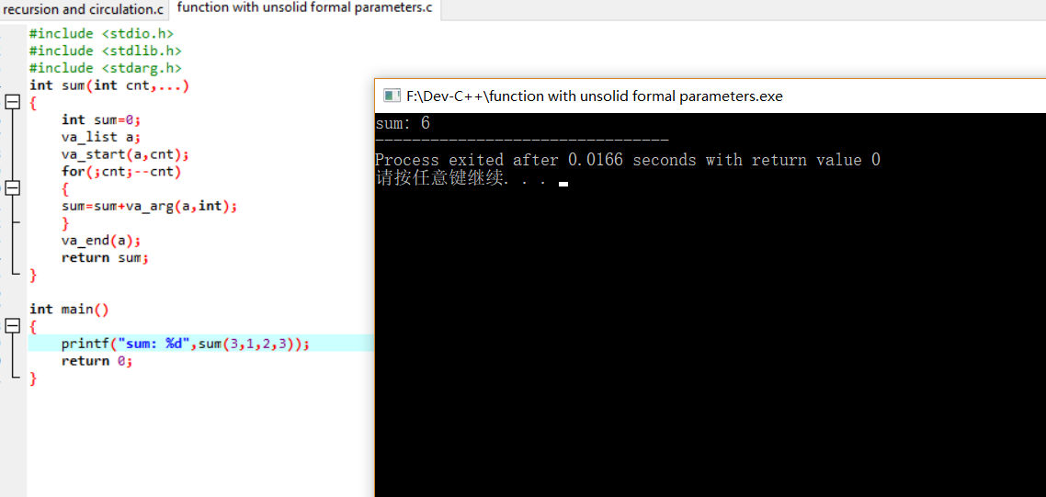#include <stdio.h>

#include <stdlib.h>

#include <stdarg.h>

int sum(int cnt,...)

{

int sum=0;

va_list a;

va_start(a,cnt);

for(;cnt;--cnt)

{

sum=sum+va_arg(a,int);

}

va_end(a);

return sum;

}

int main()

{

printf("sum: %d",sum(3,1,2,3));

return 0;

}

# 七、

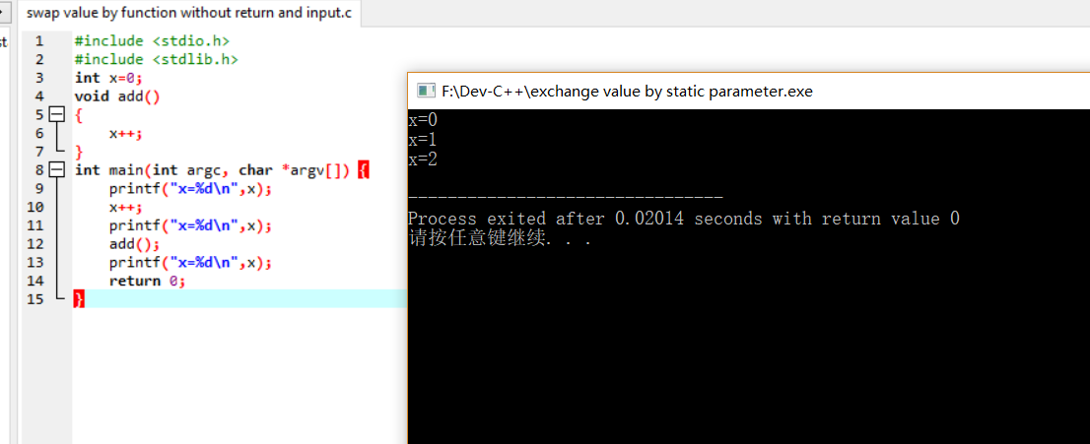#include <stdio.h>

#include <stdlib.h>

int x=0;

void add()

{

x++;

}

int main(int argc, char *argv[]) {

printf("x=%d\n",x);

x++;

printf("x=%d\n",x);

add();

printf("x=%d\n",x);

return 0;

}