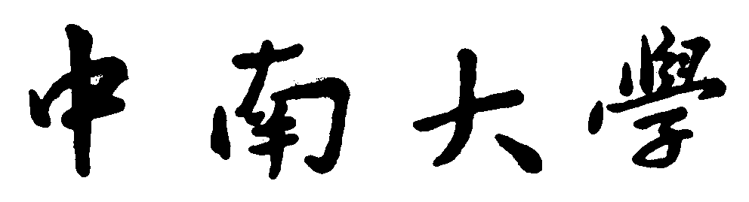

**计算机与程序设计基础**

实

验

指

导

书

信息科学与工程学院

目录

1 2

2 4

3 5

4 8

# 1

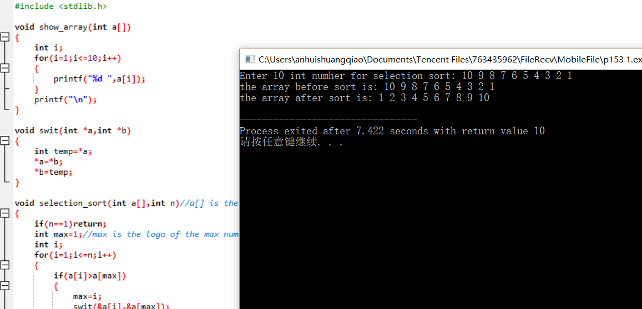#include <stdio.h>

#include <stdlib.h>

void show_array(int a[])

{

int i;

for(i=1;i<=10;i++)

{

printf("%d ",a[i]);

}

printf("\n");

}

void swit(int *a,int *b)

{

int temp=*a;

*a=*b;

*b=temp;

}

void selection_sort(int a[],int n)//a[] is the array waited for being sorted, n is the number of this array

{

if(n==1)return;

int max=1;//max is the logo of the max number in this array

int i;

for(i=1;i<=n;i++)

{

if(a[i]>a[max])

{

max=i;

swit(&a[i],&a[max]);

}

}

swit(&a[max],&a[n]);

selection_sort(a,--n);

}

void main()

{

printf("Enter 10 int numher for selection sort: ");

int a[11];

int i;

for(i=1;i<=10;i++)

{

scanf("%d",&a[i]);

}

printf("the array before sort is: ");

show_array(a);

selection_sort(a,10);

printf("the array after sort is: ");

show_array(a);

}

# 2

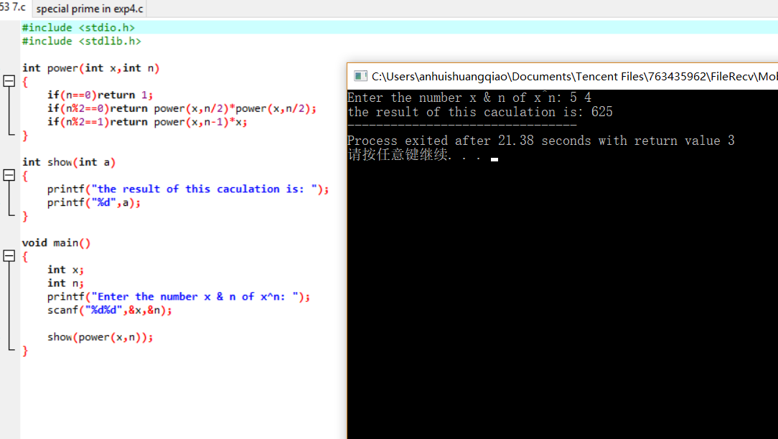#include <stdio.h>

#include <stdlib.h>

int power(int x,int n)

{

if(n==0)return 1;

if(n%2==0)return power(x,n/2)*power(x,n/2);

if(n%2==1)return power(x,n-1)*x;

}

int show(int a)

{

printf("the result of this caculation is: ");

printf("%d",a);

}

void main()

{

int x;

int n;

printf("Enter the number x & n of x^n: ");

scanf("%d%d",&x,&n);

show(power(x,n));

}

# 3

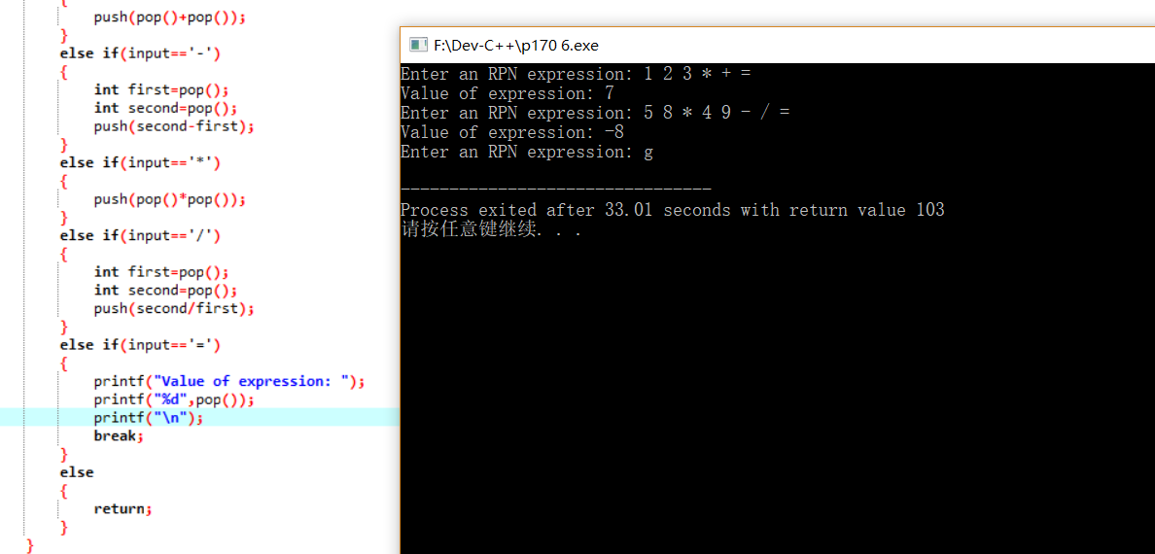#include <stdio.h>

#include <stdlib.h>

#include <stdbool.h>

#define stack_size 100

int contents[stack_size];

int top=0;

void stack_overflow(void)

{

printf("Expression is too complex");

}

void stack_underflow(void)

{

printf("Not enough operands in expression");

}

void make_empty(void)

{

top=0;

}

bool is_empty(void)

{

return top==0;

}

bool is_full(void)

{

return top==stack_size;

}

void push(int i)

{

if(is_full())

stack_overflow();

else

contents[top++]=i;

}

int pop(void)

{

if(is_empty())

stack_underflow();

else

return contents[--top];

}

void main()

{

char input;

while(1)

{

printf("Enter an RPN expression: ");

while(1)

{

scanf(" %c",&input);

// printf("%c",input);

if(input>='0' && input<='9')

{

push(input-48);

// printf("%d\n",contents[0]);

}

else if(input=='+')

{

push(pop()+pop());

}

else if(input=='-')

{

int first=pop();

int second=pop();

push(second-first);

}

else if(input=='*')

{

push(pop()*pop());

}

else if(input=='/')

{

int first=pop();

int second=pop();

push(second/first);

}

else if(input=='=')

{

printf("Value of expression: ");

printf("%d",pop());

printf("\n");

break;

}

else

{

return;

}

}

}

}

# 4

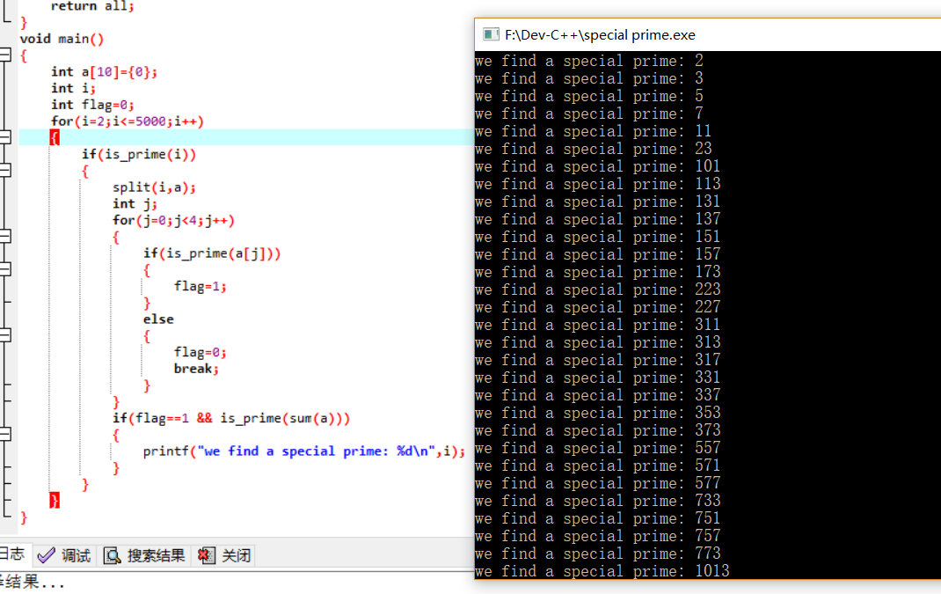#include <stdio.h>

#include <stdlib.h>

int is_prime(int n)

{

int i;

for(i=2;i<=n/2;i++)

{

if(n%i==0)

return 0;

}

return 1;

}

void split(int n,int a[])

{

for(int i=0;;i++)

{

a[i]=n%10;

n/=10;

if(i==3)break;

}

return;

}

int sum(int a[])

{

int all=0;

int i;

for(i=0;i<10;i++)

{

all+=a[i];

}

return all;

}

void main()

{

int a[10]={0};

int i;

int flag=0;

for(i=2;i<=5000;i++)

{

if(is_prime(i))

{

split(i,a);

int j;

for(j=0;j<4;j++)

{

if(is_prime(a[j]))

{

flag=1;

}

else

{

flag=0;

break;

}

}

if(flag==1 && is_prime(sum(a)))

{

printf("we find a special prime: %d\n",i);

}

}

}

}