第一题

1. 源代码

#include<stdio.h>

int main(void)

{

int h,l,w;

double v,wei;

h=8;

l=12;

w=10;

v=h\*l\*w;

wei=ceil(v/166);

printf("Dimensions: %d%d%d\n",l,w,h);

printf("Volumr(cubic inches): %lf\n",v);

printf("Dimensional weight (pounds): %lf\n",wei);

return 0;

}

1. 运行截图

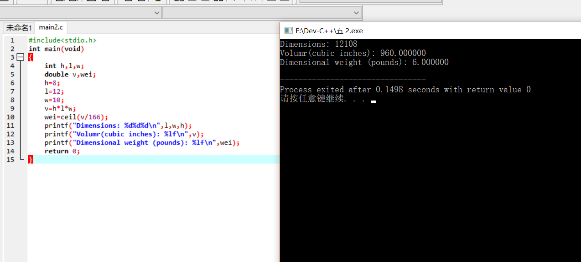第二题

1. 源代码

#include<stdio.h>

#define pi 3.14

#define x 4.0f/3.0f

int main(void)

{

printf("the volume of a ball is:%lf\n",x\*pi\*10\*10\*10);

}

1. 截图

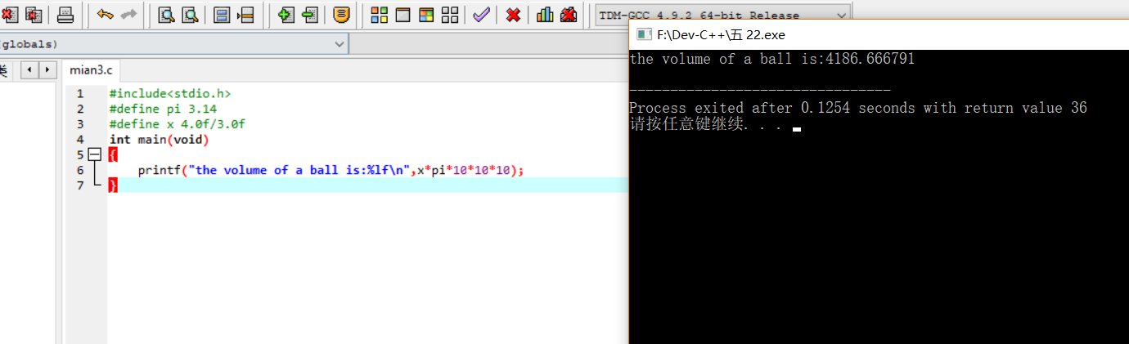

第三题

1. 源代码

#include<stdio.h>

int main()

{

int x;

printf("please enter the amount of money:");

scanf("%d",&x);

int a,b,c,d;

a=x/20;

x=x-a\*20;

b=x/10;

x=x-b\*10;

c=x/5;

x=x-c\*5;

d=x;

printf("$20 bills:%d\n",a);

printf("$10 bills:%d\n",b);

printf("$5 bills:%d\n",c);

printf("$10 bills:%d\n",d);

}

1. 截图

