NovaTalk
System Architecture & Complete Feature Documentation

A production-ready real-time social communication platform
featuring anonymous stranger chat, friend networking, communities,
live messaging, and a Firebase-powered admin control center.

Part 1 – System Architecture

1. High-Level Architecture
NovaTalk is a real-time chat and community platform built on a React + Vite frontend backed entirely by Firebase managed services. End users interact with the frontend over HTTPS/WebSocket, and the frontend integrates directly with Firebase Authentication, Firestore, the Realtime Database, Storage, and Analytics — all governed by a shared security rules layer and Firebase's cloud service primitives.
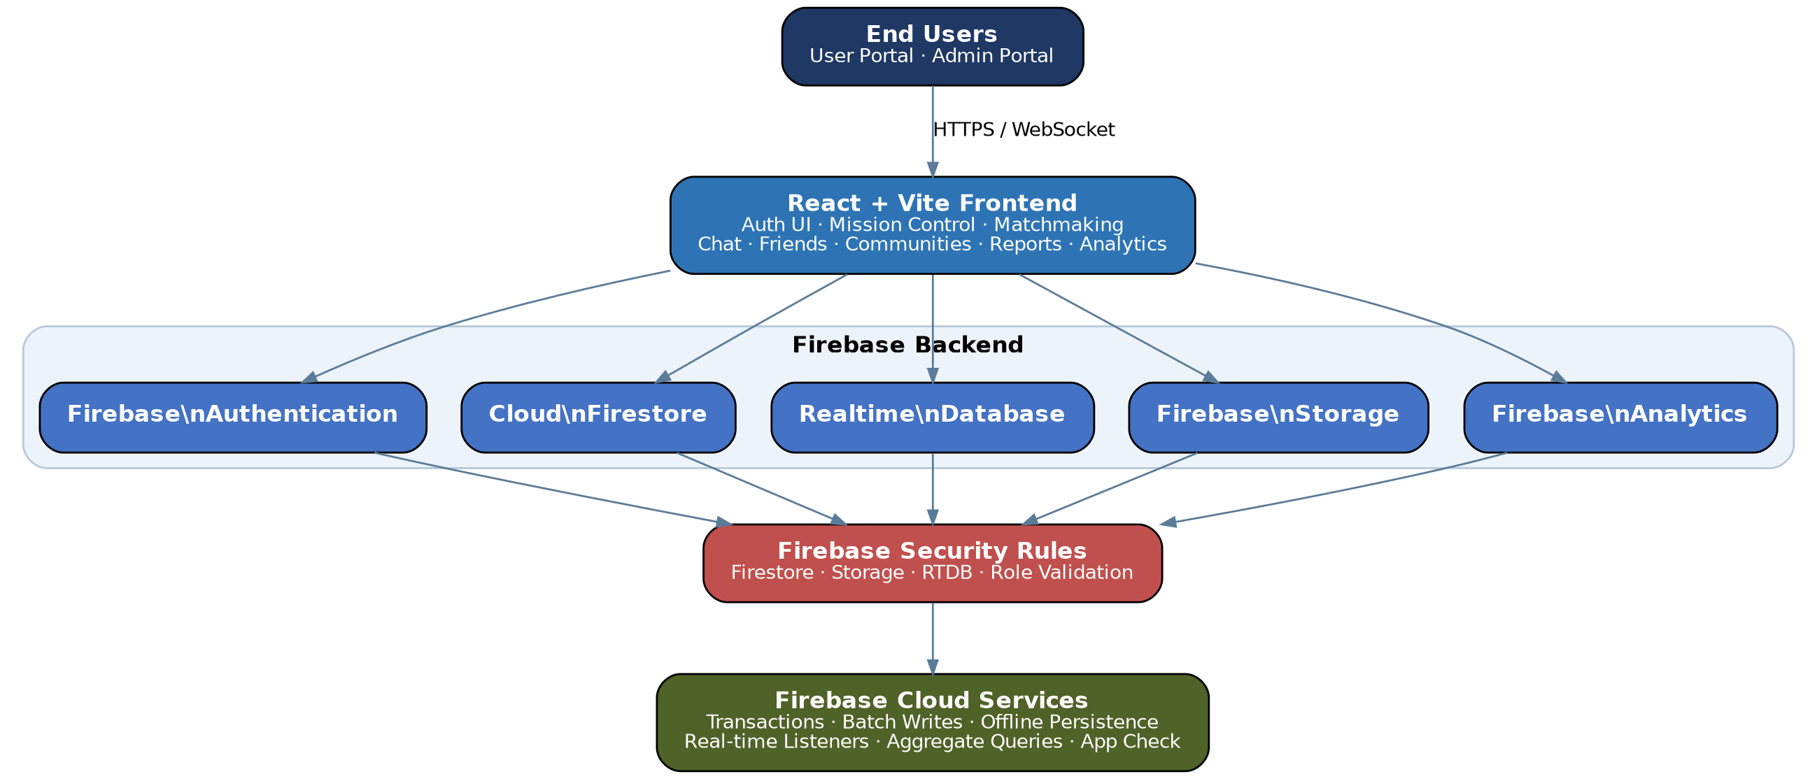
Figure 1. End-to-end high-level architecture

2. Component Architecture
The application is organized into a User Portal, an Admin Portal (Mission Control), the underlying Firebase services, and a cross-cutting security layer.
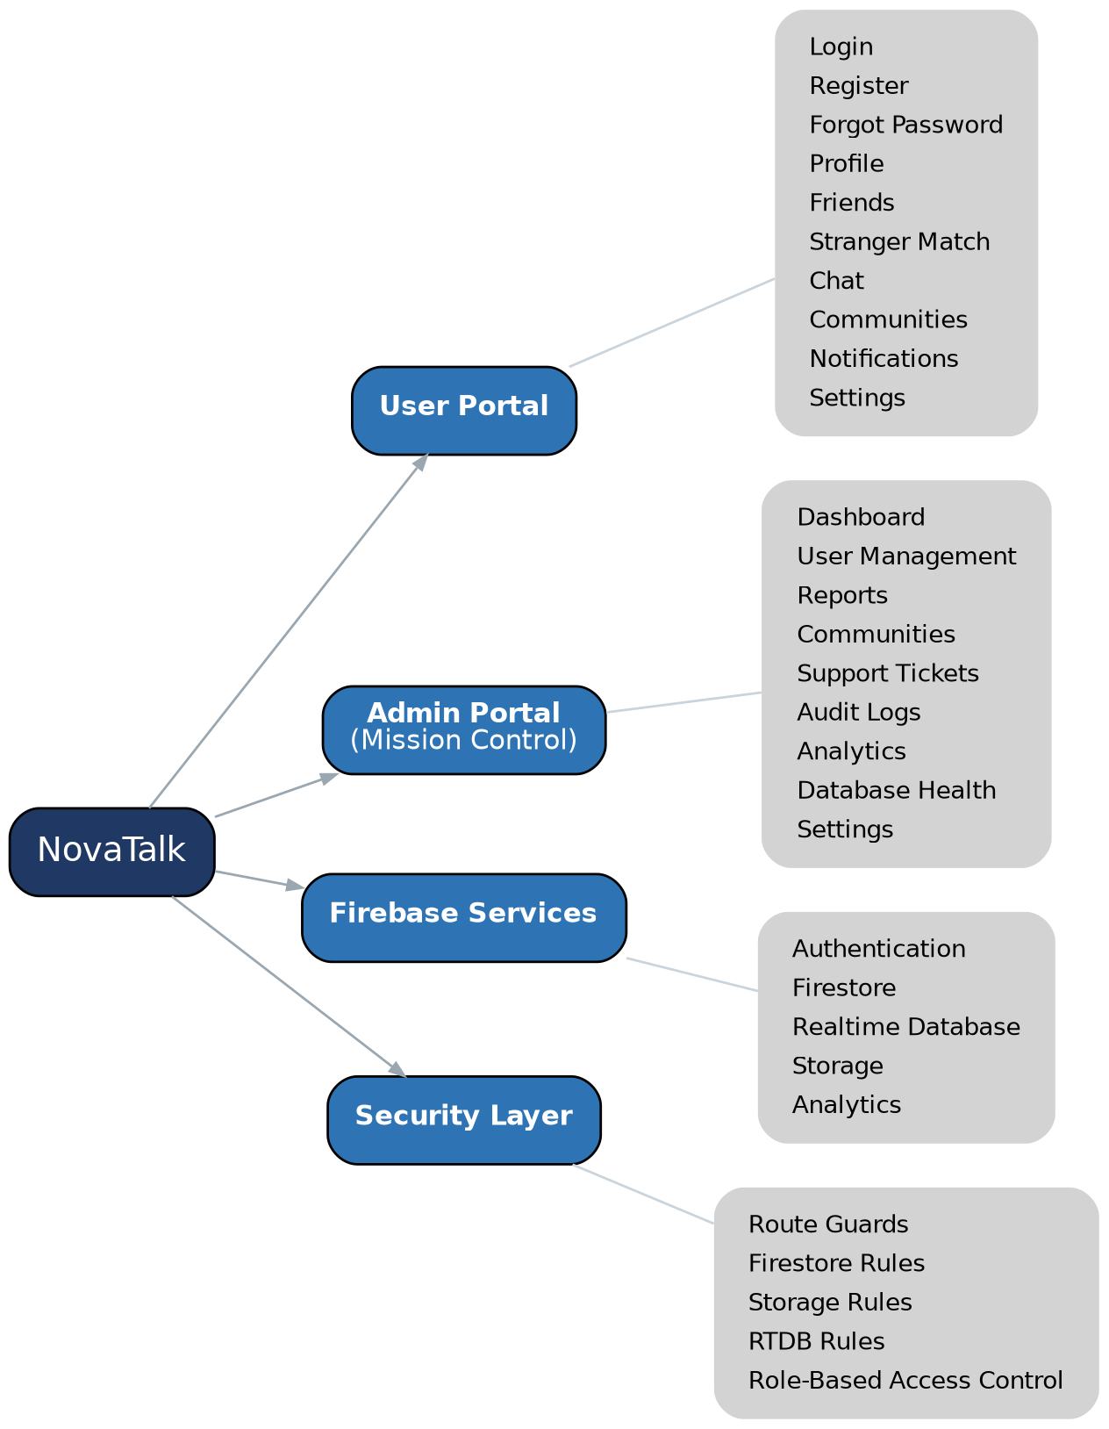
Figure 2. Component breakdown by module

3. Data Flow Architecture
User actions flow from authentication through Firestore for structured/document data, into the Realtime Database for ephemeral real-time state, into Storage for media, and finally surface in the Admin Dashboard for monitoring and moderation.
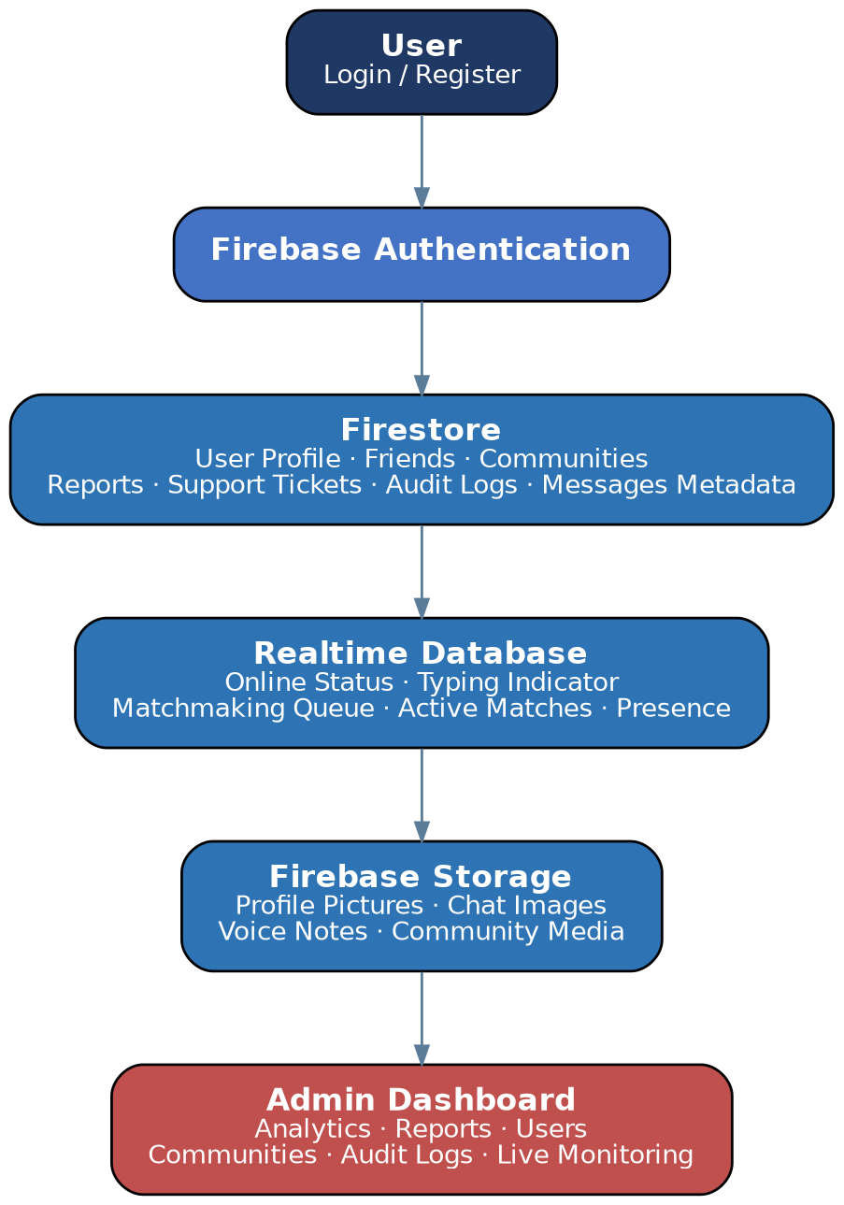
Figure 3. Data flow from user action to admin visibility

4. Security Architecture
Access control follows a role-detection pattern: authenticated users are routed to either the User Portal or Admin Portal, each guarded by a dedicated route guard, before requests reach Firestore and Realtime Database security rules.
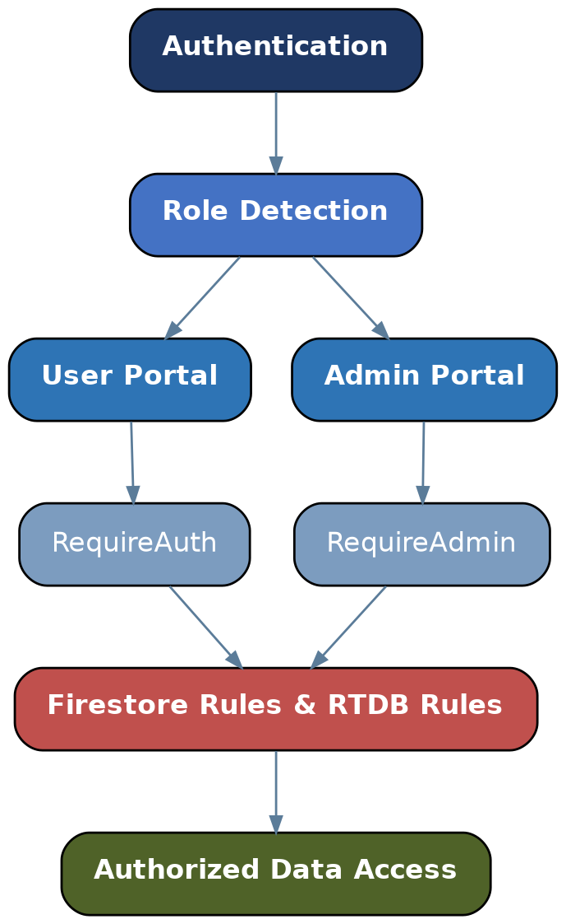
Figure 4. Authentication and role-based access flow

5. Firestore Collections
The following top-level collections are used in Cloud Firestore:
- users/
- admins/
- usernames/
- friends/
- friendRequests/
- blockedUsers/
- chats/
- messages/
- communities/
- posts/
- comments/
- reports/
- supportTickets/
- notifications/
- auditLogs/
- settings/

6. Realtime Database Structure
The Realtime Database is used for ephemeral, low-latency state:
- status/
- typing/
- waitingUsers/
- activeMatches/
- presence/
- voiceCalls/

7. Storage Structure
Firebase Storage is organized by media type:
- profile-images/
- chat-images/
- voice-notes/
- community-media/
- documents/

8. Architecture Layers
Layer | Technology
Presentation Layer | React.js, Vite, HTML5, CSS3
Business Logic Layer | React Context API, Custom Hooks
Authentication Layer | Firebase Authentication
Database Layer | Cloud Firestore
Real-Time Layer | Firebase Realtime Database
Storage Layer | Firebase Storage
Security Layer | Firebase Security Rules, RBAC
Analytics Layer | Firebase Analytics (optional)
Hosting Layer | Firebase Hosting or Vercel

9. Application Flow (User Journey)
The diagram below traces the full runtime flow of the application — from launch and session/role resolution, through the User Dashboard (stranger chat matchmaking, friends, communities) and the Admin/Moderator Dashboard (user management, reports, analytics), to logout.
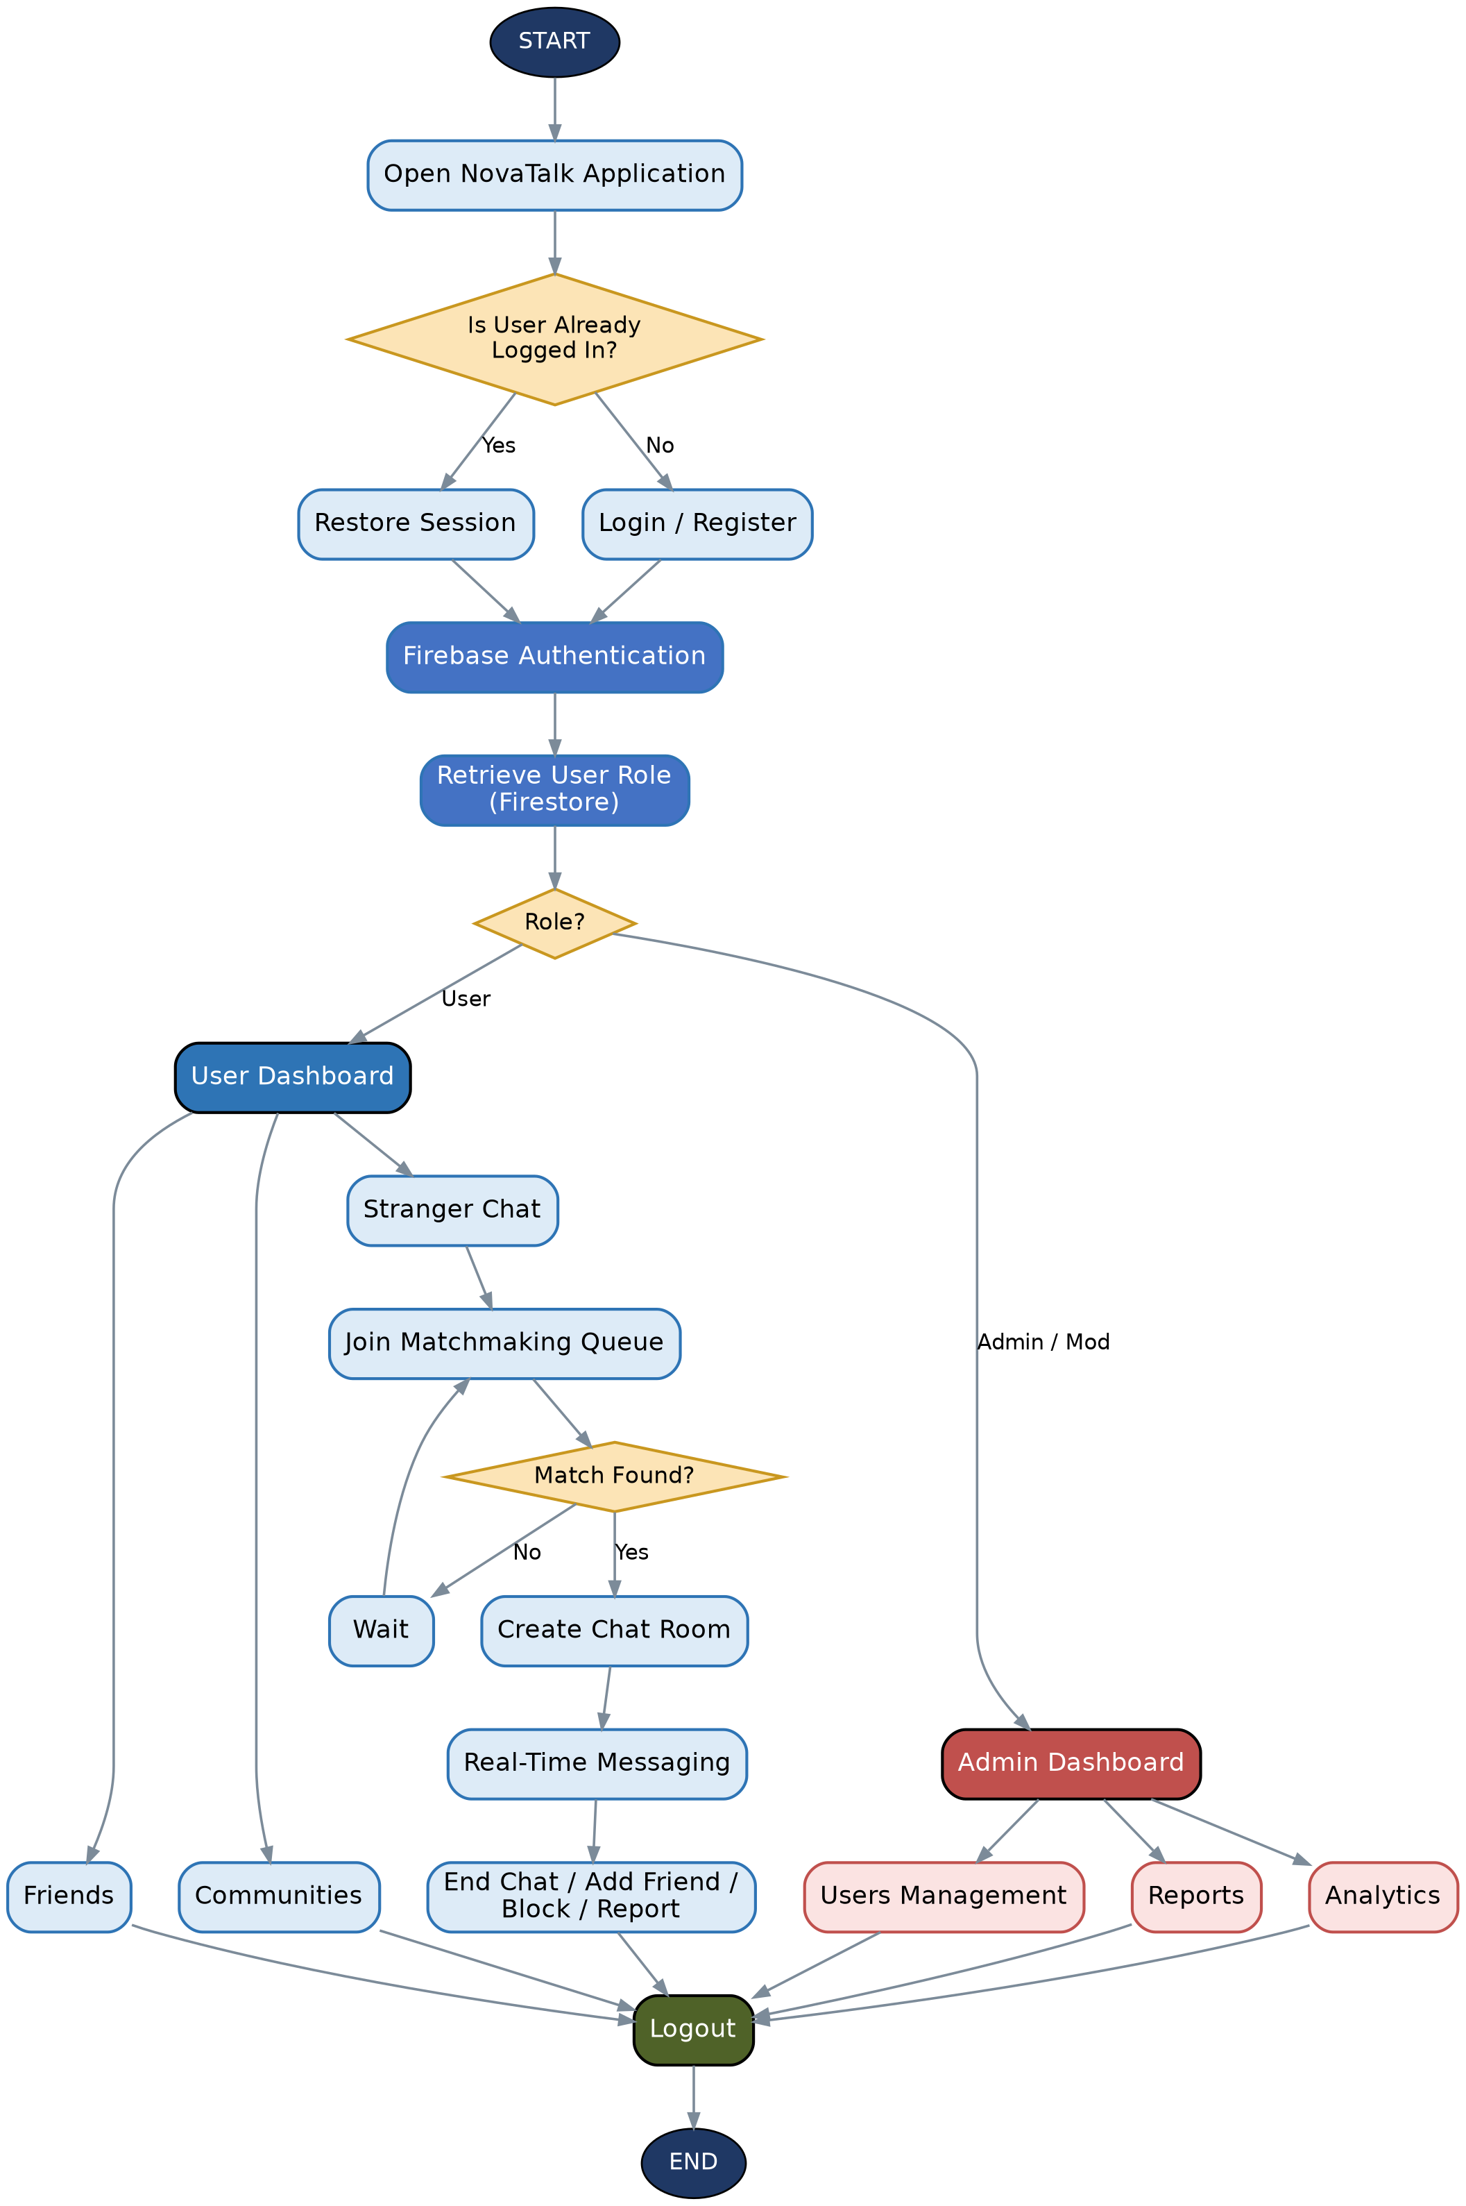
Figure 5. End-to-end application flow, from launch to logout

Part 2 – Complete Feature List
The following is the full feature inventory for NovaTalk, covering the end-user experience, the Admin Mission Control panel, the underlying Firebase capabilities, technical/engineering features, and the planned roadmap.

A. User Features

Authentication & Security
- Email & Password Registration
- Secure Login
- Google Sign-In
- Forgot Password
- Email Verification
- Automatic Session Restoration
- Logout
- Unique Username Reservation
- Role-Based Authentication
- Firebase Authentication Integration
- Secure Password Validation
- Protected Routes
- Offline Session Persistence

User Profile
- Custom Username
- Display Name
- Profile Picture Upload
- Bio/About Section
- Country Selection
- Gender Selection
- Date of Birth
- Preferred Language
- Interests
- Online Status
- Last Seen
- Account Settings
- Privacy Controls

Stranger Chat
- Anonymous Random Matching
- Live Matchmaking Queue
- Instant Stranger Connection
- One-to-One Private Chat
- End Chat
- Skip Stranger
- Find Another Stranger
- Typing Indicators
- Read Receipts
- Online Presence
- Live Connection Status

Friends System
- Send Friend Requests
- Accept Requests
- Reject Requests
- Cancel Requests
- Remove Friends
- Friend List
- Block Users
- Unblock Users
- Search Friends
- Friend Profile Viewing

Communities
- Create Community
- Join Community
- Leave Community
- Community Feed
- Community Posts
- Comments
- Reactions
- Community Media
- Community Moderation

Messaging
- Real-Time Messaging
- Text Messages
- Emoji Support
- Image Sharing
- Voice Notes
- Media Sharing
- File Sharing
- Chat History
- Message Timestamp
- Read Status
- Typing Status

Calling
- Voice Call Support
- Incoming Call Notifications
- Call History
- Mute
- End Call

Notifications
- Friend Request Notifications
- New Message Notifications
- Community Notifications
- Report Updates
- System Notifications
- Real-Time Alerts

User Safety
- Report User
- Block User
- Privacy Settings
- Community Reporting
- Chat Reporting
- Account Suspension Detection
- Ban Detection
- Safety Warnings

User Settings
- Change Password
- Change Email
- Update Profile
- Notification Settings
- Privacy Controls
- Theme Preferences (Future)
- Language Preferences

B. Admin Mission Control

Admin Authentication
- Separate Admin Login
- Role Verification
- Admin Session Management
- Super Admin Access
- Moderator Access
- Support Staff Access
- Protected Admin Routes

Dashboard (Live Firebase Dashboard)
- Total Registered Users
- Online Users
- Active Chats
- Matchmaking Queue
- Total Messages
- Communities Count
- Reports Count
- Support Tickets
- Banned Users
- Suspended Users
- Database Status
- Storage Usage
- Server Status (if configured)

User Management
- View Users
- Search Users
- Filter Users
- Suspend User
- Ban User
- Unban User
- Restrict Matchmaking
- Reset User Status
- View User Profile
- View Login History

Reports Management
- View Reports
- Approve Reports
- Reject Reports
- Resolve Reports
- Delete Reports
- Report Categories
- Reporter Information
- Report History

Chat Moderation
- View Live Chats
- Remove Messages
- Delete Chats
- Restrict Users
- Community Moderation
- Offensive Content Review

Community Management
- View Communities
- Delete Communities
- Remove Posts
- Remove Comments
- Ban Community Members
- Community Analytics

Announcement System
- Global Announcements
- Maintenance Notices
- Broadcast Messages
- Community Notices

Support Center
- View Support Tickets
- Assign Tickets
- Resolve Tickets
- Ticket History
- User Communication

Analytics (Live Firebase Analytics)
- Daily Active Users
- Monthly Active Users
- User Growth
- Message Volume
- Friend Growth
- Community Growth
- Report Trends
- Matchmaking Statistics
- User Retention
- Chat Activity
- Online Trends

Audit Logs
- Admin Login Logs
- User Actions
- Moderation Logs
- Database Changes
- Security Events
- Authentication Events

Database Management
- Firestore Monitoring
- Realtime Database Monitoring
- Storage Monitoring
- Collection Statistics
- Database Health

Security
- Role-Based Permissions
- Firestore Rules
- Storage Rules
- Realtime Database Rules
- Secure Route Guards
- Session Validation
- Username Reservation Transactions

C. Firebase Features
- Firebase Authentication
- Cloud Firestore
- Firebase Realtime Database
- Firebase Storage
- Offline Persistence
- Real-Time Listeners
- Transactions
- Batch Writes
- Security Rules
- Presence System
- Typing Indicators
- Automatic Reconnection
- Live Synchronization

D. Technical Features
- Responsive Design
- Progressive Web App (optional)
- Dark Cosmic Theme
- Glassmorphism UI
- Mission Control Dashboard
- Lazy Loading
- Optimized Firebase Queries
- Pagination
- Image Compression
- Error Boundaries
- Loading Skeletons
- Empty State Screens
- Secure Environment Variables
- Production Build Ready
- Modular Architecture
- Component-Based Design

E. Future Enhancements
- Video Calling
- AI-Powered Chat Moderation
- AI Matchmaking Recommendations
- End-to-End Encryption
- Voice & Video Rooms
- Stories/Status Updates
- Push Notifications
- Multi-Language Support
- QR Code Profile Sharing
- Premium Membership
- Subscription Plans
- User Verification Badges
- Dark/Light Theme Toggle
- Desktop Application
- Android & iOS Apps
- AI Chat Assistant
- Live Translation
- Screen Sharing
- Event-Based Communities
- Cloud Backup & Restore
Overall, NovaTalk is designed as a production-ready real-time social communication platform featuring anonymous stranger chat, friend networking, communities, live messaging, comprehensive moderation tools, and a Firebase-powered admin control center, all wrapped in a modern cosmic-themed interface.

