SCHOOL OF ICT DEPARTMENT OF IT
MODULE: Database Systems I (ITE2161) Level : II
Academic Year: 2018-2019
Assignment
- You are tasked to design and implement a database for an on-line shop. The database should contain the following data. First of all, there is data about products that the shop sells. Each product has a catalogue number, description, price and amount in stock. There is also customer data: each customer has a name, email address, and postal address (you can also choose to create customer numbers for them). Finally, there are orders, which the customers make to buy products. Each order will involve one customer and one or more products. Orders have unique numbers, and they also have status (processing, dispatched, delivered).
- List entities their attributes and the relationships between them.
- Draw an entity-relationship diagram for the shop database,
- Why and How the one-to-one and Many-to-many relationships are to be avoided. Explain Draw all table with all necessary Attributes and constraints,
- Write SQL statements to create the database and tables (don’t forget to specify primary and foreign keys).
- UPS prides itself on having up-to-date information on the processing and current location of each shipped item. To do this, UPS relies on a company-wide information system. Shipped items are the heart of the UPS product tracking information system. Shipped items can be characterized by item number (unique), weight, dimensions, insurance amount, destination, and final delivery date. Shipped items are received into the UPS system at a single retail center. Retail centers are characterized by their type, uniqueID, and address. Shipped items make their way to their destination via one or more standard UPS transportation events (i.e., flights, truck deliveries). These transportation events are characterized by a unique scheduleNumber, a type (e.g, flight, truck), and a deliveryRoute.
  - Please create an Entity Relationship diagram that captures this information about the UPS system. Be certain to indicate identifiers and constraints.

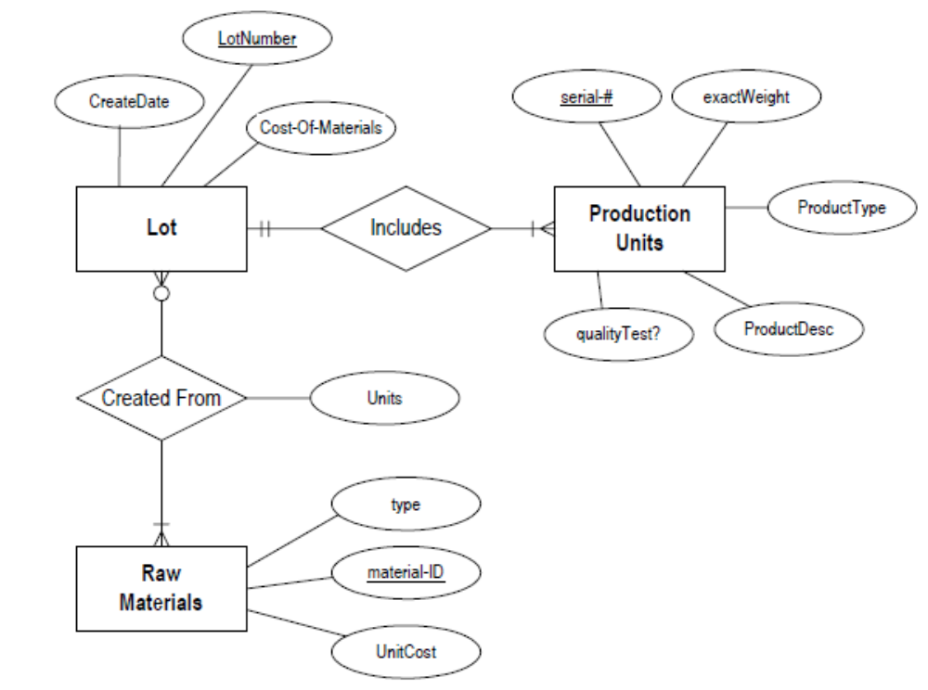
- Production tracking is important in many manufacturing environments (e.g., the pharmaceuticals industry, children’s toys, etc.). The following ER diagram captures important information in the tracking of production. Specifically, the ER diagram captures relationships between production lots (or batches), individual production units, and raw materials.
- Please convert the ER diagram into a relational database schema. Be certain to indicate primary keys and referential integrity constraints.
- Explain the following terms briefly: attribute, domain, entity, relationship, entity set, relationship set, one-to-many relationship, many-to-many relationship, participation constraint, overlap constraint, covering constraint, weak entity set, aggregation, and role indicator, relation schema, relational database schema, domain, attribute, attribute domain, relation instance, relation cardinality, and relation degree, candidate key, primary key,a superkey?

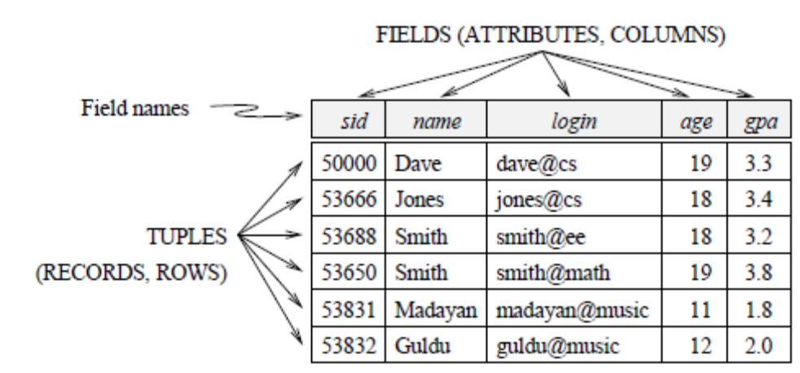
- From the relation bellow

- Give an example of an attribute (or set of attributes) that you can deduce is not a candidate key, based on this instance being legal.
- Is there any example of an attribute (or set of attributes) that you can deduce is a candidate key, based on this instance being legal?

- Answer each of the following questions briefly. The questions are based on the following relational schema:
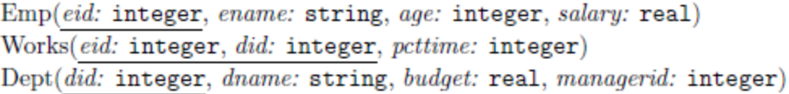
  - Give an example of a foreign key constraint that involves the Dept relation. Whatare the options for enforcing this constraint when a user attempts to delete a Dept tuple?
  - Write the SQL statements required to create the preceding relations, including appropriate versions of all primary and foreign key integrity constraints.
  - Define the Dept relation in SQL so that every department is guaranteed to have a manager.
  - Write an SQL statement to add John Doe as an employee with eid = 101, age = 32 and salary = 15, 000.
  - Write an SQL statement to give every employee a 10 percent raise.
  - Write an SQL statement to delete the Toy department. Given the referential integrity constraints you chose for this schema, explain what happens when this statement is executed.
- Given two relations R1 and R2, where R1 contains N1 tuples, R2 contains N2 tuples, and N2 > N1 > 0, give the minimum and maximum possible sizes (in tuples) for the resulting relation produced by each of the following relational algebra expressions. In each case, state any assumptions about the schemas for R1 and R2 needed to make the expression meaningful:

    - R1∪R2,
    - R1∩R2,
    - R1−R2,
    - R1×R2,
    - σa=5(R1),
    - πa(R1),
    - R1/R2

- Consider the following schema:
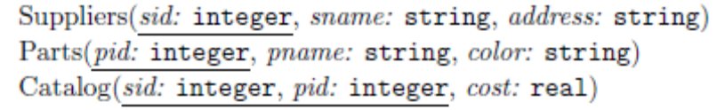

The key fields are underlined, and the domain of each field is listed after the field name. Therefore sid is the key for Suppliers, pid is the key for Parts, and sid and pid together form the key for Catalog. The Catalog relation lists the prices charged for parts by Suppliers. Write the following queries in relational algebra, tuple relational calculus, and domain relational calculus:

- Find the names of suppliers who supply some red part.
- Find the sids of suppliers who supply some red or green part.
- Find the sids of suppliers who supply some red part or are at 221 Packer Street.
- Find the sids of suppliers who supply some red part and some green part.
- Find the sids of suppliers who supply every part.
- Find the sids of suppliers who supply every red part.
- Find the sids of suppliers who supply every red or green part.
- Find the sids of suppliers who supply every red part or supply every green part.
- Find pairs of sids such that the supplier with the first sid charges more for some part than the supplier with the second sid.
- Find the pids of parts supplied by at least two different suppliers.
- Find the pids of the most expensive parts supplied by suppliers named Yosemite Sham.
- Find the pids of parts supplied by every supplier at less than $200. (If any supplier either does not supply the part or charges more than $200 for it, the part is not selected.)

0785323655 Damasc

