Characteristic | Subcategory | Result
Maternal age | Mean±SD | 31±5.9
 | Advanced maternal age (>=35) | 135 (31.00%)
Gestation age at blood sampling (week) | Median | 21w+3
 | Range | 11w+3 to 39w+3
 | 11+0 to 14+6 week | 1 (0.23%)
 | 15+0 to 20+6 week | 174 (40.00%)
 | 21+0 to 39+6 week | 260 (59.77%)
Diagnostic procedures | Chorionic villus sampling | 4 (0.92%)
 | Cordocentesis | 97 (22.30%)
 | Amniocentesis | 334 (76.78%)
Indication for diagnostic procedures | Advanced maternal age (>=35) | 84 (19.31%)
 | Positive serum screening | 217 (49.89%)
 | Ultrasound abnormality | 67 (14.48%)
 | Prior aneuploid pregnancy | 4 (0.92%)
 | More than 1 indication | 63 (15.40%)
Table S1. Overview of patient demographics.
Data are n (%) unless otherwise specified.

Karyotype | Male | Female | Subtotal (percentage)
Diploid | 170 | 172 | 342 (83.01%)
Trisomy 9 | 0 | 1 | 1 (0.24%)
Trisomy 13 | 2 | 2 | 4 (0.97%)*
Trisomy 18 | 8 | 6 | 14 (3.4%)
Trisomy 21 | 19 | 21 | 40 (9.71%)
45, X | 8 |  | 8 (1.94%)#
XXX | 1 |  | 1 (0.24%)
XXY | 1 |  | 1 (0.24%)
XYY | 1 |  | 1 (0.24%)
Total | 412 |  | 412 (100%)
Table S2. Karyotypes of the samples included in the study.
*, including a twin sample; #, including 3 mosaic 45, X samples.

Chr | CV_noGC | CV_GC | CV_ Reduction | Average | Stdev | Z_cutoff
chr1 | 0.92% | 0.38% | 59.09% | 8.607774647 | 0.032422543 | 7.33
chr2 | 0.74% | 0.26% | 65.02% | 8.843461699 | 0.022945985 | 10.64
chr3 | 1.49% | 0.32% | 78.29% | 7.137199499 | 0.023057688 | 8.54
chr4 | 3.19% | 0.59% | 81.48% | 6.379406288 | 0.037697897 | 4.67
chr5 | 1.69% | 0.44% | 74.18% | 6.389276181 | 0.027933399 | 6.31
chr6 | 1.59% | 0.38% | 75.78% | 6.060346381 | 0.023291552 | 7.18
chr7 | 0.59% | 0.40% | 32.35% | 5.529126336 | 0.022025699 | 6.93
chr8 | 0.98% | 0.42% | 57.68% | 5.336184496 | 0.022235147 | 6.62
chr9 | 0.53% | 0.37% | 30.41% | 4.23638137 | 0.015694931 | 7.45
chr10 | 0.85% | 0.45% | 46.64% | 5.093700679 | 0.023087946 | 6.09
chr11 | 0.79% | 0.28% | 64.95% | 5.083805082 | 0.014044001 | 9.99
chr12 | 0.42% | 0.34% | 18.91% | 4.84257833 | 0.01631087 | 8.19
chr13 | 2.67% | 0.48% | 81.91% | 3.334317822 | 0.016086146 | 5.72
chr14 | 0.40% | 0.50% | -23.96% | 3.300311239 | 0.016490607 | 5.52
chr15 | 1.28% | 0.69% | 46.32% | 3.114174704 | 0.021442459 | 4.01
chr16 | 3.55% | 0.96% | 72.99% | 3.176262129 | 0.030460997 | 2.88
chr17 | 4.35% | 1.10% | 74.71% | 3.116628714 | 0.034253871 | 2.51
chr18 | 1.23% | 0.47% | 62.04% | 2.810643377 | 0.013130455 | 5.91
chr19 | 6.87% | 2.11% | 69.28% | 2.15042098 | 0.045393922 | 1.31
chr20 | 3.26% | 1.02% | 68.71% | 2.592402683 | 0.026465092 | 2.70
chr21 | 0.73% | 0.92% | -25.76% | 1.35022725 | 0.012433553 | 3.00
chr22 | 6.95% | 2.28% | 67.25% | 1.515370113 | 0.034494137 | 1.21
chrX | 2.21% | 0.95% | 57.13% | 5.186392257 | 0.049206902 | 2.91

Table S3. The reduction of CVs by GC correction, as well as the average GC-corrected NCR value and standard deviation, for each of the 24 chromosomes except chromosome Y. The table also includes the z score cutoff values for each of the 23 chromosomes, using z score of 3 for chromosome 21 as the reference point, which corresponds to 5.52% fetal DNA in the maternal plasma.

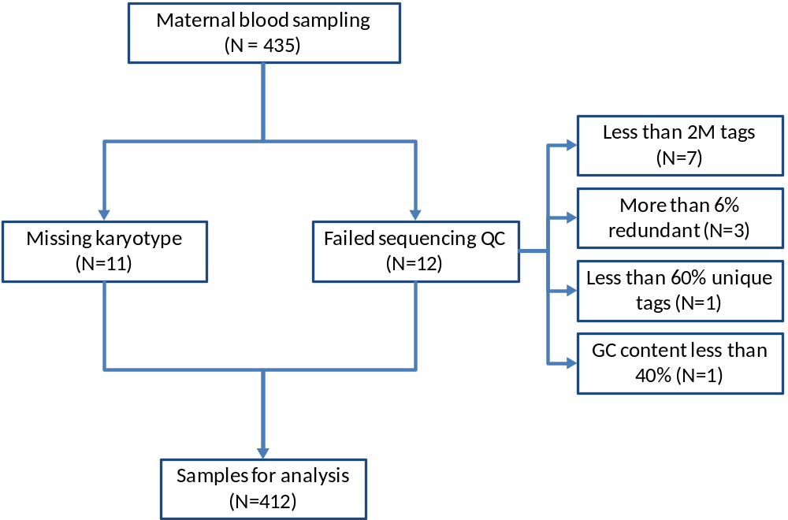
Figure S1. Quality control steps used in the study. Following criteria were applied to qualify a library for downstream analysis: no less than 2M uniquely mapped tags (7 samples failed this criterion); no more than 6% tags that were redundant (3 samples failed this criterion); no less than 60% sequence tags that were uniquely mapped to the unmasked genome (1 sample failed this criterion); the GC content of the mapped reads must be greater than 40% (1 sample failed this criterion). In addition to the 11 samples which were failed to generate karyotyping results for, there were 23 samples (5.28% of the total samples) that failed to pass the criteria. The remaining 412 were further analyzed.

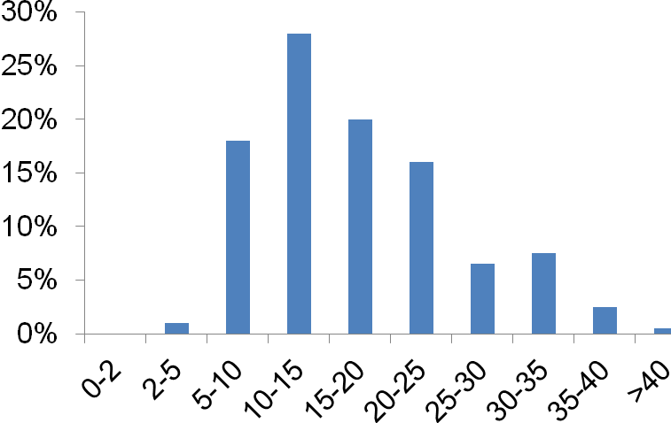

Figure S2. Distribution of fetal DNA percentage among the 201 male samples. X-axis, fetal DNA percentage. Y-axis, Proportion of pregnancies with male fetuses (%).

