**Core Practical 5: Determination of the resistivity of a constantan wire using a micrometer, ammeter and voltmeter**

**Aim:** **To determine the resistivity of a constantan wire by measuring its voltage, current, diameter, and length, and using the formula p=RA/L . The calculated value will be compared to the expected resistivity of constantan. This experiment is important because resistivity helps us understand how well a material conducts electricity, which is useful in designing electrical systems.**

**Theory:**

All materials have some resistance to the flow of electric charge. In metals, free electrons move through the structure of the wire, but as they do, they collide with vibrating ions within the metal lattice. During these collisions, the electrons transfer some of their kinetic energy to the ions, causing the ions to vibrate more vigorously. This increased vibration raises the temperature of the wire. Resistance, therefore, not only impedes the flow of electrons but also results in heating of the wire. [6]

[6]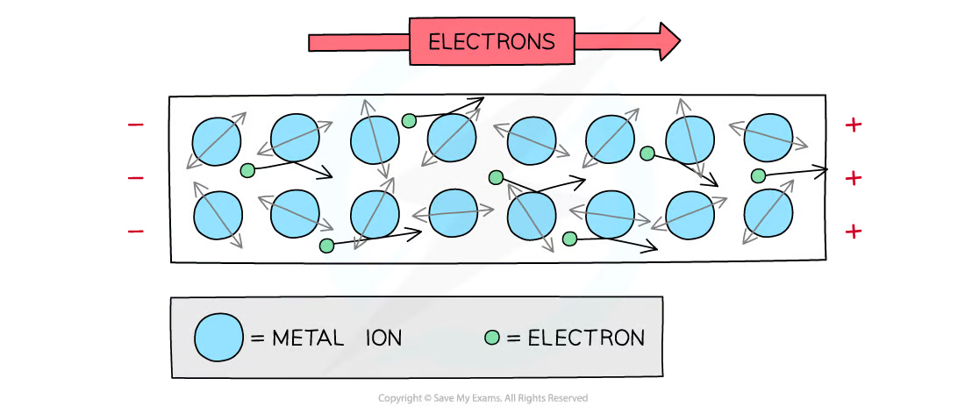

When current flows through a component, the resistance depends on its geometry (length and cross-sectional area) and a property of the material known as resistivity.

The resistance of a wire increases as its length increases. This is because a longer wire provides more opportunities for collisions between electrons and ions, similar to adding additional resistors in series, which increases the total resistance. On the other hand, increasing the cross-sectional area of the wire decreases its resistance, as a larger area provides more paths for electrons to flow, akin to adding resistors in parallel, which reduces overall resistance. [3]

The resistance (R) of a wire is directly proportional to its length (L) and inversely proportional to its cross-sectional area (A). This relationship is expressed by the formula: R= pL/A, where p (rho) is the resistivity of the material. Rearranging this equation to solve for resistivity gives: p=RA/L

Resistivity is measured in ohm meters (Ωm). It is a property of the material itself, independent of the size or shape of the sample. The units of resistivity can be derived as (Ωm^2/m) = Ωm.

In most metals, resistivity increases as the temperature rises. [6] This is because, at higher temperatures, the ions in the metal lattice vibrate more vigorously, increasing the likelihood of collisions with free electrons and thus impeding their flow. Resistivity is primarily a property of the material, but it is sensitive to temperature.[3] However, in this experiment, we assume that the resistivity remains constant because the current was kept low to minimize heating, and the material used (constantan) is known for its stability across a wide range of temperatures.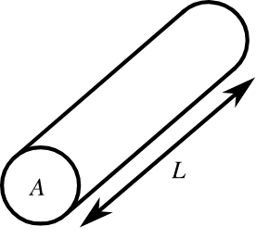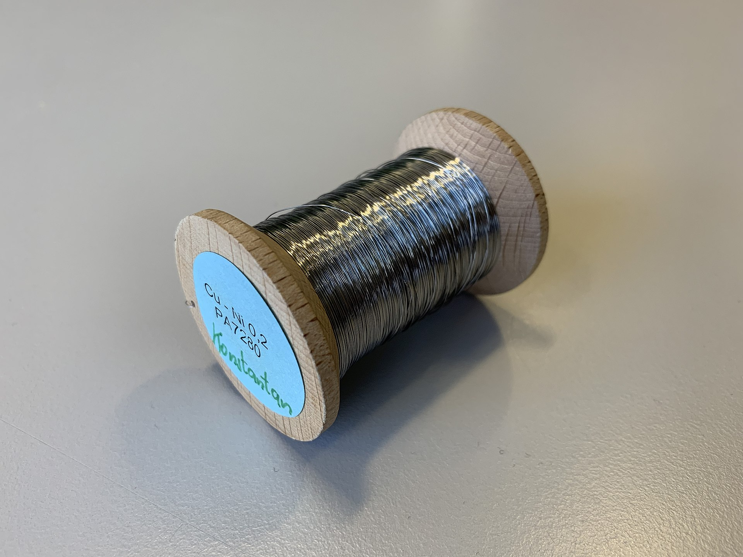

To minimize the effect of temperature on resistivity, constantan wire was used in this experiment. Constantan is a copper-nickel alloy, typically composed of 55% copper and 45% nickel. It is widely used in electrical applications because its resistivity is stable over a broad temperature range. This stability makes it an ideal choice for precise experimental work. The expected resistivity of constantan is approximately 5 * 10^-7 Ωm, which is significantly less affected by temperature fluctuations compared to other materials. [5]

**Variables:**

**Independent Variable:**Length of the wire (cm) — This is varied to investigate how resistance changes with length, which is essential for calculating resistivity.

**Dependent Variables:**Current (A) and voltage (V) — These are measured to calculate the resistance of the wire using the formula R=V/I.

| **Control Variable** | **Justification** | **Method to Control** |
| --- | --- | --- |
| Material of the wire | Different materials have different resistivity, which would affect the results. | Use only constantan wire throughout the experiment. |
| Diameter of the wire | Resistance depends on the cross-sectional area of the wire, which is calculated using the diameter. Variations in diameter would cause inaccurate results. | Measure the diameter at several points using a micrometer, calculate an average, and ensure the same wire is used. |
| Temperature of the wire | Resistivity can change with temperature, so heating of the wire could affect measurements. | Use a low current to reduce heating and allow the wire to cool if it gets warm during the experiment. |
| Contact resistance | Inconsistent contact at connections could affect the voltage readings. | Use clean and secure crocodile clips to maintain consistent contact during all measurements. |

**List of equipment:**

| **Equipment** | **Quantity** | **Resolution / Purpose** |
| --- | --- | --- |
| Ammeter | 1 | Measures current with a resolution of 0.01 A. |
| Voltmeter | 1 | Measures voltage with a resolution of 0.01V. |
| Constantan wire | 1 roll | Chosen for its relatively constant resistivity over a wide temperature range. |
| Meter ruler | 1 | Measures the length of the wire with a resolution of 1 mm. |
| Micrometer | 1 | Measures the diameter of the wire with a resolution of 0.01 mm. |
| Crocodile clips | 4 | Ensures secure connections between the wire and the circuit. |
| Masking tape | 1 roll | Used to attach the wire to the meter ruler for accurate length measurement. |
| Power supply | 1 | Provides a 3V power supply for the circuit. |
| Variable resistor | 1 | Adjusts the current to control heating effects in the wire. |
| Switch | 1 | Used to open and close the circuit, ensuring safety and ease of operation. |

**Diagram:**

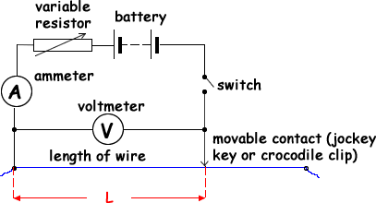[1]

**Risk Assessment:**

| **Hazard** | **Risk** | **Precaution** |
| --- | --- | --- |
| Electric shock | Risk of electric shock if exposed wires are touched or if liquids come into contact with equipment. | Keep voltage low (3V or less). Avoid touching exposed wires. Ensure the workspace is dry and free of liquids. |
| Overheating of wire | The wire and circuit components may overheat, potentially causing burns or equipment damage. | Use minimal current necessary. Disconnect the circuit when not measuring. Avoid using wire lengths shorter than 10 cm. Use a variable resistor to keep current below 1A. [4] |

**Method**

1. Secure the constantan wire along the full length of a meter ruler using masking tape to ensure it remains straight and taut. Attach crocodile clips to each end of the wire for connection to the circuit. Keeping the wire straight minimizes errors due to bends or slack, ensuring accurate length measurements.
2. Use a micrometer to measure the diameter of the wire at multiple points along its length, ensuring consistent measurements. Record all values and calculate the average diameter. Measuring at multiple points accounts for slight variations in the wire’s thickness, improving accuracy when calculating the cross-sectional area.
3. Calculate the cross-sectional area of the wire using the formula A=π(d^2/4), where d is the average diameter obtained from the micrometer measurements.
4. Set up the circuit, including the constantan wire, a variable resistor, an ammeter in series, and a voltmeter in parallel across the wire segment being measured. Add a switch to control the flow of current. Using a variable resistor allows precise control of current, reducing heating effects in the wire. The switch ensures current flows only during measurements, preventing unnecessary temperature changes.
5. Adjust the length of the wire by connecting crocodile clips at specific points on the meter ruler. Start with a minimum length of 10 cm and increase in increments of 10 cm up to 100 cm. Ensure the clips make firm contact with the wire.
6. Close the switch to complete the circuit and allow current to flow. Record the voltage across the wire using the voltmeter and the current through the wire using the ammeter, wait until both values are stable. Open the switch immediately after taking each reading to minimize heating.
7. Repeat measurements for each length three times to obtain consistent data. Record all readings and calculate the average voltage and current for each length.
8. Calculate the resistance of the wire for each length using the formula R=V/I, where R is resistance, V is voltage, and I is current.
9. Plot a graph of resistance (R) against length (L). Determine the gradient of the line of best fit on the graph (gradient = ∆R/∆L). The gradient of the resistance-length graph is proportional to resistivity when the cross-sectional area is considered, providing a graphical method for calculating resistivity. [2]

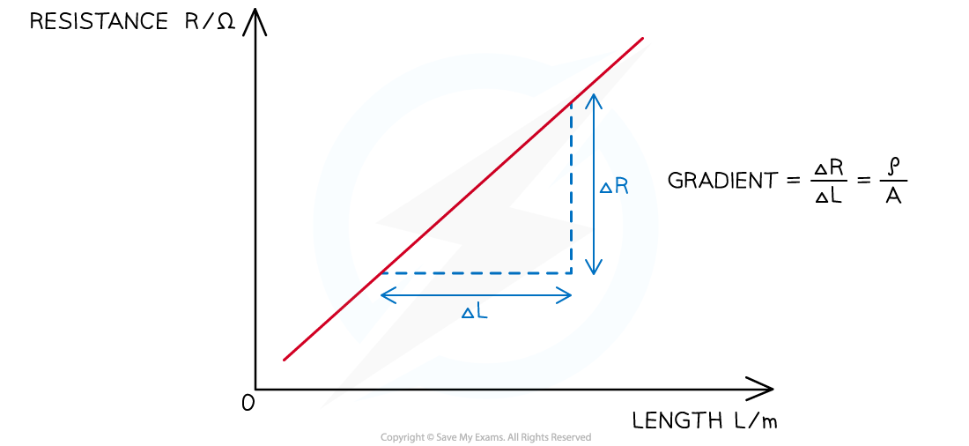[2]

1. Calculate the resistivity of the wire using the formula p=RA/L= where p is resistivity and A is the cross-sectional area of the wire. This formula can be rearranged to p=R/L A=gradient A.
2. Compare the calculated resistivity with the known theoretical value for constantan (5 10^-7), considering potential errors and uncertainties in the measurements.

We also made some adjustments along the way of the experiments.

1. The switch was removed from the circuit because it caused inconsistencies in the measurements. The force applied to the switch during operation varied, making it difficult to obtain stable readings. To ensure safety and avoid overheating, the circuit was manually disconnected when not measuring.
2. Parts of the wire were covered with masking tape to stabilize it along the meter ruler. As a result, measurements were limited to a maximum length of 90 cm instead of the intended 100 cm.
3. The wire was not measured from the 0 cm mark on the meter ruler but from the 3 cm mark, as the initial section of the wire was covered by tape. Measurements were taken starting from 3 cm, progressing to 13 cm, 23 cm, and so on. It allowed for consistent length measurements from a known starting point (even though not 0).

.

**Results:**

**Raw data:**

| **Wire Length/cm** | **Voltage/V** | | | **Current/A** | | |
| --- | --- | --- | --- | --- | --- | --- |
| **1** | **2** | **3** | **1** | **2** | **3** |
| 10 | 0.06 | 0.07 | 0.07 | 0.18 | 0.21 | 0.20 |
| 20 | 0.12 | 0.13 | 0.13 | 0.18 | 0.20 | 0.21 |
| 30 | 0.14 | 0.18 | 0.17 | 0.15 | 0.20 | 0.19 |
| 40 | 0.23 | 0.24 | 0.23 | 0.19 | 0.18 | 0.19 |
| 50 | 0.28 | 0.27 | 0.26 | 0.19 | 0.18 | 0.17 |
| 60 | 0.36 | 0.36 | 0.36 | 0.18 | 0.20 | 0.19 |
| 70 | 0.40 | 0.41 | 0.40 | 0.19 | 0.19 | 0.17 |
| 80 | 0.45 | 0.44 | 0.44 | 0.19 | 0.18 | 0.18 |
| 90 | 0.48 | 0.45 | 0.47 | 0.17 | 0.17 | 0.17 |
|  |  |  |  |  |  |  |
|  | **Diameter of Wire/mm** | | |  |  |  |
|  | **1** | **2** | **3** |  |  |  |
|  | 0.58 | 0.49 | 0.47 |  |  |  |

**Calculation:**

mean= (x1+x2+x3)/3

Resistance: R=I/V=voltage/current

D=Diameter of wire/1000 (unit conversion from mm to m)

A=(piD^2)/4

L=Wire length/100 ((unit conversion from cm to m)

Resistivity: p=RA/L

Experimental error%=(p-510^(-7))/510^(-7) 100

Note: 510^(-7) is the expected resistivity of a constantan wire [5]

**Processed data:**

| **Wire Length/cm** | **Voltage/V** | | | | **Current/A** | | | | **Resistance/Ω** | **Resistivity/Ωm** | **Experimental Error/%** |
| --- | --- | --- | --- | --- | --- | --- | --- | --- | --- | --- | --- |
| **1** | **2** | **3** | **Mean** | **1** | **2** | **3** | **Mean** |
| 10 | 0.06 | 0.07 | 0.07 | **0.07** | 0.18 | 0.21 | 0.20 | **0.20** | 0.34 | 7.02E-07 | 40.31% |
| 20 | 0.12 | 0.13 | 0.13 | **0.13** | 0.18 | 0.20 | 0.21 | **0.20** | 0.64 | 6.66E-07 | 33.30% |
| 30 | 0.14 | 0.18 | 0.17 | **0.16** | 0.15 | 0.20 | 0.19 | **0.18** | 0.91 | 6.26E-07 | 25.20% |
| 40 | 0.23 | 0.24 | 0.23 | **0.23** | 0.19 | 0.18 | 0.19 | **0.19** | 1.25 | 6.47E-07 | 29.35% |
| 50 | 0.28 | 0.27 | 0.26 | **0.27** | 0.19 | 0.18 | 0.17 | **0.18** | 1.50 | 6.21E-07 | 24.18% |
| 60 | 0.36 | 0.36 | 0.36 | **0.36** | 0.18 | 0.20 | 0.19 | **0.19** | 1.89 | 6.54E-07 | 30.71% |
| 70 | 0.40 | 0.41 | 0.40 | **0.40** | 0.19 | 0.19 | 0.17 | **0.18** | 2.20 | 6.50E-07 | 30.09% |
| 80 | 0.45 | 0.44 | 0.44 | **0.44** | 0.19 | 0.18 | 0.18 | **0.18** | 2.42 | 6.26E-07 | 25.12% |
| 90 | 0.48 | 0.45 | 0.47 | **0.47** | 0.17 | 0.17 | 0.17 | **0.17** | 2.75 | 6.31E-07 | 26.25% |
|  |  |  |  |  |  |  |  |  | **Mean** | 6.47E-07 | 29.39% |
|  | **Diameter of Wire/mm** | | | |  |  |  |  |  |  |  |
|  | **1** | **2** | **3** | **Mean** |  |  |  |  |  |  |  |
|  | 0.58 | 0.49 | 0.47 | 0.51 |  |  |  |  |  |  |  |

**Graph:**

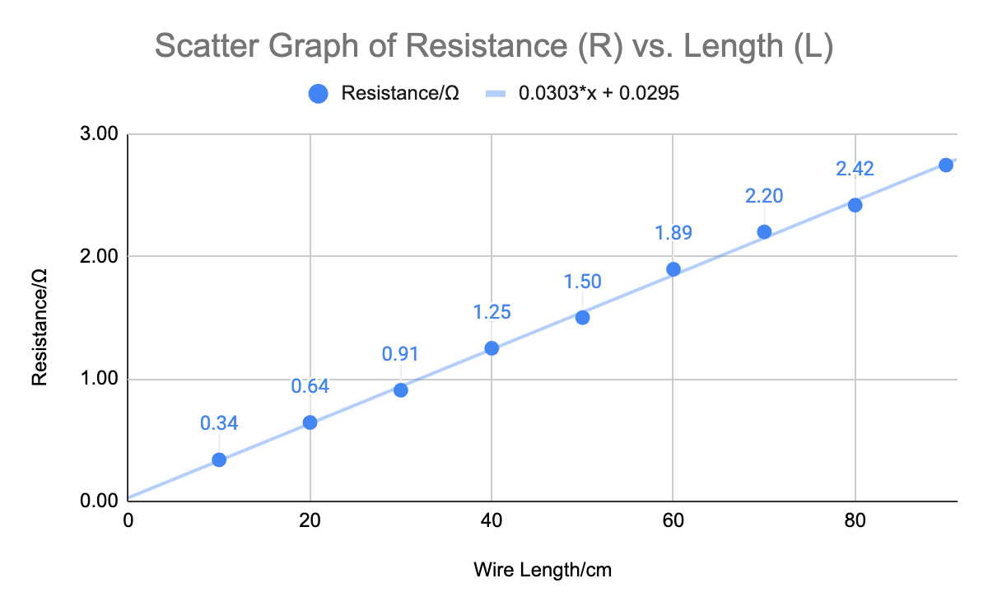

Gradient of the graph (R/L)=0.0303

The average resistance according to the graph is = 0.0303A

=0.0303(0.51/2/1000)^2)pi=6.2710^-9 Ωm

**Conclusions:**

The experiment produced an average resistivity of 6.47*10^-7 Ωm from the results table and 6.27*10^-7 Ωm based on the graph gradient. Both values are higher than the theoretical resistivity of constantan, which is 5.00*10^-7 Ωm. The experimental error was approximately 29.39%, which is acceptable. Despite this discrepancy, the data demonstrated a clear linear relationship between resistance and wire length, consistent with the theoretical equation for resistivity. The deviations from the accepted value highlight the impact of experimental limitations and sources of error.

**Evaluation:**

1. The measured diameters of the wire showed variability, with values of 0.58 mm, 0.49 mm, and 0.47 mm, leading to inaccuracies in the calculated cross-sectional area. This variability directly affected the calculated resistivity. To address this, measurements of the wire’s diameter should be taken at more frequent intervals, such as every 5 cm, and averaged to ensure greater accuracy.
2. The wire likely heated during the experiment, especially at longer lengths where the current flow was sustained for more extended periods. This would increase the resistance and inflate the calculated resistivity. To reduce heating effects, the current should be kept lower by using a variable resistor, and measurements should be taken quickly to minimize the time the circuit is active. Using a thicker wire could also help, as it would generate less heat for the same current.
3. The crocodile clips used to connect the wire to the circuit may have introduced inconsistent and additional resistance. Loose connections could result in higher resistance readings, particularly at shorter wire lengths where these contributions are more significant. To improve this, more stable connectors or soldered connections could be used to ensure consistent contact throughout the experiment.
4. The resolution of the ammeter and voltmeter was limited to 0.01 A and 0.01 V, respectively. This could introduce significant uncertainty, especially when measuring smaller currents and voltages for shorter wire lengths. Using digital instruments with a higher resolution, such as 0.001 A or 0.001 V, would provide more precise and reliable readings.

**Bibliography:**

[1] Cyberphysics. "A2 Resistivity." <https://www.cyberphysics.co.uk/Q&A/KS5/electricity/resistivity/A2_resistivity.html>

[2] Save My Exams. "AQA Physics: Required Practical - Investigating Resistivity." <https://www.savemyexams.com/a-level/physics/aqa/17/revision-notes/5-electricity/5-2-resistance-and-resistivity/5-2-4-required-practical-investigating-resistivity/>

[3] Isaac Physics. "Resistivity Concept Page." <https://isaacphysics.org/concepts/cp_resistivity>

[4] AQA. "12.3 Practical: Investigating Resistivity." Oxford A Level Physics Practical Method Sheet.

[5] Wikipedia. "Constantan." <https://en.wikipedia.org/wiki/Constantan>

[6] Save My Exams. "CIE Physics: Resistance and Resistivity." <https://www.savemyexams.com/a-level/physics/cie/25/revision-notes/9-electricity/9-3-resistance-and-resistivity/resistivity/>