TECHNICAL CONCEPT PAPER

ROOT: A local architecture for room-level AC comfort
  - Technical concept paper
A developer-preview architecture and evaluation plan for bounded local room-comfort control.
ROOT-TCP-001 | D0.1
Developer preview | Issued: 25 August 2026
Owner: Haptique Electronics Pvt. Ltd.
Technical reviewer: Not yet assigned | Evidence cutoff: 25 August 2026

Document control
Table 1. Document-control register.
Field | Controlled value
Document ID | ROOT-TCP-001
Revision | D0.1
Publication status | Developer preview
Owner | Haptique Electronics Pvt. Ltd.
Technical reviewer | Not yet assigned
Issue date | 25 August 2026
Last reviewed | 25 August 2026
Evidence cutoff | 25 August 2026
Hardware revision | Not yet assigned
Firmware revision | Not yet assigned

Table of contents
Abstract
1. The room-level problem 4
2. System architecture 4
3. Connectivity and local-control boundary 5
4. Sensing and infrared interface 5
5. Placement and installation boundary 6
6. Claim and evidence register 6
7. Evaluation methodology 9
8. Limitations, privacy, and safety boundary 11
9. Company and document position 11
References
Revision history
Appendix A. Controlled disclosures 13

Nomenclature and evidence status
Table 2. Nomenclature and evidence-status taxonomy.
Term or status | Meaning in this revision
AC | Air conditioner.
IR | Infrared command learning or transmission.
RSSI | Bluetooth received signal strength; a coarse and environment-dependent input.
ROOT | The proposed room-comfort controller described by this paper.
Cited background | A statement supported by an identified external source.
Implemented prototype behavior | A status reserved for behavior demonstrated by a revision-linked prototype record; no claim in D0.1 is assigned this status.
Hypothesis / design target | An intended behavior or bounded design thesis that remains unmeasured.
Planned evaluation | A claim framed as a protocol and acceptance decision to be completed later.

Abstract
A proposed local architecture for room-level AC comfort.
ROOT is a proposed controller for IR-operated split air conditioners. Its design thesis is to sense conditions closer to an occupied location, make bounded control decisions on the device, and transmit adjustments through the AC's existing infrared interface.
The paper limits its scope to an engineering concept: proposed climate and presence inputs, Bluetooth-assisted configuration, infrared learning and transmission, placement effects, on-device decision boundaries, and failure modes that must preserve manual AC control. It distinguishes cited HVAC context from ROOT-specific hypotheses and records the hardware and firmware revisions to which future evidence must apply.
Seven planned evaluations define how climate sensing, presence sensing, infrared interoperability, offline control, setup, power behavior, and room-comfort stability are to be tested. Each protocol requires stated conditions, comparators, sampling, repeated trials, outcomes, pre-specified acceptance criteria, missing-data handling, uncertainty, and retained artifacts. This revision reports no measured product-performance result, establishes no compatibility, accuracy, reliability, comfort, or energy claim, and treats every unmeasured behavior as a hypothesis, design target, or planned evaluation.

1. The room-level problem
The occupied part of a room can differ from the return-air reference.
Split air conditioners typically regulate from a temperature reference near the indoor unit. Airflow, heat loads, room geometry, and occupant location can create non-uniform conditions that a single reference does not fully describe.
ROOT's design hypothesis is narrower: a sensor placed near a bed, couch, or desk may provide a more relevant control input for that location. The magnitude and usefulness of any difference remain dependent on the room and must be measured.

2. System architecture
A four-stage loop with a deliberately small control boundary.
The intended loop is: sense the room; estimate occupancy or context; decide locally; and transmit an infrared adjustment. Temperature, humidity, and a bounded presence signal are proposed inputs near the intended occupied location.
The proposed decision path uses bounded setpoints, bounded command rates, manual override, and a neutral fallback. An emitted infrared command is not treated as confirmed AC state. Conceptual architecture diagrams are not measured results.
1 | Sense | 2 | Interpret | 3 | Decide | 4 | Transmit
Sample temperature, humidity, and bounded presence context. | Estimate local room context without inferring safety-critical state. | Apply bounded setpoints, command rates, override, and fallback rules. | Emit a learned IR command without assuming confirmed AC state.
Figure 1. Conceptual four-stage control loop. Conceptual architecture, not a measured result. Status: Hypothesis / design target. Claim ID: HT-01.
Signal path: environmental and bounded presence inputs -> local interpretation -> bounded local decision -> learned IR transmission. The proposed loop does not provide confirmed AC-state feedback.

Proposed control sequence
- Sense temperature, humidity, and a bounded room-presence context near the occupied location.
- Estimate context without treating coarse proximity as a safety-relevant or irreversible signal.
- Decide locally within bounded setpoints, bounded command rates, manual override, and neutral fallback targets.
- Transmit a learned IR adjustment without treating the emitted command as confirmed AC state.

3. Connectivity and local-control boundary
Local control is a scoped pathway, not a blanket privacy or uptime claim.
Bluetooth is a proposed configuration pathway. The intended remote-learning flow records supported IR commands from the existing AC remote; configuration storage, sensing, decision, and IR transmission are proposed device pathways. Exact permissions, pairing authorization, retained identifiers, storage, retention, deletion, sharing, and reset behavior require a reviewed data-flow design.
Offline operation must be evaluated after setup through sensing, decision, command, reboot, and reconnection scenarios. Bluetooth received signal strength varies with orientation, obstruction, radio conditions, and implementation; it is a coarse input and must not be the sole basis for a safety-relevant or irreversible action.

4. Sensing and infrared interface
Sensing and infrared are system elements awaiting integrated validation.
Temperature and humidity are proposed control inputs; part specifications and display resolution do not establish integrated system accuracy. Presence sensing is limited to room-control context and is not health or vital-sign monitoring.
IR learning is intended to record supported commands without implying broad compatibility. Infrared transmission reach depends on orientation, distance, line of sight, surfaces, emitter configuration, and the receiving AC. Illustrative product imagery is not evidence of final components, layout, construction, or production readiness.
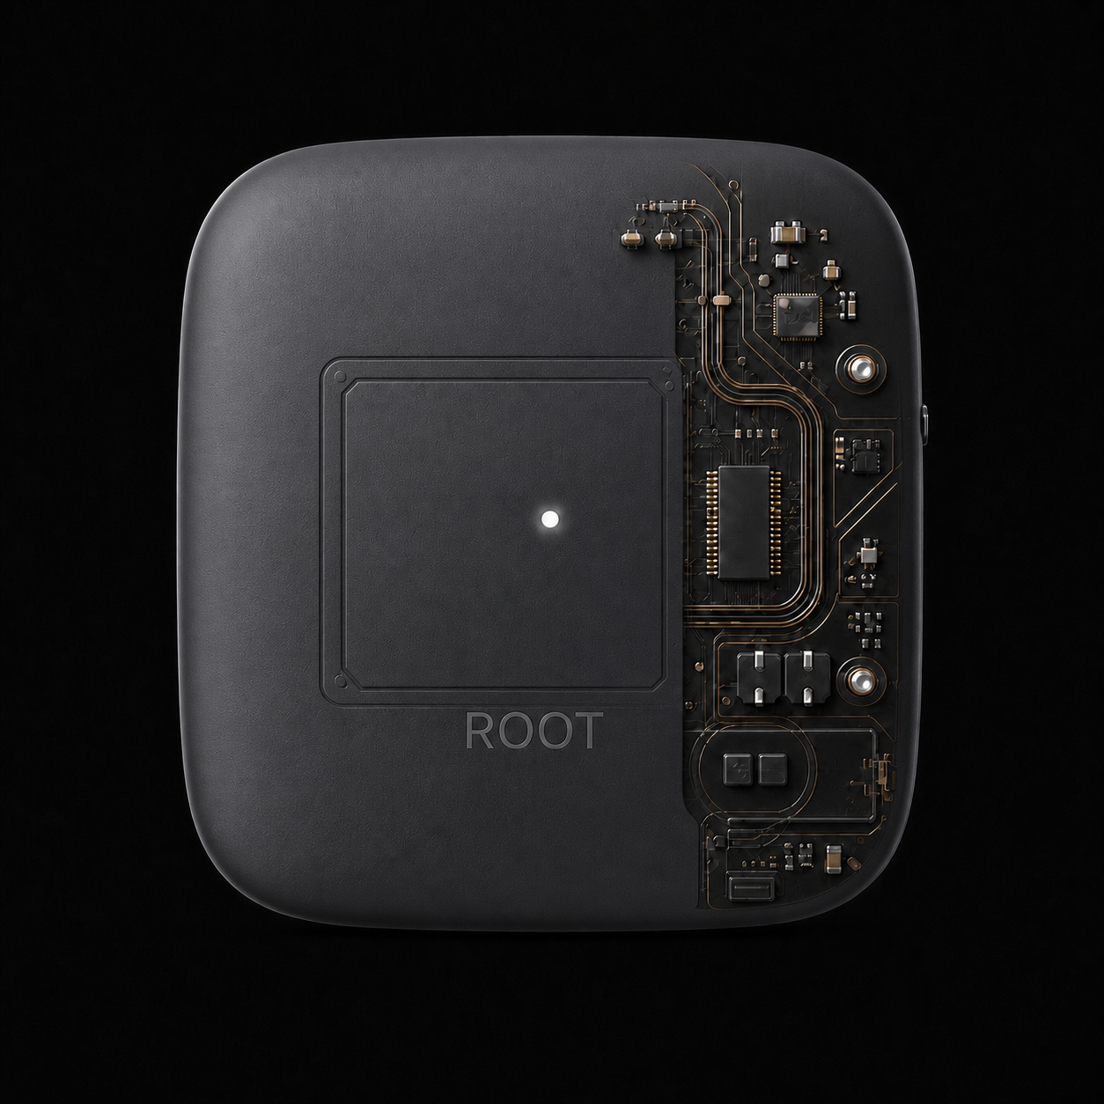
Figure 2. Illustrative ROOT product cutaway. Illustrative image, not component or production evidence. Status: Hypothesis / design target. Claim ID: HT-03.

5. Placement and installation boundary
Placement changes what the device can sense and reach.
Tabletop, nightstand, couch-side, desk-side, and wall-mounted arrangements are placement concepts, not equivalent operating modes. Each changes sampled air, exposure to drafts or heat sources, sensor obstruction, mounting stability, occupant proximity, and the IR path to the AC.
Placement guidance must be tied to tested room and AC configurations. Users should retain access to manual AC controls when the recommended position cannot provide a reliable sensing or transmission path.

6. Claim and evidence register
The register below separates cited background, unmeasured design targets, and planned evaluations. It contains no claim assigned to Implemented prototype behavior.
Table 3. Claim and evidence register.
Claim ID | Status | Scope | Revision | Evidence ID | Evidence date | Control record
CB-01 | Cited background | HVAC background and design motivation | Not applicable | REF-01 | 2026 | Wording: Non-uniform conditions can arise in split-AC rooms, so a single return-air reference may not fully describe conditions near an occupant.  Owner: Haptique Electronics Pvt. Ltd.  Review date: 25 August 2026  Superseded wording: None recorded  Hardware revision: Not applicable  Firmware revision: Not applicable
HT-01 | Hypothesis / design target | Proposed four-stage room-control loop | Target revision not yet assigned | DESIGN-REVIEW-2026-08-25 | 25 August 2026 | Wording: ROOT is designed to sense room context, decide locally within bounded controls, and transmit a learned IR adjustment.  Owner: Haptique Electronics Pvt. Ltd.  Review date: 25 August 2026  Superseded wording: None recorded  Hardware revision: Target revision not yet assigned  Firmware revision: Target revision not yet assigned
HT-02 | Hypothesis / design target | Proposed setup and local-control boundary | Target revision not yet assigned | REF-02; DESIGN-REVIEW-2026-08-25 | 25 August 2026 | Wording: Bluetooth is a proposed setup or coarse-proximity pathway, while the intended core sensing, decision, and IR paths operate on the device after configuration.  Owner: Haptique Electronics Pvt. Ltd.  Review date: 25 August 2026  Superseded wording: None recorded  Hardware revision: Target revision not yet assigned  Firmware revision: Target revision not yet assigned
HT-03 | Hypothesis / design target | Proposed sensing and infrared interface | Target revision not yet assigned | DESIGN-REVIEW-2026-08-25 | 25 August 2026 | Wording: Temperature, humidity, presence sensing, IR learning, and IR transmission require integrated validation before accuracy, reach, or compatibility claims are made.  Owner: Haptique Electronics Pvt. Ltd.  Review date: 25 August 2026  Superseded wording: None recorded  Hardware revision: Target revision not yet assigned  Firmware revision: Target revision not yet assigned
HT-04 | Hypothesis / design target | Placement concepts | Target revision not yet assigned | DESIGN-REVIEW-2026-08-25 | 25 August 2026 | Wording: Placement affects sampled conditions, obstruction, airflow exposure, line of sight, IR reach, mounting stability, and presence-detection behavior.  Owner: Haptique Electronics Pvt. Ltd.  Review date: 25 August 2026  Superseded wording: None recorded  Hardware revision: Target revision not yet assigned  Firmware revision: Target revision not yet assigned
PE-01 | Planned evaluation | Climate sensing | Target revision not yet assigned | PROTOCOL-01 | 25 August 2026 | Wording: Co-locate ROOT with a traceable reference logger and report bias, mean absolute error, repeatability, sampling interval, stabilization time, and uncertainty.  Owner: Haptique Electronics Pvt. Ltd.  Review date: 25 August 2026  Superseded wording: None recorded  Hardware revision: Target revision not yet assigned  Firmware revision: Target revision not yet assigned
PE-02 | Planned evaluation | Presence sensing | Target revision not yet assigned | PROTOCOL-02 | 25 August 2026 | Wording: Compare presence detections with timestamped ground truth across occupied, unoccupied, stationary, moving, obstructed, placement, and false-trigger scenarios.  Owner: Haptique Electronics Pvt. Ltd.  Review date: 25 August 2026  Superseded wording: None recorded  Hardware revision: Target revision not yet assigned  Firmware revision: Target revision not yet assigned
PE-03 | Planned evaluation | IR interoperability | Target revision not yet assigned | PROTOCOL-03 | 25 August 2026 | Wording: Test a declared stratified sample of AC brands, models, and commands over repeated trials, distances, angles, and line-of-sight conditions, reporting model-level successes and failures.  Owner: Haptique Electronics Pvt. Ltd.  Review date: 25 August 2026  Superseded wording: None recorded  Hardware revision: Target revision not yet assigned  Firmware revision: Target revision not yet assigned
PE-04 | Planned evaluation | Offline control | Target revision not yet assigned | PROTOCOL-04 | 25 August 2026 | Wording: Disable Wi-Fi and internet after setup, then exercise sensing, decisions, commands, reboot, and reconnection for a stated duration.  Owner: Haptique Electronics Pvt. Ltd.  Review date: 25 August 2026  Superseded wording: None recorded  Hardware revision: Target revision not yet assigned  Firmware revision: Target revision not yet assigned
PE-05 | Planned evaluation | Setup | Target revision not yet assigned | PROTOCOL-05 | 25 August 2026 | Wording: Observe first-time users completing a defined setup flow and report completion rate, timing distributions, assistance, retries, and failure reasons.  Owner: Haptique Electronics Pvt. Ltd.  Review date: 25 August 2026  Superseded wording: None recorded  Hardware revision: Target revision not yet assigned  Firmware revision: Target revision not yet assigned
PE-06 | Planned evaluation | Power behavior | Target revision not yet assigned | PROTOCOL-06 | 25 August 2026 | Wording: Measure nominal and peak draw, supported input conditions, brownout and restart behavior, and recovery state using declared equipment.  Owner: Haptique Electronics Pvt. Ltd.  Review date: 25 August 2026  Superseded wording: None recorded  Hardware revision: Target revision not yet assigned  Firmware revision: Target revision not yet assigned
PE-07 | Planned evaluation | Room comfort stability | Target revision not yet assigned | PROTOCOL-07 | 25 August 2026 | Wording: Use a randomized or counterbalanced baseline-versus-ROOT comparison with recorded conditions and predefined occupant-zone deviation, overshoot, cycling, and humidity outcomes.  Owner: Haptique Electronics Pvt. Ltd.  Review date: 25 August 2026  Superseded wording: None recorded  Hardware revision: Target revision not yet assigned  Firmware revision: Target revision not yet assigned

7. Evaluation methodology
Report protocols before results.
Every planned evaluation identifies the prototype and firmware revision, room or bench conditions, comparator and ground truth, sample interval, repeated trials, primary and secondary outcomes, acceptance criterion fixed before testing, exclusions and missing-data handling, uncertainty, and retained evidence artifact.
Future reports must include trial counts, negative results, protocol deviations, raw and derived data location, and analysis version. A simulator output is not a measured result.

Protocol-wide reporting rules
- Identify prototype hardware and firmware revisions, conditions, comparator, ground truth, sample interval, and repeated trials.
- Fix primary and secondary outcomes, acceptance criteria, exclusions, missing-data handling, and uncertainty before testing.
- Retain evidence artifacts and report trial counts, negative results, protocol deviations, data location, and analysis version.
- Keep simulator outputs distinct from measured results.
Planned evaluation IDs: PE-01, PE-02, PE-03, PE-04, PE-05, PE-06, and PE-07. Each acceptance rule will be pre-registered before testing; no threshold is approved in D0.1.
Table 4. Planned evaluation protocol register.
Evaluation | Controlled setup | Measurement and decision record
PE-01  PROTOCOL-01  Climate sensing | Hardware revision: Target revision not yet assigned  Firmware revision: Target revision not yet assigned  Conditions: Relevant temperature and humidity conditions  Comparator / ground truth: Traceable reference logger  Sample interval: Defined before testing  Repeated trials: Defined before testing | Primary outcomes: bias; mean absolute error; repeatability; measurement uncertainty  Secondary outcomes: sampling interval; stabilization time  Acceptance criterion: Defined before testing  Exclusions / missing data: Defined before testing  Uncertainty: Defined before testing  Retained artifact: Not yet assigned  Reporting: Trial counts, negative results, protocol deviations, raw and derived data location, and analysis version.
PE-02  PROTOCOL-02  Presence sensing | Hardware revision: Target revision not yet assigned  Firmware revision: Target revision not yet assigned  Conditions: Occupied, unoccupied, stationary, moving, obstructed, placement, and false-trigger scenarios  Comparator / ground truth: Timestamped ground truth  Sample interval: Defined before testing  Repeated trials: Defined before testing | Primary outcomes: sensitivity; specificity or false-positive rate; response latency  Secondary outcomes: false-trigger scenarios  Acceptance criterion: Defined before testing  Exclusions / missing data: Defined before testing  Uncertainty: Defined before testing  Retained artifact: Not yet assigned  Reporting: Trial counts, negative results, protocol deviations, raw and derived data location, and analysis version.
PE-03  PROTOCOL-03  IR interoperability | Hardware revision: Target revision not yet assigned  Firmware revision: Target revision not yet assigned  Conditions: Declared stratified AC sample; repeated distances, angles, and line-of-sight conditions  Comparator / ground truth: Declared AC brand, model, and command set  Sample interval: Defined before testing  Repeated trials: Defined before testing | Primary outcomes: model-level successes; model-level failures  Secondary outcomes: distance; angle; line-of-sight condition  Acceptance criterion: Defined before testing  Exclusions / missing data: Defined before testing  Uncertainty: Defined before testing  Retained artifact: Not yet assigned  Reporting: Trial counts, negative results, protocol deviations, raw and derived data location, and analysis version.
PE-04  PROTOCOL-04  Offline control | Hardware revision: Target revision not yet assigned  Firmware revision: Target revision not yet assigned  Conditions: Wi-Fi and internet disabled after setup for a stated duration  Comparator / ground truth: Configured device before network loss  Sample interval: Defined before testing  Repeated trials: Defined before testing | Primary outcomes: sensing, decision, command, reboot, and reconnection behavior  Secondary outcomes: network independence distinct from electrical uptime  Acceptance criterion: Defined before testing  Exclusions / missing data: Defined before testing  Uncertainty: Defined before testing  Retained artifact: Not yet assigned  Reporting: Trial counts, negative results, protocol deviations, raw and derived data location, and analysis version.
PE-05  PROTOCOL-05  Setup | Hardware revision: Target revision not yet assigned  Firmware revision: Target revision not yet assigned  Conditions: First-time users completing one defined setup flow  Comparator / ground truth: Observed user task completion  Sample interval: Defined before testing  Repeated trials: Defined before testing | Primary outcomes: completion rate; median and range or interquartile range  Secondary outcomes: assistance; retries; failure reasons  Acceptance criterion: Defined before testing  Exclusions / missing data: Defined before testing  Uncertainty: Defined before testing  Retained artifact: Not yet assigned  Reporting: Trial counts, negative results, protocol deviations, raw and derived data location, and analysis version.
PE-06  PROTOCOL-06  Power behavior | Hardware revision: Target revision not yet assigned  Firmware revision: Target revision not yet assigned  Conditions: Declared supported input conditions and brownout/restart scenarios  Comparator / ground truth: Declared measurement equipment  Sample interval: Defined before testing  Repeated trials: Defined before testing | Primary outcomes: nominal draw; peak draw; brownout and restart behavior  Secondary outcomes: recovery state  Acceptance criterion: Defined before testing  Exclusions / missing data: Defined before testing  Uncertainty: Defined before testing  Retained artifact: Not yet assigned  Reporting: Trial counts, negative results, protocol deviations, raw and derived data location, and analysis version.
PE-07  PROTOCOL-07  Room comfort stability | Hardware revision: Target revision not yet assigned  Firmware revision: Target revision not yet assigned  Conditions: Recorded room geometry, placement, AC model, loads, outdoor conditions, and occupancy  Comparator / ground truth: Randomized or counterbalanced baseline-versus-ROOT comparison  Sample interval: Defined before testing  Repeated trials: Defined before testing | Primary outcomes: occupant-zone deviation; overshoot; cycling; humidity  Secondary outcomes: recorded room and operating conditions  Acceptance criterion: Defined before testing  Exclusions / missing data: Defined before testing  Uncertainty: Defined before testing  Retained artifact: Not yet assigned  Reporting: Trial counts, negative results, protocol deviations, raw and derived data location, and analysis version.

8. Limitations, privacy, and safety boundary
A comfort controller with explicit limits.
ROOT is intended for general room-comfort control. It is not a medical device and is not intended to diagnose, prevent, monitor, predict, mitigate, or treat disease, injury, disability, a physiological condition, sleep, or a vital sign.
ROOT is not a safety-critical, emergency, or life-support controller. Users must retain the original AC remote and access to the AC's manual controls. Bounded setpoints, bounded command rates, visible fault indication, manual override, and a neutral fallback remain design targets until implemented and tested.
Validation must cover sensor faults, stale or out-of-range inputs, proximity loss, ambiguous or unsupported IR state, blocked line of sight, AC non-response, power interruption and restart, conflicting occupant preferences, mounting failure, and optional-connectivity loss. Compatibility and performance depend on AC hardware, room geometry, placement, obstruction, environmental conditions, power, firmware, and operating mode.

9. Company and document position
Haptique Electronics is developing ROOT.
Haptique Electronics Pvt. Ltd. is the company developing ROOT as a room-comfort product concept. ROOT is a product and brand, not a separate legal entity.
This revision intentionally omits third-party recognition and intellectual-property status. Those disclosures require verified identity, filing, scope, and approval records before inclusion. Developer contact: info@get-root.in.

References
References.
The cited background and Bluetooth measurement context are identified in the numbered reference register below.
Table 5. Numbered reference register.
ID | Author or organization | Title | Publication | Locator and access
REF-01 | Haiyan Yan, Yawei Li, Thomas Parkinson, Stefano Schiavon, Hui Zhang, Rui Sun, Shengkai Zhao, Wei Zhao, Zhen Sun, Fangning Shi | Human thermal responses to non-uniform cooling from intermittently operated split air conditioners | Building and Environment (2026) | https://doi.org/10.1016/j.buildenv.2026.114379  Accessed 25 August 2026
REF-02 | Bluetooth SIG | Bluetooth Low Energy Primer | Bluetooth SIG (Not dated) | https://www.bluetooth.com/bluetooth-le-primer/  Accessed 25 August 2026

Revision history
Revision history.
D0.1, issued 25 August 2026 by Haptique Electronics Pvt. Ltd.; reviewer: Not yet assigned; evidence cutoff: 25 August 2026. Initial developer-preview concept paper. No prototype performance result is reported.
Table 6. Revision history.
Revision | Issue date | Owner | Reviewer | Evidence cutoff | Summary
D0.1 | 25 August 2026 | Haptique Electronics Pvt. Ltd. | Not yet assigned | 25 August 2026 | Initial developer-preview concept paper. No prototype performance result is reported.

Appendix A. Controlled disclosures
These controlled disclosures preserve the product's intended-use, safety, company, privacy, and omission boundaries.
Table 7. Controlled-disclosure register.
ID | Type | Exact wording | Source / approval | Owner | Review control
CD-01 | Intended use and medical boundary | ROOT is intended for general room-comfort control. It is not a medical device and is not intended to diagnose, prevent, monitor, predict, mitigate, or treat disease, injury, disability, a physiological condition, sleep, or a vital sign. | WHITEPAPER-D0.1 / approved controlled disclosure | Haptique Electronics Pvt. Ltd. | Approved: 25 August 2026  Next review: Not yet assigned
CD-02 | Safety role | ROOT is not a safety-critical, emergency, or life-support controller. Users must retain the original AC remote and access to the AC's manual controls. | WHITEPAPER-D0.1 / approved controlled disclosure | Haptique Electronics Pvt. Ltd. | Approved: 25 August 2026  Next review: Not yet assigned
CD-03 | Company identity | Haptique Electronics Pvt. Ltd. is the company developing ROOT as a room-comfort product concept. ROOT is a product and brand, not a separate legal entity. | WHITEPAPER-D0.1 / company-supplied disclosure, not independently verified | Haptique Electronics Pvt. Ltd. | Approved: 25 August 2026  Next review: Not yet assigned
CD-04 | Privacy and data boundary | A future Bluetooth proximity feature may process a paired identifier and received signal strength. Storage, retention, deletion, reset behavior, sharing, and location permissions are not yet assigned. | WHITEPAPER-D0.1 / approved controlled disclosure | Haptique Electronics Pvt. Ltd. | Approved: 25 August 2026  Next review: Not yet assigned
CD-05 | Recognition and patent omission | This revision intentionally omits third-party recognition and patent-status statements. Those disclosures require verified identity, filing, scope, and approval records before inclusion. | WHITEPAPER-D0.1 / approved omission record | Haptique Electronics Pvt. Ltd. | Approved: 25 August 2026  Next review: Not yet assigned

