
Department of Computer Engineering and Technology
MINI PROJECT REPORT
Computer Networks Laboratory
(CSE20110)
Laboratory Continuous Assessment 3

GeoTrace: Network Traffic Geolocation and Visualisation on a 3D Globe

Submitted by
Sr. No. | Student Name | PRN
1 | Harshit Sharma | 1262242285
2 | Aditya Pillai | 1262242326
3 | Rohan Khalate | 1262243741
4 | Yashowardhan Bhosale | 1262240695
Group No. Panel K(iOS)
Third Year B.Tech. Computer Engineering and Technology
Under the guidance of
Dr Uma Pujeri
Academic Year 2026–2027
Submission Date 19/10/2026
Department of Computer Engineering and Technology
CERTIFICATE
This is to certify that the mini-project entitled “GeoTrace: Network Traffic Geolocation and Visualisation on a 3D Globe” has been carried out by the following students of Third Year B.Tech. Computer Science and Engineering, Panel K iOS, Group No., under my guidance during the academic year 2026–2027.
Student Name | PRN
Harshit Sharma | 1262242285
Rohan Khalate | 1262243741
Yahsowardhan Bhosale | 1262240695
Aditya Pillai | 1262242326
The report is submitted towards the mini-project component of Laboratory Continuous Assessment 3 for the Computer Networks Laboratory course.
Faculty Signature __________________________
Dr. Uma Pujeri Project Guide and Course Faculty
Date :- 19/10/2026 Place: Pune
Acknowledgement
We express our sincere gratitude to our project guide and course faculty, Uma Pujari, for the guidance and feedback received throughout this mini project. We thank the Department of Computer Engineering and Technology for the laboratory facilities and for the opportunity to carry out this work as part of Laboratory Continuous Assessment 3 of the Computer Networks Laboratory course. We also acknowledge the open-source tools and official documentation that made the implementation possible, namely Wireshark, Scapy, Three.js and globe.gl.
Group No 06
Abstract
Network traffic is normally inspected as long lists of packets and IP addresses, which makes it hard to see where data travels and when behaviour becomes unusual. This project presents GeoTrace, a software-only system that turns recorded network traffic into an interactive visual map. Traffic is captured with Wireshark and saved as a pcapng file. A Python program built on Scapy extracts source and destination addresses, ports, protocol, size and time from every IPv4 packet, groups packets into flows and identifies services from well-known port numbers. A threshold rule flags any source that attempts 20 or more distinct TCP ports within 10 seconds as a port scanner. Public IP addresses are converted to latitude and longitude through a geolocation service, and the flows are replayed as colour-coded arcs on a 3D globe built with globe.gl, together with protocol statistics and alerts. A live simulator demonstrates normal delivery, packet loss with timeout and retransmission, and attack patterns such as port scans, SYN floods and data exfiltration. The work applies core computer networks concepts, namely IP addressing, TCP and UDP, ports, DNS, reliability and network security, using standard tools on a single laptop. Test results are reported in Chapter 4.
Keywords: network traffic analysis, packet capture, IP geolocation, port scan detection, 3D visualisation
Table of Contents
1 Introduction and Project Objectives 7
1.1 Introduction and Background 7
1.2 Problem Statement 7
1.3 Scope 8
1.4 Objectives 8
2 Proposed Design and Requirements 9
2.1 Architecture and Network Topology 9
2.2 Tools and System Requirements 10
2.3 Addressing and Protocol Selection 11
3 Implementation and Technical Working 12
3.1 Methodology 12
3.2 Configuration or Code Implementation 12
3.3 Protocols and Technical Working 14
3.4 Execution Procedure 16
4 Testing and Results 18
4.1 Test Plan 18
4.2 Results and Execution Evidence 18
4.3 Objective Achievement 18
5 Discussion and Conclusion 20
5.1 Discussion and Comparative Analysis 20
5.2 Advantages and Applications 20
5.3 Limitations 20
5.4 Challenges and Troubleshooting 21
5.5 Future Scope 21
5.6 Conclusion 21
References 22
AI Usage Declaration 22
Appendices 24
Appendix A Code and Configuration 24
Appendix B Additional Evidence 37
Appendix C Individual Contributions 38
List of Figures
Figure 2.1 Proposed system architecture and data flow 10
Figure 2.2 Packet structure and the fields used by GeoTrace 11
Figure 3.1 Workflow of GeoTrace from capture to display 14
Figure 3.2 Lost packet, timeout and retransmission as shown by the simulator 18
Figure 3.3 Implementation evidence: GeoTrace dashboard replaying a captured traffic file 19
Figure 4.1 Test execution result 21
List of Tables
Table 1.1 Project objectives and verification methods 8
Table 2.1 Tools, resources and system requirements 11
Table 2.2 Addresses and endpoints used by the project 12
Table 2.3 Protocol labelling rules and arc colours 12
Table 3.1 Main code modules 14
Table 3.2 Simulator packet types and the concept each demonstrates 17
Table 4.1 Test plan and results 20
Table 4.2 Objective achievement 21
Table 5.1 Qualitative comparison with the Wireshark packet list 23
Table 5.2 Challenges and troubleshooting 24
Table B.1 Tunable parameters 41

1 Introduction and Project Objectives

1.1 Introduction and Background
Every device on the Internet communicates by exchanging packets. Each packet carries an Internet Protocol (IP) header holding the source and destination addresses [1], followed by a transport header, usually Transmission Control Protocol (TCP) [2] or User Datagram Protocol (UDP) [3], that holds the port numbers identifying the service. TCP provides reliable, ordered delivery through a three-way handshake, acknowledgements and retransmission, whereas UDP sends datagrams without delivery guarantees. Common services can be recognised from well-known ports: the Domain Name System (DNS) uses port 53 [4], the Internet Control Message Protocol (ICMP) carries control messages such as the echo request used by ping [5], and HTTP and HTTPS use ports 80 and 443 [6].
Tools such as Wireshark [7] capture packets and show them in a table of addresses and protocols. This is precise, but a long list does not show at a glance where traffic is going, which services dominate or when one host behaves unusually. Visualisation helps: placing connections on a map makes the geographic spread of traffic obvious, and highlighting unusual patterns draws attention to possible attacks.
Several sources shaped the design of this project. The Wireshark User’s Guide [7] explains how packets are captured on a network interface and saved to a capture file, which is the input of this project. The Scapy documentation [8] describes how capture files are read and how each protocol layer is accessed as named fields, which is how GeoTrace extracts IP addresses, ports and TCP flags. The ip-api batch documentation [9] describes how up to 100 addresses can be converted to coordinates in one request under a free-tier rate limit. The TCP specification [2] defines the SYN-based connection set-up and the retransmission of unacknowledged data, which the simulator illustrates. For drawing, Three.js [10] provides WebGL 3D graphics and globe.gl [11] builds on it to provide a globe with an arcs layer.

1.2 Problem Statement
Network traffic is normally analysed as long lists of packets and IP addresses. This makes it difficult to see where traffic comes from and goes to, which protocols are in use, and when behaviour becomes abnormal. Students and administrators need a simple way to understand traffic visually.
This project builds a system that reads network traffic from a recorded capture file, extracts connection details from each packet, maps the source and destination IP addresses to geographic locations and displays the flows as animated arcs on a 3D globe. Traffic is colour-coded by protocol, and simple rules highlight anomalies such as port scans. A simulator additionally shows the effect of packet loss, retransmission and attack traffic.

1.3 Scope
Users: students of computer networks and network administrators who want a visual overview of traffic. Network covered: the Wi-Fi or Ethernet traffic of one host, captured for a short period (about 1–2 minutes) and analysed offline. Application: a Python analysis program and a browser dashboard served on the local machine. The assumptions and boundaries are:
- Only IPv4 packets are processed, and only packet headers are used. Payloads are ignored because most modern traffic is encrypted.
- The main analysis is an offline replay of a recorded capture. It is not a live sniffer.
- IP geolocation is approximate and usually points to a data centre or internet service provider, not to an exact building.
- The simulator is a controlled teaching demonstration. Its delay values are estimated from distance and are not measured.
- Scanning or attack patterns are only simulated. Any real scan must be run only against systems the group owns or has permission to test.

1.4 Objectives
The objectives below are written so that each can be checked through implementation and testing. Table 1.1 lists them with the evidence used to verify each one.
Table 1.1 Project objectives and verification methods
Objective ID | Objective | Verification Method
O1 | Capture network traffic with Wireshark and save it as a capture file. | Capture file opens in Wireshark and is read by build_data.py without error.
O2 | Parse packets and extract source and destination IP, ports, protocol, size and time. | Total packets in the dashboard match the IPv4 packet count in Wireshark (Test T3).
O3 | Group packets into flows and identify the service from the port number. | Protocol bars in the dashboard agree with Wireshark filters such as dns and tcp.port==443 (Test T2).
O4 | Detect port-scan behaviour with a threshold rule. | A scan capture or the simulated scan produces red arcs and an alert (Tests T4, T8, T9).
O5 | Convert public IP addresses to latitude, longitude and country. | Arcs end in plausible countries; private IPs appear at the home point (Tests T2, T10).
O6 | Show flows on a 3D globe with statistics, legend and alerts. | Dashboard renders arcs, summary panels and alert list (Tests T1, T2).
O7 | Demonstrate normal, lost and suspicious packets in a simulator. | Simulator arcs, counters and event log behave as expected (Tests T5 to T9).

2 Proposed Design and Requirements

2.1 Architecture and Network Topology
GeoTrace is a software-only system, so its network topology is that of a single laptop. The laptop connects through its Wi-Fi adapter to a home router, which reaches the Internet through the service provider. The laptop is both the source of the captured traffic and the machine that runs every GeoTrace module. A local web server on the loopback address 127.0.0.1, port 8000, delivers the dashboard to a browser on the same laptop. The only outside server that GeoTrace itself contacts is the geolocation service. Figure 2.1 shows the modules and the data flow.
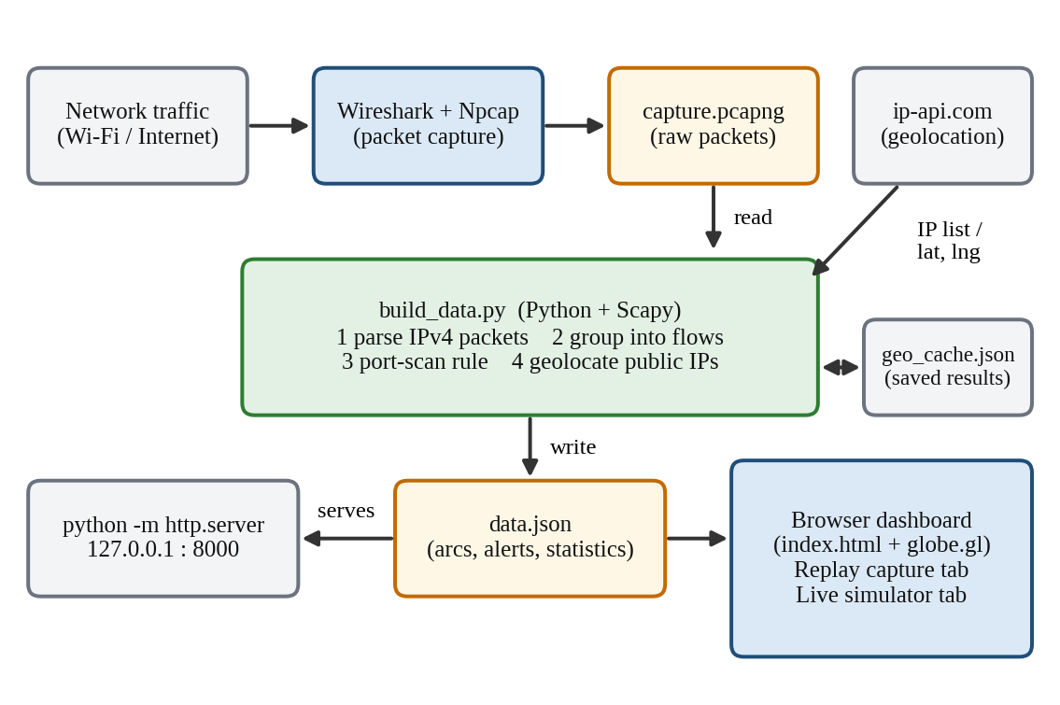
Figure 2.1 Proposed system architecture and data flow
- Capture module: Wireshark with Npcap records packets on the Wi-Fi interface and saves them as capture.pcapng.
- Analysis module (build_data.py): reads each IPv4 packet, groups packets into flows, applies the port-scan rule and builds the output.
- Geolocation: public IPs are sent in batches to ip-api.com, and answers are saved in geo_cache.json so each address is looked up only once.
- Data store: data.json holds the arcs, alerts and statistics that the dashboard reads.
- Presentation module (index.html): draws the globe with globe.gl and provides the Replay capture and Live simulator tabs.
Figure 2.2 shows which parts of a captured packet GeoTrace reads. Only the IP header, the TCP or UDP header, the timestamp and the packet length are used. MAC addresses never leave the local network and cannot be placed on a world map, and payloads are usually encrypted, so both are ignored.
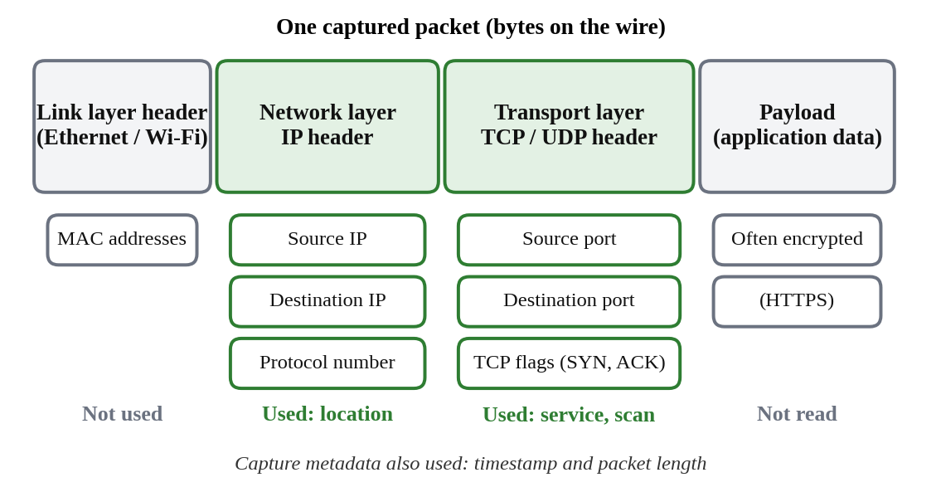
Figure 2.2 Packet structure and the fields used by GeoTrace

2.2 Tools and System Requirements
Table 2.1 lists the software and hardware used. No special network hardware is needed. Versions should be filled in from the group’s own machine (for example with python --version and pip show scapy).
Table 2.1 Tools, resources and system requirements
Tool or Resource | Version or Specification | Purpose
Laptop with Wi-Fi | Windows [version]; [RAM] GB RAM | Runs capture, analysis and dashboard
Wireshark and Npcap [12] | Wireshark [version]; Npcap [version] | Captures packets and saves capture.pcapng
Python | 3.x [exact version] | Runs build_data.py and the local web server
Scapy [8] | [version] (installed with pip install scapy) | Reads capture files and decodes IP, TCP, UDP and ICMP layers
ip-api.com batch API [9] | Free tier; HTTP; 100 IPs per request; 15 batch requests per minute | Converts public IPs to latitude, longitude and country
globe.gl [11] and Three.js [10] | Loaded from a CDN; [version used] | Renders the 3D globe, arcs, rings and pins
Web browser | [Chrome or Edge, version] with WebGL | Displays the dashboard
Python http.server | Standard library | Serves the dashboard on 127.0.0.1:8000

2.3 Addressing and Protocol Selection
GeoTrace does not configure a network, so Table 2.2 records the addresses that take part in the project. The laptop’s own private address and the router address should be copied from ipconfig. Fields that do not apply are marked N/A.
Table 2.2 Addresses and endpoints used by the project
Device / Interface | IP / Prefix | Gateway | Role
Laptop Wi-Fi interface | [192.168.x.x / 24 – from ipconfig] | [router address] | Capture host and source of traffic
Local web server | 127.0.0.1, TCP port 8000 | N/A (loopback) | Serves index.html and data.json
Remote servers in the capture | Public IPv4 addresses found in the capture | N/A | Destinations and sources shown as arcs
ip-api.com | Public address, TCP port 80 | N/A | Geolocation lookups
Table 2.3 shows how the transport protocol and port numbers are turned into the protocol labels and arc colours used throughout the dashboard.
Table 2.3 Protocol labelling rules and arc colours
Condition on the packet | Label | Arc colour
Either port is 443 | HTTPS | Blue
Either port is 80 | HTTP | Cyan
Either port is 53 | DNS | Green
Other TCP | TCP | Purple
Other UDP | UDP | Yellow
ICMP | ICMP | Orange
Any other IP protocol | OTHER | Grey
Source flagged by the port-scan rule | Same label | Red (overrides protocol colour)
Design decisions. The browser and the local server communicate over HTTP on TCP port 8000, because browsers refuse to load a data file from a page opened directly from disk. The analysis results are exchanged as one JSON file instead of a live connection, which keeps the system simple and makes a replay repeatable. The free geolocation service is queried over HTTP on port 80, and a local cache avoids repeating lookups and respects the service’s rate limit. The port-scan rule works on TCP SYN packets, because these represent new connection attempts (Section 3.3).

3 Implementation and Technical Working

3.1 Methodology
The system was built in the order of its data flow: first the analysis program, then the data file format, then the dashboard, and finally the simulator. Figure 3.1 shows the twelve steps from capture to display.
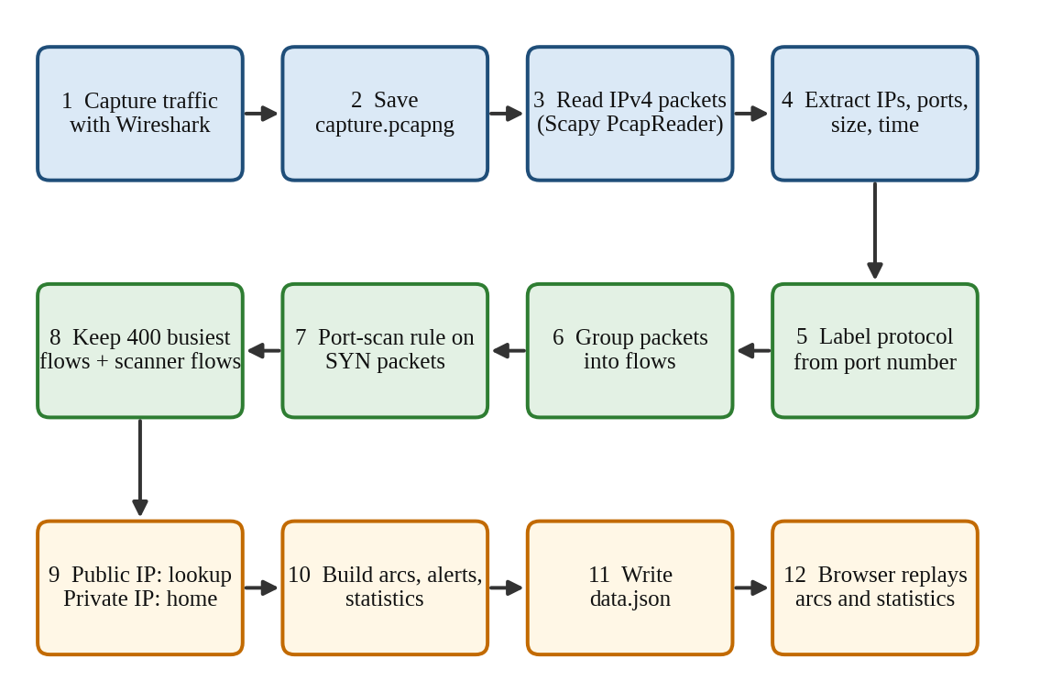
Figure 3.1 Workflow of GeoTrace from capture to display
Steps 1 and 2 are performed once with Wireshark. Steps 3 to 11 are performed by build_data.py each time it is run on a capture file. Step 12 is performed by the browser, which loads data.json and replays the flows in time order.

3.2 Configuration or Code Implementation
The project consists of two source files. Table 3.1 summarises their main parts. Short excerpts follow, and the complete code is given in Appendix A.
Table 3.1 Main code modules
File | Function / section | Role
build_data.py | parse_pcap() | Streams packets with Scapy, labels protocols, builds flows and applies the port-scan rule
build_data.py | resolve_geo() | Batch geolocation with rate-limit delay and a local cache
build_data.py | make_from_pcap(), finish() | Selects flows, builds arcs, alerts and statistics, writes data.json
build_data.py | make_demo() | Creates synthetic data so the dashboard can be shown without a capture
frontend/index.html | init(), tick() | Loads data.json, fills the panels and replays arcs along a timeline
frontend/index.html | sendOne(), sendSuspicious() | Simulator behaviour for normal, lost and suspicious packets
frontend/index.html | locate(), interp(), km() | IP lookup, great-circle midpoint and distance calculations
Protocol labelling and flow aggregation. For each IPv4 packet the protocol is chosen from the ports, and the packet is added to the flow that has the same source, destination and protocol:
ports = {sport, dport}
if 53 in ports: proto = "DNS"
elif 443 in ports: proto = "HTTPS"
elif 80 in ports: proto = "HTTP"
key = (ip.src, ip.dst, proto)
f = flows.setdefault(key, {"t": t - t0, "packets": 0, "bytes": 0})
f["packets"] += 1
f["bytes"] += len(pkt)
Port-scan rule. Only TCP packets with SYN set and ACK clear are counted. A sliding window keeps the destination ports tried by each source in the last SCAN_WINDOW seconds, and the source is flagged when the window holds SCAN_PORTS different ports:
if TCP in pkt and (pkt[TCP].flags & 0x12) == 0x02: # SYN set, ACK clear
q = windows[ip.src]
q.append((t, dport))
while q and t - q[0][0] > SCAN_WINDOW:
q.popleft()
if len({p for _, p in q}) >= SCAN_PORTS and ip.src not in scanners:
scanners[ip.src] = t - t0
Batch geolocation. Public IPs are sent in groups of 100, with a pause between groups to stay under the service’s limit:
req = urllib.request.Request(
"http://ip-api.com/batch?fields=status,country,lat,lon,query",
data=json.dumps(batch).encode(),
headers={"Content-Type": "application/json"})
for r in json.load(urllib.request.urlopen(req, timeout=20)):
cache[r["query"]] = {...} # latitude, longitude, country
time.sleep(4.5) # free API: 15 batch calls per minute
Simulated packet loss. In the dashboard, a lost packet is drawn only part of the way along its route, and a retransmission is scheduled if the option is on:
const f = 0.35 + Math.random() * 0.3, mid = interp(a, b, f);
shot(a, mid, { proto, color: ["#9aa7b8", "#4b5668"], dc: "(dropped)" }, 2400);
...
if (opts.retransmit && attempt < 3) later(1300, () => {
S.retx++;
sendOne({ ...opts, lost: Math.random() < (opts.lossP || 0), retx: true }, attempt + 1);
});

3.3 Protocols and Technical Working
Packet parsing. Scapy’s PcapReader streams packets one at a time, so large files do not have to fit in memory. Packets without an IP layer are skipped. For each remaining packet the program reads the IP addresses, the transport protocol, the ports (for TCP and UDP), the packet length and the timestamp relative to the first packet.
Flow selection. A flow is identified by (source IP, destination IP, protocol). The 400 flows with the most packets are kept for display, together with up to 100 further flows from sources flagged as scanners, so that attack traffic is never hidden by busy normal flows.
TCP handshake and the port-scan rule. A TCP connection starts with a SYN packet from the client, a SYN-ACK from the server and an ACK from the client [2]. An ordinary client contacts a few ports on a server. A port scanner sends SYN packets to many different ports in a short time to find open services. The rule therefore flags a source that sends SYN packets to 20 or more distinct destination ports within 10 seconds. Counting every packet instead of SYN-only packets would wrongly flag a busy server, because its replies go to many different client ports. Both thresholds are constants and can be tuned.
Geolocation and private addresses. Public addresses are converted to latitude and longitude. Private addresses (10.0.0.0/8, 172.16.0.0/12 and 192.168.0.0/16) exist only inside the local network and are translated by the router before traffic reaches the Internet, so they cannot be located. They are drawn at a configurable home point. A flow whose two ends fall on the same point is dropped because it would give a zero-length arc.
Replay timeline. Each flow’s start time is divided by the capture duration to give a value between 0 and 1. During replay a flow stays visible for 12 percent of the timeline, and one full replay takes 40 seconds at normal speed, so a capture of any length can be reviewed quickly. Speed (0.5x to 4x), pause and a seek slider control the playback, and hovering an arc shows its addresses, countries, protocol, packet count and bytes.
Live simulator. The user chooses a source and a destination from preset locations or types a public IP and uses Locate. Private IPs are placed at the home point. Table 3.2 summarises the three packet types.
Table 3.2 Simulator packet types and the concept each demonstrates
Packet type | What the user sees | Network concept
Normal | Coloured arc, green ring at the destination, log entry with distance and estimated delay | Successful delivery; propagation delay
Lost | Grey arc that stops between 35 % and 65 % of the route, grey ring and cross marker, timeout message, then an orange retransmission arc | Packet loss; ACK timeout; TCP retransmission (up to 3 attempts)
Suspicious | Red arcs, screen flash, red ring and warning pin, with the triggered rule in the log | Port scan (25 ports), SYN flood (40 packets in 1.5 s), data exfiltration (one 52 MB flow)
The estimated one-way delay is the great-circle distance d (in km) divided by 200 km/ms, which is roughly the speed of light in optical fibre, multiplied by 1.6 for routing overhead, plus 4 ms and a random jitter of 0–6 ms. The partial route of a lost packet is found by interpolating along the great circle between the two endpoints. Figure 3.2 shows the exchange for a lost packet that is retransmitted after a timeout. The waiting time in the animation is only a visual delay and not a real TCP timer.
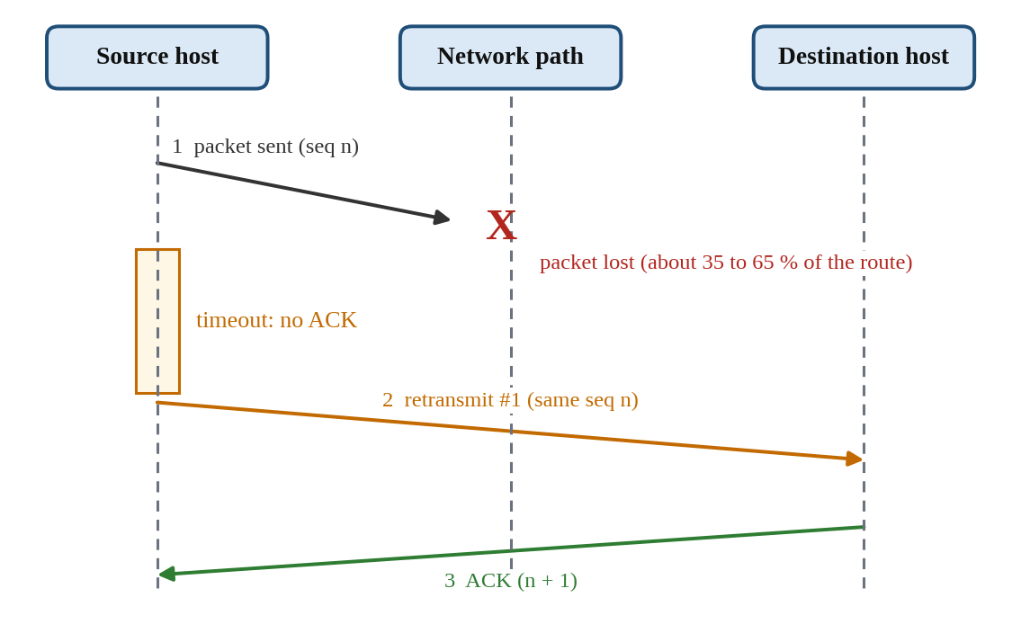
Figure 3.2 Lost packet, timeout and retransmission as shown by the simulator
A burst test sends 20 packets with a loss percentage chosen on a slider. Counters show packets sent, delivered, lost, attacks, retransmits and the loss rate, so the effect of loss with and without retransmission can be compared.
Error handling. build_data.py stops with a clear message if the capture contains no IPv4 packets, prints a message and continues if a geolocation request fails, and skips flows whose addresses cannot be located. In the simulator, an invalid IPv4 address is rejected with a message, and a failed lookup asks the user to pick a preset city instead.

3.4 Execution Procedure
Prerequisites: Python 3, the scapy package (pip install scapy), Wireshark with Npcap, a web browser with an Internet connection (for the globe library and the location lookup), and the files build_data.py and frontend/index.html in the folder layout below.
geotrace/
build_data.py
capture.pcapng (created with Wireshark)
geo_cache.json (created automatically)
frontend/
index.html
data.json (created by build_data.py)
- Open Wireshark, double-click the Wi-Fi interface whose activity graph is moving, browse several websites for 1–2 minutes with any VPN switched off, then stop the capture.
- Check Statistics → Conversations → IPv4 for public addresses, then save the file as capture.pcapng in the geotrace folder.
- In the geotrace folder run python build_data.py capture.pcapng. For a demonstration without a capture run python build_data.py --demo.
- Change into the frontend folder and run python -m http.server 8000.
- Open http://localhost:8000 in the browser. Use the Replay capture tab for recorded traffic and the Live simulator tab for the demonstrations.
Figure 3.3 should show the dashboard running on the group’s own capture.
[INSERT SCREENSHOT: dashboard in Replay capture mode showing arcs, protocol bars and the alert list]
Figure 3.3 Implementation evidence: GeoTrace dashboard replaying a captured traffic file
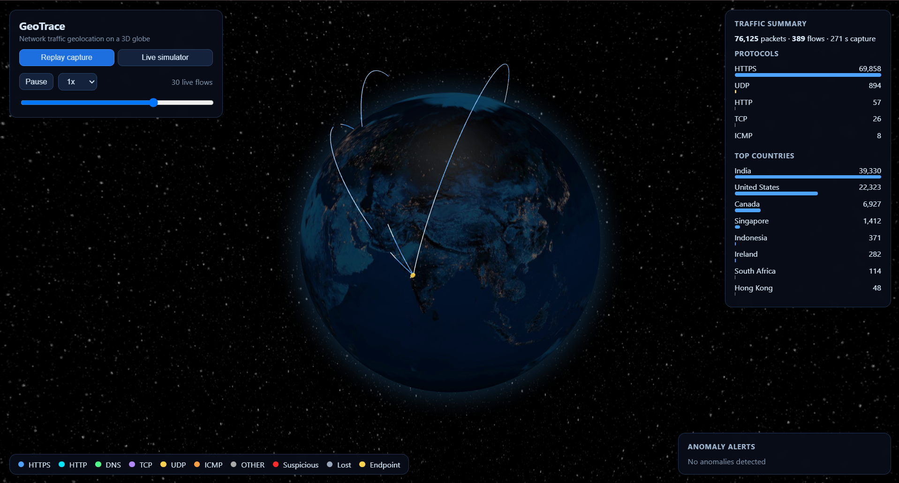

4 Testing and Results

4.1 Test Plan
The tests are run on the group’s laptop, using the dashboard served on localhost and a Wi-Fi Internet connection. A test passes when the observed result matches the expected result. The plan covers normal operation (T1 to T5), loss and attack behaviour (T6 to T9) and invalid or failure cases (T10 to T12). The “Observed Result” and “Status” columns are completed after running each test.
Table 4.1 Test plan and results
Test ID | Test and Input | Expected Result | Observed Result | Status
T1 | Run python build_data.py --demo and open the dashboard. | data.json is written with 174 arcs (160 normal flows and 14 scan flows) and 1 alert; arcs replay on the globe. | [Observed] | [Pass / Fail]
T2 | Capture 1–2 minutes of browsing, then run python build_data.py capture.pcapng. | Packet, arc and alert counts are printed; arcs run from the home point to several countries; protocol bars are filled. | [Observed] | [Pass / Fail]
T3 | Compare total packets in the dashboard with the IPv4 count in Wireshark’s Protocol Hierarchy. | The two counts are equal. | [Observed] | [Pass / Fail]
T4 | Replay a capture that contains a port scan (sample capture, or a small scan of an authorised host). | Scanner flows are red and the alert shows the IP, country and time. | [Observed] | [Pass / Fail]
T5 | Simulator: Normal HTTPS packet from Moscow to Home. | Blue arc, green ring, log shows about 4,980 km and an estimated delay of about 44–50 ms (default home point). | [Observed] | [Pass / Fail]
T6 | Simulator: Lost packet with auto-retransmit on. | Arc stops part-way; log shows lost, timeout, Retransmit #1, delivered; counters: sent 2, delivered 1, lost 1, retransmits 1. | [Observed] | [Pass / Fail]
T7 | Simulator: burst of 20 packets at 30 % loss, retransmit off. | About 6 packets are lost (random); delivered plus lost equals 20. | [Observed] | [Pass / Fail]
T8 | Simulator: Suspicious, port scan pattern. | 25 red arcs, screen flash, “Port scan detected” in the log, attacks counter 1. | [Observed] | [Pass / Fail]
T9 | Simulator: Suspicious, SYN flood and data exfiltration patterns. | 40 red arcs for the flood and one thick red arc for exfiltration; each adds 1 to the attacks counter. | [Observed] | [Pass / Fail]
T10 | Simulator: enter private IP 192.168.1.5 as source and click Locate. | Endpoint is placed at the home point with a “private IP” note. | [Observed] | [Pass / Fail]
T11 | Simulator: enter 999.1.1.1 and click Locate. | Message “Enter a valid IPv4 address.” and the endpoint is unchanged. | [Observed] | [Pass / Fail]
T12 | Run the build with the Internet disconnected. | A “Geo lookup failed” message is printed; unresolved flows are skipped; --demo still works. | [Observed] | [Pass / Fail]

4.2 Results and Execution Evidence
Insert the screenshots and logs gathered while running the tests, and explain what each one proves. Useful evidence: the build_data.py console output (T1, T2), the Wireshark Protocol Hierarchy next to the dashboard totals (T3), a red scan alert (T4, T8), a lost packet with its retransmission and counters (T6, T7), and the invalid-input message (T11).
[INSERT RESULT IMAGE HERE]
Figure 4.1 Test execution result
[Describe what Figure 4.1 shows and which test and expected result it confirms.]

4.3 Objective Achievement
Table 4.2 connects each objective to its tests. Any objective that is only partly achieved or not achieved must be reported as such.
Table 4.2 Objective achievement
Objective ID | Evidence or Test ID | Outcome
O1 | T2 | [Achieved / partial / not achieved]
O2 | T2, T3 | [Achieved / partial / not achieved]
O3 | T2 | [Achieved / partial / not achieved]
O4 | T4, T8, T9 | [Achieved / partial / not achieved]
O5 | T2, T10 | [Achieved / partial / not achieved]
O6 | T1, T2 | [Achieved / partial / not achieved]
O7 | T5 to T9 | [Achieved / partial / not achieved]

5 Discussion and Conclusion

5.1 Discussion and Comparative Analysis
GeoTrace turns the header fields of a capture into a picture that can be read in seconds: the spread of arcs shows how many countries were contacted, the colours show which services dominate, and a red arc draws attention to a possible scanner. The simulator complements the real capture because loss, retransmission and attacks can be produced on demand, which is difficult with a real network. [Add the group’s own observations here after testing, for example how many countries and protocols appeared in the capture and how long the build took.]
GeoTrace is not a replacement for a packet analyser. Table 5.1 compares it qualitatively with using the Wireshark packet list alone.
Table 5.1 Qualitative comparison with the Wireshark packet list
Criterion | Wireshark packet list | GeoTrace
Packet-level detail | Very detailed: every layer and the payload bytes | Summary of IP, ports, flags, size and time only
Overview of where traffic goes | Read from address columns | Animated arcs on a world map
Port-scan indication | Analyst applies filters and judges | Automatic threshold rule and red arcs
Loss and retransmission teaching | Seen only if it happens in a capture | Controlled simulator with counters
Setup effort | Install only | Install Python and Scapy, then run the build step

5.2 Advantages and Applications
- Makes traffic easy to understand for students, and useful for demonstrations of IP addressing, ports, TCP and UDP.
- Needs no special hardware and uses free, standard tools.
- Gives a quick overview of which countries and services a host talks to, which helps in spotting unexpected destinations.
- The simulator can be used in teaching to show loss, timeout, retransmission and common attack patterns without generating real attack traffic.

5.3 Limitations
- The main analysis is an offline replay, not a real-time sniffer.
- Only headers are used, and only IPv4 is processed, so IPv6 packets are skipped.
- Geolocation is approximate, and anycast or CDN addresses may appear at an unexpected location. The free service needs Internet access and has a rate limit.
- Detection is threshold-based, so it can give false positives or miss a slow scan. Other attacks are only demonstrated in the simulator.
- Simulator delays are estimates from distance. Very large captures and IPv6 traffic have not been tested.

5.4 Challenges and Troubleshooting
[Edit Table 5.2 so that it lists the problems the group actually met.]
Table 5.2 Challenges and troubleshooting
Issue | Cause or Diagnosis | Solution and Verification
Wireshark lists many interfaces | Only the physical Wi-Fi adapter carries real Internet traffic; loopback, virtual and remote-capture entries do not | Capture on the Wi-Fi interface with a moving activity graph; check Statistics → Conversations → IPv4 for public IPs
Globe nearly empty | Capture held mostly private addresses, or a VPN sent everything to one server | Switch the VPN off and browse many sites while capturing; recheck the conversations
Servers flagged as scanners | Counting all packets treats a server replying to many client ports as a scanner | Count only SYN-without-ACK packets; verified with Tests T4 and T8
Geolocation limit | The free batch endpoint allows 15 requests per minute | Pause 4.5 s between batches and cache results in geo_cache.json
Dashboard cannot load data.json | Browsers block file loading from a page opened by double-click | Serve the folder with python -m http.server 8000

5.5 Future Scope
- Live capture with real-time streaming to the dashboard over WebSocket.
- An offline geolocation database (such as MaxMind GeoLite2) to remove the Internet dependency.
- IPv6 support and more detectors, for example ARP spoofing, DNS tunnelling and repeated failed logins.
- Filters by country, protocol and time range, and export of the findings as a report.

5.6 Conclusion
GeoTrace converts a Wireshark capture into an interactive map of network traffic by extracting header fields, grouping packets into flows, labelling protocols from ports, locating public IP addresses and flagging port-scan behaviour. Together with the simulator, it links the packet-level concepts studied in the course (IP addressing, ports, TCP and UDP, DNS, reliability and retransmission, and basic network security) to something that can be seen and explored. The achievement of each objective is recorded in Table 4.2 after the tests are run.

References
[1] J. Postel, “Internet Protocol,” RFC 791, Internet Engineering Task Force, Sep. 1981. [Online]. Available: https://www.rfc-editor.org/info/rfc791
[2] W. Eddy, Ed., “Transmission Control Protocol (TCP),” RFC 9293, Internet Engineering Task Force, Aug. 2022. [Online]. Available: https://www.rfc-editor.org/info/rfc9293
[3] J. Postel, “User Datagram Protocol,” RFC 768, Internet Engineering Task Force, Aug. 1980. [Online]. Available: https://www.rfc-editor.org/info/rfc768
[4] P. Mockapetris, “Domain names – implementation and specification,” RFC 1035, Internet Engineering Task Force, Nov. 1987. [Online]. Available: https://www.rfc-editor.org/info/rfc1035
[5] J. Postel, “Internet Control Message Protocol,” RFC 792, Internet Engineering Task Force, Sep. 1981. [Online]. Available: https://www.rfc-editor.org/info/rfc792
[6] R. Fielding, M. Nottingham, and J. Reschke, Eds., “HTTP Semantics,” RFC 9110, Internet Engineering Task Force, Jun. 2022. [Online]. Available: https://www.rfc-editor.org/info/rfc9110
[7] Wireshark Foundation, “Wireshark User’s Guide.” https://www.wireshark.org/docs/wsug_html_chunked/ (accessed [date]).
[8] Scapy Project, “Scapy documentation.” https://scapy.readthedocs.io/ (accessed [date]).
[9] ip-api.com, “IP Geolocation API: batch endpoint documentation.” https://ip-api.com/docs/api:batch (accessed [date]).
[10] Three.js, “Three.js documentation.” https://threejs.org/docs/ (accessed [date]).
[11] V. Asturiano, “globe.gl: UI component for globe data visualization,” GitHub. https://github.com/vasturiano/globe.gl (accessed [date]).
[12] Npcap Project, “Npcap: packet capture library for Windows.” https://npcap.com/ (accessed [date]).

AI Usage Declaration
AI tools were used in this project. The group used Claude, an AI assistant from Anthropic, for exploring project ideas, drafting and explaining the Python and JavaScript code, and drafting this report. The results in Chapter 4 come only from tests run by the group.
Declaration: We take responsibility for the accuracy of this report and understand the submitted implementation and results. Sources and assistance used have been acknowledged.
Student Name | PRN | Signature
Harshit Sharma | 1262242285
Rohan Khalate | 1262243741
Aditya Pillai | 1262242326
Yashowardhan Bhosale | 1262240695

Appendices

Appendix A Code and Configuration
The complete source code of the project is given below. No credentials or secrets are used.
A.1 build_data.py (capture parser, detector, geolocation and data builder)
"""
GeoTrace data builder.
python build_data.py --demo -> synthetic data, no pcap / no internet needed
python build_data.py capture.pcap -> parse a real capture (pcap or pcapng)
Writes frontend/data.json
"""
import sys, os, json, time, random, ipaddress, urllib.request
from collections import defaultdict, deque, Counter

HOME = {"lat": 19.9975, "lng": 73.7898, "country": "India (You)"} # <- change to your city
OUT = os.path.join("frontend", "data.json")
SCAN_PORTS, SCAN_WINDOW = 20, 10 # >=20 distinct ports in 10 s = port scan
MAX_FLOWS = 400

def is_public(ip):
try:
a = ipaddress.ip_address(ip)
except ValueError:
return False
return not (a.is_private or a.is_loopback or a.is_multicast
or a.is_link_local or a.is_reserved or a.is_unspecified)

def arc(src, dst, sg, dg, proto, packets, size, t, alert=False):
return {"src": src, "dst": dst, "startLat": sg["lat"], "startLng": sg["lng"],
"endLat": dg["lat"], "endLng": dg["lng"], "sc": sg["country"], "dc": dg["country"],
"proto": proto, "packets": packets, "bytes": size, "t": round(t, 2), "alert": alert}

def finish(arcs, alerts, duration, total):
protos, countries = Counter(), Counter()
for a in arcs:
protos[a["proto"]] += a["packets"]
other = a["dc"] if a["sc"] == HOME["country"] else a["sc"]
if other != HOME["country"]:
countries[other] += a["packets"]
arcs.sort(key=lambda a: a["t"])
data = {"home": HOME, "duration": max(duration, 1), "total_packets": total,
"flows": arcs, "alerts": alerts,
"stats": {"protocols": dict(protos), "countries": countries.most_common(8)}}
os.makedirs("frontend", exist_ok=True)
with open(OUT, "w") as f:
json.dump(data, f)
print(f"OK: {len(arcs)} arcs, {len(alerts)} alerts, {total} packets -> {OUT}")

# ---------------------------------------------------------------- demo mode
CITIES = {
"New York": (40.71, -74.0, "United States"), "San Francisco": (37.77, -122.42, "United States"),
"London": (51.5, -0.12, "United Kingdom"), "Frankfurt": (50.11, 8.68, "Germany"),
"Singapore": (1.35, 103.82, "Singapore"), "Tokyo": (35.68, 139.69, "Japan"),
"Sydney": (-33.87, 151.21, "Australia"), "Sao Paulo": (-23.55, -46.63, "Brazil"),
"Dubai": (25.2, 55.27, "UAE"), "Johannesburg": (-26.2, 28.04, "South Africa"),
"Moscow": (55.75, 37.62, "Russia"), "Mumbai": (19.07, 72.88, "India"),
}

def rand_ip():
return f"{random.randint(11, 223)}.{random.randint(0, 255)}.{random.randint(0, 255)}.{random.randint(1, 254)}"

def make_demo():
random.seed(7)
protos = ["HTTPS"] * 5 + ["DNS"] * 2 + ["HTTP", "UDP", "TCP", "ICMP"]
arcs = []
for _ in range(160):
lat, lng, c = CITIES[random.choice(list(CITIES))]
remote = {"lat": lat, "lng": lng, "country": c}
a, b, ia, ib = HOME, remote, "192.168.1.10", rand_ip()
if random.random() < 0.5:
a, b, ia, ib = b, a, ib, ia
arcs.append(arc(ia, ib, a, b, random.choice(protos), random.randint(5, 400),
random.randint(500, 90000), random.uniform(0, 60)))
lat, lng, c = CITIES["Moscow"]
attacker = {"lat": lat, "lng": lng, "country": c}
for i in range(14):
arcs.append(arc("203.0.113.66", "192.168.1.10", attacker, HOME, "TCP", 40, 2400, 30 + i * 0.4, True))
alerts = [{"ip": "203.0.113.66", "country": c, "t": 30.0, "type": "Port scan (20+ ports in 10 s)"}]
finish(arcs, alerts, 60, sum(a["packets"] for a in arcs))

# ---------------------------------------------------------------- real pcap
def parse_pcap(path):
from scapy.all import PcapReader, IP, TCP, UDP, ICMP
flows, windows, scanners = {}, defaultdict(deque), {}
t0 = last = None
total = 0
with PcapReader(path) as reader:
for pkt in reader:
if IP not in pkt:
continue
ip, t = pkt[IP], float(pkt.time)
t0 = t if t0 is None else t0
last = t
total += 1
sport = dport = None
if TCP in pkt:
proto, sport, dport = "TCP", pkt[TCP].sport, pkt[TCP].dport
elif UDP in pkt:
proto, sport, dport = "UDP", pkt[UDP].sport, pkt[UDP].dport
elif ICMP in pkt:
proto = "ICMP"
else:
proto = "OTHER"
ports = {sport, dport}
if 53 in ports: proto = "DNS"
elif 443 in ports: proto = "HTTPS"
elif 80 in ports: proto = "HTTP"

key = (ip.src, ip.dst, proto)
f = flows.setdefault(key, {"t": t - t0, "packets": 0, "bytes": 0})
f["packets"] += 1
f["bytes"] += len(pkt)

# port-scan rule: count only SYN-without-ACK packets (new connection attempts)
if TCP in pkt and (pkt[TCP].flags & 0x12) == 0x02:
q = windows[ip.src]
q.append((t, dport))
while q and t - q[0][0] > SCAN_WINDOW:
q.popleft()
if len({p for _, p in q}) >= SCAN_PORTS and ip.src not in scanners:
scanners[ip.src] = t - t0
if not total:
sys.exit("No IPv4 packets found in that file.")
return flows, scanners, total, (last - t0)

def resolve_geo(ips):
try:
cache = json.load(open("geo_cache.json"))
except Exception:
cache = {}
todo = [i for i in ips if i not in cache]
for n in range(0, len(todo), 100):
batch = todo[n:n + 100]
try:
req = urllib.request.Request(
"http://ip-api.com/batch?fields=status,country,lat,lon,query",
data=json.dumps(batch).encode(), headers={"Content-Type": "application/json"})
for r in json.load(urllib.request.urlopen(req, timeout=20)):
cache[r["query"]] = ({"lat": r["lat"], "lng": r["lon"], "country": r["country"]}
if r.get("status") == "success" else None)
except Exception as e:
print("Geo lookup failed (check internet):", e)
if n + 100 < len(todo):
time.sleep(4.5) # free API: 15 batch calls / minute
json.dump(cache, open("geo_cache.json", "w"))
return cache

def make_from_pcap(path):
print("Reading", path, "...")
flows, scanners, total, duration = parse_pcap(path)
ranked = sorted(flows.items(), key=lambda kv: -kv[1]["packets"])
chosen = ranked[:MAX_FLOWS]
chosen += [kv for kv in ranked[MAX_FLOWS:] if kv[0][0] in scanners][:100]
ips = {ip for (s, d, _), _ in chosen for ip in (s, d) if is_public(ip)}
print(f"Resolving {len(ips)} public IPs ...")
cache = resolve_geo(sorted(ips))
geo = lambda ip: HOME if not is_public(ip) else cache.get(ip)

arcs = []
for (s, d, proto), f in chosen:
sg, dg = geo(s), geo(d)
if not sg or not dg or (sg["lat"], sg["lng"]) == (dg["lat"], dg["lng"]):
continue
arcs.append(arc(s, d, sg, dg, proto, f["packets"], f["bytes"], f["t"], s in scanners))
alerts = [{"ip": ip, "country": (geo(ip) or {}).get("country", "Unknown"), "t": round(t, 2),
"type": f"Port scan ({SCAN_PORTS}+ ports in {SCAN_WINDOW} s)"} for ip, t in scanners.items()]
finish(arcs, alerts, duration, total)

if __name__ == "__main__":
if len(sys.argv) < 2 or sys.argv[1] == "--demo":
make_demo()
else:
make_from_pcap(sys.argv[1])
A.2 frontend/index.html (dashboard, globe, replay and simulator)
<!DOCTYPE html>
<html lang="en">
<head>
<meta charset="utf-8">
<title>GeoTrace – Network Traffic Globe</title>
<style>
html, body { margin:0; height:100%; background:#000; color:#d6e6f5; font-family:system-ui,-apple-system,Segoe UI,sans-serif; overflow:hidden; }
#globe { position:absolute; inset:0; }
.panel { position:absolute; background:rgba(8,14,26,.84); border:1px solid #1f3350; border-radius:12px; padding:14px 16px; font-size:13px; backdrop-filter:blur(6px); }
h1 { font-size:18px; margin:0 0 2px; } .sub { color:#7f95ad; font-size:12px; margin-bottom:10px; }
h3 { margin:0 0 8px; font-size:12px; color:#9fb6cf; text-transform:uppercase; letter-spacing:.06em; }
#ctl { top:16px; left:16px; width:330px; max-height:calc(100vh - 110px); overflow:auto; }
#stats { top:16px; right:16px; width:250px; }
#legend { bottom:16px; left:16px; display:flex; gap:14px; flex-wrap:wrap; padding:8px 14px; max-width:60vw; }
#alerts { bottom:16px; right:16px; width:330px; max-height:230px; overflow:auto; }
button, select, input[type=text] { background:#14233b; color:#d6e6f5; border:1px solid #2a4468; border-radius:8px; padding:6px 10px; font-size:13px; }
button { cursor:pointer; } button:hover { background:#1b3150; }
button.primary { background:#1d6fe0; border-color:#3b8bff; font-weight:600; }
button.danger { background:#a82a35; border-color:#d9505b; }
.tabs { display:flex; gap:6px; margin-bottom:12px; }
.tab { flex:1; } .tab.on { background:#1d6fe0; border-color:#3b8bff; }
input[type=range] { width:100%; margin-top:8px; }
.row { display:flex; align-items:center; gap:8px; margin:5px 0; }
.dot { width:10px; height:10px; border-radius:50%; flex:none; }
.bar { height:6px; border-radius:3px; background:#4da3ff; }
.barrow { margin:5px 0; } .barrow > span { display:flex; justify-content:space-between; }
.field { margin:8px 0; } .field label { display:block; font-size:11px; color:#7f95ad; margin-bottom:3px; text-transform:uppercase; letter-spacing:.05em; }
.field .line { display:flex; gap:6px; } .field select { flex:1; min-width:0; } .field input[type=text] { width:120px; }
.info { font-size:12px; color:#7f95ad; margin-top:3px; min-height:15px; }
.seg { display:flex; gap:6px; margin:6px 0; } .seg label { flex:1; text-align:center; border:1px solid #2a4468; border-radius:8px; padding:6px 2px; cursor:pointer; font-size:12px; }
.seg input { display:none; } .seg input:checked + span { color:#fff; } .seg label:has(input:checked) { background:#1d6fe0; border-color:#3b8bff; }
.seg label.sus:has(input:checked) { background:#a82a35; border-color:#d9505b; } .seg label.lost:has(input:checked) { background:#4b5668; border-color:#7d8aa0; }
.counters { display:grid; grid-template-columns:1fr 1fr; gap:8px; }
.counter { background:#0d1a2e; border-radius:8px; padding:8px; } .counter b { font-size:20px; display:block; }
.alert { color:#5a6b80; margin:6px 0; } .alert.on { color:#ff7b7b; }
.ev { margin:5px 0; padding-left:8px; border-left:3px solid #4da3ff; } .ev.ok { border-color:#4dff88; } .ev.bad { border-color:#9aa7b8; color:#b9c4d2; }
.ev.sus { border-color:#ff3b3b; color:#ff9a9a; } .ev.warn { border-color:#ff9f43; color:#ffc58a; } .ev small { color:#5f748c; }
.pin { position:absolute; transform:translate(-50%,-150%); white-space:nowrap; font-size:11px; padding:2px 7px; border-radius:6px; background:rgba(8,14,26,.9); border:1px solid #2a4468; pointer-events:none; }
.pin.lost { border-color:#9aa7b8; color:#cdd6e2; } .pin.ok { border-color:#4dff88; color:#4dff88; } .pin.sus { border-color:#ff3b3b; color:#ff7b7b; font-weight:700; }
.pin.ep { color:#ffd24d; border-color:#6b5a1d; }
#flash { position:fixed; inset:0; pointer-events:none; box-shadow:inset 0 0 0 0 rgba(255,40,40,0); }
#flash.go { animation:flash .9s ease-out; } @keyframes flash { 0%{box-shadow:inset 0 0 160px 50px rgba(255,40,40,.75);} 100%{box-shadow:inset 0 0 160px 50px rgba(255,40,40,0);} }
#err { display:none; color:#ff9a9a; font-size:12px; margin:8px 0; }
</style>
</head>
<body>
<div id="globe"></div>
<div id="flash"></div>

<div class="panel" id="ctl">
<h1>GeoTrace</h1>
<div class="sub">Network traffic geolocation on a 3D globe</div>
<div class="tabs"><button id="tabReplay" class="tab on">Replay capture</button><button id="tabSim" class="tab">Live simulator</button></div>

<div id="replayBox">
<div class="row">
<button id="play">Pause</button>
<select id="speed"><option value="0.5">0.5x</option><option value="1" selected>1x</option><option value="2">2x</option><option value="4">4x</option></select>
<span id="now" style="margin-left:auto;color:#7f95ad"></span>
</div>
<input type="range" id="seek" min="0" max="1000" value="0">
<div id="err">data.json not found. Run <code>python build_data.py --demo</code>, then serve this folder with <code>python -m http.server 8000</code>. The Live simulator works without it.</div>
</div>

<div id="simBox" style="display:none">
<div class="field"><label>Source</label>
<div class="line"><select id="sCity"></select><input type="text" id="sIp" placeholder="IP address"><button id="sGo" title="Look up this IP">Locate</button></div>
<div class="info" id="sInfo"></div></div>
<div style="text-align:center"><button id="swap" title="Swap source and destination">⇅ Swap</button></div>
<div class="field"><label>Destination</label>
<div class="line"><select id="dCity"></select><input type="text" id="dIp" placeholder="IP address"><button id="dGo" title="Look up this IP">Locate</button></div>
<div class="info" id="dInfo"></div></div>

<div class="field"><label>Protocol</label>
<select id="proto" style="width:100%"><option>HTTPS</option><option>HTTP</option><option>DNS</option><option>TCP</option><option>UDP</option><option>ICMP</option></select></div>

<div class="field"><label>Packet type</label>
<div class="seg">
<label><input type="radio" name="ptype" value="normal" checked><span>Normal</span></label>
<label class="sus"><input type="radio" name="ptype" value="sus"><span>Suspicious</span></label>
<label class="lost"><input type="radio" name="ptype" value="lost"><span>Lost</span></label>
</div></div>
<div class="field" id="susBox" style="display:none"><label>Attack pattern</label>
<select id="susKind" style="width:100%"><option value="scan">Port scan (25 ports)</option><option value="flood">SYN flood (40 packets)</option><option value="exfil">Data exfiltration (52 MB)</option></select></div>
<div class="field">
<label style="display:flex;gap:6px;align-items:center;text-transform:none;font-size:12px;color:#d6e6f5"><input type="checkbox" id="retx" checked> Auto-retransmit lost packets after timeout (TCP-style)</label></div>

<div class="row"><button class="primary" id="send" style="flex:1">Send packet</button><button id="clear">Clear</button></div>
<div class="field" style="margin-top:12px"><label>Burst test: <span id="lossVal">20</span>% random loss</label>
<input type="range" id="loss" min="0" max="100" value="20">
<button id="burst" style="width:100%;margin-top:6px">Send burst of 20 packets</button></div>
</div>
</div>

<div class="panel" id="stats">
<div id="replayStats">
<h3>Traffic summary</h3><div id="total" style="margin-bottom:10px"></div>
<h3>Protocols</h3><div id="protos"></div>
<h3 style="margin-top:12px">Top countries</h3><div id="countries"></div>
</div>
<div id="simStats" style="display:none">
<h3>Live counters</h3>
<div class="counters">
<div class="counter"><b id="cSent">0</b>sent</div><div class="counter"><b id="cOk" style="color:#4dff88">0</b>delivered</div>
<div class="counter"><b id="cLost" style="color:#9aa7b8">0</b>lost</div><div class="counter"><b id="cSus" style="color:#ff5c5c">0</b>attacks</div>
<div class="counter"><b id="cRetx" style="color:#ff9f43">0</b>retransmits</div><div class="counter"><b id="cRate">0%</b>loss rate</div>
</div>
</div>
</div>

<div class="panel" id="legend"></div>
<div class="panel" id="alerts">
<div id="replayAlerts"><h3>Anomaly alerts</h3><div id="alertList"></div></div>
<div id="simLog" style="display:none"><h3>Event log</h3><div id="log"></div></div>
</div>

<script src="https://unpkg.com/globe.gl"></script>
<script>
const $ = id => document.getElementById(id);
const COLORS = { HTTPS:"#4da3ff", HTTP:"#00e5ff", DNS:"#4dff88", TCP:"#b388ff", UDP:"#ffd24d", ICMP:"#ff9f43", OTHER:"#aaaaaa" };
const LOOP = 40, WIN = 0.12;
const HOME = { lat: 19.9975, lng: 73.7898, country: "India (You)" };

let D = null, FLOWS = [], playing = true, speed = 1, phase = 0, lastKey = "", mode = "replay", dirty = false, replayVis = [];
const manual = [], rings = [], transient = [];
const EP = { src: null, dst: null };
const S = { sent:0, ok:0, lost:0, sus:0, retx:0 };
const timers = new Set();
const later = (ms, fn) => { const id = setTimeout(() => { timers.delete(id); fn(); }, ms); timers.add(id); return id; };

/* ---------- geometry helpers ---------- */
const rad = Math.PI / 180;
function ang(a, b) {
const p1 = a.lat*rad, p2 = b.lat*rad, l1 = a.lng*rad, l2 = b.lng*rad;
return 2*Math.asin(Math.sqrt(Math.sin((p2-p1)/2)**2 + Math.cos(p1)*Math.cos(p2)*Math.sin((l2-l1)/2)**2));
}
const km = (a, b) => ang(a, b) * 6371;
function interp(a, b, f) {
const d = ang(a, b); if (!d) return { lat:a.lat, lng:a.lng };
const p1 = a.lat*rad, p2 = b.lat*rad, l1 = a.lng*rad, l2 = b.lng*rad;
const A = Math.sin((1-f)*d)/Math.sin(d), B = Math.sin(f*d)/Math.sin(d);
const x = A*Math.cos(p1)*Math.cos(l1) + B*Math.cos(p2)*Math.cos(l2);
const y = A*Math.cos(p1)*Math.sin(l1) + B*Math.cos(p2)*Math.sin(l2);
const z = A*Math.sin(p1) + B*Math.sin(p2);
return { lat: Math.atan2(z, Math.hypot(x, y))/rad, lng: Math.atan2(y, x)/rad };
}
const latencyMs = (a, b) => Math.round(km(a, b)/200*1.6 + 4 + Math.random()*6); // ~fibre speed + routing overhead
const esc = s => String(s).replace(/[&<>"]/g, c => ({ "&":"&amp;", "<":"&lt;", ">":"&gt;", '"':"&quot;" }[c]));

/* ---------- globe ---------- */
const globe = Globe()($("globe"))
.globeImageUrl("//unpkg.com/three-globe/example/img/earth-night.jpg")
.bumpImageUrl("//unpkg.com/three-globe/example/img/earth-topology.png")
.backgroundImageUrl("//unpkg.com/three-globe/example/img/night-sky.png")
.arcColor(d => d.color || (d.alert ? ["#ff2b2b", "#ffb3b3"] : [COLORS[d.proto] || "#aaa", "#ffffff"]))
.arcStroke(d => d.stroke || (d.alert ? 0.7 : 0.35))
.arcDashLength(0.4).arcDashGap(0.25).arcDashAnimateTime(1500)
.arcAltitudeAutoScale(0.45)
.arcLabel(d => `<div style="font:12px system-ui;background:#0b1626;padding:6px 8px;border-radius:6px">
<b>${esc(d.src)}</b> → <b>${esc(d.dst)}</b><br>${esc(d.sc)} → ${esc(d.dc)}<br>${esc(d.proto)} · ${d.packets} pkts · ${d.bytes} B
${d.alert ? '<br><span style="color:#ff7b7b">⚠ suspicious</span>' : ''}</div>`)
.pointAltitude(0.02).pointRadius(0.6).pointColor(() => "#ffd24d")
.ringsData(rings).ringColor(d => t => `rgba(${d.rgb},${1 - t})`)
.ringMaxRadius(d => d.r || 5).ringPropagationSpeed(3).ringRepeatPeriod(800)
.htmlElementsData([]).htmlLat(d => d.lat).htmlLng(d => d.lng)
.htmlElement(d => { const el = document.createElement("div"); el.style.cssText = "width:0;height:0;position:relative";
el.innerHTML = `<div class="pin ${d.kind}">${esc(d.text)}</div>`; return el; });
globe.controls().autoRotate = true;
globe.controls().autoRotateSpeed = 0.45;

/* ---------- legend ---------- */
$("legend").innerHTML = Object.entries(COLORS).map(([p, c]) => `<div class="row" style="margin:0"><span class="dot" style="background:${c}"></span>${p}</div>`).join("") +
`<div class="row" style="margin:0"><span class="dot" style="background:#ff2b2b"></span>Suspicious</div>
<div class="row" style="margin:0"><span class="dot" style="background:#9aa7b8"></span>Lost</div>
<div class="row" style="margin:0"><span class="dot" style="background:#ffd24d"></span>Endpoint</div>`;

/* ---------- replay mode ---------- */
fetch("data.json").then(r => r.json()).then(init).catch(() => { $("err").style.display = "block"; setMode("sim"); });

function init(data) {
D = data;
FLOWS = D.flows.map((f, i) => ({ ...f, id: i, tn: f.t / D.duration }));
HOME.lat = D.home.lat; HOME.lng = D.home.lng;
PRESETS[0].lat = HOME.lat; PRESETS[0].lng = HOME.lng;
globe.pointsData([D.home]);
globe.pointOfView({ lat: D.home.lat, lng: D.home.lng, altitude: 2.4 }, 1500);

$("total").innerHTML = `<b>${D.total_packets.toLocaleString()}</b> packets · <b>${D.flows.length}</b> flows · ${Math.round(D.duration)} s capture`;
const maxP = Math.max(1, ...Object.values(D.stats.protocols));
$("protos").innerHTML = Object.entries(D.stats.protocols).sort((a, b) => b[1] - a[1]).map(([p, n]) =>
`<div class="barrow"><span><span>${p}</span><span>${n.toLocaleString()}</span></span><div class="bar" style="width:${n/maxP*100}%;background:${COLORS[p] || "#aaa"}"></div></div>`).join("");
const maxC = Math.max(1, ...D.stats.countries.map(c => c[1]));
$("countries").innerHTML = D.stats.countries.map(([c, n]) =>
`<div class="barrow"><span><span>${esc(c)}</span><span>${n.toLocaleString()}</span></span><div class="bar" style="width:${n/maxC*100}%"></div></div>`).join("") || "<span style='color:#7f95ad'>none</span>";
$("alertList").innerHTML = D.alerts.length
? D.alerts.map((a, i) => `<div class="alert" id="al${i}">⚠ ${esc(a.type)}<br>${esc(a.ip)} · ${esc(a.country)}<br>at t = ${a.t}s</div>`).join("")
: "<span style='color:#7f95ad'>No anomalies detected</span>";
}

let last = performance.now();
function tick(now) {
const dt = (now - last) / 1000; last = now;
let changed = dirty; dirty = false;
if (mode === "replay" && D) {
if (playing) phase = (phase + dt * speed / LOOP) % (1 + WIN);
replayVis = FLOWS.filter(f => f.tn <= phase && phase - f.tn < WIN);
const key = replayVis.length + ":" + (replayVis[0] ? replayVis[0].id : "") + ":" + (replayVis.length ? replayVis[replayVis.length - 1].id : "");
if (key !== lastKey) { lastKey = key; changed = true; }
D.alerts.forEach((a, i) => $("al" + i)?.classList.toggle("on", a.t / D.duration <= phase));
$("now").textContent = replayVis.length + " live flows";
if (playing) $("seek").value = Math.min(1000, phase / (1 + WIN) * 1000);
}
if (changed) globe.arcsData((mode === "replay" ? replayVis : []).concat(manual));
requestAnimationFrame(tick);
}
requestAnimationFrame(tick);

$("play").onclick = e => { playing = !playing; e.target.textContent = playing ? "Pause" : "Play"; };
$("speed").onchange = e => speed = +e.target.value;
$("seek").oninput = e => { phase = e.target.value / 1000 * (1 + WIN); };

/* ---------- mode switching ---------- */
function setMode(m) {
mode = m; resetSim();
const sim = m === "sim";
$("tabReplay").classList.toggle("on", !sim); $("tabSim").classList.toggle("on", sim);
$("replayBox").style.display = sim ? "none" : ""; $("simBox").style.display = sim ? "" : "none";
$("replayStats").style.display = sim ? "none" : ""; $("simStats").style.display = sim ? "" : "none";
$("replayAlerts").style.display = sim ? "none" : ""; $("simLog").style.display = sim ? "" : "none";
globe.controls().autoRotate = !sim;
globe.pointsData(sim ? [] : (D ? [D.home] : []));
if (sim) refreshPins();
dirty = true; lastKey = "";
}
$("tabReplay").onclick = () => setMode("replay");
$("tabSim").onclick = () => setMode("sim");

/* ---------- endpoints: presets + live IP lookup ---------- */
const PRESETS = [
{ key:"home", name:"Home (You)", ip:"192.168.1.10", lat:HOME.lat, lng:HOME.lng },
{ key:"mv", name:"Mountain View, US", ip:"8.8.8.8", lat:37.39, lng:-122.08 },
{ key:"sf", name:"San Francisco, US", ip:"208.67.222.222", lat:37.77, lng:-122.42 },
{ key:"ash", name:"Ashburn, US", ip:"198.41.0.4", lat:39.04, lng:-77.49 },
{ key:"ams", name:"Amsterdam, NL", ip:"193.0.14.129", lat:52.37, lng:4.90 },
{ key:"mos", name:"Moscow, RU", ip:"77.88.8.8", lat:55.75, lng:37.62 },
{ key:"tok", name:"Tokyo, JP", ip:"202.12.27.33", lat:35.68, lng:139.69 },
{ key:"nj", name:"Nanjing, CN", ip:"114.114.114.114",lat:32.06, lng:118.80 },
];
const ipOpts = PRESETS.map(p => `<option value="${p.key}">${p.name}</option>`).join("") + `<option value="custom">Custom IP…</option>`;
$("sCity").innerHTML = ipOpts; $("dCity").innerHTML = ipOpts;

const isIPv4 = s => /^(\d{1,3}\.){3}\d{1,3}$/.test(s) && s.split(".").every(n => +n <= 255);
const isPrivate = s => /^(10\.|127\.|192\.168\.|169\.254\.|172\.(1[6-9]|2\d|3[01])\.)/.test(s);

function setEndpoint(which, e) {
EP[which] = e;
const p = which === "src" ? "s" : "d";
$(p + "Ip").value = e.ip;
$(p + "Info").textContent = `${e.name} · ${e.lat.toFixed(2)}, ${e.lng.toFixed(2)}${e.private ? " · private IP → shown at Home" : ""}`;
refreshPins();
}
function choose(which) {
const p = which === "src" ? "s" : "d", key = $(p + "City").value;
if (key === "custom") { $(p + "Ip").focus(); return; }
setEndpoint(which, PRESETS.find(x => x.key === key));
}
async function locate(which) {
const p = which === "src" ? "s" : "d", ip = $(p + "Ip").value.trim();
if (!isIPv4(ip)) { $(p + "Info").textContent = "Enter a valid IPv4 address."; return; }
if (isPrivate(ip)) { setEndpoint(which, { ...PRESETS[0], ip, private: true }); $(p + "City").value = "custom"; return; }
$(p + "Info").textContent = "Looking up…";
try {
const r = await (await fetch(`http://ip-api.com/json/${ip}?fields=status,message,country,city,lat,lon`)).json();
if (r.status !== "success") throw new Error(r.message || "no result");
$(p + "City").value = "custom";
setEndpoint(which, { name: [r.city, r.country].filter(Boolean).join(", "), ip, lat: r.lat, lng: r.lon });
} catch (err) { $(p + "Info").textContent = "Lookup failed (offline or reserved IP). Pick a city from the list instead."; }
}
$("sCity").onchange = () => choose("src"); $("dCity").onchange = () => choose("dst");
$("sGo").onclick = () => locate("src"); $("dGo").onclick = () => locate("dst");
$("sIp").onkeydown = e => { if (e.key === "Enter") locate("src"); }; $("dIp").onkeydown = e => { if (e.key === "Enter") locate("dst"); };
$("swap").onclick = () => {
const a = EP.src, b = EP.dst; setEndpoint("src", b); setEndpoint("dst", a);
const sc = $("sCity").value; $("sCity").value = $("dCity").value; $("dCity").value = sc;
};
$("sCity").value = "mos"; $("dCity").value = "home"; choose("src"); choose("dst");

/* ---------- drawing primitives ---------- */
function refreshPins() {
const eps = [];
if (mode === "sim") {
if (EP.src) eps.push({ lat: EP.src.lat, lng: EP.src.lng, kind: "ep", text: "SRC · " + EP.src.ip });
if (EP.dst) eps.push({ lat: EP.dst.lat, lng: EP.dst.lng, kind: "ep", text: "DST · " + EP.dst.ip });
}
globe.htmlElementsData(eps.concat(transient));
}
function ring(pt, rgb, r) { const o = { lat: pt.lat, lng: pt.lng, rgb, r }; rings.push(o); globe.ringsData(rings.slice()); later(2600, () => { rings.splice(rings.indexOf(o), 1); globe.ringsData(rings.slice()); }); }
function pin(pt, kind, text, ttl) { const o = { lat: pt.lat, lng: pt.lng, kind, text }; transient.push(o); refreshPins(); later(ttl, () => { transient.splice(transient.indexOf(o), 1); refreshPins(); }); }
function shot(a, b, extra, ttl) {
const o = { src: extra.sip || EP.src.ip, dst: extra.dip || EP.dst.ip, sc: a.name || "", dc: b.name || "", packets: 1, bytes: 1200, startLat: a.lat, startLng: a.lng, endLat: b.lat, endLng: b.lng, ...extra };
manual.push(o); dirty = true;
later(ttl, () => { manual.splice(manual.indexOf(o), 1); dirty = true; });
}
function log(cls, html) {
const t = new Date().toLocaleTimeString([], { hour12: false });
$("log").insertAdjacentHTML("afterbegin", `<div class="ev ${cls}">${html} <small>${t}</small></div>`);
while ($("log").children.length > 40) $("log").lastChild.remove();
}
function counters() {
$("cSent").textContent = S.sent; $("cOk").textContent = S.ok; $("cLost").textContent = S.lost;
$("cSus").textContent = S.sus; $("cRetx").textContent = S.retx;
$("cRate").textContent = (S.sent ? Math.round(S.lost / S.sent * 100) : 0) + "%";
}
function flash() { const f = $("flash"); f.classList.remove("go"); void f.offsetWidth; f.classList.add("go"); }
function focusPath() { const m = interp(EP.src, EP.dst, 0.5); globe.controls().autoRotate = false; globe.pointOfView({ lat: m.lat, lng: m.lng, altitude: 2.6 }, 900); }

/* ---------- packet behaviours ---------- */
function sendOne(opts, attempt = 0) {
const a = EP.src, b = EP.dst, proto = opts.proto, d = Math.round(km(a, b)).toLocaleString();
S.sent++; counters();
if (opts.lost) {
const f = 0.35 + Math.random() * 0.3, mid = interp(a, b, f);
shot(a, mid, { proto, color: ["#9aa7b8", "#4b5668"], dc: "(dropped)" }, 2400);
later(1100, () => {
ring(mid, "154,167,184", 6); pin(mid, "lost", "✕ packet lost", 4000);
S.lost++; counters();
log("bad", `✕ <b>Packet lost</b> ${esc(proto)} ${esc(a.ip)} → ${esc(b.ip)} after ~${Math.round(km(a, mid)).toLocaleString()} km`);
if (opts.retransmit && attempt < 3) later(1300, () => {
S.retx++; log("warn", `⏱ Timeout – no ACK. <b>Retransmit #${attempt + 1}</b>`);
sendOne({ ...opts, lost: Math.random() < (opts.lossP || 0), retx: true }, attempt + 1);
});
});
} else {
shot(a, b, { proto, color: opts.retx ? ["#ff9f43", "#ffffff"] : null }, 2800);
later(1300, () => {
ring(b, opts.retx ? "255,159,67" : "77,255,136", 5); pin(b, "ok", opts.retx ? "✓ retransmit delivered" : "✓ delivered", 2500);
S.ok++; counters();
log("ok", `✓ <b>Delivered</b> ${esc(proto)} ${esc(a.ip)} → ${esc(b.ip)} · ${d} km · ~${latencyMs(a, b)} ms${opts.retx ? " (after retransmit)" : ""}`);
});
}
}

function sendSuspicious(kind) {
const a = EP.src, b = EP.dst;
const detect = (txt, rule) => later(1300, () => {
S.sus++; counters(); flash(); ring(b, "255,60,60", 8); pin(b, "sus", "⚠ " + txt, 5000);
log("sus", `⚠ <b>${esc(txt)}</b> from ${esc(a.ip)} (${esc(a.name)})<br><small>Rule: ${esc(rule)}</small>`);
});
if (kind === "scan") {
for (let i = 0; i < 25; i++) later(i * 120, () => { S.sent++; counters(); shot(a, b, { proto: "TCP", alert: true, bytes: 60 }, 1800); });
later(25 * 120, () => detect("Port scan detected", "≥20 distinct ports in 10 s from one source"));
} else if (kind === "flood") {
for (let i = 0; i < 40; i++) later(Math.random() * 1500, () => { S.sent++; counters(); shot(a, b, { proto: "TCP", alert: true, bytes: 60, stroke: 0.5 }, 1800); });
later(1500, () => detect("SYN flood detected", ">30 SYN packets/s with no completed handshake"));
} else {
S.sent++; counters(); shot(a, b, { proto: "HTTPS", alert: true, stroke: 1.4, bytes: 52000000 }, 3200);
detect("Data exfiltration suspected", "single flow >50 MB to a rarely contacted country");
}
}

$("send").onclick = () => {
if (!EP.src || !EP.dst) return;
focusPath();
const type = document.querySelector("input[name=ptype]:checked").value, proto = $("proto").value;
if (type === "normal") sendOne({ proto });
else if (type === "lost") sendOne({ proto, lost: true, retransmit: $("retx").checked });
else sendSuspicious($("susKind").value);
};
$("burst").onclick = () => {
if (!EP.src || !EP.dst) return;
focusPath();
const p = +$("loss").value / 100, proto = $("proto").value, retransmit = $("retx").checked;
log("warn", `▶ Burst of 20 ${esc(proto)} packets with ${Math.round(p * 100)}% random loss${retransmit ? " + retransmit" : ""}`);
for (let i = 0; i < 20; i++) later(i * 170, () => sendOne({ proto, lost: Math.random() < p, retransmit, lossP: p }));
};
document.querySelectorAll("input[name=ptype]").forEach(r => r.onchange = () => {
const t = document.querySelector("input[name=ptype]:checked").value;
$("susBox").style.display = t === "sus" ? "" : "none";
});
$("loss").oninput = e => { $("lossVal").textContent = e.target.value; };

function resetSim() {
timers.forEach(clearTimeout); timers.clear();
manual.length = 0; rings.length = 0; transient.length = 0; globe.ringsData([]);
Object.keys(S).forEach(k => S[k] = 0); counters(); $("log").innerHTML = ""; refreshPins(); dirty = true;
}
$("clear").onclick = resetSim;
</script>
</body>
</html>

Appendix B Additional Evidence
B.1 Structure of data.json (example from demo mode)
{
"home": {"lat": 19.9975, "lng": 73.7898, "country": "India (You)"},
"duration": 60,
"total_packets": 30539,
"flows": [ {"src": "219.11.65.9", "dst": "192.168.1.10",
"startLat": 1.35, "startLng": 103.82, "endLat": 19.9975, "endLng": 73.7898,
"sc": "Singapore", "dc": "India (You)", "proto": "HTTP",
"packets": 305, "bytes": 64702, "t": 0.01, "alert": false}, ... ],
"alerts": [ {"ip": "203.0.113.66", "country": "Russia", "t": 30.0,
"type": "Port scan (20+ ports in 10 s)"} ],
"stats": {"protocols": {...}, "countries": [[...], ...]}
}
B.2 Tunable parameters
Table B.1 Tunable parameters
Parameter | File | Default | Effect
HOME | build_data.py | 19.9975, 73.7898 | Location at which private IPs are drawn
SCAN_PORTS | build_data.py | 20 | Distinct SYN destination ports that mark a scan
SCAN_WINDOW | build_data.py | 10 s | Time window for the port-scan rule
MAX_FLOWS | build_data.py | 400 | Busiest flows kept for display
time.sleep | build_data.py | 4.5 s | Pause between geolocation batches
LOOP | index.html | 40 s | Duration of one replay at 1x speed
WIN | index.html | 0.12 | Fraction of the timeline an arc stays visible
B.3 Worked example of the estimated delay (Moscow preset to the default home point)
Great-circle distance d is about 4,981 km. Delay = d / 200 × 1.6 + 4 + jitter = 24.9 × 1.6 + 4 + (0 to 6) = 39.85 + 4 + (0 to 6), which gives about 44 to 50 ms one way.
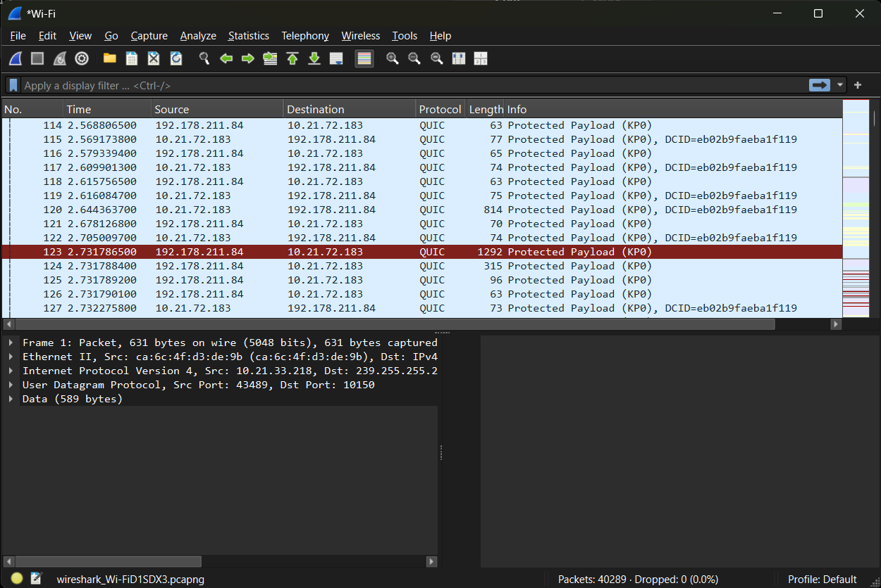
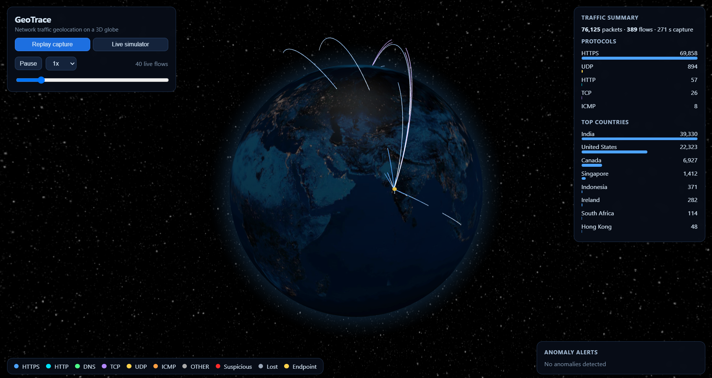

Appendix C Individual Contributions
The contribution of each student is recorded in Table C.1.
Student Name and PRN | Work Completed | Evidence or Deliverable
Harshit Sharma | Wireshark Implementation | [File / test / section]
Rohan Khalate | PPT and report | [File / test / section]
Aditya Pillai | Backend | [File / test / section]
Yashowardhan Bhosale | Frontend | [File / test / section]
YouTube Link:- https://youtube.com/shorts/n3pqUkSVoW0?feature=share
GitHub Link:- https://github.com/Har-2208/geo_trace

