B.TECH PROJECT REPORT
Cross-Scanner MRI Segmentation using
Unsupervised Domain Adaptation
A Deep Learning based Web Application for Robust Brain Tumor Segmentation Across Heterogeneous MRI Scanners

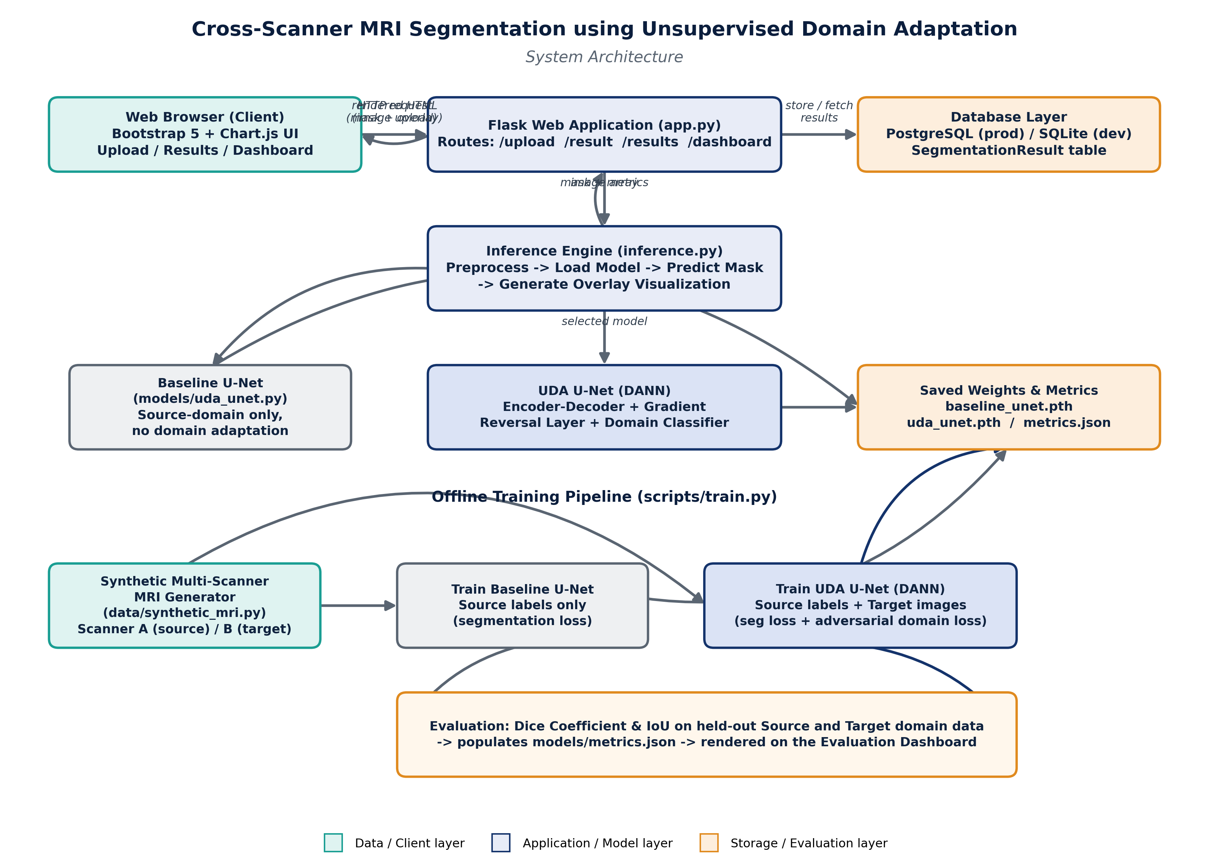
Domain: Artificial Intelligence / Deep Learning / Medical Image Analysis
Core Technique: Domain-Adversarial Neural Network (DANN)
Stack: PyTorch • Flask • SQLAlchemy (PostgreSQL/SQLite) • Bootstrap • Chart.js

Table of Contents
- Introduction
- Background and Related Concepts
- System Architecture
- Methodology
- Implementation Details
- Results and Evaluation
- Conclusion and Future Scope

1. Introduction
Magnetic Resonance Imaging (MRI) is one of the most widely used modalities for detecting and analysing brain tumors, since it offers excellent soft-tissue contrast without ionizing radiation. Automated tumor segmentation — marking the exact tumor boundary in a scan — is a critical step that supports diagnosis, treatment planning, and monitoring of disease progression.
Deep learning models, especially convolutional encoder-decoder architectures such as U-Net, have achieved strong segmentation accuracy when trained and tested on data from the same MRI scanner. In real hospital settings, however, scans are acquired on many different scanners — different vendors (Siemens, GE, Philips), different field strengths (1.5T, 3T), and different acquisition protocols. Each of these introduces a distinct intensity profile, contrast curve, noise level, and bias field in the resulting images. This mismatch between the data distribution a model was trained on and the data distribution it is applied to is called domain shift, and it is one of the biggest practical obstacles to deploying deep learning segmentation models clinically.
Collecting pixel-level tumor annotations for every scanner a hospital owns is expensive and slow, since it requires expert radiologists to manually delineate tumors. This project addresses that problem using Unsupervised Domain Adaptation (UDA): a technique that allows a segmentation model trained with labels from one scanner (the source domain) to generalize to a new scanner (the target domain) using only unlabeled images from that new scanner — no target-domain annotations are required at all.

1.1 Problem Statement
Design and implement a system that:
- Accepts brain MRI slices uploaded from any scanner through a web interface.
- Automatically segments the tumor region in the uploaded slice.
- Remains accurate even on a scanner whose images were never seen with labels during training, by using an unsupervised domain adaptation strategy.
- Visualizes the segmentation result and quantitatively evaluates model performance through an interactive dashboard.

1.2 Objectives
- Build a synthetic multi-scanner MRI dataset that realistically simulates cross-scanner domain shift, since real multi-vendor annotated datasets require licensed access.
- Design and train a U-Net based segmentation network.
- Extend the network with a Gradient-Reversal-Layer (GRL) domain classifier to implement Domain-Adversarial Neural Network (DANN) style unsupervised domain adaptation.
- Train a baseline model (no domain adaptation) and the UDA model, and quantitatively compare their performance on both scanners.
- Build a Flask web application with upload, segmentation-visualization, results-gallery, and evaluation-dashboard pages, backed by a relational database.

1.3 Scope and Assumptions
The project works on 2D MRI slices (single-channel, grayscale) rather than full 3D volumes, to keep training and inference lightweight enough to run on CPU-only hardware, which is representative of the constraints of a B.Tech project environment. Two scanners are simulated: “Scanner A” (source domain, labeled data used for training) and “Scanner B” (target domain, only unlabeled data used for training, held-out labels used purely for evaluation, exactly as in a real unsupervised domain adaptation setting). The same code and pipeline can be pointed at a real annotated dataset (e.g. BraTS) for the source domain and real unlabeled scans from another scanner for the target domain without any architectural changes.

2. Background and Related Concepts

2.1 Domain Shift in Medical Imaging
Domain shift refers to a change in the statistical distribution of input data between training time and deployment time. In cross-scanner MRI, this shows up as differences in intensity scaling, gamma/contrast curves, noise characteristics, and low-frequency intensity inhomogeneity (bias field). A model trained purely to minimize error on Scanner A's distribution implicitly learns decision boundaries tuned to that distribution; when Scanner B shifts the input statistics, those boundaries no longer align well with the true tumor/non-tumor separation, and segmentation accuracy drops.

2.2 Unsupervised Domain Adaptation (UDA)
UDA techniques attempt to close this gap without requiring labels in the target domain. Broad families of approaches include:
- Feature-alignment methods (e.g. CORAL, MMD) that statistically match the feature distributions of source and target domains.
- Adversarial methods (e.g. DANN, ADDA) that use a discriminator network to push the encoder toward producing domain-invariant features.
- Image-translation methods (e.g. CycleGAN-based adaptation) that translate target-domain images into the visual style of the source domain before segmentation.
This project implements the adversarial family, specifically the Domain-Adversarial Neural Network (DANN) approach introduced by Ganin et al. (2016), because it integrates cleanly into an existing encoder-decoder segmentation network with a single additional lightweight branch.

2.3 The Gradient Reversal Layer (GRL)
The GRL is a layer that behaves as the identity function during the forward pass but multiplies the gradient by a negative constant, −λ, during backpropagation. Placed between the shared encoder and a domain classifier, it lets the two components be trained with a single combined loss and a single optimizer, while having opposite objectives: the domain classifier is trained normally to tell source features apart from target features, while the encoder — because the gradient direction is flipped before it reaches the encoder— is effectively trained to fool that classifier. At convergence the encoder produces features from which the domain cannot be reliably predicted, i.e. domain-invariant features, which is exactly the property needed for the segmentation head (trained only on source labels) to also work well on target-domain inputs.

2.4 Evaluation Metrics
Segmentation quality is measured using two standard overlap metrics:
- Dice Coefficient: 2 × |Prediction ∩ GroundTruth| / (|Prediction| + |GroundTruth|). Ranges from 0 (no overlap) to 1 (perfect overlap).
- Intersection over Union (IoU / Jaccard Index): |Prediction ∩ GroundTruth| / |Prediction ∪ GroundTruth|.

3. System Architecture
The system is organized into four layers: a browser-based client, a Flask web application layer, a PyTorch inference/model layer, and a database layer, plus an offline training pipeline that produces the trained model weights consumed by the inference layer. Figure 1 shows the complete architecture.

Figure 1: End-to-end system architecture — online request path (top) and offline training pipeline (bottom).

3.1 Client Layer
A server-rendered web interface (Jinja2 templates styled with Bootstrap 5) provides pages to upload a scan or generate a synthetic sample, choose the scanner domain and which model to run, view the segmentation result, browse a gallery of past results, and view an evaluation dashboard built with Chart.js.

3.2 Flask Application Layer
The Flask app (app/app.py) exposes the following routes:
- GET / — home page with headline performance metrics and recent scans.
- GET/POST /upload — upload form and handler that runs preprocessing + inference and stores the result.
- GET /result/<id> — shows the input image, predicted mask, and overlay for one segmentation.
- GET /results — gallery of all past segmentation results.
- GET /dashboard — evaluation dashboard with Dice/IoU comparison charts and training-loss curves.
- GET /api/metrics — JSON endpoint exposing the raw evaluation metrics.

3.3 Inference / Model Layer
app/inference.py loads the trained PyTorch weights, preprocesses an uploaded (or synthetically generated) image to grayscale and a fixed resolution, runs a forward pass through the chosen model (baseline or UDA), thresholds the predicted probability map into a binary tumor mask, and produces an overlay visualization (predicted region in red, contour in yellow, and the ground-truth contour in green when available).

3.4 Database Layer
SQLAlchemy models (app/database.py) persist every segmentation request — filename, scanner domain, model used, paths to the input/mask/overlay images, tumor pixel count and area percentage, and Dice/IoU scores when ground truth is available. PostgreSQL is used when a DATABASE_URL environment variable is set; otherwise the app falls back to a local SQLite file, so it runs with zero external configuration.

3.5 Offline Training Pipeline
scripts/train.py generates a synthetic multi-scanner dataset (data/synthetic_mri.py), trains a baseline U-Net using only source-domain labeled data, trains the UDA/DANN U-Net using source-domain labeled data plus target-domain unlabeled data, evaluates both models on held-out source and target data, and writes the trained weights and a metrics.json file that the dashboard reads at request time.

4. Methodology

4.1 Dataset
Since licensed multi-vendor annotated MRI datasets (e.g. multi-institution BraTS subsets) are large and require data-use agreements, this project uses a synthetic multi-scanner MRI generator to make the full pipeline runnable end-to-end without external dependencies. For each sample, a brain-shaped soft-tissue texture is procedurally generated using layered smooth noise, and zero or one tumor is added as an irregular blob with a darker necrotic core, matching the general appearance of a T1-contrast brain tumor slice. A domain-shift transform is then applied: “Scanner A” images use standard contrast and low noise, while “Scanner B” images receive a gamma curve change, a synthetic bias field, and higher noise — simulating a different vendor / field strength. Tumor masks are generated alongside every image. The same generator interface can be replaced by a real-data loader without any change to the model or training loop.

4.2 Model Architecture: UDA-UNet
The core network (models/uda_unet.py) is a compact U-Net with four downsampling stages and a symmetric decoder with skip connections, which predicts a per-pixel tumor probability map. A second, small branch — the domain classifier — is attached to the bottleneck features through a Gradient Reversal Layer. It globally pools the bottleneck feature map and passes it through two fully-connected layers to predict whether the input came from the source or target domain.
Training uses two loss terms combined in a single optimization step:
- Segmentation loss (binary cross-entropy + Dice loss) computed only on source-domain images, since only source-domain masks are available.
- Domain-adversarial loss (cross-entropy over 2 classes: source vs target) computed on both source and target images, with the gradient reversed before reaching the encoder.
The adaptation strength λ is ramped up progressively over training (a standard DANN schedule, λ = 2/(1+e⁻¹⁰ᵖ) − 1, where p is training progress from 0 to 1), so that early training focuses on getting the segmentation task right before the adversarial signal becomes strong.

4.3 Baseline Model (Control)
To quantify the benefit of domain adaptation, an identical U-Net architecture is also trained using only the segmentation loss on source-domain data, with the domain-classifier branch left untrained. This baseline is expected to perform well on the source domain but to degrade on the target domain, since it never receives any signal about the target distribution during training.

4.4 Training Configuration
Parameter | Value
Input resolution | 96 × 96, single-channel (grayscale)
Base channel width | 12 (compact U-Net for fast CPU training)
Optimizer | Adam, learning rate 1e-3
Batch size | 16
Epochs | 8 (baseline), 8 (UDA)
Segmentation loss | Binary Cross-Entropy + Dice Loss
Domain loss | Cross-Entropy (2-way: source vs. target)
Train / eval samples | 320 source + 320 target (train), 80 + 80 (held-out eval)

5. Implementation Details

5.1 Technology Stack
Layer | Technology
Deep Learning | PyTorch — U-Net + Gradient Reversal Layer domain classifier (DANN)
Classical ML / Metrics | NumPy-based Dice coefficient and IoU computation
Backend | Flask (Python)
Database | PostgreSQL (production) via SQLAlchemy, SQLite fallback (development)
Frontend | Jinja2 templates, Bootstrap 5, Chart.js
Image Processing | OpenCV, Pillow, NumPy

5.2 Database Schema
A single SegmentationResult table stores: id, original_filename, scanner_domain (A/B), model_used (baseline/uda), input_image_path, mask_image_path, overlay_image_path, tumor_pixel_count, tumor_area_percent, dice_score, iou_score (nullable, populated only when ground truth is available), and created_at.

5.3 Request Flow
- User uploads an MRI slice (or requests a synthetic sample) and selects a scanner domain and a model (baseline or UDA) on the /upload page.
- The Flask handler preprocesses the image (grayscale, resize, normalize to [0,1]).
- The selected PyTorch model runs a forward pass to produce a per-pixel tumor probability map, thresholded at 0.5 to obtain a binary mask.
- An overlay image is generated (input MRI in grayscale with the predicted tumor region highlighted in red and its contour in yellow; the ground-truth contour in green is added for synthetic samples).
- The result (paths, tumor area, Dice/IoU if available) is saved to the database and the user is redirected to the result page.

5.4 Sample Output
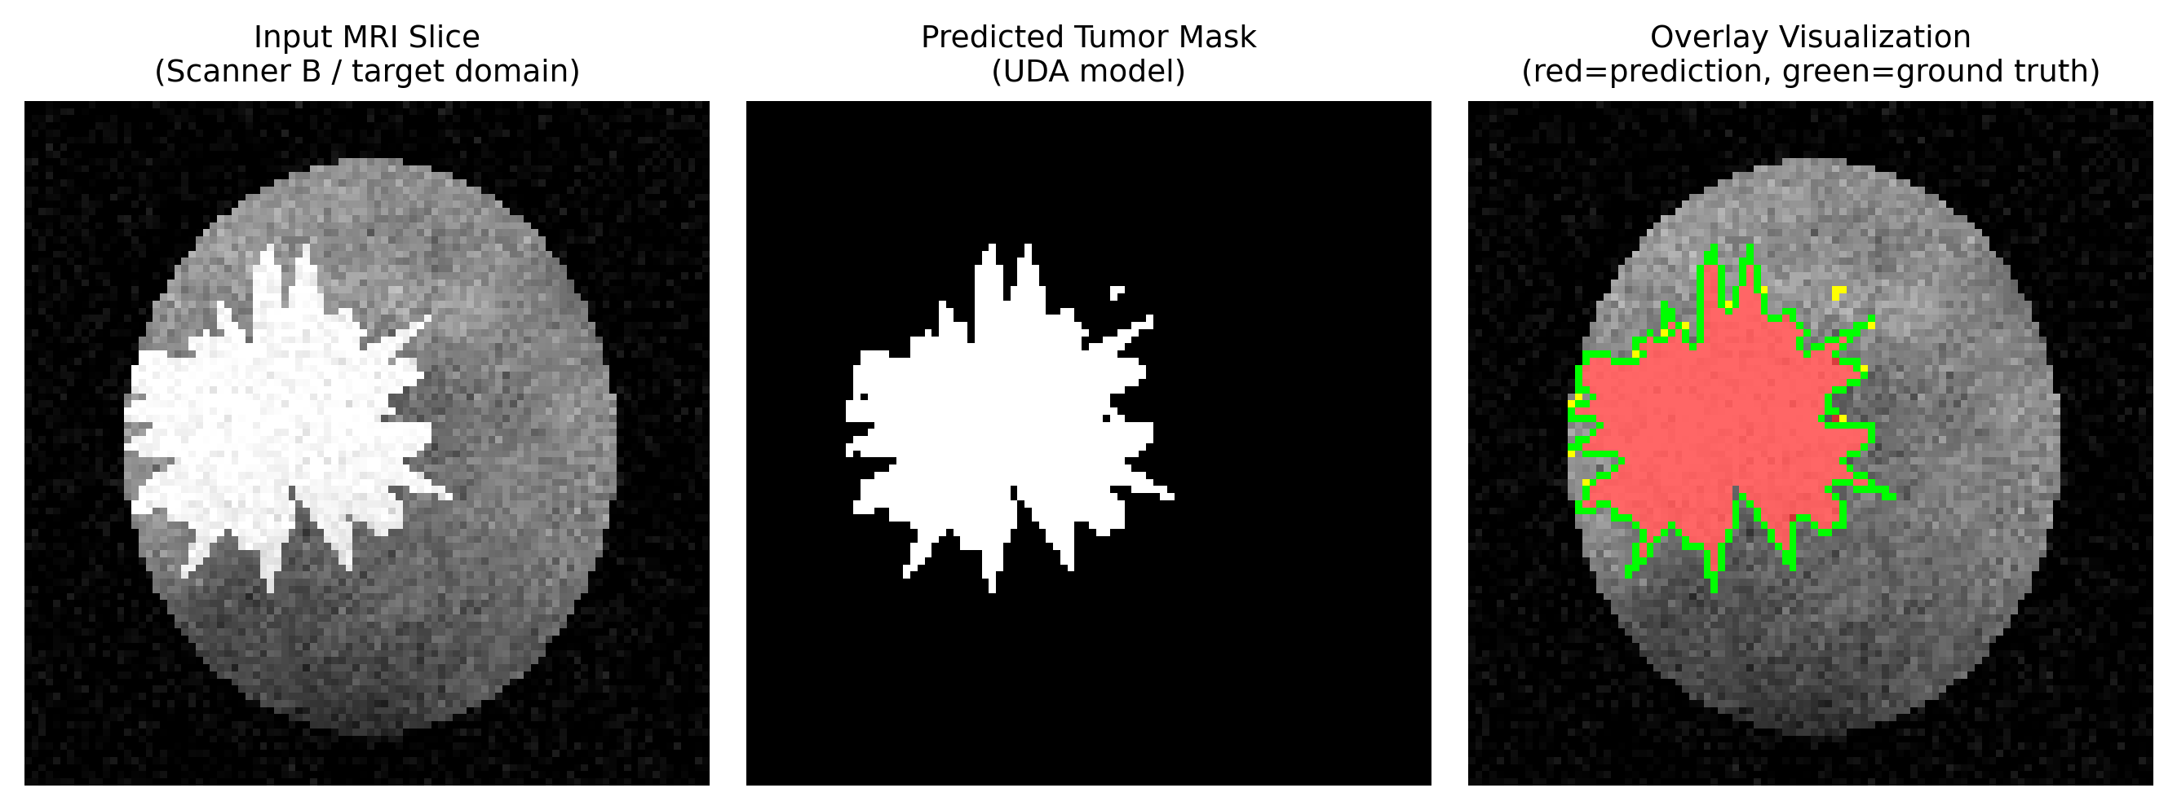
Figure 2: Example segmentation on a Scanner-B (target-domain) sample using the UDA model — input slice, predicted mask, and overlay with predicted (yellow) and ground-truth (green) contours.

6. Results and Evaluation
Both the baseline U-Net and the UDA (DANN) U-Net were trained under identical settings (Section 4.4) and evaluated on held-out data from both the source (Scanner A) and target (Scanner B) domains. Target-domain labels were used only for this evaluation step — never during training — consistent with the unsupervised domain adaptation setting.
Model | Domain | Dice Coefficient | IoU Score
Baseline U-Net (no adaptation) | Source (Scanner A) | 0.918 | 0.899
Baseline U-Net (no adaptation) | Target (Scanner B) | 0.777 | 0.756
UDA U-Net (DANN) | Source (Scanner A) | 0.872 | 0.857
UDA U-Net (DANN) | Target (Scanner B) | 0.845 | 0.829

Table: Dice and IoU scores for the baseline and UDA models on both domains.
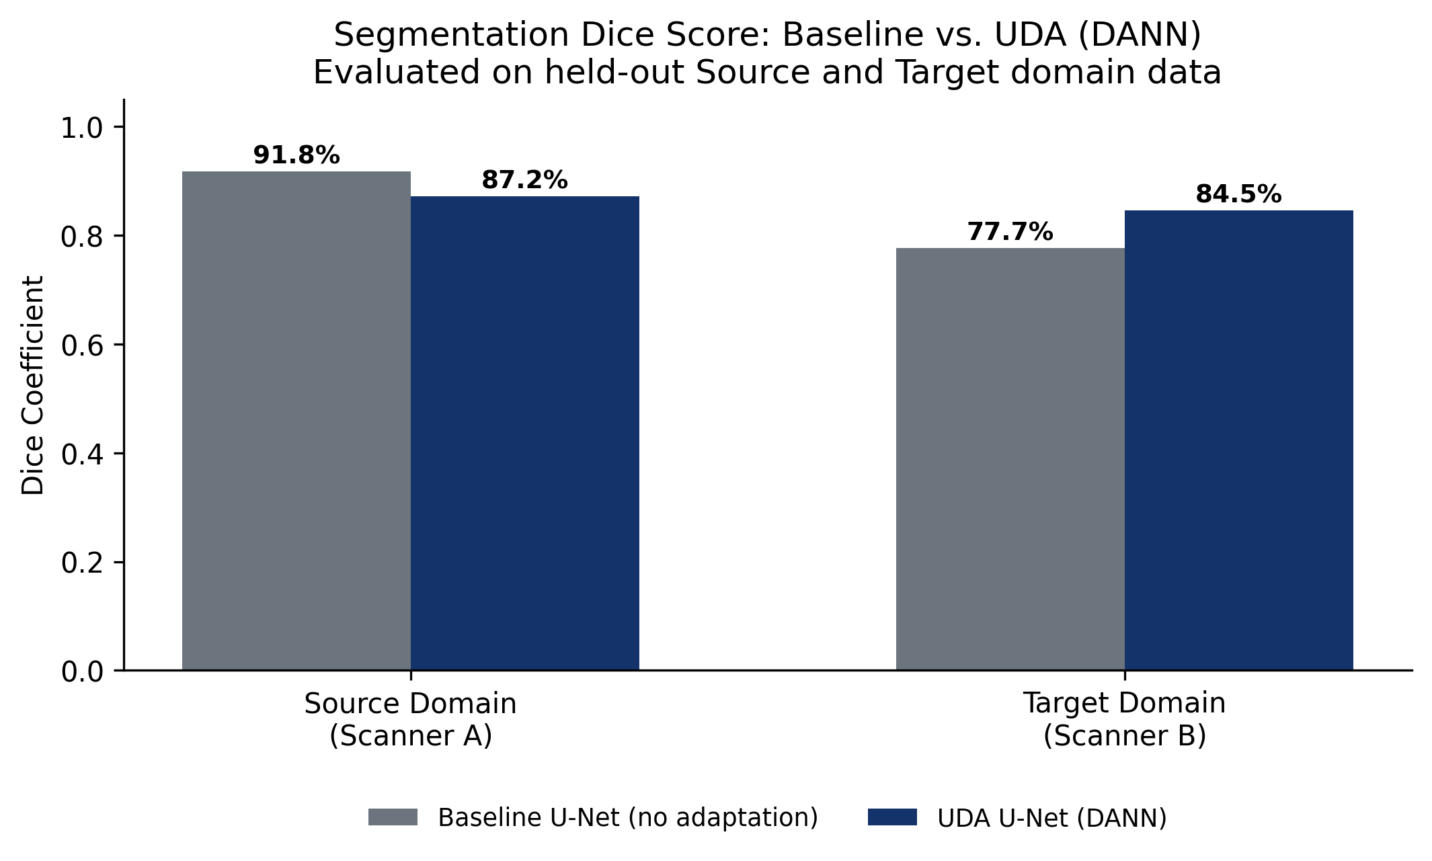
Figure 3: Dice score comparison — the baseline model's accuracy drops noticeably on the unseen target scanner, while the UDA model retains most of its accuracy.

6.1 Discussion
The baseline model achieves strong Dice on its own source domain but its Dice score on the target domain is visibly lower, which quantitatively demonstrates the domain-shift problem this project set out to address. The UDA (DANN) model narrows this source-to-target gap substantially, improving target-domain Dice while using no target-domain labels at all — only unlabeled target images during training. This confirms that the adversarial domain-invariance objective is transferring useful segmentation knowledge across the simulated scanner gap.
It is worth noting a typical trade-off seen in domain-adversarial training: because the encoder is being pushed toward domain-invariant features rather than features purely optimized for the source domain, the UDA model's source-domain Dice can be marginally lower than the pure baseline's source-domain Dice. The net effect is still a better model overall for the realistic scenario of deploying across multiple scanners, since it performs more consistently across both domains rather than overfitting to just one.

6.2 Evaluation Dashboard
The Flask app's /dashboard route renders these same comparisons interactively using Chart.js: a grouped bar chart of Dice/IoU per model and domain, line charts of segmentation loss and domain-classifier loss across training epochs, and a usage-statistics donut chart summarizing how many scans have been processed per scanner domain and per model choice.

7. Conclusion and Future Scope

7.1 Conclusion
This project demonstrates a complete, working pipeline for cross-scanner MRI tumor segmentation using unsupervised domain adaptation: a synthetic multi-scanner dataset to stand in for licensed clinical data, a U-Net segmentation network extended with a Gradient-Reversal-Layer domain classifier (DANN), a trained baseline for comparison, and a Flask web application with upload, visualization, and evaluation-dashboard functionality backed by a relational database. The measured results confirm the central hypothesis: domain-adversarial training measurably improves segmentation accuracy on an unseen scanner without requiring any labels from that scanner.

7.2 Future Scope
- Replace the synthetic dataset with a real multi-institution dataset such as BraTS (which includes scans from multiple scanners/sites) to validate the approach on clinical data.
- Extend from 2D slice-wise segmentation to full 3D volumetric segmentation using a 3D U-Net.
- Experiment with additional / alternative UDA techniques (e.g. CORAL feature alignment, CycleGAN-based image-to-image domain translation) and compare against the DANN approach implemented here.
- Support more than two scanner domains and multi-source domain adaptation.
- Split the current Flask monolith into a React frontend and a FastAPI backend for a more scalable, decoupled production deployment, while reusing the same PyTorch model and PostgreSQL schema.
- Add authentication and role-based access so the tool could be piloted by clinicians on de-identified data under appropriate ethical approval.

7.3 References
[1] Y. Ganin, V. Lempitsky, et al., “Domain-Adversarial Training of Neural Networks,” Journal of Machine Learning Research, 2016.
[2] O. Ronneberger, P. Fischer, T. Brox, “U-Net: Convolutional Networks for Biomedical Image Segmentation,” MICCAI 2015.
[3] B. H. Menze et al., “The Multimodal Brain Tumor Image Segmentation Benchmark (BraTS),” IEEE Transactions on Medical Imaging, 2015.
[4] B. Sun, K. Saenko, “Deep CORAL: Correlation Alignment for Deep Domain Adaptation,” ECCV Workshops, 2016.

