MedTriage AI
Cross-Lingual Medical Triage Assistant
System Architecture & Project Documentation
Supported languages: English · Hindi · Hinglish · Marathi · Tamil · Telugu
Stack: Flask · SQLAlchemy · SQLite/PostgreSQL · Bootstrap 5
Version 1.0

Table of Contents
1. Executive Summary
2. Problem Statement & Objectives
3. System Architecture
4. Technology Stack
5. Core Modules & Responsibilities
6. Multilingual NLP Approach
7. Database Schema
8. User Workflow
9. Security & Compliance Considerations
10. Limitations, Disclaimer & Future Roadmap
11. Testing & Sample Walkthrough
Appendix A — Full Symptom Lexicon & Department Mapping

1. Executive Summary
MedTriage AI is a working web application that lets a patient describe their symptoms in their own language — English, Hindi, Hinglish (Roman-script Hindi), Marathi, Tamil, or Telugu — and immediately receive an automated preliminary urgency assessment, a recommended hospital department, and a structured clinical summary for hospital staff.
The application is built as a self-contained Flask system: a single Python codebase serves the user interface (server-rendered HTML with Bootstrap), handles authentication, runs the multilingual symptom classification logic, generates the clinical note, and persists every triage request to a relational database for later review.
This document describes what the application does, how it is put together end to end, the technology choices behind it, the data model, the multilingual classification approach, and the security and clinical-safety considerations that apply before any real-world deployment.
Important scope note: the current classification engine is a curated, rule-based multilingual lexicon — not a trained neural network. It was built this way so the application works fully offline, with zero setup cost and zero external dependencies, while remaining structured so a real fine-tuned model can be substituted later without touching any other part of the system (see Section 10).

2. Problem Statement & Objectives
In multilingual regions, patients frequently describe symptoms in a regional language or a mixed Roman-script form ("Hinglish") rather than in English or formal Devanagari/Tamil/Telugu script. Hospital front-desk and triage staff may not speak every patient's language, which can delay correct routing to the right department, especially during high patient volume.
The application targets the following objectives:
- Accept free-text symptom descriptions in six language modes (EN, HI, HG, MR, TA, TE).
- Automatically classify the urgency of the reported symptoms into Emergency, Urgent, or Non-Urgent.
- Recommend an appropriate hospital department for initial routing.
- Generate a concise, structured clinical summary that staff can quickly read regardless of the patient's input language.
- Maintain a secure, authenticated history of each patient's past triage submissions.
- Remain deployable with zero external API dependencies, while leaving a clear upgrade path to a production-grade fine-tuned multilingual model.

3. System Architecture
The system follows a layered, monolithic Flask architecture. Each layer has a single responsibility, and data flows strictly downward for a request (input → classification → persistence) and upward for a read (dashboard history).
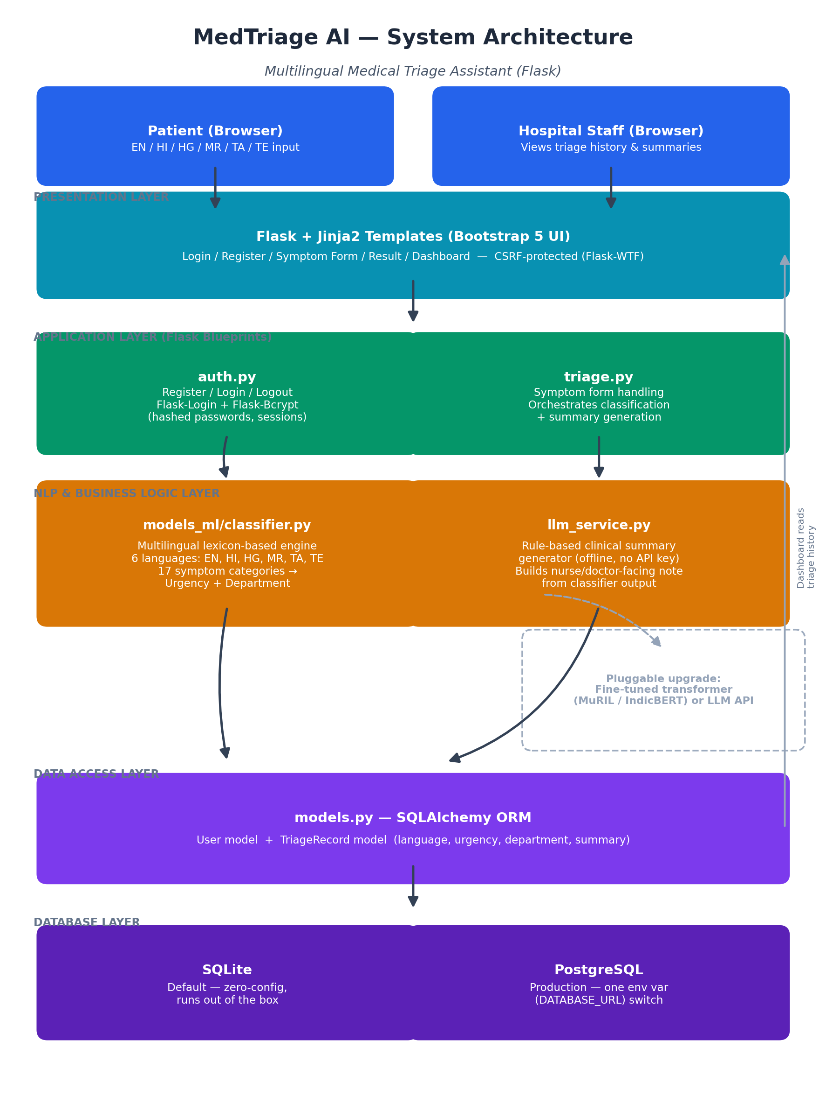

3.1 Layer Descriptions
- Presentation Layer — Flask routes render Jinja2 templates styled with Bootstrap 5: login/register forms, the symptom-entry form, the result page, and the dashboard. All forms are CSRF-protected via Flask-WTF.
- Application Layer (Blueprints) — auth.py handles registration, login, and logout using Flask-Login for session management and Flask-Bcrypt for password hashing. triage.py handles the symptom form, orchestrates classification and summary generation, and persists results.
- NLP & Business Logic Layer — classifier.py holds the multilingual symptom lexicon and scoring logic. llm_service.py turns the classifier's structured output into a readable clinical note, entirely offline.
- Data Access Layer — models.py defines two SQLAlchemy models, User and TriageRecord, providing a database-agnostic ORM interface.
- Database Layer — SQLite by default (zero configuration, ideal for development/demo); PostgreSQL in production via a single DATABASE_URL environment variable change.

4. Technology Stack
Layer | Technology | Purpose
Web framework | Flask 3.x | Routing, request handling, app factory pattern
Templating | Jinja2 + Bootstrap 5 | Server-rendered, responsive UI
Authentication | Flask-Login, Flask-Bcrypt | Session management, password hashing
Forms & CSRF | Flask-WTF, WTForms | Form validation, CSRF protection
ORM | SQLAlchemy | Database-agnostic data models
Migrations | Flask-Migrate | Schema version control (Alembic)
Database (dev) | SQLite | Zero-config local/demo storage
Database (prod) | PostgreSQL | Production-grade relational storage
NLP engine | Custom Python lexicon module | Multilingual symptom → urgency/department classification
Summary generation | Custom Python rule engine | Offline clinical note generation, no external API

5. Core Modules & Responsibilities

5.1 app.py — Application Factory
Creates and configures the Flask app, initializes extensions (SQLAlchemy, Bcrypt, Login Manager, Migrate), registers the auth and triage blueprints, and creates database tables on startup.

5.2 auth.py — Authentication Blueprint
Implements registration and login forms with validation, hashes passwords before storage, and manages user sessions. Roles supported: patient and hospital staff.

5.3 triage.py — Triage Blueprint
Presents the symptom-entry form, invokes the classifier and summary generator in sequence, stores the resulting TriageRecord, and renders the dashboard (recent history) and individual result pages.

5.4 models_ml/classifier.py — Multilingual Classifier
Contains a hand-curated lexicon covering 17 symptom categories, each with surface-form phrases in all six supported language modes, an urgency weight (1–10), and a mapped hospital department. Free text is normalized and matched against this lexicon; the highest-severity match determines the final urgency level and department.

5.5 llm_service.py — Summary Generator
Converts the classifier's structured output into a human-readable clinical note using sentence templates: what the patient appears to be reporting, the urgency rationale, and the recommended department — entirely offline, with no external API calls.

5.6 models.py — Data Models
Defines the User model (credentials, role, timestamps) and the TriageRecord model (language, raw symptom text, urgency level/score, department, matched symptom tags, generated summary, timestamp).

6. Multilingual NLP Approach
Rather than depending on a hosted translation or classification API, the application matches symptom phrases directly in each language's native script (or Roman script for Hinglish), avoiding both translation latency and translation-introduced ambiguity for medical terms.
Code | Language | Example input | Detected
EN | English | "I have chest pain and breathlessness" | Emergency → Cardiology
HI | Hindi | "मुझे सीने में दर्द और सांस लेने में तकलीफ है" | Emergency → Cardiology
HG | Hinglish | "mujhe chest me dard aur saans lene me takleef hai" | Emergency → Cardiology
MR | Marathi | "मला छातीत दुखणे आणि श्वास घ्यायला त्रास होतोय" | Emergency → Cardiology
TA | Tamil | "எனக்கு மார்பு வலி மற்றும் மூச்சு திணறல்" | Emergency → Cardiology
TE | Telugu | "నాకు ఛాతీ నొప్పి మరియు శ్వాస ఆడకపోవడం" | Emergency → Cardiology

Symptom categories covered include chest pain, breathlessness, severe bleeding, unconsciousness, stroke warning signs, fever, abdominal pain, vomiting, headache, cough/cold, fractures and injuries, general body pain, skin conditions, labor/pregnancy-related concerns, chest infections, and mental-health distress — each mapped to an urgency weight and a hospital department.

7. Database Schema

7.1 users table
Column | Type | Notes
id | Integer, PK | Auto-increment primary key
full_name | String(150) | Required
email | String(150) | Unique, indexed, used for login
password_hash | String(255) | Bcrypt hash, never stored in plaintext
role | String(20) | "patient" or "staff"
created_at | DateTime | Account creation timestamp

7.2 triage_records table
Column | Type | Notes
id | Integer, PK | Auto-increment primary key
user_id | Integer, FK → users.id | Owning patient
language | String(10) | en / hi / hg / mr / ta / te
raw_symptom_text | Text | Patient's original description
urgency_level | String(20) | Emergency / Urgent / Non-Urgent
urgency_score | Integer | 1–10 severity score
department | String(80) | Recommended hospital department
matched_symptoms | Text | Comma-separated matched symptom keys
ai_summary | Text | Generated clinical summary
summary_source | String(20) | "template" (rule-based) or future "llm"
created_at | DateTime | Submission timestamp

8. User Workflow
- 1. Patient registers or logs in (email + password, hashed and session-managed).
- 2. Patient selects a language and submits a free-text symptom description.
- 3. triage.py passes the text to the classifier, which returns urgency, score, department, and matched symptom tags.
- 4. llm_service.py converts that structured result into a readable clinical summary.
- 5. The full result is saved as a TriageRecord and the patient is shown the assessment immediately (urgency badge, department, and summary).
- 6. The patient's dashboard lists their recent submissions for later reference by themselves or hospital staff.

9. Security & Compliance Considerations
- Passwords are hashed with bcrypt; plaintext passwords are never stored or logged.
- All forms are CSRF-protected via Flask-WTF tokens.
- Sessions are managed by Flask-Login; unauthenticated users are redirected to login for protected routes.
- Symptom text and triage records constitute sensitive health data. Before any production deployment: encrypt data at rest, restrict database access, add audit logging, and confirm compliance with applicable regulations (e.g., India's Digital Personal Data Protection Act, or HIPAA if serving US patients).
- Recommended production hardening: HTTPS-only cookies, rate limiting on login and triage-submission endpoints, and a Web Application Firewall in front of the app.

10. Limitations, Disclaimer & Future Roadmap
MedTriage AI is a decision-support prototype and is not a certified medical device. It must not be used as the sole basis for real clinical triage decisions without validation by qualified medical professionals and appropriate regulatory review. In a genuine medical emergency, patients should contact local emergency services immediately rather than rely on this tool.

10.1 Current Limitations
- Classification is lexicon/keyword-based, not a trained statistical or neural model — it can miss symptom phrasings not present in the lexicon.
- No mechanism yet for combining multiple co-occurring conditions beyond taking the single highest-severity match.
- Clinical summaries are template-generated, not context-aware natural language generation.

10.2 Upgrade Path to a Fine-Tuned Multilingual Model
- Select a base model suited to Indic languages, e.g. google/muril-base-cased or ai4bharat/indic-bert.
- Collect and label real (de-identified, consented) triage text with urgency and department targets, per language.
- Fine-tune a classification head, or prompt-engineer a multilingual LLM for structured output.
- Swap the implementation inside score_symptoms() in classifier.py, keeping the same return contract — no other file needs to change.
- Clinically validate accuracy per language and symptom category before any real-world use, with particular attention to false-negative (under-triage) rates.

11. Testing & Sample Walkthrough
The application was exercised end-to-end using the Flask test client — covering registration, login, symptom submission across multiple languages, and dashboard history retrieval. Representative test cases and their results are shown below.
Language | Input (as submitted) | Result
Hindi | "मुझे सीने में दर्द और सांस लेने में तकलीफ हो रही है" | Emergency (10/10) → Cardiology / Emergency
Hinglish | "mujhe chest me dard aur saans lene me takleef ho rahi hai" | Emergency (10/10) → Cardiology / Emergency
Hinglish | "accident me haddi toot gayi hai bahut chot lagi hai" | Urgent (7/10) → Orthopedics / Emergency
Tamil | "எனக்கு இருமல் மற்றும் சளி உள்ளது" | Non-Urgent (2/10) → General Medicine / ENT
Telugu | "నాకు ఛాతీ నొప్పి మరియు శ్వాస తీసుకోవడంలో ఇబ్బంది ఉంది" | Emergency (10/10) → Cardiology / Emergency

Functional flows verified: account registration with duplicate-email rejection, login/logout session handling, CSRF token validation on all forms, correct urgency badge and department rendering on the result page, and accurate history listing on the patient dashboard.

Appendix A — Full Symptom Lexicon & Department Mapping
The table below lists every symptom category currently in the lexicon, its urgency weight (1–10, used to derive Emergency / Urgent / Non-Urgent), and the hospital department it routes to. Each category has matching surface-form phrases authored in all six supported language modes.
Symptom Category | Urgency Weight | Routed Department
Chest pain | 10 | Cardiology / Emergency
Severe bleeding | 10 | Emergency / Trauma
Unconsciousness | 10 | Emergency
Stroke warning signs | 10 | Neurology / Emergency
Breathlessness | 9 | Pulmonology / Emergency
Labor / pregnancy concern | 8 | Obstetrics & Gynecology
Fracture / severe injury | 7 | Orthopedics / Emergency
High fever | 6 | General Medicine
Chest infection / wheezing | 6 | Pulmonology
Mental distress (anxiety, panic, low mood) | 6 | Psychiatry
Abdominal pain | 5 | Gastroenterology
Vomiting / nausea | 4 | General Medicine
Headache | 3 | Neurology (OPD)
Fever (general) | 3 | General Medicine
Cough / cold / sore throat | 2 | General Medicine / ENT
General body / joint / back pain | 2 | Orthopedics (OPD)
Skin rash / itching / allergy | 2 | Dermatology

This lexicon is intentionally editable and extensible — new symptom categories, phrases, and department mappings can be added directly to models_ml/classifier.py without any change to the surrounding application code.

