XboxWirelessController
Old Input System
https://www.youtube.com/watch?v=384_g0f7K_I

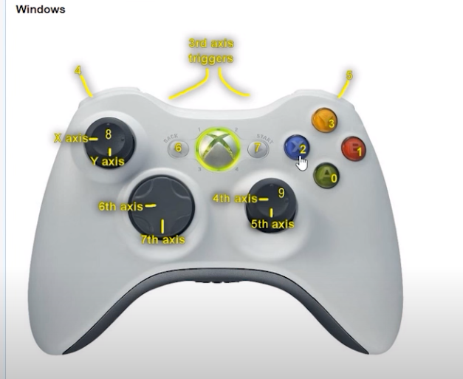

Edit/ProjectSettings/Input

Drone Controll
https://www.youtube.com/watch?v=3R_V4gqTs_I&list=PLPAgqhxd1Ib1YYqYnZioGyrSUzOwead17

