Ideas about a Quantum Theory without Process Type 2
by Harald Rieder, 2018. A summary is at the end of the document.

Since stones are grammatically animate [in Ojibwa language], I once asked an old man: ‘Are all the stones we see about us here alive?’ He reflected a long while and then replied, ‘No! But some are.’
from A. Irving Hallowell, Ojibwa Ontology

This article collects arguments for a quantum theory without process type 2. In quantum mechanics we have 2 different types of unitary processes. To cite Hugh Everett
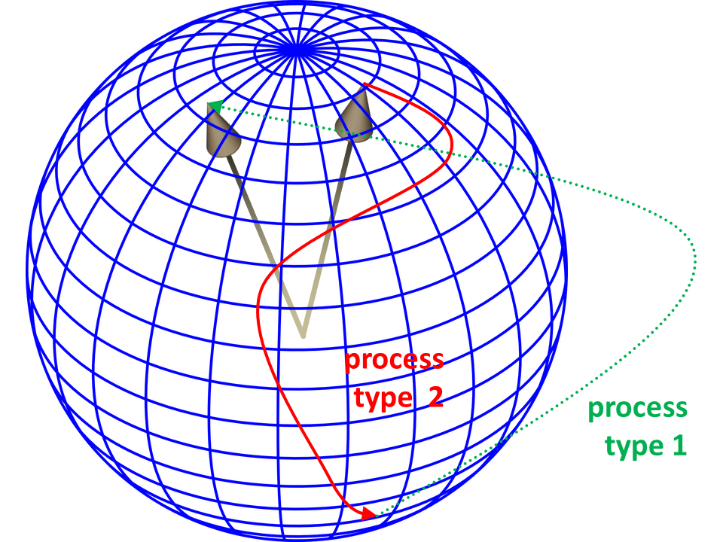
Process 1: The discontinuous change brought about by the observation of a quantity with eigenstates 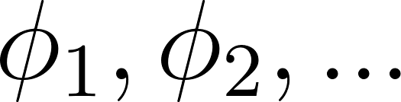 in which the state 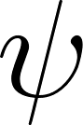 will be changed to the state 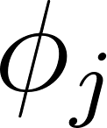 with probability 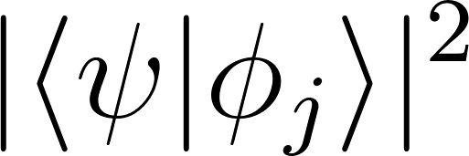.
Process 2: The continuous, deterministic change of state of the (isolated) system with time according to a wave equation 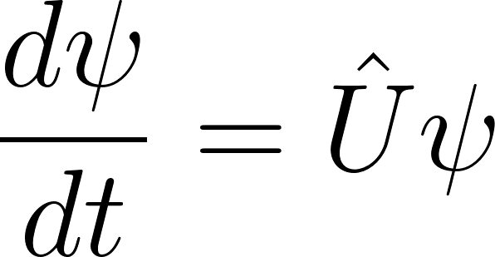, where 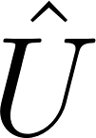 is a linear operator.

Process type 1 is related to the state change of a conscious observer. Process type 2 shall describe an objective physical reality. The existence of these 2 process types gave us the measurement problem and the paradox of Wigner’s friend. Nobody currently knows why and when process type 1 takes place and when process type 2 evolves.

Decoherence Theory and Measurements
From decoherence theory we learn that we can gain knowledge about a “quantum system” only by destroying it. As long as there is no interaction with the quantum system, it can be described by process type 2 alone. However to find out whether this is really true, we must interact with the quantum system and observe some quantities. The observation starts with the coupling of our quantum system, i.e. the rest of the world, to the one that shall be observed. Technically this coupling means that the state vector of the measured system loses its existence as well as the state vector of the rest world does. In non-relativistic quantum mechanics both together must be described by the state vector of the whole world which lives in the product space of the spaces of the formerly independent systems.
An observable O that acts only on the measured system is represented by a linear operator , that acts only in a subspace of the product space. There is an infinite number of ways, how the world’s Hilbert space can be split into subspaces. With the selection of an observable we choose a certain split of the Hilbert space into 2 subspaces. This subjective choice brings the quantum system back to life for “observation”.
Technically the probabilities for measurement outcomes are given by the reduced density operator of the quantum system
.
The degrees of freedom of the rest world are traced out completely. The expectation value of an observable O of the quantum system alone then is given by
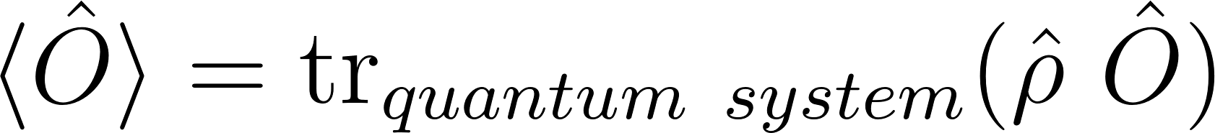.
Decoherence theory tells us how the dynamical evolution according to process type 2 shapes the density operator and in which basis the entanglement of the subspaces is high. But still the measurement process has different outcomes that may enter consciousness with different probabilities. Decoherence theory does not solve the problem of outcomes as stated clearly for example in Schlosshauer’s book.
Because we destroy the quantum system when gaining information about it, it is generally not possible to gain complete knowledge about it. Only if the measurement (entanglement) basis fits to the possible states before the measurement, which depend on our preparation, we can gain complete knowledge. Such a measurement is an ideal von Neumann measurement and establishes the von Neumann chain before it “collapses” according to process type 1 because of the observation.
For example according to Everett’s description of Wigner’s gedankenexperiment the observer W outside of the room thinks he has this chain with a superposition of his friend’s F state up to the end when W looks at the notebook.

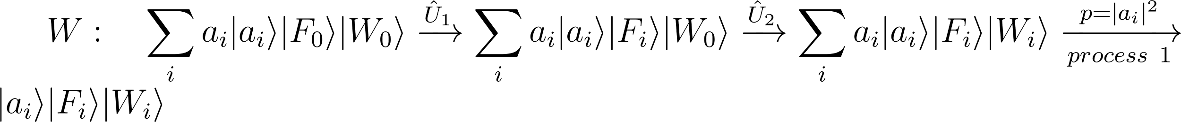

But in F’s opinion process 1 took place earlier before W opened the door
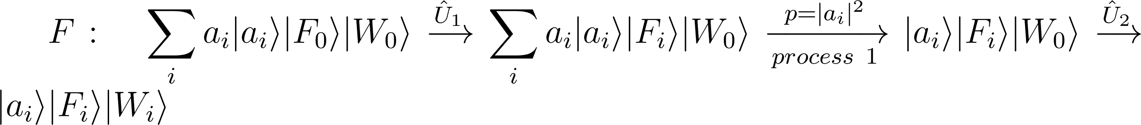
As you can see probabilities 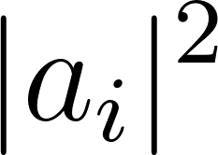 and outcomes are the same. However W has the possibility to find out whether F had been in a superposition by measuring in a basis 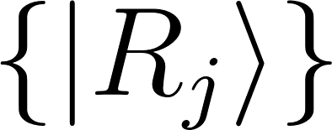 where
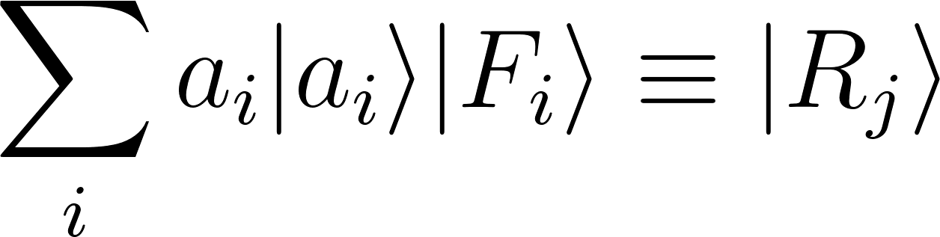
W’s and F’s chains then lead to different probabilities for the outcomes.
W gets this result meaning ”F had been in a superposition relating to the original basis” with probability 1, whereas F’s earlier process 1 leads to probabilities 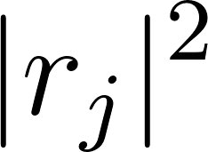 for the different outcomes.

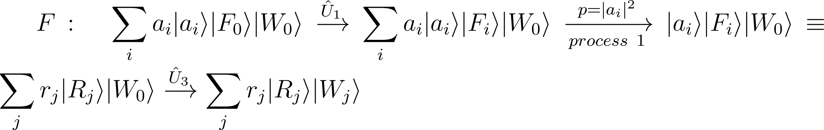
At least theoretically thus it should be possible to find out what is realized in nature.

The Many Worlds Interpretation
The many worlds interpretation tries to solve the paradox by denying the existence of process type 1 in favour for the continuous process type 2. The state of mind shall correspond to a state vector or density operator living in a subspace, just as for the states of matter or particles. The reason why F never experiences a superposition like
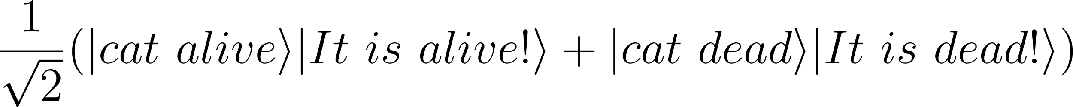
shall be that F has only access to a frog’s perspective where his state of mind is either the belief that there is a dead or there is a living cat. However from the bird’s perspective the superposition exists. But this way new problems are introduced:
- If there are only processes of type 2, their time-reversed counterparts are possible, too, if not forbidden by an additional postulate. Umkehreinwand (Loschmidt’s paradox) and Wiederkehreinwand (Poincaré recurrence) as they came up in classical thermodynamics can be applied here in a similar way. This means product-state producing processes like
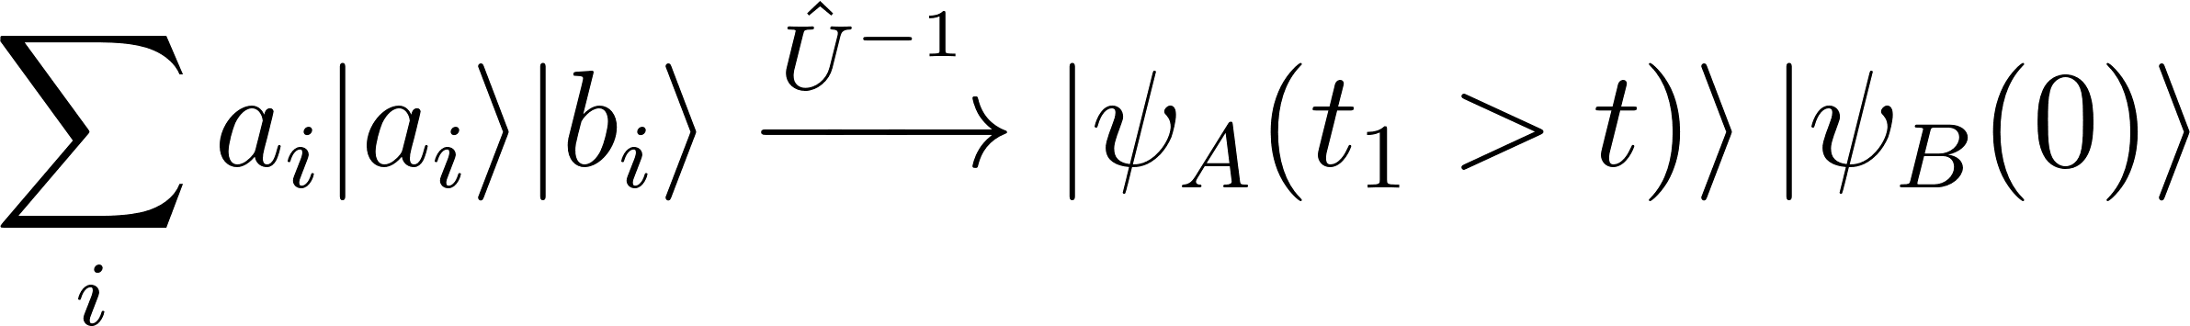
are allowed with the meaning that a dead-alive superposition of a cat may come to life also from the bird’s perspective. There is no explanation for the arrow of time.
- There is no explanation why some separations of the Hilbert space split the state of mind and others not. There is no explanation why a Schrödinger cat state is never observed from any frog’s perspective. Note that the state

is pure only in some (though infinitely many) bases. There are (“more”) infinitely many bases where it appears as a superposition.
- Life forms can be modeled successfully by non-linear equations. The differential equations of quantum theory are linear (allowing the superposition of solutions, i.e. state vectors). The solutions of the Schrödinger equation, which turns out to be a mixture of a wave and a Laplace equation when real and imaginary parts are separated, are boringly simple. These solutions, dispersing wave packets, do not really look alive. Eigenvalues may depend chaotically on parameters though. But process type 1 is necessary to make this dependency visible to an observer.
- Finally there is no explanation for obviously existing things like joy, pain and will. This statement is true for nearly the whole contemporary physics leaving us alone with the mind-body problem and dualism. If experimenters have a “free will”, qubits should have free will, too.
While there may lie some truth in the radical suggestion to drop one of the process types, the many worlds interpretation is not only an interpretation of quantum mechanics. It is missing an explanation for the frog’s perspectives. It can often be read that a state vector shall split into its components (often or even continuously) thus creating the frogs’ perspectives. But the problem is, that a state vector does not have any components without choosing a basis. At any point of time it has components and has not, depending on the basis. Decoherence theory gives us pointer states and a basis, but why should these pointer states have something to do with a conscious perspective? Answering this question requires to modify quantum mechanics somehow. The answer is not included in current quantum theory.

There are no Big Jumps
The first figure above suggests that process type 1 allows big jumps while process type 2 requires some time to travel from A to B. In the figure the processes take place on a 2-dimensional surface of a 3-dimensional unit sphere. But in a space with many dimensions the difference between the process types may vanish.
In the smallest Hilbert space - a qubit - the distance between two unit vectors is restricted by
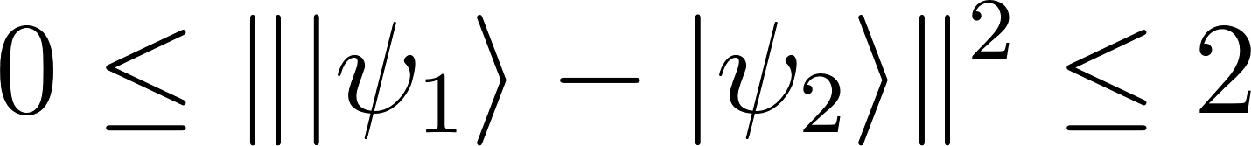
In a very large Hilbert space - of the world - the distance between any two unit vectors lies within the same interval [0,√2]. Imagine there are so many dimensions that you can always find one that gives you a shortcut from A to B. You might want to say that these 2 vectors, that are composed of qubits
have a bigger distance because several bits are different. But in contrast to the distance we defined first this is not an absolute measure. You can always find a basis where only 1 bit is different and then the same vectors may look like this
An infinite number of bases is totally equivalent to describe the same abstract Hilbert space vectors.

Thermodynamics and Black Holes
Consider these 2 equations from classical statistical physics
They define the entropy S via purely classical mechanical quantities like energies E and H, particle numbers n, positions q and momenta p or more general canonical variables q and p.
However Planck’s constant appears in the denominator of the partition function . It enters the formula not before a comparison of the quantum mechanical entropy of 1 particle trapped in a box of a certain volume with its classical analogon. Planck’s constant puts a finite number of 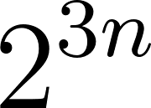 dimensional areas into the classical phase space (Γ space). Their size is fixed but their shape is totally undefined.
The mechanical entropy definition is quite general (formula above is for 1 particle type, can be generalized for several types). For an ideal gas with particle energies independent of momenta  it is proportional to the volume V, i.e. the entropy is an extensive quantity depending on the amount of matter as already stated by empirical thermodynamics.
2 things are worth noting:
- The extensivity of the classical entropy of an ideal gas does not depend on how a volume, and hence the phase space, is divided into parts (which is in relation to the ergodic hypothesis). This holds for any thought separation. Physical walls are not necessary.
- The division of the phase space corresponds to non-vanishing quantum mechanical commutators 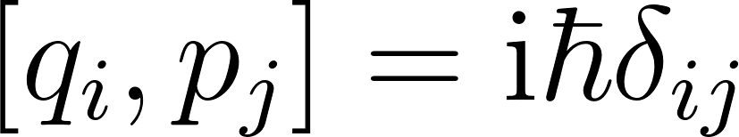. The commutator however means a process of information retrieval from a subspace. An ideal measurement with an interaction operator depending on position 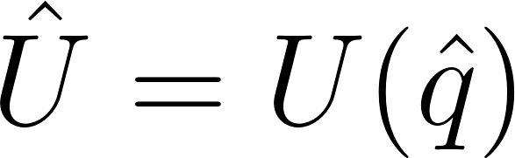 is not compatible with one using an interaction operator 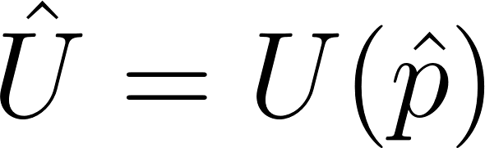.

The entropy of black holes gives a partly similar, partly different picture. Nobody currently knows whether the Bekenstein-Hawking entropy gives us what is realized in nature, because an experimental test is not feasible. In the simplest case of a Schwarzschild black hole it gives us
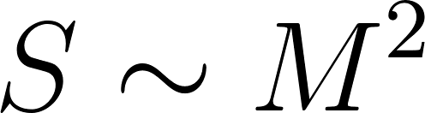 or 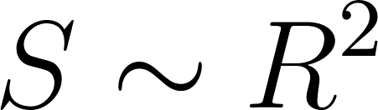 or 
where M is the mass of the black hole, R the Schwarzschild radius of the horizon and A its surface area. Again a separated space - separated in thoughts, there is no wall at the horizon though some bring a firewall into the game - gets a finite entropy despite the fact that any position coordinate can encode an infinite amount of information. Again a non-absolute division of a continuum - here the spacetime - is achieved by considering quantum effects: the Compton wavelength of a particle falling into a black hole. Interestingly Bekensteins original work from 1973 mentions that if there wouldn’t be a quantum limit, the particle’s gravitational radius would be limiting. General relativity can bring us finite information without the help of quantum mechanics.

In quantum mechanics a mixed state of the world would mean a new postulate. Where should it come from? However mixed states are popular in physics because they often deliver the correct results. For simplicity they mostly are explained by “classical noise” entering a quantum experiment “somehow”.
In quantum theory any entropy must be explained by the von Neumann entropy of an entangled state, i.e. by
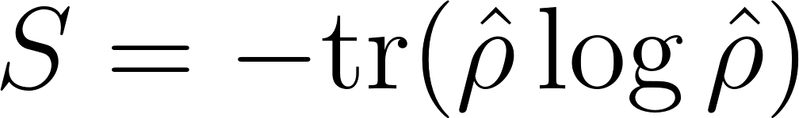
where 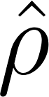 is the reduced density operator.

The Bekenstein-Hawking entropy is strange for several reasons that shall not be discussed here. But at this point we have the second strong hint that nature delivers us information in an absolute measure. And the process how information is delivered are the quantum processes described above.

No Continuum?
When functions of space or momentum or energy appear in quantum theory, they always mean components of abstract Hilbert space vectors in a chosen basis. They have no meaning a priori. For example you can think of space coordinates as indices of a very long n-tuple. Then a complex function of a space coordinate can be approximated by a long n-tuple

Physicists believe that the space-time continuum must break down somewhere at the Planck scale. The Planck length is around  and the Planck time 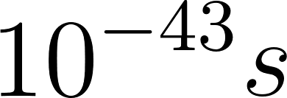. Imagine the indices would enumerate such very small Planck units. Then the size of the universe would limit the length of our n-tuples. Or the other way round: the lengths of n-tuples give us the size of our universe.
However in Hilbert space dimensions are not ordered per se. So the question is what orders indices in certain bases and therefore gives sense to statements like “this event happened near that one and soon after”? This additional structure is modelled as Hamiltonian operators in non-relativistic quantum theory. The matrix elements of an operator in a certain basis may strongly connect certain indices and weakly most of the other indices. So the operator may lead to an emergence of ordered index chains and thereby to pseudo continuous quantities like space, momentum and energy.
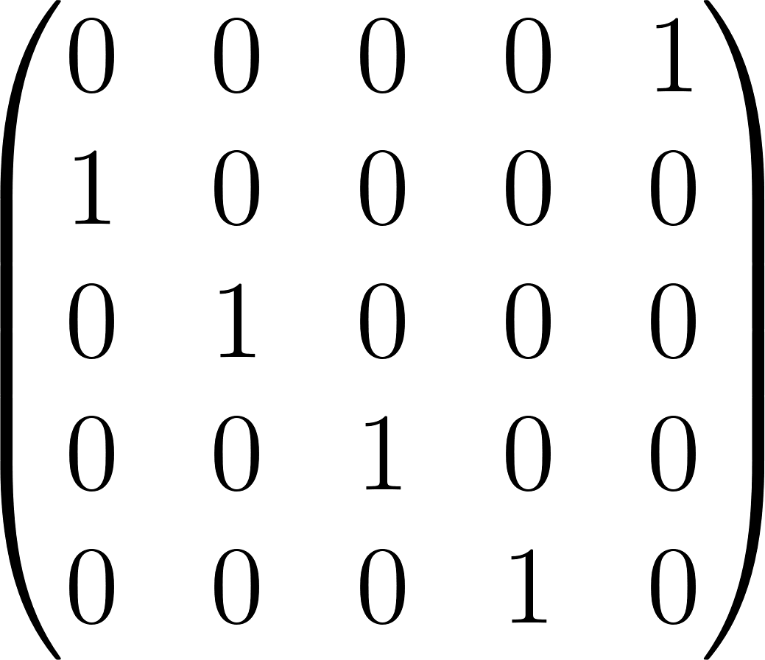
can be seen as the matrix representation of an operator in a basis, where it connects adjacent indices cyclically thus leading to a position-like variable.

The Role of Time
Clearly in relativistic physics space and time have no different quality and are transformed into each other by a change of the viewpoint or the metrics, for example by a Lorentz boost. Same applies for energy and momentum. All continuous quantities of relativistic physics could emerge as described above from an unordered fine graining with the help of ordering operators.
In quantum theory space, momentum and energy are only some of an infinite number of equivalent bases. Time and space are paired by relativistic physics in the same way as energy and momentum are, and the energy-time relation is similar to the momentum-space relation. Therefore in relativistic quantum theory time must be (or contribute to) a basis equivalent to all others. While time played a special role in classical mechanics, non-relativistic quantum theory and thermodynamics, it can’t do so any longer in relativistic physics, which includes relativistic quantum theory, which is the most accurate description of nature that we possess.
Very obviously time plays a special role in the world where human observers live. This is the reason why time has a special role in the older physical theories. The psychological time has a direction and the most famous equation with a direction of time is the phenomenological law of classical thermodynamics 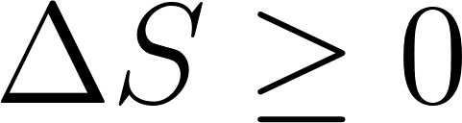 or
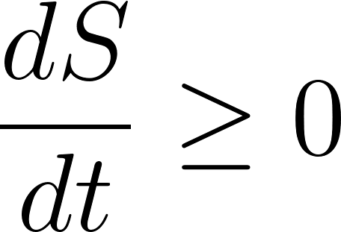
There have been many attempts to derive this phenomenological law from more fundamental theories. However they all failed, and the reason is that all proven physical theories contain some type of T-symmetry, meaning that moving into the past is possible in the same way as moving into the future. Boltzmann’s H-theorem cannot be derived without an additional T-asymmetric postulate that is not part of statistical mechanics. A very exact investigation about the physical basis of the direction of time can be read in Dieter Zeh’s book.
The contradiction between directionless physical time (similar to space) and directed psychological time must be taken seriously. While there are attempts to make the direction of time physical, a physicist normally will feel uncomfortable with the idea of breaking space-time or energy-time relations that way. But where is the way out of the contradiction?
The way out could be keeping both, i.e. a physical time related to space and energy and therefore having no direction, and a directed psychological time related to consciousness.

Information and Meaning
The information content of a message 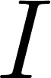 is related to the number  of distinguishable modifications it can cause in a receiver
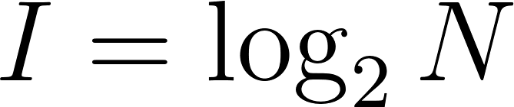
At first it depends on the message and the receiver.
Physically a message is a state vector in some subspace. A qubit, the most simple Hilbert space, can deliver a maximum of 1 classical bit of information to an observer after a “measurement”. A continuous Hilbert space can deliver an infinite amount of classical information, for example about the [continuous] position (x,y,z) of a “particle”. If there shall be an absolute measure of information in nature as implied by the thermodynamic and Bekenstein-Hawking entropies, there can’t be a continuum. If there were a continuum in nature, any finite measure of information would require a cultural agreement between sender and receiver on how to separate the continuous message into a finite number of parts. But without a continuum information gets the chance to become a purely physical concept.

Meaning is the concrete change in a receiver that is caused by a message. There is no meaning in any message, because the receiver is not part of the message by definition. In quantum theory the message therefore is a message only as long as it is not entangled with the receiver. With the entanglement the message loses its existence.
There is no meaning in any information. There is no meaning in this text. There is no text here. Rather you only see some dark and bright pixels on a computer screen. But there are no pixels at all. Rather there are crystals emitting light in different ways. But there are no crystals. Rather there are electromagnetic and lepton fields. But there are no fields, … and so on.
All our physical theories contain and relate mathematical symbols. They work if used by people who “understand” them. Without the people they mean nothing. Already in classical mechanics space and momentum can be exchanged by canonical transformations. The descriptions of nature in many pictures are mathematically equivalent. But which is the “right” picture?
With the additional relations between indices that come from the introduction of operators in Hilbert space pseudo continuous variables may emerge. But which of these variables is an energy and which a particle position? This question cannot be answered without the receiver. Energies and particle positions appear as such not before state changes of a conscious observer that is coupled to the Hilbert space.

Only Process 1
Is there something special of the jump destination of process type 1 which is related to consciousness? First of all it is a Hilbert space vector like all others. So why jump there and not anywhere else, for example onto a state
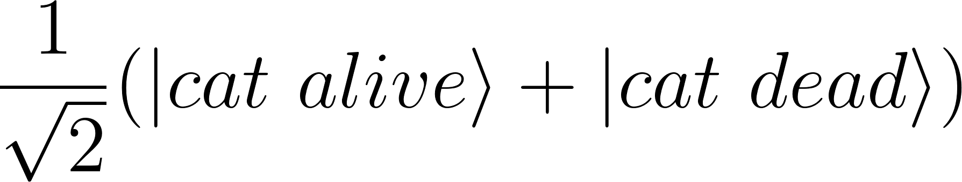
The difference arises when we cut out a subspace of the Hilbert space. Suddenly there are world vectors that look like a mixed state (a density operator) in the subspace, and few others that are pure in the subspace, i.e. they are a product of a vector in the subspace and another vector in the rest of the world. The jump destination is always a pure state. But why should we separate the Hilbert space exactly in that way and not in any other of the infinite many ways? The reason may be, that consciousness includes a certain separation. Hilbert space separation is a property of a conscious entity.
What is really strange in quantum theory is the existence of 2 process types and the unanswered question of why and when they alternate. While the many worlds (or many minds) interpretation denies the existence of type 1, we try to get rid of type 2. This means the continuous evolution of the world state vector actually shall be a sequence of fine jumps. Thus we get a non-linear stochastical collapse theory. Bassi and Ghirardi state, that non-linearity implies randomness and vice versa. We already discussed that there are only short distances in a high dimensional space. A Schrödinger equation could be seen as a differential equation of macroscopic variables like the heat equation 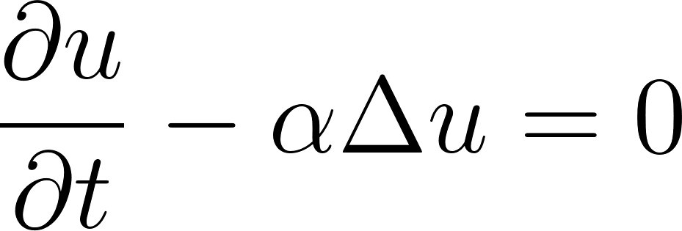. The apparent smooth motion of the probability amplitude could be the result of a stochastic process of fine jumps. The overwhelming amount of dimensions would not be reflected by the simple macroscopic equation.
But now we are facing a new old problem. Why are there 2 alternating process types, i.e. a process type 1 related to a conscious entity and a process type 1 unrelated to any consciousness? We can choose a similar way out as in the many minds interpretation: There are no unconscious jumps, every change of the world’s state enters some conscious entity.
This last postulate might look monstrous at a first glance. But in fact it is only the extrapolation of an epistemology on a path which has been directed by modern science. The main reason why we did not recognize other conscious entities in the past has always been the lack of communication channels. Science gave us more channels, and at least apes, dogs and perhaps worms, plants and forests must be regarded as conscious entities. Of course it is still a long journey to a world of myriads of conscious entities wrapping subspaces of qubits.
Interestingly psychologists have theories of perception that resemble the consequences we are faced to after getting rid of process type 2 in physics:
- the world contains conscious entities, called conscious agents.
- the combination of 2 conscious agents is again a conscious agent. Its state space is the product space of the individual agent’s spaces - just as for Hilbert spaces in quantum theory.
- a conscious agent sees the world through an interface (remember our subspace separation). It can by no means find out whether its perceptions are caused by other conscious agents or by an external [material] world. The more simple model that survives Occam’s razor is a network of conscious agents without material world.
- a conscious agent has its own proper time (eigenzeit), a time with a direction.

What is new with this idea?
In 2003 Bassi and Ghirardi gave an overview of attempts to solve the measurement problem:
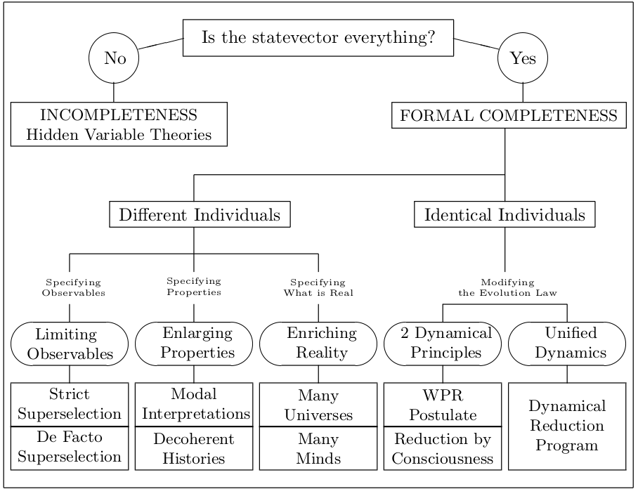
Some aspects of this idea already appear in other attempts, but this idea cannot be filed into the figure because it claims:
- The state vector is not everything. There are different reasons for that. First the state vectors in our current equations might not be Dirac vectors. The continuum might be the apparently smooth and simple result of a rich underlying and still unknown structure. Second it has not a direction in time. Third it does not describe conscious perception, will, joy and pain.
- There are many minds, but not because of formal completeness and the Schrödinger dynamics.
- “Jump” is by consciousness. “Jump” is a more adequate expression than “reduction” because of the basis ambiguity.
- There is 1 dynamical principle, but no continuous one.
- The dynamics are non-linear and apparently stochastical. The randomness might be the result of randomly acting minds, which individually follow more deterministic/causal strategies.
Normally the state of the brain is supposed to be or at least largely corresponds to the state of a mind, of one mind. And the state of a second brain should correspond to the state of a second mind. Therefore in quantum models that state of mind is often shown as [reduced] density operator or even as state vector.
While a density operator might be an adequate description of a brain, it is not so for a mind. There is no state of mind living in a subspace. There is only 1 state vector, and this 1 state vector is the state of all brains together.
There are many different views onto the common state. Perception occurs along a split of the whole configuration space and is strongly related to changes of entanglement, that can be experienced on this conscious split. From the infinite number of bases for the whole space the split emphasizes such, that can be built from products of subspace base vectors.

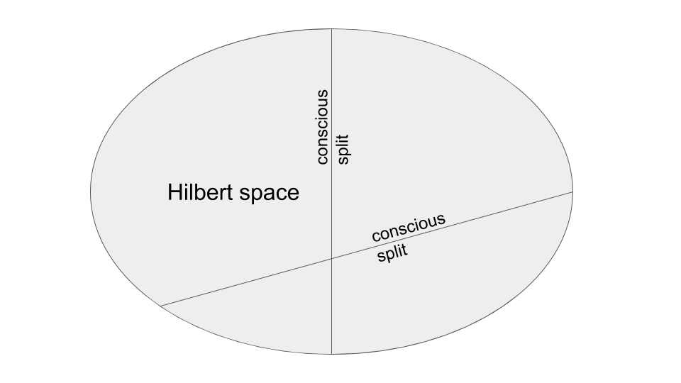
Such splits do not split the space like sharing a cake. Rather they draw ’s out of it.

The world state vector together with a conscious split separating the Hilbert space are sufficient to uniquely define a Schmidt decomposition (for the degenerate case see appendix) of the state vector
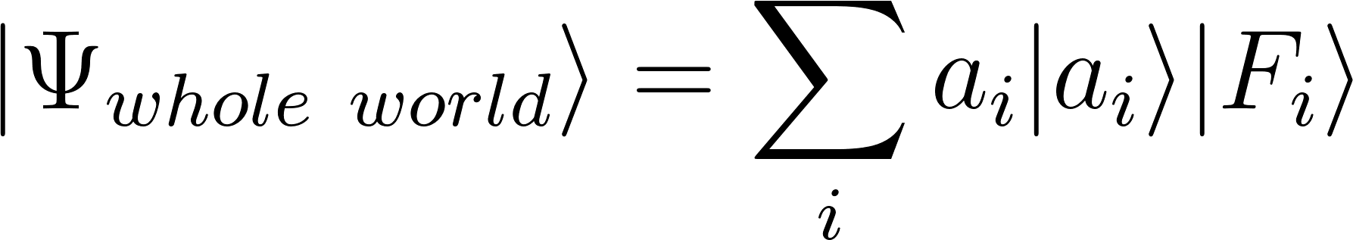
The unique  deliver the classical probabilities for the outcomes that are chosen by accident - or by the conscious split enriched with some 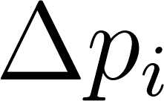 representing its will.

The requirement that a Hilbert space shall contain conscious splits excludes prime numbers from the set of possible dimensions for Hilbert spaces. The space must be separable into at least 2 parts. The dimension of each part must be > 1, because the product space of a Hilbert space with a one dimensional space would be itself. Thus the smallest possible space with conscious splits is four-dimensional.

A split that separates the space into a qubit and a bigger rest will in general perceive only few changes of the Schmidt decomposition caused by jumps of the state vector. The dimension of the smaller part is therefore a measure for the possible richness of perceptions, and of course it determines the maximum possible entanglement entropy at the same time.
If there should be a will that plays a role in jumping from an entangled state (as observed from the perspective of a conscious split) to one of the offered outcomes, the dimension of the smaller part would be a measure for its might.

Chances and Challenges
Concerning the mind body problem most scientists still seem to hope that someday science can explain how the mind is generated by a configuration of matter. Recognizing consciousness as primary ontic entity saves us from this task. Putting it everywhere saves us from the need to explain how it gets localized in position space. There is the chance to connect physics to psychology, where models for will, pain and joy exist already, thus ending the dualism of mind and matter. Philosophers always told us that you may deny the existence of matter, but you can’t deny the existence of a mind that experiences its own being (“cogito ergo sum”).
Introducing “hidden variables” for the psychological times could help to understand why the second law of thermodynamics is working in practice. The jumps end on a product state (for those conscious entities that perceive the jump) with an entanglement entropy of 0. Starting from there entanglement can only grow like thermodynamic entropy.
The big challenge is the development of a microscopic theory which reproduces current quantum theory as macroscopic theory. The idea is not new and has first been picked up by von Weizsäcker et al. and called Ur theory.
Omitting process type 2 has also experimental consequences. Whenever there are several observers observing the same von Neumann chains, they must jump together [simultaneous in the non-relativistic limit]. A measurement of “is he in a superposition?” in an appropriate measurement basis must always lead to the outcome “no”.

Emergence of Time
Time evolution in non-relativistic quantum mechanics is simple. A closed world has a Hamiltonian that is not explicitly time dependent. Therefore any whole-world Schrödinger equation can be integrated at once.
On the right hand side the Planck constant has been absorbed into energy and time so that only dimensionless parameters are left. The common non-relativistic time t can now be interpreted as emerging from a big number n of equal unitary jumps. The unitary jumps in turn could have jitter, i.e. not each  is equal, rather
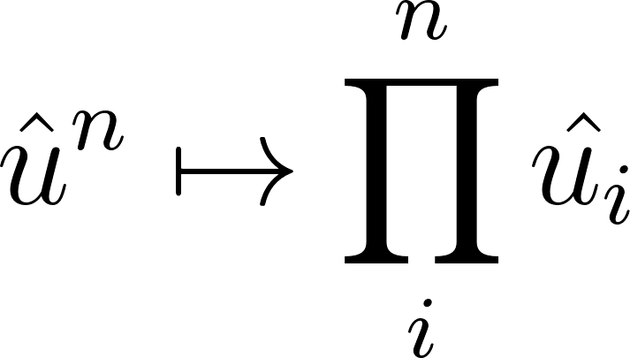
Since
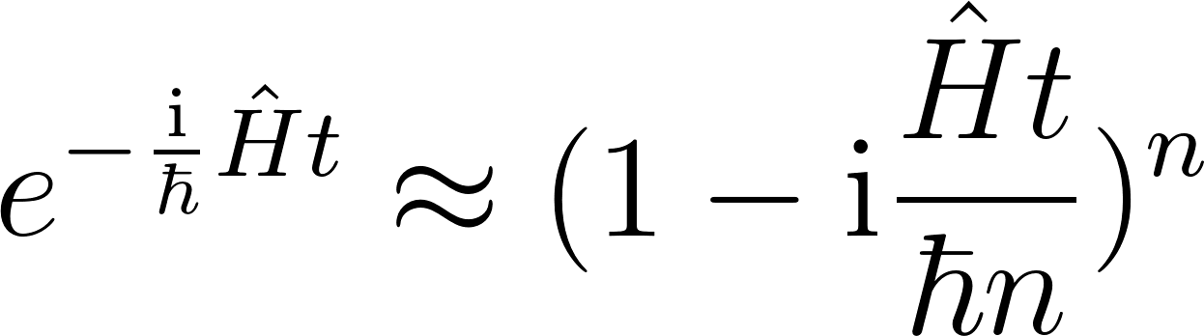
with the choice of 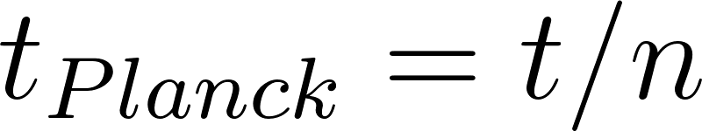 as elementary unit of time we arrive at
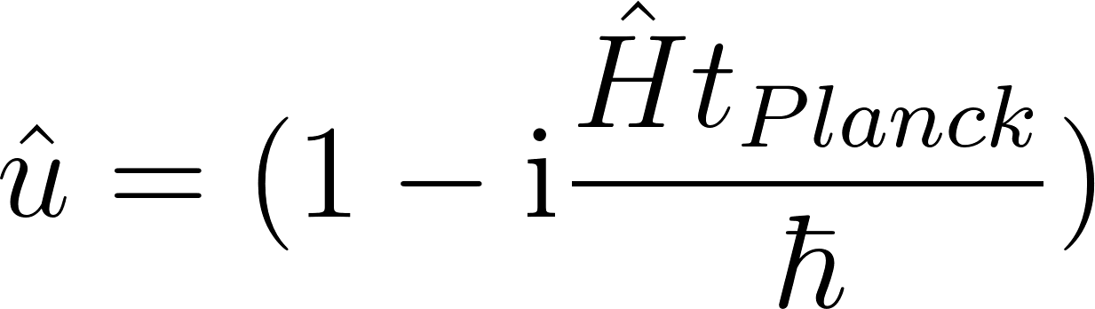
The smallest time that can be measured in 2018 is 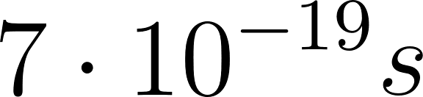, while the Planck time is 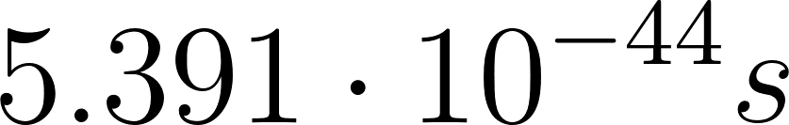. This would mean the smallest change we can observe is the result of 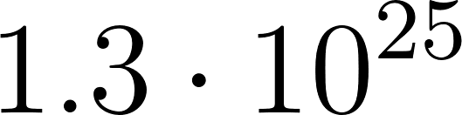 jumps of the state vector.

Is there a chance to observe the difference from Schrödinger dynamics? We set
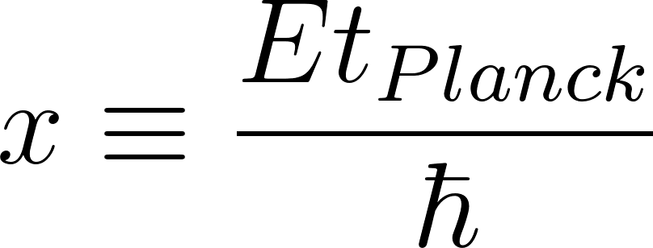
where E shall be any eigenvalue of the Hamiltonian. The more x differs from 0, the bigger the difference between the exponential function 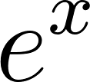 and the approximation 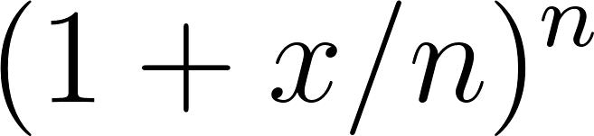 is.

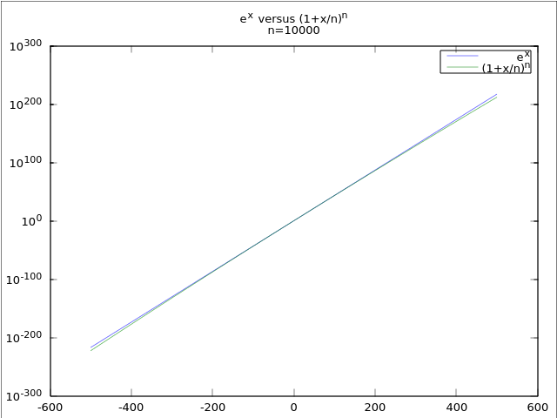

The relative error
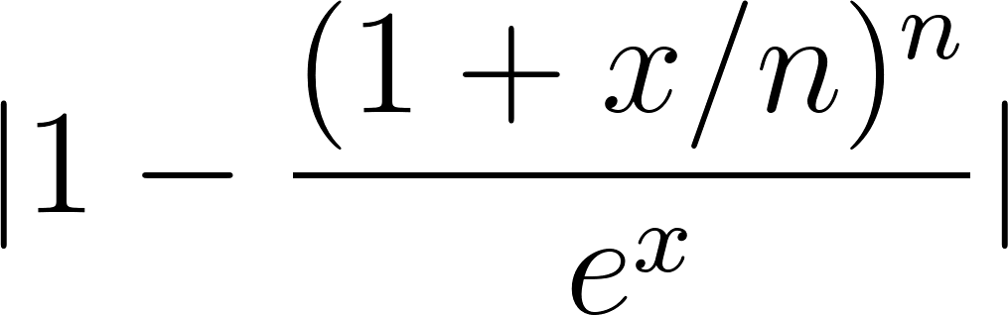
quickly increases when leaving the origin.

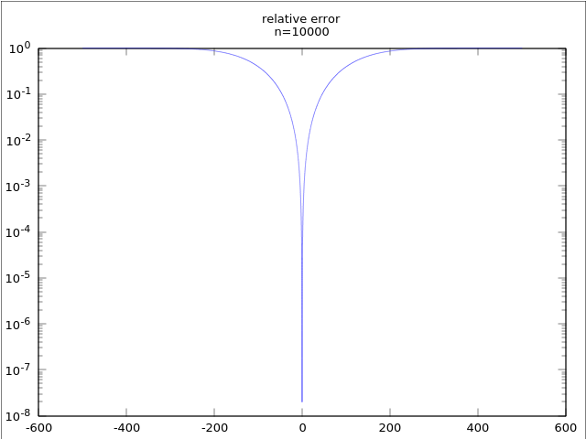

However energy eigenvalues of quantum systems are small. Even 1 TeV means 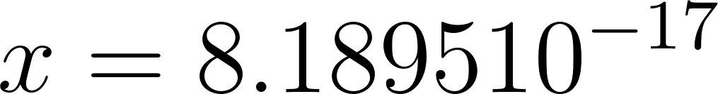.
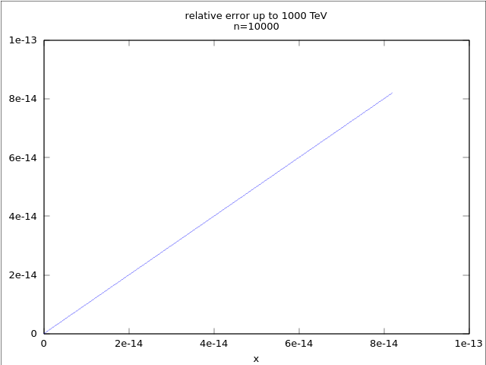

The very accurate electron g-factor measurement has a relative error of around 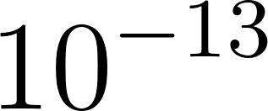. However n is very big, not only 10000 as in the diagrams. So there is no chance to detect a deviation, if the 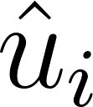 are chosen appropriately. But of course nature needs not to choose them in a way to reproduce Schrödinger dynamics as accurate as possible.

How to Split a Hilbert Space?
This is not an easy task! Combining 2 quantum things is easy. You build tensor products of their vectors and tensor products of their operators and take them and their linear superpositions as new vectors and operators resp. in the product space.
However if you start with the product space, for example the whole world, how could you find parts therein? The strict answer is: generally you can’t! Combining quantum things is sort of one-way street. In all real cases there will be a non-zero interaction Hamiltonian 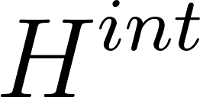, and as soon as there is one it will not be possible to find a basis where the Hamiltonian gets the shape
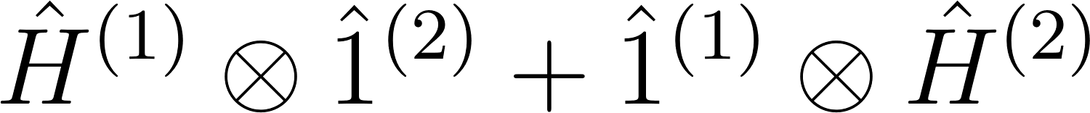
which would tell you exactly which the parts are - for the time evolution see appendix. However you can still try to solve a non-trivial minimum value problem:
- Start with your initial basis,
- then find a transformation to a new basis and in the new basis
- find an index map  making two indices (i,k) out of one (m) so that you get a Hamiltonian with matrix elements looking like
with a minimum interaction Hamiltonian
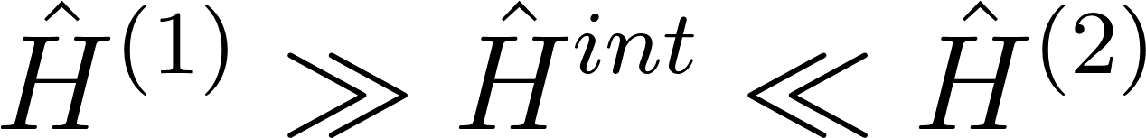.

But our task will not be to solve such minimum value problems. We need to find a unique method to split a given Hilbert space in several ways. Herefore
- we start with an arbitrary basis. We have no Hamiltonian, therefore our Hilbert space is fully symmetric without any structure. On the contrary: we want to re-construct Hamiltonians from interacting conscious splits.
- We define a convention how a split is defined by the choice of a basis.
- We may add more splits: choose another basis. The new basis is given by the choice of a unitary transformation U transforming the first basis into the new one. With the same convention as above the new basis uniquely defines a second split.
- And so on.

Convention How to Split
We start with an arbitrary basis and enumerate the basis vectors with 0..3. Then we define the index map as usual in quantum information theory
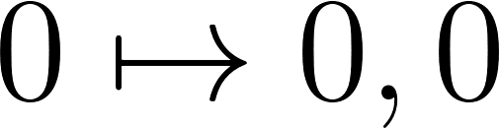
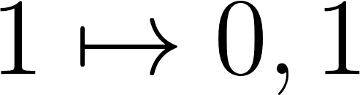
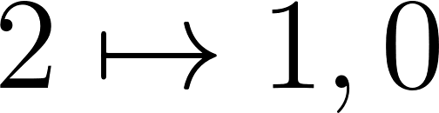
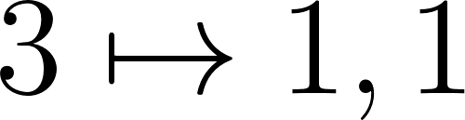
thus defining subspace vectors and so on.
For space dimensions containing only 2 prime factors this will keep working with the additional convention that the smaller space shall enumerate the higher digit. Split a 6-dimensional space like this:
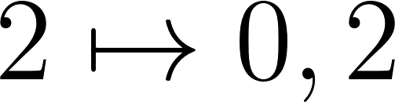
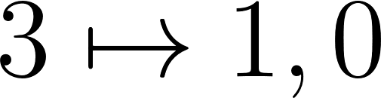
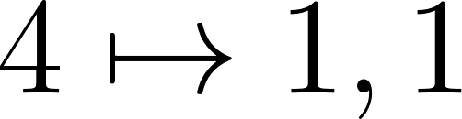
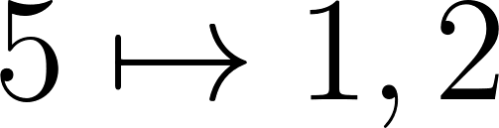
For space dimensions consisting of 3 and more prime factors more conventions must be defined.

2 Qubits Space
A space of 2 qubits is the smallest space with vectors that can appear entangled. According to our convention how to split a Hilbert space any Schmidt vector will have the following components in the basis defining the split
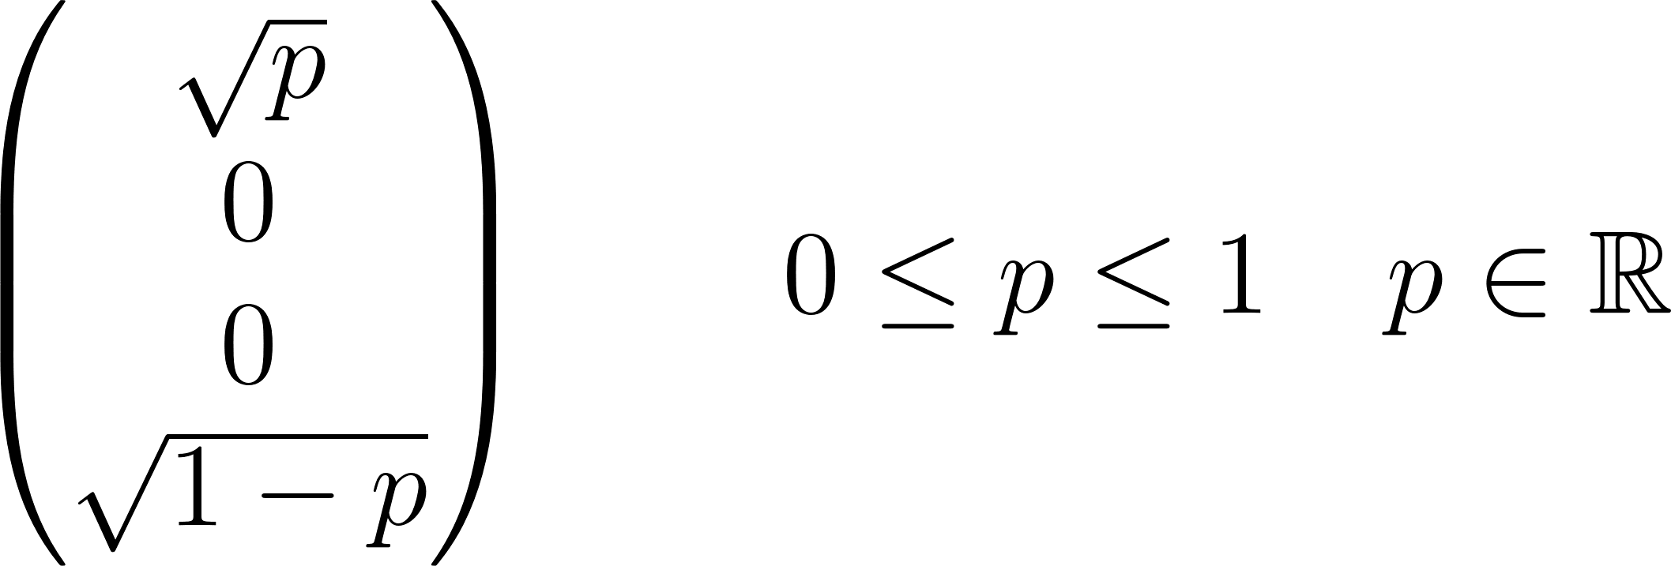
with p and (1 - p) being the probabilities for the 2 different qubit “measurement” outcomes. These components mean the vector
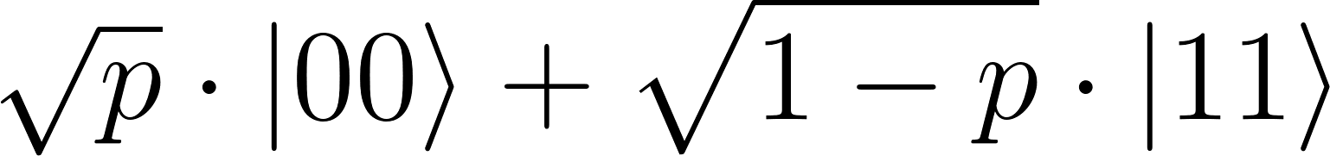
in the Schmidt basis.
In general a vector has the components
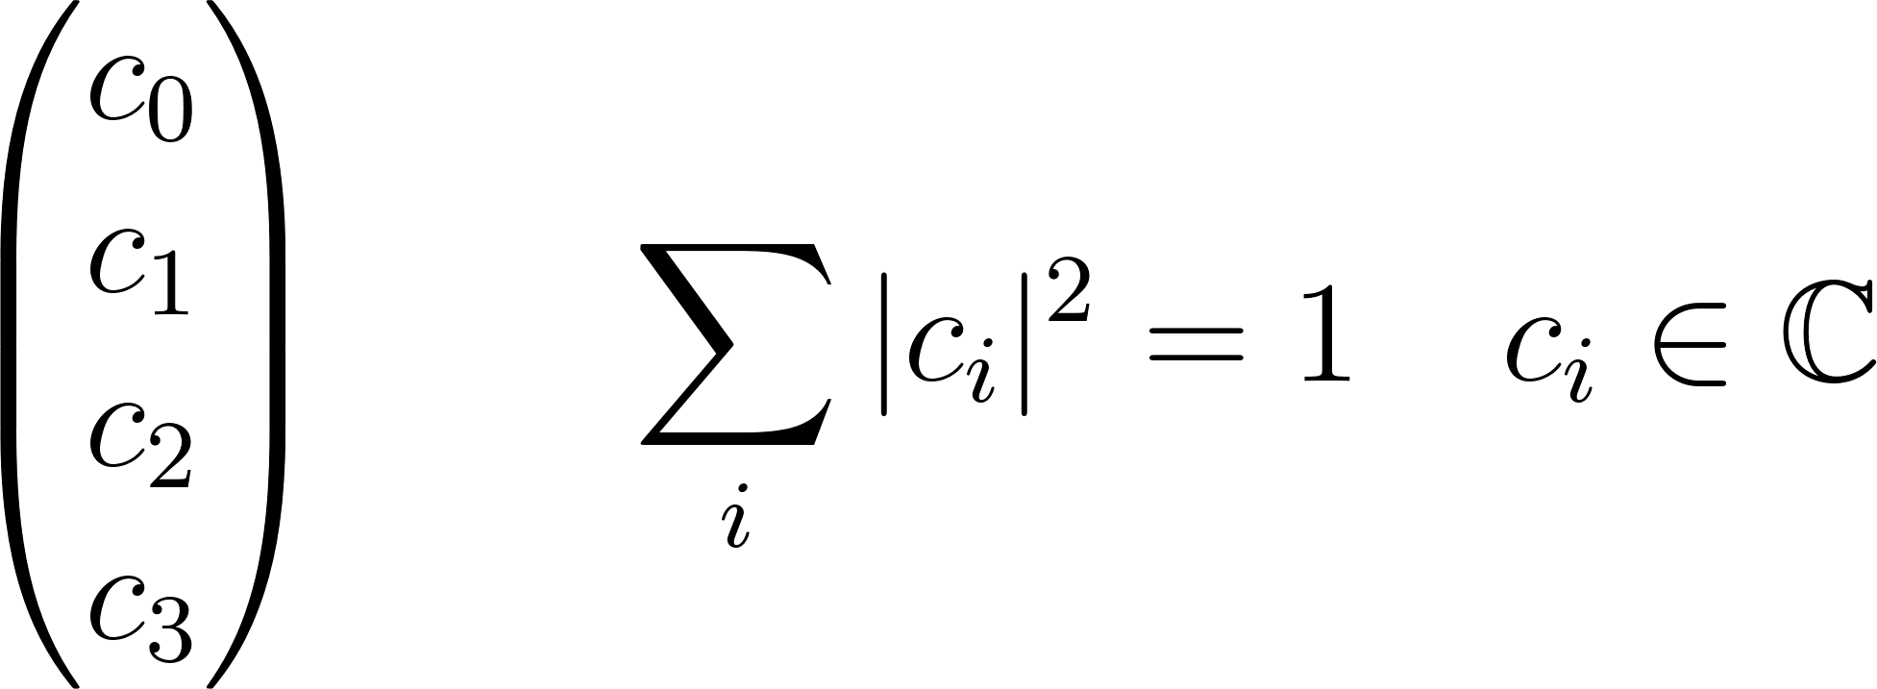
in a given basis. The task to find the Schmidt decomposition is the task to find 2 SU(2) rotations in the 2 subspaces defined by the basis, so that the total transformation in the 2 qubits space transforms the general vector into the Schmidt form. The general vector has 7 degrees of freedom (real numbers), the 2 SU(2) rotations together have 6 degrees of freedom leaving the 1 degree of freedom .

Consider 2 bases in this space. Let us call the first one the 10 basis. Its orthonormal base vectors we name 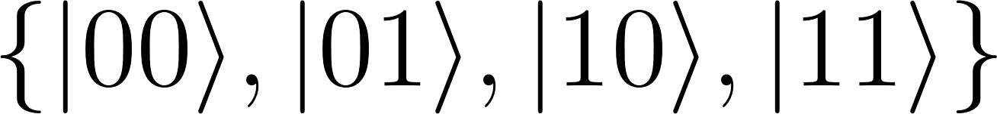. The second base we call the +- basis with base vectors . The unitary transformation that transforms us one base into the other shall be U.
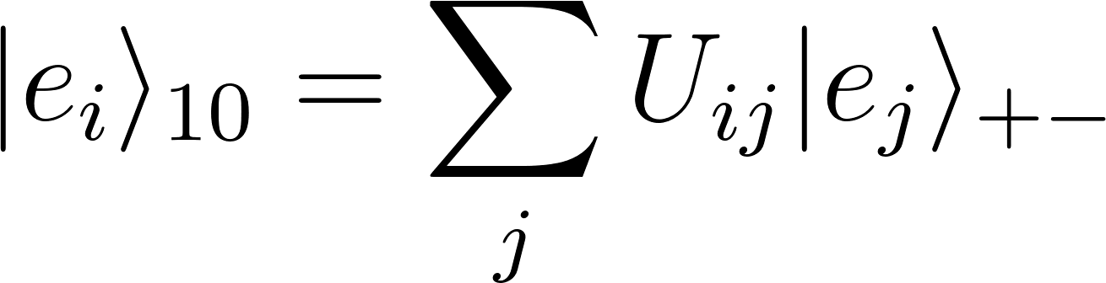
Base vectors of the +- basis shall be entangled in the 10 view and vice versa. For example these 2 orthonormal vectors
are entangled in the 10 view and not entangled in the +- view. We assume 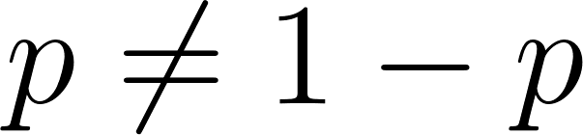 to avoid degeneracy.

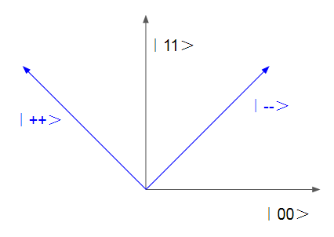
Having these 4 vectors in 1 “paper” plane means a special choice of the bases. Every real linear combination of these vectors is already a Schmidt vector from the viewpoints of the 10 basis and of the +- basis thus saving ourselves the trouble of finding out Schmidt decompositions.

We want a rotation of the state vector approximated by jumps. There shall be 2 conscious splits in the 2 qubit space corresponding to the 2 views. I.e. the 10 split shall separate the whole space into 2 parts labeled (1) and (2), so that 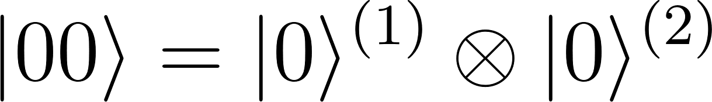, and the +- split shall separate the space into 2 different parts labeled (3) and (4), so that 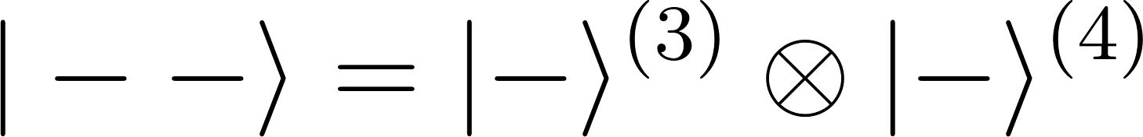.
Assume the initial state vector is 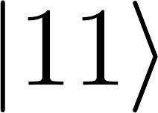. The 10 split sees an unentangled vector. To reproduce the Born rule the probability to change the state into must be 1 and the probability for the outcome 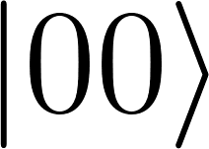 must be 0. The 10 split thus will not change this state vector. But since the Schmidt decomposition is
in the +- view, the +- split sees entanglement. With probabilities p and 1-p one of the outcomes 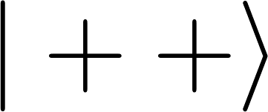 and 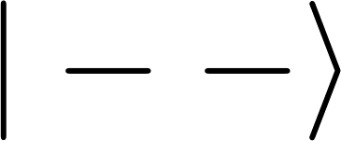 is selected when this split perceives. After perception the situation is inverted: the +- split will not change the state while perception in the 10 split will change it. The 2 conscious splits drive the state vector forever. However the movement will resemble more a Brownian motion than a rotation, because the probabilities for “forward” and “backward” jumps are equal. In this example the jump destination is always a base vector of the bases related to the conscious splits. Of course in general this must not be the case.
A rotation-like movement requires an internal state somewhere, a “hidden variable”, so that when the initial state has accidentally started a clockwise movement, the probability for further clockwise movement is higher and the probability for counter-clockwise movement is lower. This could be achieved for example by postulating:
After perception of a new [unentangled] state (after the jump), the probability for this jump destination is reduced by a hidden variable in the conscious split that has triggered the jump until the next jump to be triggered by this split.
At the moment it is not yet clear whether hidden variables are necessary to give psychological time a direction, because in relativistic theories the psychological time considered here will be different from physical times which should be ordered index chains like positions in space.

Energy
All jumps in the example
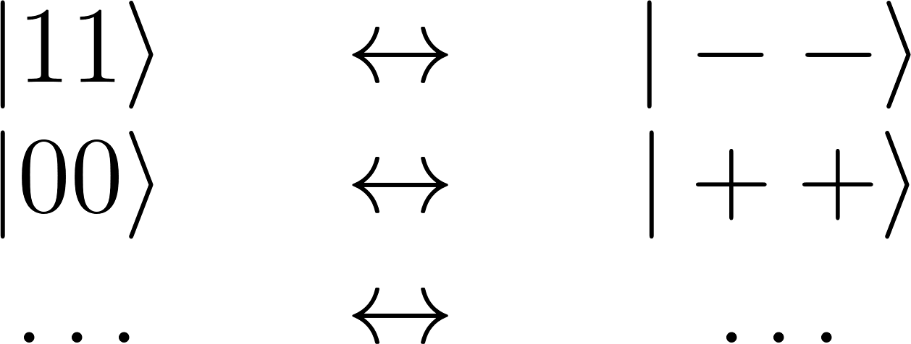
shall now be performed by the matrices
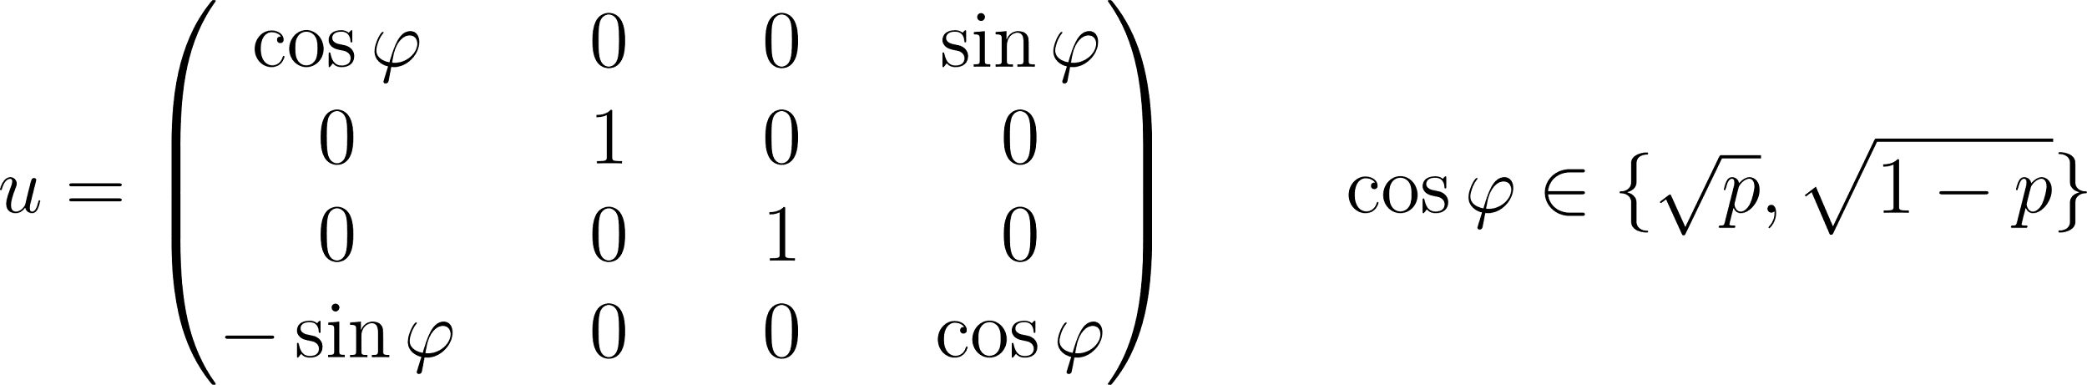
so that all jumps take place into the same direction. After every 8 jumps we arrive at the identical operation.  can be diagonalized to 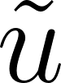 by another unitary matrix  and its inverse
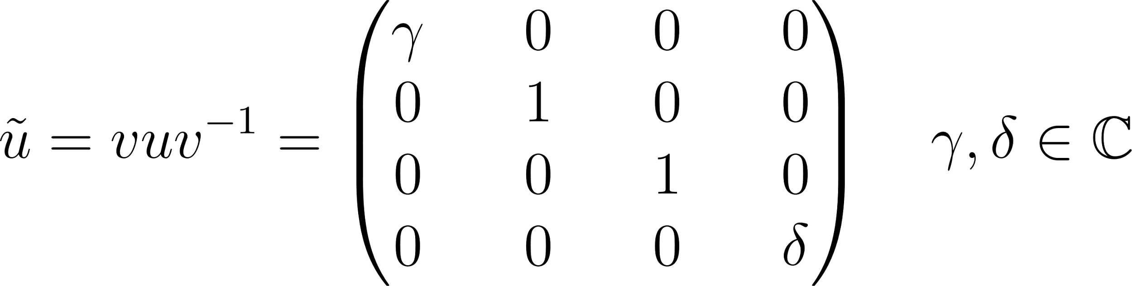
A general form of is
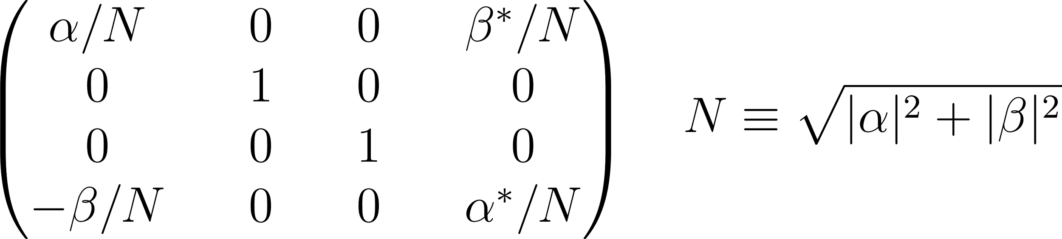
After a short calculation (appendix) we get
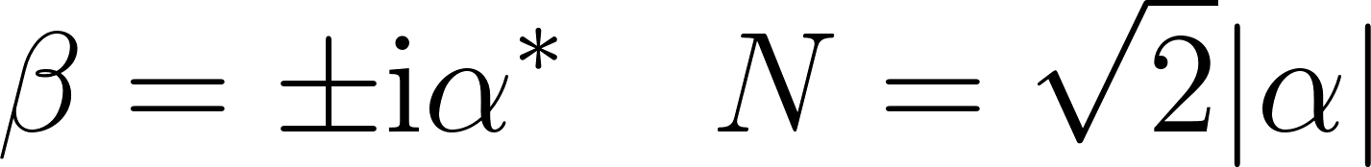
therefore when choosing the 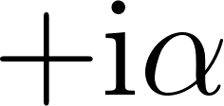 solution

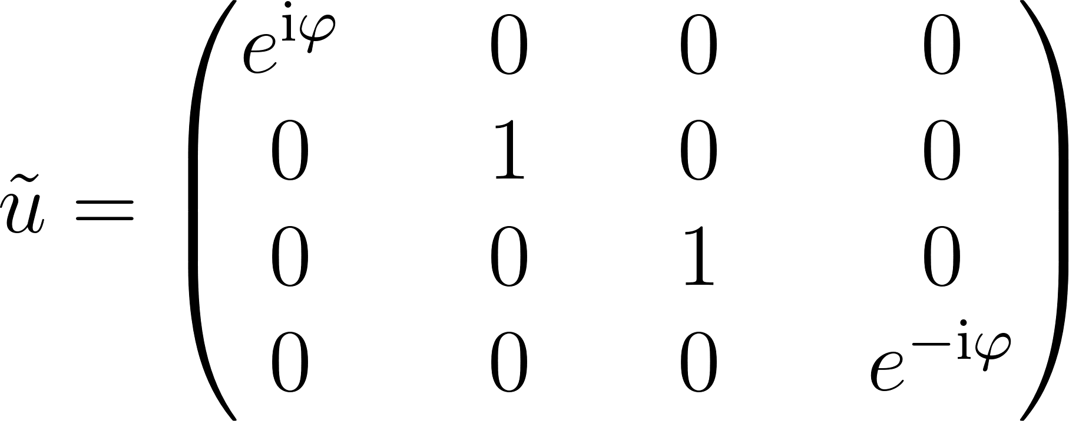
We define a Hermitian matrix 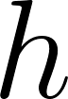 by
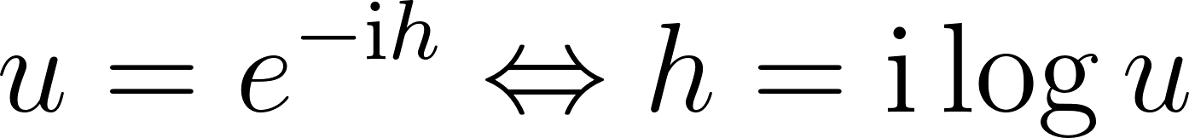
and get, because 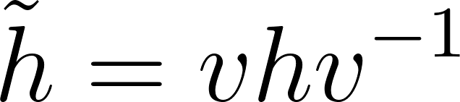
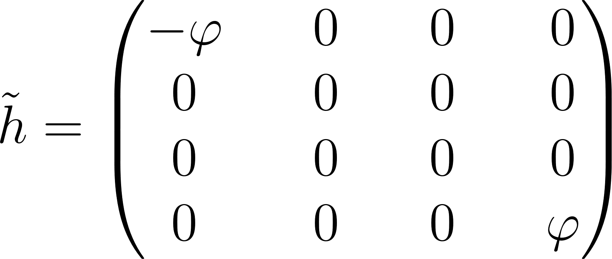
If a jump corresponds to the smallest perceivable time 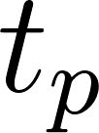, the fastest frequency  in the smallest separable Hilbert space, which can be achieved when all jumps always rotate in the same direction, is 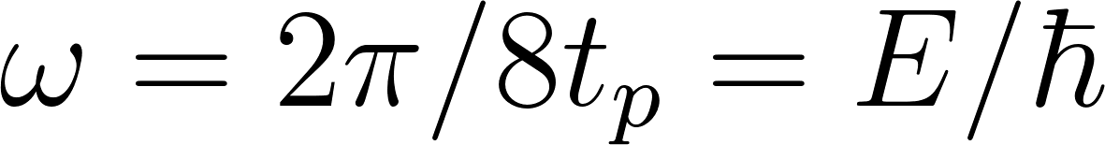. If would be the Planck time, the energy eigenvalue 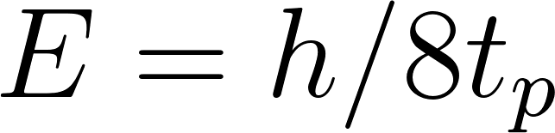 would be close to the Planck energy 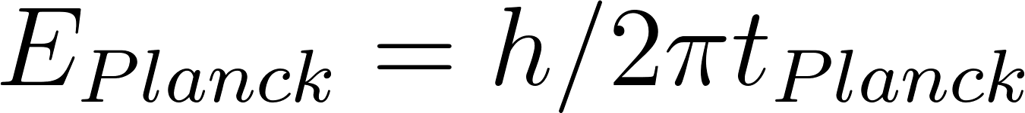. Lower frequencies may appear, if not all jumps go into the same direction or not all perceptions of your own conscious split go along with a jump of the state vector in the plane spanned by the 10 (and +-) bases. At this point there is still no explanation for energies higher than the Planck energy.

Of course we can introduce a second pair of splits driving the state vector in directions orthogonal to the ones above like this
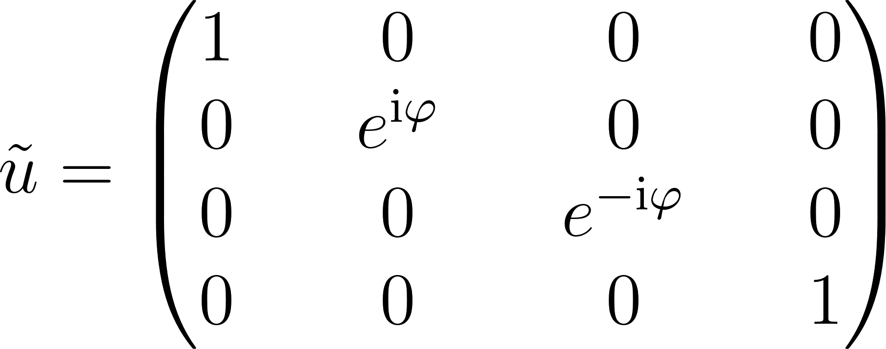
The speed could be different and therefore a different energy eigenvalue would appear.

Motion and The Emergence of Space
The free Schrödinger equation for one scalar “particle” in the correct non-relativistic approximation is
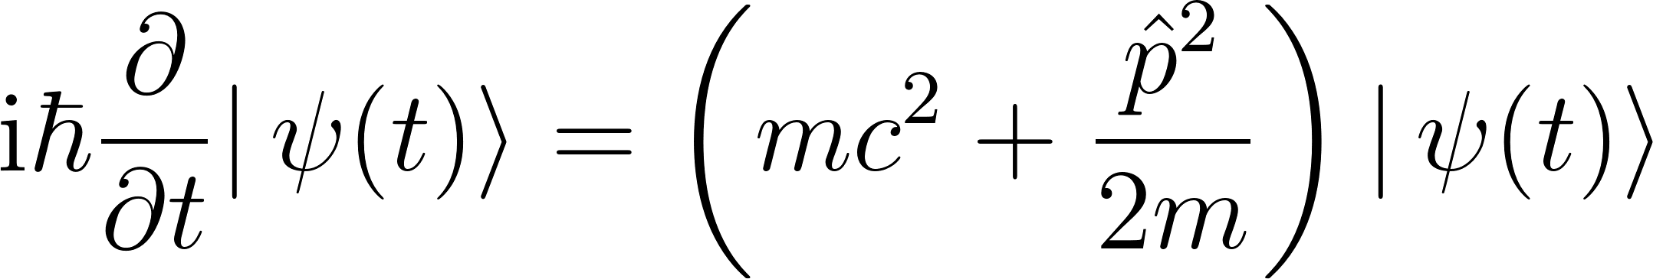
Energy and momentum operators have common eigenvectors, energy eigenvalues 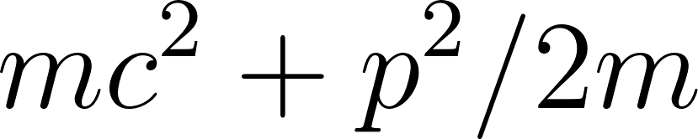 and momentum eigenvalues both are continuous. The matrix elements of the Hamiltonian in the energy basis are
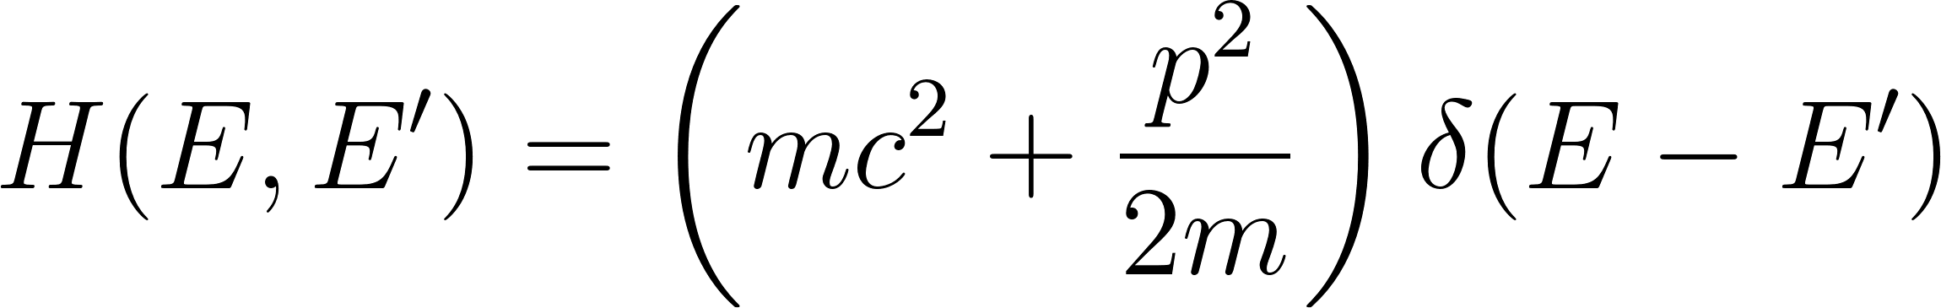
Leaving the continuum we arrive at the unitary diagonal matrix
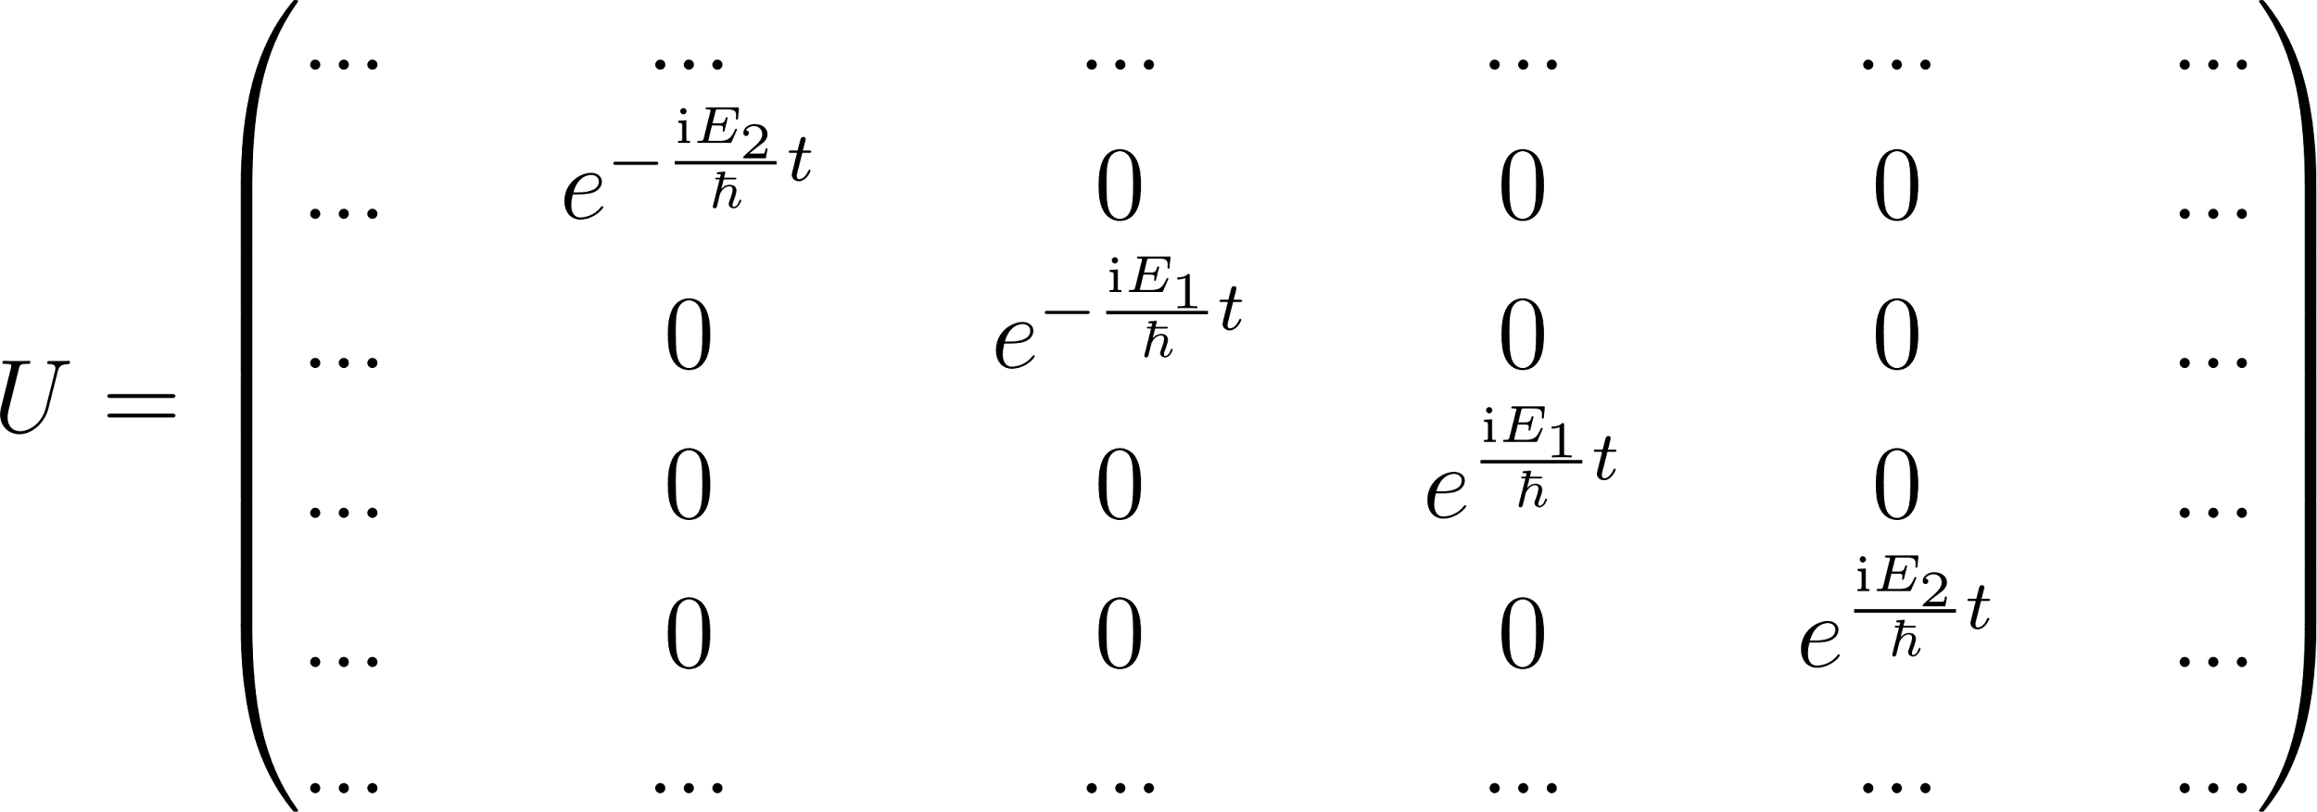
From relativistic physics we know that energy eigenvalues always occur pairwise, and therefore we have paired the positive energies with negative energies
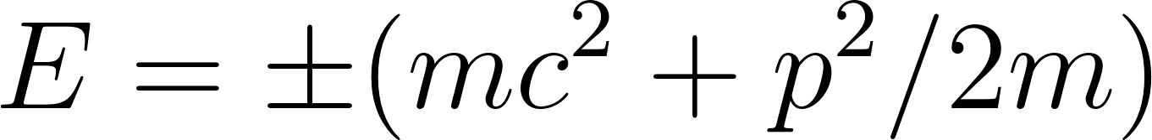
When comparing this matrix with the 2 qubits space we see the analogy: each pair of energy eigenvalues corresponds to a split orthogonal to all other ones, cutting out 2 qubits of the Hilbert space. There is no sort order of these qubit pairs up to now!

The next question is why this matrix should model a motion in space and not pairs of coupled spins or anything else. Every Hamilton operator corresponds to such a unitary diagonal matrix, except that we additionally request pairs. We know already that meaning arises in the receiver. If the receiver is a conscious split, its orientation will determine what can be perceived from the abstract structure defined by U. Therefore we expect that the commutation relation
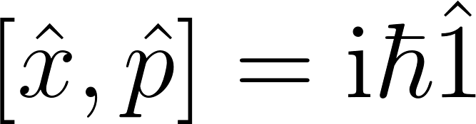
will lead us to those orientations of conscious splits that will perceive such U as motion in space. Now we need a little quantum mechanics in finite dimensions from the important 1976 paper of Santhanam and Tekumalla. In the following any equation numbers refer to their paper.
We start with the equidistant diagonal matrix elements of momentum in N dimensions with a smallest momentum unit . N is even.
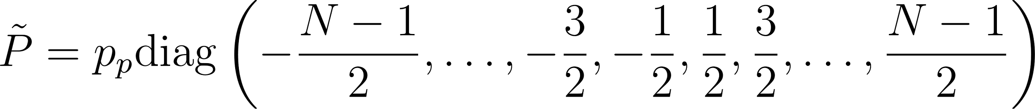

This P corresponds to a unitary matrix B
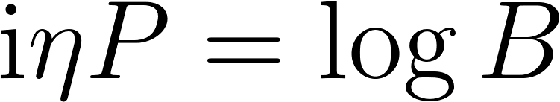 | (12) |  | (4) | 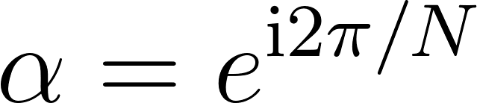
Instead of the paper’s  we write  and we start with B corresponding to momentum space, not position space. We get the matrix elements

and on the other hand

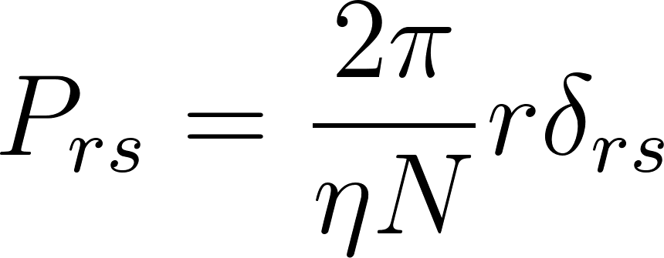 | (14)
We notice that the overhead  does not disturb when connecting to continuous quantum mechanics, because the commutator

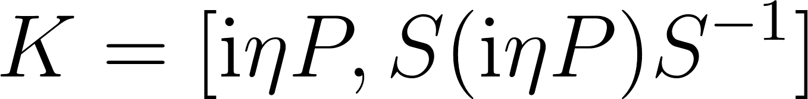 | (15)

remains unchanged when adding a multiple of the identity matrix to P, i.e. the results of the paper remain valid. When transforming to

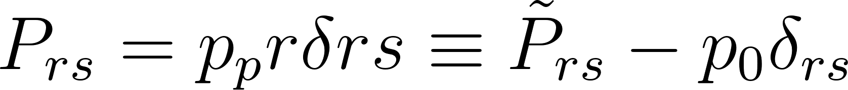
we therefore get the relation
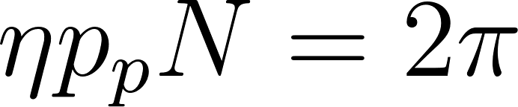

If this relation is fulfilled we can apply the Sylvester matrix S (9’) to transform to position space
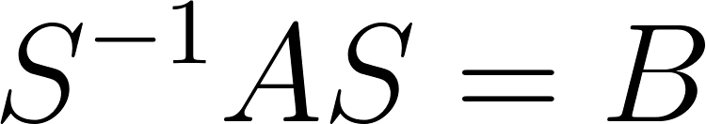 | (9)

And this gives us the trace free matrix A (“shift matrix”). A is connecting adjacent indices of space as we had postulated above.
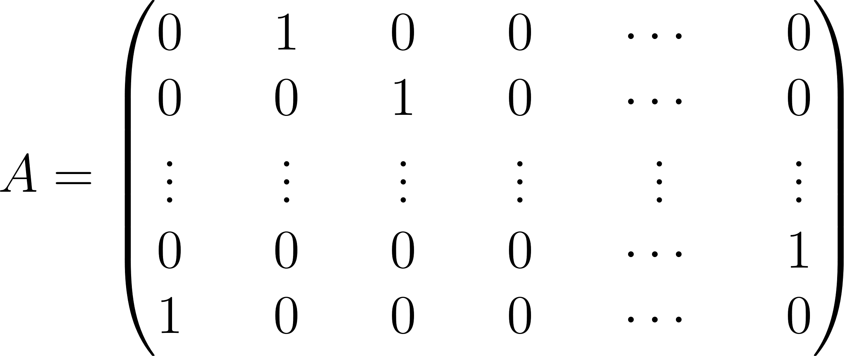 | (5)
The limit 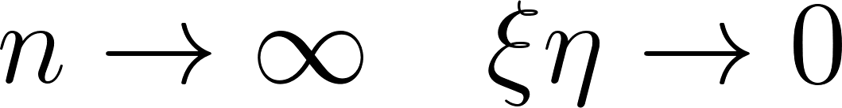 will lead to the Heisenberg commutation relation only if 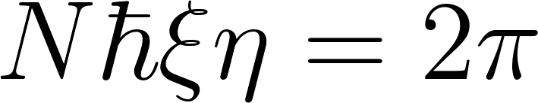. Therefore we must require
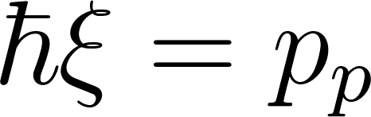
 is an inverse smallest length which we call 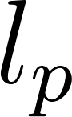 now. With this definition we have
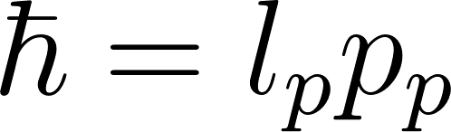
This equation connects a smallest length and smallest momentum with Planck’s constant. The smallest momentum is connected to a smallest frequency via the dispersion relation. The smallest frequency is related to the number of splits driving the motion in configuration space.
From decoherence theory we know that a strong interaction with the environment can shape the state vector and suppress interference terms in the position base. Therefore coupling the “particle” to the environment will lead to a state that is close to a Schmidt state from viewpoint of the position base. A conscious split oriented this way, i.e. rotated with the Sylvester matrix against the splits driving the free motion, therefore gets the possibility to perceive a particle at a position (appendix).

Compatibility of Observations
Consider one split defined by the fact that each Hilbert space vector is expressed as
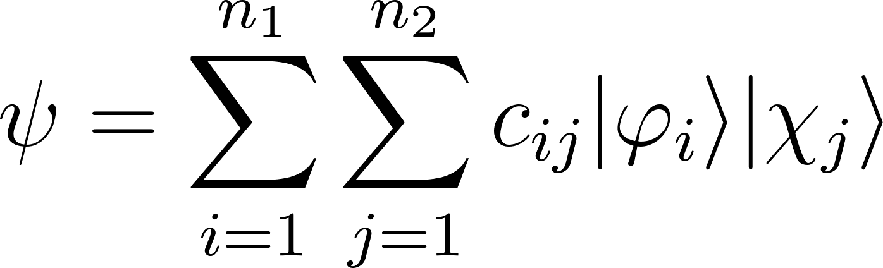
and a second split defined by the fact that each Hilbert space vector is expressed as
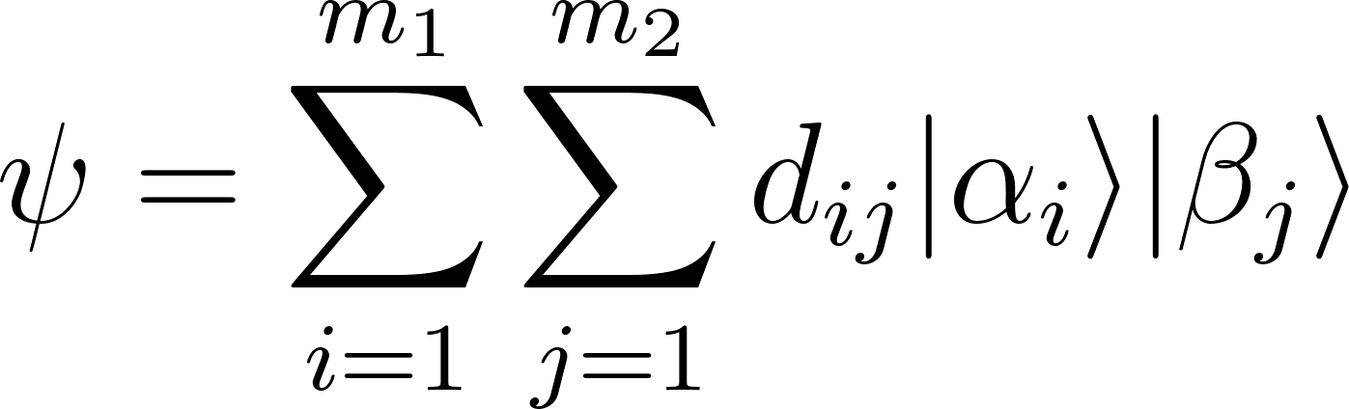
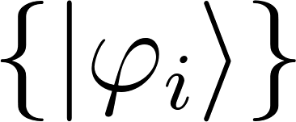, 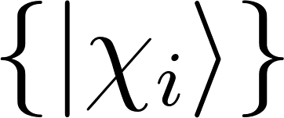, 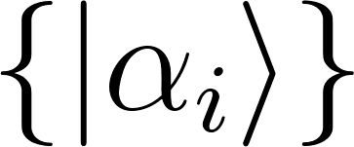, 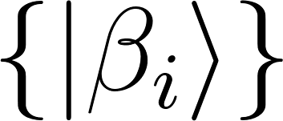 are the sets of basis vectors of the 4 subspaces. In general their dimensions can all be different but obey 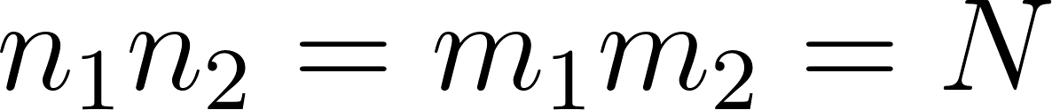with being the dimension of the whole Hilbert space. Now imagine that the subspaces can be split further, for simplicity we assume into qubits. The original splits above are compatible if it is possible to find a qubit basis 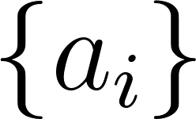 with dimension  so that

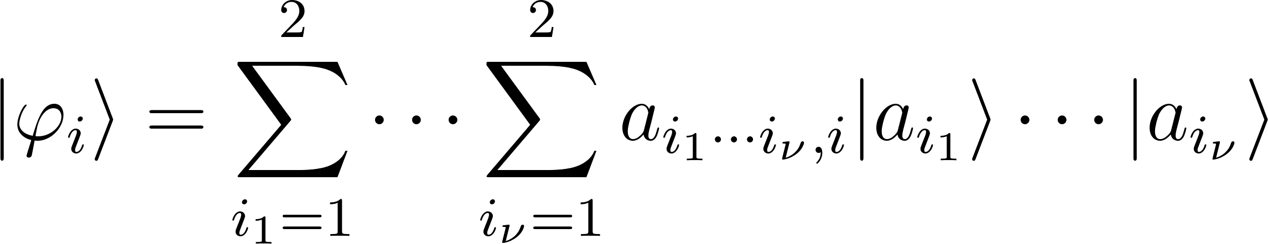
and
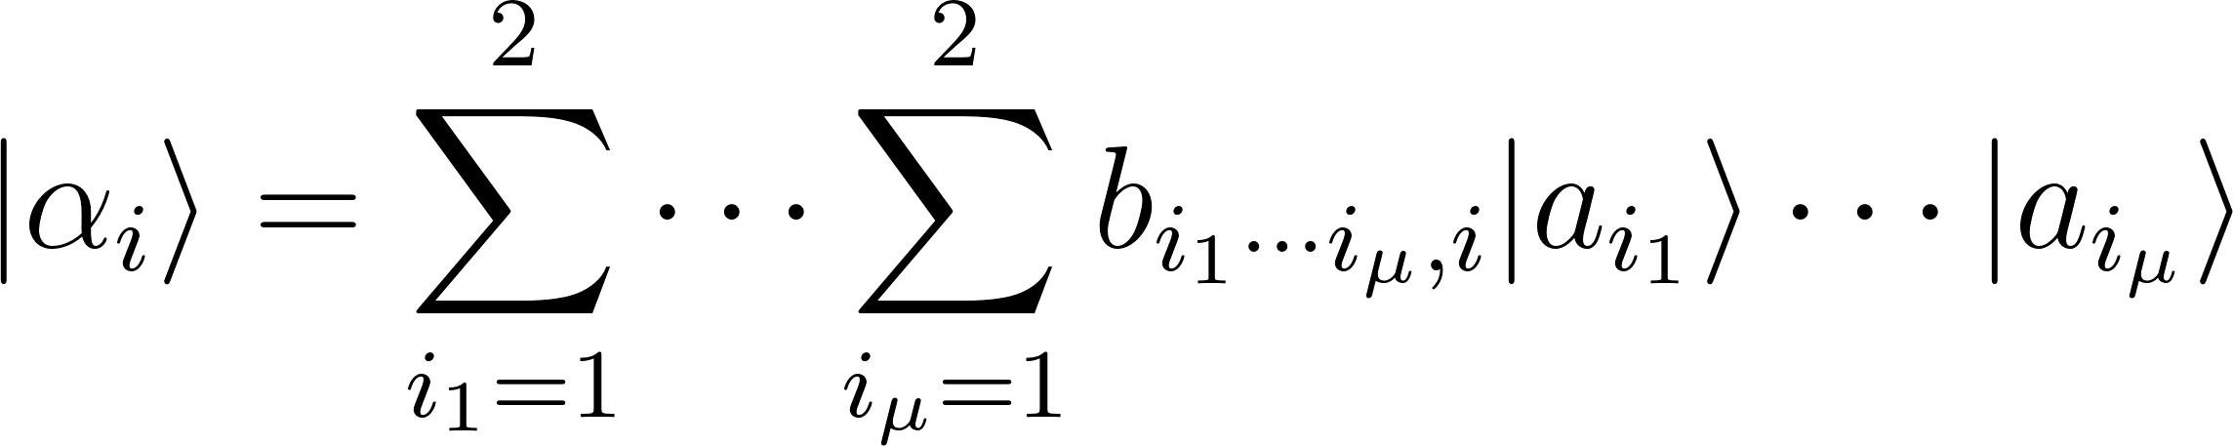
Now we have boosted the number of base vectors in the 4 subspaces.
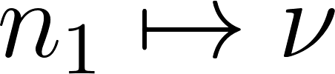

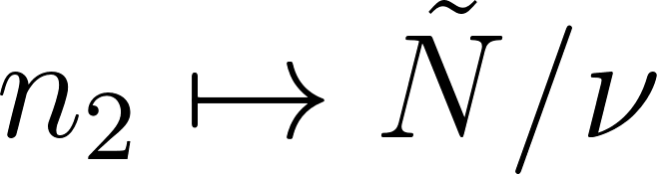
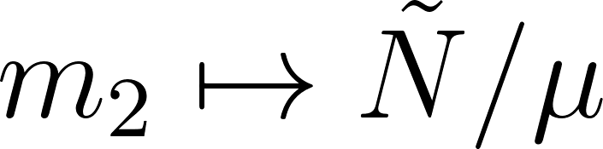
If 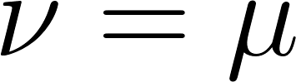 the splits would be identical. If 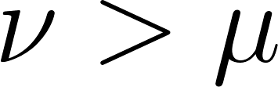 the subspace of the 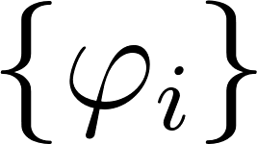 would contain the subspace of the 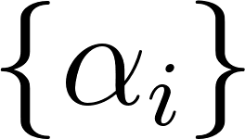 completely. Such a containment means compatibility.

If it is not possible to find such a qubit basis, the splits are not compatible. A perception of one split will produce a product state from the view of this split, which never will be a product state from the view of the second split. A perception at the second split will destroy the first split’s product state again, producing a product state for its own view. The Sylvester matrix above defines such an incompatible relation, because it mixes all elementary base vectors when transforming from one basis to the other, e.g. from the position to the momentum basis. Thus incompatible splits work like non-commuting operators.

Summary
We started with Wigner’s paradox to demonstrate how quantum dynamics is connected to conscious processes. We looked at the many worlds interpretation, which rather is an incomplete theory than an interpretation. From it we learned that a unique process could perhaps resolve the paradox. In contrast to MWI and because of its deficiencies we decided to keep the other process, process type 1, and go for a pure “collapse” theory. Unlike other collapse theories it should not extend Schrödinger dynamics but replace it completely. And it should not inject notions like “position space“ a priori as some other collapse theories do.

We saw that there are strong hints in statistical and black hole physics that processes in nature will deliver information in finite quantities. Our rough estimations showed that stochastic processes somewhere at the Planck scale could be able to reproduce smooth dynamics at the scale accessible to current technology.

We found that the state vector’s jump directions are related to its unique Schmidt decomposition. Therefore we introduced a new ontic entity: a split splitting the Hilbert space into two parts. For a model of consciousness at least some of the jumps must be related to consciousness. We applied Occam’s razor and dropped unconscious jumps, arriving at a theory where the complete dynamics is driven by conscious processes.

Starting with the most simple case - two qubits - we saw that two incompatible conscious splits could drive a state vector in a way that frequencies and energies can roughly emerge, if a “hidden” inner behaviour of the splits would favour an initially chosen direction of motion in configuration space.

We could put a finite number of qubit pairs together to arrive at a Hamiltonian corresponding to the free motion of a “particle” in finite configuration space dimensions. We saw that a Sylvester matrix will transform from split orientations standing for momentum space to splits that will perceive such dynamics in configuration space as particle events in position space.

Concerning physics we have seen how ontic entities occuring in current physical theories, like particles and positions, might emerge from only two different ontic entities: conscious splits and a Hilbert space with finite dimensions.

Finally we saw how commuting and non-commuting operators can be founded in the relative orientations of conscious splits.

In this new light a brain appears as the result of mind activity and not the other way round. Today’s quantum physics would merely describe the communication channel between minds.

Of course there have been new questions opened:
- What is the meaning of the highest possible frequency/energy in a space of two qubits? This question is similar to the question about the size of the Planck mass.
- What inner behaviour and relative orientation of splits is necessary to reproduce more of current physics? Is it possible at all?
- How is psychological time connected to physical time? This question might find an answer after extending our approach to relativistic physics, where physical times might turn out to be indices in an appropriate vector base like physical positions, while psychological times still could be the result of stochastic jumps.

Appendix

Unitary Time Evolution in Product Space
Consider a friendly function that can be expressed as
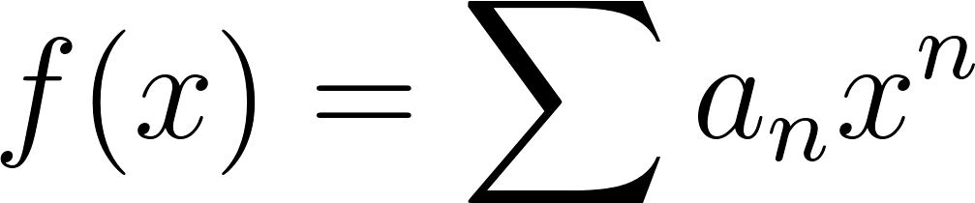
We give it a product space operator as argument

We used that 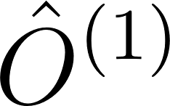 and 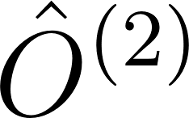 always commute. In the special case 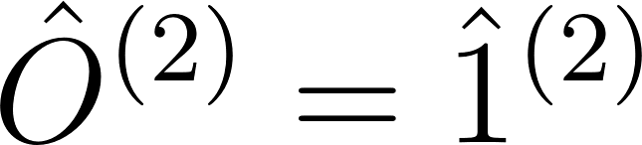 because of 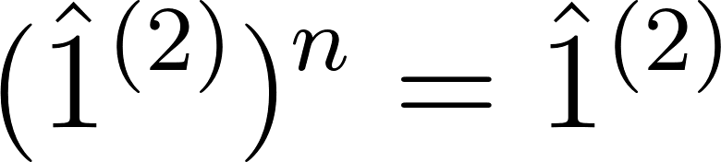 we get

and similarly

Therefore the unitary evolution of a Hamiltonian

is

Because of the vanishing commutator 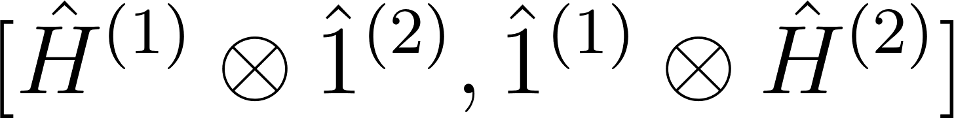 the Baker-Campbell-Hausdorff formula simply leads to
So with 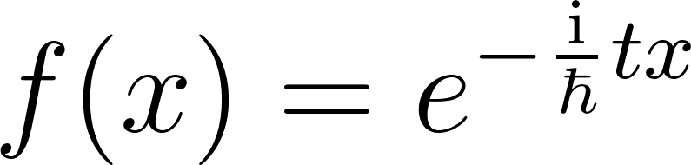 we arrive at

which means that both evolve “independently” if they have been independent initially and there is no interaction between them - the expected result.

Any initial entropy, the measure for entanglement, is preserved. If the initial state has been a pure product vector, it will stay a pure product. Only then the parts are really independent, but this also means that one part does not belong to the world of the other part. If the initial state has been entangled, it will stay entangled, so in a strong sense the “independent” parts are not independent then.
Entropy is not a property of a part, it is a property of a state relative to a split of its Hilbert space. Its existence does not depend on interaction, but its change (at a certain split) does.

Diagonalization of 4x4 Matrix u
We only consider the outer area because the inner area is already diagonal. The 2x2 matrix then is
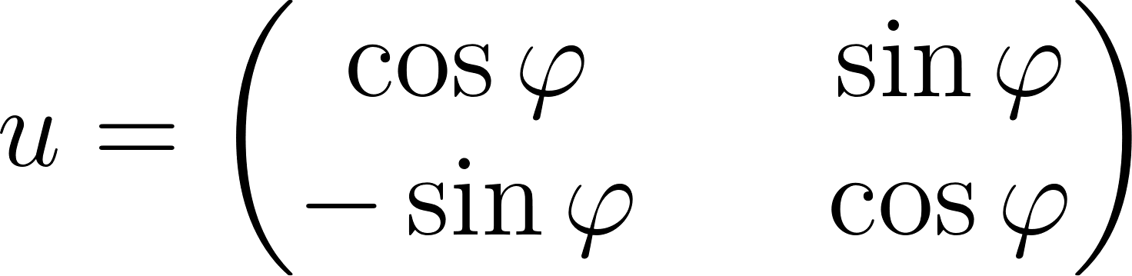
and it shall be diagonalized to
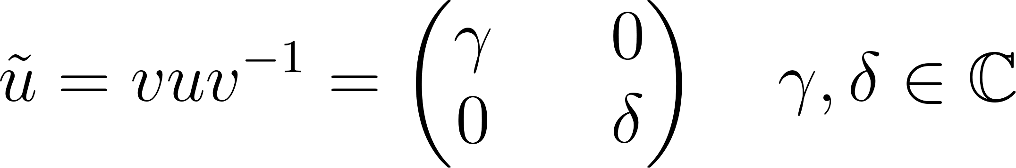
with the help of

This yields
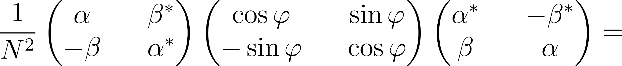

The 2 homogeneous equations are equivalent and yield 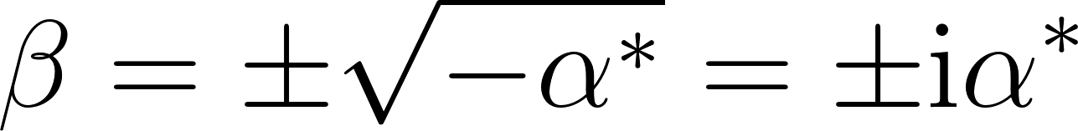. So we get from the inhomogeneous equations because now 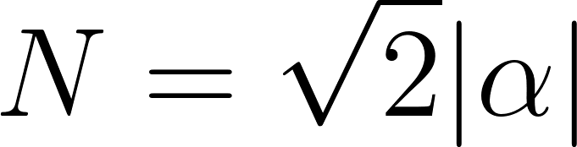

Of course the diagonal of a diagonalized unitary matrix must contain complex numbers with absolute values of 1.

Decoherence and Position Entanglement
In the quantum measurement limit the dynamics is driven exclusively by an interaction Hamiltonian 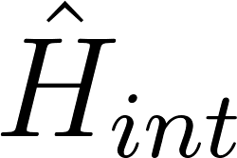 between quantum system and environment. It is well known that an interaction Hamiltonian
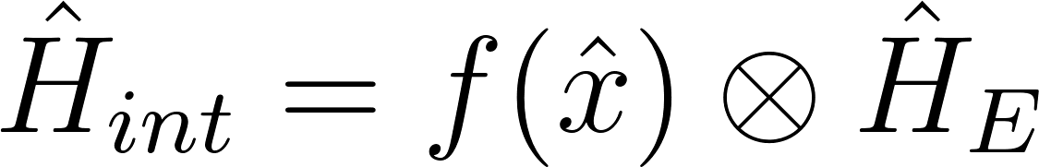
- with 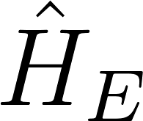 acting on the environment only - will select pointer states in the position base, i.e. position eigenvectors 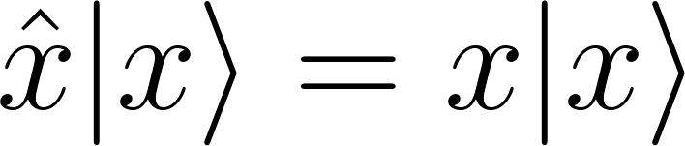 of the system will be robust when the system entangles with the environment.

In our finite dimensional model the matrix elements of operator 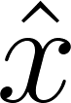 correspond to the matrix

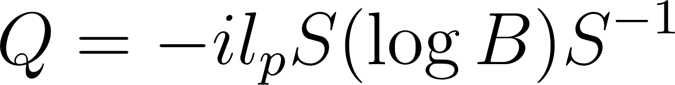

We chose B and P diagonal, which means that our matrices contain momentum space components. Transforming with S from momentum to position base will transform the typical components (0, …, 0, 1, 0, …, 0) of a momentum eigenvector (a “particle moving at constant speed”) in the momentum base to components spread over the whole position space. The measurement with will entangle each such component with a different state of the environment. A conscious split oriented in a way that it sees this entanglement thus will be able to perceive a particle at a position.

Degenerate Schmidt Decompositions
When the diagonal matrix of the singular value decomposition contains equal values, we have the degenerate case. In the 2 qubits example if 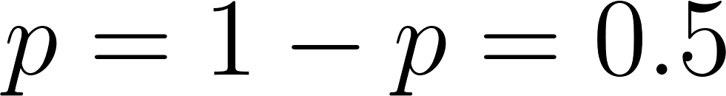 then the 10 and the +- bases both are Schmidt decompositions. Actually there will be an infinite number of Schmidt decompositions. In the degenerate case it is undefined what the conscious split may perceive.
The probability that 2 randomly chosen real numbers are equal is 0. As well the probability to hit any degenerate case by randomly choosing a state vector and a split of the Hilbert space is 0. We could say that this case is only of interest for mathematicians and will not occur in a real world.

Note that even in the case of complex numbers, i.e. the case of quantum mechanics, the diagonal elements in the singular value decomposition build a unique set of non-negative real numbers. Or: only with the requirement to have non-negative real numbers on the diagonal the Schmidt decomposition is unique in the case of quantum mechanics with its complex coefficients. So with the help of a split and not by Hermitian measurement operators we arrive at real numbers and probabilities.

History
- 2018 article written
- 2019 January: corrected connection to Santhanam/Tekumalla paper, some details hopefully clearer now. Added “Decoherence and Position Entanglement” to the appendix. Dropped the unclear (and here irrelevant) discussion whether mass constants help to define splits of Hilbert spaces.
- 2019 March: considered degenerate Schmidt decompositions
- 2019 May: added missing square root sign in value set of cos 𝛗.

Resources
Powerpoint containing 1st picture
GSuite picture: conscious splits

