Twitter Identification Assignment

Nathan Losee, Quentin Higley, Matthew Harames

1. We are using Text analysis of tweets revolving around the Video Games Valorant, APEX, and Fortnite to model Positive and Negative Sentiment.
2. Apex Wordcloud, the others are similar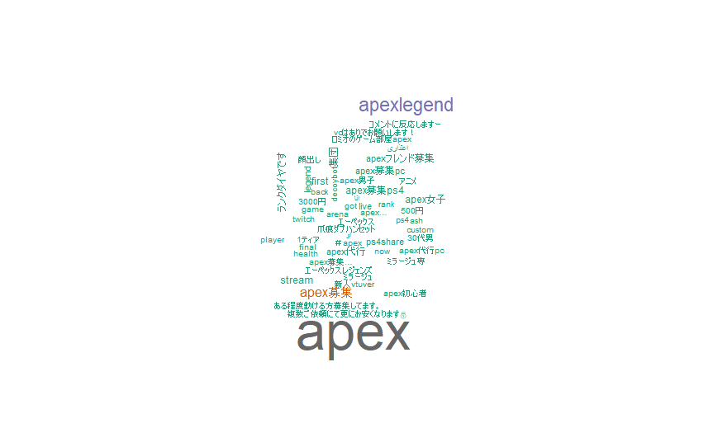

1. Sentiments for APEX

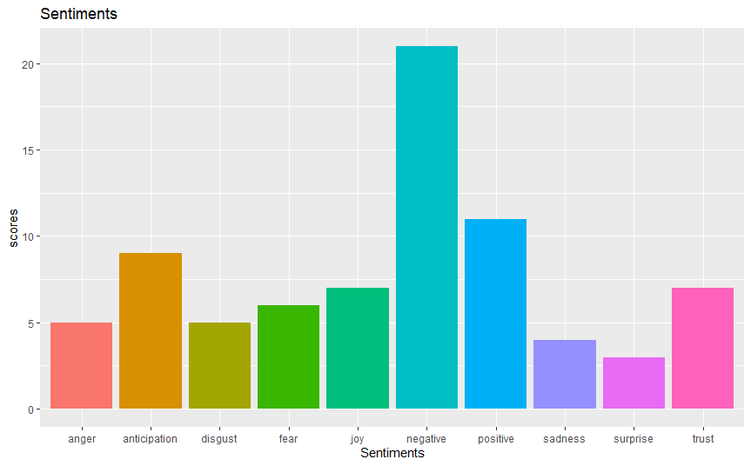

1. We will use a tree classifier here, using the tweet text data to classify a positive or negative sentiment, and discover which input variables are the most important ones
2. We will try either KNN/Logistic Regression/QDA here. Once we find the Regression/Classification that performs best, we will report out findings and which one we wound up using.