**CHAPTER THREE**

**3.0 SYSTEM INVESTIGATION AND ANALYSIS**

It deals with information system project to which organizational resources have been committed. System analysis describes what the information system must do to solve the problem. Existing systems and work processes and studied and requirement for the new system are defined.

**3.1 BACKGROUND OF THE STUDY**

ADRON is a Real Estate and Property Development Company whose purpose to help people realize their aspirations for the pride of ownership, comfort, security and wealth through the provision of excellent homes and the will to provide homes for all classes of society with focus on the neglected populace in respect to government housing programs.  
  
The core value is built on consistent Quality Services to clients and subscribers; develop talents and achieve high quality standard; make decisions and help grow the business; and unity in purpose and sharing ideas to achieve a common goal.  
  
The company has over 4000 acres of land in its Estates cut across three developing Real Estate areas in the sub urban areas, to be developed into an Estate with affordability status for low and medium income earners.

**3.2 OPERATIONS OF EXISTING SYSTEM**

The currently operated method of Adron home and estate management uses online but no client area that enables personal secured interaction and conversation with the administrative in-charge.

**3.3 ANALYSIS OF FINDINGS**

This is an important stage in the system development lifecycle. According to McNab (2004), system development with the identification and specification of both functional and non-functional requirements of the system. He said to achieve this objective, that there is need for analyst or researcher to use systematic approach to ensure that specification derived are accurate and the analysis process is carried out in a controlled manner.

Analysis is the breaking down of a complex structure into smaller units so that an intensive detailed cross-examination can be effectively carried out on it.

Effiong E. E (2001) defined System analysis as the process of breaking down system (problems) into subsystem and their component parts so as to analyze on details the information needs of a user and thereafter develop the system requirements.”

System analysis therefore is the study of a business problem domain to recommend improvements and specify the business requirements for a solution. It is also the dissection of a system into pieces to study how they interact and work.

1. **OUTPUTS FROM THE SYSTEM**

The outputs from the currently existing system of of Adron home and estate management were generated through manual methods. The property management status information of client is done manually.

1. **INPUT TO THE SYSTEM**

The inputs into the currently existing system are the client information such as name, email, phone number, address, gender etc. they are provided manually by client and they are input to the system.

1. **PROCESSING ACTIVITIES CARRIED OUT BY THE SYSTEM**

The processing activities by the system include:

* Collection of needed information.
* Viewing of available properties
* Communication with admin if need be
* Acquiring properties

1. **ADMINISTRATION/ MANAGEMENT OF THE SYSTEM**

The existing system is managed by selected officer of the company who is assigned duty of administrator. The duties include keeping files of client and communicating with them.

1. **THE CONTROLS USED BY THE SYSTEM**

The controls used in an existing system to capture and store information of each client include; folders for keeping files and security measures are provided on the folders.

1. **HOW DATA AND INFORMATION ARE BEING STORED BY THE SYSTEM**

Details of client that have gone through the process are filed in a folder recorded in a ledger (hardcover notebook) with respective date for later use.

**3.4 PROBLEMS ARE IDENTIFIED FROM ANALYSIS**

The problems are associated with the manual method:

1. A lot of time is used up in sorting through thousands of application and document.
2. When information is needed later, a lot of time is required to sort it out from folder where they have been stored.
3. Through transit some information may get lost.
4. Hard copies are stored and it consumes a lot of space.

**3.5 SUGGESTED SOLUTION TO PROBLEMS IDENTIFIED**

1. Time wasting is eliminated due to computerization of the processes.
2. Loss of information in anyway is eliminated.
3. Quick storage and retrieval of records to save time.
4. Acquiring can be done from any location on the earth once client login into the portal.

**CHAPTER ONE**

**1.0 INTRODUCTION**

Clearance is a status granted individuals, typically members of Military, University graduates and Employees of Government and their contractors, allowing them access to classified information, a clearance by itself is normally not sufficient to gain access. The organization must determine that the clearance individual has a “need to know” the information. Clearance is the process of determining and negotiating any permission that are needed to use of someone else’s intellectual property in creative project. Part of that process include

1. Determining the owner(s) of the intellectual property.
2. Contacting the owners and negotiating on agreement.
3. Administering written contracts
4. Handling other issue related to the use and licensing of intellectual property.

No one is supposed to be granted access to classified information solely because of rank of position, but once a clearance is obtained access to certain information or gain of freedom will be granted.

The changing online college landscape now includes online clearance system, traditional undergraduate and general studies programs. The process of clearing involves the student academic department, faculty, and bursary, students’ affair etc. A student is allowed to collect his graduation certificate only after he has been cleared, the tentative value of amount is initially deposited in enrolled students account by checking the clearance amount it will be deducted when then system is commanded by the user

**1.2 STATEMENT OF THE PROBLEM**

The process of clearing final year students requires that the students must be cleared in their various departments and units. Among which are:

1. The Sport Unit.
2. The student department.
3. The student faculty.
4. The library.
5. The hostel.
6. The vocational unit.
7. The student affairs unit.

Furthermore, for a graduating student to carry out his/her clearance from all these departments it normally takes a lot of time and a lot of processes and delay in clearing the student for youth service as well as collection of statement of results. Hence, it became imperative for computer software based online clearance system to eliminate the shortcoming of the manual system in place.

**1.3 AIM AND OBJECTIVES OF THE STUDY**

The aim of this project is to develop an online student clearance system

The objectives of this computer software based online clearance system for the graduating student includes the following:

1. To effectively and efficiently process students clearance.
2. To provide a reliable and transparent system devoid of personal inclination and interest.
3. To grant easy access.
4. To ensure prompt clearance.
5. To alleviate the problems and stress of travelling and queuing up of student during clearance.

**1.4 SIGNIFICANCE OF THE STUDY**

The project will help in a good number of ways to ease the queuing system in the school as the online clearance system will help student to achieve whatever they want to achieve without coming to the various offices for clearance. Clear advantages of internet information processing over those of traditional manual system are higher yields. Online clearance system allows the users to check their clearance status as whether they are in any way indebted to the school, fill and submit their clearance form, and obtain their clearance letter. There are many other advantages of online clearance system and some of them are listed below

1. It save a lot of time.
2. It is very convenient to use it right from the bedroom, office or anywhere in the world.
3. Information processing is very fast and delays can be avoided.
4. It is inexpensive to student and school management.
5. It is also help the school in reducing cost such as labor and stationary.

**1.5 SCOPE OF THE STUDY**

This project is to develop an online clearance system for graduating students of the school. The software development will be carried out using PHP/MY SQL Access to manage both the database and at the same time make the software online.

**1.6 DEFINITION OF TERMS**

* **Computer Network:** Computer network is a system that connects two or more computers together using a communication link.
* **World Wide Web:** World Wide Web simply called “www” is the most important tool of the internet, it was created in the late 1980’s in Europe and was limitedly use in academics cycle.
* **Clearances:** Official certification of blamelessness trustworthiness or suitability for graduation and issue of certificate in degree course.
* **File Transfer:** Any kind of computer file can be sent via the internet from one internet user to another. Table of account in a spreadsheet, design by a graphic artist, music and sound files etc. can all be exchanged in this way.
* **Web Browser:** This is special kind of software that processes hypertext mark-up language (HTML) document. In other words, a web browser is a computer program that interprets HTML command to collect, arranged and display the parts of a web page.
* **Web Site:** A web site is a collection of many interconnected web page organized by a specific college, organization company etc., containing web page (goods and commodities) on the internet. Web site is stored on web servers. There are many web sites and thousands of HTML pages on each web site. A web is a treasure of information and entertainment.
* **Hyperlinks:** Hyperlinks are highlighted words and phrase you find on a web document that you can click on as to jump to some other document or internet services.
* **Online:** Connected via a computer attached to or available via a central computer network
* **Offline:** Disconnected from computer network, describe a computer terminal or peripheral devices disconnected from a computer network. 16 System: Set of computer components that is, an assembling of hardware, software and peripheral functioning together.
* **Database:** This is designed to offer an organized mechanism for storing, managing and retrieving information.
* **SQL:** Structured query language is a database computer language designed for managing data in relational database management system (RDBMS) and originally based upon relational algebra.
* **Server:** A computer or program managing access to a resource or service in a network.
* **Portal:** A web application that is designed to represent a ton of information in a concise and centered way, thereby making the internet easier to use e.g. yahoo.com, netscape.com etc.
* **Web pay:** A web application that is designed for monetary transaction to be made which involves inputting pin into the web provided etc.
* **PHP:** (Hypertext Preprocessor) this is a programming language used in developing a web based software.

**CHAPTER TWO**

**2.0 LITERATURE REVIEW**

It is a systematic analysis of document containing about problem being studied it is an exercise about what other researchers identify, locate, evaluate and their previous research they could not complete.

**2.1 BACKGROUND THEORY OF STUDY**

The aim of information system to clearance in universities using online clearance system is to improve the quality and accuracy of information provided to all involved as well as assisting universities in compiling and reporting information, making work lesser for the management.

Information technology has been an integral part of academic system since almost four decades. According to Hewlet (1993) the world is entering an era in which technology will literally transform every aspect of business, every aspect of life and every aspect of society.

According to Taylor (1980) computer base education includes both computer-assisted instruction programs that interact with students in a dialogue and a broader array of educational computer applications such as simulations or instructions in computer programming. Student online clearance is a method where the student obtains his/her clearance letter without carrying files around. This is safe, fast and has no hazels. Filling out the documents and comparing options and writing for approval is a time consuming process. Through the internet, this process is made much easier and sometimes the approval is made within minutes. This explains an efficient way of obtaining clearance and saves time and money for students.

**DATA AND INFORMATION**

The concept of data and information are very important in understanding issues that go with development and implementation of an online clearance system. The term “data” and “information” are used interchangeably every day conversation as meaning the same thing. Too many manager and information specialist. However, these terms have distinct meaning. According to O’Leary (1996) data simply consist of raw unprocessed facts while information is a data that have been processed by the computer. Hordeski (1986) gives the following definition of data; A graphic or textual representation of facts concepts, numbers, letters, symbols or instructions suitable for communication, interpretation or processing. Data is the basic element of information that is use to described objects, ideas, conditions or situations.

Lucy (1991) defines data and information as Data is fact events, transactions and so on, which have been recorded. They are the raw materials from which information is produced. Information is data that has been produced in such a way as to be useful to the recipient. Data are fact obtained by observation, counting, measuring, weighing etc, which are often records of day-to-day transactions of the organization. For example, the date, amount, and other details of an invoice or cheque, payroll details of payment, the number of a student living in a particular hostel and so on.

Enwerem (1992) argue that concept of information in an organization sense is more complex and difficult than the frequent use of this common word would suggest. Oketunji (2002) emphasized that information is data that have been processed, transmitted by the recipient, interpreted and understood by the recipient. Here it should be noted that the user, not just the sender is involved in the transformation of data into information. There is a process of though and understanding involved and if follows that a given message can have different meaning to different people. Based on this, one can conclude that data which has been analyzed summarized or processed in some other fashion to produce a message or report which is conveniently deemed “management information” only becomes information if it is understood by the recipient. Therefore it the user who determine whether a report contains information or just processed data.

**2.2 RELATED WORKS**

According to Jeremy v ernest, a comparison of traditional and hybrid online system in communication technology

Online system has become a central element of the discourse on higher education (cox 2005). There seems to be an overall derive towards online system given the mountain need for flexibility in scheduling and the daily emergency of communication technology and capabilities (Hill stock 2005).

Online system is presented as a means of conveying instruction to an extensive learning community any place at any time Cox (2005). Indicate that adequate designate online learning as the driving force and model for transformation in teaching, learning and formal schooling online course has the potential to provide learner individualized attention by the instructor, otherwise impossible in a large classroom environment (environmental education and training partnership 2006).

Online clearance system present educational experience very different from standard face-to-face environment (Hew, Liu, Martinez, Bonk and Lee 2004). When conducting a micro level courses evaluation, interest commonly lies in learner perception of the course experience pertaining to the level of comfort, ability to communicate with class mate and the instructor, as well as comparison to traditional face-to-face lecture. Many times the only means of evaluating learner perception is in the form of a questionnaire or survey. Although perception of online system can be extremely useful information, it is usually not sufficient to conclude the evaluation without expanding to learners understanding.

**ONLINE INFORMATION SYSTEM**

An information specialist Lucey (1991) define computer based management information system as: the combination of human and computer based resource that result in the collection, storage, retrieval, communication and use of data for the purpose of efficient management of operations and for business planning.

Computer based information system is a feature of all large organization nowadays. The literature identifies four kinds of computer based information: Transaction processing system (TPS), management information system (MIS), decision support system (DSS) and executive support system (ESS). Some system record routine activities: Employees hired, material purchased or produced and the like. Such recorded events are called transactions. Other system uses this recorded event to help managerial planning and control. The systems form a pyramid each primarily supporting one another level of management.

**a.** Transaction processing system (TPS): these system record day-to-day transactions such as customer order, bills, inventory levels and production output. The TPS helps supervisors by generating data base that act as foundation for other information system.

**b.** Management information system (MIS). These summarize the detailed data of the transaction processing system standard report for middle level managers. Such report might include production schedules and budget summarizes.

**c.** Decision support system (DSS); The DSS provide the flexible tools for analyzes. The DSS help middle level managers and other in the organization analyze a wide range of problem, such as effect of event and trend outside the organization. Like the MIS, the DSS draws on the detailed data of transaction processing system.

**d.** Executive support system (ESS): The ESS is easy-to-use systems that present information in a very highly summarized form. It helps top level management to oversee the company operation and develop strategic plans. The ESS combines internal data from TPS and MIS with external data.

**DATA BASES**

In the early days of computerization, it was normal to maintain specific files for individual application. Data where processes centrally in batches and there was little or no online interrogation of data. This approach is wholly inefficient for most of today’s data processing systems. Supporting this vossen (1991) enumerated the problems that result from organizing the data using the file system.

**a.** There exist high redundancies between files which result from the fact that the information is replicated in different places, and that these replications are not controlled by a central monitor

**b.** Inconsistencies might result from the possibilities that a program makes changes on the files it uses without these changes being made (at the same time) by all other programs that uses the files.

**c.** There exist in flexibility against changes in the application**:** if new actions or event arise in the cause of time, these can be realize at a substantial expense of time.

**d.** The work of many programmers involved is characterize by low productivity, seems program maintenance is expensive: if the structure of an existing file has to be modify during it life time, then all application program has to be modify correspondently

**e.** Finally, there is the problem of adopting and maintaining standard (with respect to coding data format etc), which is important for exchanging data or for migration to new operating system released, or even to a new computer system.

To overcome these problems, data bases where developed. It is now common for large organization to organize their operational data using the data base technology.

The subject of data is adequately covered in many works in data base technology. Clifton (1983) briefly define data base as a collection of data supporting the operation of an organization. Quoting CIMA, Lucey (1991) provide a more detailed definition.

A data base is a file of data structured in such a way that it may serve a number of application without it structure being dictated by any one of those application, the concept being that programs are written round the data base rather than files being structure to meet the need of particular programs.

Russel M. (1987) dealt extensively on the need for the use of computer on such data base system like computerized clearance system. In the world of Dimorji (2003).

“At the center of any information system is a data base, which is any collection of related information grouped together as a simple item. The term can also apply to the ways in which information is catalogued, analyzed, stored and used manually”.

Rossell (2005) was also of the view that without computer, effective handling of candidate record cannot be achieved effectively in a data base, all the data is defined together rather than each file being define separately. In fact, all the literature consulted seem to support the fact that a data base is a collection of structured data with the structure of data being independent of any particular application. Specify the need for data base, O’leary (1996) listed the following advantages:

a. Sharing: in an organization, information from one department can be readily shared with others.

b. Security: users are giving password or access only to the kind information they need to know. Thus, the payroll department may have access to employees pay rate but they would not.

c. Fewer files: with several departments having access to one files, there are fewer files therefore, excess storage or what is called redundancy is reduced.

d. Data Integrity: older filing system many times did not have integrity i.e. a change made in the file in one department might not be made in the file in another department. As one might expect, these can cause serious problems and conflict when data is used for important decision affecting but department.

To advantages enumerated above, vossen (1991) at abbs.

a. Standard/access protocols can be enforced.

b. Currency of data can be maintained.

c. Data/program independent can be maintained.

d. Conflicting requirement can be balanced among users.

In these days of integrated networks, the database appeared as the most logical method for organizing the operational data of large organizations. One may as well say that these advantages give the database the attraction over the traditional file processing method.

**COMMUNICATION TECHNOLOGY USED IN ONLINE CLEARANCE SYSTEM**

Several communicational tools are at the disposal of students and staffs to support their activities during the clearance. The partner universities offer two virtual communication tools with different capabilities (marratech and central). It is also available online and the communication management systems (OCMS) and in dependent discussion forum.

**Marratech**

Marratech is a virtual online tool that allows holding meeting and video conferencing on the web, face-to-face, whenever you want to talk, see each other and share application and document without being in the same room, the same building, or even the same country. This platform is used in several systems like in the energy online master program for online lectures, project meetings and project presentation.

**Central**

Central enables group to work faster and more effectively by automating critical clearance system and training initiatives online through virtual classroom, online meeting and web conferences. Central has a broad array of features that make live, group-oriented system effective on the web. Interactive white board, yes/no feedback, had-raising, multi-point conferencing, advanced application shearing and text and fool-duplex chart examples, in the energy online master program for online lectures, project meetings and project presentation.

Communication management tools are available at each university and also in an online clearance system homepage.

**2.3 CURRENT METHODS IN USE**

The existing method is largely manual. The process which involves students going to HOD to collect clearance slip and go to various department such as faculty, bursary, student academic department, sport centers etc. to clear them by signing the space provided for each department. This method due to its largely manual nature is highly inefficient in that it is prone to human errors, takes a lot of time, delay in process etc.

**2.4 APPROACH TO BE USED IN THIS STUDY**

The approach to be used in this study is largely data and information collection by reviewing of materials available on clearance no interview was conducted as the information obtained from materials online, physical libraries and observation were sufficient for this project.

**CHAPTER THREE**

**3.0 SYSTEM INVESTIGATION AND ANALYSIS**

It deals with information system project to which organizational resources have been committed. System analysis describes what the information system must do to solve the problem. Existing systems and work processes and studied and requirement for the new system are defined.

**3.1 OPERATIONS OF EXISTING SYSTEM**

The currently operated method is normal face-to-face learning non computerized method.

**3.3 ANALYSIS OF FINDINGS**

When a student is about to graduate, he/she will take his/her degree exam after which he obtain clearance letter from various departments and unions. The registrar office carefully reviews each degree candidate academic records and certificate to faculty that the candidate has completed his requirement for the degree. Also the bursary has to certify that the student has completed all payment.

The current clearance system of the university is a manual one. These make the system tedious and time consuming. Here, student has to visit all the clearance offices with a form for them to sign, once this forms are sign, it prove that the student has been cleared, the process take some months to be completed and processes a lot of stress to both staffs and the student involved. In the manual system, the clearance forms are documented in a file cabinet. Each time the clearance form is needed, a search operation is conducted on the file cabinet to locate a particular student clearance form.

1. **OUTPUTS FROM THE SYSTEM**

The outputs from the currently existing system were generated through manual methods. The clearance status information of student is done manually.

1. **INPUT TO THE SYSTEM**

The inputs into the currently existing system are the student information such as name, matric no, department etc. they are provided manually by student and they are input to the system.

1. **PROCESSING ACTIVITIES CARRIED OUT BY THE SYSTEM**

The processing activities by the system include:

* Collection of needed information with pen and paper e.g. school fees receipt no to clarify payment, library card id no etc.
* The respective information are collected from various department e.g. hostel clearance.
* Processing/clearing identification no if it is genuine then the officer signs and stamp.
* When every section is signed student take it to student affairs.
* Student affairs issues certificate to student that he or she has completed clearance.
* An amount is paid to bursary for completion and payment slip is taken to CIDM for notification.

1. **ADMINISTRATION/ MANAGEMENT OF THE SYSTEM**

The existing system is managed by selected officer of the institution who is assigned duty of clearance. The duties include keeping files of student that come for clearance manually for future reference.

1. **THE CONTROLS USED BY THE SYSTEM**

The controls used in an existing system to capture and store information of each student for clearance include; paper and pen, hard cover notebook, folders for keeping files and security measures are provided on the folders.

1. **HOW DATA AND INFORMATION ARE BEING STORED BY THE SYSTEM**

Details of student that have gone through the process are filed in a folder recorded in a ledger (hardcover notebook) with respective date for later use.

**3.4 PROBLEMS ARE IDENTIFIED FROM ANALYSIS**

The problems are associated with the manual method of clearance:

1. A lot of time is used up in sorting through thousands of application and document.
2. When information is needed later, a lot of time is required to sort it out from folder where they have been stored.
3. Through transit some students’ information may get lost.
4. Hard copies are stored and it consumes a lot of space.

**3.5 SUGGESTED SOLUTION TO PROBLEMS IDENTIFIED**

1. Time wasting is eliminated due to computerization of the processes.
2. Loss of information in anyway is eliminated.
3. Quick storage and retrieval of records to save time.
4. Clearance can be done from any location on the earth once student login into the portal.

**CHAPTER FOUR**

**4.0 SYSTEM DESIGN**

This chapter gives the functional specification of what the new system is to achieve and end with detailed specification from which the program can be performed. The proposed system intends to achieve the followings:

**4.1 OUTPUT DESIGN**

This section of the project report discusses the output generated by the system, the reports generated and the files used in producing the report.

**4.1.1 REPORTS TO BE GENERATED**

The following reports will be generated by the system

* List of all students.
* List of bursary payments.
* List of cleared students.
* Final clearance slip.

**4.1.2 SCREEN FORM OF REPORT**

The following are the screen forms of the reports to be generated

1. All registered Students

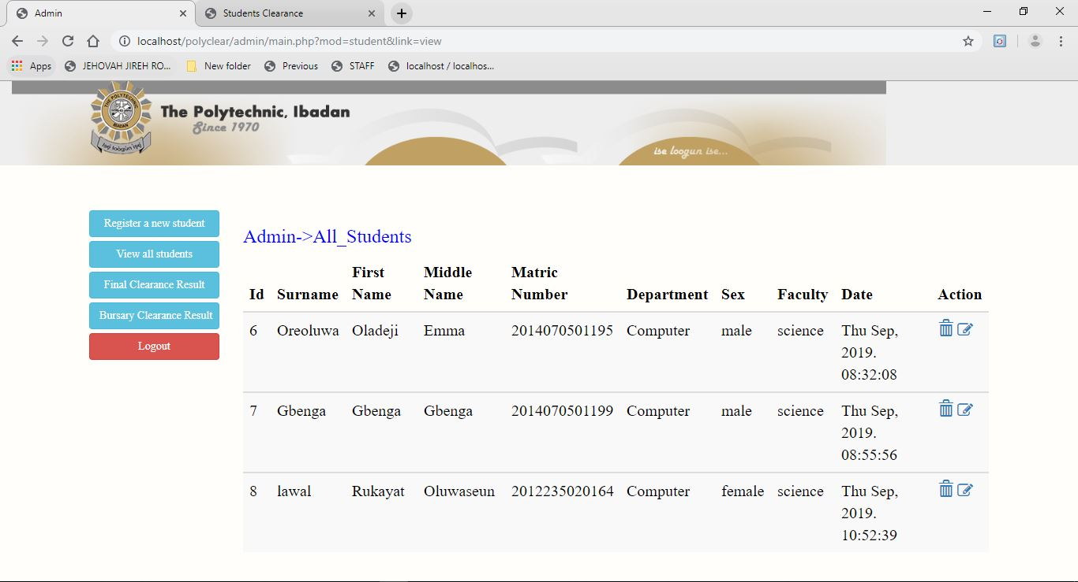

1. List of bursary payments result

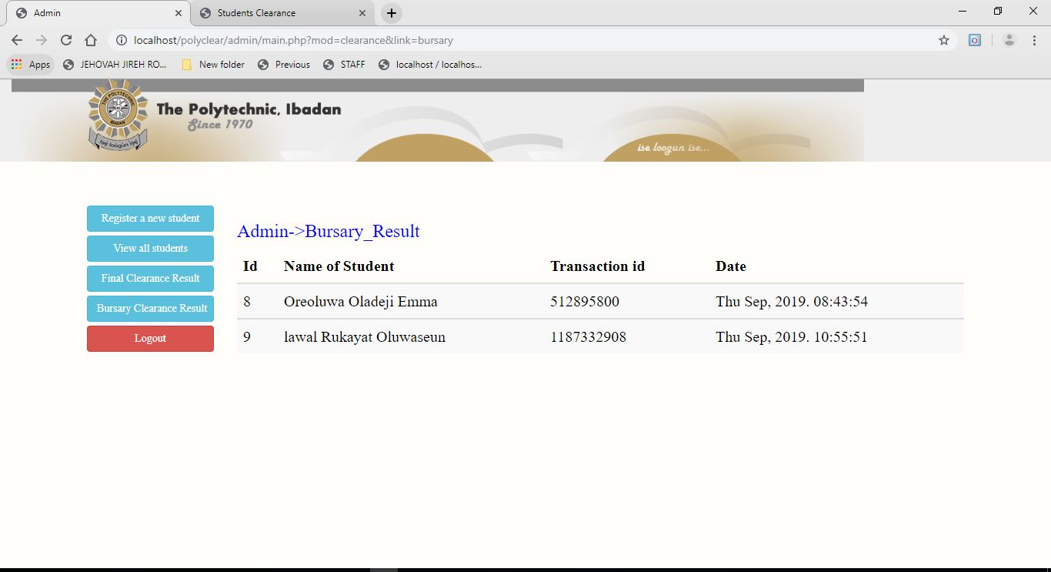

1. List of cleared students

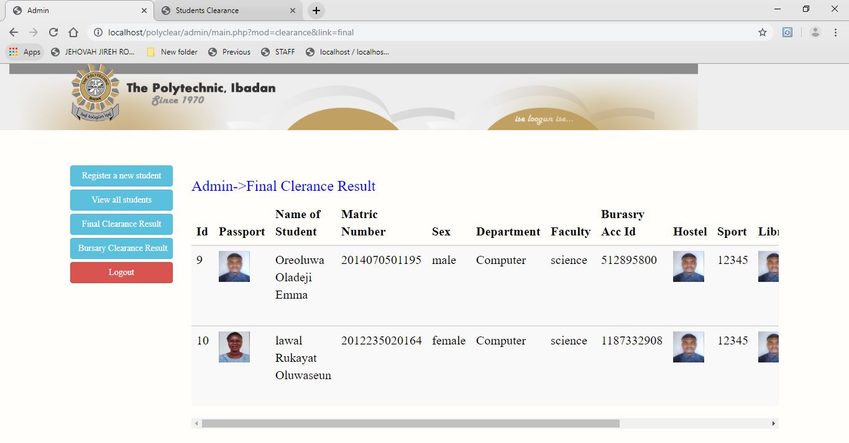

1. Final clearance slip

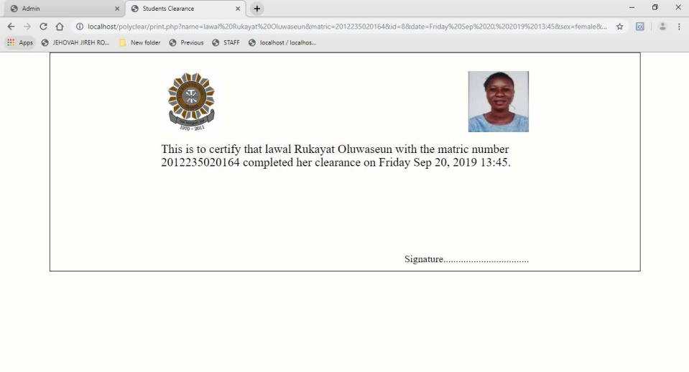

**4.1.3 FILES USED TO PRODUCE REPORTS**

The file used to produce the report generated as output by the system is mysql database file.

* 1. **INPUT DESIGN**

There are some set of input required by the system to be able to function optimally

* + 1. **LIST OF INPUT ITEM REQUIRED**
* Surname
* First Name
* Middle Name
* Matric Number
* Department
* Sex
* Faculty
* Username
* Password
* Card Details
* Transaction ID
* Sport unique number
* Library card
* Hostel card
* VSESC slip
* Department Slip
  + 1. **DATA CAPTURE SCREEN FORMS FOR INPUTS**

The data capture screen forms for inputs are

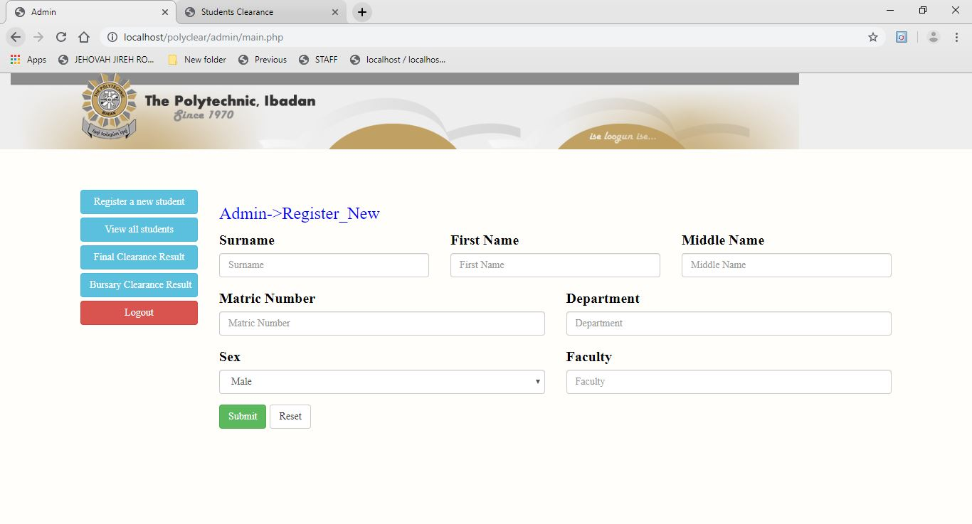

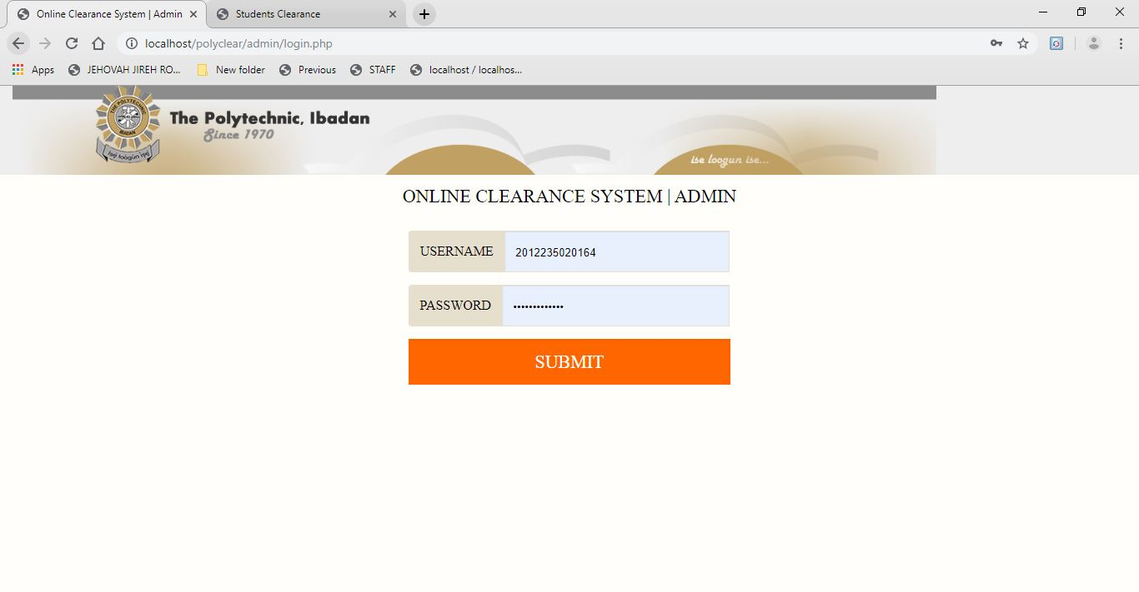

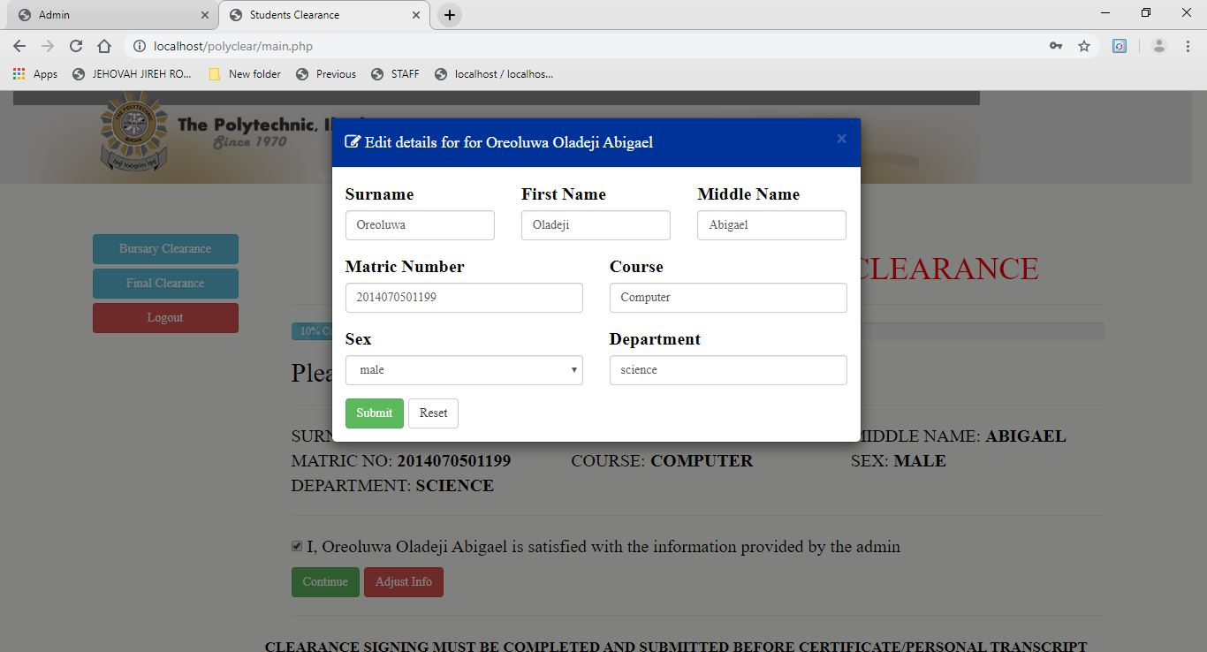

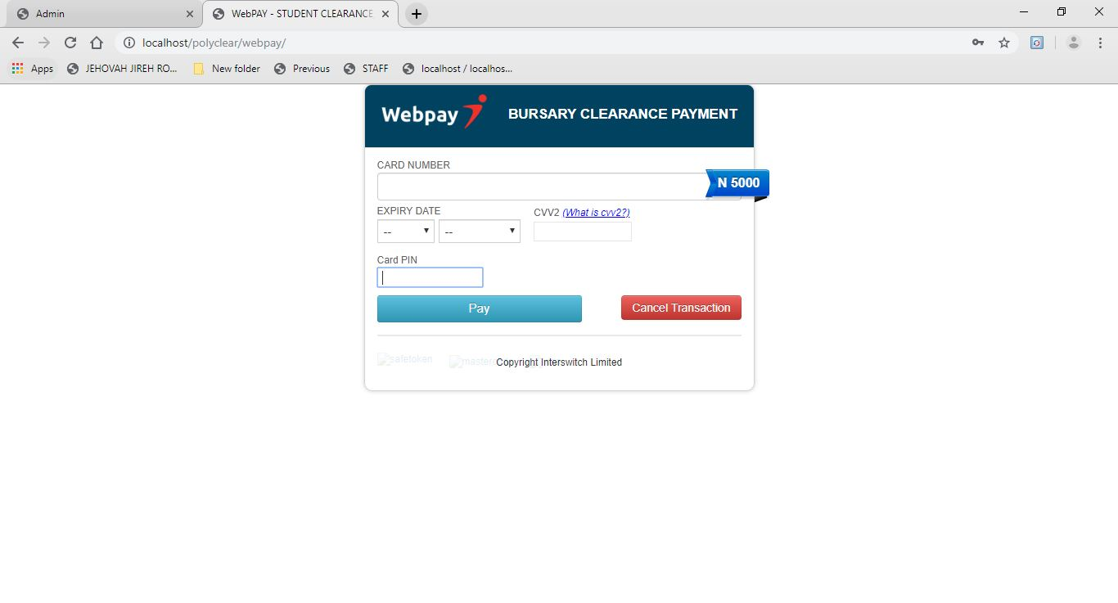

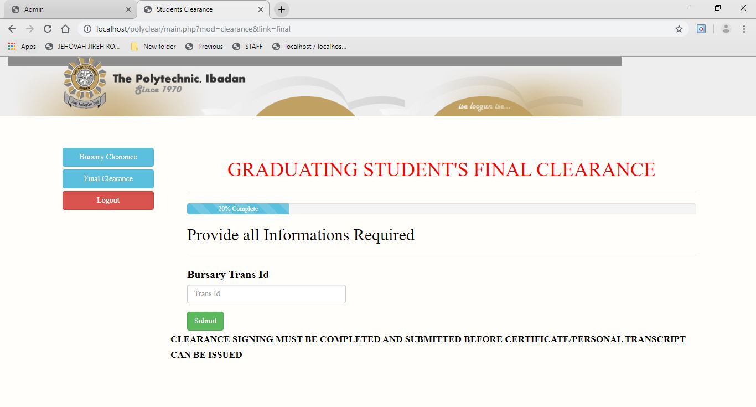

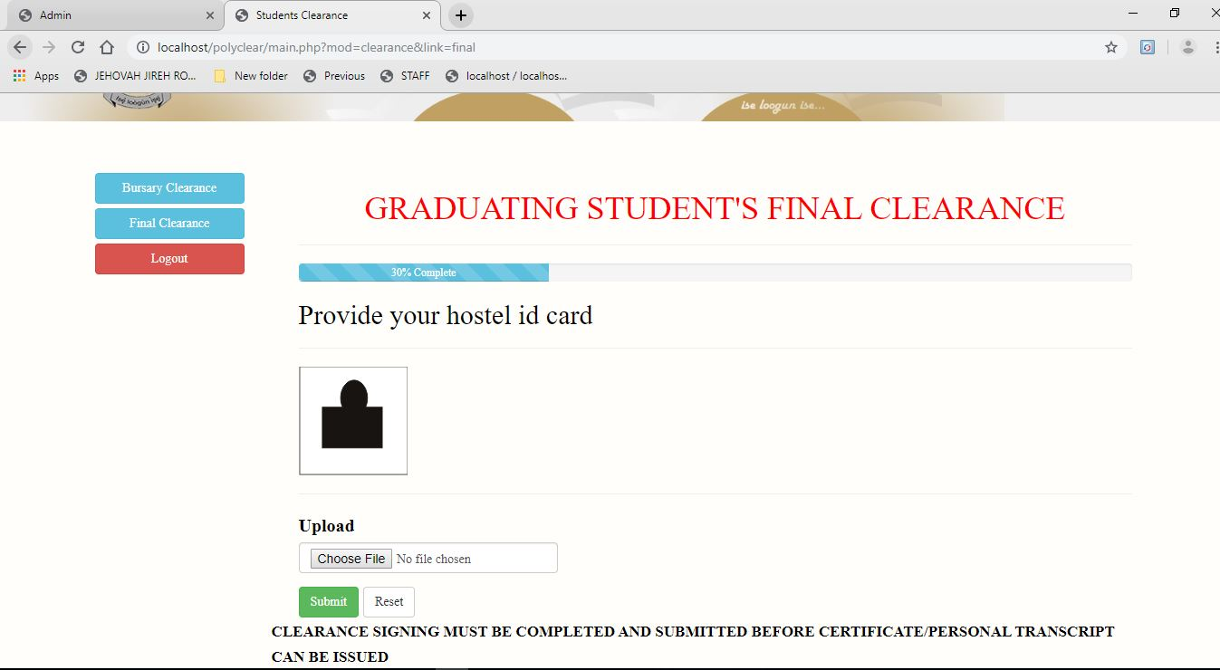

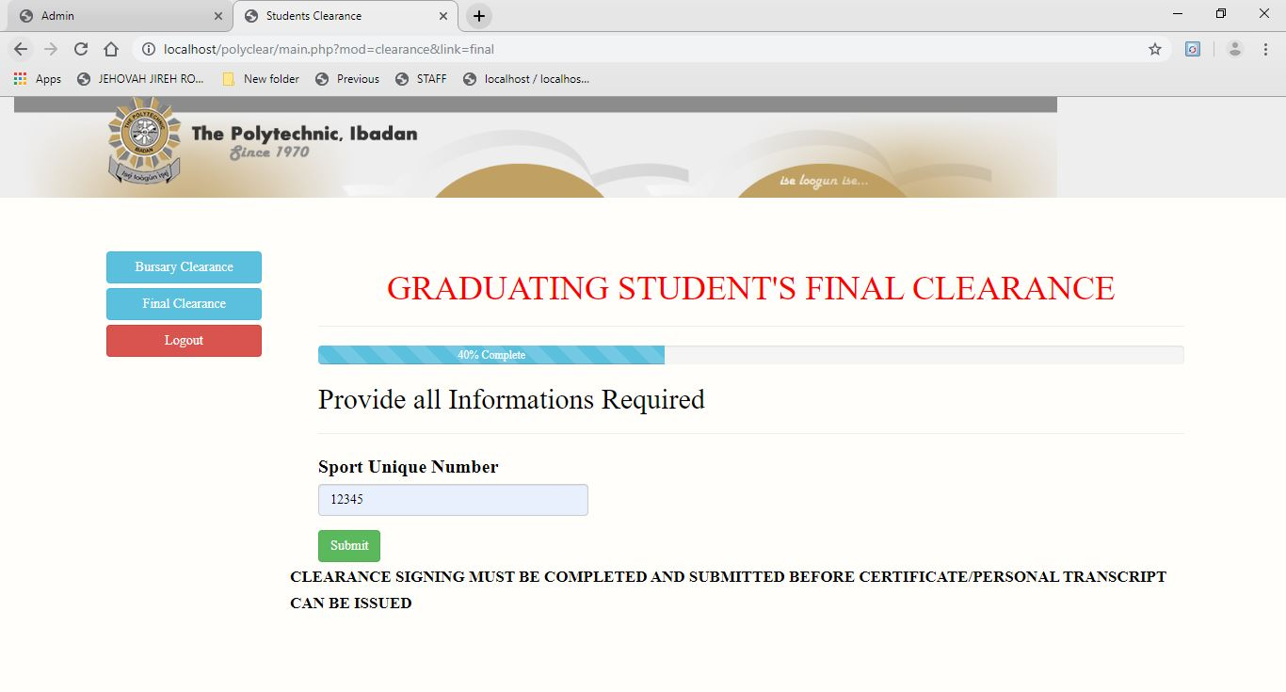

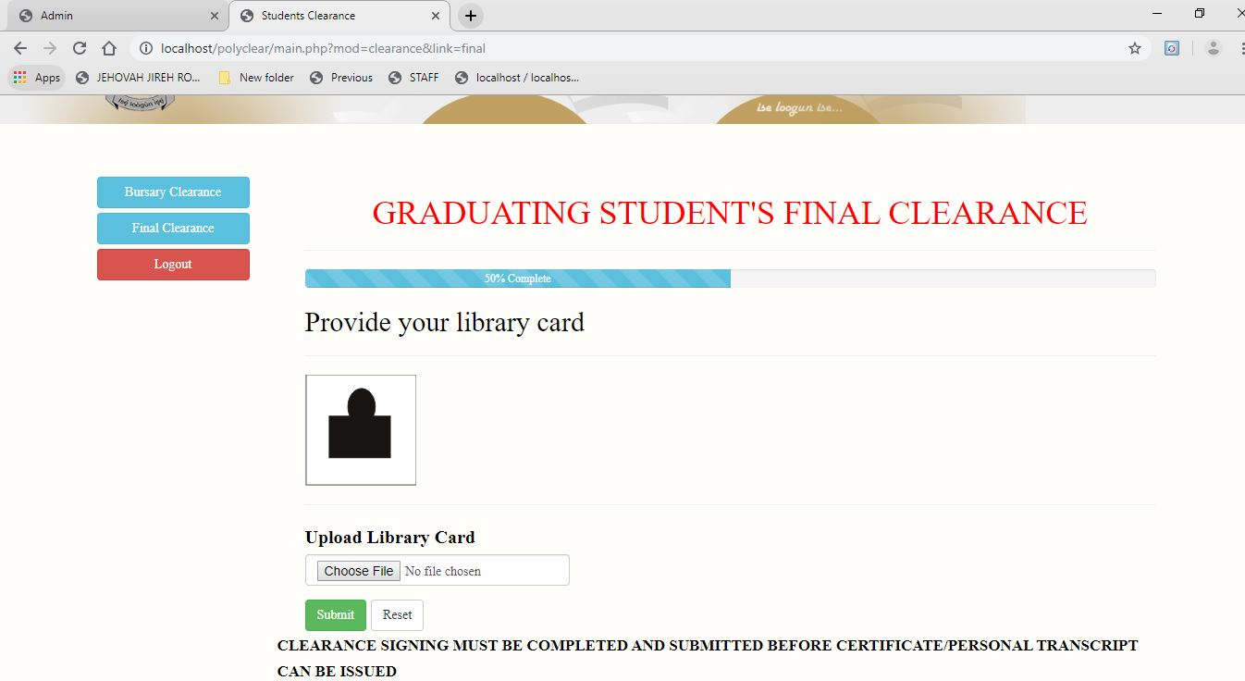

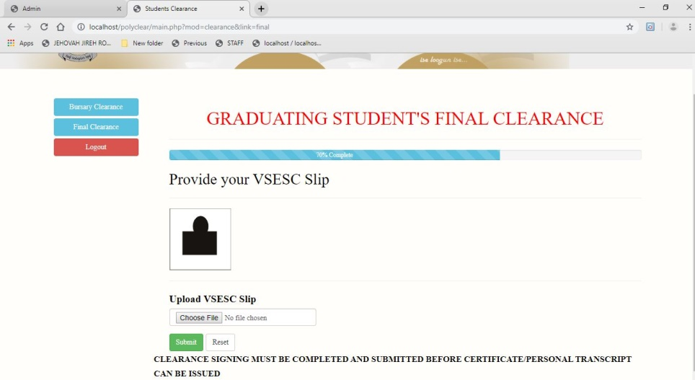

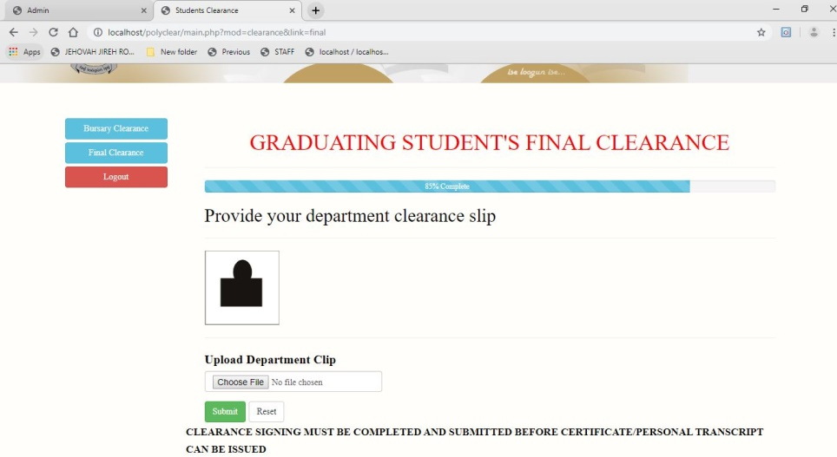

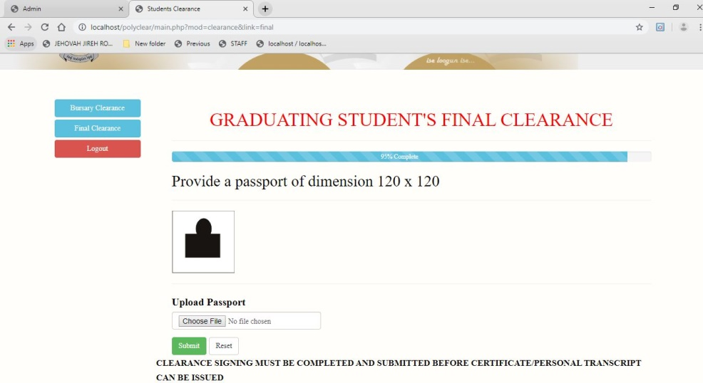

**4.2.3 FILE USED TO RETAIN INPUTS**

The file is as follows:

Polyclear.sql

**4.3 Process Design**

**4.3.1 Programming activities necessary**

1. Writing of program algorithm.
2. Drawing of program flowchart.
3. Psuedo Code
4. Database Creation
5. Program Coding
6. Program Testing

**4.3.2 Program Modules To Be Developed**

The modules to be developed are

* Admin Login Page
* Student Registration Page
* Student Viewing Page
* Bursary Result Page
* Final Clearance Result Page
* Student Login Page
* Student Bursary E-Payment Page
* Student Final Clearance Process Page
* Student Final Clearance Slip Page

**4.3.3 VTOC**

Page

Login

Login

Admin

Student

Reg. Student

View Student

Clearance Result

Bursary Result

Final Clearance

Bursary Clearance

**4.4 STORAGE DESIGN**

**4.4.1 Description of Database Used**

The database management system used for this project is MySql server. The DBMS was accessed through wampserver and phpmyadmin.

**4.4.2. Description of Files Used**

The file used to hold the data to be used by the system is a mysql database file saved by the name polyclear. The file contains four tables, admin, clear, payment and students. The schema for the tables are outlined further in the module below.

**4.4.3 Record Structure Of All Files Used**

The record structures used for these files are;

admin

|  |  |  |  |
| --- | --- | --- | --- |
| **S/N** | **FIELD NAME** | **FIELD TYPE** | **SIZE** |
| 1. | Id | bigint | 20 |
| 2. | Username | varchar | 255 |
| 3. | Password | varchar | 255 |

students

|  |  |  |  |
| --- | --- | --- | --- |
| **S/N** | **FIELD NAME** | **FIELD TYPE** | **SIZE** |
| 1. | Id | bigint | 20 |
| 2. | Sname | varchar | 255 |
| 3. | Fname | varchar | 255 |
| 4. | Mname | varchar | 255 |
| 5. | Matric | varchar | 255 |
| 6. | Dept | varchar | 255 |
| 7. | Sex | varchar | 255 |
| 8. | Faculty | varchar | 255 |
| 9. | Password | varchar | 255 |
| 10. | Date | varchar | 255 |

payment

|  |  |  |  |
| --- | --- | --- | --- |
| **S/N** | **FIELD NAME** | **FIELD TYPE** | **SIZE** |
| 1. | Id | bigint | 20 |
| 2. | trans_id | varchar | 255 |
| 3. | payment_by | varchar | 255 |
| 4. | Amount | bigint | 20 |
| 5. | Date | varchar | 255 |

clear

|  |  |  |  |
| --- | --- | --- | --- |
| **S/N** | **FIELD NAME** | **FIELD TYPE** | **SIZE** |
| 1. | Id | bigint | 20 |
| 2. | for_id | bigint | 20 |
| 3. | Sname | varchar | 255 |
| 4. | Fname | varchar | 255 |
| 5. | Mname | varchar | 255 |
| 6. | Matric | varchar | 255 |
| 7. | Dept | varchar | 255 |
| 8. | Sex | varchar | 255 |
| 9. | Faculty | varchar | 255 |
| 10. | Bac | varchar | 255 |
| 11. | Hostel | varchar | 255 |
| 12. | Sport | varchar | 255 |
| 13. | Library | varchar | 255 |
| 14. | Vesc | varchar | 255 |
| 15. | Department | varchar | 255 |
| 16. | Passport | varchar | 255 |
| 17. | Date | varchar | 255 |

**4.5 DESIGN SUMMARY**

In the course of input and output design, hardware andf sogtware componrnts of the system are involved in proper execution of computerization of the activities of copyright company. It involved the system flowchart.

**System Flowchart**

This ic the graphical representation that shows the processing procedure and how the procedure is arranged from input to output with the detail as how the processing is to be achieved

**4.5.1 System Flowchart**

For Admin

Display Login Page

Store Data

Register New Student

Do Admin Login

Is login Admin

For Students

Display Login Page

Do Admin Login

Is login Admin

Register New Student

Store Data

**CHAPTER FIVE**

**5.0. SYSTEM DEVELOPMENT AND IMPLEMENTATION**

This chapter commences after the system design phase, where the development activities and software, hardware required will be properly treated.

**5.1. PROGRAM DEVELOPMENT ACTIVITIES**

This is the process or means of acquiring the necessary tools for the development of the program which is being divided into three layers, they are:

1. Programming language used
2. Environment used for development
3. Source-code

**A. PROGRAMMING LANGUAGE USED**

The programming language used for the development of the software is PHP

**B. ENVIRONMENT USED FOR DEVELOPMENT**

The environment used for developing this program is Sublime Text environment. This envirenment is shared with several other programming language including HTML, JavaScript, CSS, Ajax, etc

However, because they share the same environment, it becomes easy to integrate the product with each other, it is possible to share data from MySQL, to create quick professional looking interface of data presentation.

**C.SOURCE CODE**

These are the codes used in the generation of both the input and output data, these codes are used to save each field name created in each form of input data into the database system.

**5.2. PROGRAM TESTING**

During the programming stage, each modules of the program were tested to determine the reliability of the system for installation and to specify laid down rules by the designer. The testing of this particular program is easy because it is menu driven and modular in structure. Testing has been performed both by desk checking the program, design with the original specification and by running the final program using test data and selecting options from the main to carry out the desired goal. Program testing can be categorized into two parts:

1. Coding problem encountered.
2. Use of test data.

**A. CODING PROBLEM ENCOUNTERED**

At different stages of developing the program, the different types of problems encountered are:

**a. SYNTAX ERROR**

PHP simplifies coding by applying syntax coloring during compilations stage. Any misused rule governing PHP such as keywords are changed from default color to yellow highlights to show where error occurred and refuse to compile until corrected before compilation.

**b. LINKING ERROR**

These errors occur during linking. When a reference module is not found for linking, an error occurs.

**c. LOGIC ERROR**

This error is as a result of improper sequencing of program statements. However, results produced by the computer are not reliable.

**d. RUN TIME ERROR**

These errors occur as a result of condition that arises making it impossible for program to continue running e.g. "Arithmetic flow"

**5.3. SYSTEM IMPLEMENTATION**

System implementation is an important phase in system development life cycle. System implementation involves acquiring hardware, software, training, data conversion, switching over operation from the manual to the new computerized system. This is categorized into four part:

**a. SYSTEM REQUIREMENT**

When a system starts functioning it is necessary to monitor its operation to ensure that the user requirements are met. The new system has to be examined from time to time to ensure that it works as expected.

The user and operators of the system should constantly check the output of the system to ascertain its performance. The purpose is to deal with unforeseen problems that may occur during the operation of the system and ensure that objectives are met.

**b. TASKS PRIOR TO IMPLEMENTATION**

This includes the hardware and software required for the execution of activities in the organization. This task can be divided into three:

1. Hardware requirement
2. Software requirement
3. Program requirement.

**i. HARDWARE/SOFTWARE ACQUISITION**

The hardware requires ensuring proper running of the new system are:

1. Pentium IV processor
2. 512MB random access memory
3. 40Gigabytes hard drive for primary storage
4. Enhanced keyboard and mouse
5. External had drives as backup for database.
6. UPS (Uninterrupted Power Supply).

**SOFTWARE REQUIREMENT**

The software requirement includes:

1. Operating system from Windows XP and above.
2. Sublime Text
3. Wamp Server (Any Version)
4. Updated anti-virus for protection of the software.

**ii. PROGRAM INSTALLATION**

Follow the steps below to install the software compact disc (CD):

1. Insert the CD in the CD ROM
2. Locate My Computer, and there double click on CDROM to see polyclear folder
3. Copy the folder to C:\wamp\www.
4. For more operation on the software, see operation manual in the next chapter

**c. TRAINING**

This is the training of the users to the new system, if it is to be operated correctly and full benefit of the new system is to be reaped. The department in charge of the clearance system should functionally support to assist in training the necessary users within the institution. However, by the time the system is ready to be fully implemented, all operational users must be fully acquainted with its workings.

**CHANGING OVER**

This is the process of changing from one system to another especially from the existing manual system to the automated system. There are four different methods of changing from existing system to new system, namely:

**i. DIRECT CHANGE OVER**

This is a situation in which the system in use is discarded and replaced by a new system. This system is risky and not advisable

**ii. PARALLEL CHANGE OVER**

This is a situation where the old system and the new system are being used concurrently; the old system is then discontinues immediately the new system is satisfied to be working

**i. PILOT CHANGE OVER**

The new system is implemented in a specific area of the organization; it is brought into another area of the organization immediately it is successful in the first area.

**iv. PHASED CHANGE OVER**

The new system is divided into phases; the first phase is introduced, if it is working well, the next phase is made operational. However, this type of change over is to be used for room allocation in parallel change over so that both new and old system will be used until there is enough confidence in the new one to discontinue the old system so as to give room to work out debug.

**CHAPTER SIX**

**6.0. SYSTEM DOCUMENTATION**

It is a written description of any system design which tells the user how to go about using the system. It also refers to the details of all the modules involved in the design of the system. This program is developed using PHP programming language which consists of the following modules, each performing a specific function.

**6.1. FUNCTIONS OF PROGRAMMING MODULES**

The program modules are of diverse types and their functions are listed below:

**A. LOG IN**

Here, Admin has its own panel to login with his username and password and also the student has its own panel to login with his username and password as his matric number, hence can change the password if desired.

**B.ADMIN**

The admin module requests an admin ID and Password to allow the Webpage Administrator access to register a graduating student and view all clearance result.

**B.STUDENT**

The student module requests the student username and password to allow the access to confirm details given by the administrator and make payment in bursary and then complete the final clearance.

**D. Logout**

This is used to unload the whole program by ending it.

**6.2. USER MANUAL**

To run the program, the procedure below should be adhered to; The system will require a wamp server and a browser

**STEP 1:**

1. insert the CD (compact disc) into the CD drives.
2. Double click on My Computer on the desktop or click on Start menu, locate My Computer, then click.
3. Double click on CD drive in order to display the content of the CD.
4. Copy the folder (polyclear) to C:\wamp\www.

**STEP II**

Turn on the wamp server and go to ‘localhost/phpmyadmin’ on the browser, create a new database of the name (polyclear), click on ‘import’ and upload the sql file in the folder.

**STEP III**

1. On the browser, type ‘localhost/polyclear/admin’ to go to the admin panel to register a graduating student and logout when done.
2. On the browser, type ‘localhost/polyclear’ to go to the student panel to confirm, pay and complete the final clearance, then logout when done.
3. The username and password for admin is ‘admin’.
4. The username and password for students is their matric number.

**CHAPTER SEVEN**

**7.0. SUMMARY, CONCLUSION AND RECOMMENDATIONS**

**7.1. SUMMARY**

The use of computer software based online clearance system forms the basis of the school management decision. It aims at providing the management with adequate, effective, well documented up-to-date and formatted output. To help as a tool in planning and decision making/based on the student clearance form.

The lack of learner outcome variation of the online system signals the establishment of concurrency between the two measures even though they are measures of same construct. This investigation supports the use the online system delivery structure to broaden the instruction audience in technology education program.

The use of online clearance system in technology education at the university remain at the minimal level as suggested by the 80 percent of the online student participant, predominantly technology education measures who report that they have not done online clearance previously. Also 75 percent of online student participant report that they have not used computer software base online clearance system previously. Having come to completion of this project work a lot of achievement was made and they include;

1. The replacement of error prone manual system with new automated online clearance system.
2. Data can now be processed with great speed and efficiency.
3. The application has the ability to update record in various files automatically there relieving the university staff the stress from working from file to file.
4. The security of data is ensured.
5. The use of database server was implemented.

**7.2 CONCLUSION**

Research and development are continuous processes; this is same in computer and software development. However the effectiveness and efficiency of this new system provide room for further improvement. As early mentioned some of the objectives of this project were not actualized due to some limitation. So this objectives could be improved upon, the outline clearance system developed will offer greater opportunity in school management. All transaction or payment with regards to student’s clearance can be carried out online.

**7.3 RECOMMENDATION**

The research work carried out is limited to online clearance only. It would be better if a full portal is developed for effective and wholesome of information management technology in our institutions. When this is done the following modules are recommended to include in the portal.

1. Developing an online students admission system to enable full tracking of student records
2. Automation of student academic record to enable the management to have access to student academic performance.
3. Maintaining a central database for accessing information relating to student.